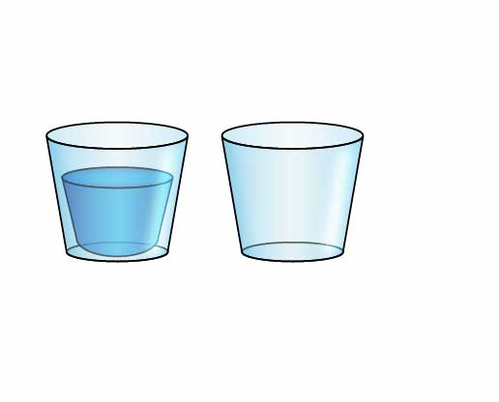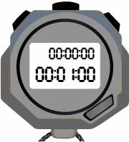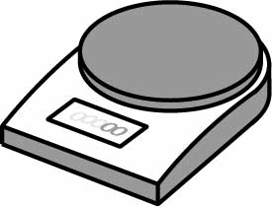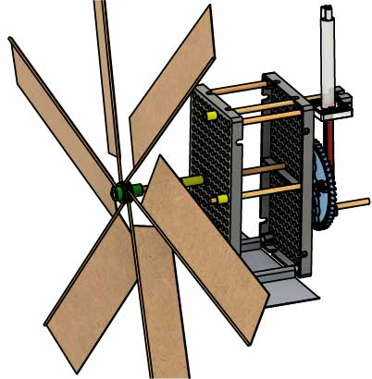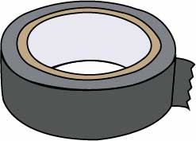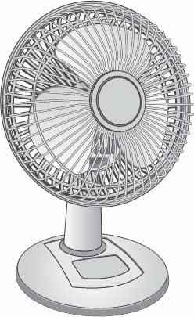

Scale   
(to measure mass of water)

2 Cups   
(one filled with water)

Stopwatch

Books

“Built” Wind Pump

Build your Wind Pump using the [**Go Guide**](https://teachergeek.org/wind_pump_2.0_go_guide.docx). Download it at [**teachergeek.com/windpump**](https://teachergeek.com/windpump)

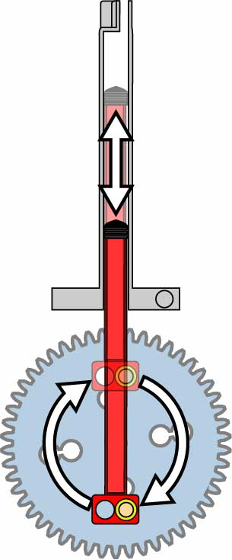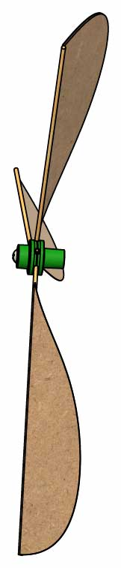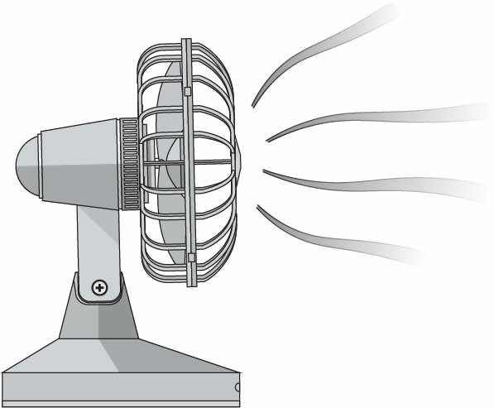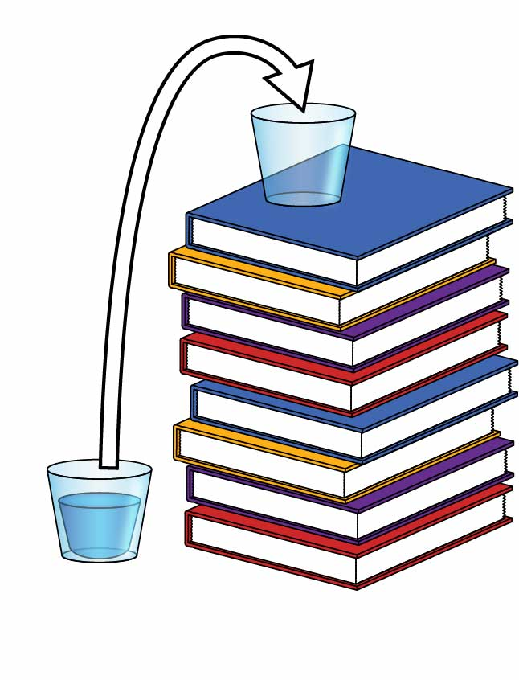

Wind Energy

Mechanical Energy

Potential Energy

Mechanical Energy

Energy of the wind’s motion.

Energy of the spinning rotor.

Energy of the gears’ and cylinder’s motion.

Energy stored in gravity when water is pumped to a greater height.

# Lab Supplies

**Your Wind Pump converts Wind Energy into Potential Energy.   
The faster your pump can convert energy, the more powerful it is!**

How powerful is your turbine? Time to find out!

Name:__________________________________ Period:___________

Date:__________________

Duct Tape

Fan

**P = E / t**

Power

Time to pump the water

**E = m g h**

Change in Potential Energy

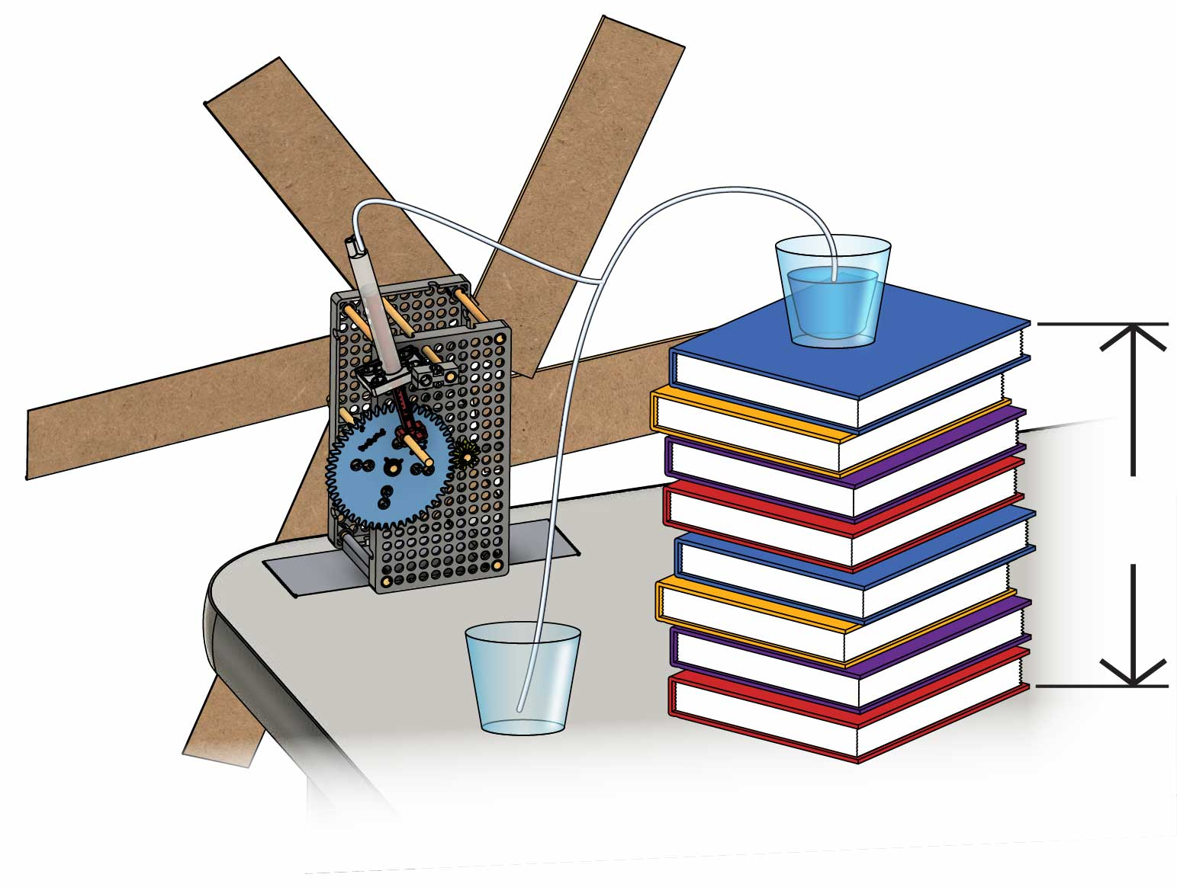

**m**

**h**

**g**

**Mass** of the water (in kg)

**Height** the water is pumped upward (in m)

Acceleration due to **gravity** (9.8 m/s2)

Height is positive when water is pumped upward

Height is negative when water is pumped downward

# 2

# 1

Time your turbine pumping the water from the lower cup to the upper cup, then calculate the power it produced.

Calculate the change in potential energy of the water when its pumped from the lower cup to the upper cup (you’ll need to measure m & h).

The change in the water’s potential energy can be found by multiplying m $*$ g $*$ h .

Calculate your pump’s energy and power!

**P = E / t**

# 6

# 5

Time your turbine pumping the water from the upper cup to the lower cup, then calculate the power it produced.

Does your pump go faster when pumping the water upwards   
or downwards?

**E = m g h**

Calculate the change in potential energy of the water when it’s pumped downwards – from the upper cup to the lower cup.

The energy you calculated in #3 should have been negative (because height is negative). If the water lost its potential energy, where do you think it went?

# 4

# 3

What happens if you pump downwards?

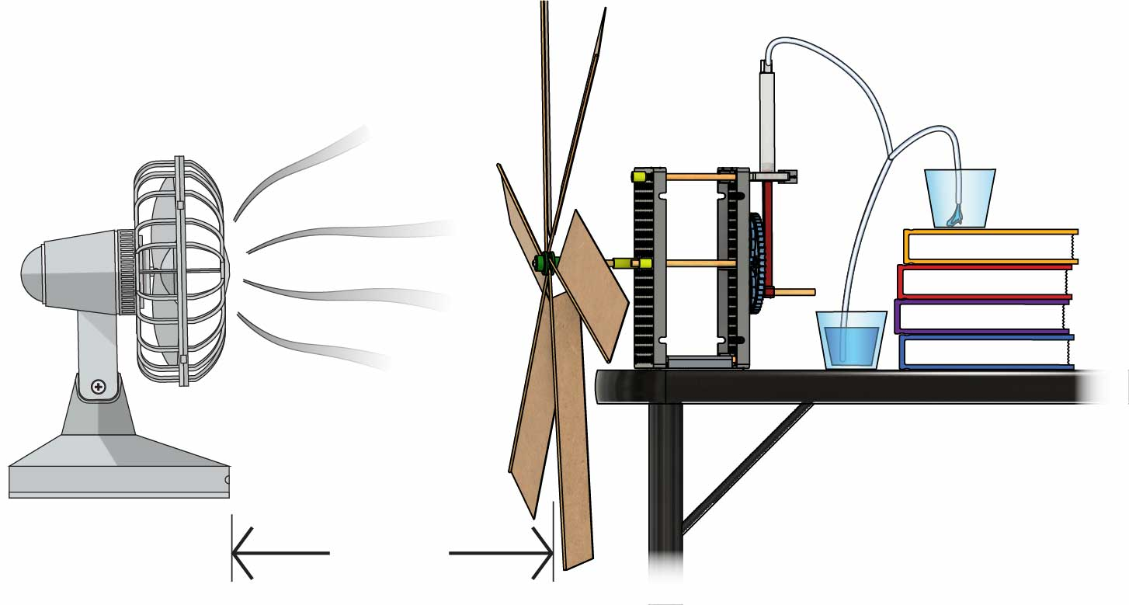

Only wind can power your pump (but you can give it one small push to get it started).

Optional

Power Challenge

Redesign your wind pump to create as much power as possible!

The pump that generates the greatest power wins!

Criteria:

Constraints:

The fan must be 60 cm (24 in) from the blades.

**60 cm**   
(24 in)

You may adjust your cups to any height as you try to generate the greatest power.

If a AA battery can store about 5000 J of energy, how long would it take your wind pump to charge the battery?

# 8

# 7

**Recommended Heights:**  
40 cm, 30 cm, 20 cm, 10 cm

Test pumping water upward to 4 different heights. At what height does your wind pump develop the greatest power?

How much power can your pump generate?