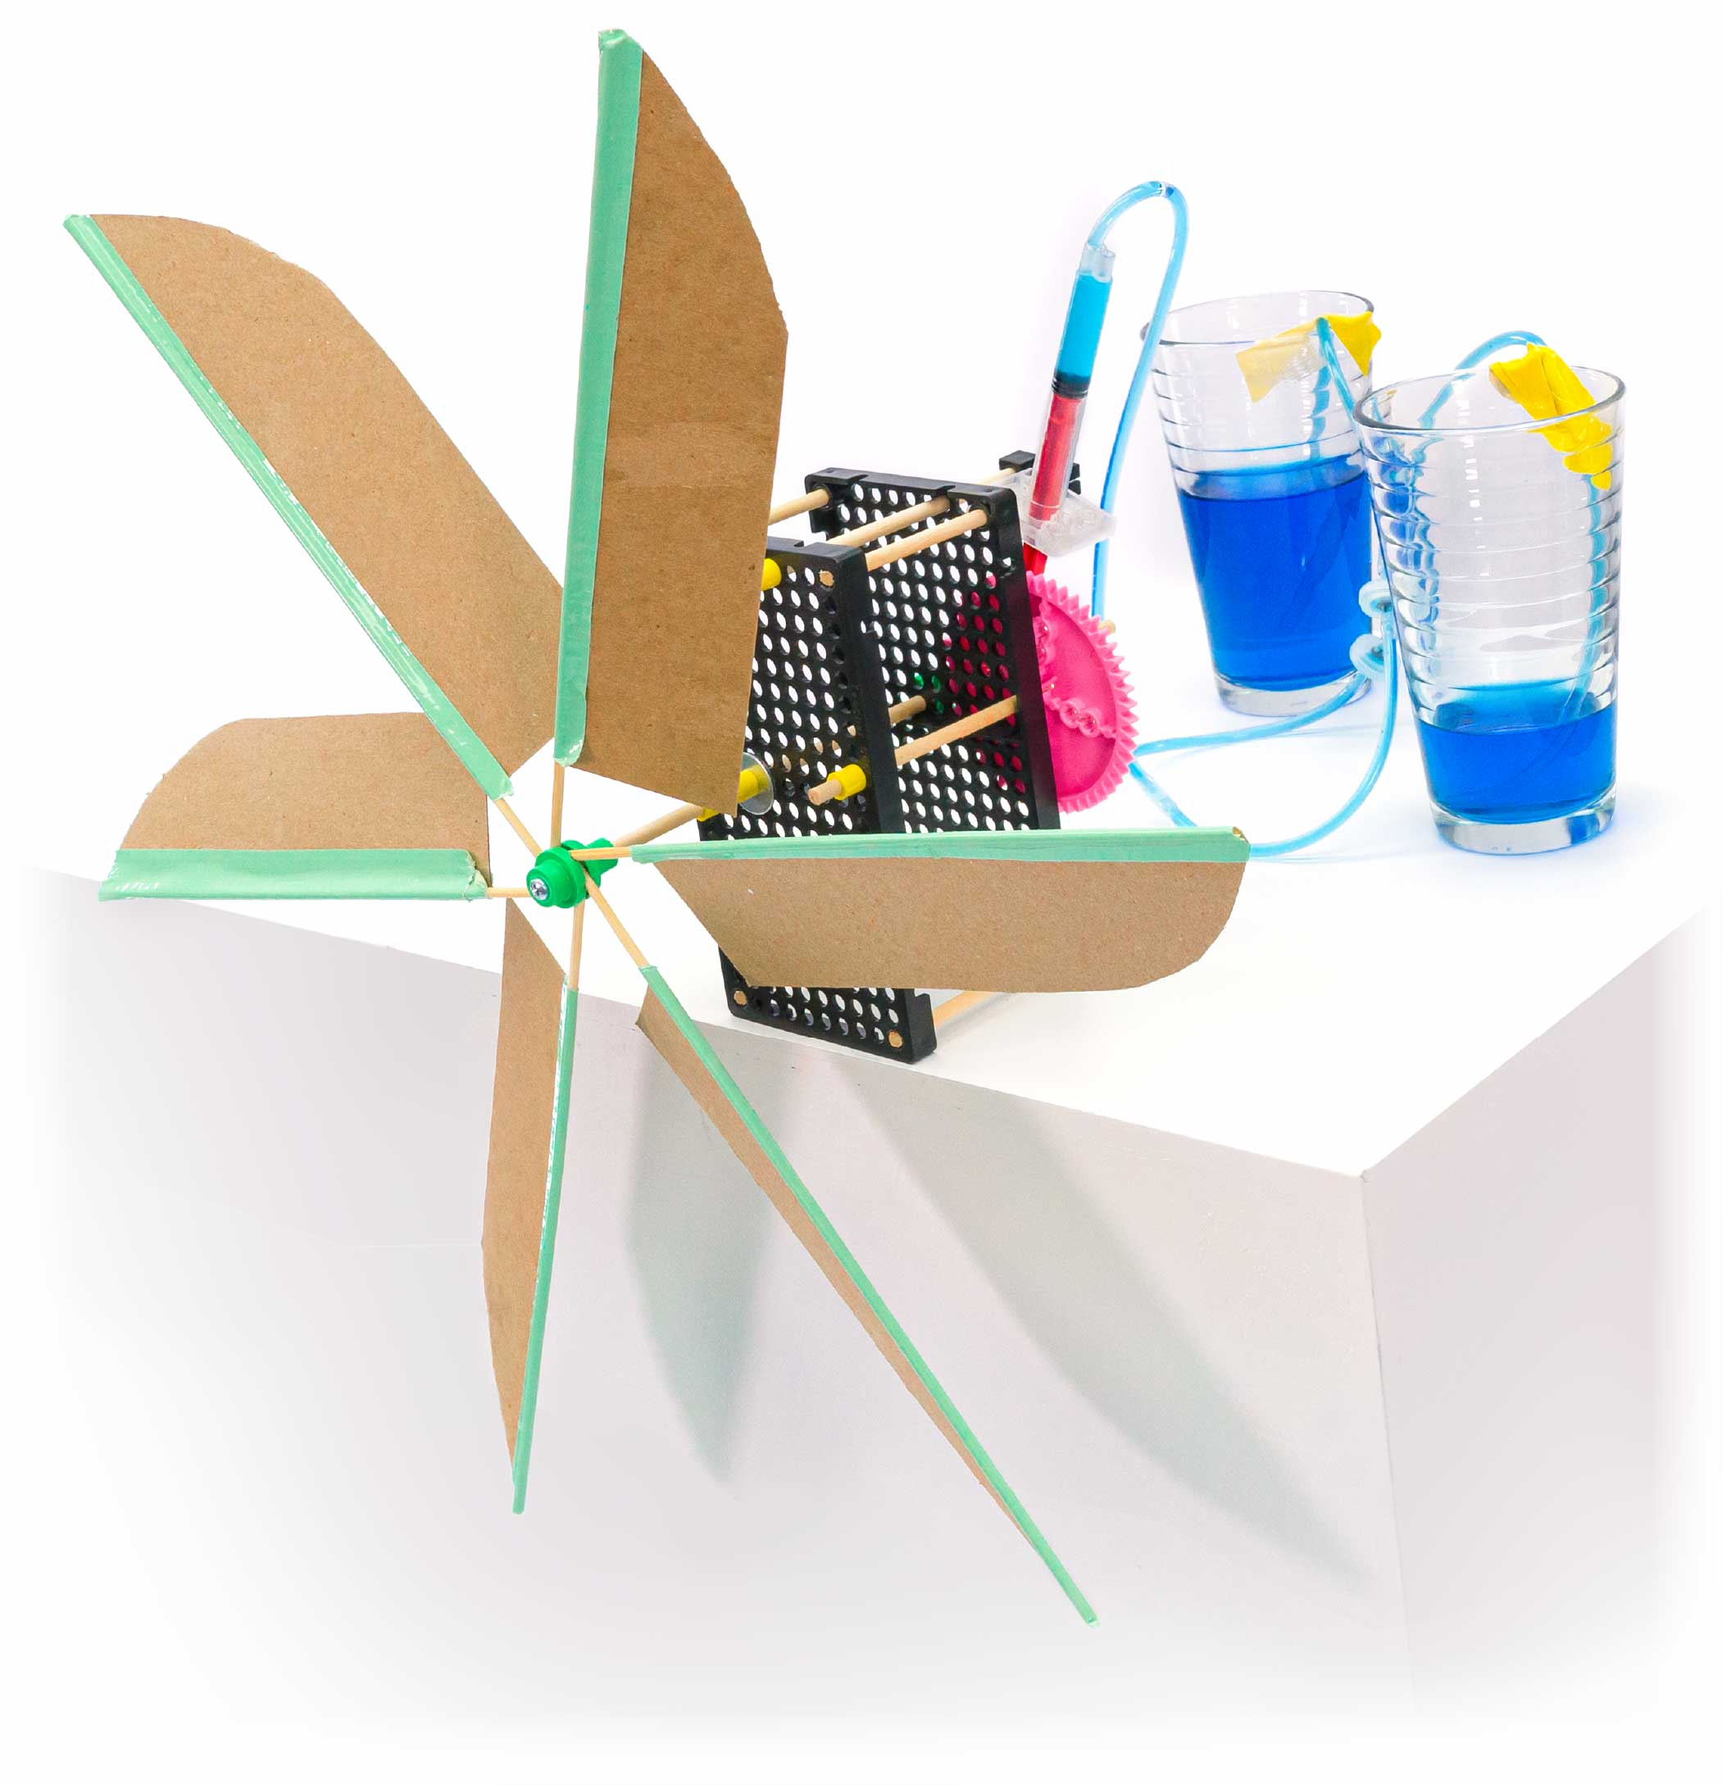

**Learn about wind energy and power by engineering and re-engineering your very own wind-powered pumped!**

TRUE

STEM

STEAM

Start here! Build your Wind Pump, evolve your design, and begin   
the Steady Wind Challenge!

-[Energy & Power Lab   
 (Ages 9+)](https://teachergeek.org/wind_pump_2.0_lab_energy_power.docx)

-Steady Wind Challenge*  
-Variable Wind Challenge*  
-Elevation Challenge*  
-Environmental Challenge*

*See Page 10

Optional Challenges

Optional Labs

Go Guide

You Are Here

**Choose how you would like to complete this activity.  
Download documents & videos at** [**teachergeek.com/windpump**](https://teachergeek.com/windpump)

# Supplies

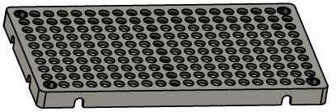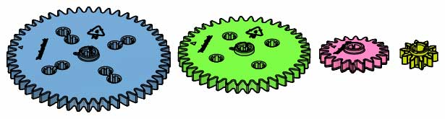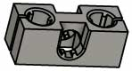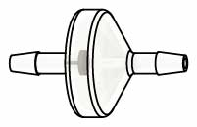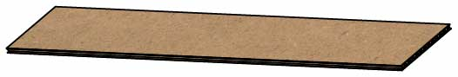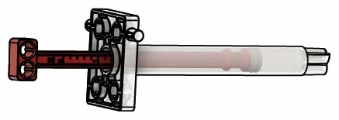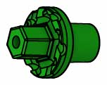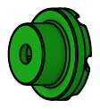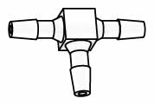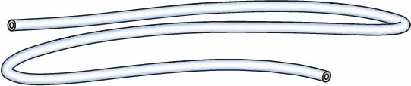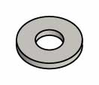

**Dowels**various sizes  
SKU 1821-20

**Picture**

**Name**

**Qty**

**Hole Plates**  
SKU 1821-32

**Block**  
SKU 1821-34

**Cylinder**4.5 ml  
SKU 1821-52

**Tubing**60 cm (24 in)  
SKU 1821-51

**T-Connector**  
SKU 1821-56

**Chipboard**22 cm x 5 cm  
(8.5 in x 2 in)  
SKU 1823-48

**Project Sticks**25 cm (10 in)  
SKU 1821-18

**Check Valves**  
SKU 1821-57

**Mini Hub Base**Green  
SKU 1821-67

**Mini Hub Cover**Green  
SKU 1821-67

**Mini Hub Screw**  
SKU 1821-67

**Washers**#10 size  
SKU 1821-24

**Slide Stop** 8 cm (3 in)  
SKU 1821-49

2

1

1

2

1

2

1

1

1

10

6

1

1

1 – 5 cm (2 in)  
4 – 8 cm (3 in)  
4 – 10 cm (4 in)  
1 – 13 cm (5 in)  
2 – 15 cm (6 in)

**Gear Set**  
SKU 1821-28

1 **set**  
(4 gears)

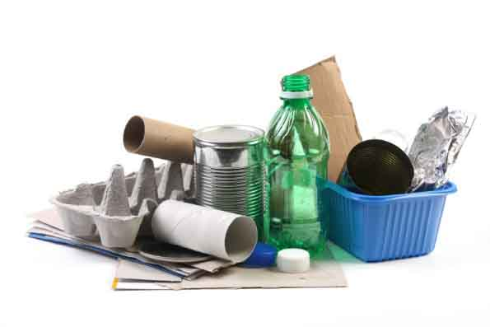

Materials You Supply

* **Phillips Screwdriver**
* **Scissors**
* **Duct Tape**
* **2 Cups** (one filled with water)
* **Fan**
* **Stopwatch**
* **Recycling Bin Materials**What can you use to make turbine blades?

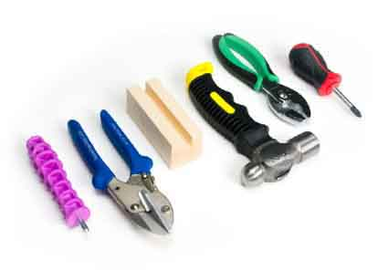

Modify materials to make even more creative designs with the **Maker Tool Set**

SKU 1823-84

Optional Tools

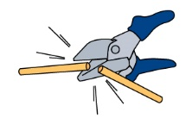

Have a Maker Cart? Use Multi-Cutters   
to cut your own dowels.

PUMP Parts

These are the parts you need to build one Wind Pump, plus some extras, so you can make your own unique designs.

Included tools

**TeacherGeek Reamer**  
SKU 1823-87

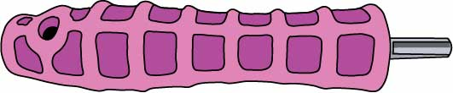

**Check out the** [**Scenario Video**](https://vimeo.com/411195838)**!**   
Play it by scanning the   
QR Code or going to[**teachergeek.com/windpump**](https://teachergeek.com/products/wind-pump-wind-turbine-mill-activity_v1-2)

# Make Your Pump

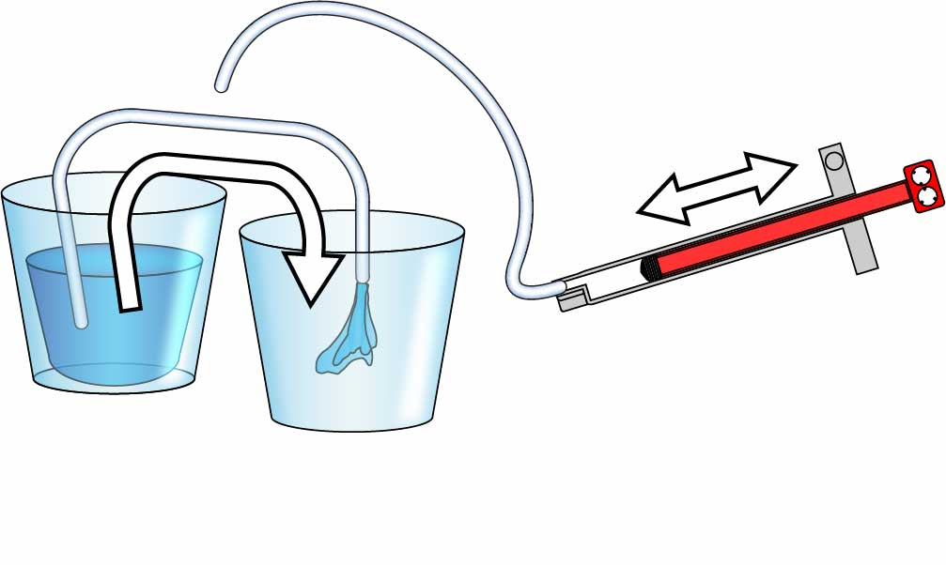

**Did you do it? Does your hand pump suck water from one cup and push it into the other? Awesome! You’re ready to move on to the Gears.**

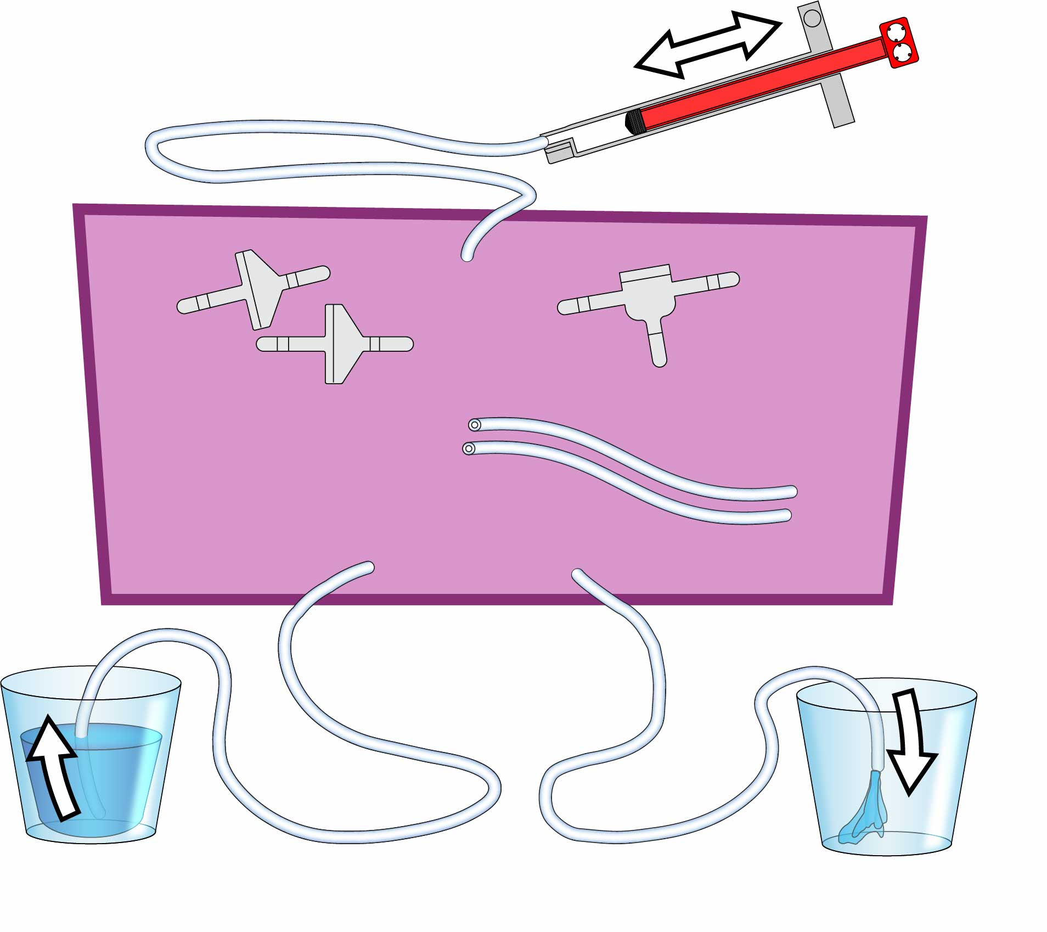

Mystery Parts

**Tubing  
30 cm** (12 in)

**2x**

**2x**

**1x**

**Tubing  
30 cm** (12 in)

**Check Valves**

Only let water (or air) through in one direction.

**T-Connector**

Joins 3 sections of tubing.

**Tubing  
15 cm** (6 in)

**Cylinder**

**Cup of Water**

**Empty Cup**

**Tinker with the Mystery Parts!**   
You will need to **use all of them** to make your pump!

**You’re going to engineer your very own hand pump!**   
Later, you’ll convert it to use wind power!

Mystery Parts

Your pump must move water from one cup to the other when you push & pull the cylinder.

Can you figure out how to use these parts to build your pump?

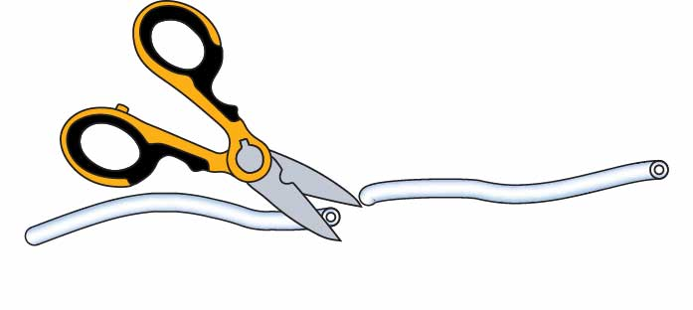

**Cut your tubing** to make   
 -**3x 30 cm** (12 in) sections &   
 -**2x 15 cm** (6 in) sections.

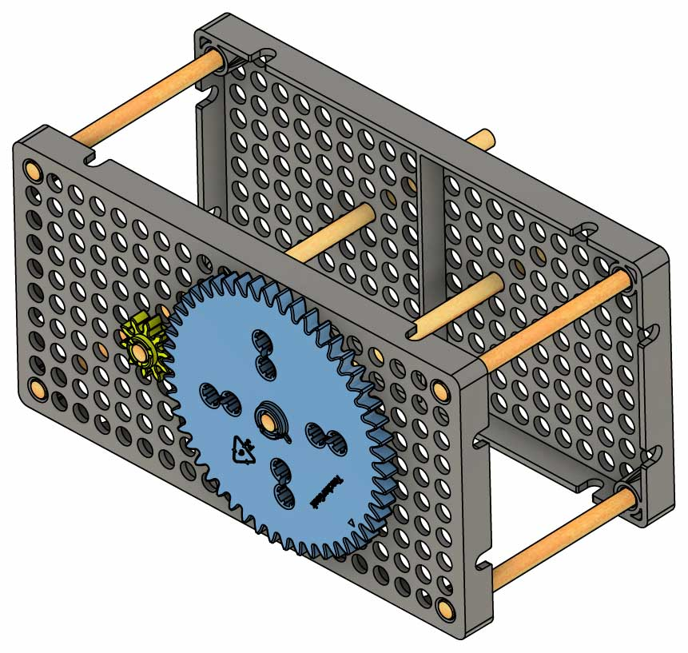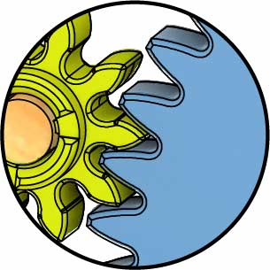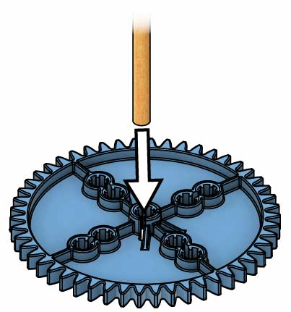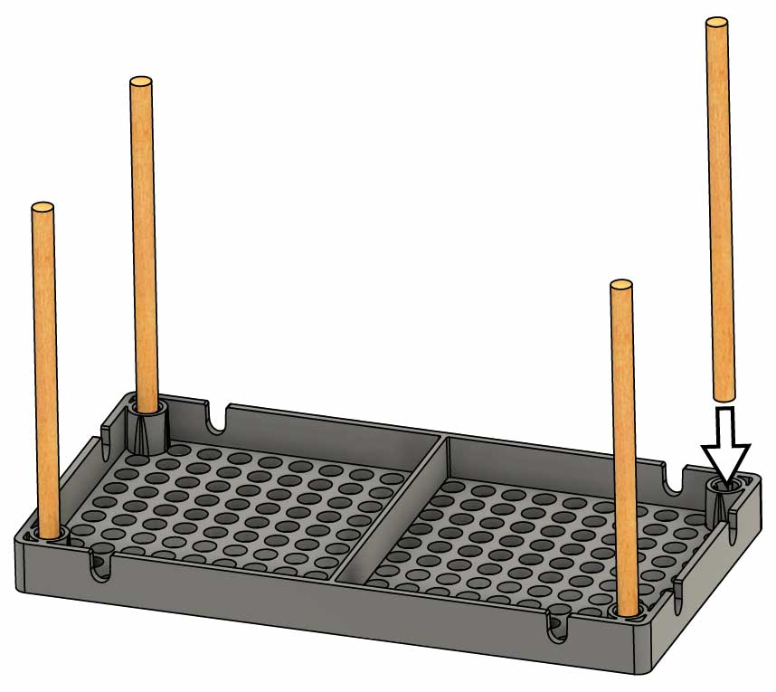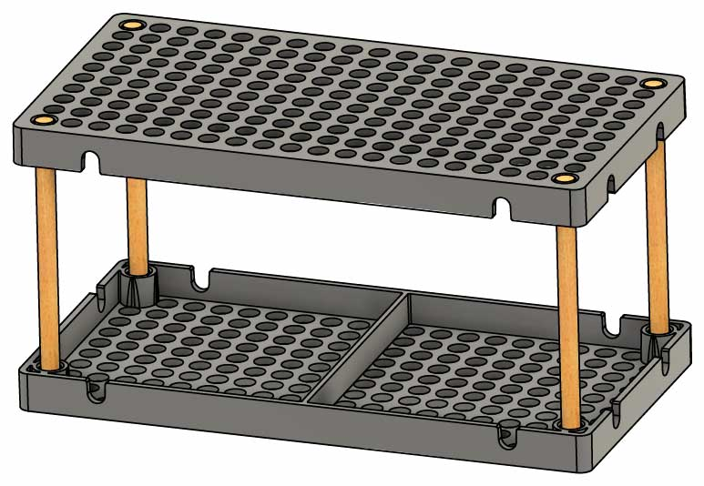

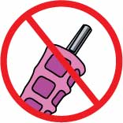

**Don’t Ream**

# 4

**Slide** your   
largest and smallest **gears**   
**into** the **frame**   
so they **mesh**.

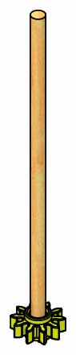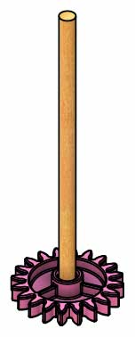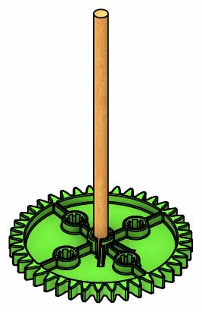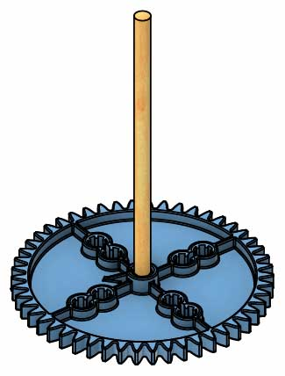

Finished Gears

**10 cm** (4 in) **Dowels**

**15 cm** (6 in) **Dowel**

**Your pump will use gears to pump faster or with more torque.  
Get your gears set up, then play with them to see how they work.**

# Make Your Gears

# Gear Up

# Build Your Frame



**Don’t Ream**

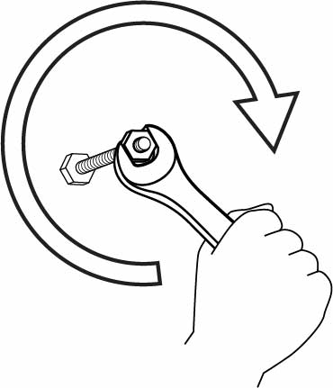

**Torque** is turning force.

**Your frame is done!**  
Time to add gears.

**Push** or tap another   
**hole** **plate** onto the dowels.

# 2

# 1

**8 cm** (3 in)   
**Dowel**

**Hole Plate**

**Wiggle** or tap **four** **8 cm** (3 in) **dowels** into the four corners of a **hole** **plate**.

**Wiggle** or tap a **dowel** **into** each of your four **gears**.

# 3

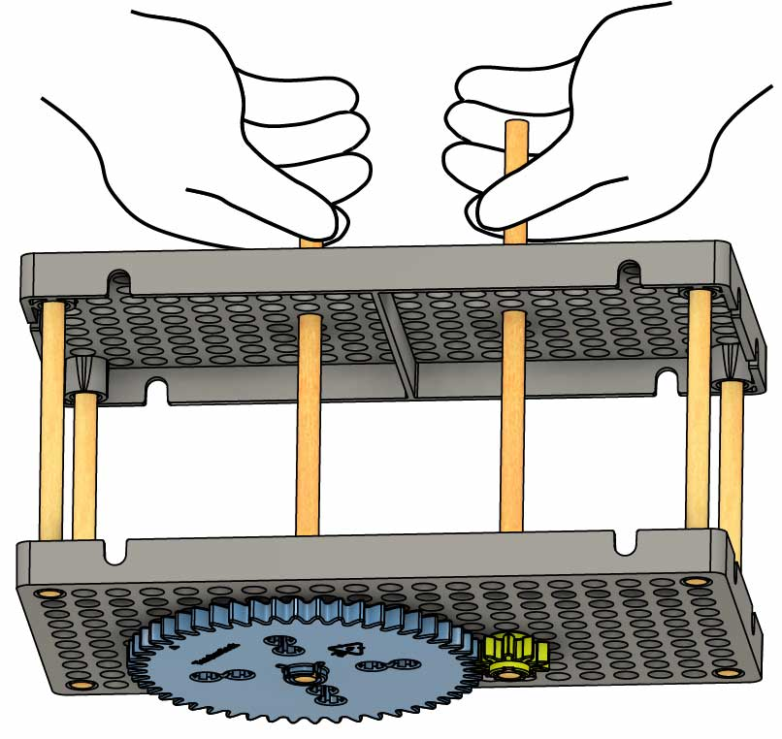  
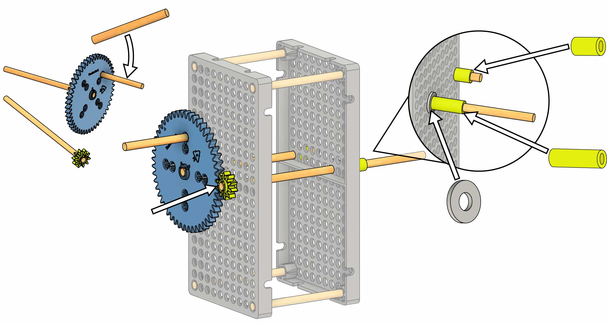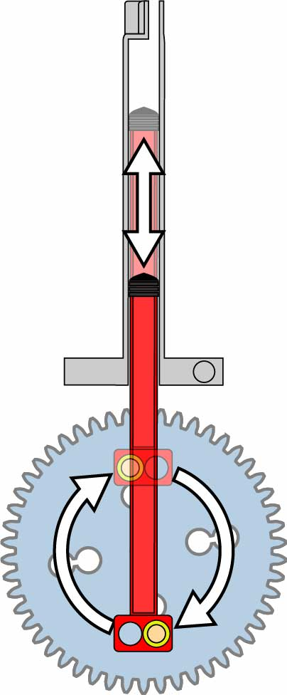

**Now you have a feel for how gears work!** Next, you’re going to use the gears to drive your pump.

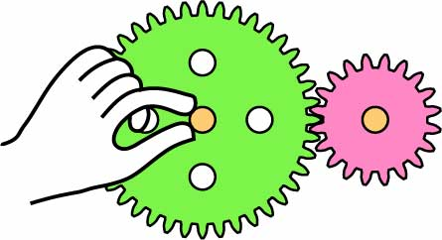

40 Teeth

20 Teeth

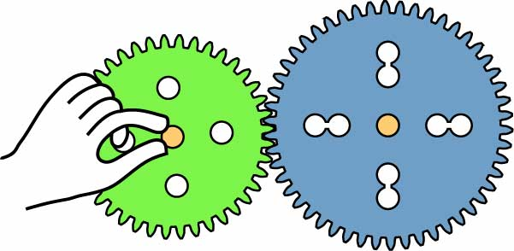

40 Teeth

50 Teeth

Try other gear combinations

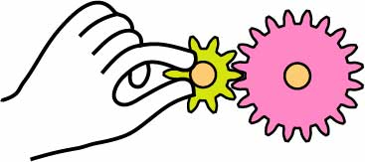

10 Teeth

20 Teeth

Gear Ratio

=

50

10

5

1

÷10

÷10

**Torque Decreases**

**1**

**5**

the torque

**Speed Increases**

5

1

= **5x** the speed

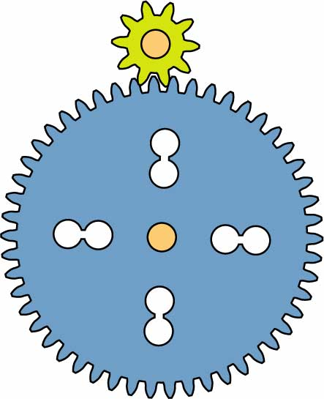

**Twist This Dowel**

**Watch & Feel This Dowel**

10-Tooth Gear

50-Tooth Gear

Speed **for** Torque

Torque **for** Speed



**Twist This Dowel**

**Watch & Feel This Dowel**

10-Tooth Gear

50-Tooth Gear

Gear Ratio

=

10

50

1

5

÷10

÷10

**Speed Decreases**

**1**

**5**

the speed

**Torque Increases**

5

1

= **5x** the torque

-OR-

**Spin the dowels to turn the gears!**



**Torque** is turning force.

The easier it is to twist the dowel, the more torque its gear has.

**Feel the Torque**

**See the Speed**

Watch the gears to see which one revolves faster.

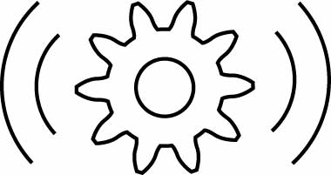

Gears can trade speed for torque(and vice-versa)

# Play with Gears!



**Don’t Ream**

**5 cm** (2 in) **Dowel**

# 6

# 7

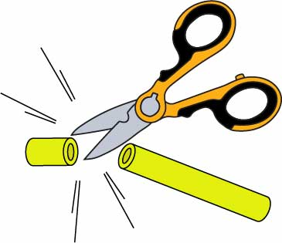

Use scissors   
to cut slide stop.

**Test your gears!** If they don’t spin freely, loosen the slide stop until they do. Now you’re ready to add the pump!

**Secure** the **dowels** with **slide stop** and a **washer**.

**1 cm** (1/2 in) **Slide Stop**

**2 cm** (1 in) **Slide Stop**

**Washer**

**Mesh** the **50-tooth** **gear** and **10-tooth** **gear** about halfway up your frame.

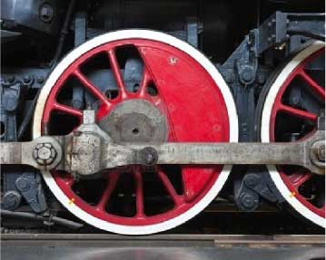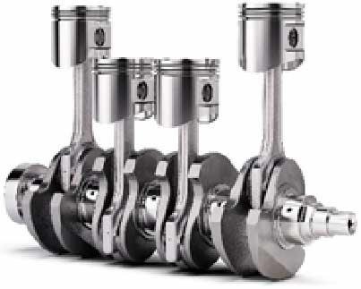

Cams are used on train wheels and gasoline engines.

# Geared Pump

**You’re going to use your gear as a cam to convert rotational (circular) motion to linear (straight-line) motion.**

# 5

# Attach the Cam

**Start by connecting the cam to the frame; next, you’ll connect the cylinder.**

**Wiggle** or tap a **5 cm** (2 in) **dowel** into the **50-tooth gear**.

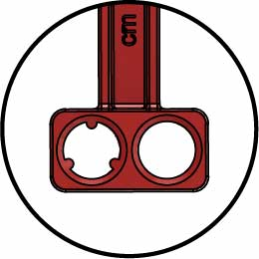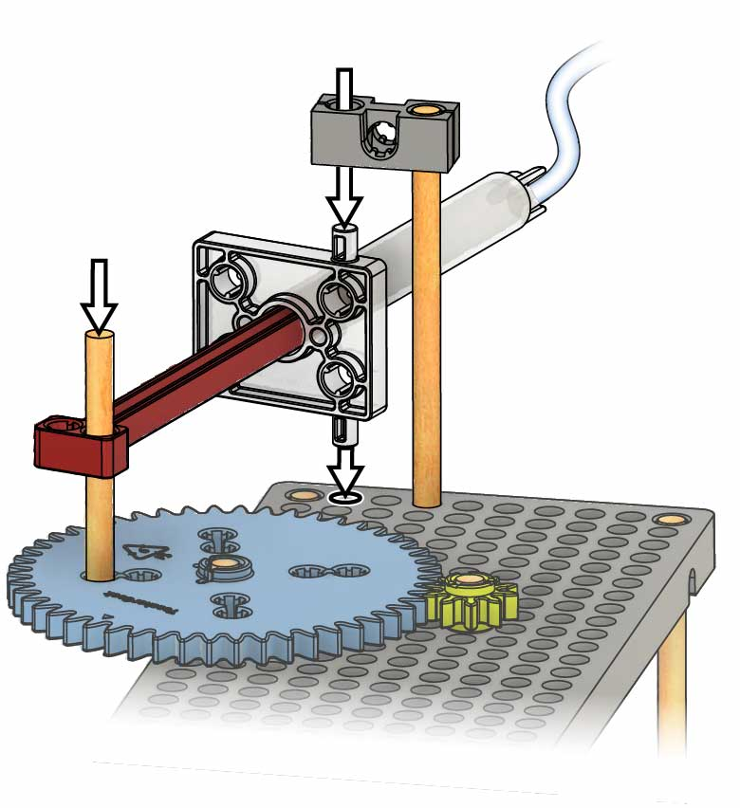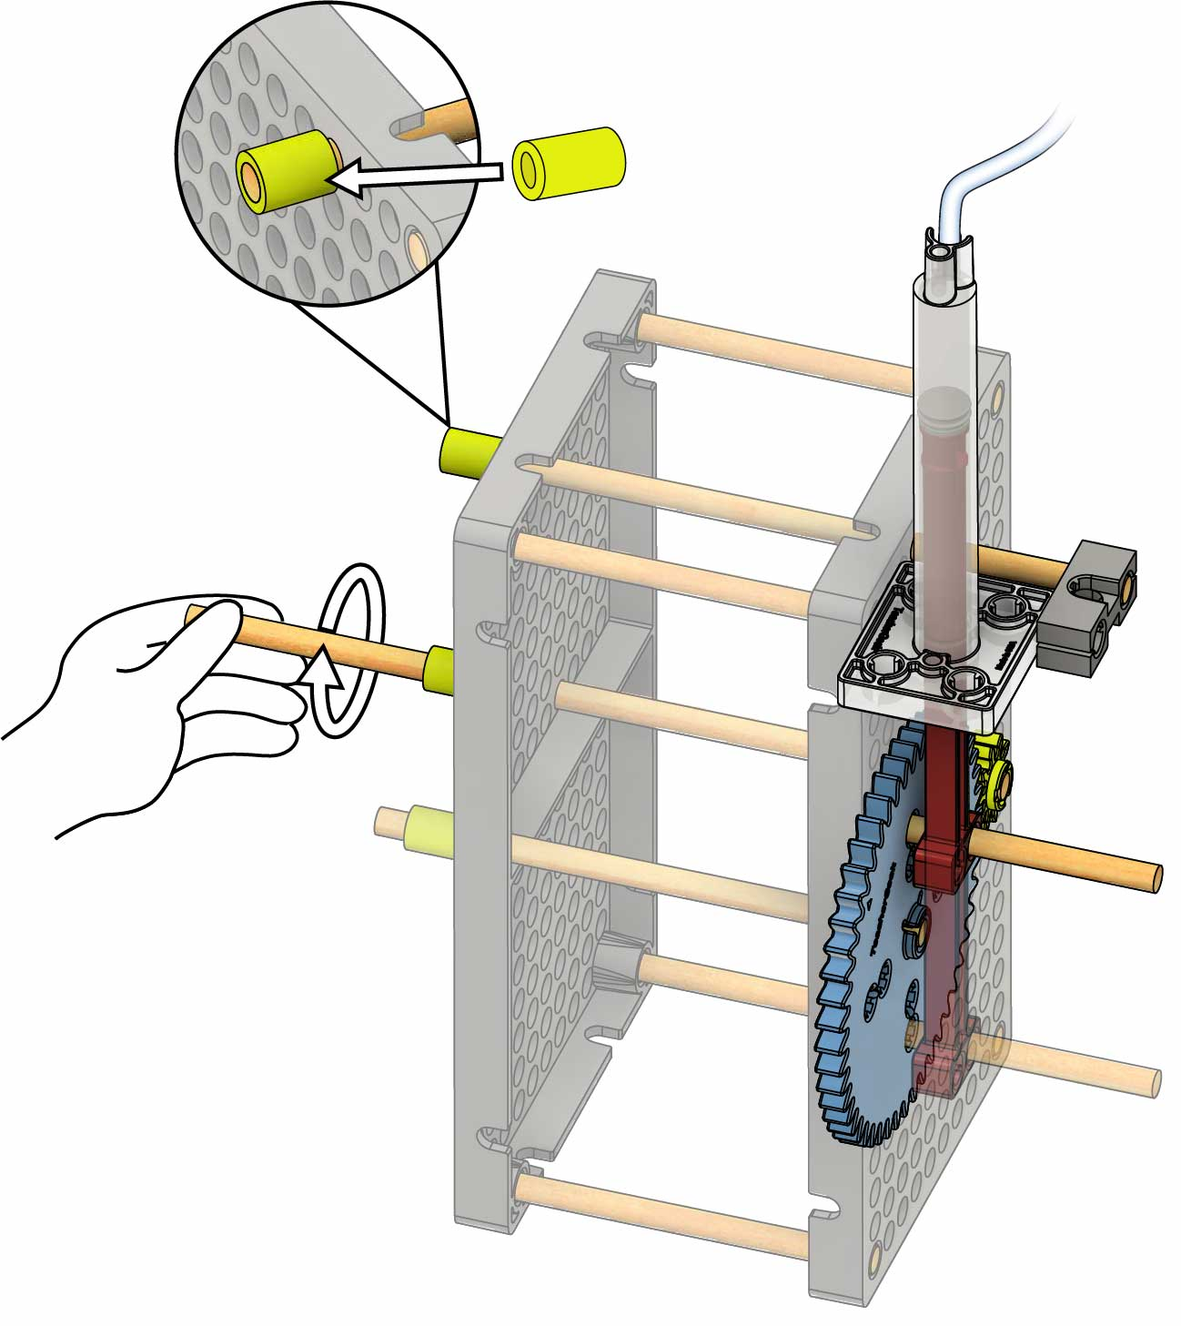

**1 cm** (1/2 in) **Slide Stop**

**Your geared pump is done.** It’s time to add the rotor!

**Not working?**

You may need to move your gears or cylinder on your frame or loosen your slide stop.

**Test it out!** Spin the longest dowel (10-tooth gear) to run   
your pump!

# 12



**Don’t Ream**

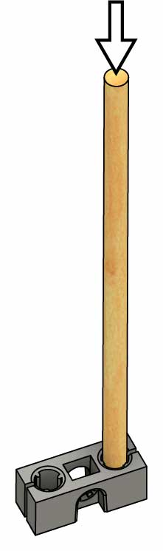

**13 cm** (5 in) **Dowel**

**Block**

**Reamed Hole**

**Support**

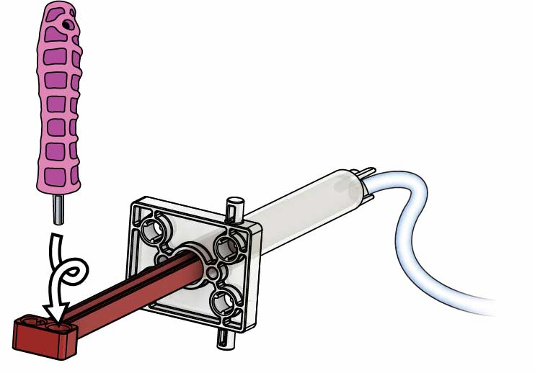

**Push & Twist**

(to pump)

# 8

Reamed holes have no splines (teeth) so dowels can spin freely.

**Ream** one of the holes in the **cylinder**.

**Connect you pump’s cylinder to finish your geared pump.**

**Use** the **support** to **attach** the   
**cylinder**.

**Wiggle** or tap a **13 cm** (5 in) **dowel** into a **block** to make a **support**.

# Attach the Pump

# 11

# 10

# 9

**Secure** the **support** with **slide** **stop**.

# Ready the Rotor

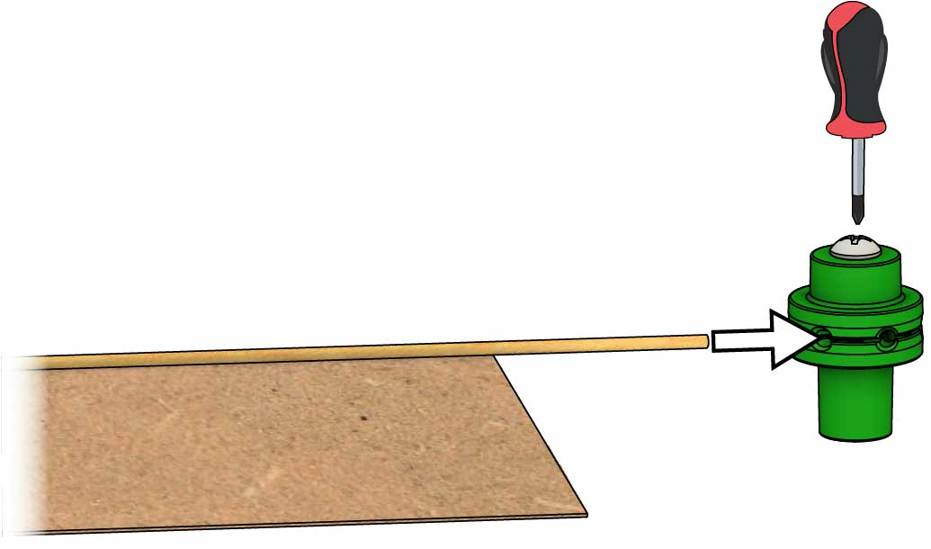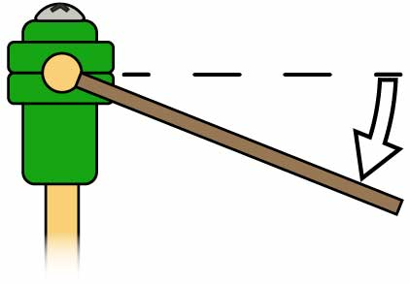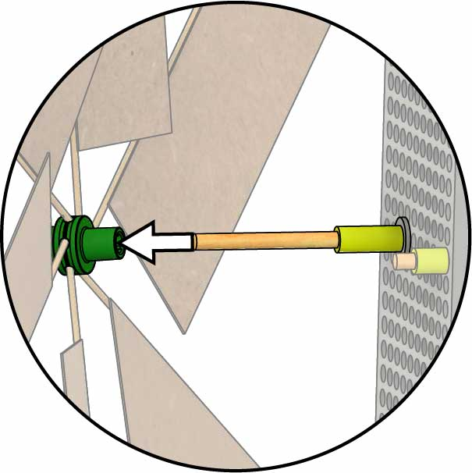­

**Your rotor is done!**   
Time to mount it on the frame.

**Attach** the **hub cover** to the **hub base** with the **hub screw**.

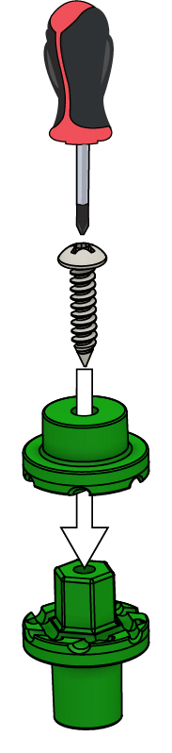

**Hub Cover**

**Hub Base**

**Hub Screw**

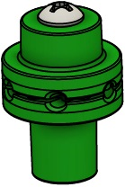

**Complete Hub**

# 15

**Blade**

**Loosen** the **screw** just enough to allow the **blades** to be **pushed** **in** (about 1 ½ turns).

# 16

**Angle your blades** so they spin in   
the wind.

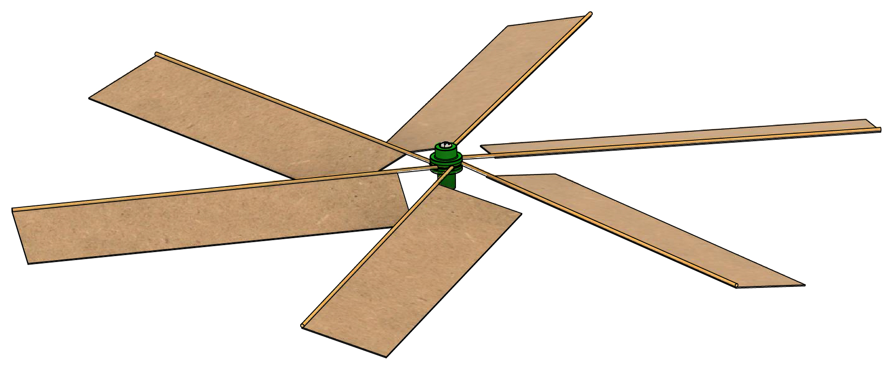

**Add** all the **blades** and **tighten** your **hub screw** to complete the rotor.

# 17

# 13

Get **six** **22 cm x 5 cm** (8.5 in x 2 in) **pieces** of **chipboard**.

**Tape** a **project** **stick** **to** each **edge**, leaving the extra on one side.

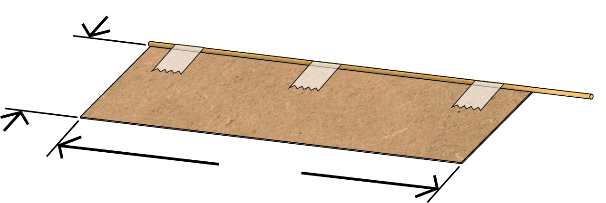

**22 cm**  
(8.5 in)

**5 cm**  
(2 in)

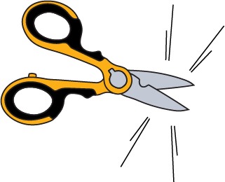

6x

# 14

# Build Your Blades

**You’re going to add a rotor to harness wind energy to turn the gears that drive your pump.**

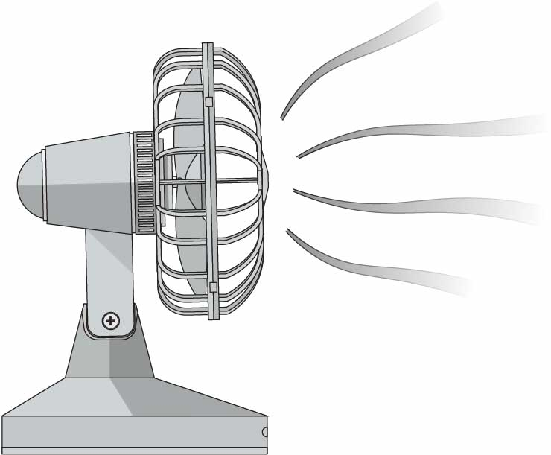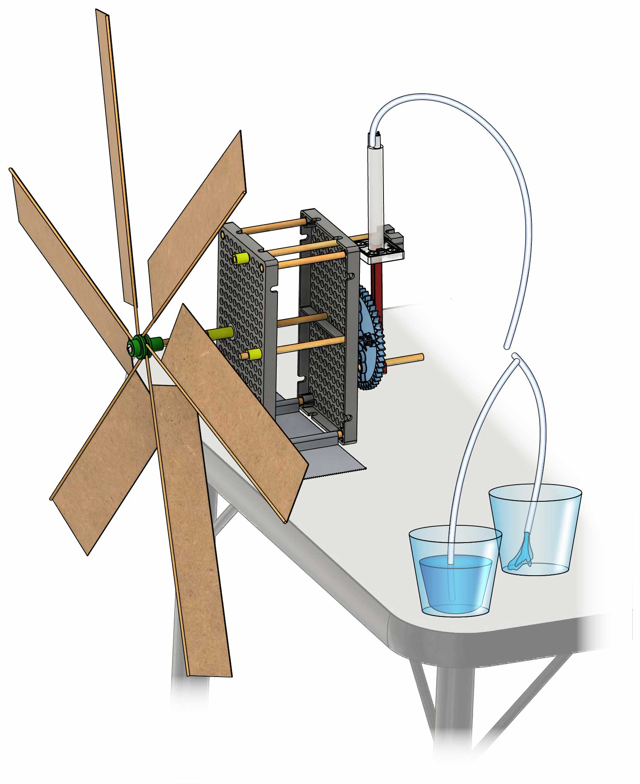

Mystery Parts

This is the pump you designed on Page 2.

You may need to **nudge your blades** to start the pump.

**Point** a **fan** at your turbine to **pump water** from one cup to another!

[**Energy & Power Lab** (Ages 14+)](https://teachergeek.org/wind_pump_2.0_lab_energy_power.docx)



Get documents and more at   
[teachergeek.com/windpump](https://teachergeek.com/windpump)

# 20

**Your example wind pump is done, but you aren’t... Make it better, try a lab, or start a challenge!**

Optional Lab

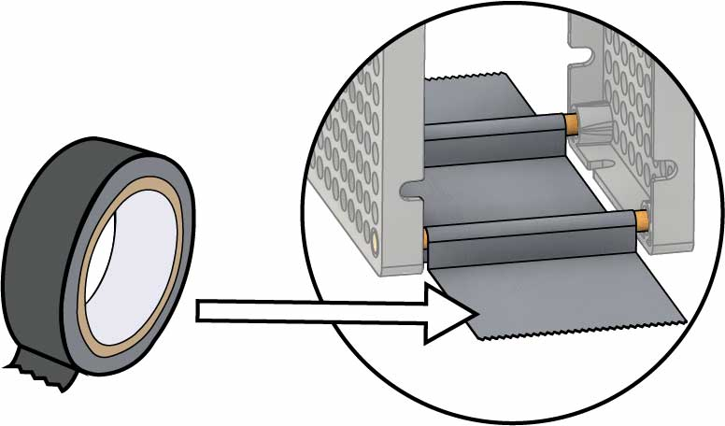

**Tape** your **frame** to a **table**.

**Push** the **rotor** **onto** the **dowel** attached to the 10-tooth gear.

# 19

# 18

# Test It Out

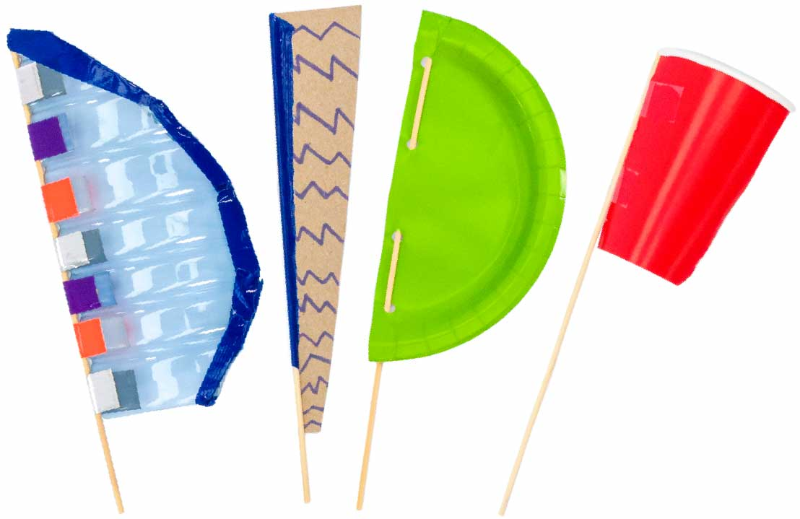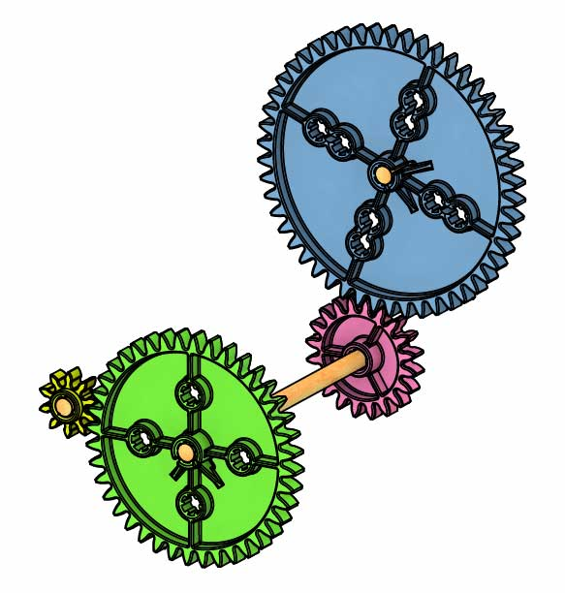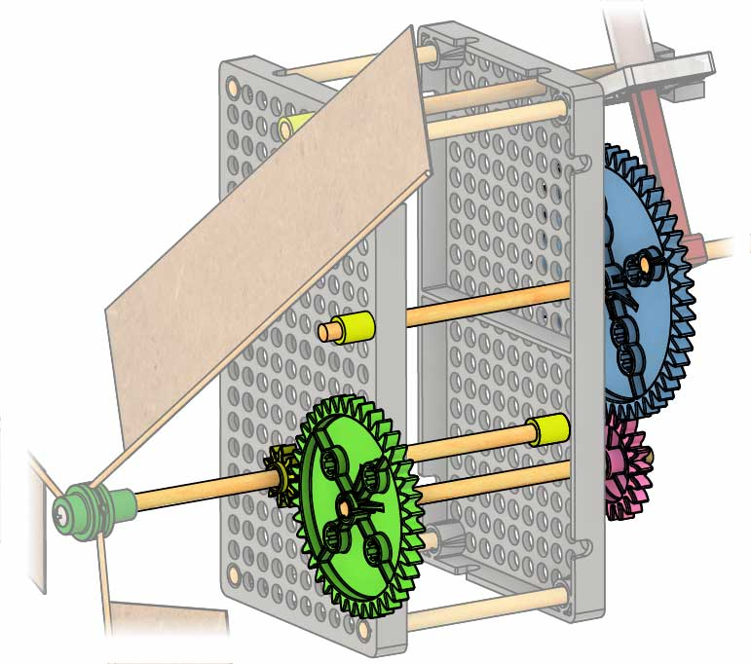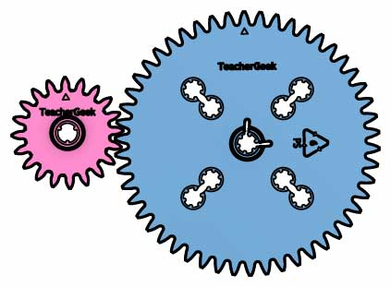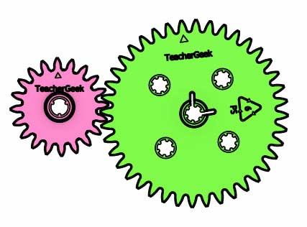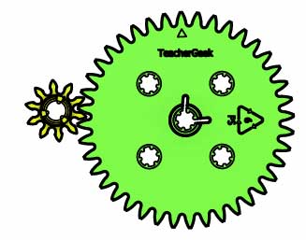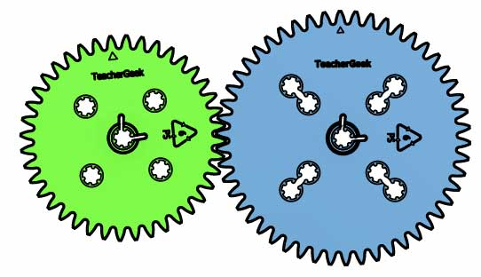

Blade Shape

Try all different shapes, sizes, and materials. What can you make into a turbine blade?

Experiment with the Gears

Compound Gears

Swap the Gears

Try different gear ratios.   
What works best with *your* blades?

Compound gears  
multiply the ratios of the other gears, giving you even more ratio options.

Blade Number

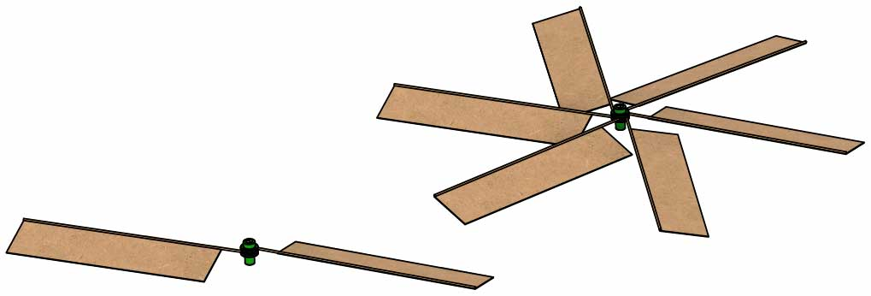

More blades can catch more wind but also creates more   
drag (air friction).

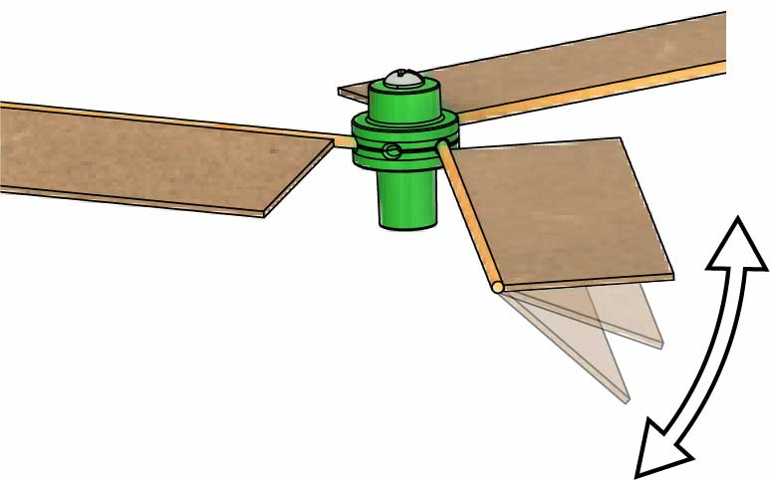

Blade Angle

Blade angle trades between speed and torque.

# Tuning Your Turbine

10

40

20

50

10

40

20

50

**x**

**=**

200

2000

=

1

10

Gear Ratio:

=

20

40

1

2

=

20

50

2

5

=

10

40

1

4

=

40

50

4

5

÷10

÷10

Experiment with the Blades

**Pump water faster by harvesting as much wind energy as possible and getting the right balance between speed and torque.**  Your turbine needs *just enough* torque to get started – any extra torque should be traded for speed.

# Steady Wind Challenge

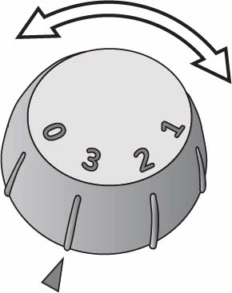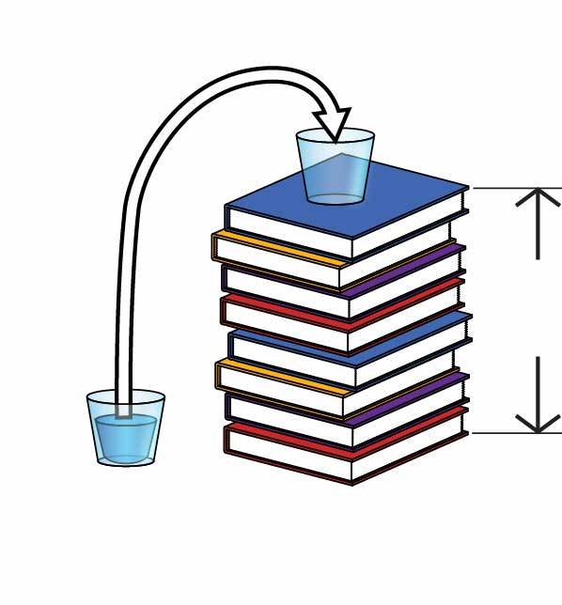

Change setup so you **pump a vertical distance of 45 cm** (18 in).

* **Pump 110 ml** (4 oz) of **water** from one cup to another in the **shortest time possible** to win!

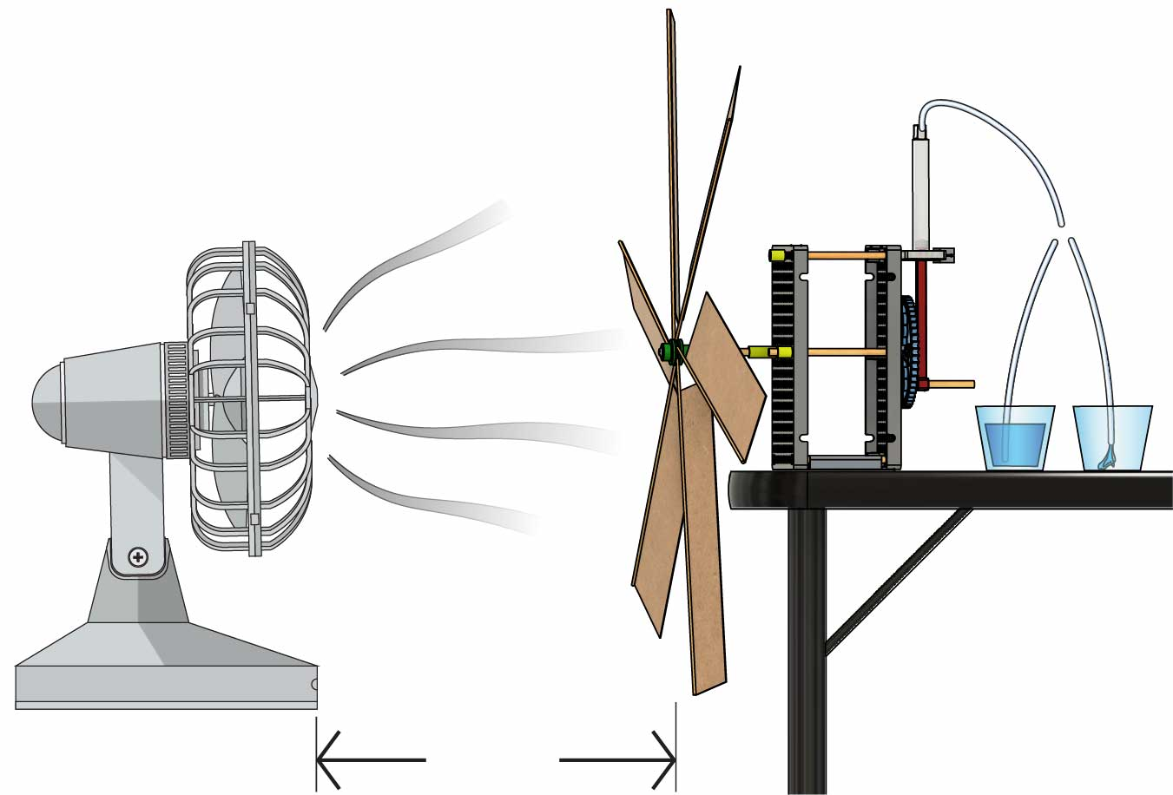

**60 cm**  
(24 in)

This is the pump you designed on Page 2.

Mystery Parts

Tape the pump’s frame to a table (see Page 8).

Constraints:  
(rules and limits for your design)

* **Only wind** can **power** your pump (but you can give it one small push to get it started).
* You may **only use** the **supplies** listed on **Page 1**.
* The **fan** must be **60 cm** (24 in) **from the blades**.
* There is **no limit** on **recycling bin materials**.

# Additional Challenges

**Use the Criteria & Constraints above for these challenges.**

Do three trials, back-to-back, with **different fan speeds**. There’s 1 minute between trials to swap gears/blades.   
The turbine   
with the   
**shortest** ***total***   
***time*** wins!

Modify your turbine to **look nice in nature** and have safety features to **protect birds** from the blades.

**45 cm** (18 in)

Elevation Challenge

Environmental Challenge

Variable-Wind Challenge

Engineer your pump to empty one cup into another as fast as you can!

Criteria:  
(what your design must do)

**Make a Kinetic Sculpture** thatuses the wind to make moving artwork.

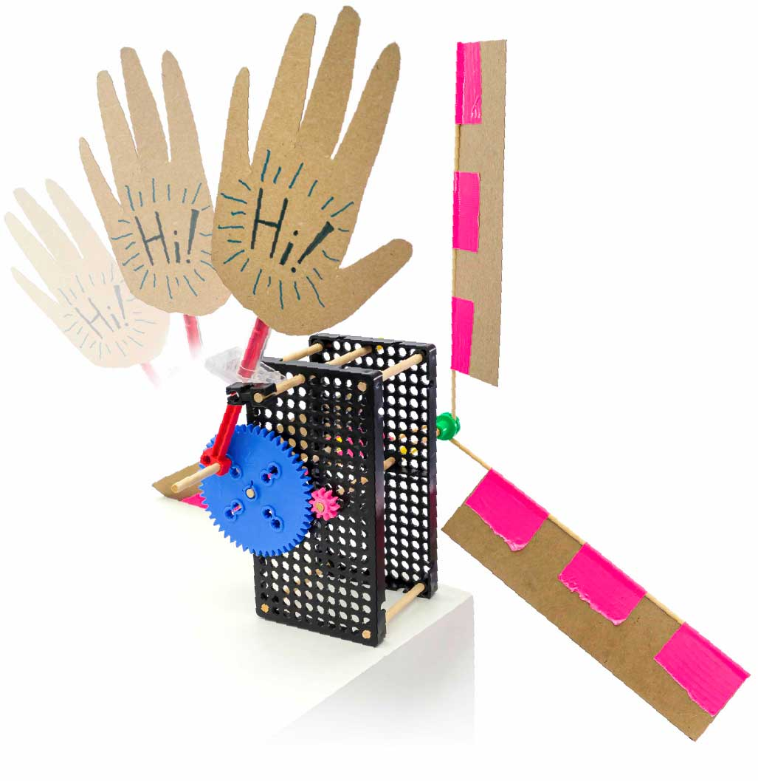

## Design

## Process

## Design

## Redesign

## Test

## Evaluate

The Engineering Design Process never ends!   
**There is no perfect design**.

**Design a Vertical Axis Turbine** – they work no matter what direction the wind comes from!

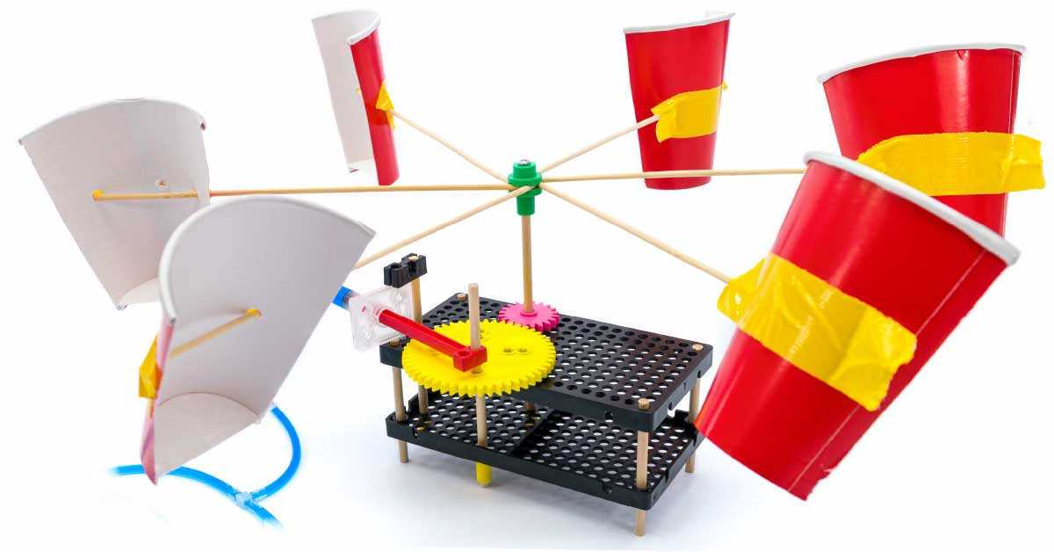

**Try crazy blade designs!**

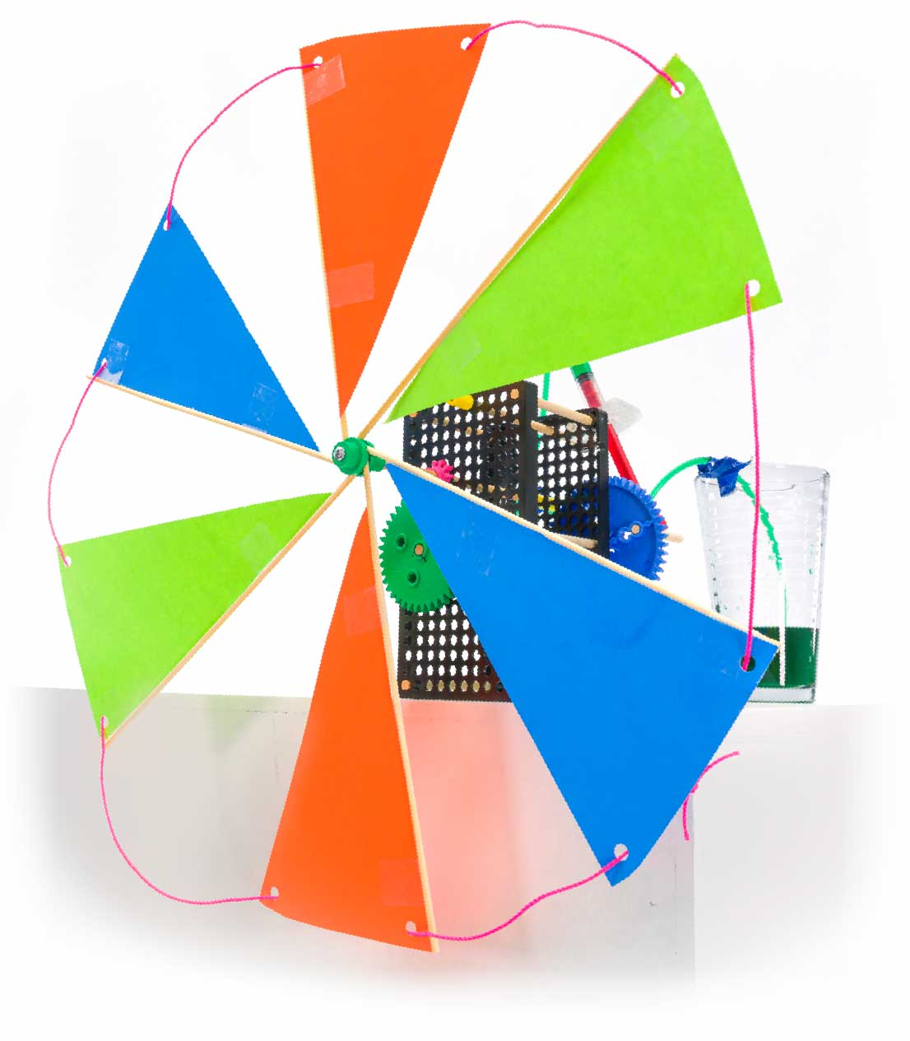

**How else can you make your turbine? What else can you make with the parts?**

# Inspiration