Name(s): ________________________________________________________
Some wind turbines/windmills have blades with a lot of area, while others have blades with very little area.
Make sure you have a built TeacherGeek Wind Lift, before starting this lab.
1. Hypothesis: How do you think the Wind Lift blade area affects the number of pennies that can be lifted?

__________________________________________________________________
__________________________________________________________________
__________________________________________________________________
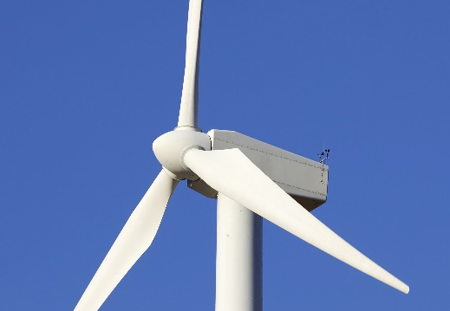
__________________________________________________________________
Get Ready
Make sure that your blades are 23cm x 5cm. If they are not, cut new blades and tape them on. They should be like this.
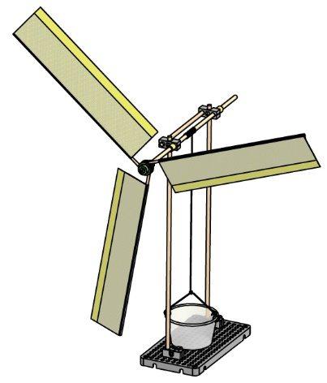
23cm

5cm
Blade Area:
23 x 5 = 115cm²
115cm² x 3 = 345 cm²
Blade Area x # of blades = total area

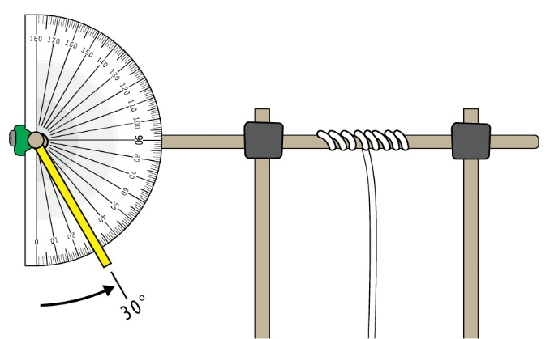
Set the angle of your blades to approximately 30°.

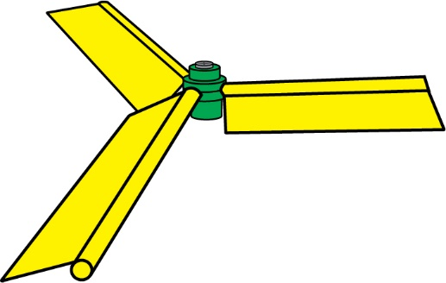

Change the blade angle by: 1. Loosening the hub screw a little bit; so the blades can turn, but do not fall out. 2. Changing the blade angle using a protractor. 3. Tightening the screw up again.

Test your Hypothesis: How does blade area affects the number of pennies that can be lifted?
Use your 5cm wide blades. | Cut your blades to 3cm wide. | 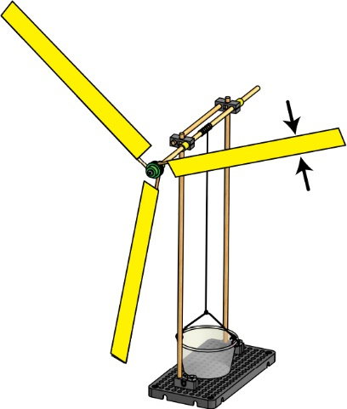  Cut your blades to 1 cm wide.
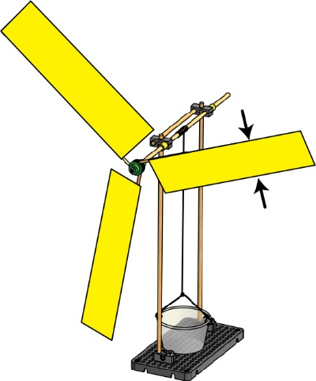  5cm | 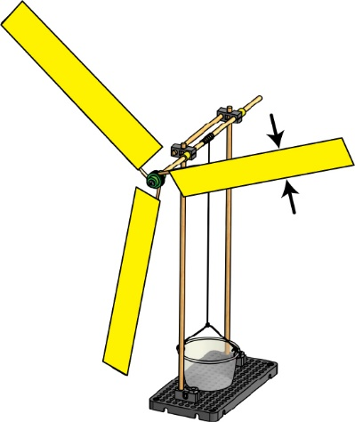  3cm | 1cm
2. What is the combined area of all of the blades?  _____________________________  3. What is the maximum number of pennies that can be lifted?  _____________________________  4. How long does it take to lift the bucket?  ____________________ seconds | 5. What is the combined area of all of the blades?  _____________________________  6. What is the maximum number of pennies that can be lifted?  _____________________________  7. How long does it take to lift the bucket?  ____________________ seconds | 8. What is the combined area of all of the blades?  _____________________________  9. What is the maximum number of pennies that can be lifted?  _____________________________  10. How long does it take to lift the bucket?  ____________________ seconds
11. Was your hypothesis correct? Please explain why, or why not (don’t just write “yes” or “no”).
__________________________________________________________________________________________________
__________________________________________________________________________________________________
__________________________________________________________________________________________________
__________________________________________________________________________________________________

