  
Name(s): **_________________________________________________________**

Make sure you have a built TeacherGeek Wind Lift, before starting this lab.

**1. Hypothesis:** How do you think changing the angle of the Wind Lift Blades will affect the number of pennies it can lift?

**__________________________________________________________________**

Many wind turbines change the angle of their blades to adjust to wind conditions.

**__________________________________________________________________**

**__________________________________________________________________**

|  |  |  |  |
| --- | --- | --- | --- |
| **Test your Hypothesis**  Test how many pennies your wind turbine can pick up, at different blade angles.    Use a protractor to set blade angles. | | **Change the Blade Angle**  **A.** Loosen the hub screw  a little bit; so the blades can turn, but do not fall out.  **B.** Change the blade angle using a protractor.  **C.** Tighten the  screw up again. | |
| **0° Blade Angle** | **30° Blade Angle** | **60° Blade Angle** | **90° Blade Angle** |
|  |  |  |  |
| **2.** What happens when the blade is at 0°?  _____________________  _____________________  _____________________  _____________________ | **3.** How many pennies can it lift at 30°?  _____________________    **4.** How long does it take to lift the bucket?  _____________________ | **5.** How many pennies can it lift at 60°?  _____________________    **6.** How long does it take to lift the bucket?  _____________________ | **7.** What happens when the blade is at 90°?  _____________________  _____________________  _____________________  _____________________ |

**8.** Was your hypothesis correct? Please explain why, or why not (don’t just write “yes” or “no”).

**__________________________________________________________________________________________________**

**__________________________________________________________________________________________________**

**__________________________________________________________________________________________________**

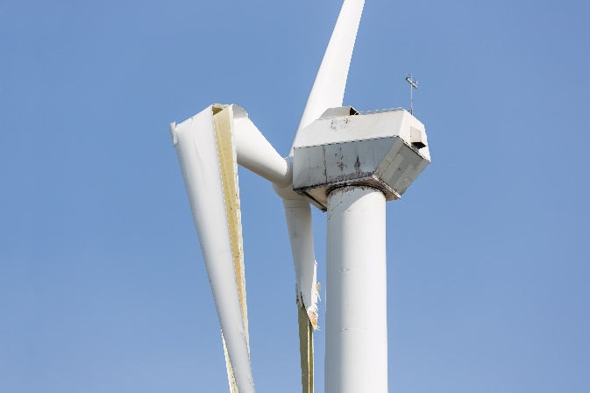**9.** The wind turbine shown on the right was damaged from high winds. What did you learn from your blade angle tests that could have helped this wind turbine? What would you have it do in high winds to protect the blades?

**________________________________________________________________________**

**________________________________________________________________________**

**________________________________________________________________________**

**________________________________________________________________________**

**10.** Write the names of the components shown below. Note: Blade is not an answer.

# A

____________________________________________

# B

____________________________________________

# C

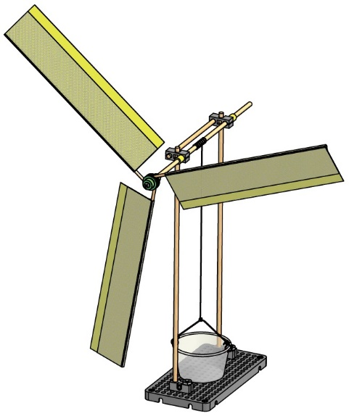____________________________________________

**Rotor**(blades mounted on a central hub)

# A

# C

# B

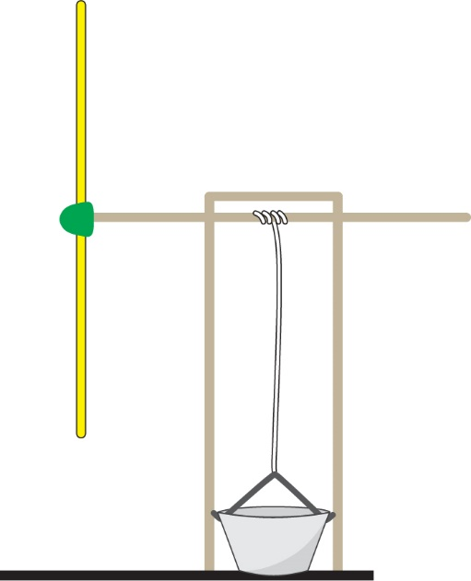

**Rotor Diameter**

**Lift**

**Tower**

**Hub**



These protractors will work well for the Wind Lift Angle Lab. Print them on heavy paper and cut them out. The notch allows them to position centrally on the blade shaft.

