Check out our [**Wind Lift Videos**](https://vimeo.com/showcase/7318133) by scanning the QR Code or going to [**teachergeek.com/lift**](https://www.teachergeek.com/lift)

You Are Here

Go Guide

Start here! Build your Wind Lift, evolve your design, and begin   
the Heavy Lift Challenge!

Optional Labs

Optional Challenges

-[Energy Lab (Ages 9+)](https://teachergeek.org/wind_lift_lab_energy.docx)  
-[Blade Angle Lab (Ages 11+)](https://teachergeek.org/wind_lift_lab_blade_angle.docx)  
-[Blade Area Lab (Ages 11+)](https://teachergeek.org/wind_lift_lab_blade_area.docx)

-Heavy Lift Challenge*  
-Speed Challenge*

*See Page 6

**Choose how you would like to complete this activity.  
Download documents & videos at** [**teachergeek.com/lift**](https://teachergeek.com/lift)

**Learn about   
wind energy by   
designing your very   
own Wind Lift!**

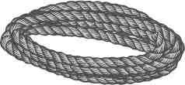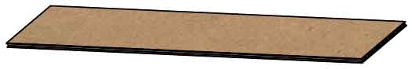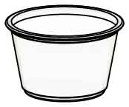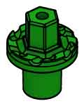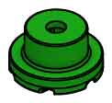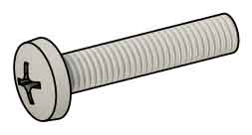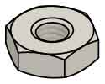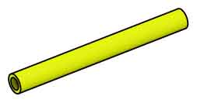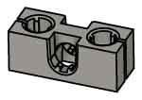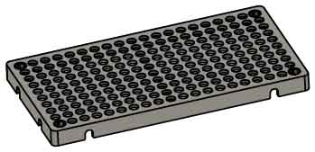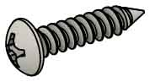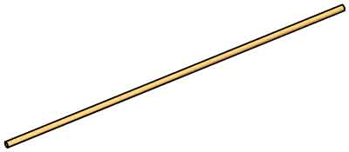

* **Fan**
* **100 Pennies**or jelly-beans, screws, nuts, etc. to use   
  as weights
* **Tape**
* **Phillips Screwdriver**
* **Recycling Materials**(to use for turbine blades)

Have a Maker Cart? Use Multi-Cutters to cut your own dowels.

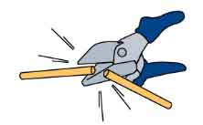

**Dowels**various sizes  
SKU 1821-20

**PICTURE**

**NAME**

**QTY**

**4**

**Hole Plate**  
SKU 1821-32

**Block**  
SKU 1821-34

**Slide Stop**7 cm (3 in)  
SKU 1821-22

**Nuts**# 10 Hex  
SKU 1821-25

**Screws**25 mm (1 in)  
SKU 1821-22

**Mini Hub Screw**  
SKU 1821-67

**Mini Hub Cover**  
SKU 1821-67

**Mini Hub Base**  
SKU 1821-67

**Portion Cup**  
SKU 1823-68

**Wire**15 cm (6 in)  
SKU 1821-43

**Project Sticks**25 cm (10 in)  
SKU 1821-18

**10**

**1**

**1**

**1**

**1**

**1**

**2**

**2**

**1**

**4**

**1**

**String**45 cm (18 in)

**Chipboard**22 cm x 5 cm

(8.5 in x 2 in)  
SKU 1823-48

**1**

**3**

Dowel Sizes  
2x 30 cm (12 in)  
1x 25 cm (10 in)  
1x 15 cm (6 in)

MATERIALS YOU SUPPLY

**Reamer**

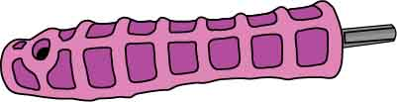

These are the parts you need to build one Wind Lift.

LIFT PARTS

INCLUDED TOOLS

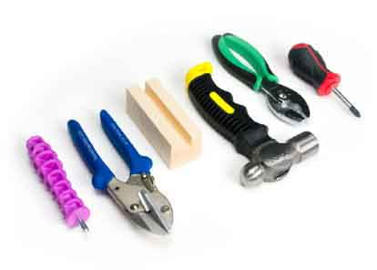

Modify materials to make even more creative designs with the **Maker Tool Set**

SKU 1823-84

**Optional Tools**

# Supplies

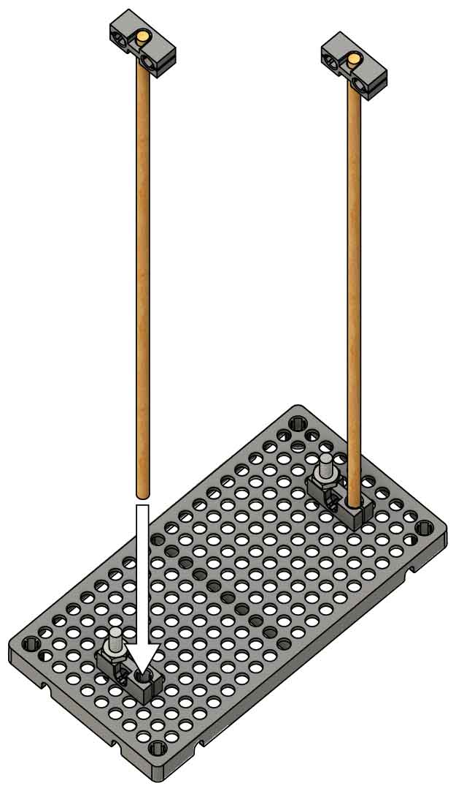

# 4

**Push** the **15 cm**   
(6 in) **dowel** **into**   
the top **blocks**.

**Attach** **two** **blocks** to the top of the **hole** **plate** using **two** **25 mm** (1 in) **screws** and **two** **nuts**.

2x

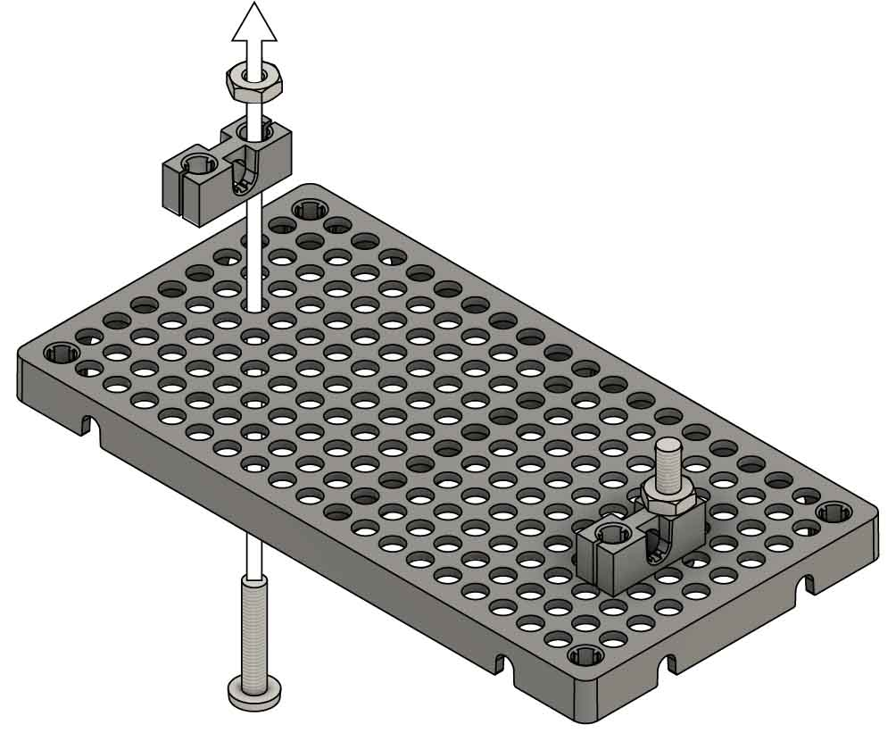

**Screw**

**Nut**

**Block**

**Hole Plate**

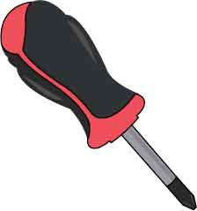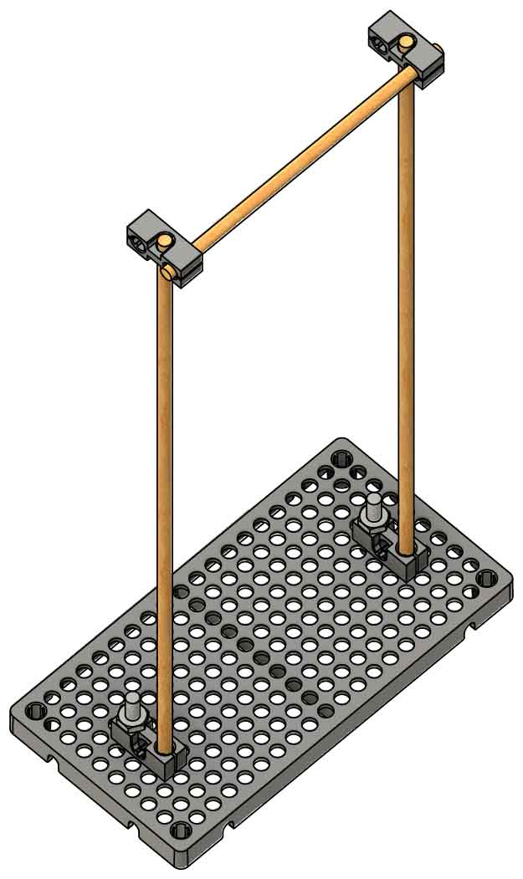

**15 cm** (6 in)

**Dowel**

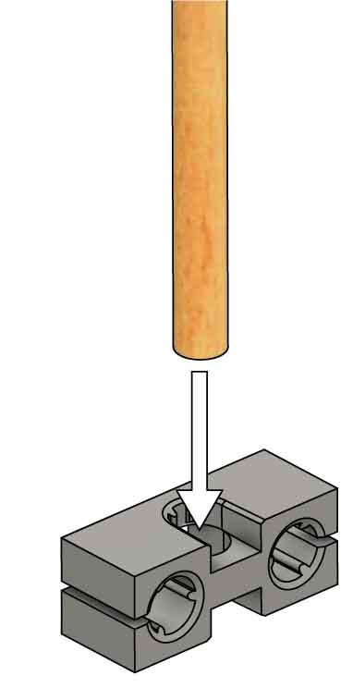

**30 cm** (12 in) **Dowel**

# 3

**Push** the **dowels**, from Step 2, **into** the **blocks** on the hole plate.

# 2

**Wiggle** or tap **two**  
 **30 cm** (12 in) **dowels** into the **center** **holes**   
of the **blocks**.

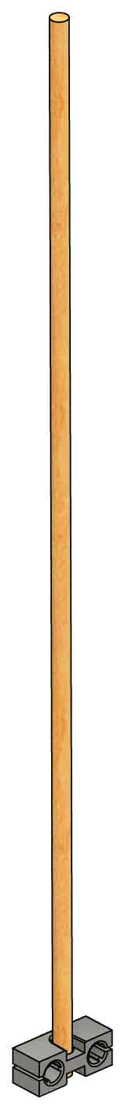

# Build The Base

# 1

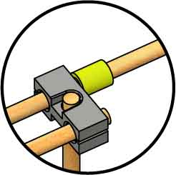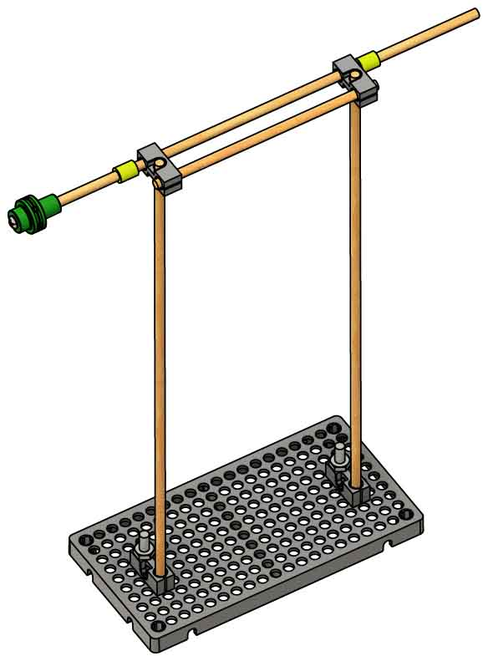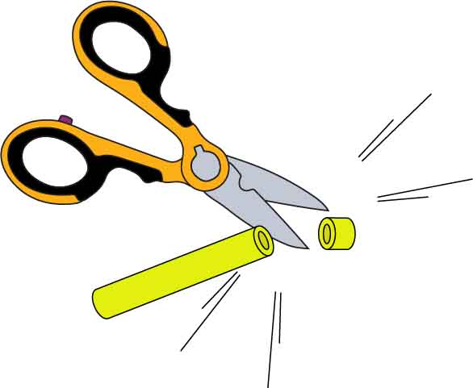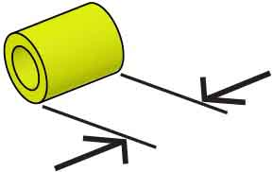

# Add the Axle

**Slide Stop**

**Cut** a **1 cm** (½ in) section of **slide stop**.

**1 cm**  
(½ in)

**Ream** the **two** **holes**, as shown, to remove the splines (teeth).

# 5

# 6

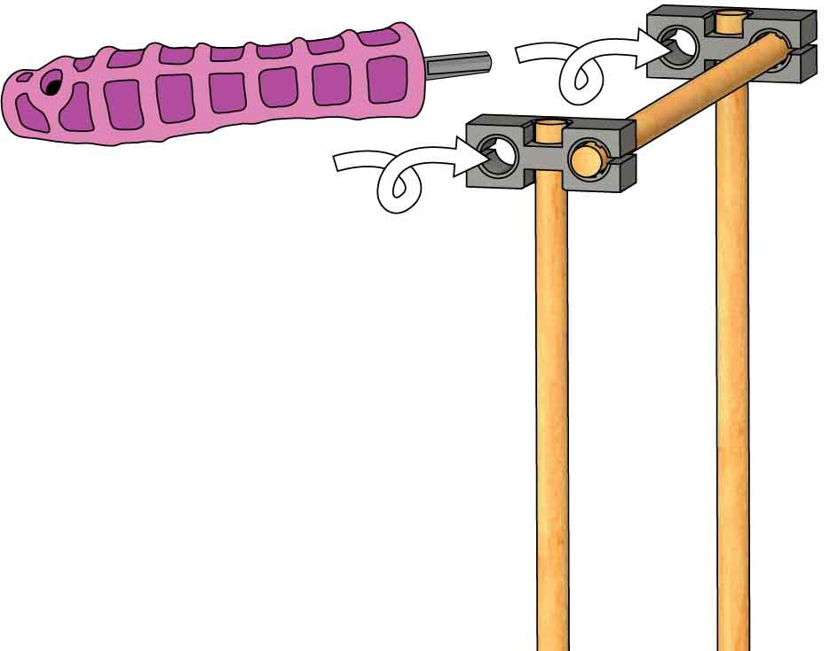

**Push & Twist**

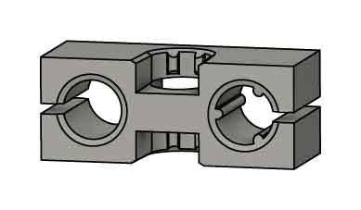

**Reamed holes** let dowels slide and spin.

**Splined holes** hold dowels   
in place.

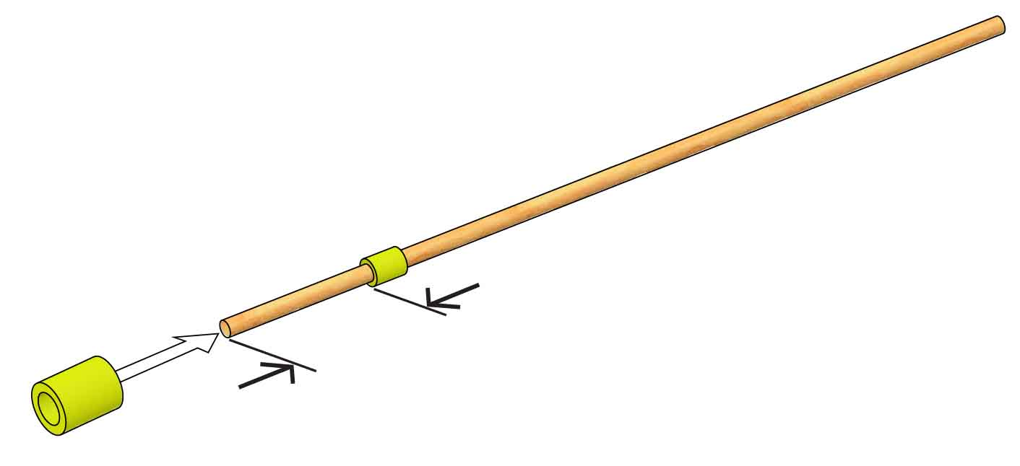

**5 cm**  
 (2 in)

**25 cm** (10 in) **Dowel**

# 7

**Push** the **slide** **stop** about 5 cm (2 in) **onto** the   
25 cm (10 in)   
**dowel**.

# 8

**Push** or tap the **hub** **base** **onto** the end of the **dowel**   
from Step 7.

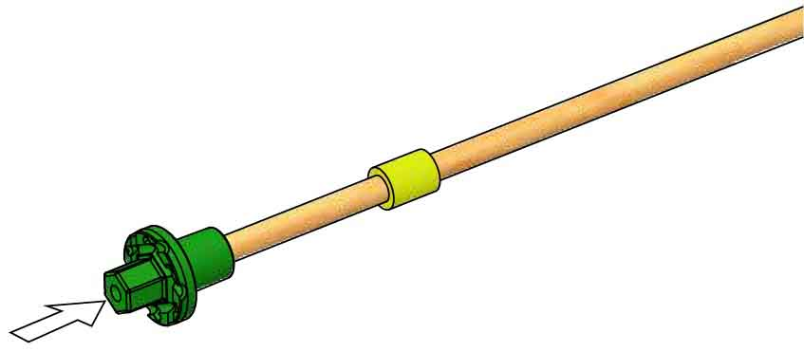

**Hub Base**

# 9

**Attach** the **mini** **hub** **cover** **with** the mini hub **screw**.

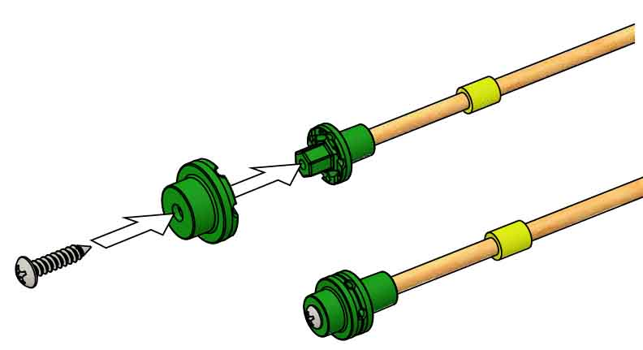

**Hub Cover**

**Hub Screw**

**Finished Hub**



# 10

**Slide** the **dowel** with hub **through** the **reamed** **holes**.

Use more slide stop to secure   
the dowel.

Try **loosening** the **screw** one full turn, then retightening it.

**Hard to Tighten?**

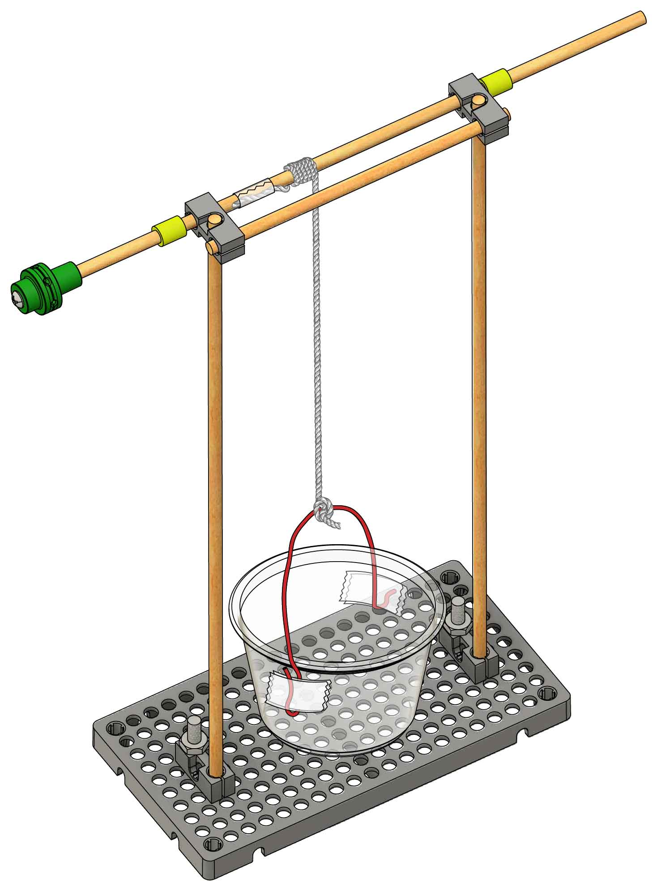

**Tie** the **string** **to** the **cup**’s wire to finish your lift.  
Spin the dowel to test it out, then continue on to add blades that capture wind power!

# 12

**Tape** the 15 cm (6 in) **wire** **to** the **portion** **cup**.

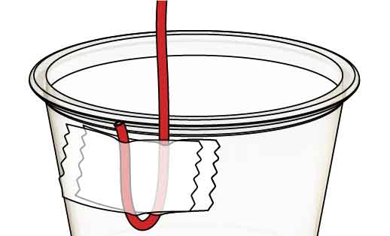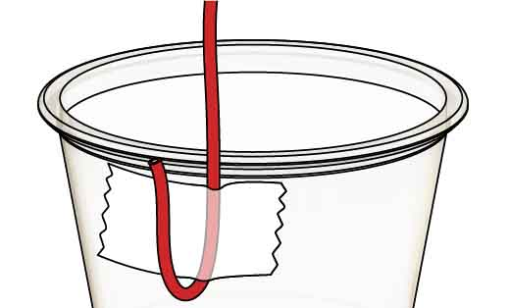

Tape the wire to the cup, leaving some extra.

Fold the extra over, then tape again.

Repeat on the other side of the cup.

**Tape** the 45 cm (18 in) **string** **onto** the **dowel** with the hub.

# 11

If using this activity in a classroom, your lift mechanism can be re-used by kids year-after-year as they engineer and test different blade designs.

# 13

# Make The Lift

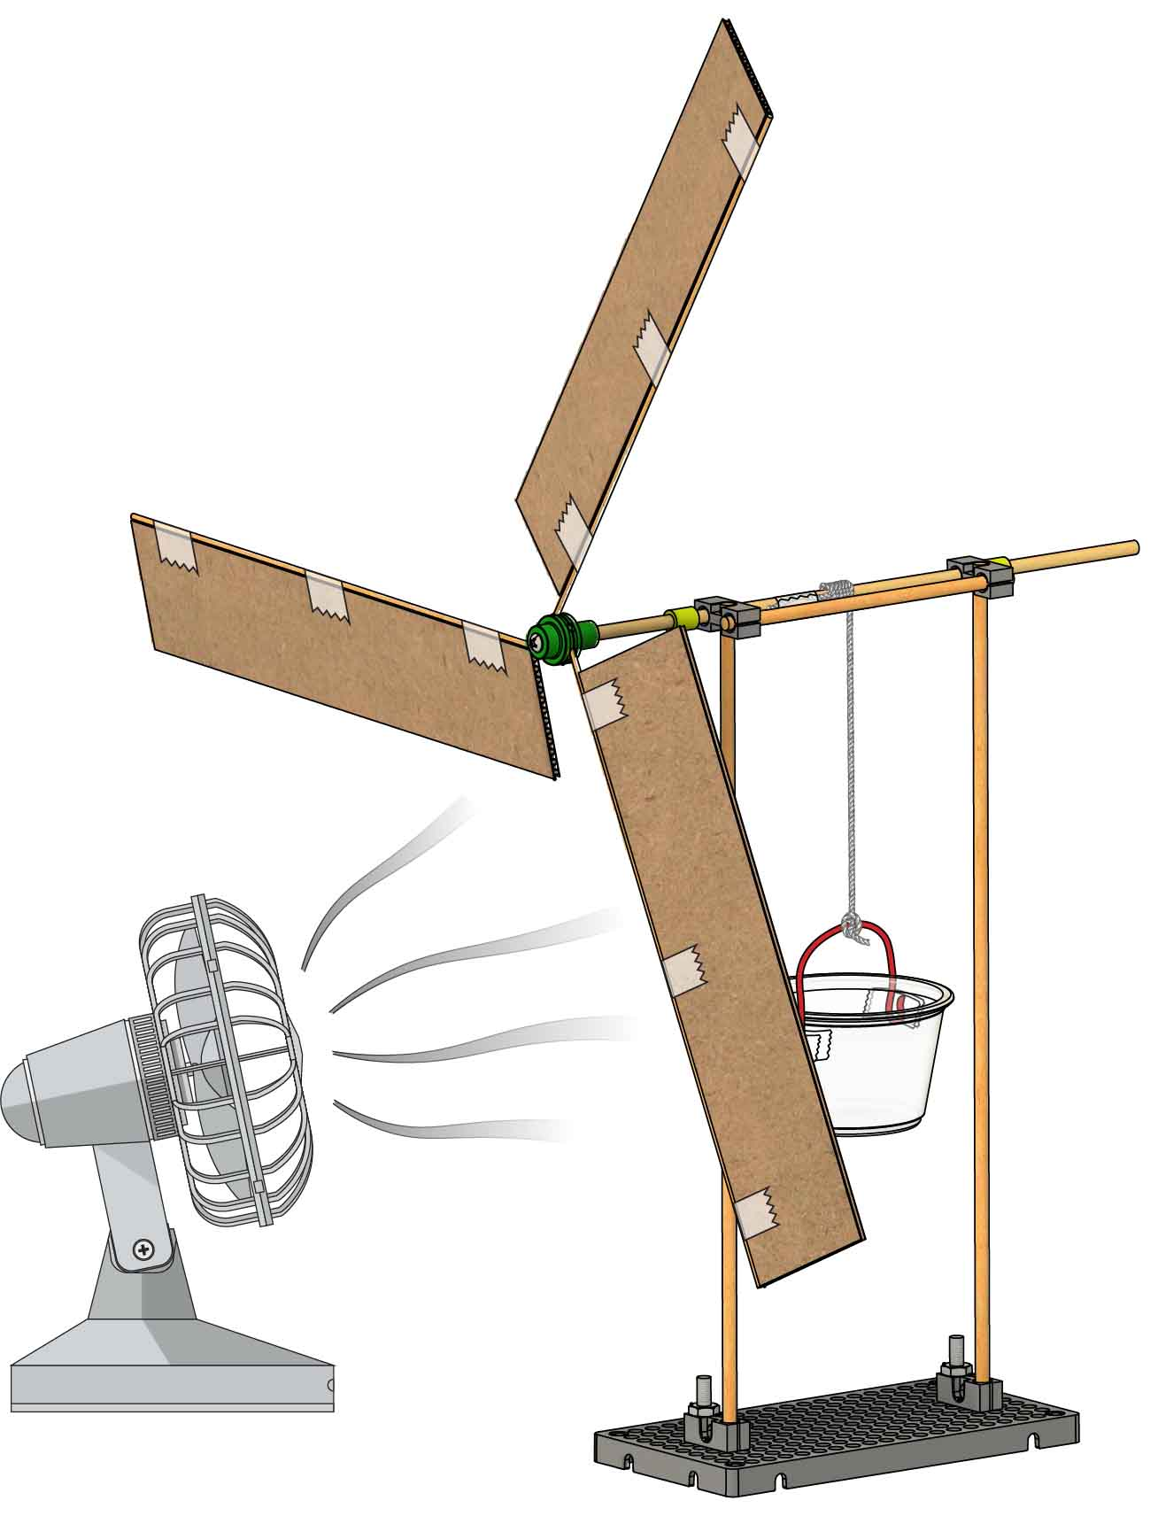

Download these labs at [**teachergeek.com/lift**](https://teachergeek.com/lift)

**It’s time for labs or challenges!**Complete one of the optional labs   
below or continue on to set up   
for an engineering challenge!

# 18

**Tighten** the hub **screw** and **test it out!**

3x

# Add Blades

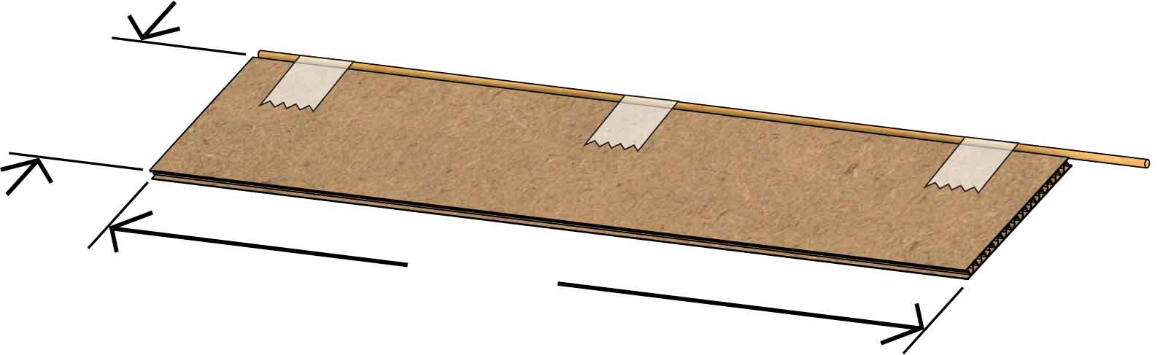

**22 cm**  
(8.5 in)

**5 cm**  
(2 in)

# 17

**Add** **the** **blades**, being sure to **angle** **them** (that’s what will   
make them spin).

[-Energy Lab (Ages 9+)](https://teachergeek.org/wind_lift_lab_energy.docx)  
[-Blade Angle Lab (Ages 11+)](https://teachergeek.org/wind_lift_lab_blade_angle.docx)  
[-Blade Area Lab (Ages 11+)](https://teachergeek.org/wind_lift_lab_blade_area.docx)

**Tape** a **project** **stick** **to** each **edge**, leaving some extra on one side.

# 15

Get **three** 22 cm x 5 cm   
(8.5 in x 2 in) **pieces**   
of **chipboard**.

# 16

**Loosen** the mini hub **screw** just enough to allow the blades to be pushed in (about 1 ½ turns).

# 14

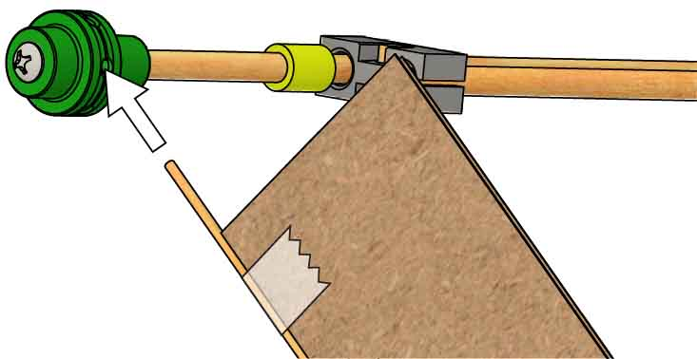

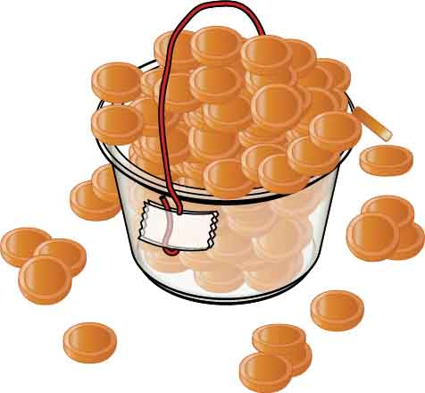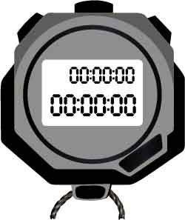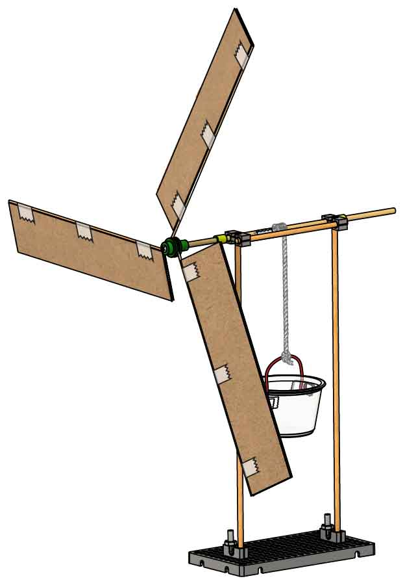

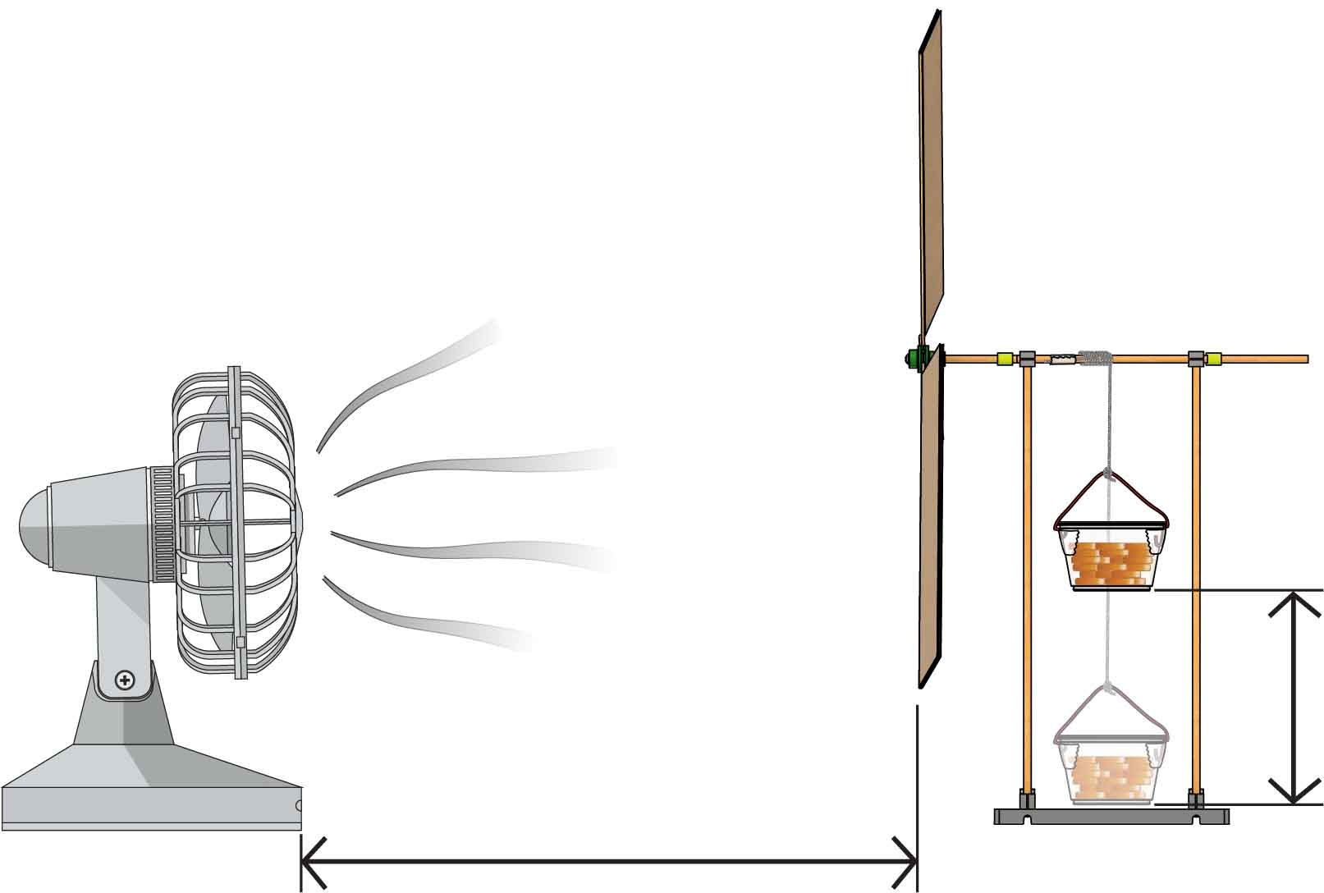

**20 cm**  
(8 in)

**60 cm**  
(24 in)

Your **wind** **lift** must be at least **60 cm** (24 in) **from** the **fan**.

**Weights** must be **raised** at least **20 cm** (8 in).

You may **only alter the** **blade** **design** – the lift and base must stay the same.

The **fan** must be the **only power source** for your lift.

Use the same constraints as the Heavy Lift Challenge.

Engineer your Wind Lift to raise the most weight possible!

Engineer your Wind Lift to raise 10 pennies in the shortest time possible!

Speed Challenge

Constraints:

(rules and limits for your design)

# Heavy Lift Challenge

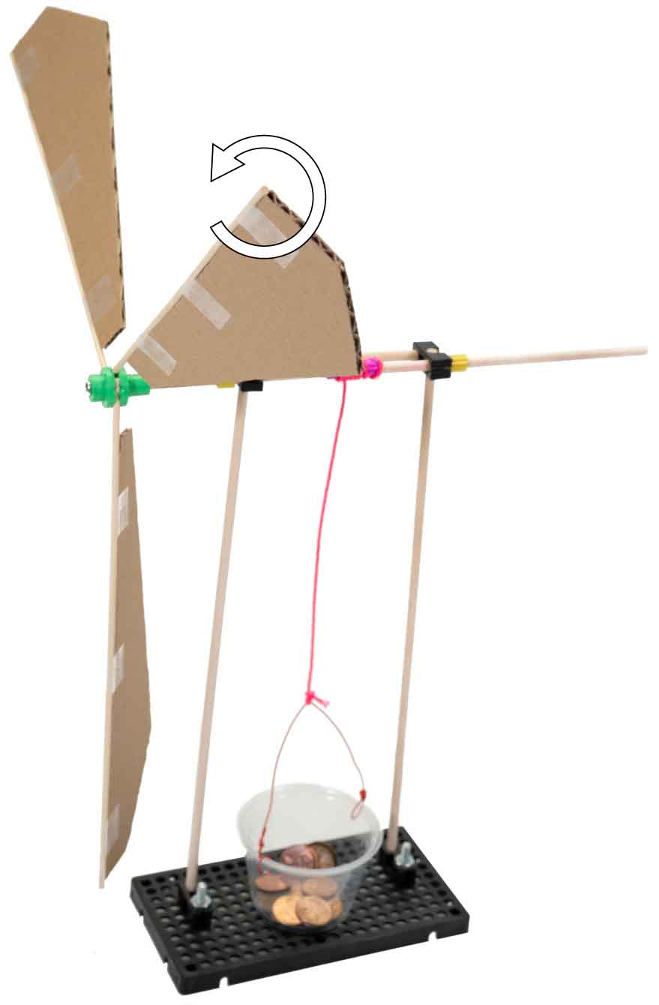

Test different blade angles.

Twist

Wind up the weight and let it go to make   
a gravity-powered fan!

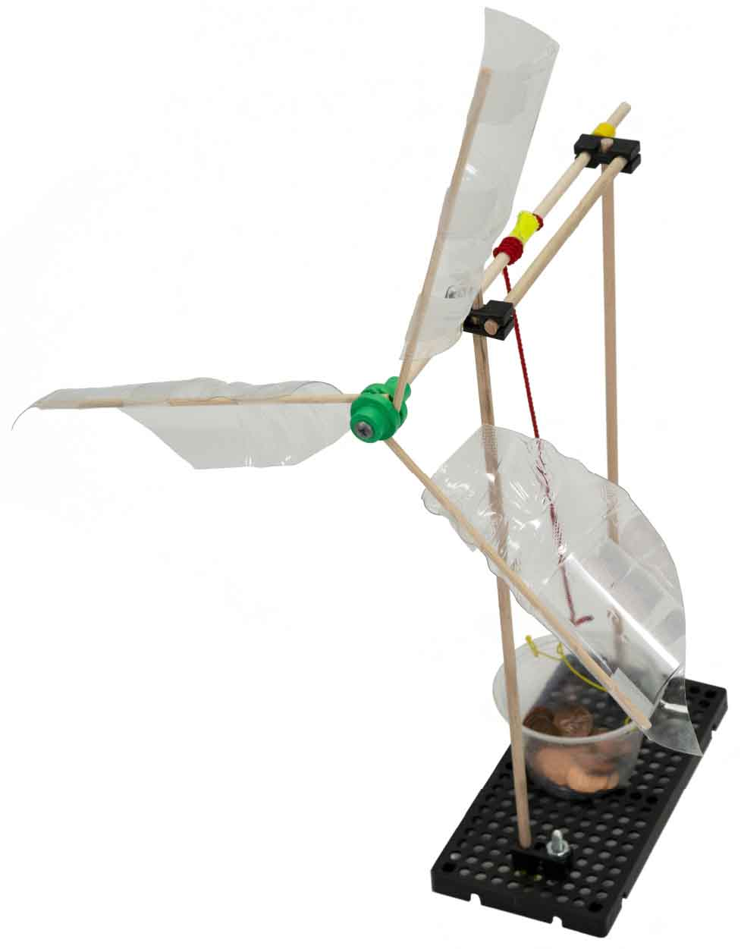

Make unique 3D shapes by cutting up plastic bottles and other recyclable materials.

Time to engineer your own blades for the wind lift! Try using cardboard, card stock, cereal boxes, plastic bottles… there are tons of ways to make turbine blades!

What will you use for blades?

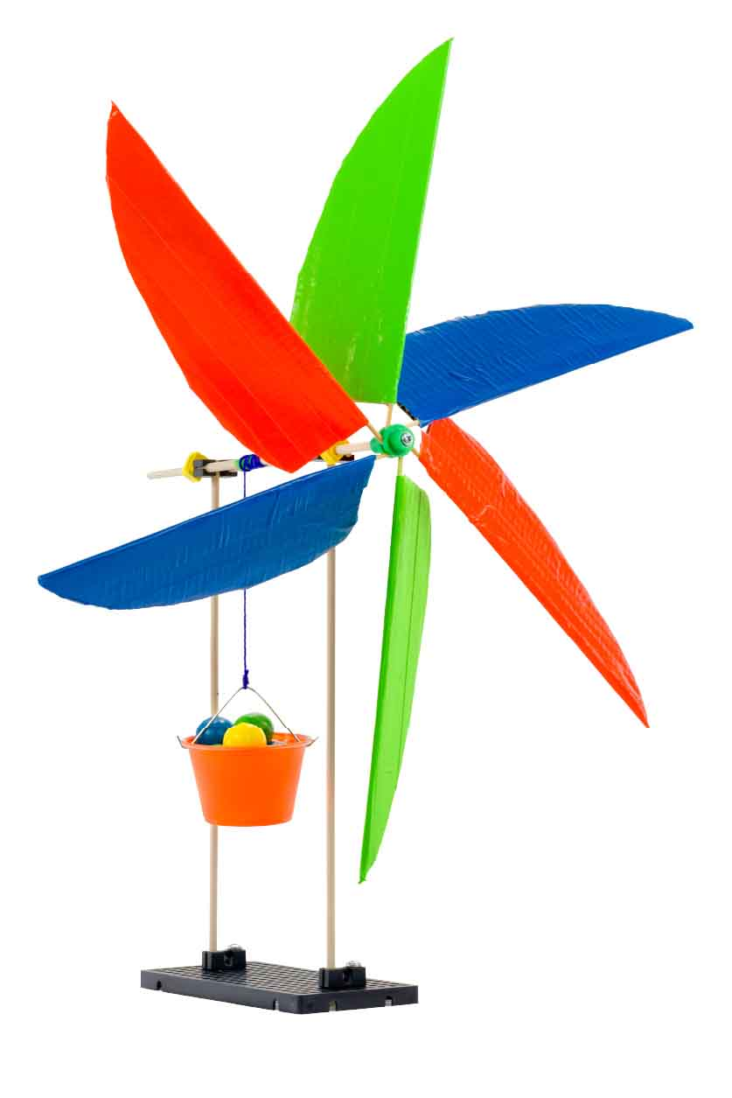

Change the size, shape and number of blades.

## Design

## Process

## Design

## Redesign

## Test

## Evaluate

**The design process never ends! There is no perfect design.**

# Make It Your Own!