

Name: ________________________________________________ Date: __________

Design #: __________

What problem do you want your design (launcher) to solve?



Build it.

Draw your new design.  
***Tip****: think of the trigger, launcher angle, amount of rubber bands, etc*.



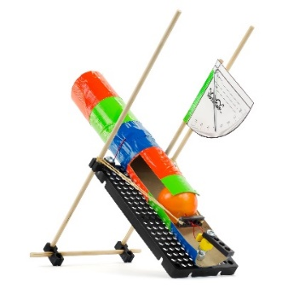



***Have fun storming the castle!***Redesign your launcher to   
knock down a castle wall -  
*as quickly as possible!*



**Before You Start:** Make sure   
you have built a launcher for   
use on this challenge.  
Documents & Supplies at:   
**teachergeek.com**

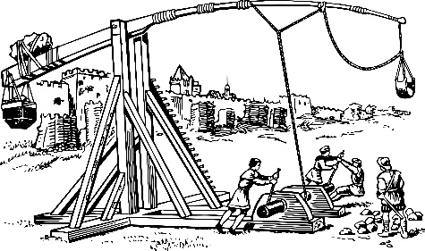

**

*Medieval   
Catapults*

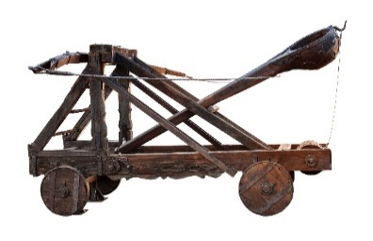

1. Adjust your angle and trigger design.  
2. Aim. Take as many shots as possible in the span   
 of three minutes to knock down the castle wall.  
3. Record your results on an Engineering Notebook Sheet.





*Use cups or cards to make a wall.*

**►**

**►**

**►**

(rules and limits for your design)

**Challenge Supplies**Launcher (from Build Guide), protractor, castle/wall material, ruler, tape,   
stop-watch, ping pong balls

**Allowable Materials**• TeacherGeek Components• Found & Recycling Bin • Teacher Approved• Non-Hazardous



**►**

**►**

**Ground Rules:**• Launch from behind the starting line  
• Wall must fall only from projectiles

**Difficulty:** Easy-Medium

**Teacher’s Note**Find more information on setting up   
targets and running this challenge,   
in the Launcher Classroom Overview.



Fill in how much   
time you have



*The time from building   
and re-designing your   
launcher to the start   
of the competition.*

**Time Limit:** ___________



Name: ________________________________________________ Date: __________

Design #: __________

What problem do you want your design (launcher) to solve?



Build it.

Draw your new design.  
***Tip****: think of the trigger, launcher angle, amount of rubber bands, etc*.



**►**

Test it.



**Angle of Launcher***(Degrees)*

**Launch Distance in**  _________

Mark your targets’ distance on the graph with a vertical **line.**Recordthe **distance** of at least three launches for each design or **angle** you test on the graph below.



How **precise** (consistent) were your results? Does your data look   
*grouped together* in one area , or does it look *scattered* ?

0

How **accurate** (close to the ‘true’ value) were your results?   
How close is your data to the line indicating the targets’ distance?

0

**►**



Evaluate it.

How can your design be improved?   
This will become your next problem to solve.



Get another engineering notebook page.   
Solve the new problem.

