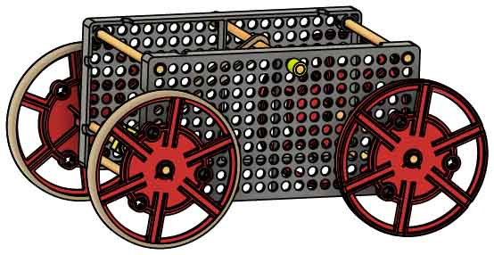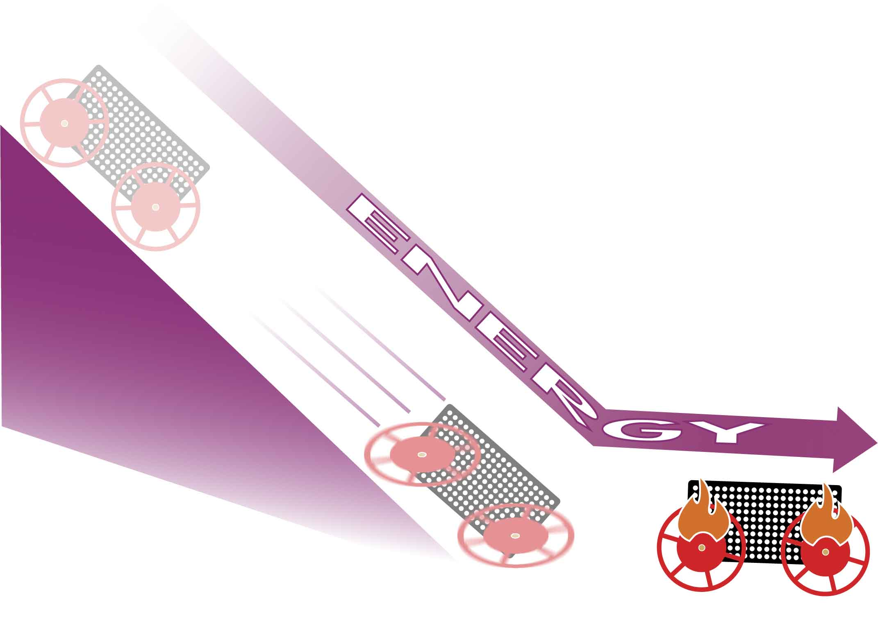



Check out the [**Energy Lab Set-Up Video**](https://vimeo.com/423228617) by scanning the QR Code or going to [**teachergeek.com/rubberband**](https://www.teachergeek.com/rubberband)

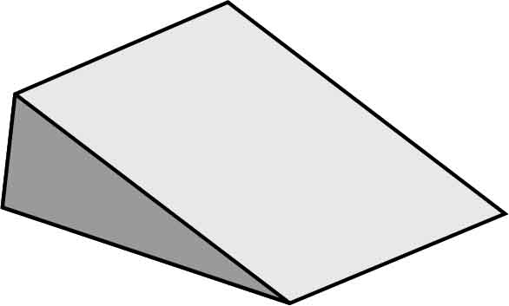

**Ramp**

Need help building a ramp? Check out the [**Ramp Build**](https://teachergeek.org/ramp_build.pdf) at [**teachergeek.com/rubberband**](https://teachergeek.com/rubberband)

**“Built” Rubber Band Racer**

LAB SUPPLIES

**Use your Rubber Band Racer to explore the different types of energy and how they transform!**

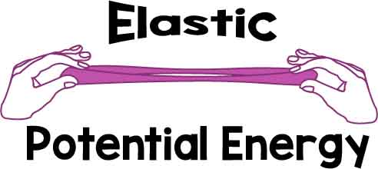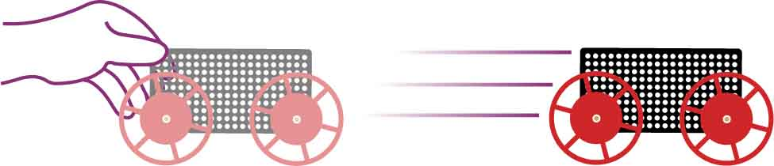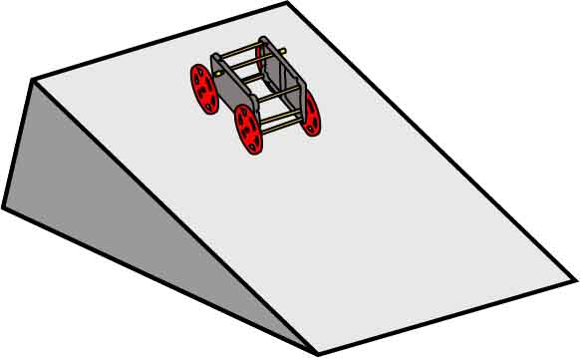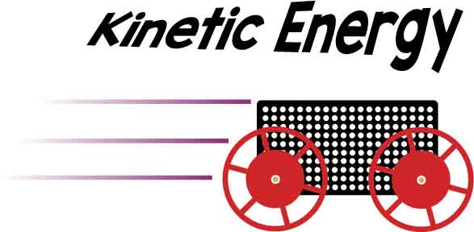

When you wind up your racer, energy is stored in its rubber bands.

When you lift your racer off the ground, energy is stored in the gravitational field.

Potential Energy is stored energy that can be converted to Kinetic Energy and make objects move. Here are two types of Potential Energy:

Potential Energy

When your car is moving, it contains kinetic energy – the energy of motion. The faster your car moves, the more energy it has.

How can you control the amount of energy stored in the rubber bands?

How can you control the amount of energy stored by gravity?

TEST IT OUT!

GOOD ENERGY

Wind up your car and release it to convert Elastic Potential Energy to Kinetic Energy.

___________________________________________________________________________________________________________________

___________________________________________________________________________________________________________________

Roll your car down the ramp to convert Gravitational Potential Energy to Kinetic Energy.



WHERE’D THE ENERGY GO?

According to Newton’s Laws, your racer should roll forever. What force do you think makes it stop?

An object in motion keeps moving the same speed and direction unless there is an external force on the object.

Newton’s Law of Inertia

________________________________  
________________________________  
________________________________  
____________________________________________________________________________________________

What do you think happens to the kinetic energy when the racer is stopping? Energy can’t be destroyed, so where does it go?

(*Hint: you can feel where it goes if you rub your hands together really fast!)*

Energy cannot be created nor destroyed; it can only change forms.

Conservation of Energy

____________________________________________________________________________________________________________________________________________________________________________________________________________________________________________________________________________________

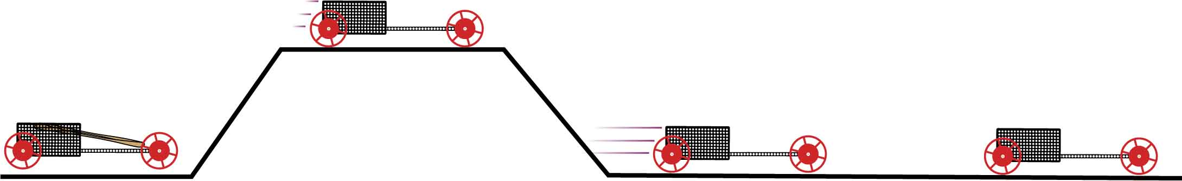

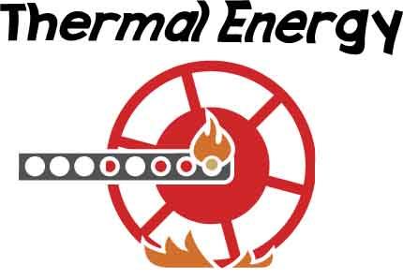

Friction makes your car slow down and heat up – transforming kinetic energy into thermal energy. The hotter an object is, the more energy it has.

What type of energy is greatest for each of the racer’s positions?

______________________________________________________________________________________________________________________________________________

ENERGY TRANSFER

BAD ENERGY

stretched rubber bands

Word Bank

Thermal Energy

Kinetic Energy

Gravitational Potential Energy

Elastic Potential Energy

DESIGN FOR ENERGY

**Changes you make to your design affect your racer’s energy transfers. The best racers store lots of elastic potential energy and turn it into kinetic energy. They are also designed to reduce friction, which steals good energy and makes it thermal energy.**

POTENTIAL ENERGY

**You want your car to store as much energy as possible so it can change it into Kinetic Energy and go even faster!**

If a rubber band runs out of room or is wrapped around the axle, it stores less energy.

Make sure rubber bands can be stretched all the way so they can store more energy.

Store more energy with more rubber bands. Add them in series or parallel to change their strength.

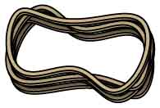

Parallel

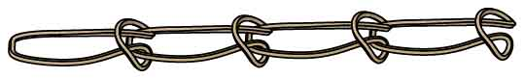

Series



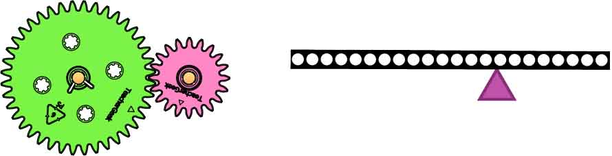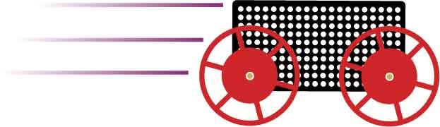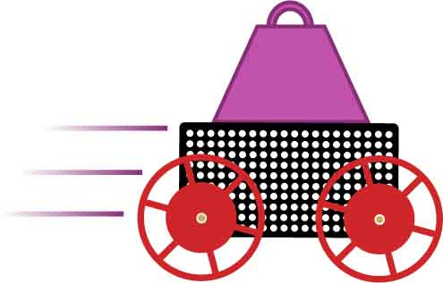

If going for distance, it’s better to build kinetic energy slowly and steadily.

Use gears, levers, and series/parallel rubber bands to control energy delivery.

Reduce your car’s mass. If two cars are moving with the same Kinetic Energy, the lighter car will be moving faster.

**This is where you want your energy! Generate as much Kinetic Energy as possible, and keep it as long as you can, to maximize your speed and distance.**

KINETIC ENERGY

If going for speed, you want kinetic energy as quickly as possible.

THERMAL ENERGY

**Friction can steal your racer’s kinetic energy and turns it into thermal energy. But friction can be helpful when it gives you traction, letting your car push off the ground and go faster!**

Gears, pulleys, and levers can help you control the force of your rubber bands, but they also add more friction.

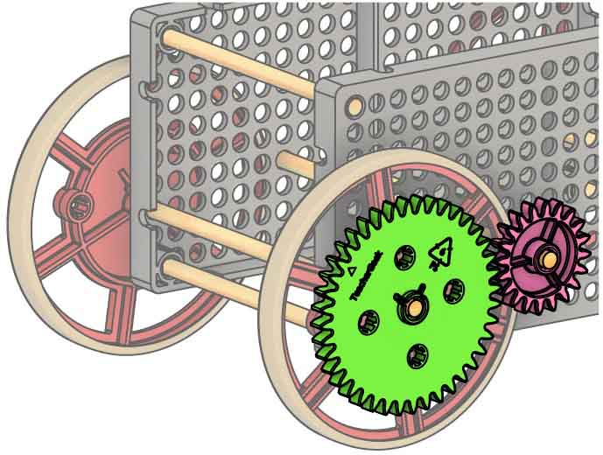

Decrease axle friction by lubricating with graphite (pencil lead). If you reamed the axle holes, make sure the holes are reamed completely.

Tire rubber bands add traction to your wheels, helping you convert Potential Energy to Kinetic Energy… But they also increase friction called rolling resistance.

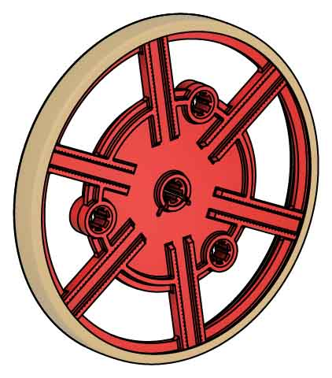

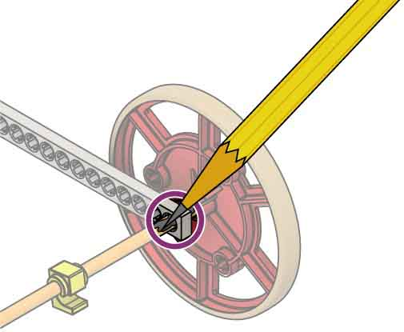



Describe one design change you want to make and how it will impact the energy stored or transferred in your racer.

____________________________________________________________________________________________________________________________________________________________________________________________________________________________________________________________________________________