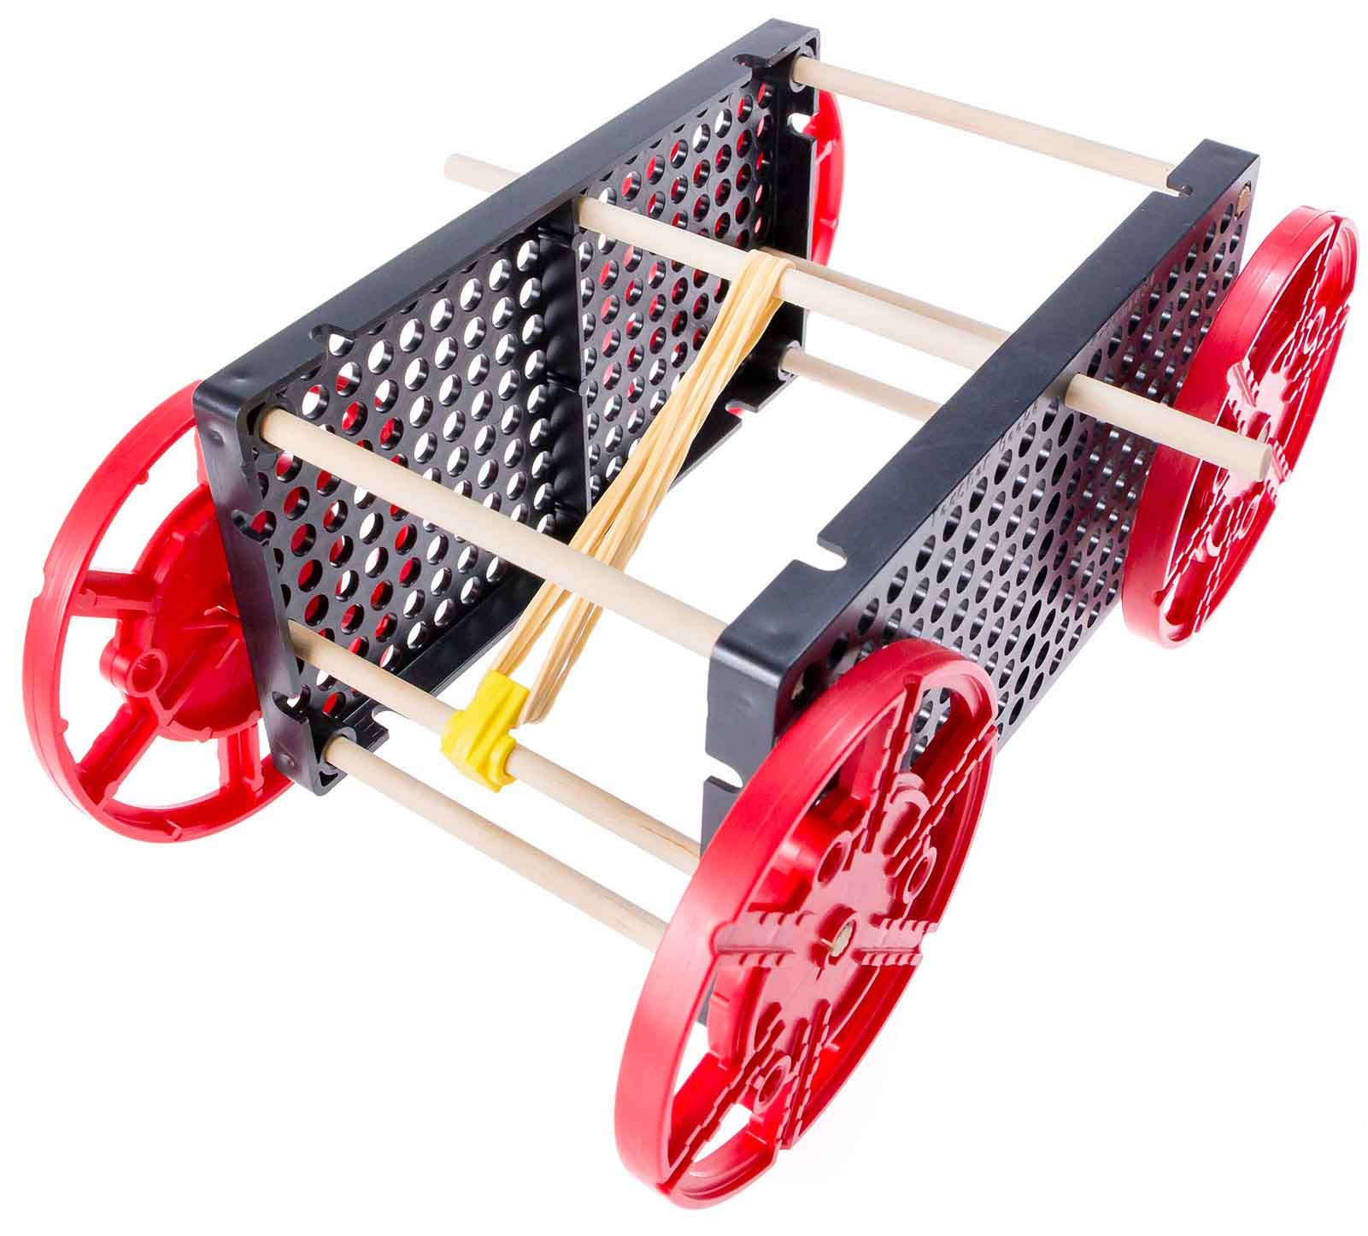

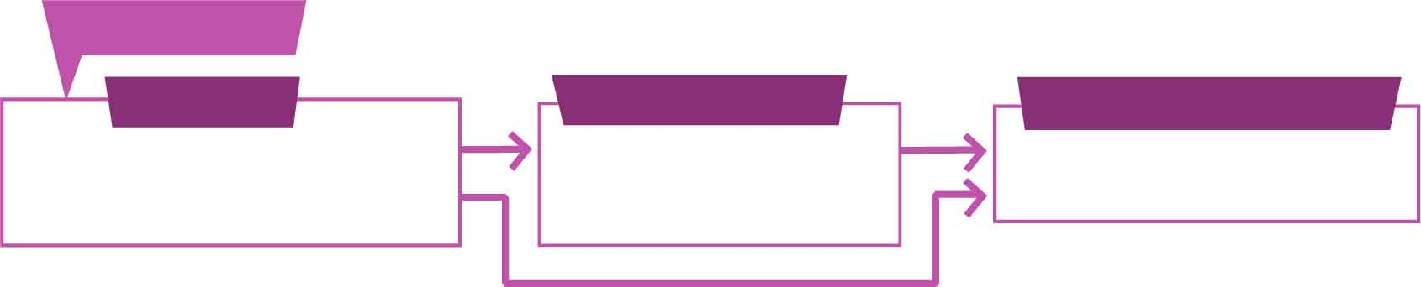

You Are Here

Go Guide

Start here! Build your example racer, evolve your design, and begin the Long Shot Challenge!

Optional Labs

Optional Challenges

[-Ramp Roll Lab](https://teachergeek.org/rubber_band_racer_lab_ramp_roll.docx)  
[-Energy Lab](https://teachergeek.org/rubber_band_racer_lab_energy.docx)  
[-Atwood’s Machine](https://teachergeek.com/atwoods)

-Sprint Challenge*  
-Target Challenge*

*See Page 6

**Choose how you would like to complete this activity.  
Download documents & videos at** [**teachergeek.com/rubberband**](http://teachergeek.com/rubberband)

Get started with the example build, then make your own unique design!

wind powered sail car!

sail car.

**Build your very own race car using the energy stored in rubber bands!**

* **Scissors**
* **Glue or Super Glue**(optional)
* **Recycling Bin Materials**(optional)

MATERIALS YOU SUPPLY

TEACHERGEEK PARTS

These are the components you need to build one Rubber Band Racer, including some extra parts so you can experiment and create your own designs.

RACER SUPPLIES

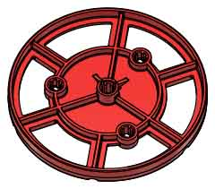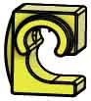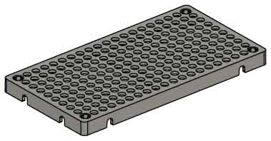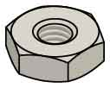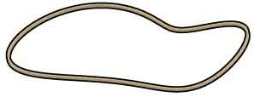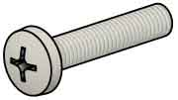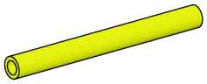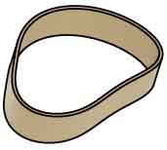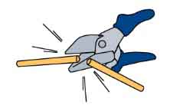

Have a Maker Cart? Use Multi-Cutters to cut your own dowels.

**Strips**

30 cm (12 in)

SKU 1821-31

**4**

**Wheels**SKU 1821-30

**Tire Rubber Bands**  
SKU 1821-64

**2**

**2**

**Hole Plates**SKU 1821-32

**1**

**Slide Stop**8 cm (3 in)  
SKU 1821-49

**4**

**2**

**10**

**4**

**4**

**12**

**PICTURE**

**NAME**

**QTY**

**Stop Clip**SKU 1821-60

**Rubber Bands**SKU 1823-41

**Screws**25 mm (1 in)  
SKU 1821-22

**Nuts**#10 Hex  
SKU 1821-25

SKU 1821-22

**Dowels**various sizes  
SKU 1821-20  
SKU 1821-22

Dowel Sizes

1x 15 cm (6”) 4x 13 cm (5”)

4x 10 cm (4”) 3x 5 cm (2”)

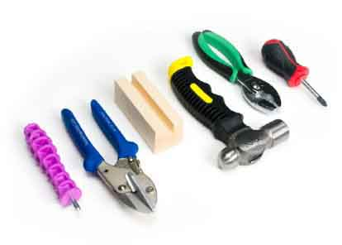

Modify materials to make even more creative designs with the

**TeacherGeek / Maker Tool Set**

SKU 1823-84

Optional Tools



GET READY TO ROLL

Check out the [**Build Video**](https://vimeo.com/414747768) scanning the QR Code or going to [**teachergeek.com/rubberband**](https://www.teachergeek.com/rubberband)

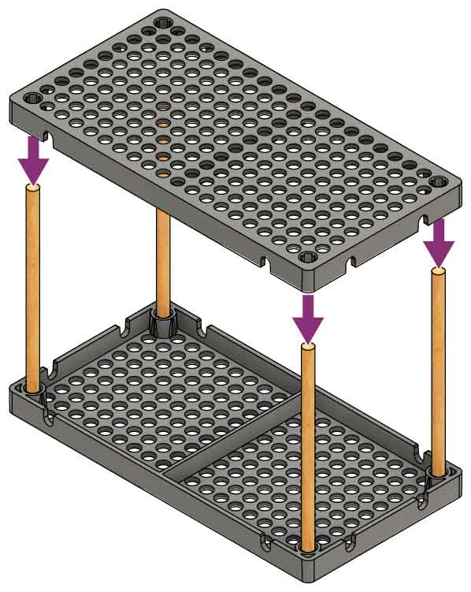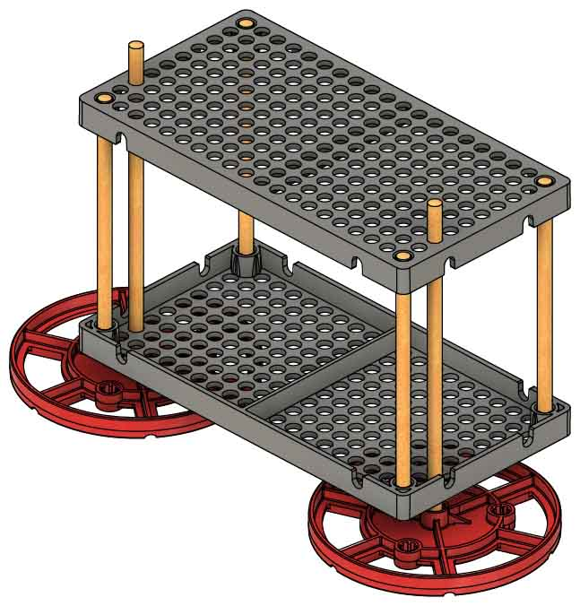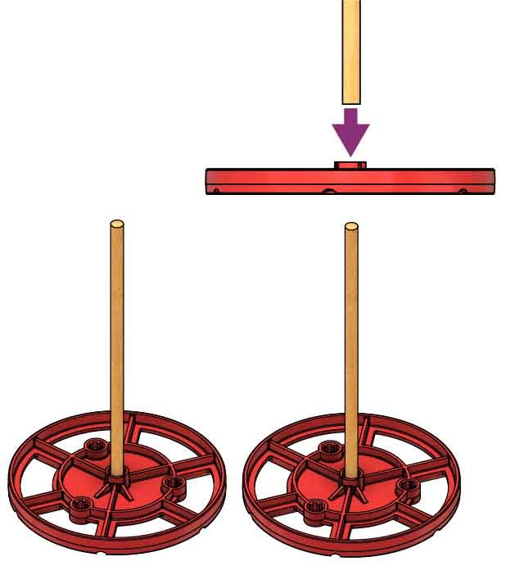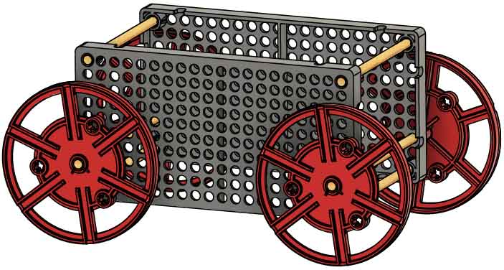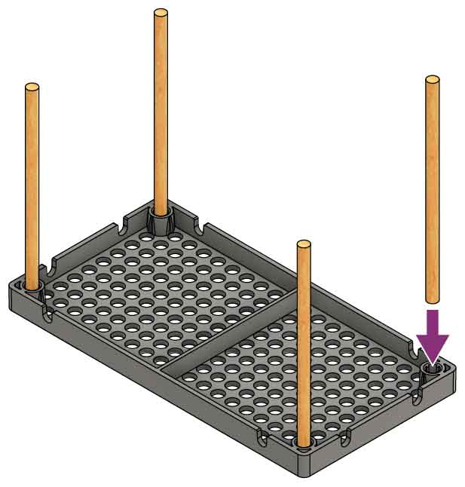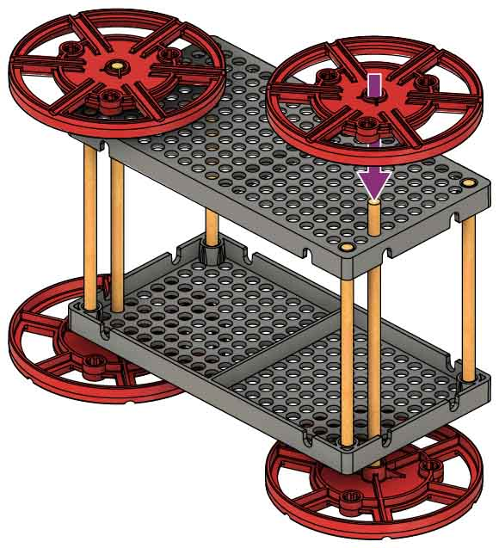

Tap or push another hole plate onto the dowels to finish your frame.

Slide the **axles** (dowels attached to wheels) through the frame, two holes from the bottom.

Dowel

Wiggle two 13 cm (5 in) dowels into wheels so the   
boss (bump)   
faces up.

Wiggle four 10 cm (4 in) dowels into the corners of an upside-down hole plate.

**Want to learn about   
gravity using your car?**

Download the   
**Ramp Roll Lab** at[**teachergeek.com/rubberband**](http://teachergeek.com/rubberband) **Ages 9+**

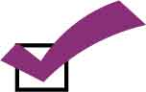

You’re ready to roll! Next, you’ll add rubber bands.

Push or tap wheels onto the other side of the axles.

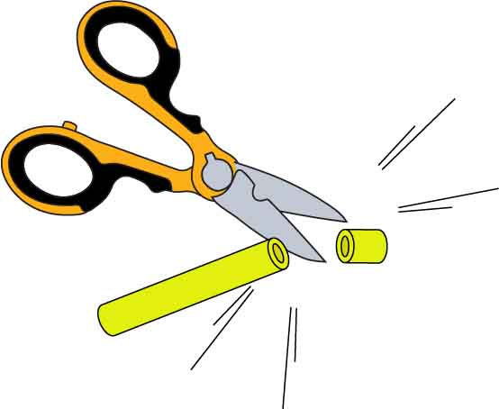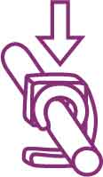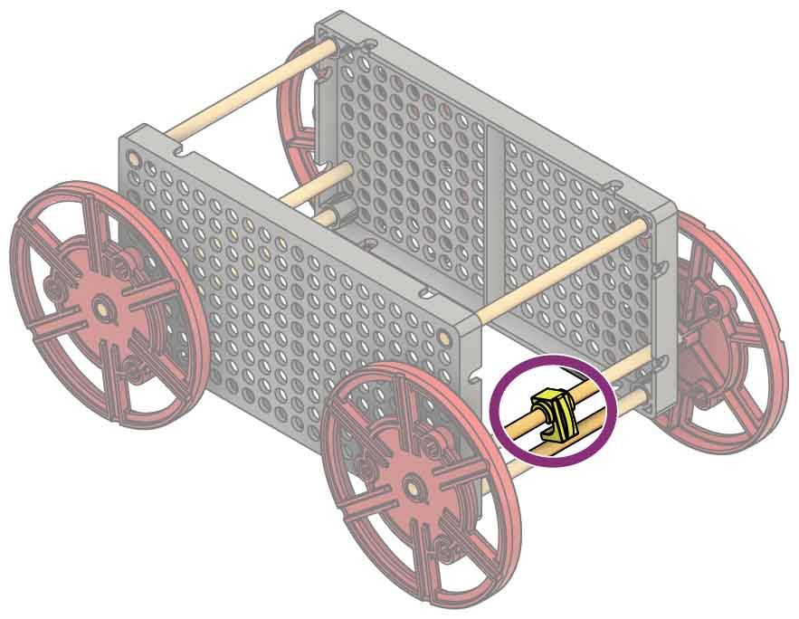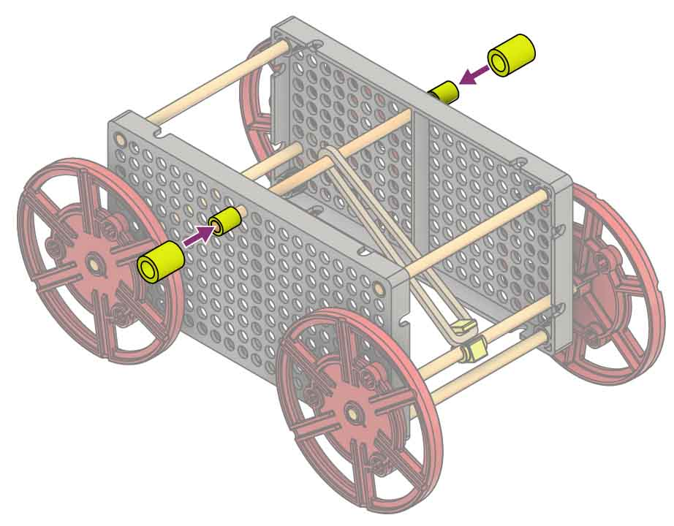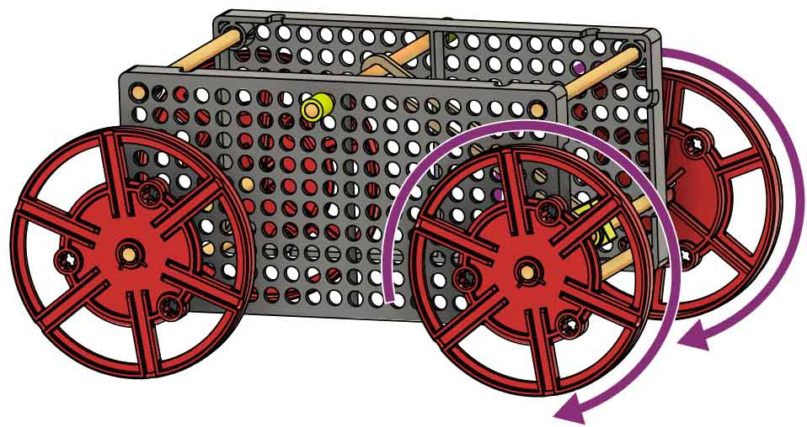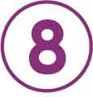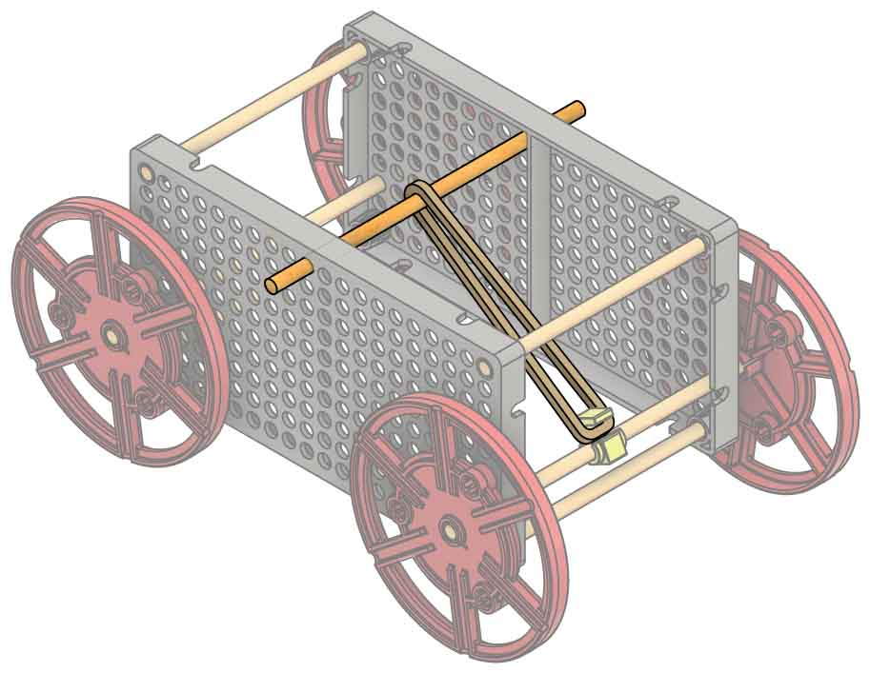

Test it out. Make sure the rubber band is hooked to the clip, then wind it up and release it!

POWER UP

Snap a stop clip onto one of the axles. An adult may need to help snap the clip on.

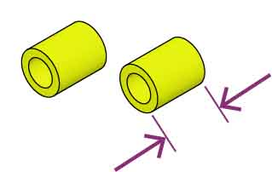

**1 cm**(3/8 in)

EXPORTS COMPLETE

Insert a 13 cm (5 in) dowel through the frame and a rubber band, as shown.

Cut two 1 cm (1/4 in) pieces of slide stop.

Add the slide stop to each end of the dowel.



GET A GRIP

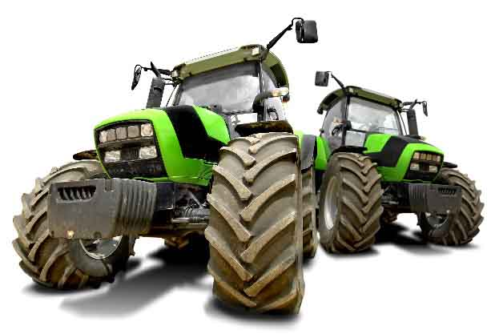

Traction is the friction between the wheels and the ground. It lets the vehicle push on the ground to move forward.

TRACTION

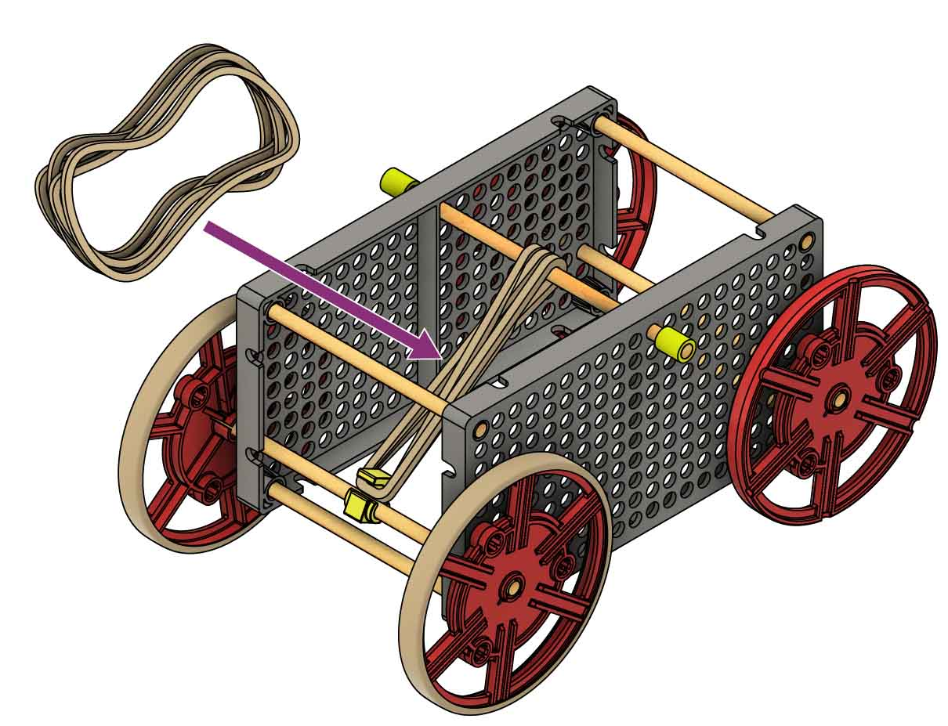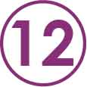

Try adding more rubberbands to your racer.

Do the rubber bands release their energy too fast?

Can you redesign your   
racer so rubber bands   
release energy slower?

Download these labsat [**teachergeek.com/rubberband**](http://teachergeek.com/rubberband)



[Atwood’s Machine Lab](https://teachergeek.com/atwoods)

[(Ages 14+)](https://teachergeek.com/atwoods)

[Energy Lab](https://teachergeek.org/rubber_band_racer_lab_energy.docx)

[(Ages 12+)](https://teachergeek.org/rubber_band_racer_lab_energy.docx)

[Ramp Roll Lab](https://teachergeek.org/rubber_band_racer_lab_ramp_roll.docx)

[(Ages 9+)](https://teachergeek.org/rubber_band_racer_lab_ramp_roll.docx)

Optional Labs:

**It’s time for labs and/or challenges!**   
Complete one of the optional labs below or continue on to set up for the engineering challenge!

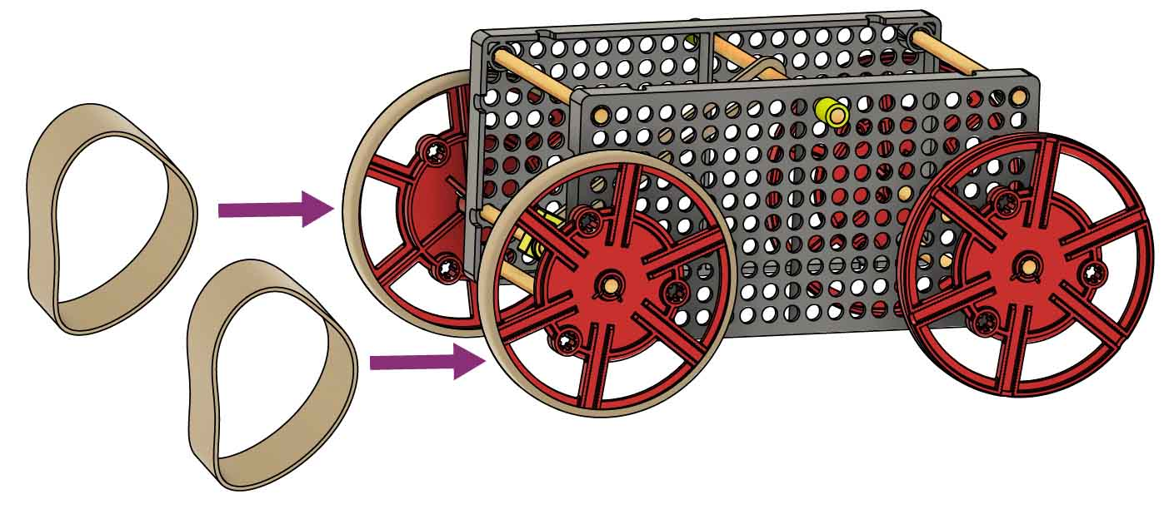

Place rubber band tires on your drive wheels   
to increase traction.



TROUBLESHOOTING

The RACER is STOPPING

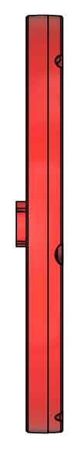

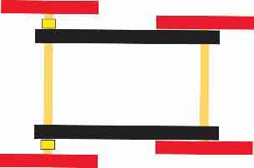

slide stop

Make sure the wheel’s boss (bump) is on the inside to make more space.

Check for wheels rubbing the frame. Add slide stop as a spacer, if necessary.

The RACER is TURNING

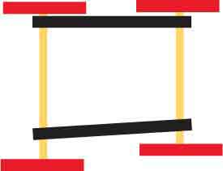

crooked

asymmetrical

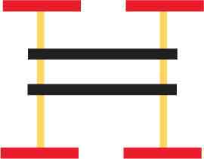

too far

The wheels should be close to the frame (not touching),   
so they can’t bounce around.

Make sure the frame and axles are straight and symmetrical.

The CLIP is SPINNING

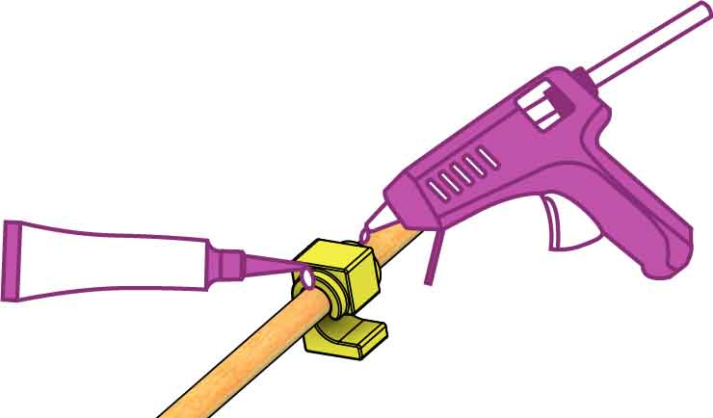

Glue the stop clip to the dowel.   
Hot glue and super glue work well.

The WHEELS are SLIPPING

Slow the energy transfer by using a lever or rearranging your rubber bands. See Page 7.

Add tire rubber bands to your drive wheels, if you haven’t   
already.

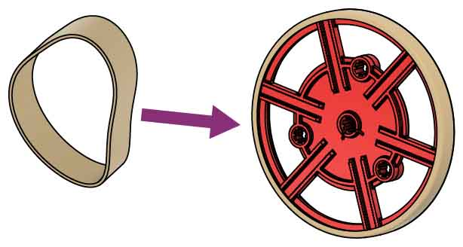

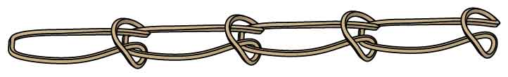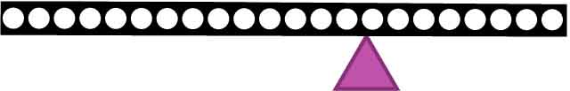

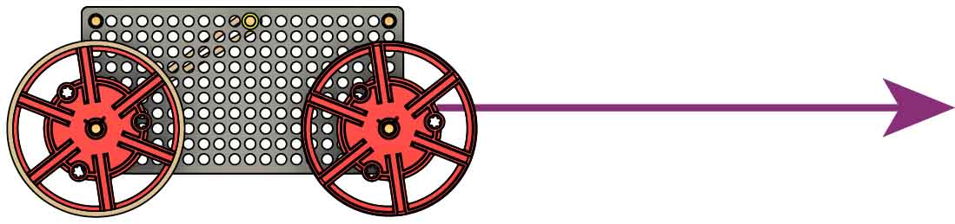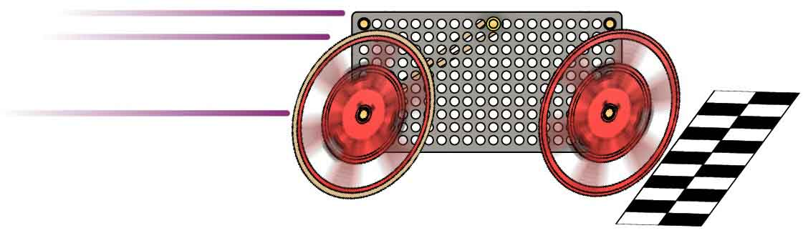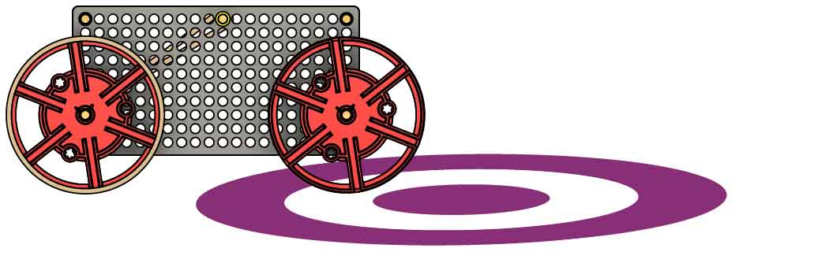

MORE CHALLENGES

Design your racer to stop as close to the bullseye as possible. **The closest racer wins!**

Compete for the fastest time on a 3 m (10 ft) track. **The fastest racer wins!**

Target:

Sprint:

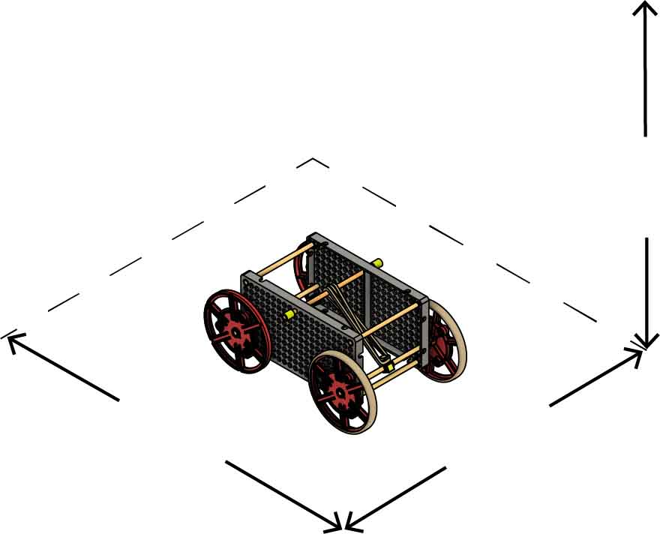

**50 cm**(20 in)

**Max Length**

**50 cm**(20 in)

**Max Width**

**50 cm**(20 in)

**Max Height**

Size: At the start of the competition, vehicles must fit within a   
50 cm x 50 cm x 50 cm cube.

Power: Only 5 small rubber bands may be used to power your vehicle. The tire rubber bands may not be used to store or release energy.

Components: You may only use the TeacherGeek components listed on Page 1.

There is no limit on recycling bin materials, but they can’t power your racer.

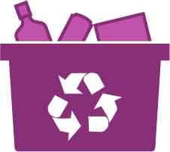

Constraints:  
(rules and limits for your design)

Your rubber band racer must travel the furthest distance down the track.

Make your racer go the farthest!

LONG SHOT CHALLENGE

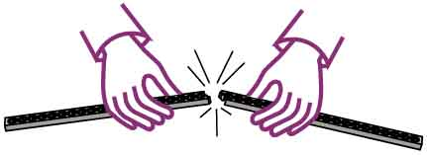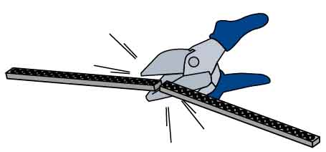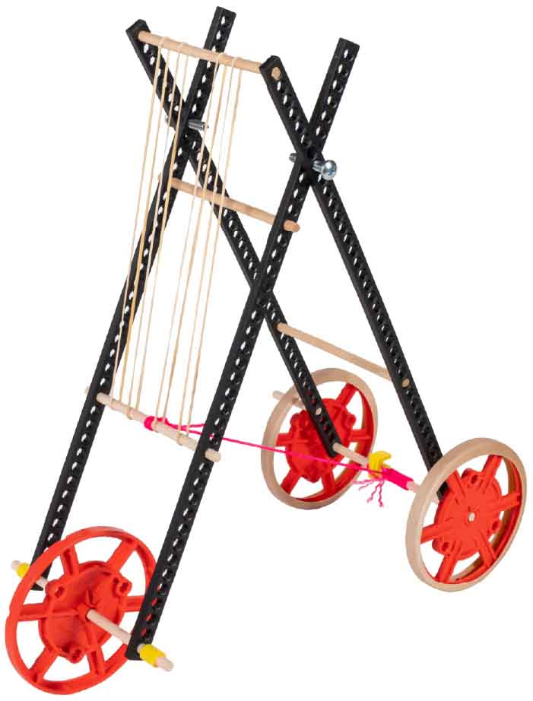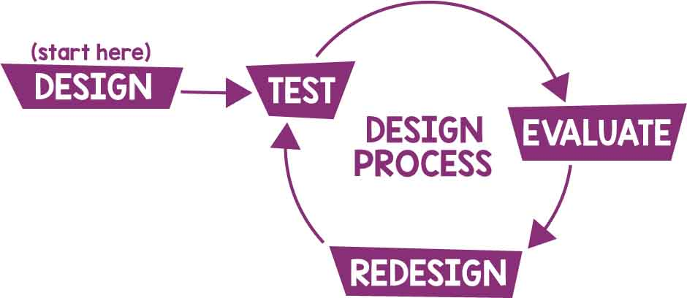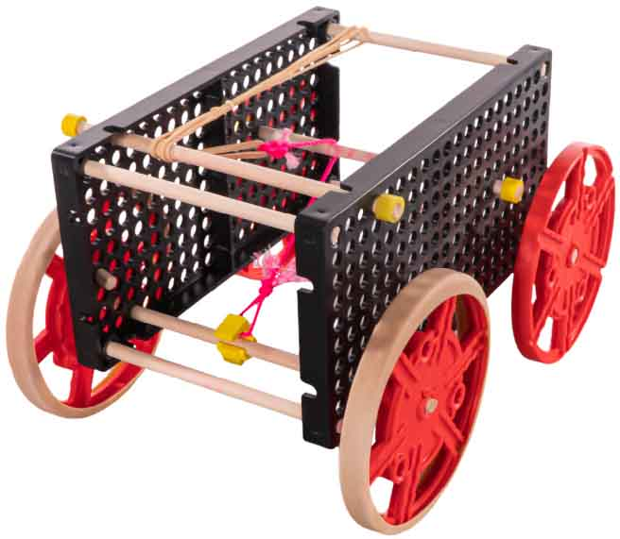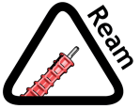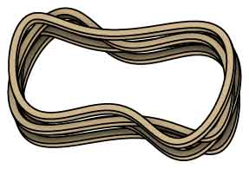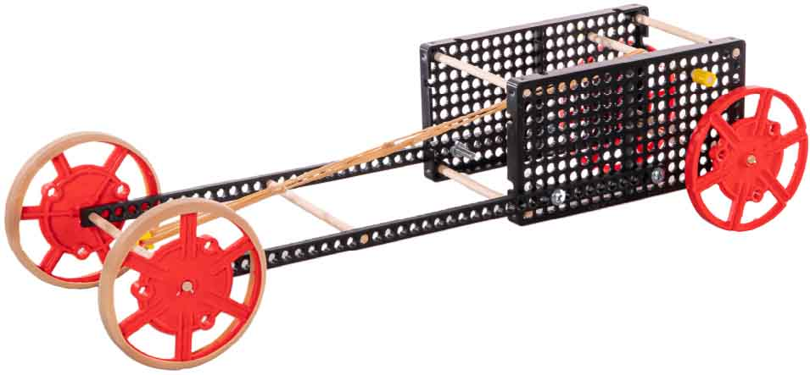

IMPROVE THE DESIGN

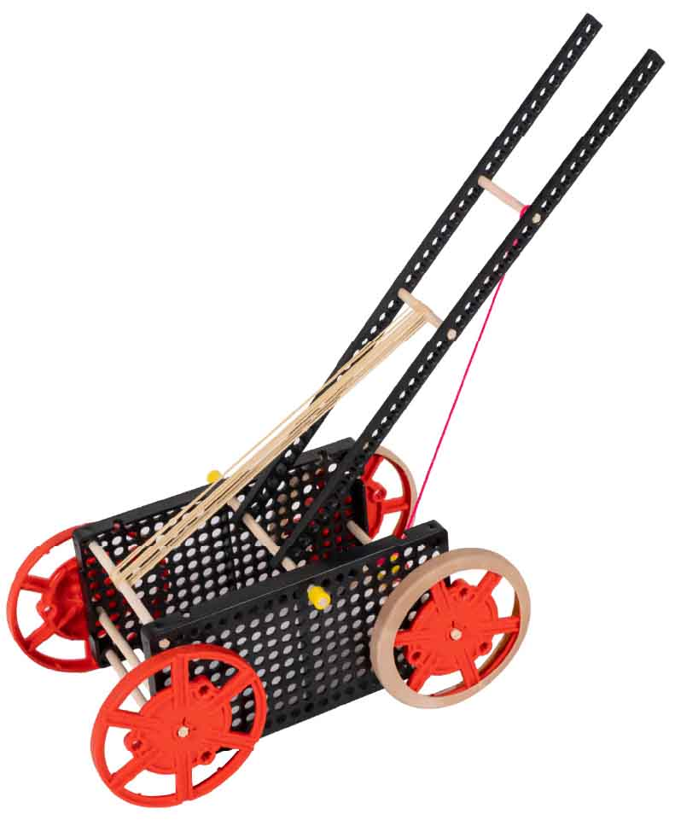

Add a Lever

Levers slow down or speed up the energytransfer.

String attaches the lever to   
the clip.

The Design Process never ends. There is no perfect design.

Ream the holes for where the axle turns. Do not ream wheels.

Tip

Cut or snap strips to the length that you need.

Get Crazy!

Don’t just copy these. Experiment and create your own designs!

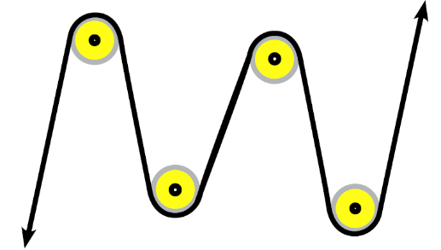

Use Pulleys

Pulleys can change the direction of a rubber band or string. Dowels that can spin can be used as pulleys.

Parallel or Series

Chaining rubber bands in series releases energy slower than rubber bands in parallel.

Parallel

Series