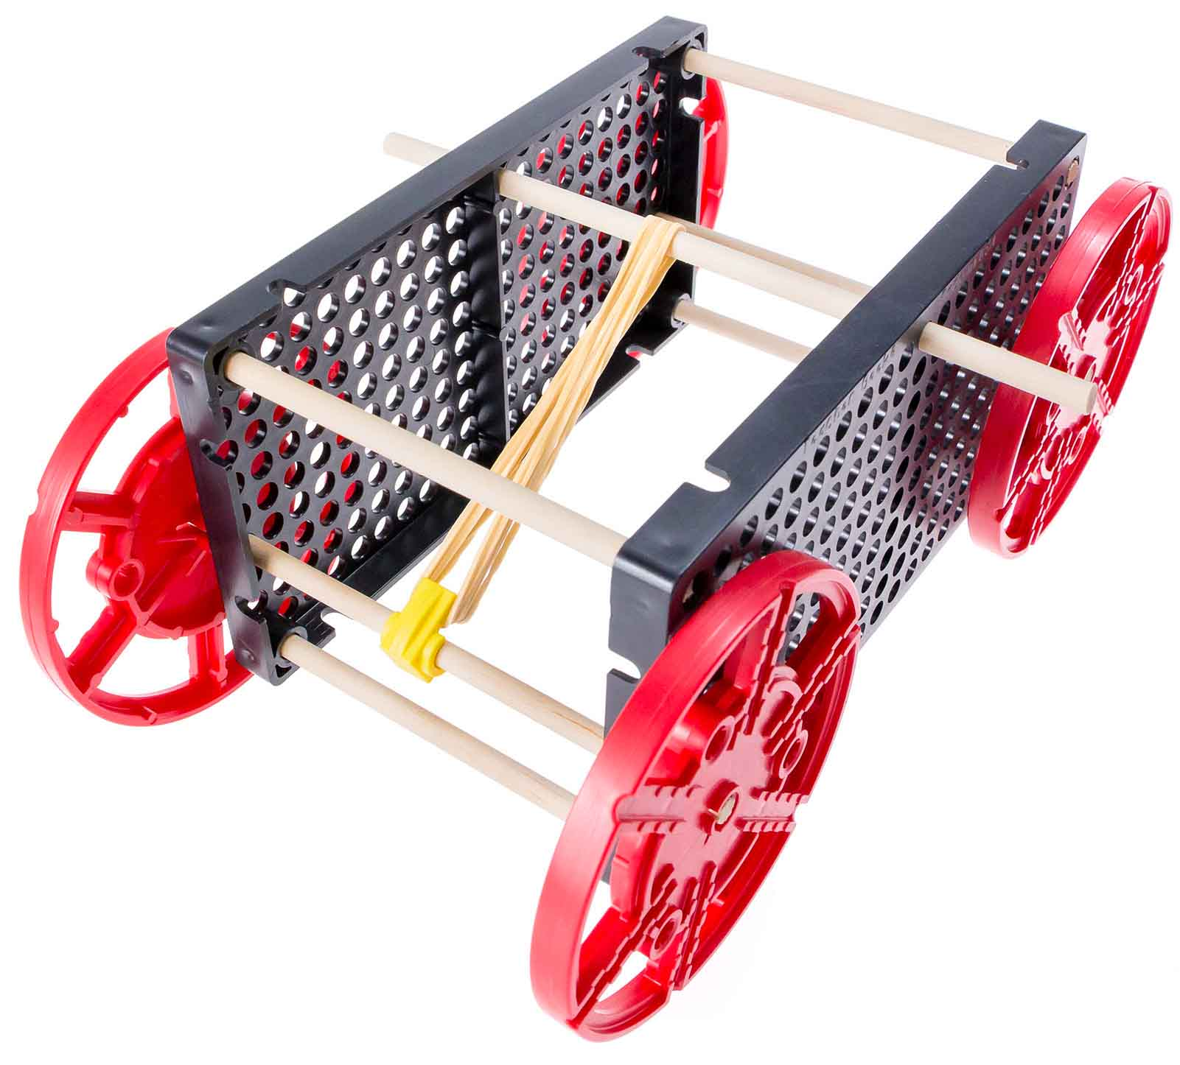

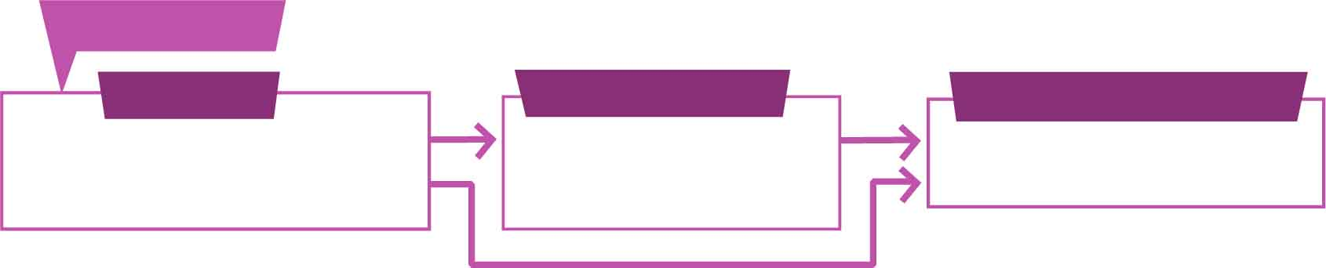

You Are Here

Go Guide

Start here! Build your example racer, evolve your design, and begin the Long Shot Challenge!

Optional Labs

Optional Challenges

[-Ramp Roll Lab](https://teachergeek.org/rubber_band_racer_lab_ramp_roll.docx)  
[-Energy Lab](https://teachergeek.org/rubber_band_racer_lab_energy.docx)  
[-Atwood’s Machine](https://teachergeek.com/atwoods)

-Sprint Challenge*  
-Target Challenge*

*See Page 6

**Choose how you would like to complete this activity.  
Download documents & videos at** [**teachergeek.com/rubberband**](http://teachergeek.com/rubberband)

Get started with the example build, then make your own unique design!

wind powered sail car!

sail car.

**Build your very own race car using the energy stored in rubber bands!**

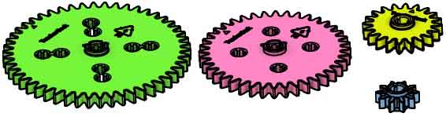

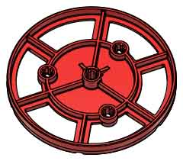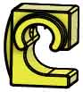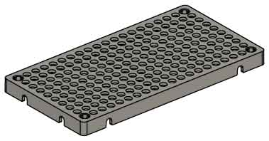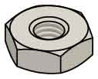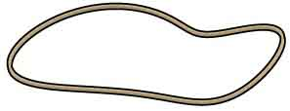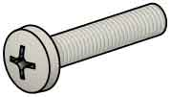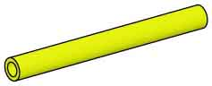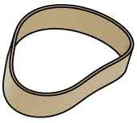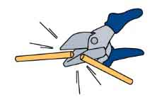

Have a Maker Cart? Use Multi-Cutters to cut your own dowels.

**Strips**

30 cm (12 in)

SKU 1821-31

**6**

**Gear Set**SKU 1821-28

**1 set**4 gears

**Wheels**SKU 1821-30

**Tire Rubber Bands**  
SKU 1821-64

**2**

**2**

**Hole Plates**SKU 1821-32

**1**

**Slide Stop**8 cm (3 in)  
SKU 1821-49

**4**

**4**

**10**

**8**

**8**

**17**

**PICTURE**

**NAME**

**QTY**

**Stop Clip**SKU 1821-60

**Rubber Bands**SKU 1823-41

**Screws**25 mm (1 in)  
SKU 1821-22

**Nuts**#10 Hex  
SKU 1821-25

SKU 1821-22

**Dowels**various sizes  
SKU 1821-20  
SKU 1821-22

Dowel Sizes

1x 15 cm (6”) 6x 13 cm (5”)

6x 10 cm (4”) 4x 5 cm (2”)

TEACHERGEEK PARTS

These are the components you need to build one Rubber Band Racer, including some extra parts so you can create your own unique designs.

RACER SUPPLIES

* **Scissors**
* **Glue or Super Glue**(optional)
* **Recycling Bin Materials**(optional)

MATERIALS YOU SUPPLY

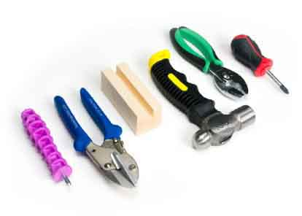

Modify materials to make even more creative designs with the

**TeacherGeek / Maker Tool Set**

SKU 1823-84

Optional Tools



GET READY TO ROLL

Check out the [**Build Video**](https://vimeo.com/414747768) scanning the QR Code or going to [**teachergeek.com/rubberband**](https://www.teachergeek.com/rubberband)

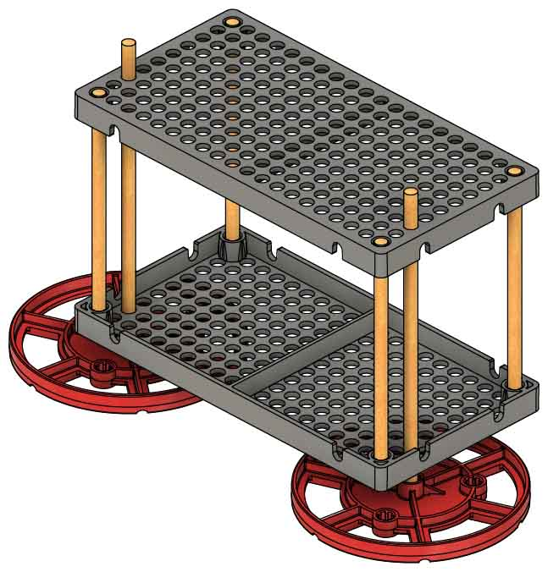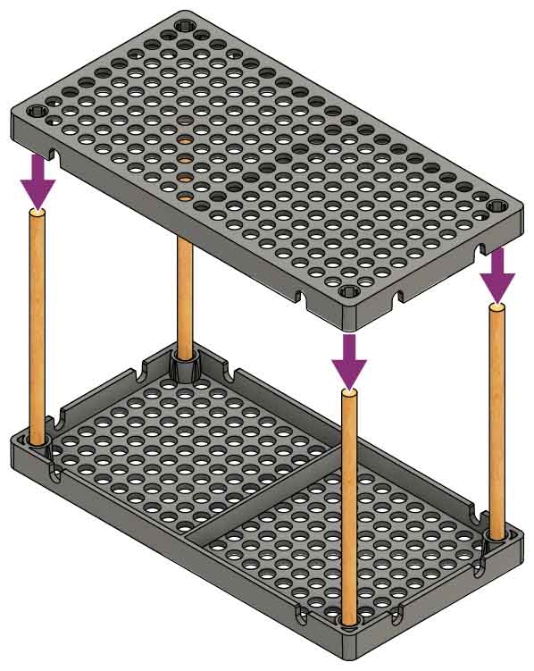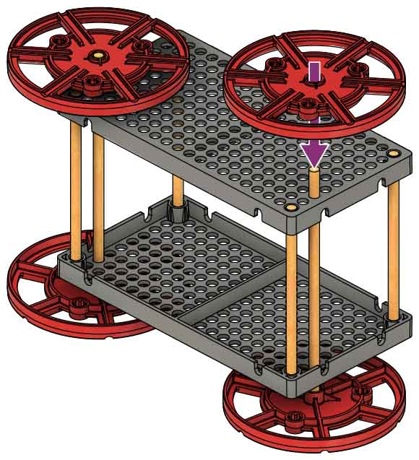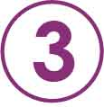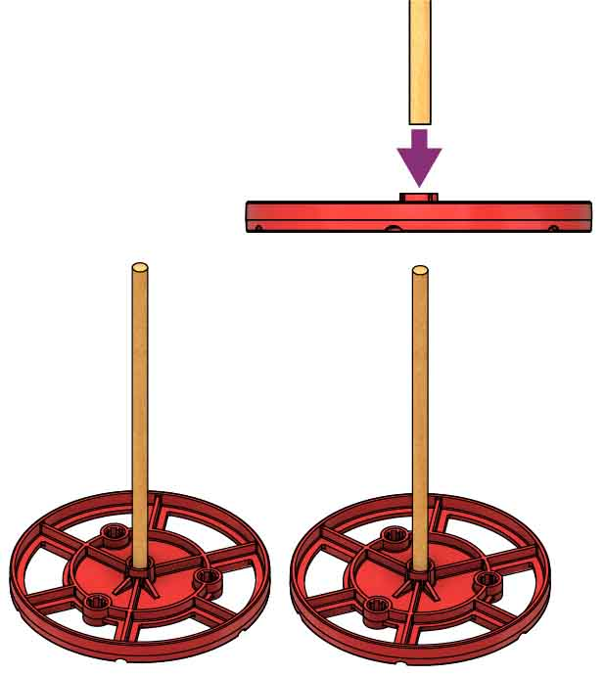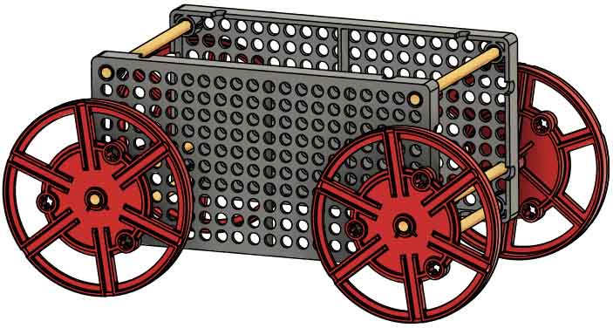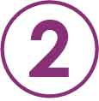

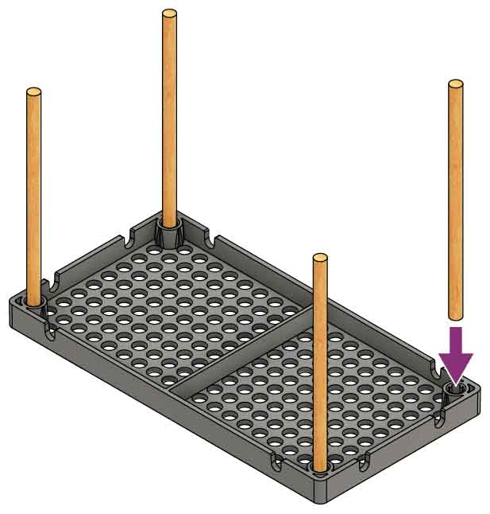

Dowel

Tap or push another hole plate onto the dowels to finish your frame.

**Want to learn about   
gravity using your car?**

Download the   
**Ramp Roll Lab** at[**teachergeek.com/rubberband**](http://teachergeek.com/rubberband) **Ages 9+**



Slide the **axles** (dowels attached to wheels) through the frame, two holes from the bottom.

Wiggle two 13 cm (5 in) dowels into wheels so the   
boss (bump)   
faces up.

Wiggle four 10 cm (4 in) dowels into the corners of an upside-down hole plate.

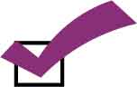

You’re ready to roll!   
Next, you’ll add rubber bands.

Push or tap wheels onto the other side of the axles.

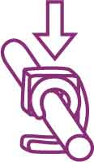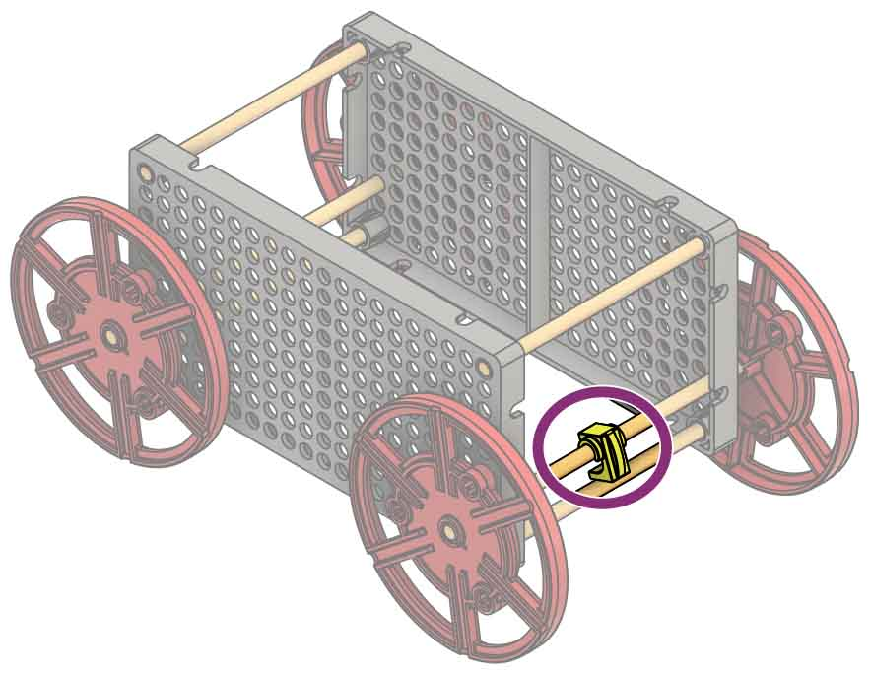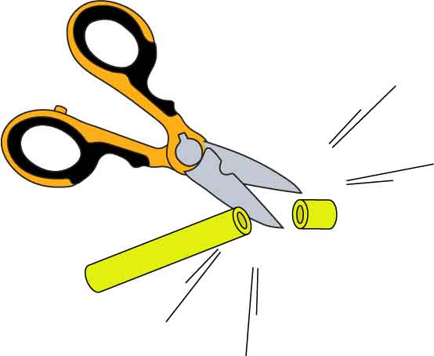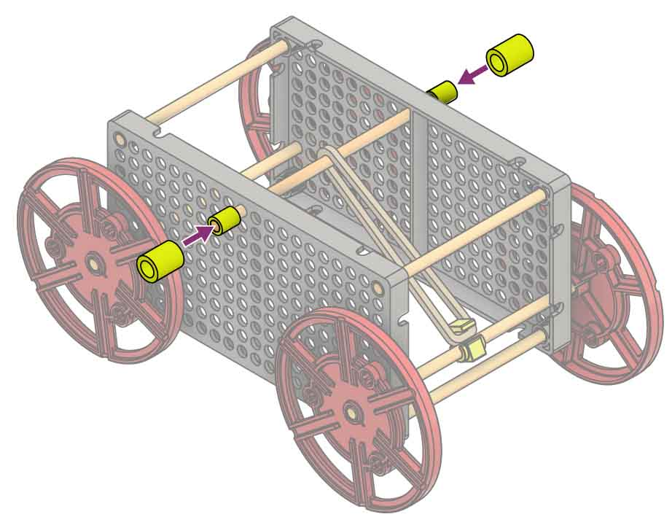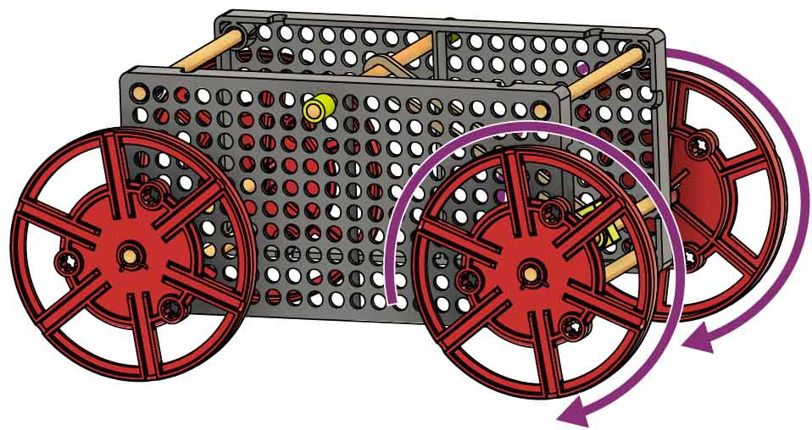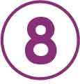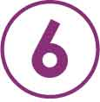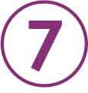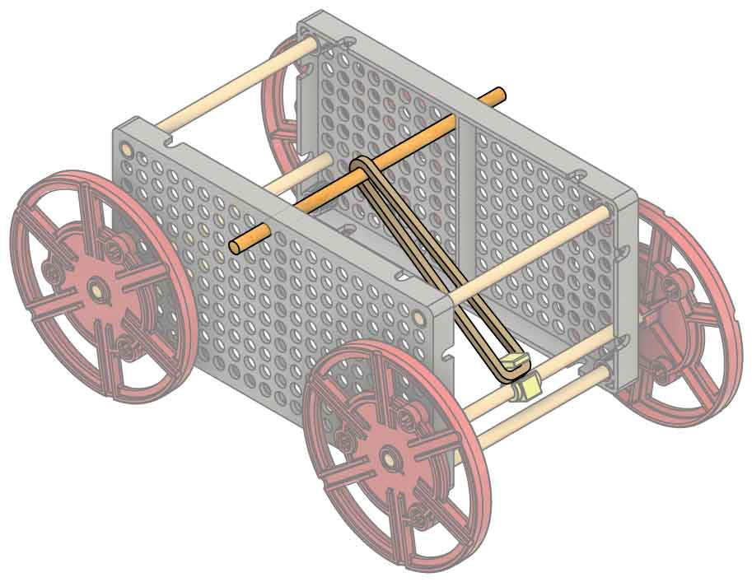

Cut two 1 cm (1/4 in) pieces of slide stop.

POWER UP

Insert a 13 cm (5 in) dowel through the frame and a rubber band, as shown.

Snap a stop clip onto one of the axles. An adult may need to help snap the clip on.

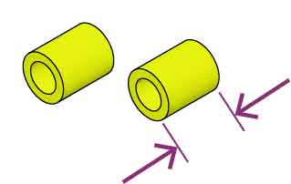

**1 cm**(3/8 in)

EXPORTS COMPLETE

Add the slide stop to each end of the dowel.

Test it out. Make sure the rubber band is hooked to the clip, then wind it up and release it!

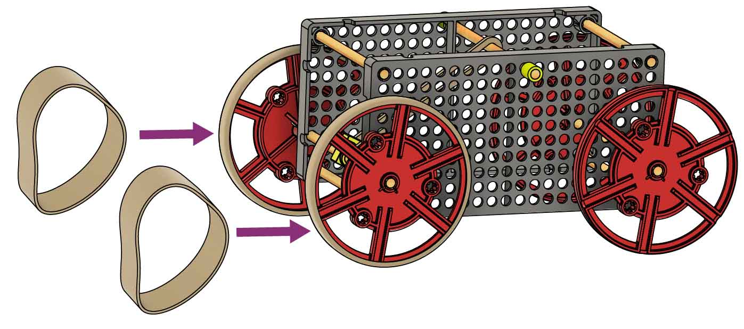

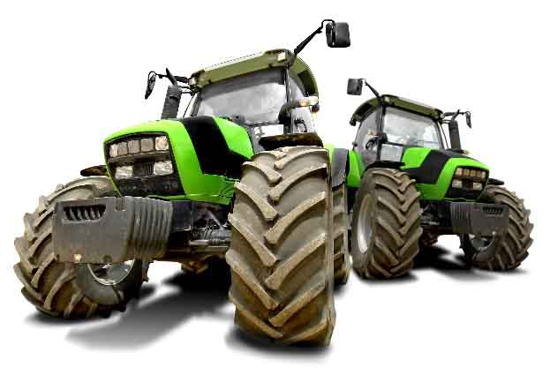

Traction is the friction between the wheels and the ground. It lets the vehicle push on the ground to move forward.

TRACTION

Place rubber band tires on your drive wheels   
to increase traction.

GET A GRIP

[Atwood’s Machine Lab](https://teachergeek.com/atwoods)

[(Ages 14+)](https://teachergeek.com/atwoods)

Download these labsat [**teachergeek.com/rubberband**](http://teachergeek.com/rubberband)



[Energy Lab](https://teachergeek.org/rubber_band_racer_lab_energy.docx)

[(Ages 12+)](https://teachergeek.org/rubber_band_racer_lab_energy.docx)

[Ramp Roll Lab](https://teachergeek.org/rubber_band_racer_lab_ramp_roll.docx)

[(Ages 9+)](https://teachergeek.org/rubber_band_racer_lab_ramp_roll.docx)

Optional Labs:

**It’s time for labs and/or challenges!** Complete one of the optional labs below or continue on to set up for the engineering challenge!

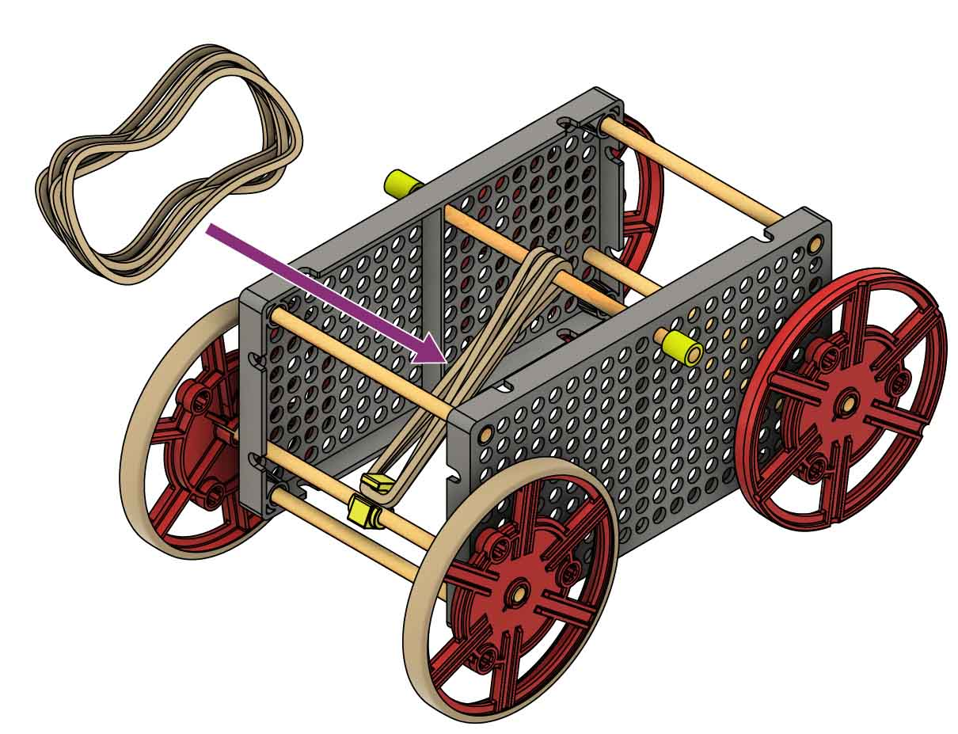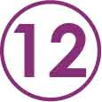

Try adding more rubberbands to your racer.

Do the rubber bands release   
their energy too fast?

Can you redesign your   
racer so rubber bands   
release energy slower?

TROUBLESHOOTING

The RACER is STOPPING

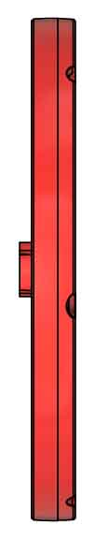

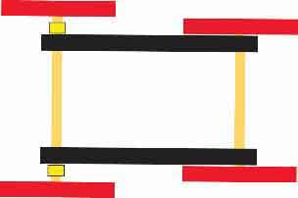

slide stop

Make sure the wheel’s boss (bump) is on the inside to make more space.

Check for wheels rubbing the frame. Add slide stop as a spacer, if necessary.

The RACER is TURNING

The wheels should be close to the frame (not touching),   
so they can’t   
bounce around.

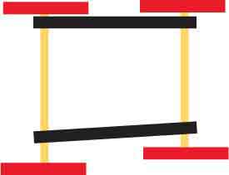

crooked

asymmetrical

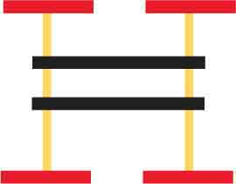

too far

Make sure the frame and axles are straight and symmetrical.

The CLIP is SPINNING

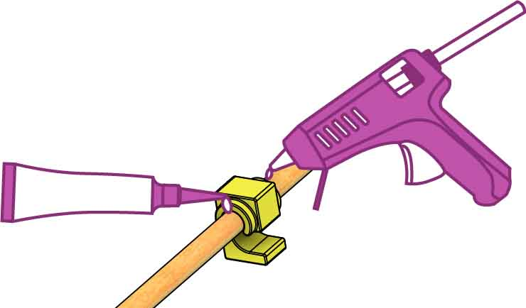

Glue the stop clip to the dowel.   
Hot glue and super glue work well.

The WHEELS are SLIPPING

Use simple machines to reduce the wheels’ torque (turning force).   
See Page 7.

Add tire rubber bands to your drive wheels, if you haven’t already.

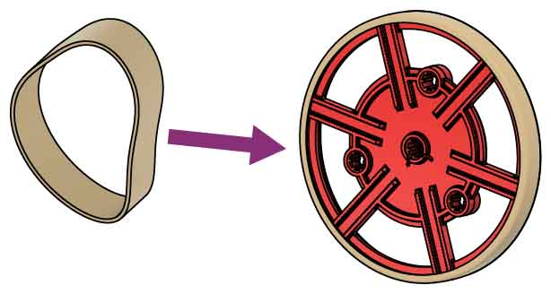

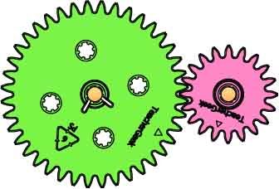

gears

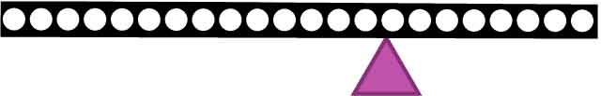

levers

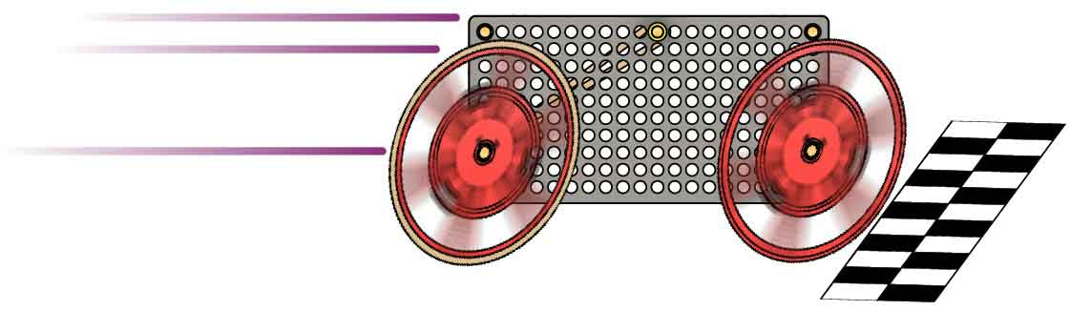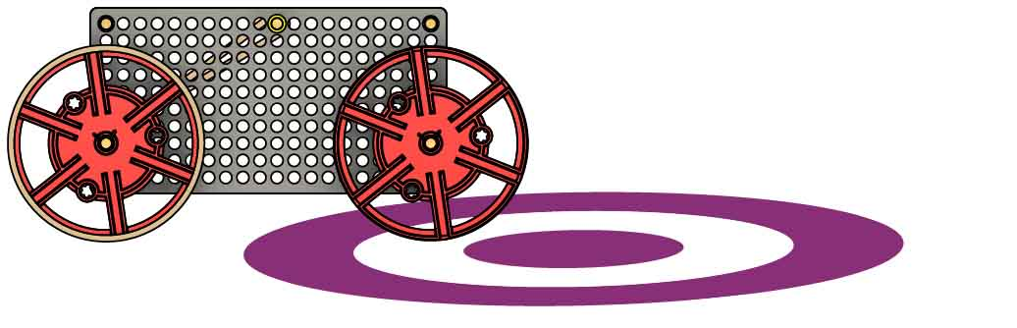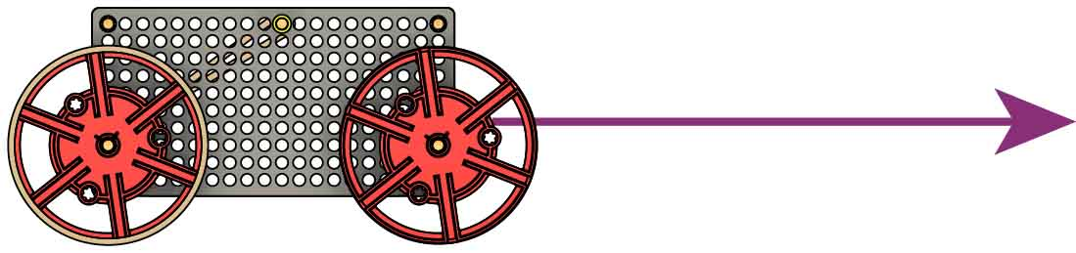

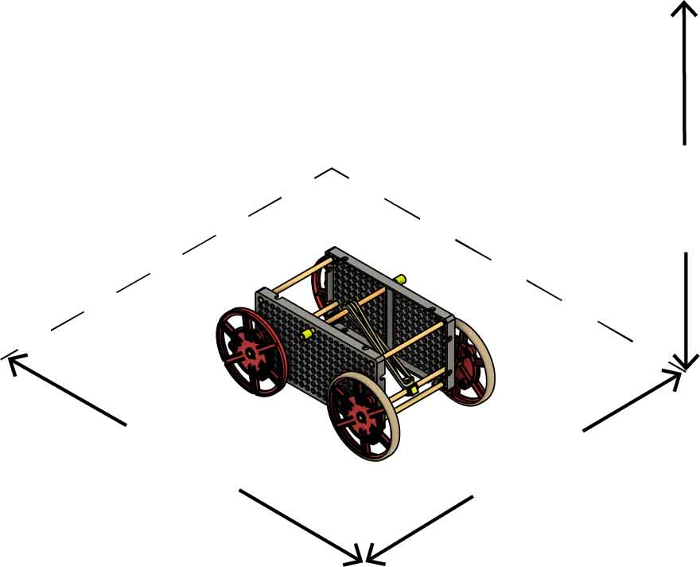

**50 cm**(20 in)

**Max Length**

**50 cm**(20 in)

**Max Width**

**50 cm**(20 in)

**Max Height**

Power: Only 5 small rubber bands may be used to power your vehicle. The tire rubber bands may not be used to store or release energy.

Components: You may only use the TeacherGeek components listed on Page 1.

There is no limit on recycling bin materials, but they can’t power your racer.



LONG SHOT CHALLENGE

Size: At the start of the competition, vehicles must fit within a   
50 cm x 50 cm x 50 cm cube.

Your rubber band racer must travel the furthest distance down the track.

Make your racer go the farthest!

Constraints:  
(rules and limits for your design)

MORE CHALLENGES

Sprint:

Target:

Compete for the fastest time on a 3 m (10 ft) track. **The fastest racer wins!**

Design your racer to stop as close to the bullseye as possible. **The closest racer wins!**

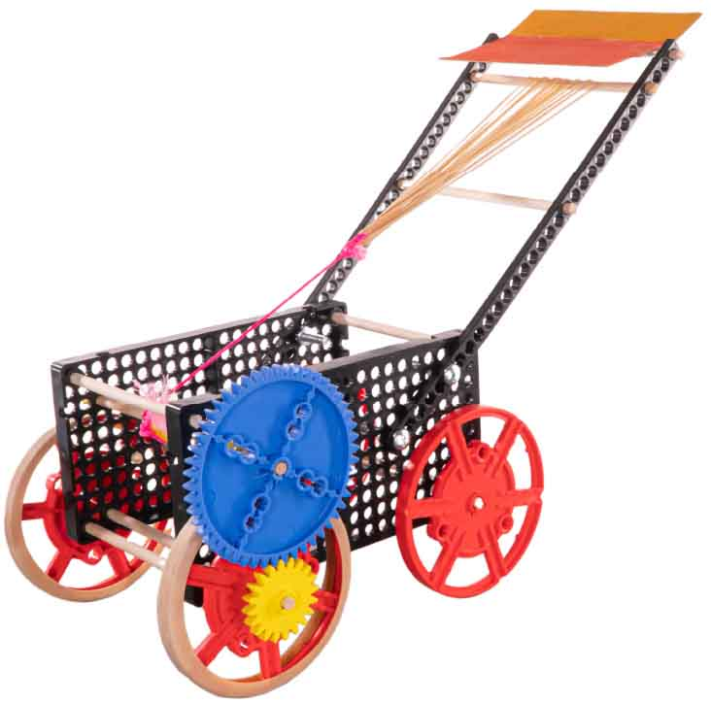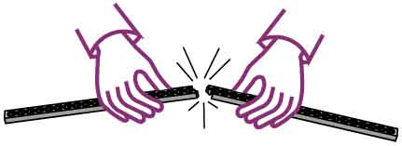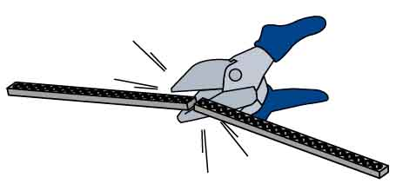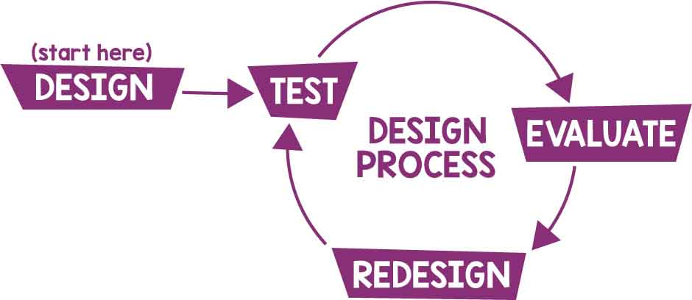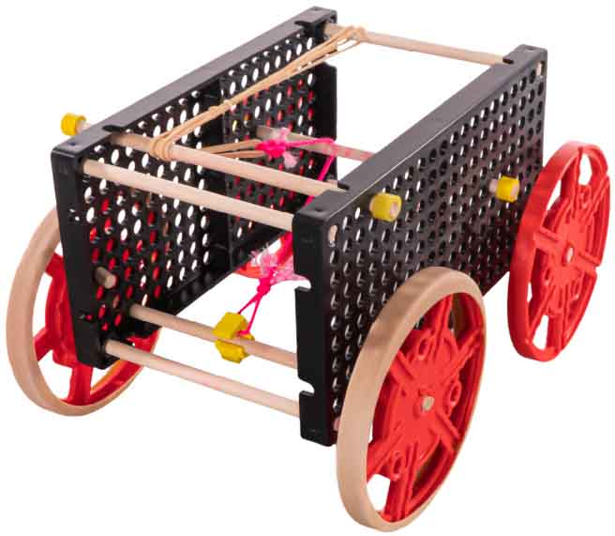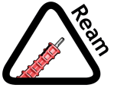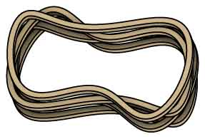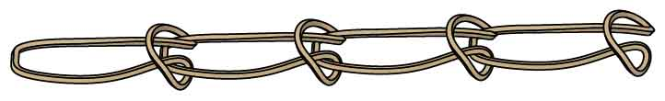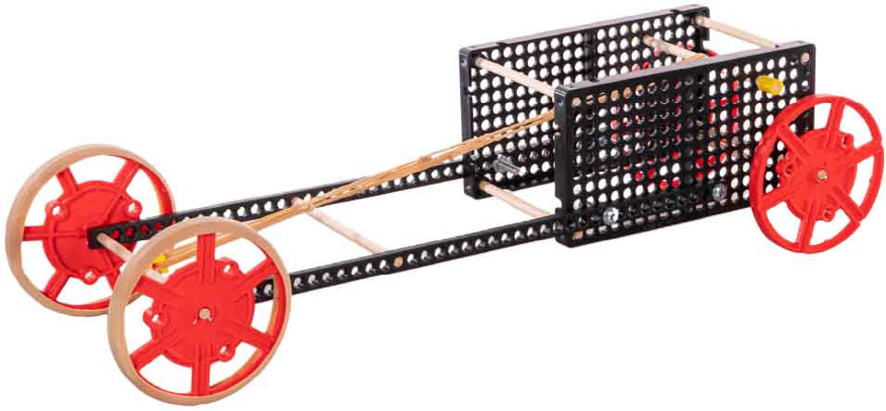

IMPROVE THE DESIGN

Parallel or Series

Chaining rubber bands in series releases energy slower than rubber bands in parallel.

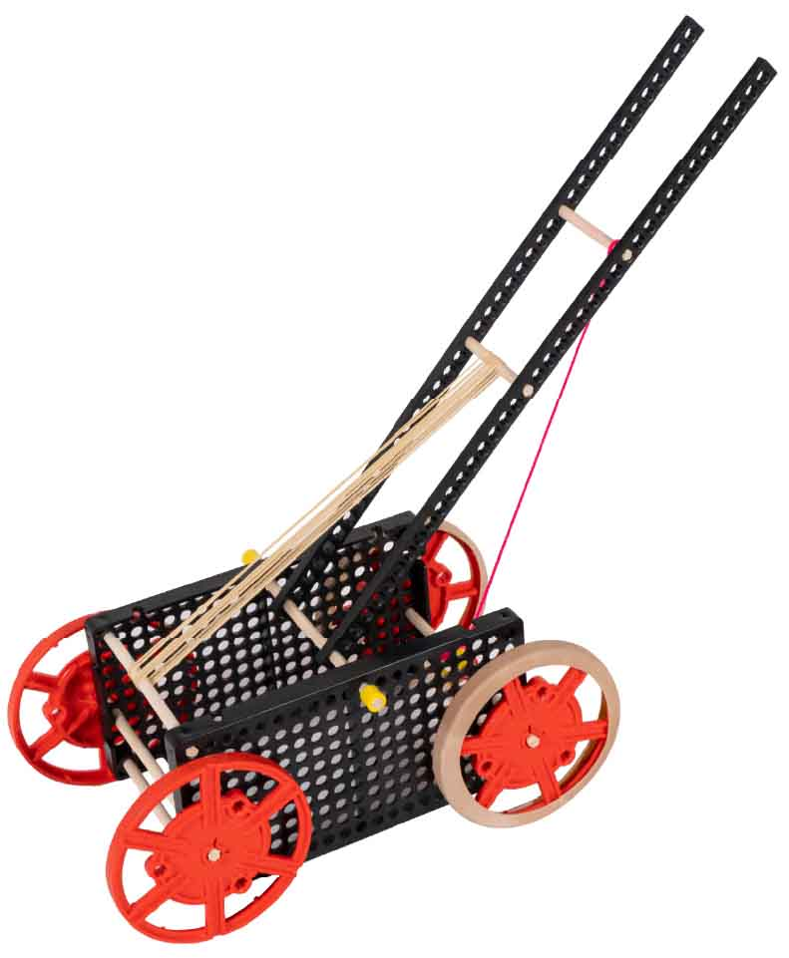

Add a Lever

Levers slow down or speed up the energytransfer.

String   
attaches the lever to the clip.

Use Gears

Gears can also slow down or speed up energy transfer.

The Design Process never ends. There is no perfect design.

Ream the holes for where the axle turns. Do not ream wheels.

Tip

Cut or snap strips to the length that you need.

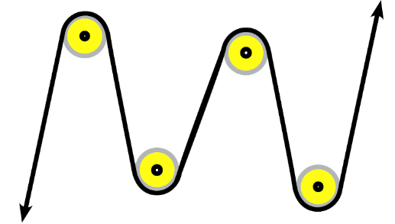

Use Pulleys

Pulleys can change the direction of a rubber band or string. Dowels that can spin can be used as pulleys.

Parallel

Series