**Grades**

[**2-6 version**](https://teachergeek.org/rubber_band_advanced_build_guide_elementary_v1.0.docx) available at [**teachergeek.com/rubberband**](https://teachergeek.com/rubberband)

**7-12+**

**Start by building the example racer, then turn into your own unique design.**

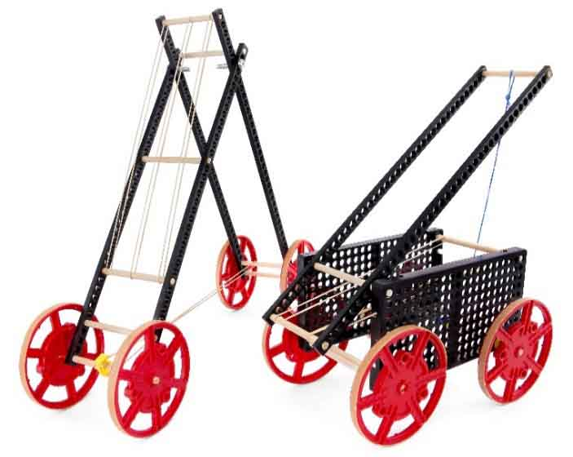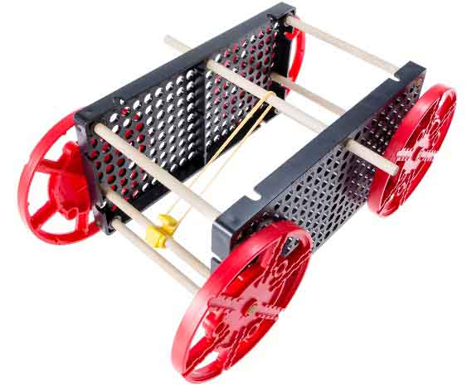





For optional labs, challenges, and other extensions, check out [teachergeek.com/rubberband](https://teachergeek.com/rubberband)





[**6 - Connector Strips**](https://teachergeek.com/products/rubber-band-racer?variant=344648175)



**[8 - Dowels](https://teachergeek.com/products/rubber-band-racer?variant=344648175)**

[300mm (12″)](https://teachergeek.com/products/rubber-band-racer?variant=344648175)



[**2 - Hole Plates**](https://teachergeek.com/products/rubber-band-racer?variant=344648175)



[**4 - Wheels**](https://teachergeek.com/products/rubber-band-racer?variant=344648175)

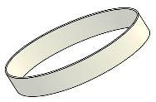

[**2 - Stretch Tires**](https://teachergeek.com/products/rubber-band-racer?variant=344648175)



**[4 - Screws](https://teachergeek.com/products/rubber-band-racer?variant=344648175)**

[#10 1″](https://teachergeek.com/products/rubber-band-racer?variant=344648175)



**[4 - Nuts](https://teachergeek.com/products/rubber-band-racer?variant=344648175)**

[#10](https://teachergeek.com/products/rubber-band-racer?variant=344648175)



**[1 - Slide Stop](https://teachergeek.com/products/rubber-band-racer?variant=344648175)**

[75mm (3″)](https://teachergeek.com/products/rubber-band-racer?variant=344648175)



[**4 - Stop Clip**](https://teachergeek.com/products/rubber-band-racer?variant=344648175)



[**10 - Rubber Bands**](https://teachergeek.com/products/rubber-band-racer?variant=344648175)

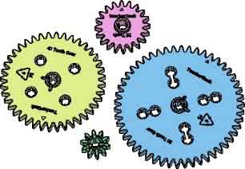

**4 – Gears**

One of each size

10, 20, 40, 50 Tooth

*****[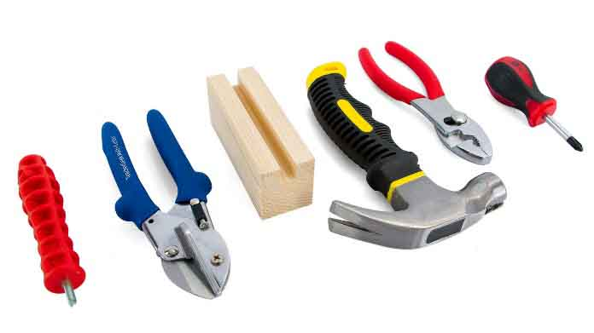](https://teachergeek.com/products/easy-engineering-tool-set?variant=344866731)*

* **TeacherGeek Reamer**
* **TeacherGeek** [**Multi-Cutter**](https://teachergeek.com/products/1823-81)
* **Tapping Block** -Optional
* **Small** [**Hammer**](https://teachergeek.com/products/stubby-claw-hammer)
* **Pliers** -Optional
* **Philips** [**Screwdriver**](https://teachergeek.com/products/stubby-2-screwdriver)





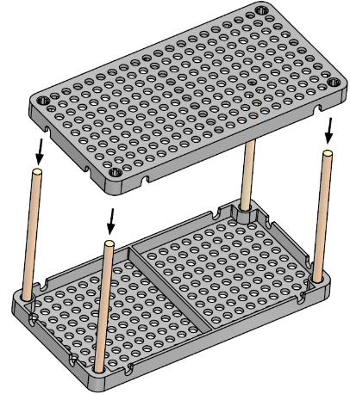

Tap or push a   
**hole plate** on top of the **dowels**.



Tap or push **dowels** into an upside-down **hole plate**.

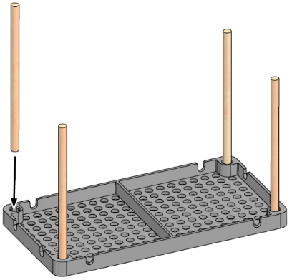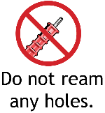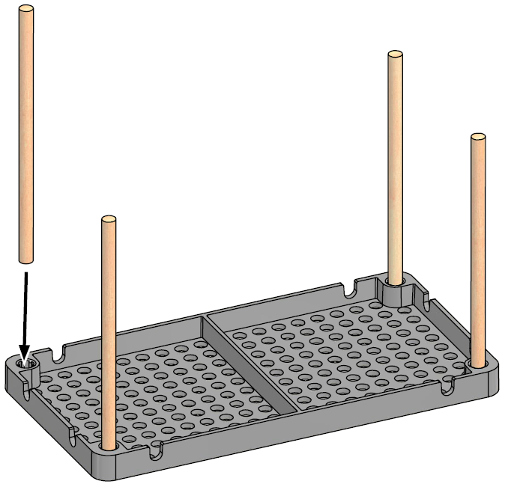

10cm (4in)



**Cut** four **10cm** (4”) **dowels**.





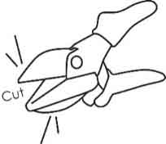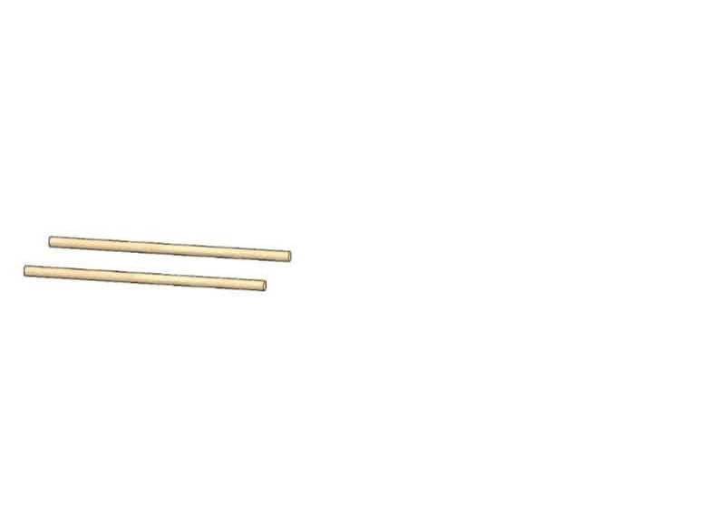

13cm (5in)

**Cut** two 13cm (5.1”) **dowels**. These will become **axles** for the **wheels**.

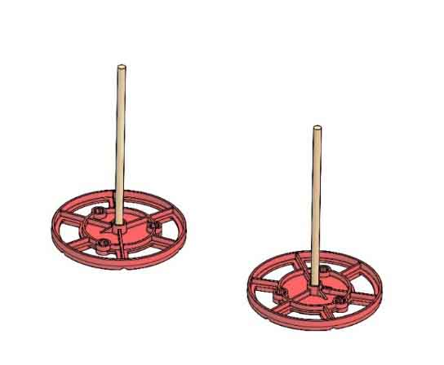

Push or tap the two **axles** into **wheels**.



Place the **axles** through the **frame**, three holes up from the bottom.

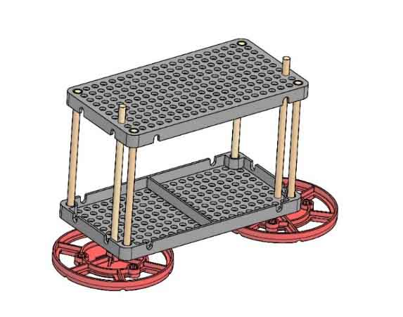

Push or tap two **wheels** onto the other side of the **axles**.

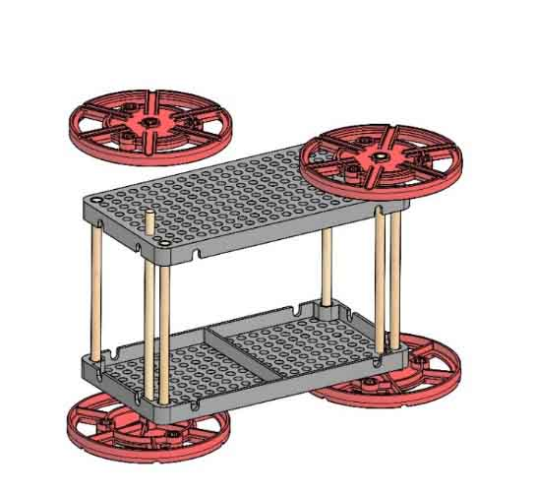



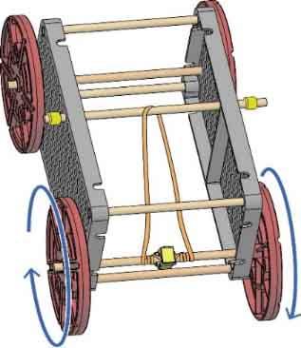

**Hook** the **rubber band** around the **stop clip**. Wind it up by turning the **wheels**.

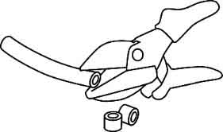

1cm   
(0.4in)

**Cut** one 13cm (5.1”) **dowel** and two 1cm sections of **slide stop**.

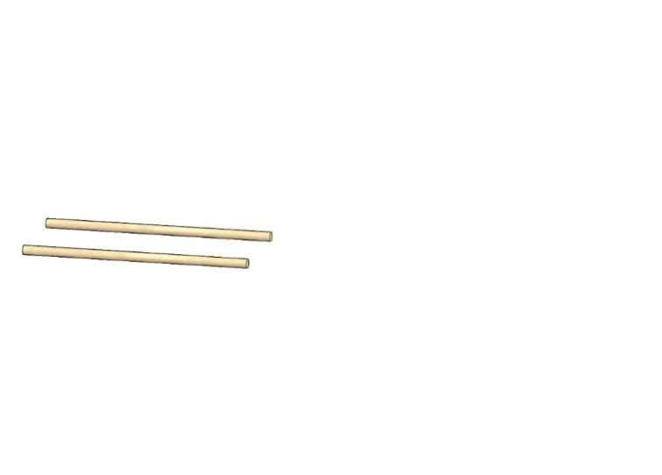

13cm (5in)

Place the 13cm **dowel** through the **frame** and   
a **rubber band**. Secure with **slide stop**.

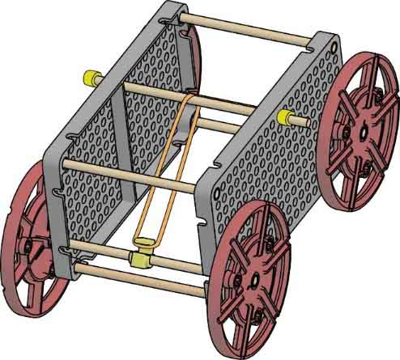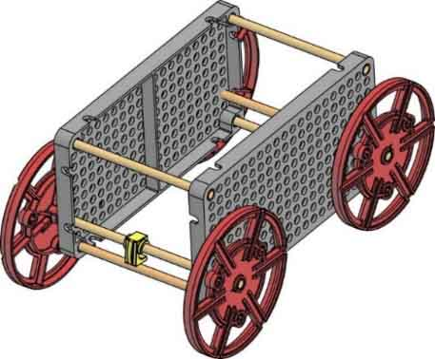

**Snap** on the **stop**

**clip** to one of the wheel **axles**.

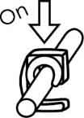



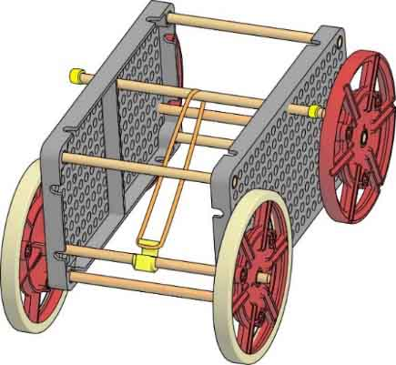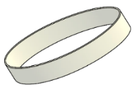

Place **stretch tires** on the drive **wheels**.





Find the challenges at [teachergeek.com/rubberband](https://teachergeek.com/rubberband)

**Long Shot**

Redesign your racer go the greatest distance.

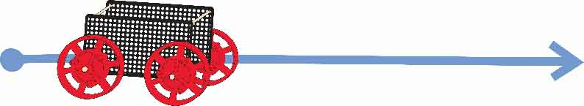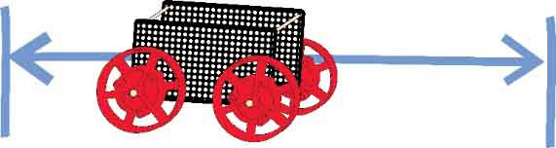

**Target**

Redesign your racer to stop on a target.

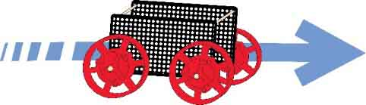

**Sprint**

Redesign your racer to break a speed record or win a race.





TURNING

The racer is

STOPPING

The racer is



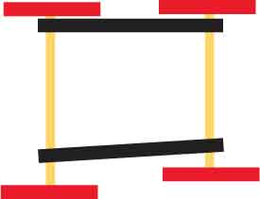

Make sure the frame and axles are straight and symmetrical.



crooked

asymmetrical

The axles should be close to the frame (not touching), so they can’t bounce around.

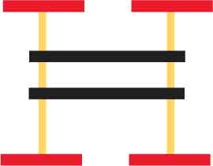

too far



Make sure boss (bump) on the axle hole is on the inside to give more space.

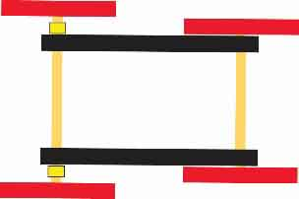

slide stop



Check for wheels rubbing the frame. Add slide stop as a spacer, if necessary.

**Try adding more rubber bands** to store more potential energy.

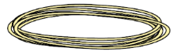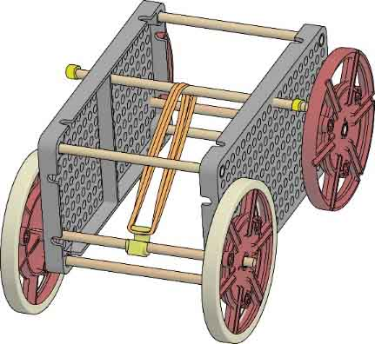

**Can you use all the rubber bands to maximize kinetic energy?**

Not with this design! Your clip will slip, your axle will bend, and if you fix those, your wheels will spin in place! Read on for tips that will help you improve your car so it can handle more force.



The energy of motion.



The stored energy of a stretched rubber band.

**Add a Lever**

Use **levers** to **slow** the **transfer** **of** potential to kinetic **energy**.

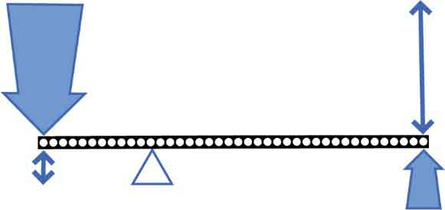

**Levers create mechanical advantage – they trade force for distance.**

big input  
force

small input distance

big output distance

small input  
force

**Move** **the** **fulcrum** to adjust the output force.

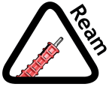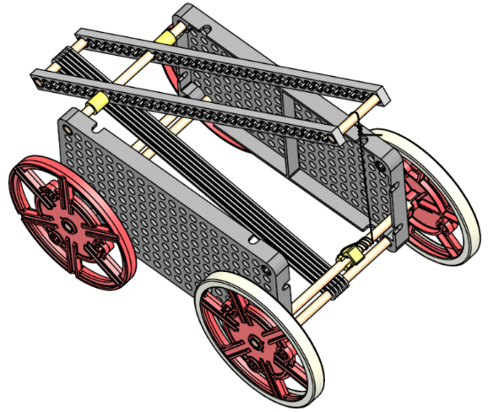

Rubber Bands

Ream the holes for the fulcrum (where the dowels go through the lever).

Tie a string to the lever. Add a loop to the other end for the stop clip.



**Use Gears**

Gears create mechanical advantage, just like levers.

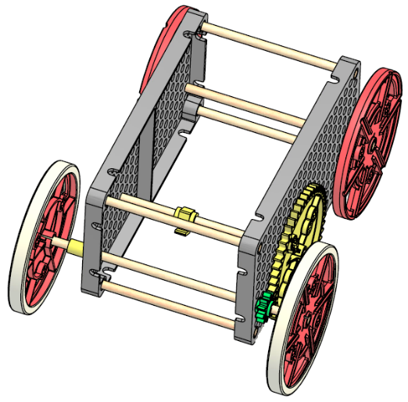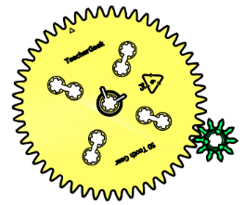

Every revolution of the big gear makes the small gear go 5 revolutions, but with less force.

The Engineering Design Process never ends. There is no perfect design.

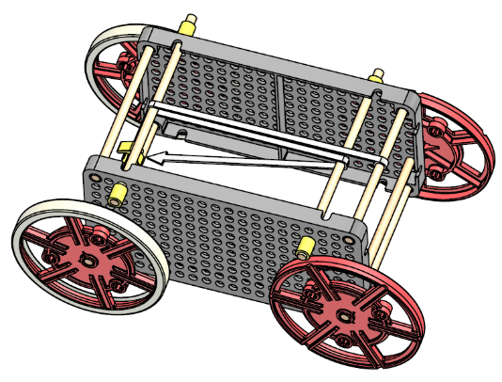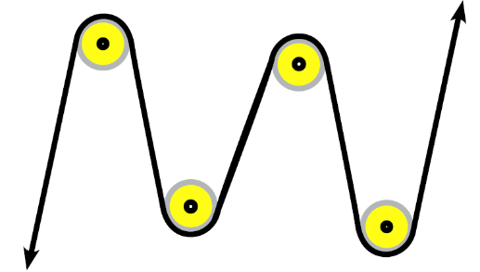

**Use Pulleys**

**Pulleys** can be used to **change** the **direction** of a rubber band or string. Dowels, that can spin, can be used as pulleys.

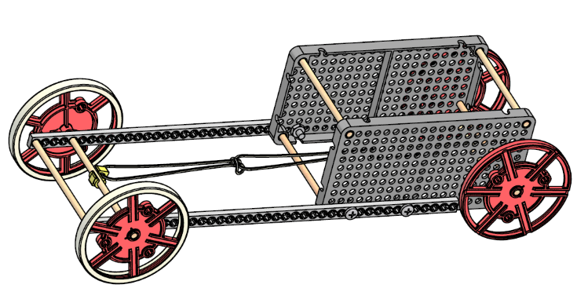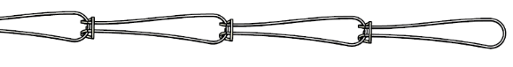

Series



Parallel

**Parallel or Series**

**Rubber** **bands** can be **connected** in **series** (forming a thin, long band) or in **parallel** (forming a short, thick band).

?

13cm (5in)

