How high &   
how far it goes.

**How To Use A Graph To Hit A Target**Adjusting the launcher angle changes your **projectile’s** (ball) **trajectory**.





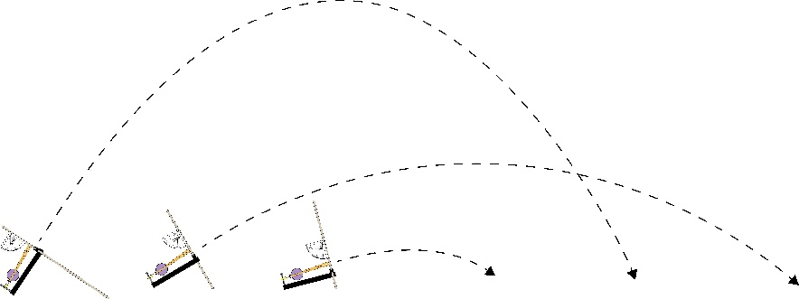

**Adjust** your launcher’s **angle** size three times,  
taking three shots for each angle.



**Small**

**Medium**

**Large**

< 30˚

30˚-60˚

> 60˚

*Take your best shot!*

**Graph** the distance each shot landed.





**Y-Axis Angle˚**

**X-Axis** **=** **Distance in Meters**

1 2 3 4 5 6 7 8 9 10

**Misfire** (Outlier)

**Draw** a **curve** or **line of best fit**that follows (fits) your data’s path.

|  |  |  |
| --- | --- | --- |
| **Sample Data** | | |
| **25˚** | 2 m | 2 m |
| **50˚** | 4 m | 5 m |
| **70˚** | 8 m | 2 m |

Some shots misfire.   
These **outliers** are   
too far from the line   
of best fit to include.

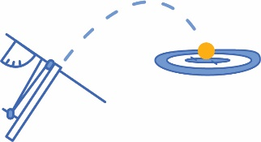

**Curve of Best Fit!**





This angle prediction **should** hit the target distance. If it doesn’t   
land after three shots,   
*launch and graph the   
line of best fit again.*

**Angle Prediction**



**Y-Axis Angle˚**

**X-Axis** **=** **Distance in Meters**

1 2 3 4 5 6 7 8 9 10

**Mark** the target   
distance with   
a **line|**

Using the graph, **predict** which angle will hit a **target distance**. Draw a **line |** from the target distance up until it crosses the curve of best fit – your **angle prediction**.  
  
**Launch** with the predicted angle.  
Repeat with more predictions –   
**refine** the line/curve of best fit!

**Remember!** Each   
time you re-design your launcher, make   
another graph.   
*New designs need   
to test new data.*

