Name: _______________________________________________________ Set: ________ Date: ________



Make sure you have built an example **Projectile Launcher** before starting this lab. Find the Build Guide at teachergeek.com/learn

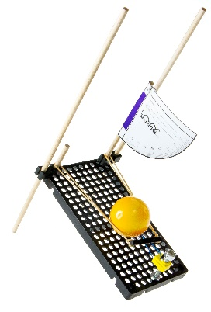

**[](https://teachergeek.com/collections/secondary-schools-camps/products/ping-pong-ball-launcher-projectile-launcher?variant=344626559)**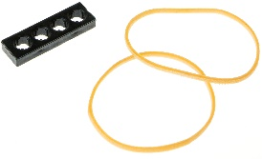

*Tape*

*Protractor*

*Ping Pong Balls*



*Target Materials*

*Launcher*

*Extra Rubber Bands*



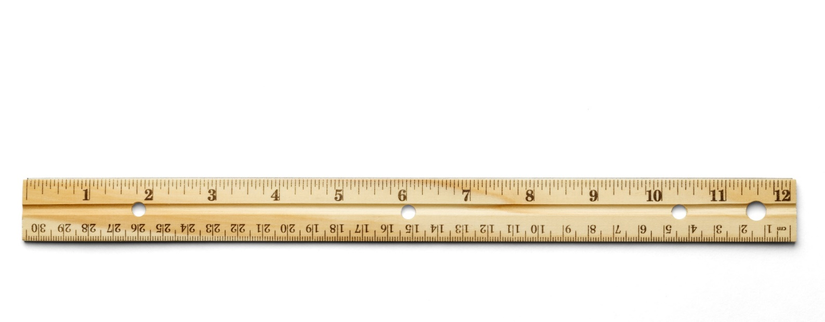



**Protractors** measure **angles**. Your flat semi-circle measures up to 90˚.  
Use your TeacherGeek protractor to answer the questions below.

In science, we measure **data** to collect, compare and analyze.  
So many tools help us measure – rulers, scales, even our eyes!  
List other “stuff” we can use to measure:

_____________________________________________________________________

_____________________________________________________________________

**Collect**

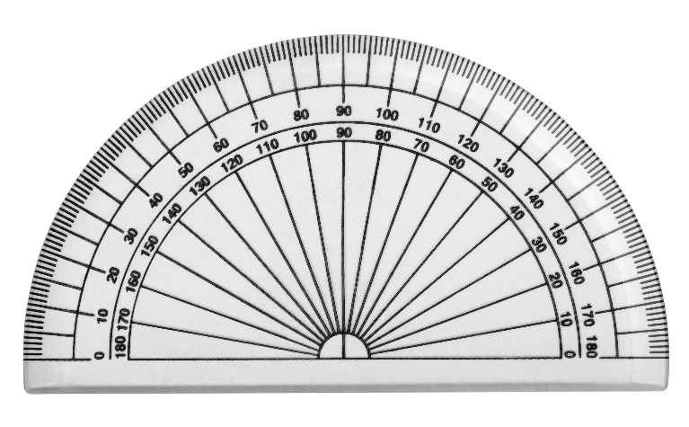

How many degrees˚ is the *widest angle*   
the TeacherGeek protractor can measure? ______________

**A**

**B**



TeacherGeek Protractors



**A**

**B**

An **acute** angle is ***less than*** ≤ 90˚.  
An **obtuse** angle is ***greater than*** ≥ 90˚.  
A **right** angle is **exactly** = 90˚.



Angle **A** is a(n) __________________

Angle **B** is a(n) __________________

Angle **C** is a(n) __________________



**C**



Shots that land in the   
***same*** place each time.

**Precision** is a characteristic of scientific measurement.  
Precise data is reliable and **consistent** (repeatable).

**Compare**



Shots that land in the   
***center*** of a target.

**Accuracy** is another feature of scientific measurement.  
Accurate data is close to the **actual** (or predetermined) result.

|  |  |  |
| --- | --- | --- |
| **Circle** whether the targets below are **accurate**, **precise**, or **neither**. | | |
|  |  |  |
| **Accurate** | **Accurate** | **Accurate** |
| **Precise** | **Precise** | **Precise** |
| **Neither** | **Neither** | **Neither** |



*Weighing a textbook &   
getting the same result   
each day, for a week.*



**Precision**

*Tossing darts at a target  
& hitting the bull’s-eye   
(also a great way to win).*



**Accuracy**

Describe how a **precise**, yet **inaccurate**, target would look:

_______________________________________________________________

Describe how an **accurate**, yet **imprecise**, target would look:

_______________________________________________________________

Describe how an **inaccurate**, **imprecise** target would look:

_______________________________________________________________

__________

**A**

**B**

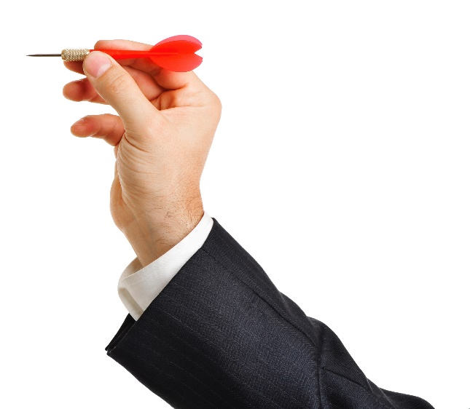

**C**



If your launcher’s **projectile** (ball) went the farthest in the class each shot, but never hit the floor target, would your launcher be precise or accurate?

Why? _________________________________________________________

__________







**Analyze/Interpret**



Using your example launcher, adjust the **angle** of the legs to **70˚**.  
Take three shots, measuring the **distance** each landed.



Were the shots **precise** (landing in the same place?)

__________________________________________

**Sample Average:**  
2 **+** 2.2 **+** 2 **=** 6.2 meters  
6.2 **÷** 3 **=** 2 meters





Find the **mean** (average) of the **70˚**   
launch angle by adding each shot’s   
distance together and dividing by three.

____ + ____ + ____ = ____ ÷ 3 = ________

**Mean**



?





Now, adjust the **angle** of the legs to **10˚**.  
Take three shots, measuring the **distance** each landed.

Find the **mean** (average) of the **10˚** launch angle.

____ + ____ + ____ = ____ ÷ 3 = ________



**Mean**



The **range** (difference between the lowest and highest values) is useful for **estimating distance** and **labeling graphs**.



**Subtract** the **10˚** mean from the **70˚** mean -  
this is the **range** of your launches.

_______ - _______ = _______

**Range**



**Estimate** (guess) where a launch from **40˚** would land, based on the mean(s) and range above.

___________________________



**Hint:** the distance would be **between** the 10˚ and 70˚ mean.

0

*You need a partner (or two)   
to complete these questions.*

*An experiment’s data needs to be reproduced by different people, at   
different times, to be truly* ***precise****.*

Test if your launcher is precise and accurate through **repeatability** and **reproducibility**.



Adjust the **angle** of your launcher’s legs to **45˚**.  
Take three shots, measuring the distance each landed.

Were the shots **precise** (landing in the same place?)

__________________________________________



If your shots are **precise**,   
then the data has **repeatability**.

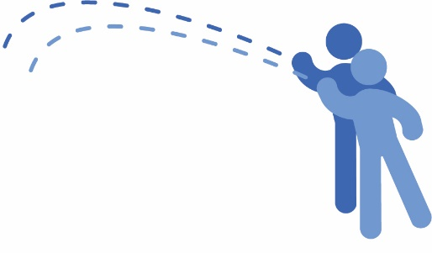****

Have another person take three more shots, with   
the same **angle** and from the same **starting point**.

Were the shots **precise** (landing in the same place?)

__________________________________________

Did the shots land in the same place as **Question 10**?

__________________________________________





*Nice!*

If their shots are **precise**, and match your data from before, then the data has **reproducibility.**



**►**

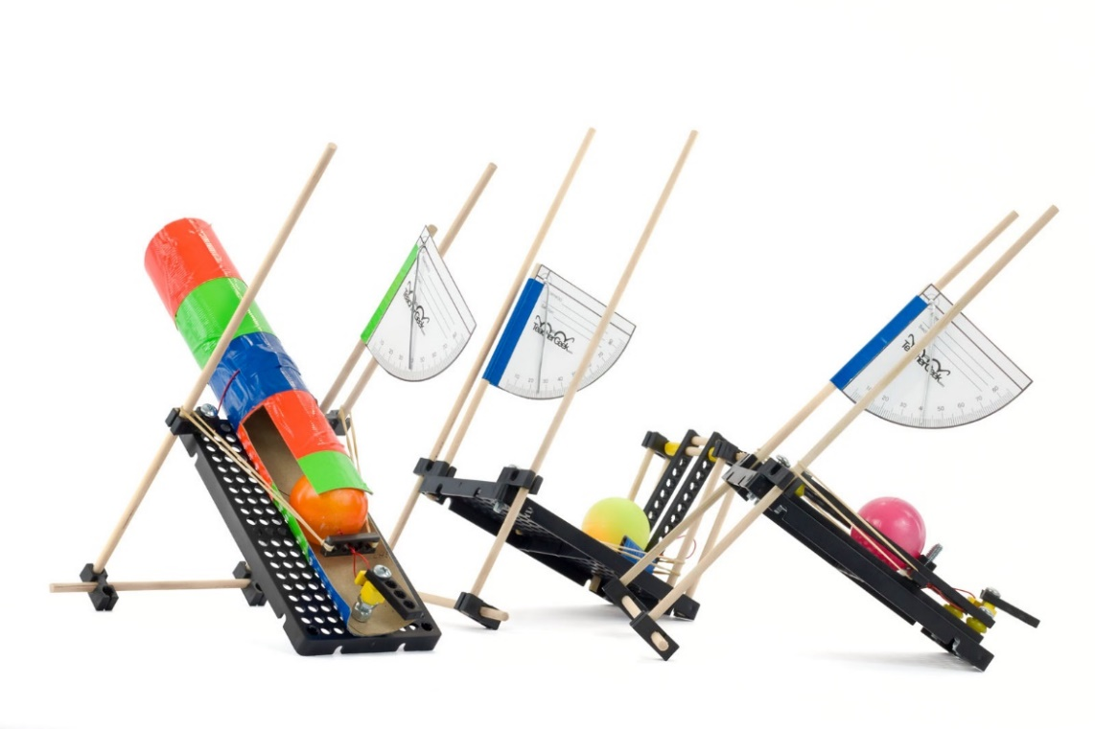

**Nice Shot!**

Repeatable, reproducible data helps to better re-design your launcher – accurate shots are a **HUGE** advantage in competition!

If you are going   
to do the optional   
*Launcher Challenges*,   
now’s the time!

Documents at **teachergeek.com/learn**

