­­­­ ­­­

**Use the power of air or water to create your very own animatronic pal!**

TRUE

STEM

STEAM

v

CHOMP!

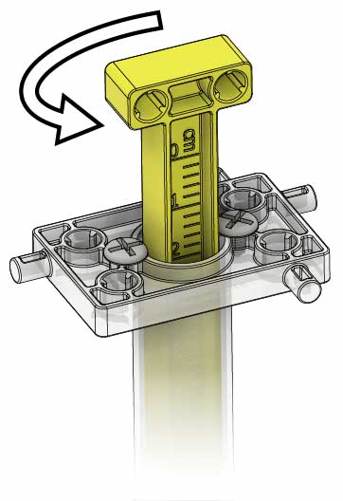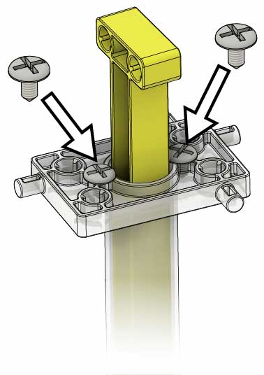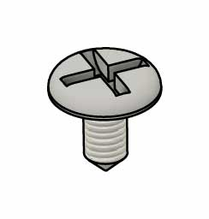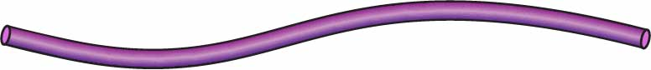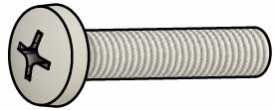

**Assemble these before the activity.**  
An adult may need to help with this step.

Twist the piston as shown.

Turn the cylinder screws into the holes on top of each cylinder.

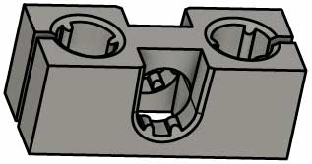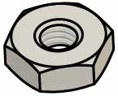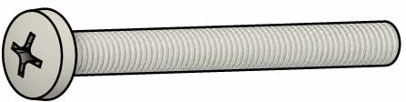

**Picture**

**Name**

**Qty**

**Screws**25 mm (1 in)  
SKU 1821-22

**Screws**50 mm (2 in)  
SKU 1821-27

**Nuts**#10  
SKU 1821-25

**Wire Section**13 cm (5 in)

**Cylinders**14 ml  
SKU 1821-53

**Tubing**38 cm (24 in)  
SKU 1821-51

**Blocks**38 cm (15 in)  
SKU 1821-34

**5**

**4**

**5**

**4**

**2**

**1**

**2**

**Half Strips**15 cm (6 in)

**6**

**Cylinder Screws**SKU 1821-21

**6**

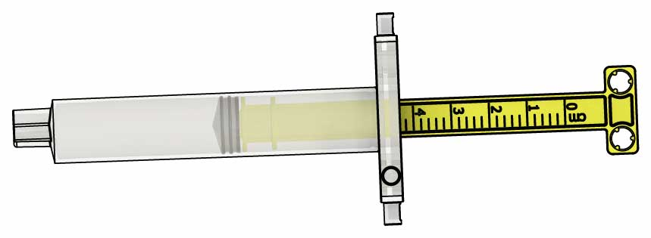

# Supplies

Pet Parts

These are the parts you need to build one pet, plus some extra parts for your own unique designs.

* **Scissors**
* **Container** **of** **Water** (optional)
* **Decorations**   
  (optional)
* **Recycling** **Bin** **Materials** to incorporate into   
  your designs

Materials You Supply

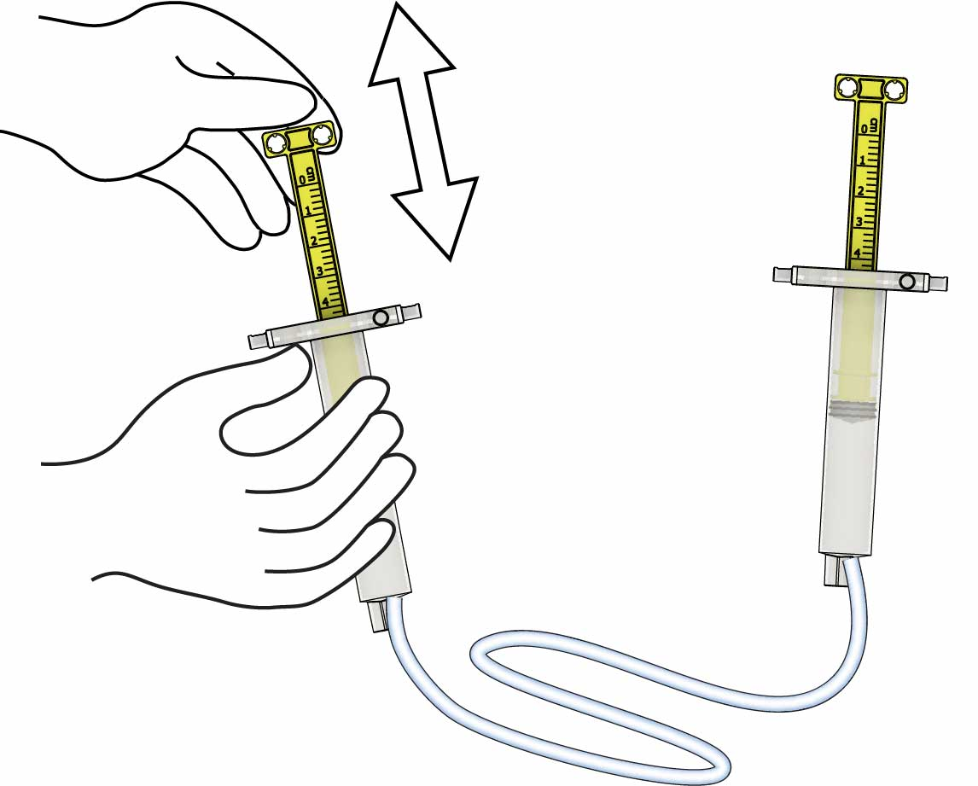

?

**Gently push & pull** on both cylinders to unstick them.

Not Moving?

**The cylinders will power your remote-controlled pet!**

# 1

**Connect** an **open** **cylinder** to a **closed** **cylinder** with **tubing**.

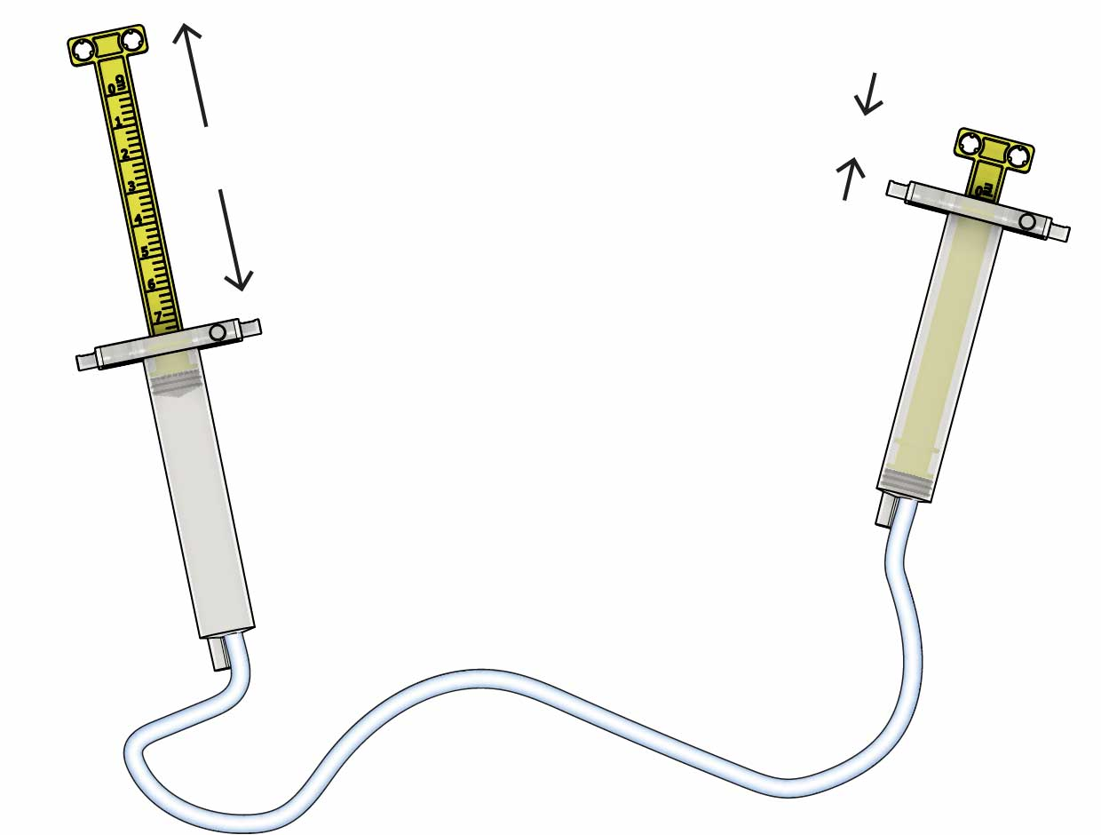

Open

Closed

Always use one open and one closed cylinder!

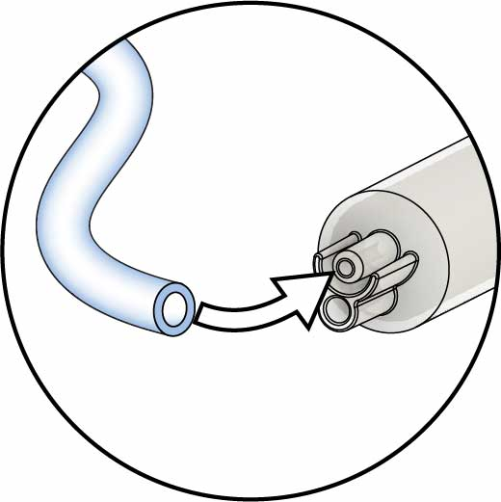

For **smoother operation**, you can **fill** your **cylinders with water** (optional).

Download the [**Fill Guide**](https://teachergeek.org/powered_pets_cylinder_fill_guide.docx)   
at[**teachergeek.com/**](http://teachergeek.com/claw)**pet**

**Test it!** What happens when you push and pull on a cylinder?

# 2

# Assemble Your Cylinders

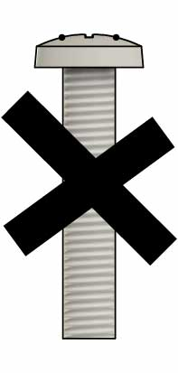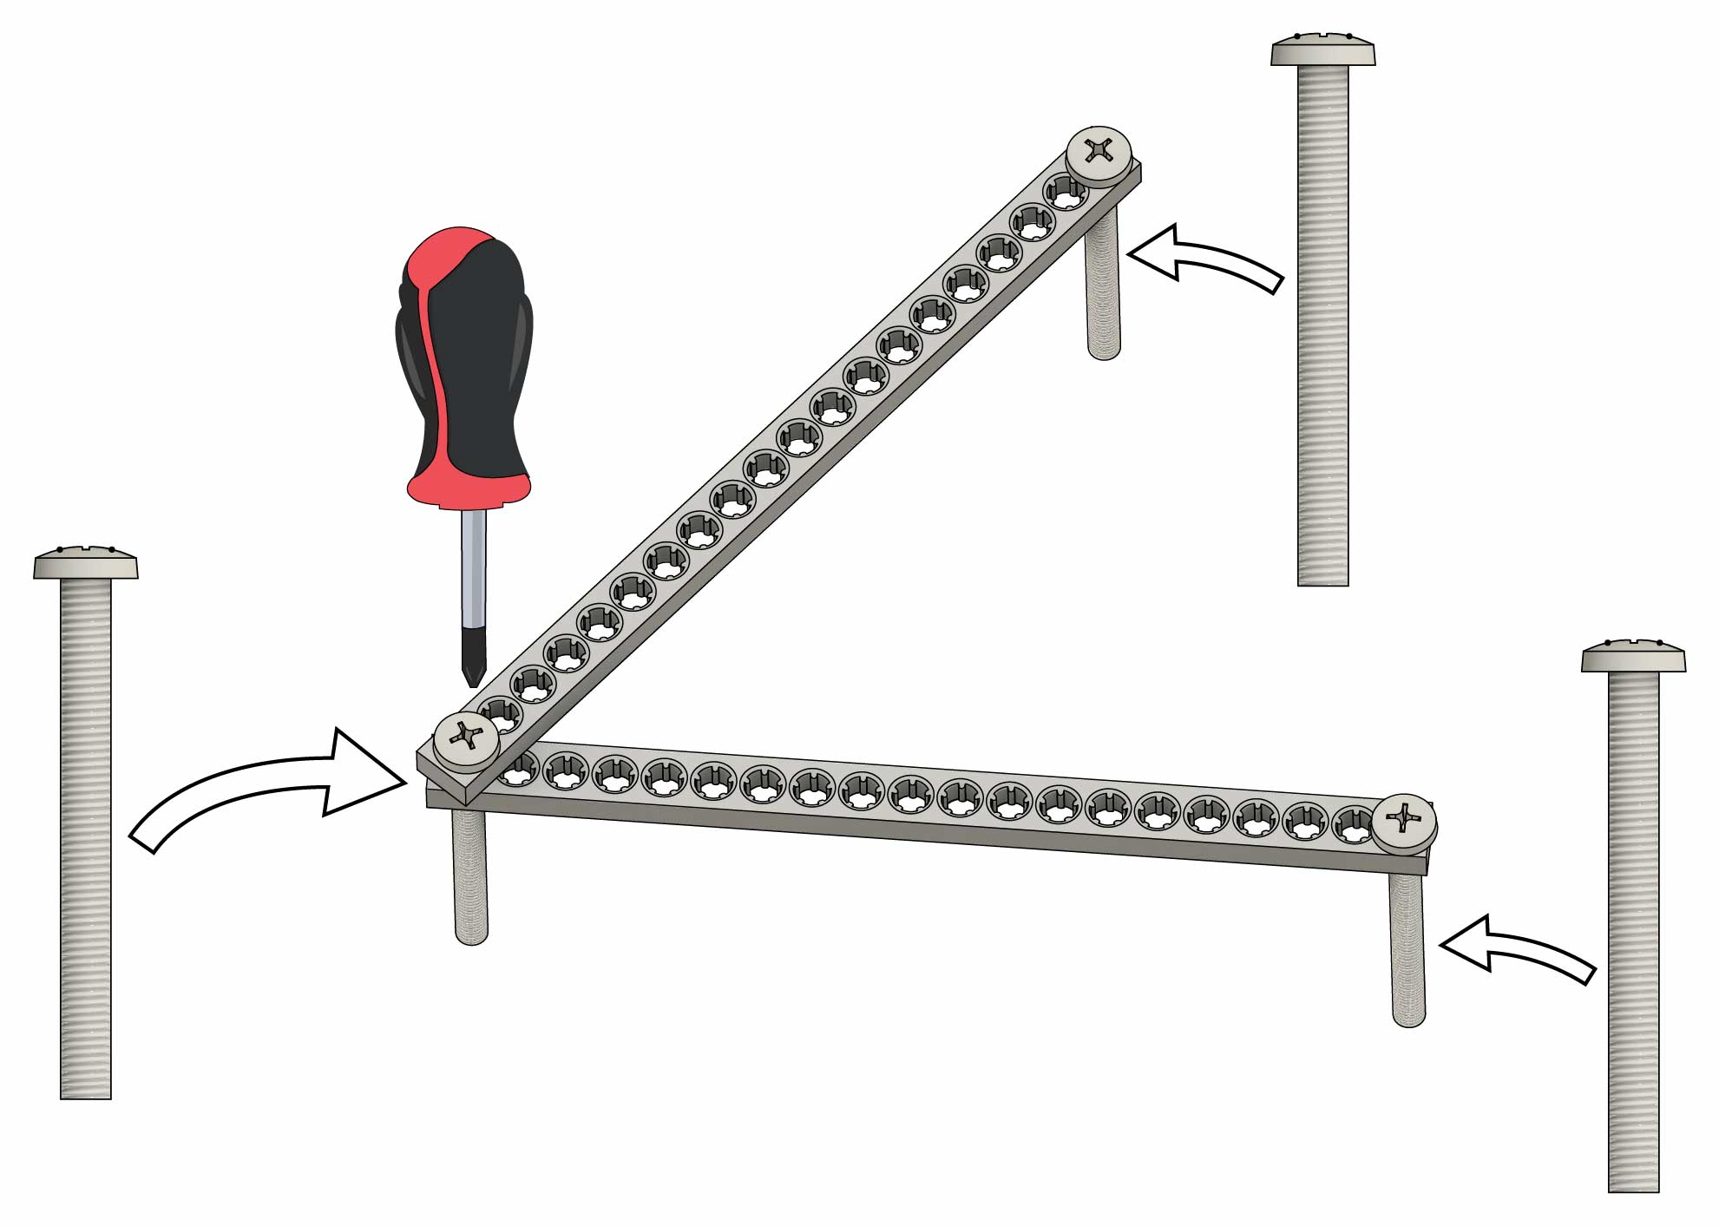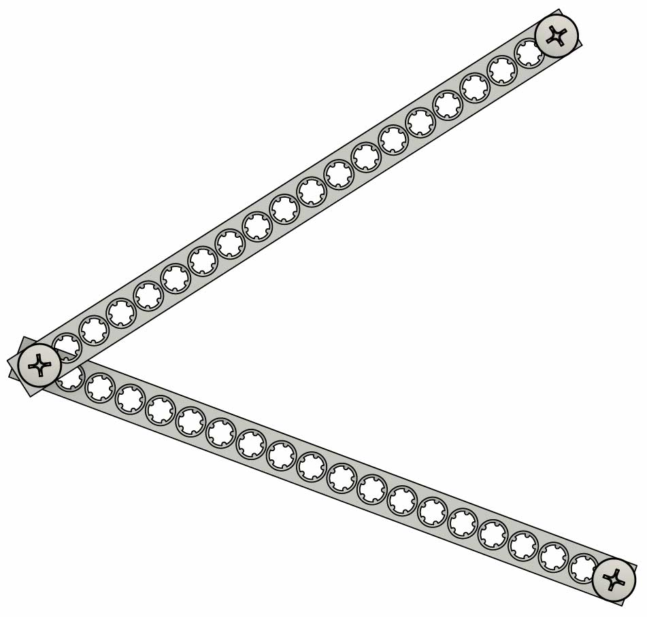

Screw in two more **50 mm** (2 in) **screws.**

# 4

Attach **two half strips** using a **50 mm** (2 in) **screw**.

CHOMP!

CHOMP!

**You just made a mouth.** Make it eat something!

# 5

# Make a Mouth

# 3

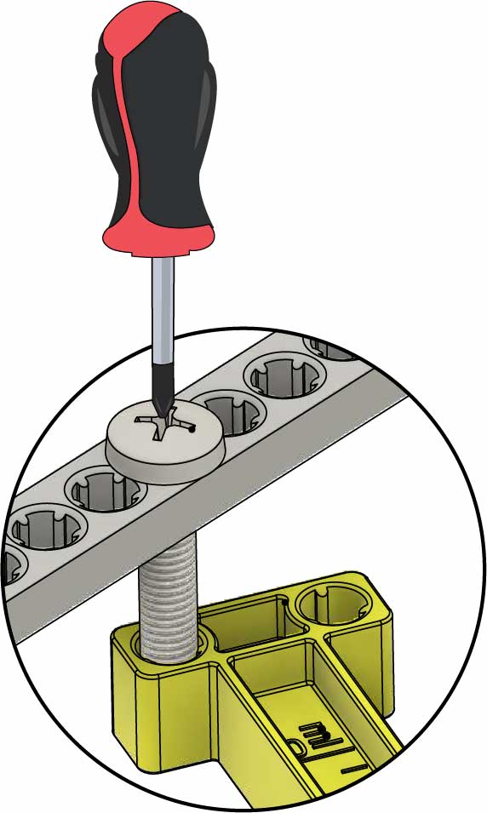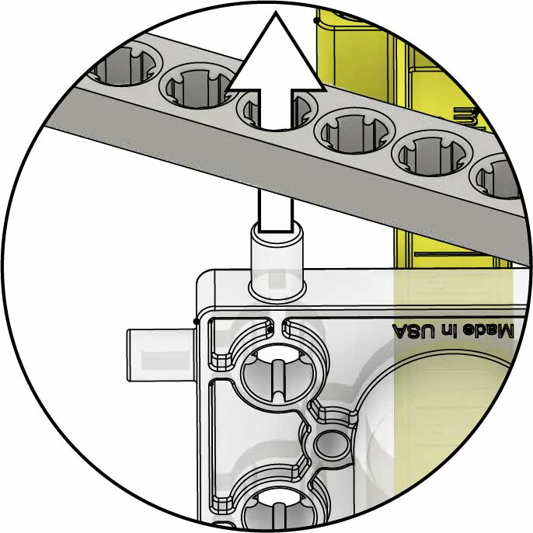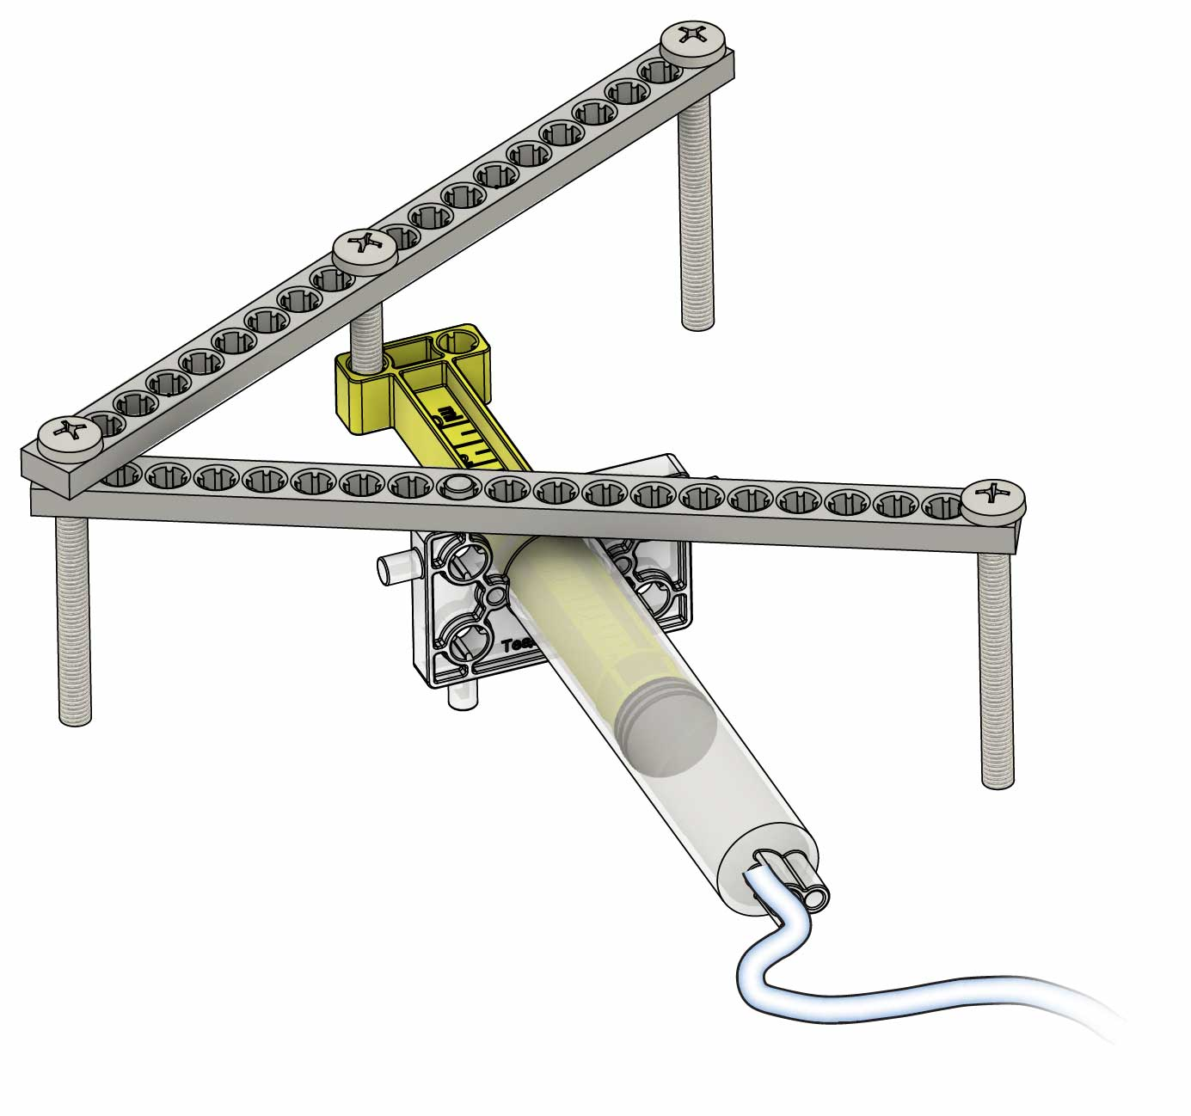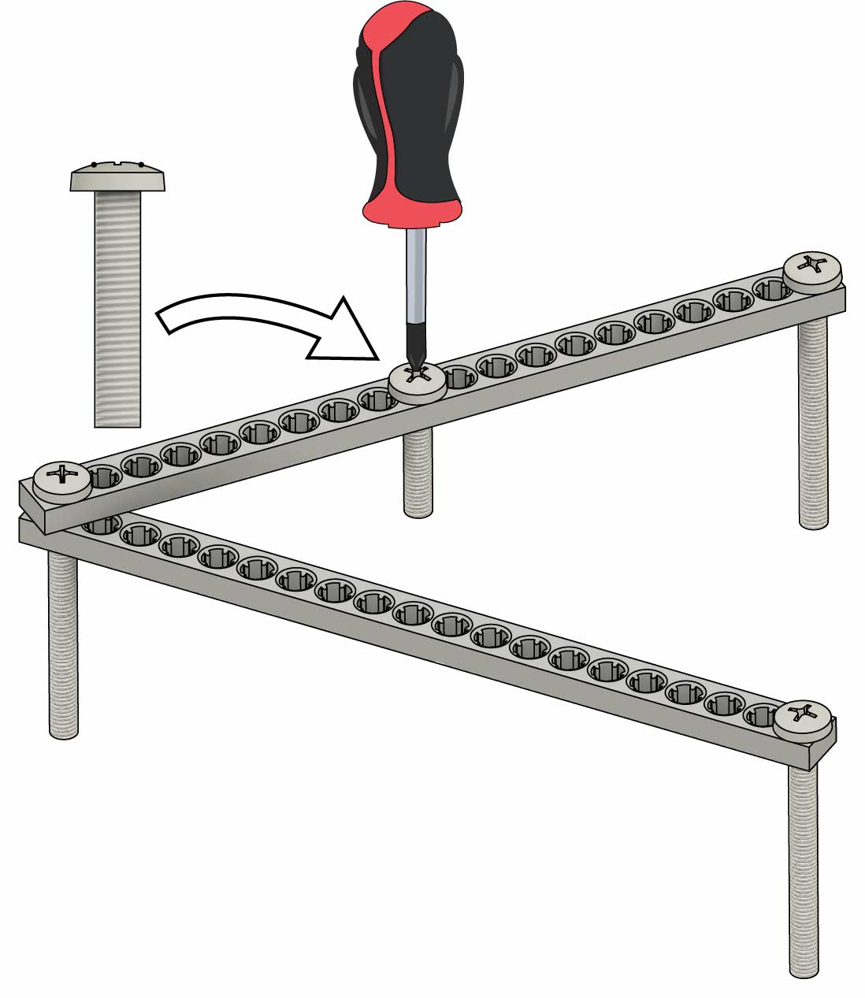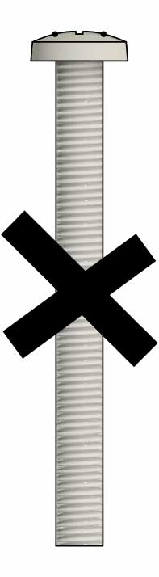

**Screw** the **cylinder** ontothe **screw** from **Step 6.**

# 7

# 8

**Push** the **cylinder pin** intothe **half strip.**

# 6

**Turn** a **25 mm** (1 in) **screw** into the   
**half-strip** (near   
the middle).

# Remote-Controlled Mouth

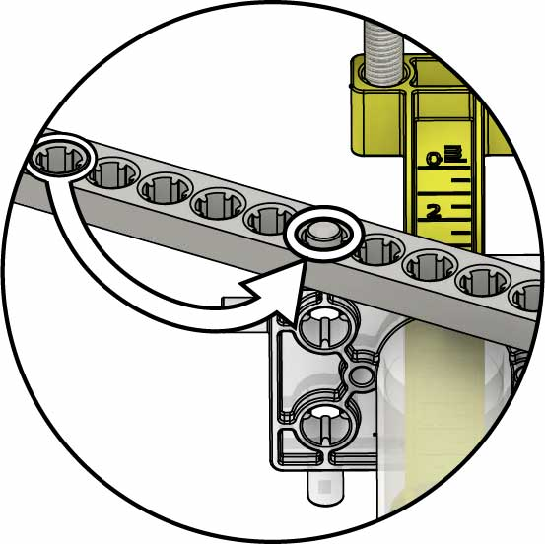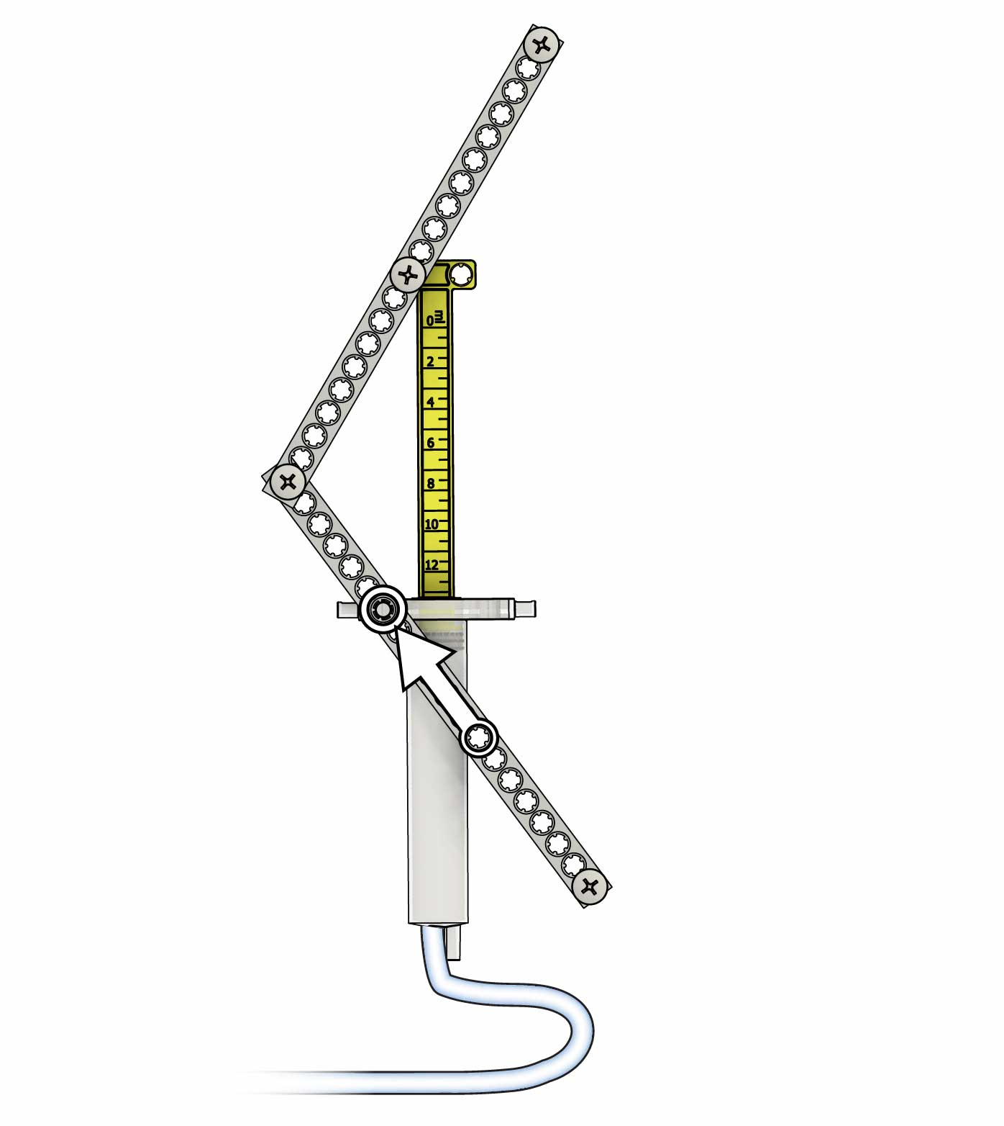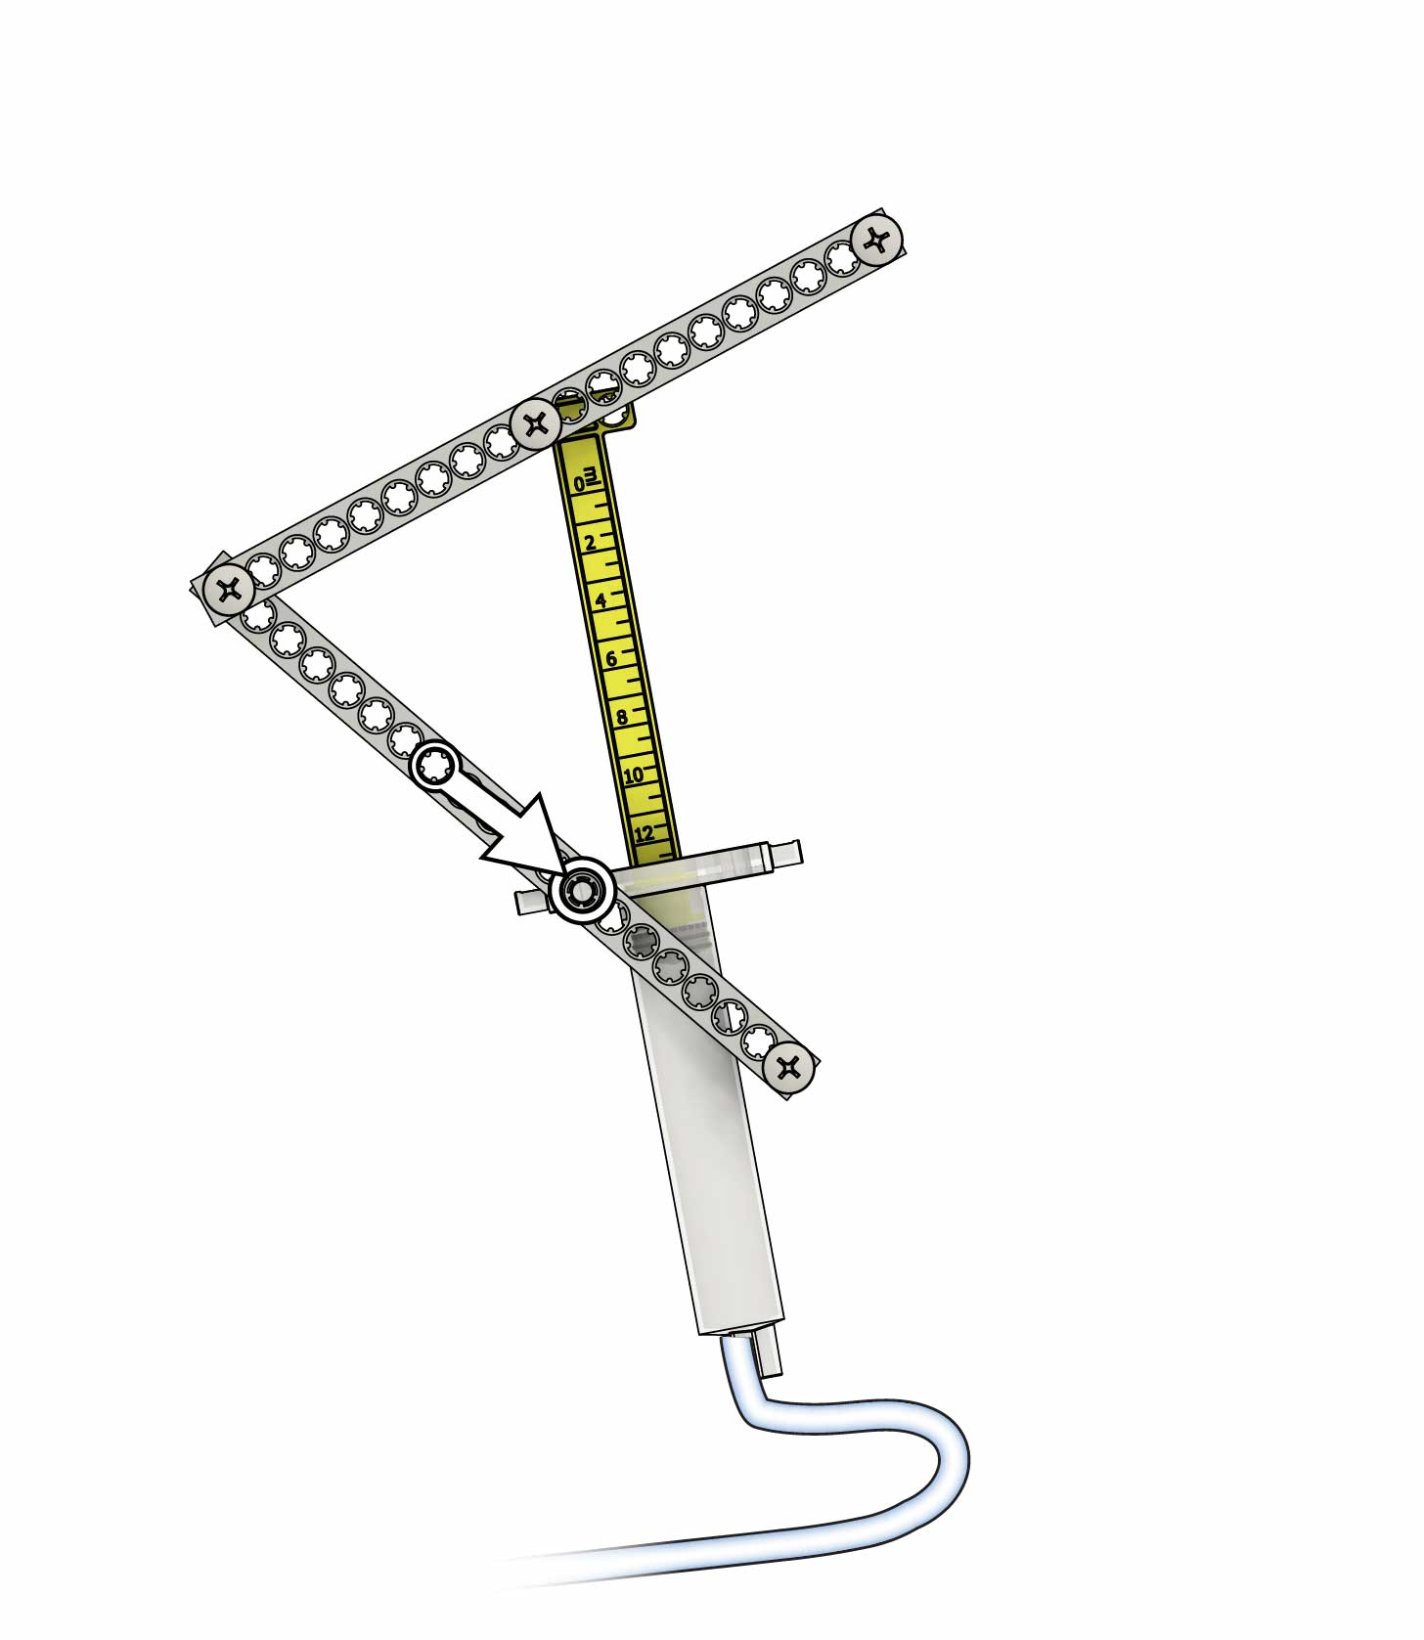

CHOMP!

CHOMP!

**Further Forward**

**Further Back**

**You can put the pivot wherever you want!**

**Move the cylinder pin**.   
How does it change how your mouth moves?

# 10

**Gently push & pull** on both cylinders to unstick them.

Not Moving?

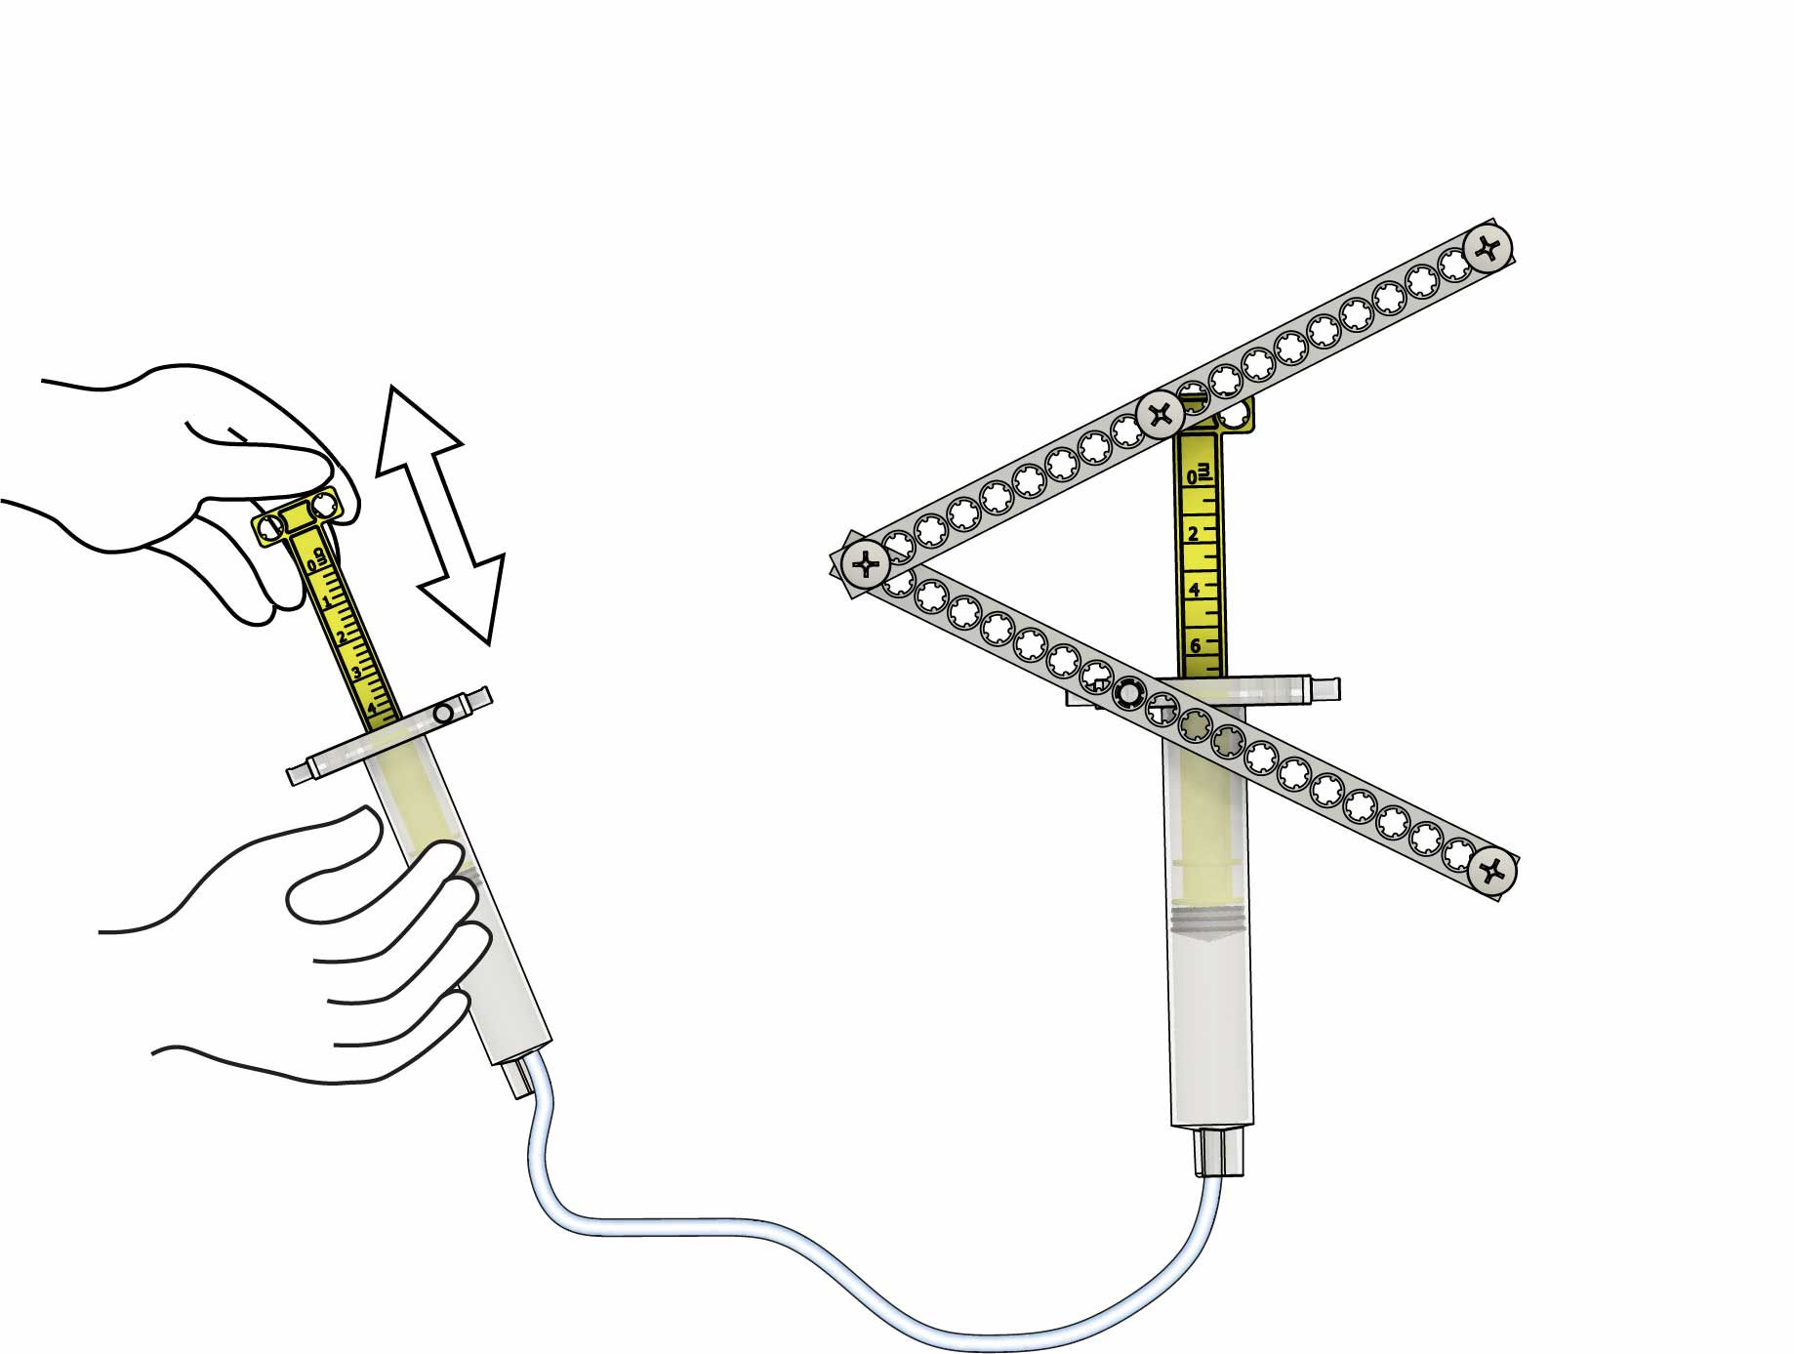

**Test** your remote-controlled mouth!

# 9

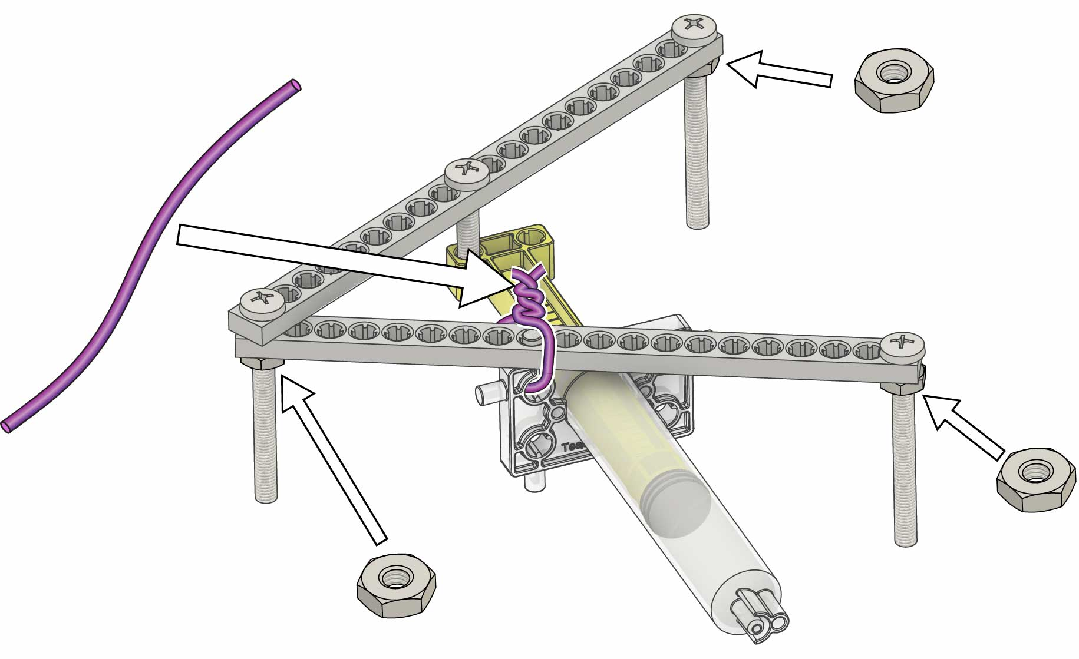

# 14

**Make it jump!**

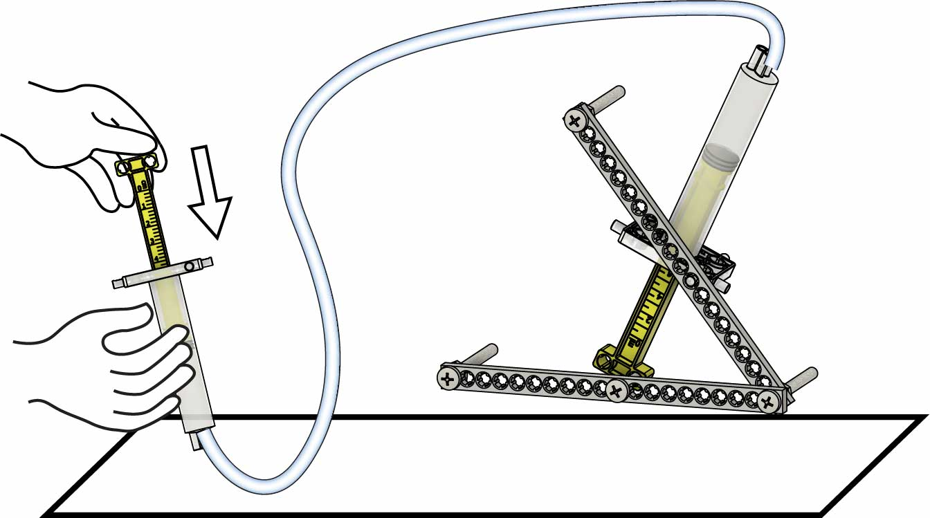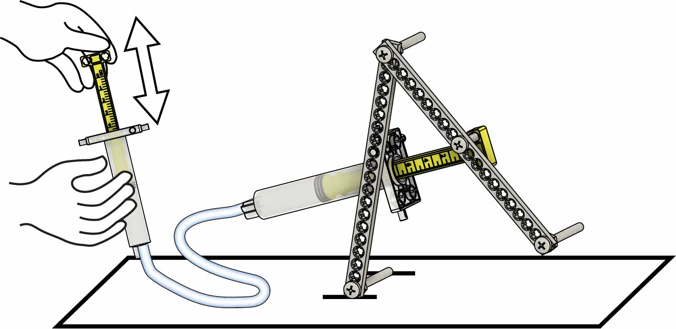

# Make It Walk & Jump!

# 12

**Twist** a **nut** onto your three longest **screws**.

**Make it walk!**

# 13

# 11

**Twist wire** to hold the cylinder pins in the half strips.

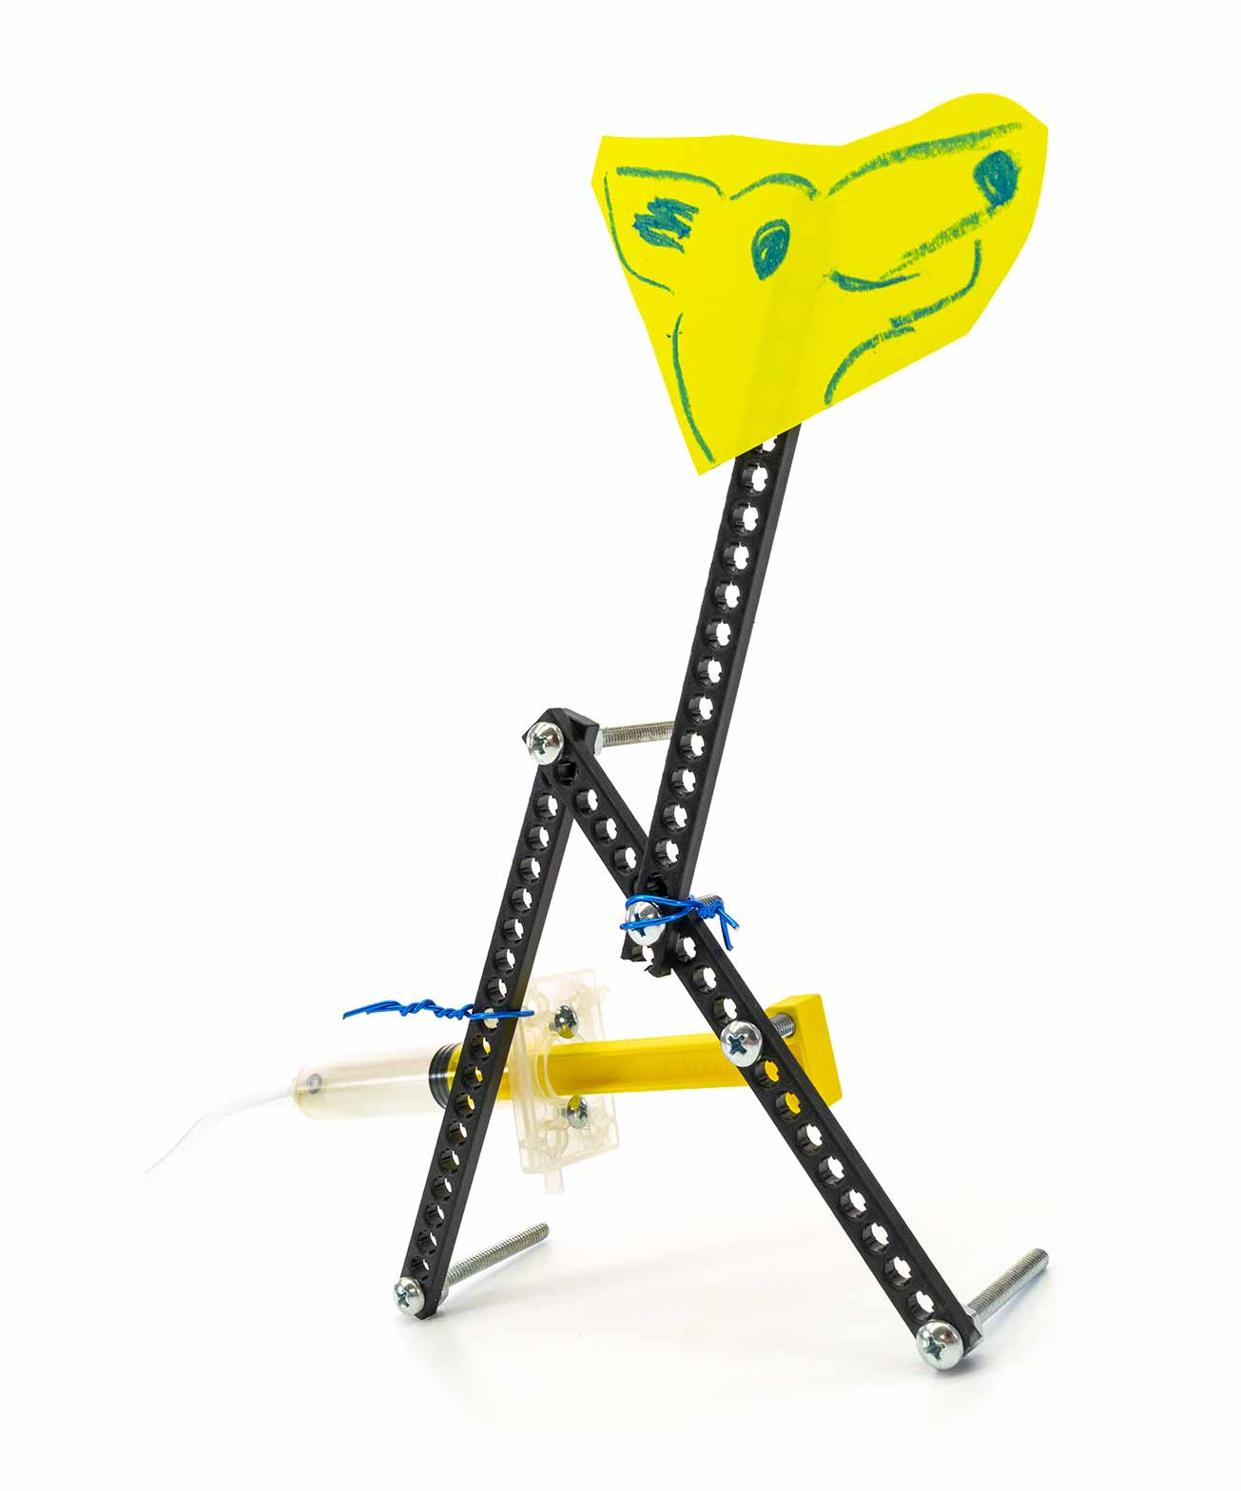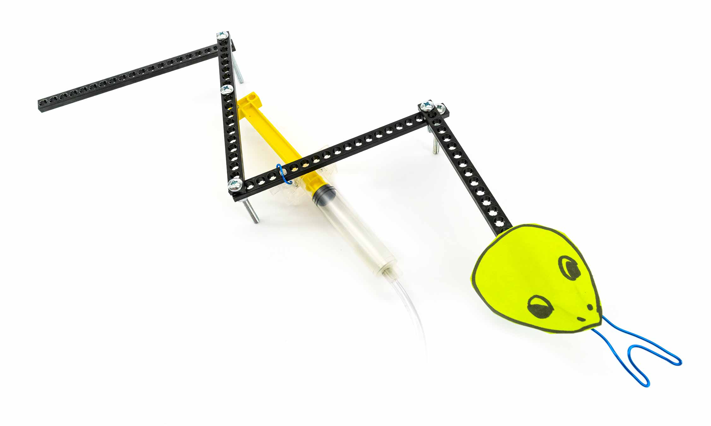

**Walk** like a **Giraffe?**

**Fly** like a **Bird?**

**Slither** like a **Snake?**

# Pet Challenge

Rebuild your pet into as many different animals as you can!

Can you make your pet…