**You can choose to fill your cylinders with either water or air**. Water allows for smoother operation, while air is more abrupt (and easier).

For **air-filling instructions**, see the [**Powered Pets Go Guide**](https://teachergeek.org/powered_pets_go_guide.docx).

# 2

# 1

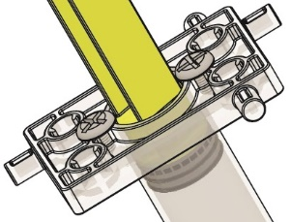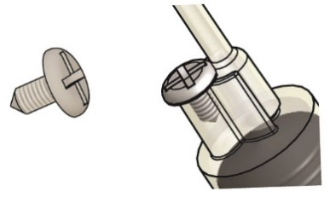

**Cylinder Screw**

Insert two cylinder screws into each cylinder to prevent the pistons from pulling out (if you didn’t already).

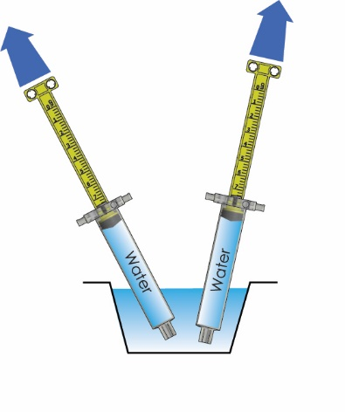

Fill both cylinders with water:

A. Push cylinder piston in

B. Place cylinder   
tip underwater

C. Pull piston back   
to completely fill   
with water

# 3

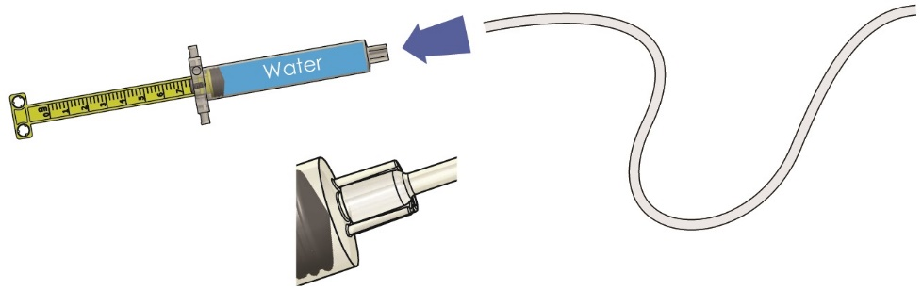

Connection Close-up

Attach tubing to just one filled cylinder.

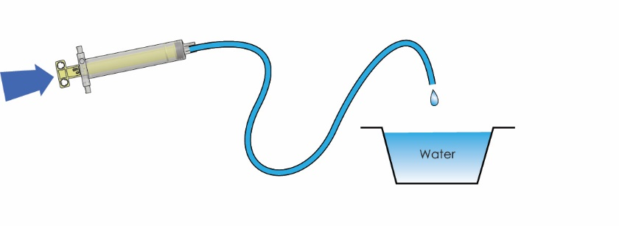

Water

Fill the tubing completely with water by pushing the piston completely in.

# 4

# 6

# 5

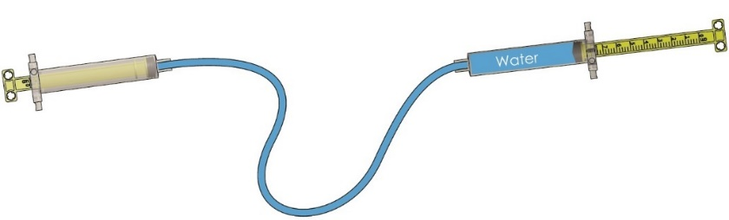

Water

Attach the water-filled tubing to the remaining water-filled cylinder from Step 2.

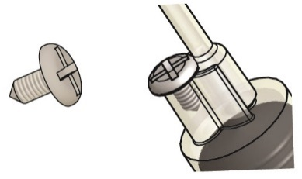

**Cylinder Screw**

Insert a cylinder screw in each cylinder to prevent the tubing from pulling off.

Your cylinders are filled! You can get back to making your pet.