Name:__________________________________ Date:__________________

Lab Supplies

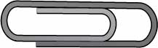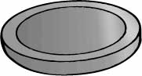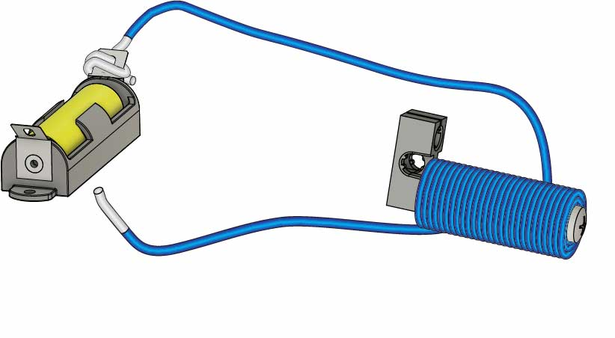

Ideas: *(what else can you test?)*

* Staple
* Chair Leg
* Quarter

**Objects To Test**

**Built Electromagnet**

* Electromagnet Wire
* Doorknob
* Paper Clip

Build your electromagnet using the[**Go Guide**](https://teachergeek.org/pick-up_stick_go_guide.docx),available at[**teachergeek.com/pickupstick**](https://teachergeek.com/pickupstick)

Test Stuff!

**Magnetic** **objects** will attract or **stick** **to** **your** **electromagnet**. Pick some **objects** from the list above or find your own. Then test them to see if they’re magnetic.   
Record the results below.

|  |  |  |  |
| --- | --- | --- | --- |
| Object | Predict: **Will it  be magnetic?** | Test: **Is it magnetic?** | Material: **What’s it made of?** |
|  |  |  |  |
|  |  |  |  |
|  |  |  |  |
|  |  |  |  |
|  |  |  |  |
|  |  |  |  |
|  |  |  |  |
|  |  |  |  |
|  |  |  |  |

Conclusion

What was **similar** about the materials that **were magnetic**?

# 1

__________________________________________________________________________

__________________________________________________________________________

__________________________________________________________________________

__________________________________________________________________________

# 2

What was **similar** about the materials that **weren’t magnetic**?

__________________________________________________________________________

__________________________________________________________________________

__________________________________________________________________________

__________________________________________________________________________

# 3

How can you **predict** if an object will be **magnetic**?

__________________________________________________________________________

_________________________________________________________________________

__________________________________________________________________________

__________________________________________________________________________