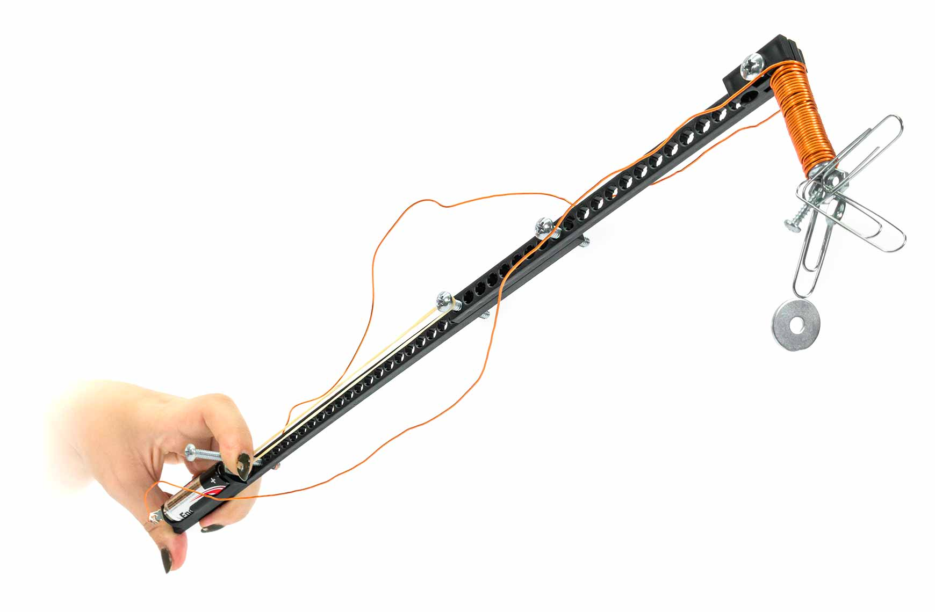

You Are Here

Start here! Build your Crane,   
evolve your design, and begin   
the In-The-Bucket Challenge!

Optional Lab

Optional Challenges

[-Magnetic Materials Lab   
 (Ages 8+)](https://teachergeek.org/pick-up_stick_lab_magnetic_materials.docx)

-Space Mining Challenge*  
-[Clip Hanger Challenge](http://teachergeek.org/electromagnet_hanger_challenge.docx)  
-[Super Sort Challenge](http://teachergeek.org/electromagnet_sort_challenge.docx)

Go Guide

*See Page 9

**Choose how you would like to complete this activity.  
Download documents & videos at** [**teachergeek.com/pickupstick**](https://teachergeek.com/pickupstick)

**Learn about electricity and magnetism by designing   
and building your very own Pick-Up Stick!**

TRUE

STEM

STEAM

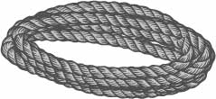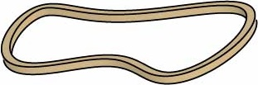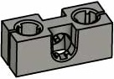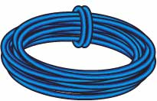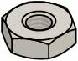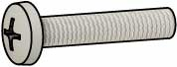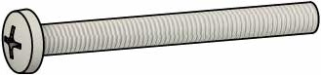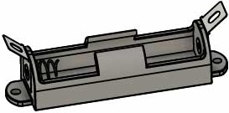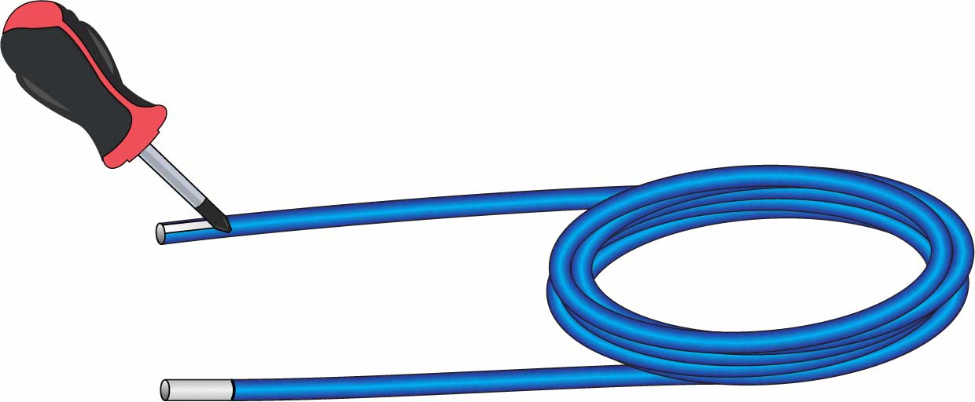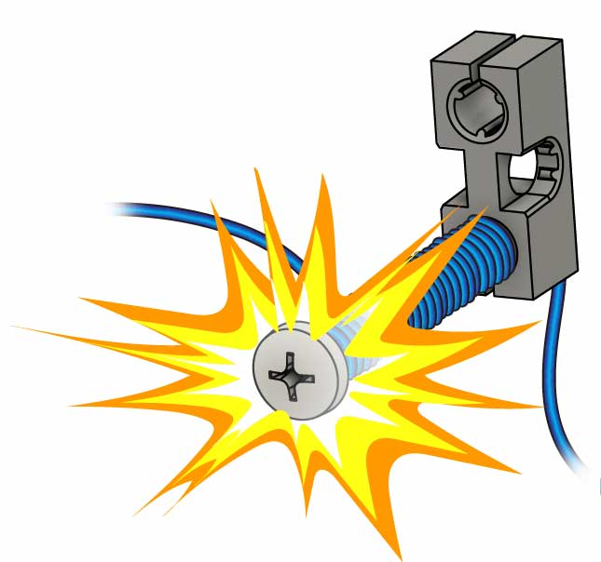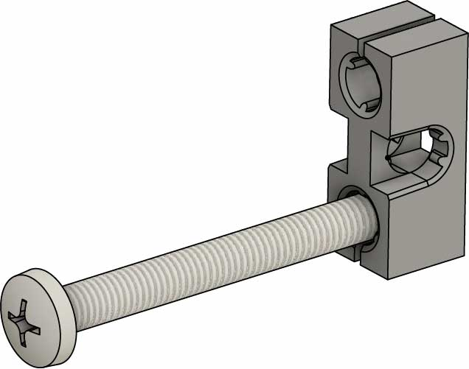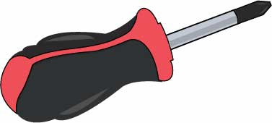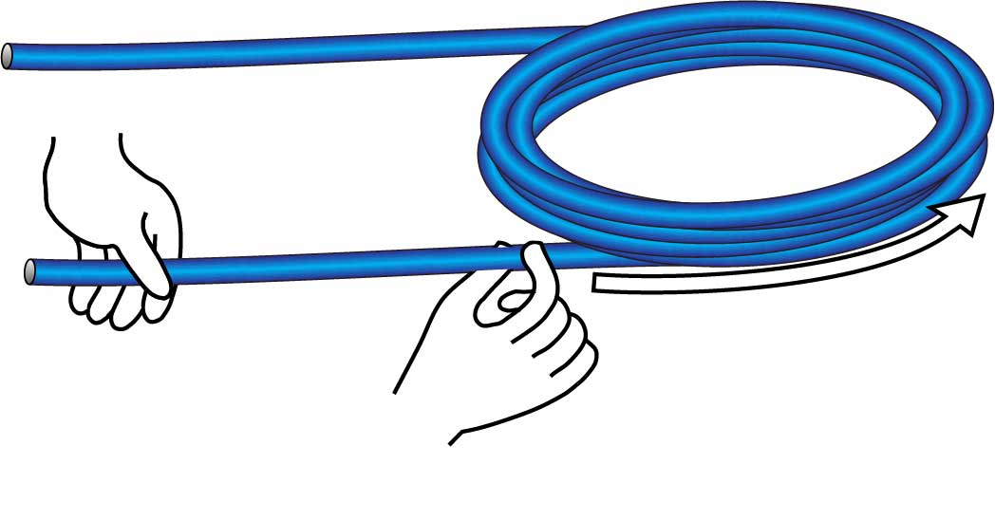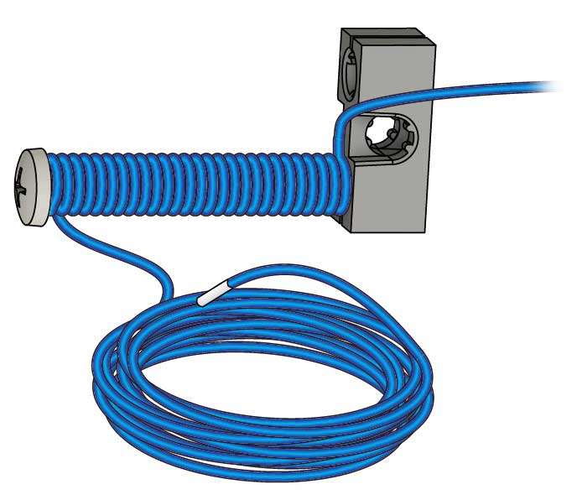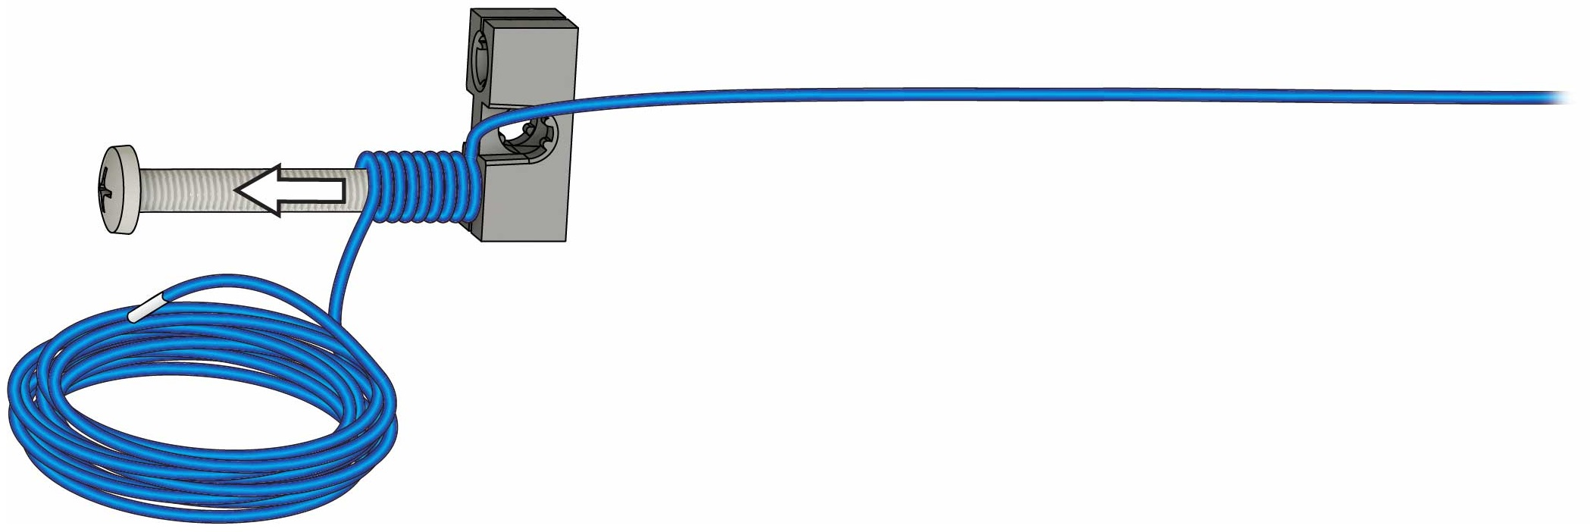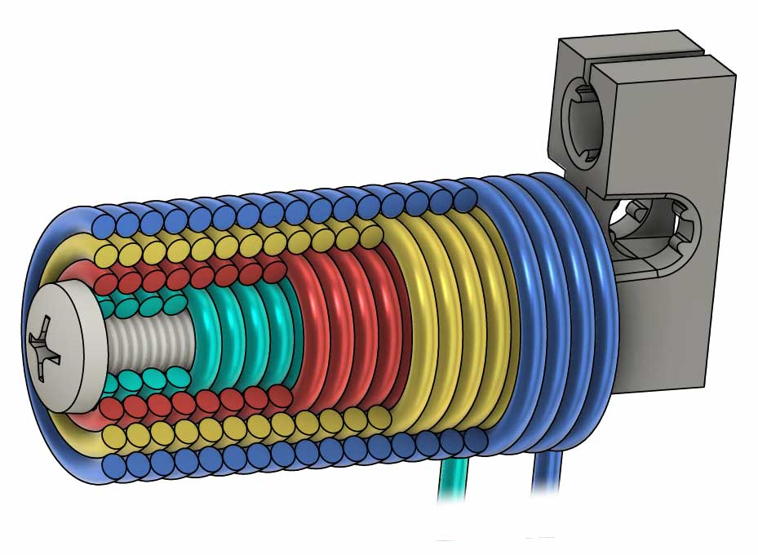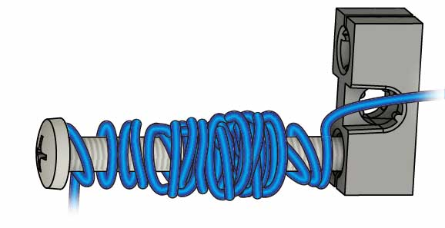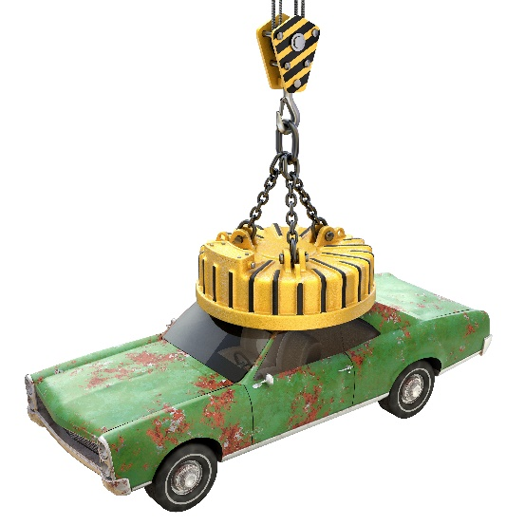

Pick-up stick Parts

Materials You Supply

* **Phillips Screwdriver**
* **Pliers** (optional)
* **AA Battery**
* **Bowl**
* **Aluminum Foil** (optional)
* **Any two of: rice, beans, small candies, crumpled paper, etc.** (for challenge on Page 9)
* **Recycling Bin Materials**

Maker Cart Users: We recommend using Aluminum Wire for this activity (not included with Maker Carts until summer 2021).

**Picture**

**Name**

**Qty**

**Strips**30 cm (1 in)  
SKU 1821-31

**3**

**Blocks**SKU 1821-34

**Wire Roll**5 m (16.4 ft)  
SKU 1823-47

**Screws**25 mm (1 in)  
SKU 1821-22

**Screws**50 mm (2 in)  
SKU 1821-27

**Mini-Hub Screws**16 mm (5/8 in)  
SKU 1821-19

**Battery Holder**Single AA  
SKU 1821-62

**Rubber Bands**Small  
SKU 1821-39

**Nuts**#10  
SKU 1821-25

**2**

**1**

**5**

**3**

**4**

**1**

**2**

**5**

**String**60 cm (24 in)  
SKU 1823-47

**1**

These are the parts you need to build one Electromagnet Crane, plus some extras, so you can make your own unique designs.

# Supplies

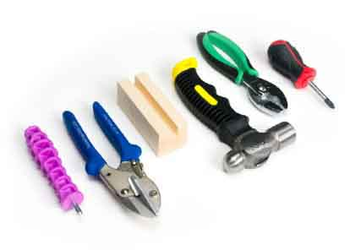

Modify materials to make even more creative designs with the **Maker Tool Set**

SKU 1823-84

Optional Tools

**Turn** a **50 mm** (2 in) **screw** into a **block**.

**Your wire and core are ready!** Next, you’ll make them into   
an electromagnet!

**Screw**50 mm(2 in)

**Block**

# 3

Make the Core

**Scrape** **2 cm** (1 in) of **enamel** off **both** **ends** of the wire.

# 2

**Carefully** **uncoil** **both** **ends** of the wire. Don’t tangle it!

# 1

Get your wire and core ready – they’ll become your magnet.

# Prepare the Parts

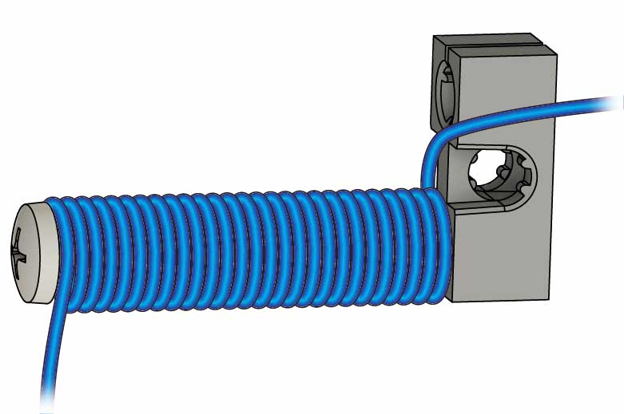

Electromagnets are made by wrapping wire around a magnetic core.

**Wire**

**Core**

Uncoil

Prepare Your Wire

**Scraped**

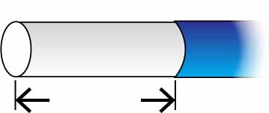

**2 cm**  
(1 in)

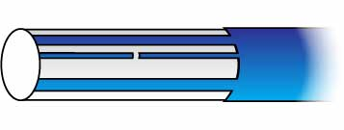

Missed Enamel

**Not Scraped**

**Finished**

**65 cm** (25 in) of **extra wire**

# 4

**Wrap** one layer of **wire** down the **screw**, leaving **50 cm** (20 in) of **extra wire** at the base.

Do you think more wraps will make your magnet stronger or weaker?

4 Layers of Wire

Don’t make your magnet like this…   
**Neat magnets are stronger!**

Your magnet will get four layers of wire wrapping. After you add each layer, you’ll test your magnet.

Neatness Counts!

**Your magnet is ready! Let’s see how much   
it can pick up.**

# Wrap the First Layer

# Test Your Magnet!

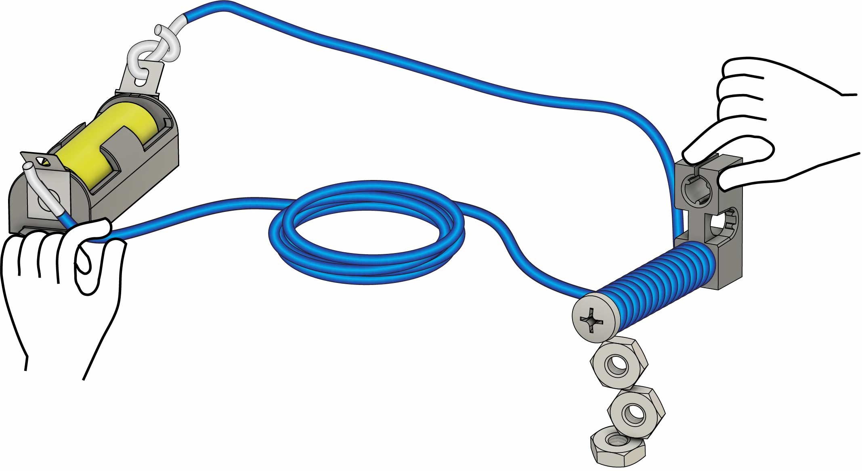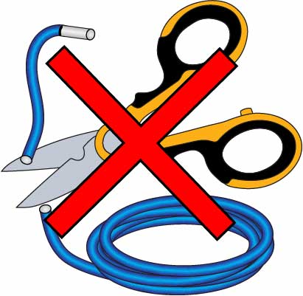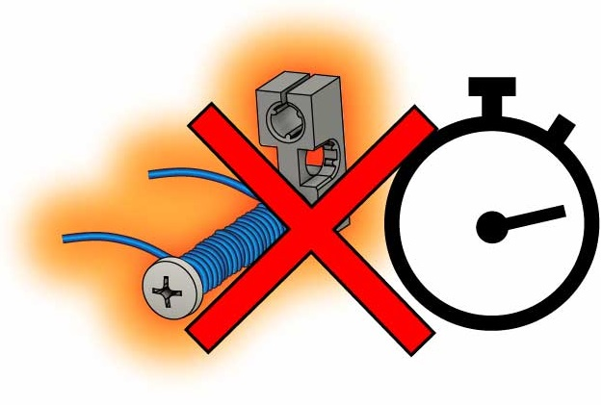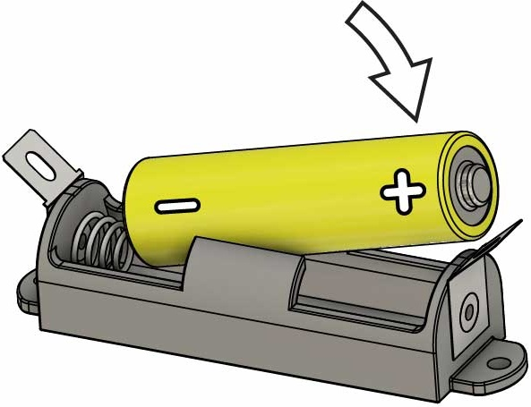

Grab!

65 cm (25 in) side of wire

Twist

Touch

How many nuts can you pick up?

You may see sparks, but you won’t get shocked!

**Don’t leave your magnet on!**

**Don’t cut the wire!**

# 5

# 6

**Hook up your magnet and pick stuff up!**

The wire, battery, and battery holder can get *very* hot.

Do not permanently attach the magnet to the battery, run the magnet continuously, or cut the wire much shorter.

**!**

Don’t Overheat!

Flat side of battery against the spring.

Put the **battery** **into** the **holder**.

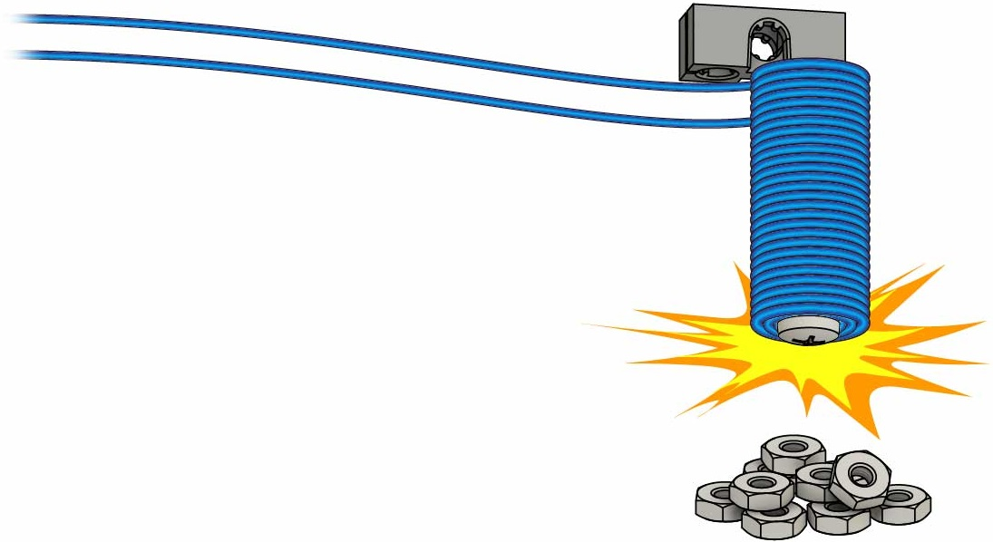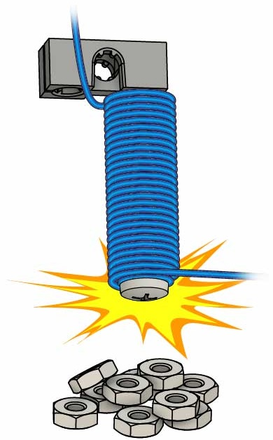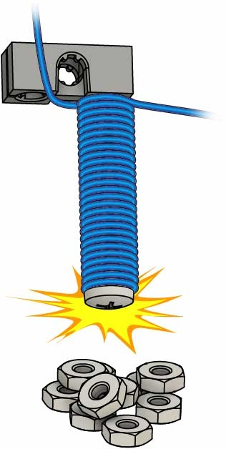



**Want to learn more about magnets?**

Download the [**Magnetic Materials Lab**](https://teachergeek.org/pick-up_stick_lab_magnetic_materials.docx)   
at [**teachergeek.com/pickupstick**](https://teachergeek.com/pickupstick)

**Ages 8+**

How many nuts   
can you grab now?

**Both wires about 65 cm (25 in)**

How many nuts   
can you grab now?

How many nuts   
can you grab now?

# 9

**Wrap** until both **wires** are the **same** **length**, then **test it!**

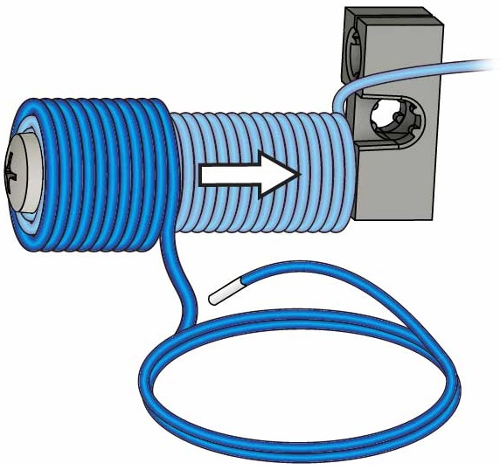

Layer 4

**You’re ready to make an arm for your electromagnet!**

# 8

Wrap a **third layer**, then **test your magnet!**

# 7

Wrap a **second layer**, then **test your magnet!**

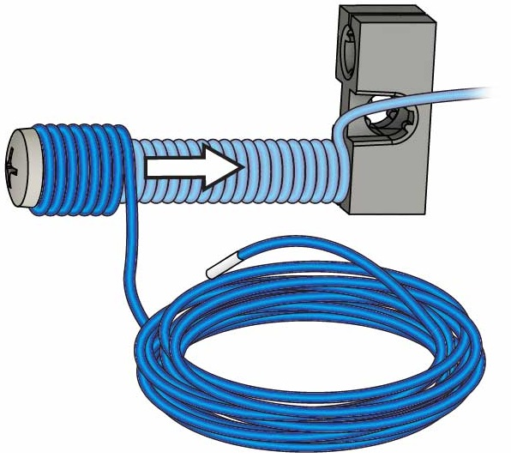

Layer 2

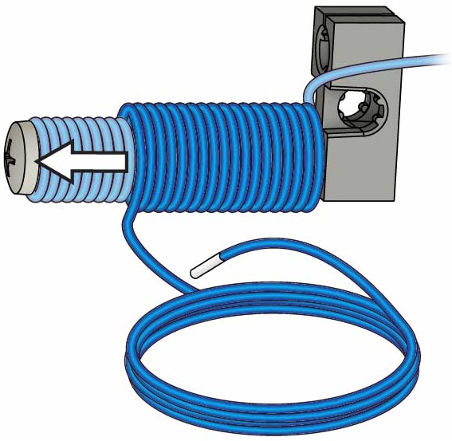

Layer 3

# Wrap More Layers

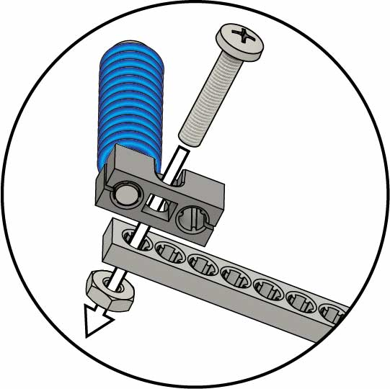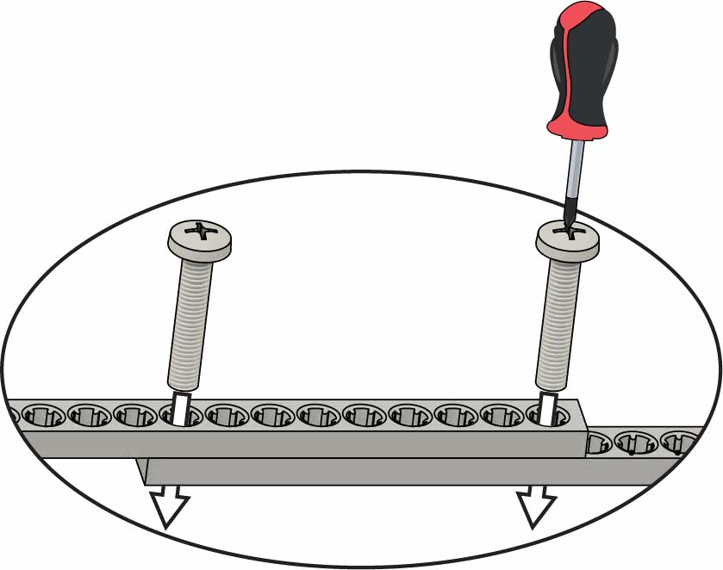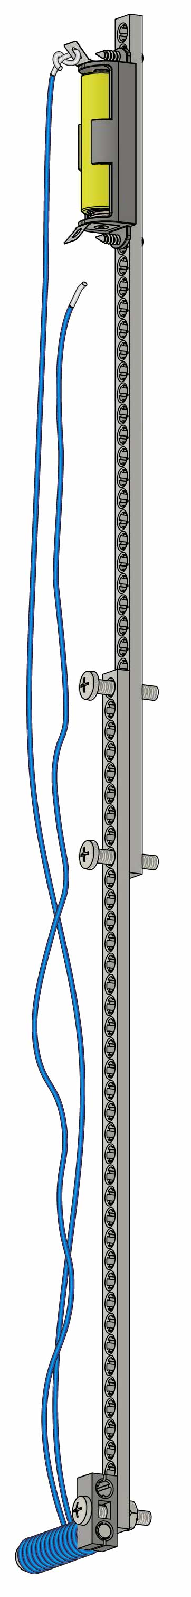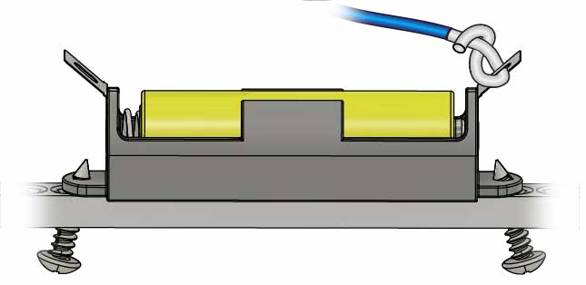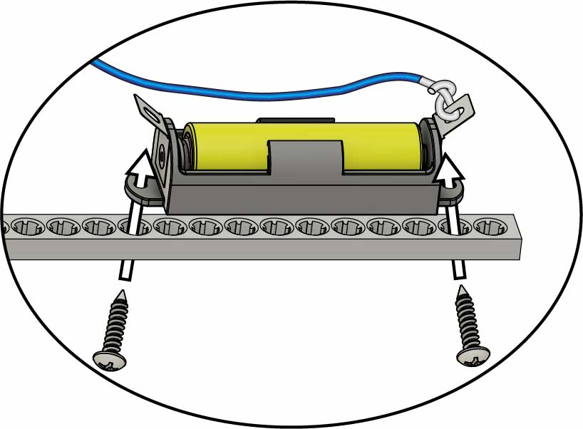

**Test it out!   
Next, you’re going to add a switch.**

**Screw**25 mm   
(1 in)

**Nut**

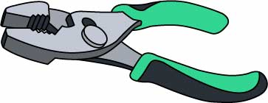

**Optional**: to tighten the nut

**Screws**25 mm (1 in)

**Strip**

**Strip**

Tip

Start both screws first, then tighten.

Attach the **electromagnet**   
using a **nut** and a   
**25 mm** (1 in) **screw**.

# 12

# 10

Attach **two strips** with   
**two** **25 mm** (1 in) **screws**.

**Wire**

**Mini Hub Screws**6 mm (5/8 in)

# Make The Arm

Attach the **battery holder** using **two   
Mini Hub Screws**.

# 11

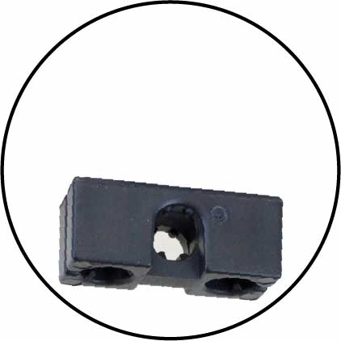

Through this hole

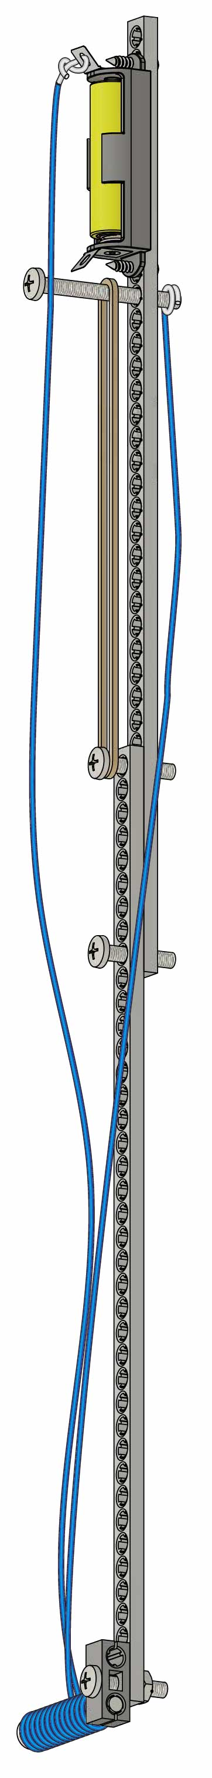

# Make Your Switch

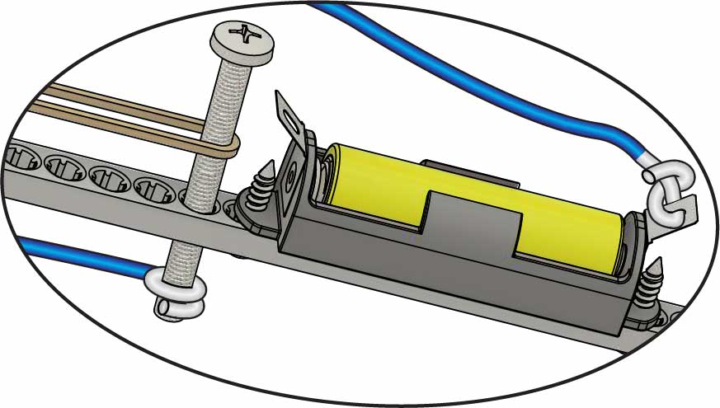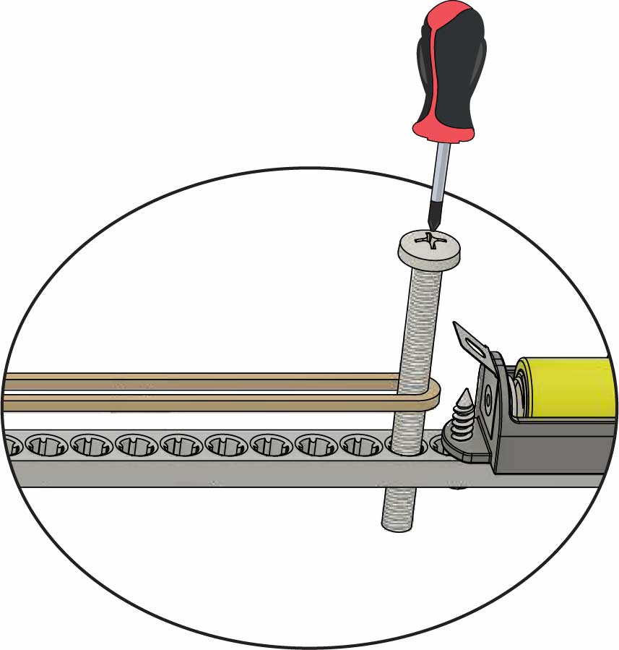

Other wire on this side.

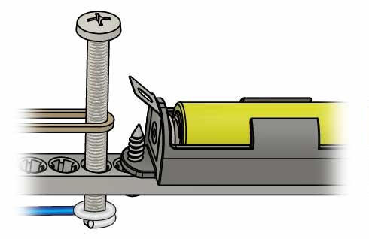

Off

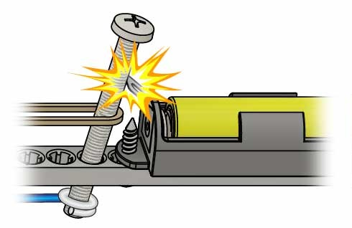

On

**Test it out!** Hold the screw back to turn on the magnet.

# 15

Tip

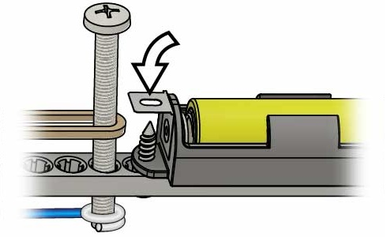

Bend the battery terminal down to make it easier to turn on.

**Your example build is   
done, but you aren’t!** Try adding a grapple (next page)   
or complete a lab or challenge!

**Wrap** the unconnected **wire** around the screw.

# 14

Stretch other side of rubber band to this screw.

**Your switch will turn your magnet on and off!**

**Screw**50 mm (2 in)

**Rubber Band**

Add a **50 mm** (2 in) **screw** and **rubber band**.

# 13

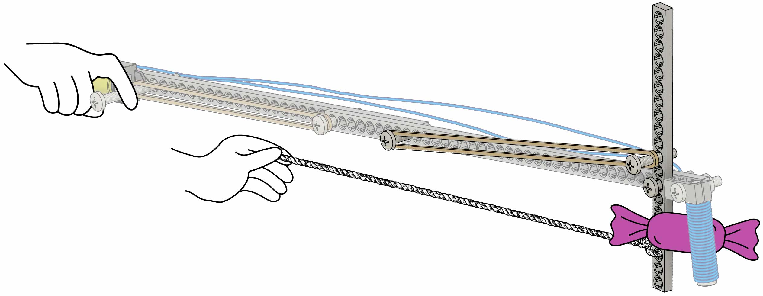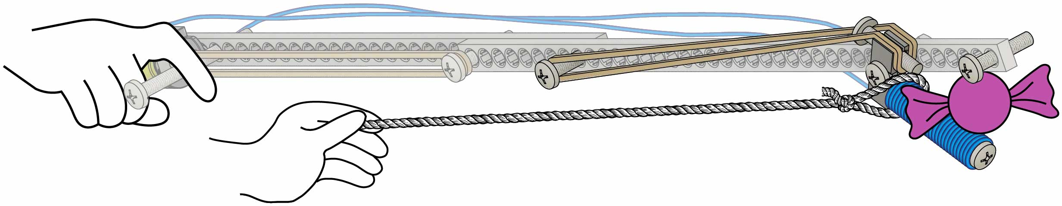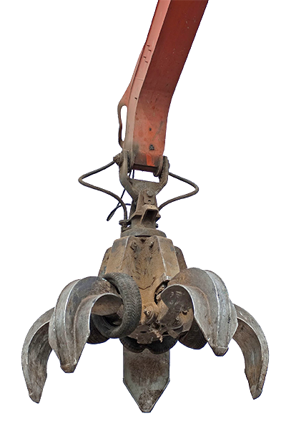

Half Strip

The magnet moves when you pull the string.

Rubber Band

Grapple Idea #2

Grapple Idea #1

Rubber Band

String

The strip moves when you pull the string.

**These grapple ideas just get you started – you can make better ones. Tinker and experiment to make your own unique grapples!**

**Grapples let you grab non-magnetic objects.**

Tip

You can cut or snap full strips to make half strips.

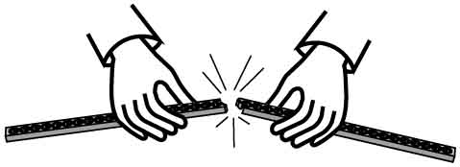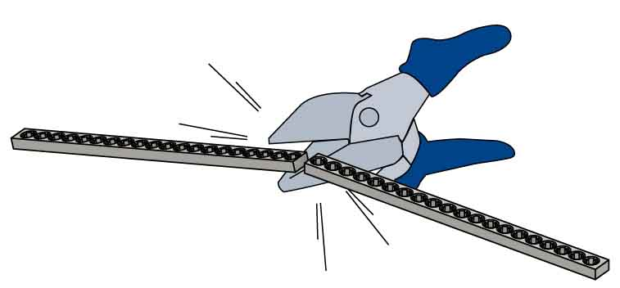

OR

# Add a Grapple

Optional

String

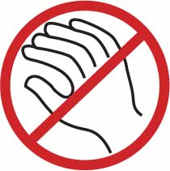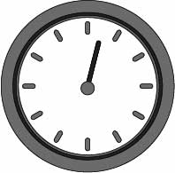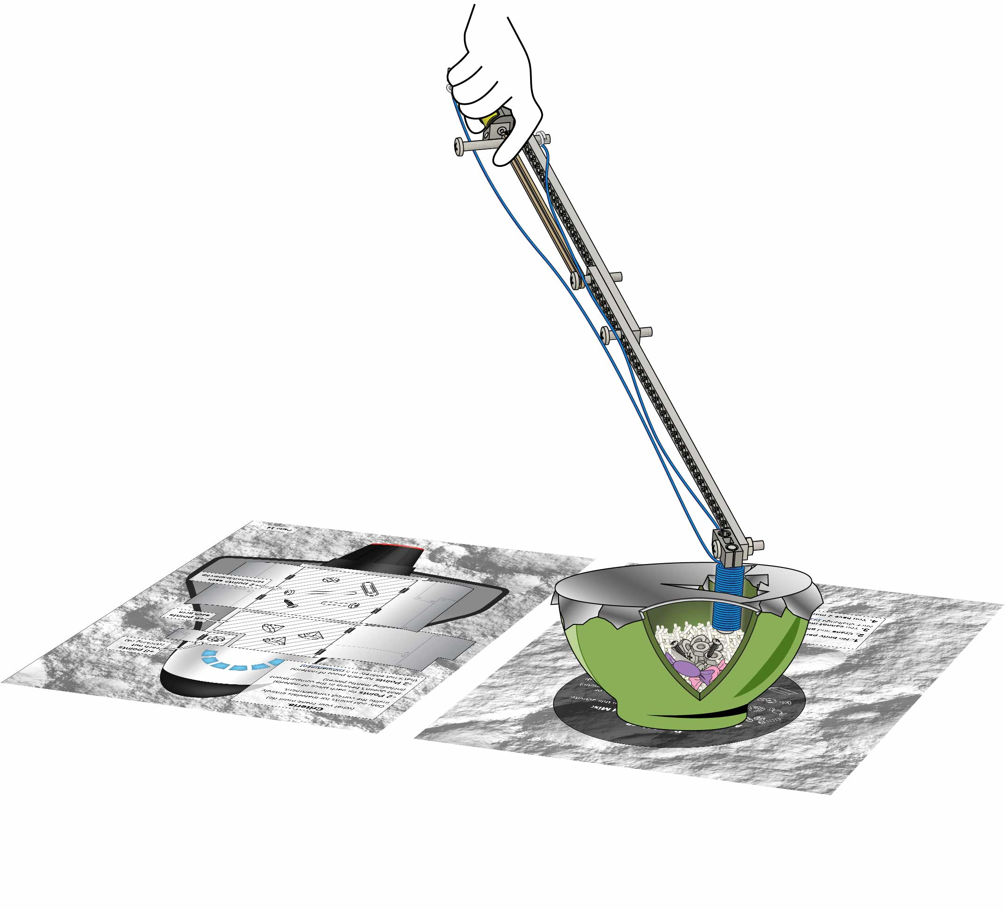

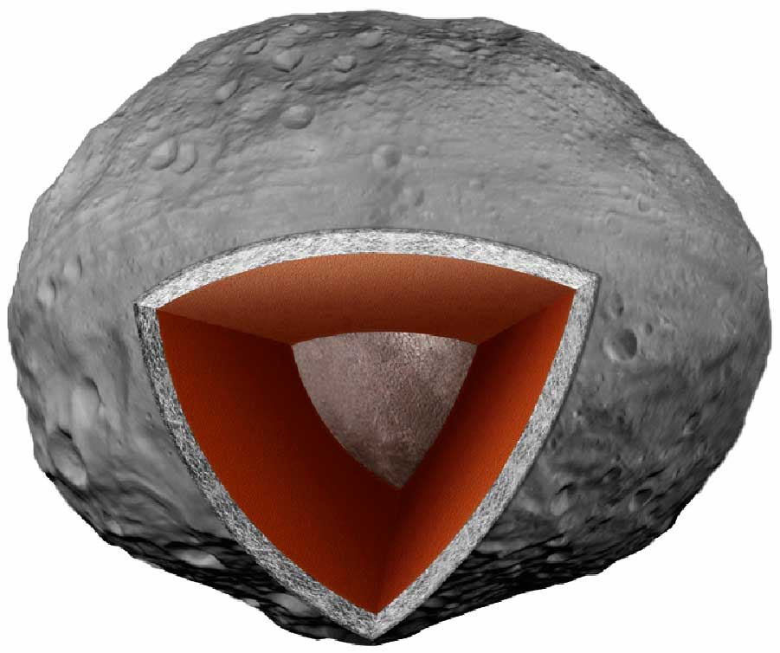

**Crust**

**Mantle**

**Iron Core**

Layers of 4-Vesta, a large asteroid in our solar system.



**Want more challenges?**

Download them at [**teachergeek.com/pickupstick**](https://teachergeek.com/pickupstick)

(rules and limits for your design)

Constraints

Smash through the crust (optional), gather minerals, and place them in the spacecraft to ship back to Earth!

**Redesign your crane to mine minerals from asteroids! Load the most minerals in the spacecraft to win!**

1.Bowl and game boards **cannot be moved** once the challenge begins

3. **You have 2 minutes** to per challenge attempt  
(you can retry it and change your design)

2. **No body parts above gameboards**

**Setup instructions on the gameboards.**

(Pages 10 & 12)

# Space Mining Challenge

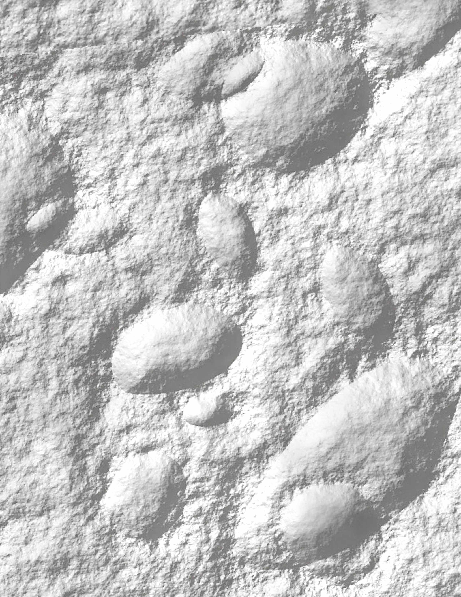

Bowl Here

Iron **(15 pieces):** spare parts from this activity,   
or paperclips, etc.

SpaceGems **(optional; 5 pieces):**   
small candies or crumpled colored paper, etc.   
(can’t be magnetic)

Mantle Material **(enough to bury iron/gems):** rice, beans, or pieces of crumpled paper, etc.

Crust **(optional):** stretch aluminum foil   
across top (add layers for greater challenge)

Challenge Rules

1.You **cannot** **move** **bowl**, or **game boards** once challenge begins

2. **No body parts above gameboards**

3. **You have 2 minutes** to complete challenge

Add These to the Bowl and Mix:



**Page 10**

[back of game board]

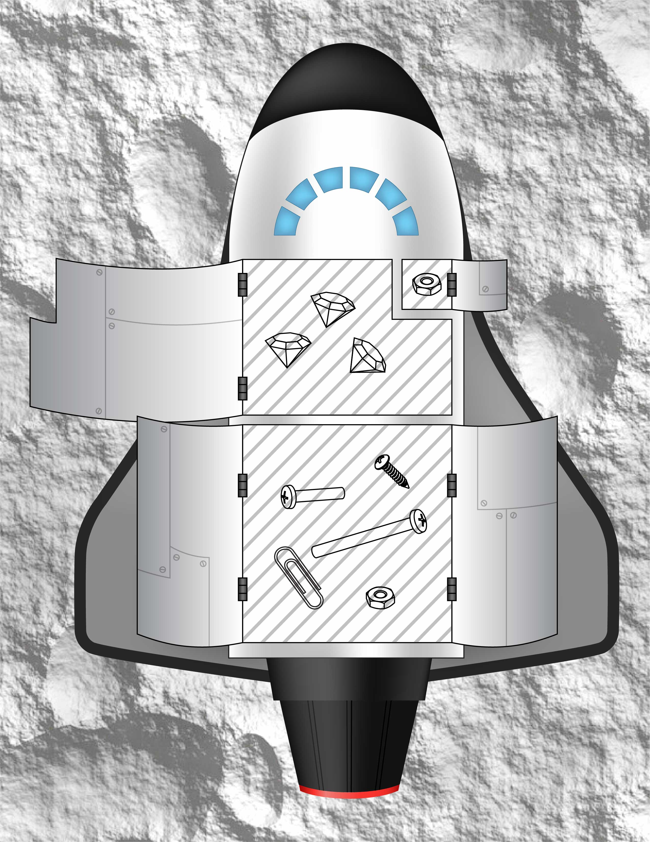

**+8 points each nut** (*stacking is ok*)

**+2 points each screw/nut/paperclip**

**+6 points each gem**

Criteria:  
(what your crane must do)

Only add points for materials entirely inside the correct compartment.

**-2 Points** for each piece of material that doesn’t belong in the compartment (including mantle pieces)

**-2 Points** for each piece of material that’s not entirely in a compartment

**Page 12**

[back of game board]