Name:_______________________________________ Date:____________________

**Learn how to use levers to make *your* vehicle go farther or faster!**

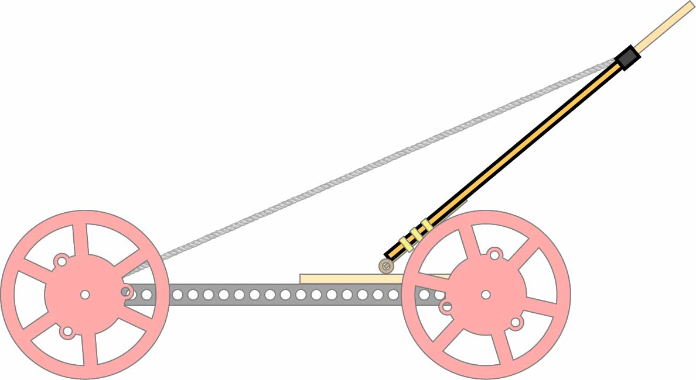

VS

Long Levers

Short Levers

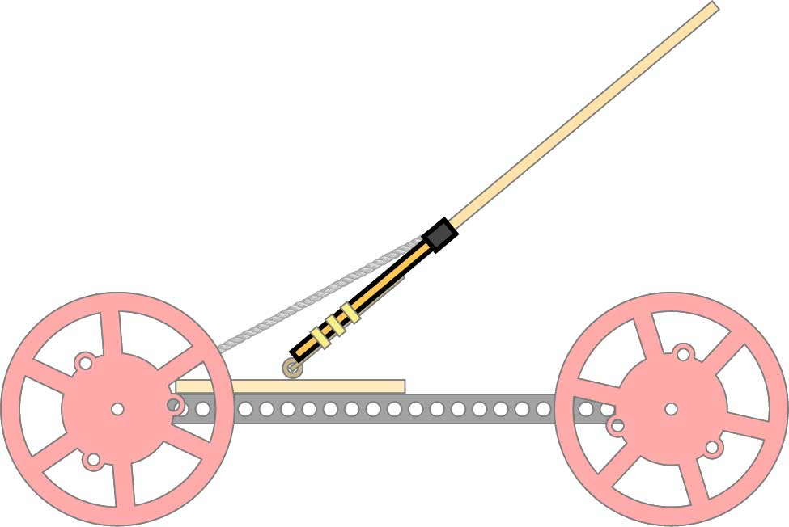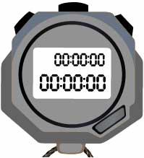

**Stopwatch**

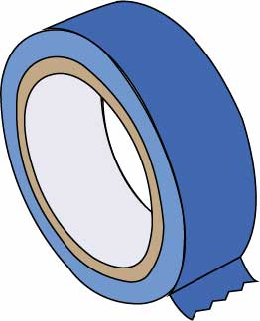

**Tape**

For marking start/finish lines

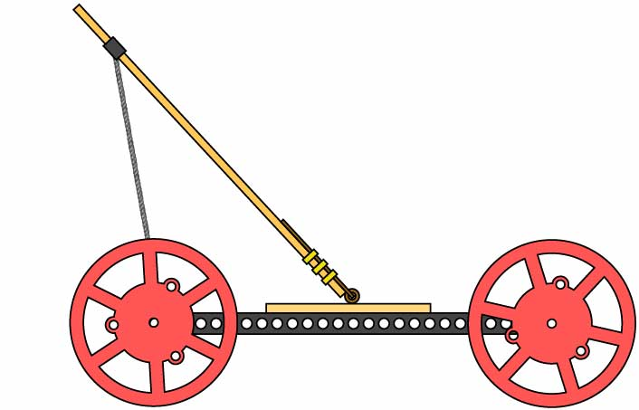

**Built Mousetrap Vehicle**

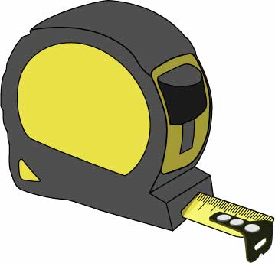

**Measuring Tape**

Build your electromagnet using the[**Go Guide**](https://teachergeek.org/mousetrap2.0_go_guide.docx),available at[**teachergeek.com/mousetrap**](https://teachergeek.com/mousetrap)

# Lab Supplies

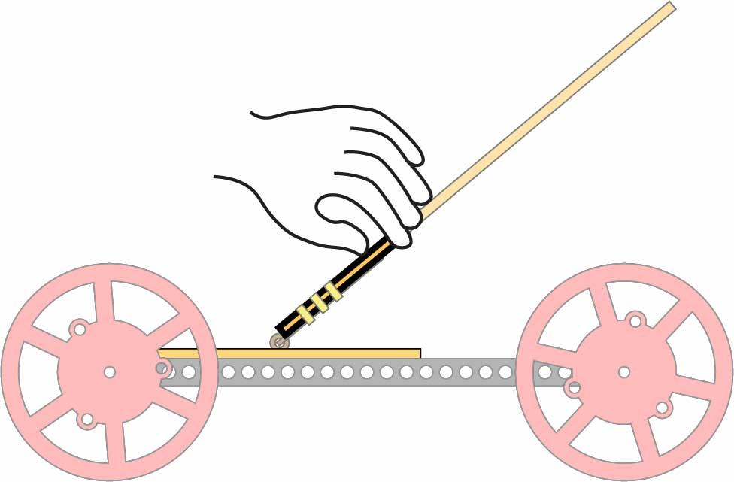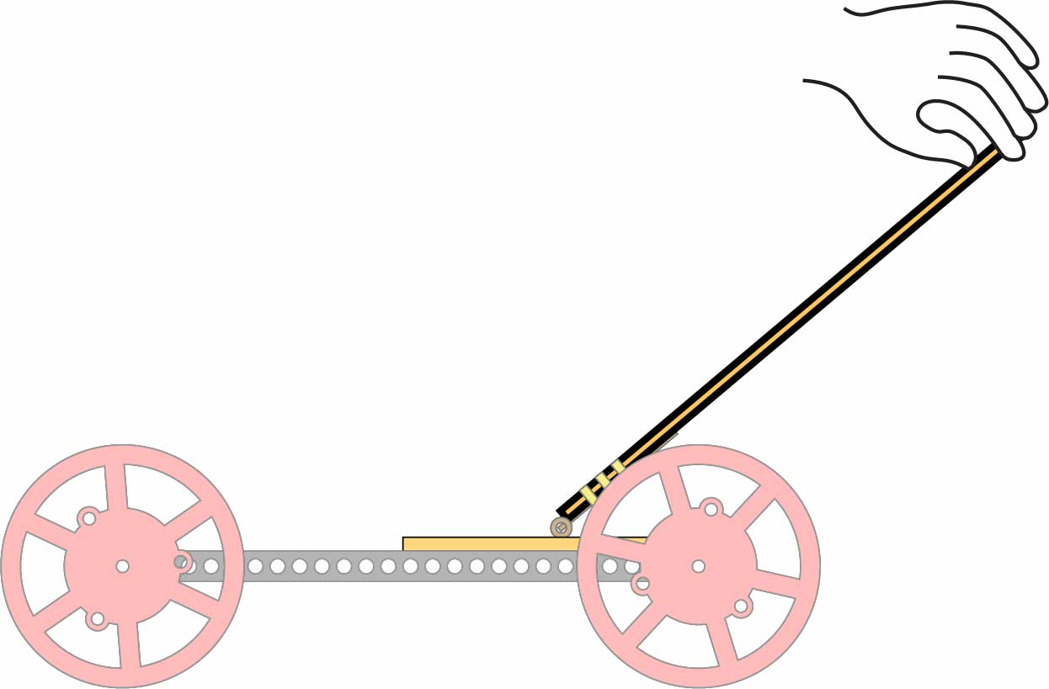

Now that you’ve got a feel for levers, it’s time to see what torque and distance do on the racetrack!

Push near the end to test a **long lever**.

**Test the**

Long Lever

**Test the**

Short Lever

Push near the mousetrap to test a **short lever**.

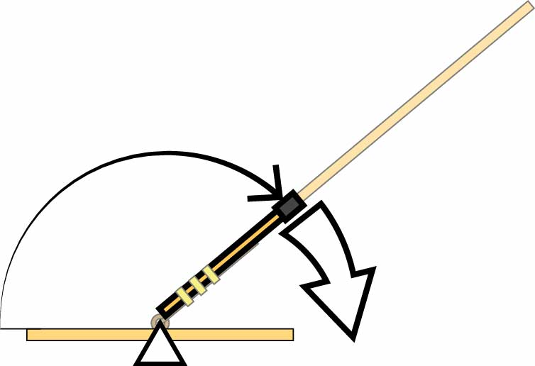

Less Distance

**More Torque**

Short levers pull the string harder (more torque), but over a smaller distance.

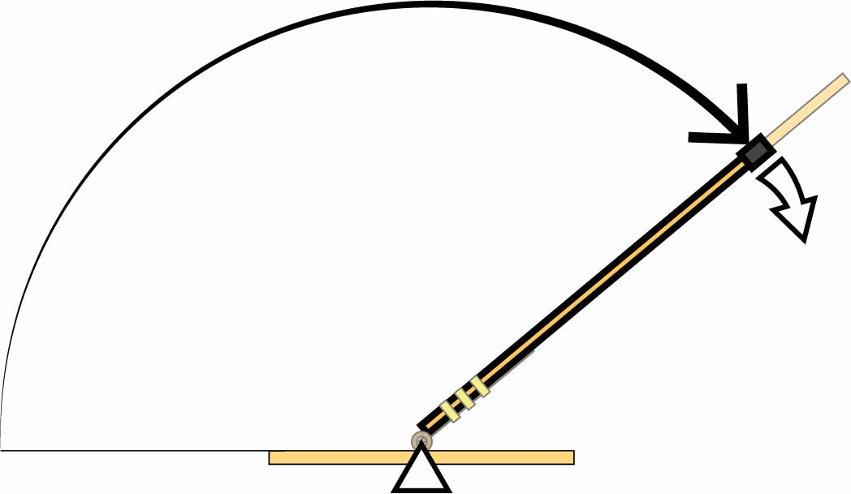

Less Torque

**More Distance**

Long levers pull the string farther, but with less torque.

Do short or long levers have more torque?

**Levers trade between distance and torque (turning force).**

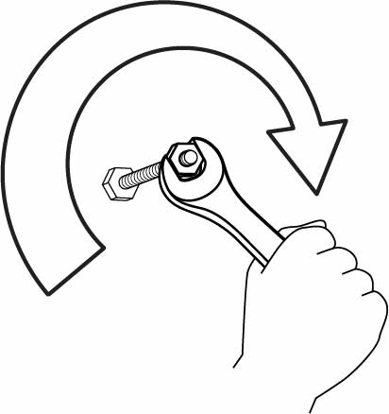

**Torque** is turning force.

# How do levers work?

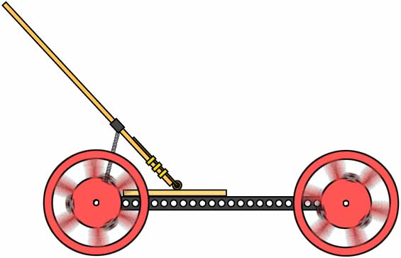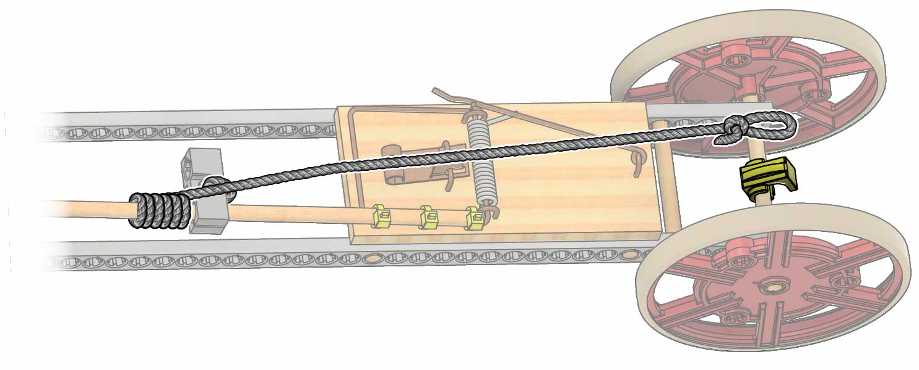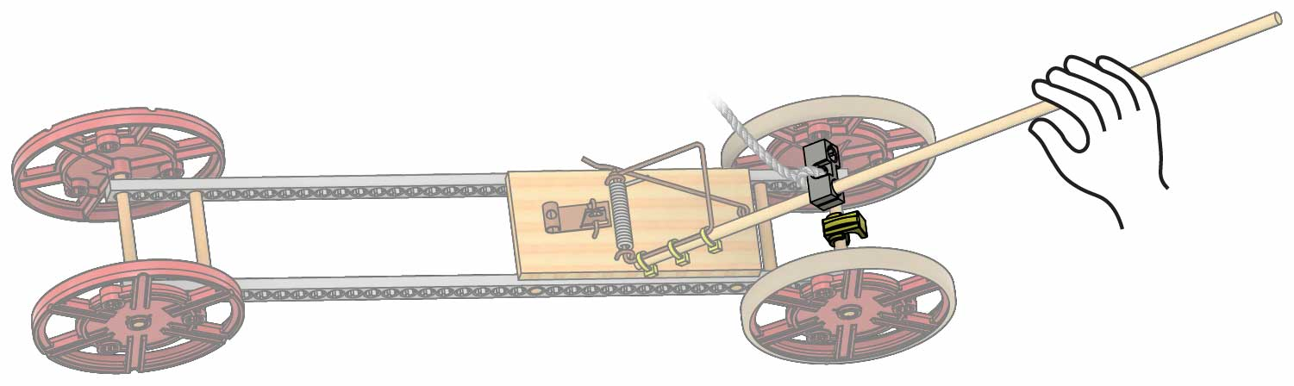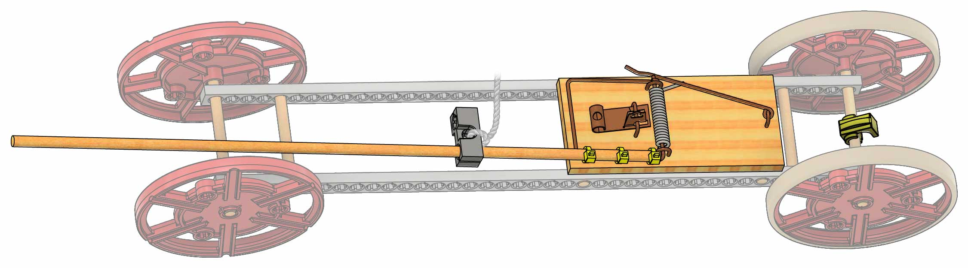

**You’re going to move your mousetrap and string to make a shorter lever.**

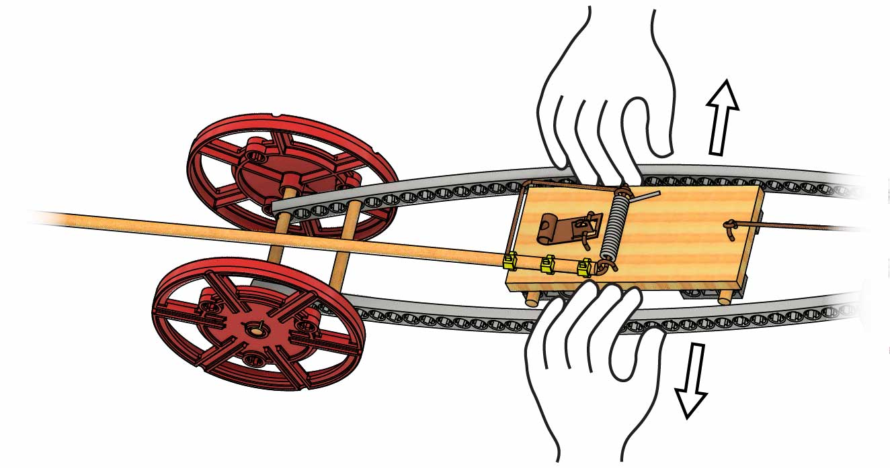

Pull the strips apart to move the trap.

Pop!

Pop!

**Your short lever is ready to test!**

**Extra String**

The block should be **right over the clip** when the lever is bent back.

**Clip**

**Block**

# 3

**Wrap** **extra** **string** around the **dowel** until the loop reaches **just past the clip**.

**Slide** the **block** down the dowel.

# 2

# 1

**Move** the **mousetrap** as close to the **clip** as possible.

**Clip**

**Loop**

**Clip**

# Shorten the Lever

# Test It Out!

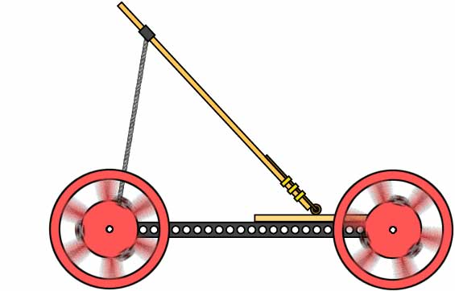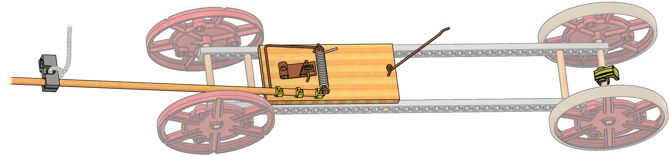

**Test your vehicle and fill in data for the Short Lever.**

Short Lever

Long Lever

Speed Data

Short Lever

Long Lever

Distance Data

Short Lever

Long Lever

Distance Under Power Data

**Got all your Short Lever Data?** On the next page, you’ll make a Long Lever and return to this page to get the rest of the data.

!

**Only fill in the Short Lever Data** You’ll test a Long Lever after you make it on the next page.

!

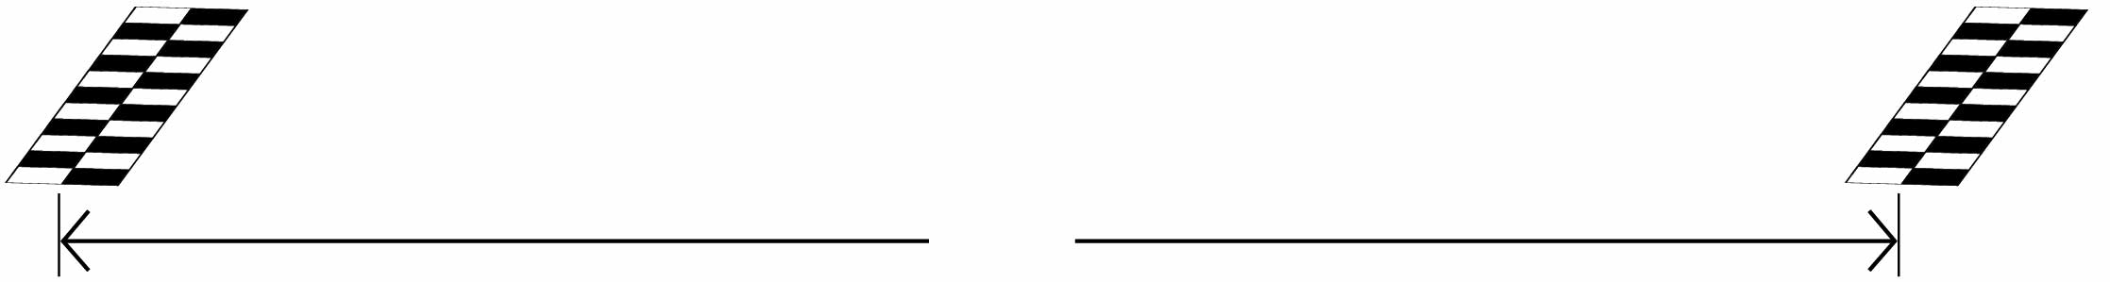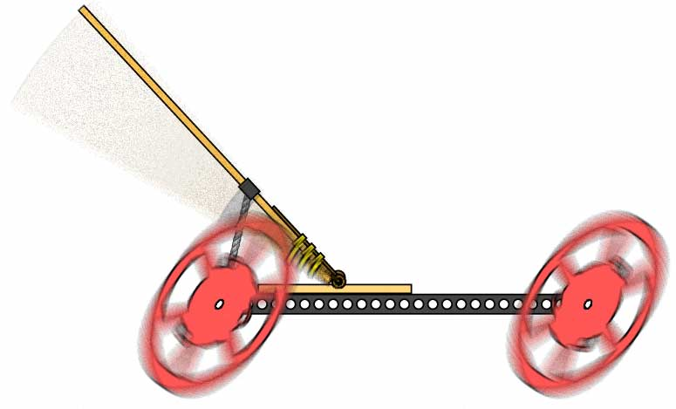

**3 m**  
(10 ft)

Time your vehicle – how long does it take to go 3 m (10 ft)?

Speed



Distance Under Power

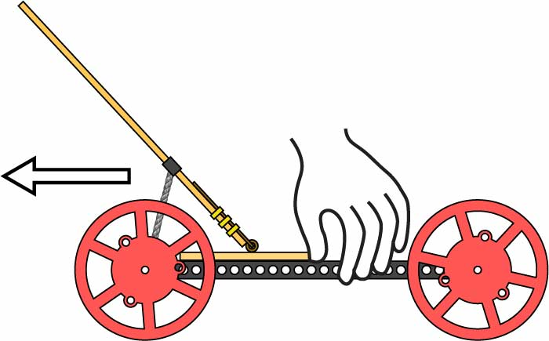

How far backwards do you need to roll your car to wind it up?

(When you let your car go, it will be under power for that same distance)

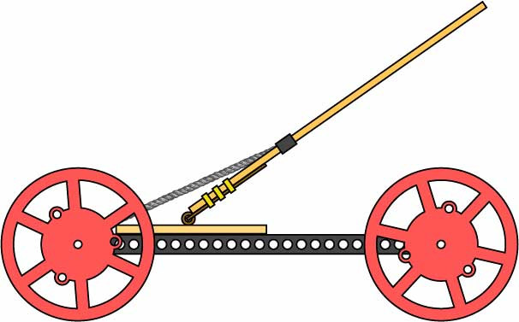

Distance

How far does your vehicle go?

# 7

**Time to test your long lever!**

**Record your data on Page 4.**

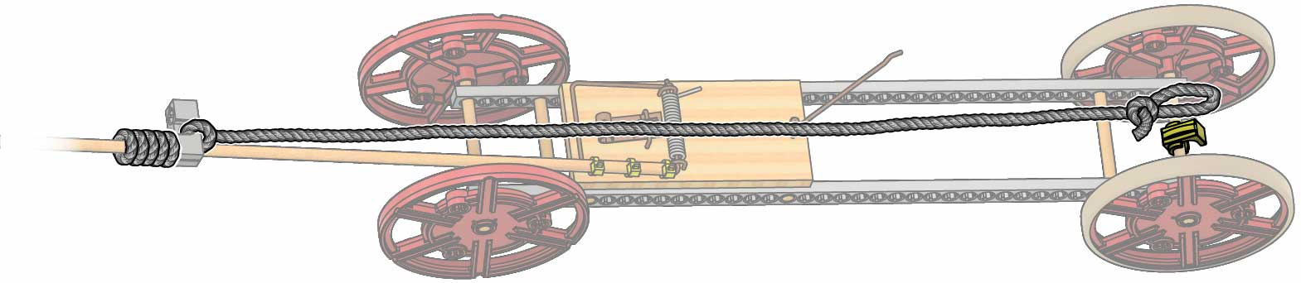

**Extra String**

**Loop**

**Clip**

**Wrap** **extra** **string** around the **dowel** until the loop reaches **just past the clip**.

# 6

# 5

# 4

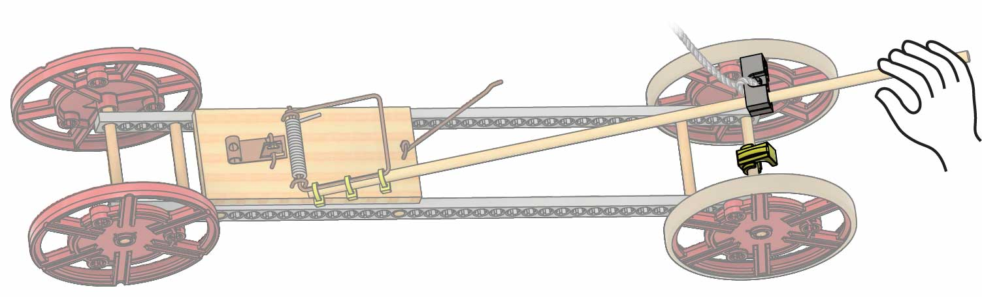

The block should be right **over the clip** when the lever is bent back.

**Clip**

**Block**

**You’re going to move your mousetrap and string to make a longer lever.**

Pull the strips apart to move the trap.

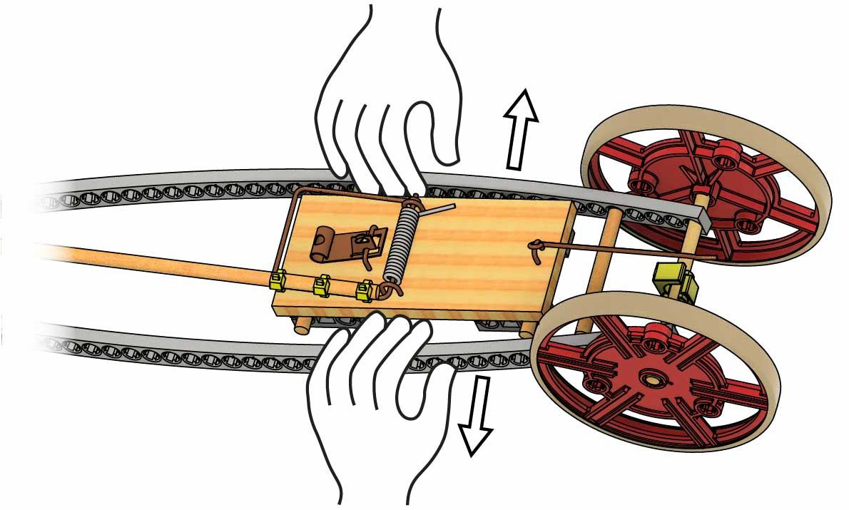

Pop!

Pop!

**Move** the **mousetrap** as far from the **clip** as possible.

**Slide** the **block** up the dowel.

**Clip**

# Lengthen the Lever

**Did you test your Long Lever on Page 4? You’re ready to analyze the data.**

If you’re designing a vehicle for distance, do you think a Long Lever or a Short Lever will work better? Justify your answer using your lab data.

________________________________________________________________________________________________________________________________________________________________________________________________________________________

# 8

How do you think Distance Under Power affects your vehicle’s distance   
and speed?

________________________________________________________________________________________________________________________________________________________________________________________________________________________

# 10

To design a vehicle for speed, would you want a Long or Short Lever? Justify your answer using your lab data.

________________________________________________________________________________________________________________________________________________________________________________________________________________________

# 9

Your mission: create a mousetrap vehicle that goes 3 m (10 ft) in *exactly*   
3 seconds. You test your vehicle, and it goes 3 m in 2 seconds. What do you do?

________________________________________________________________________________________________________________________________________________________________________________________________________________________________________________________________________________________________

# 11

# Conclusion

# Test Mousetrap Position

Optional

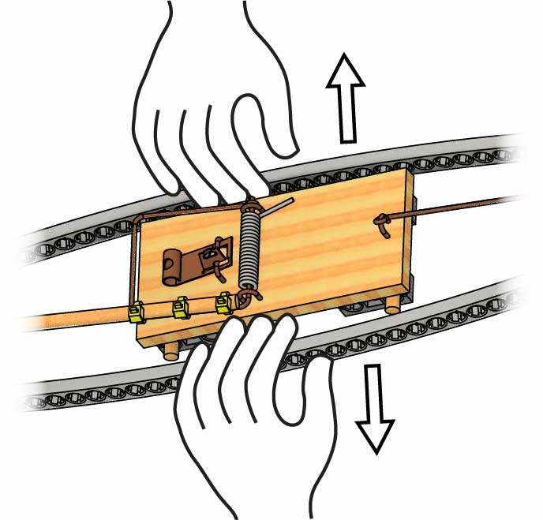

Pop!

Pop!

Pull the strips apart to move the trap.

**Keeping your lever long, you’re going to test how changing your mouse trap’s position affects performance.**

Far Mousetrap

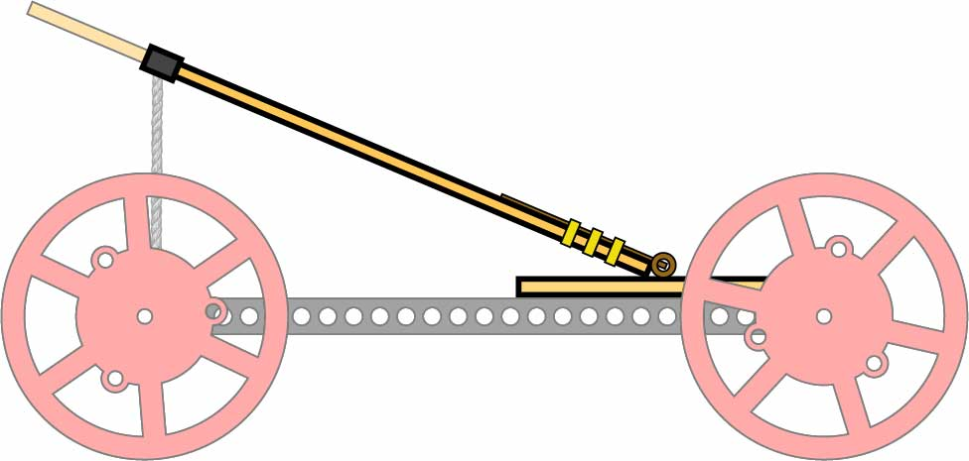

Data

Test both positions as you did on Page 4.

Test first with the mousetrap as far from the clip as possible.

Far

Close

Distance

Far

Close

Speed

Far

Close

Distance Under Power

Close Mousetrap

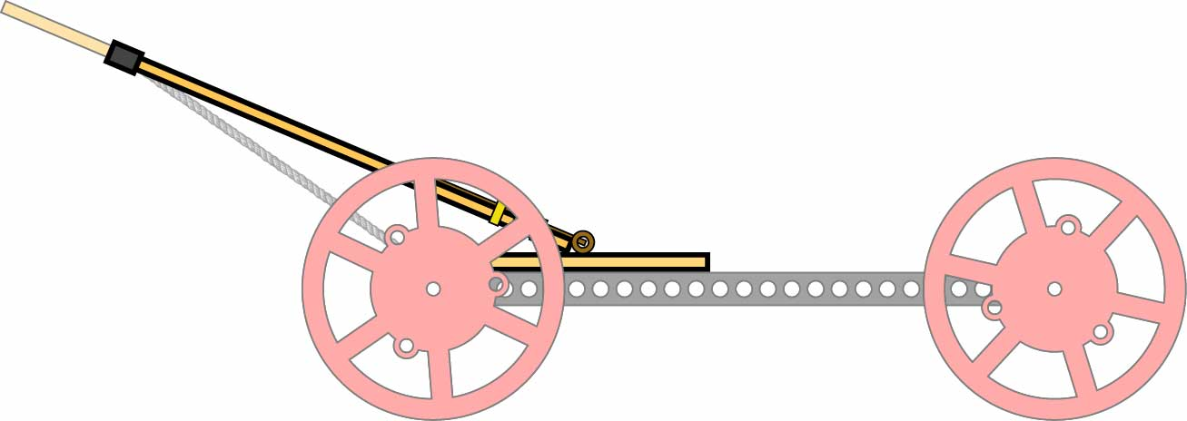

Congratulations! You’ve finished the lab. Now use what you’ve learned to make your Mousetrap Vehicle even better.

Which position is better for speed?   
What about distance?

Then move the trap as close to the clip- as possible, and test again.