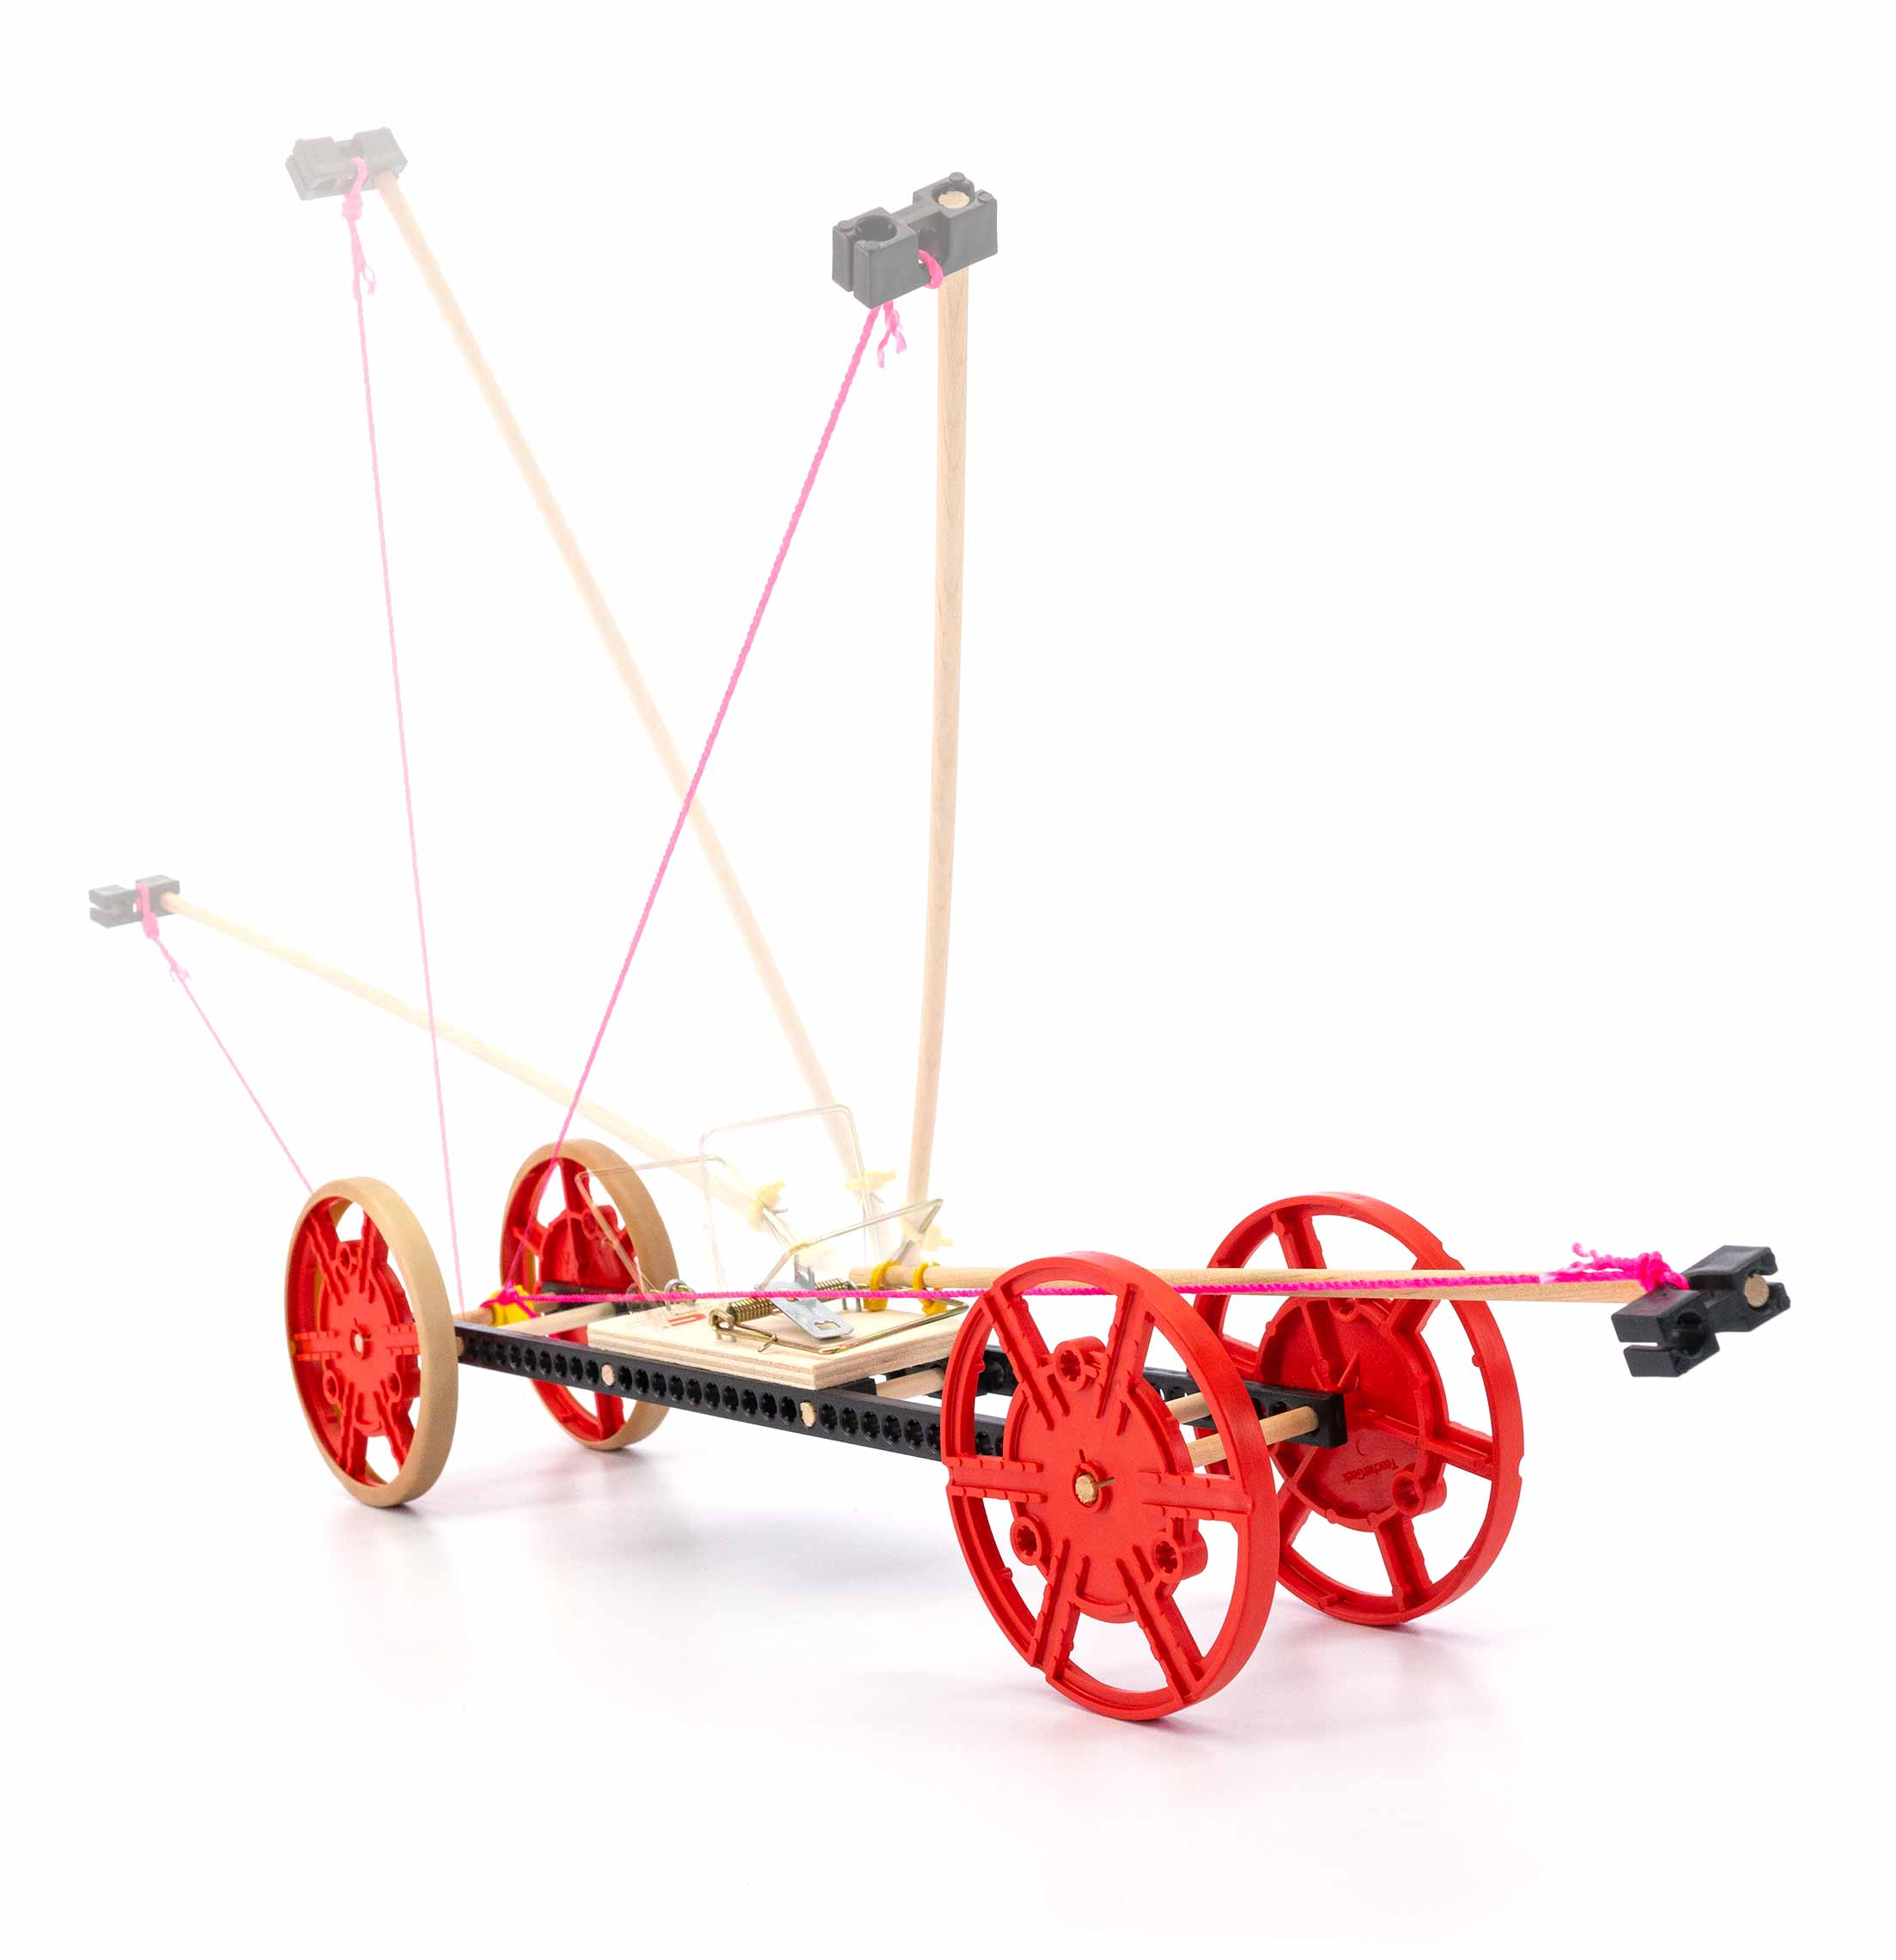
Learn about energy and friction by building and re-engineering your own mousetrap-powered vehicle!
TRUE
STEM
STEAM
You Are Here
Start here! Build your Vehicle,
evolve your design, and begin
the Long Shot Challenge!
Optional Lab
Optional Challenges
-Lever Lab
(Ages 8+)
-Long Shot Challenge*
-Sprint Challenge*
-Target Challenge*

Go Guide
*See Page 9
Choose how you would like to complete this activity.
Download documents & videos at teachergeek.com/mousetrap
Supplies
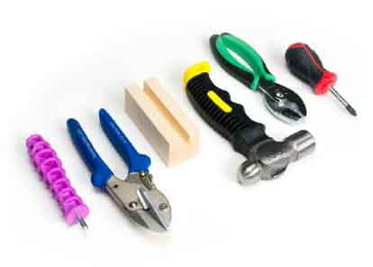

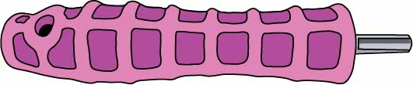
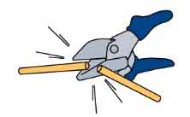
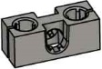
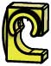
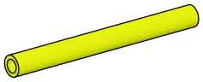
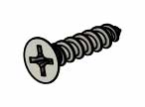
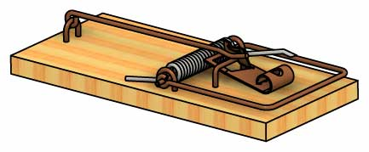
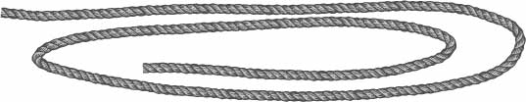
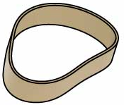
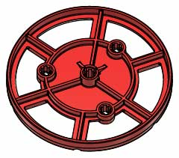
Modify materials to make even more creative designs with the Maker Tool Set
SKU 1823-84
Optional Tools
Materials You Supply
- Phillips Screwdriver
- Scissors
- Recycling Bin Materials
to incorporate into your designs
Included tools
TeacherGeek Reamer
SKU 1823-87

Have a Maker Cart? Use Multi-Cutters to cut your own Dowels.
Maker Cart users must supply their own Mousetraps.
Mini Hub Screws on the Maker Cart can be substituted for these.
Dowels
various sizes
SKU 1821-20

PICTURE

NAME

QTY

Blocks
SKU 1821-34

Strips
30 cm (12 in)
SKU 1821-31

8

6

Mousetrap
SKU 1821-46

1

Mousetrap Screws
#6 x ⁵/₈ in

4

Zip Ties
12 cm (5 in)
SKU 1823-50

Clips
SKU 1821-60

6

1

String
60 cm (24 in)
SKU 1823-47

3

Tire Rubber Bands
SKU 1821-64

2

Wheels
SKU 1821-30

4

Slide Stop
8 cm (3 in)
SKU 1821-49

1

3 - 30 cm (12 in)
2 - 15 cm (6 in)
2 - 8 cm (3 in)
6 - 5 cm (2 in)
These are the parts you need to build one vehicle,
so you can make your own unique designs.
Mousetrap Vehicle Parts
Make Your Frame
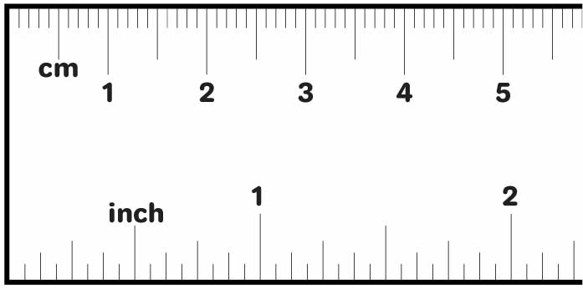
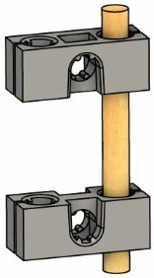
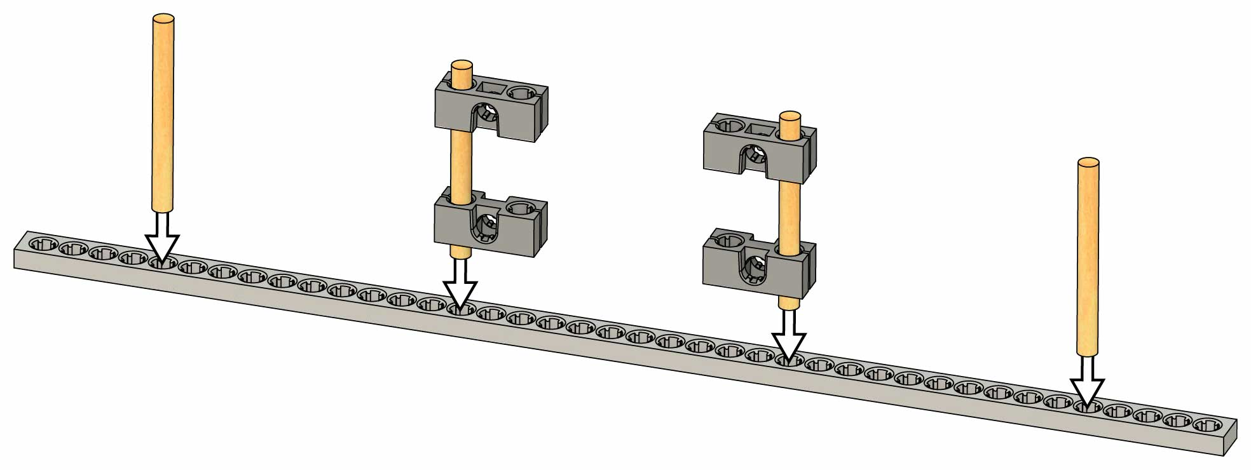

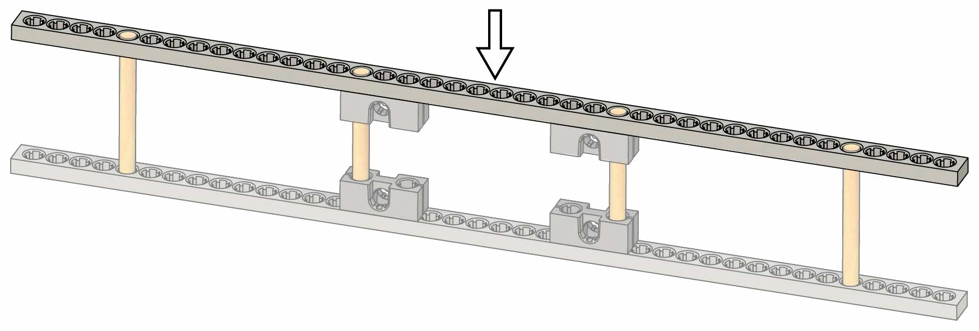
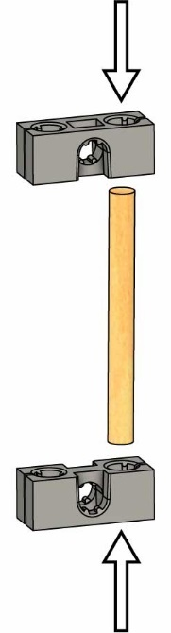
Dowels should stick out 5 mm (3/16 in)
Finished Supports
Wiggle or tap 5 cm (2 in) dowels into blocks to make two supports.
Push or tap another strip on top.
Your frame is done!
Time to add the mousetrap.
Supports (from Step 1)
Strip
5 cm (2 in) Dowel
5th hole
(from left)
5 cm (2 in) Dowel
5th hole
(from right)
15th hole
(from right)
15th hole
(from left)
Wiggle or tap two 5 cm (2 in) dowels and the two supports from Step 1 into a strip.
2
3
Don’t Ream
Strip
Block
Block
5 cm (2 in) Dowel
1
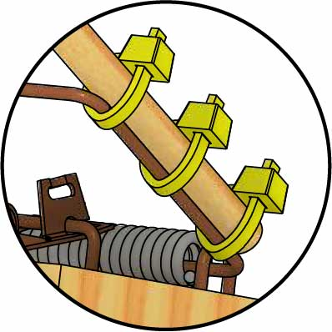
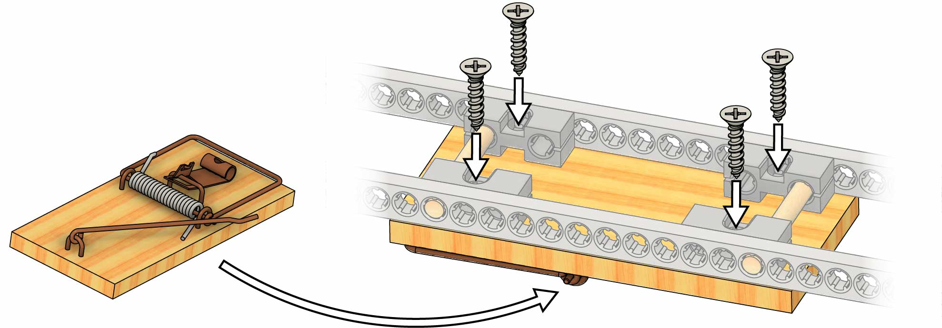
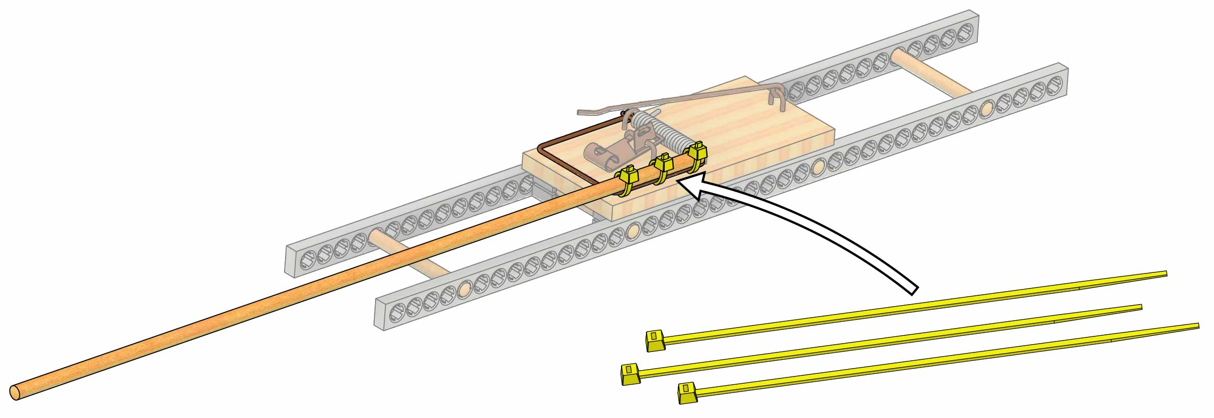
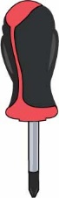
Upside-Down Mousetrap
It doesn’t matter which way your mousetrap faces (but it must be upside down).
Congratulations! Your mousetrap is mounted. You’re ready to add the wheels.
Screw the mousetrap onto the frame using 4 mousetrap screws.
4
Mousetrap Screw
The screws will make their own holes in
the mousetrap.
5
Zip Ties
30 cm (12 in) Dowel
Make sure they’re tight!
Attach a 30 cm (12 in) dowel to the mousetrap using three zip ties.
Add The Mousetrap
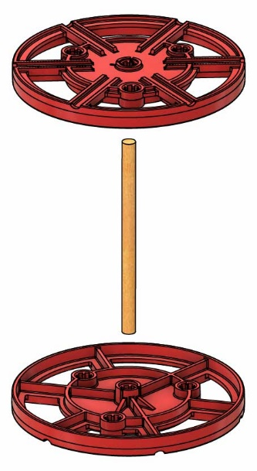
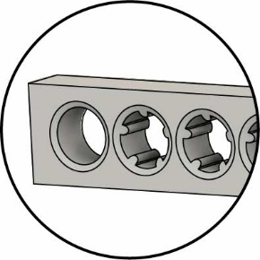
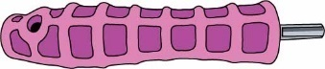

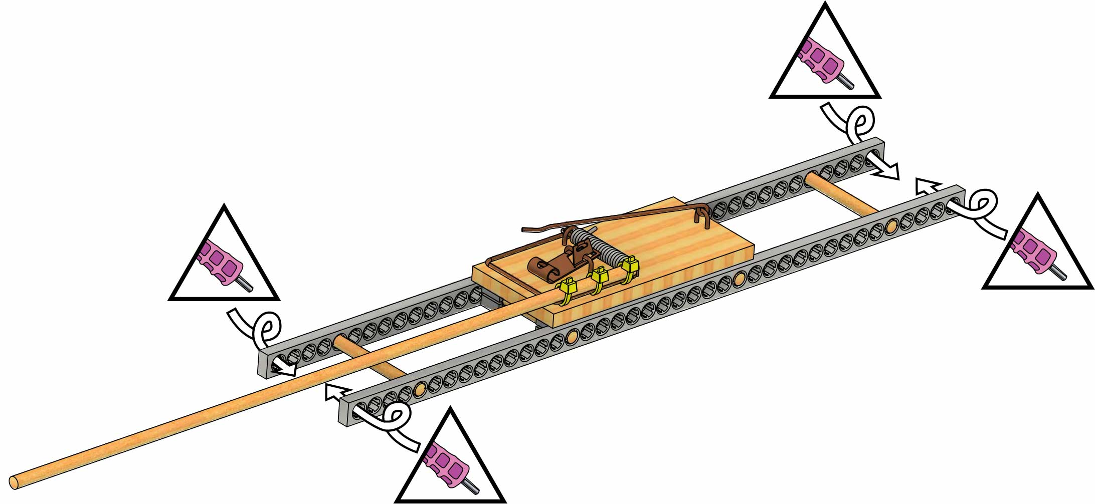
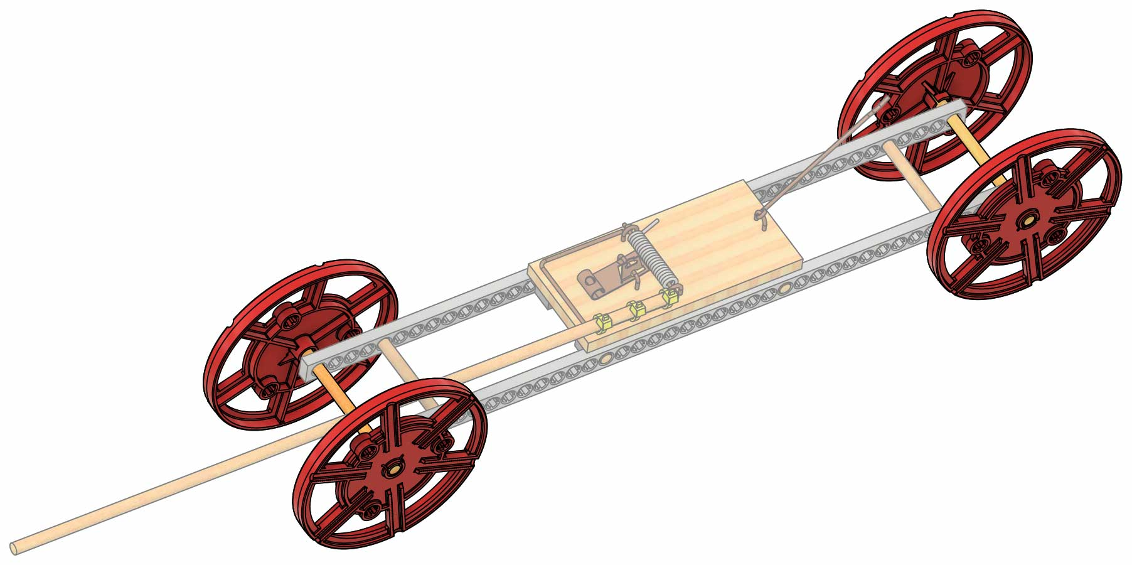
Bumps face inside.
Never Ream Wheels
8 cm (3 in) Dowel
Wheel
Wheel
Reaming removes splines (teeth)
so dowels can
spin freely.
Push & Twist
Put Away Your Reamer!
Reaming is fun, but you can’t attach a dowel to a reamed hole (it slides out). Don’t ream any more holes until you’re experimenting with your own designs.
Ream
Ream
Ream
Ream
Make sure your wheels spin freely. If they don’t, re-ream the frame (Step 6).
You’re ready to roll!
7
Slide two 8 cm (3 in) dowels through the reamed holes, then add the wheels.
Wheels On
6
Ream the four end holes of your frame.
Tie It Together!
Push hard to attach the clip!
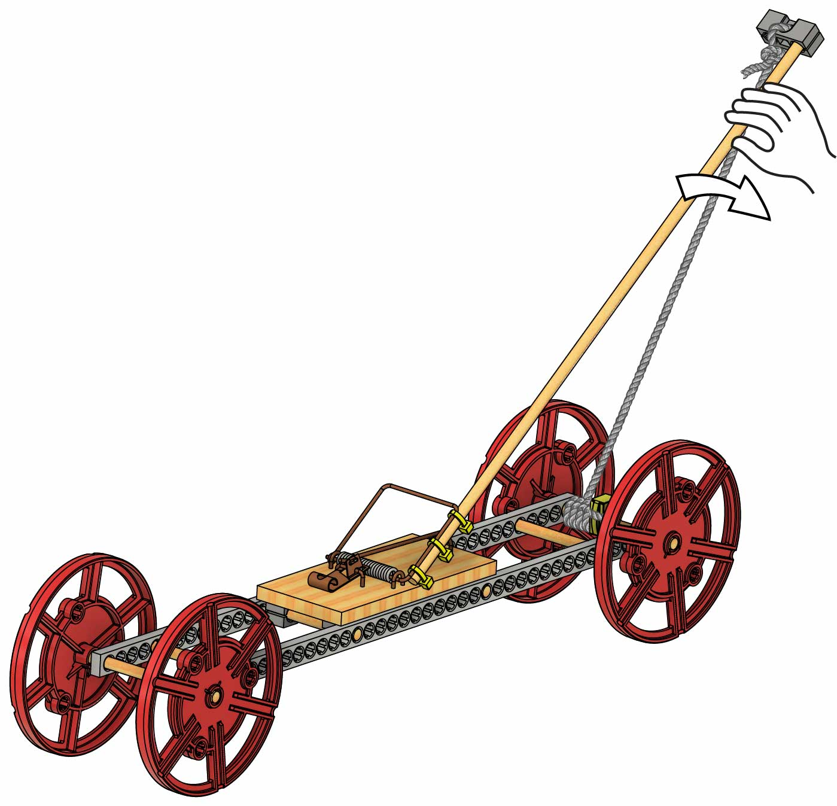
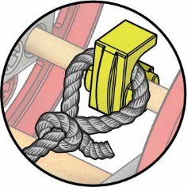
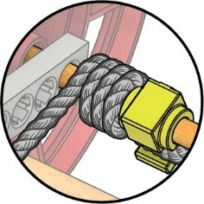
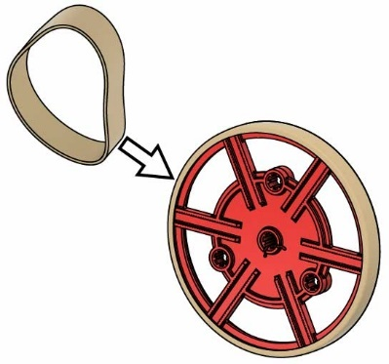
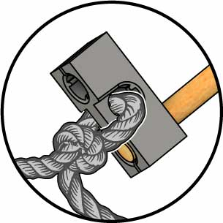
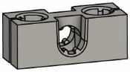
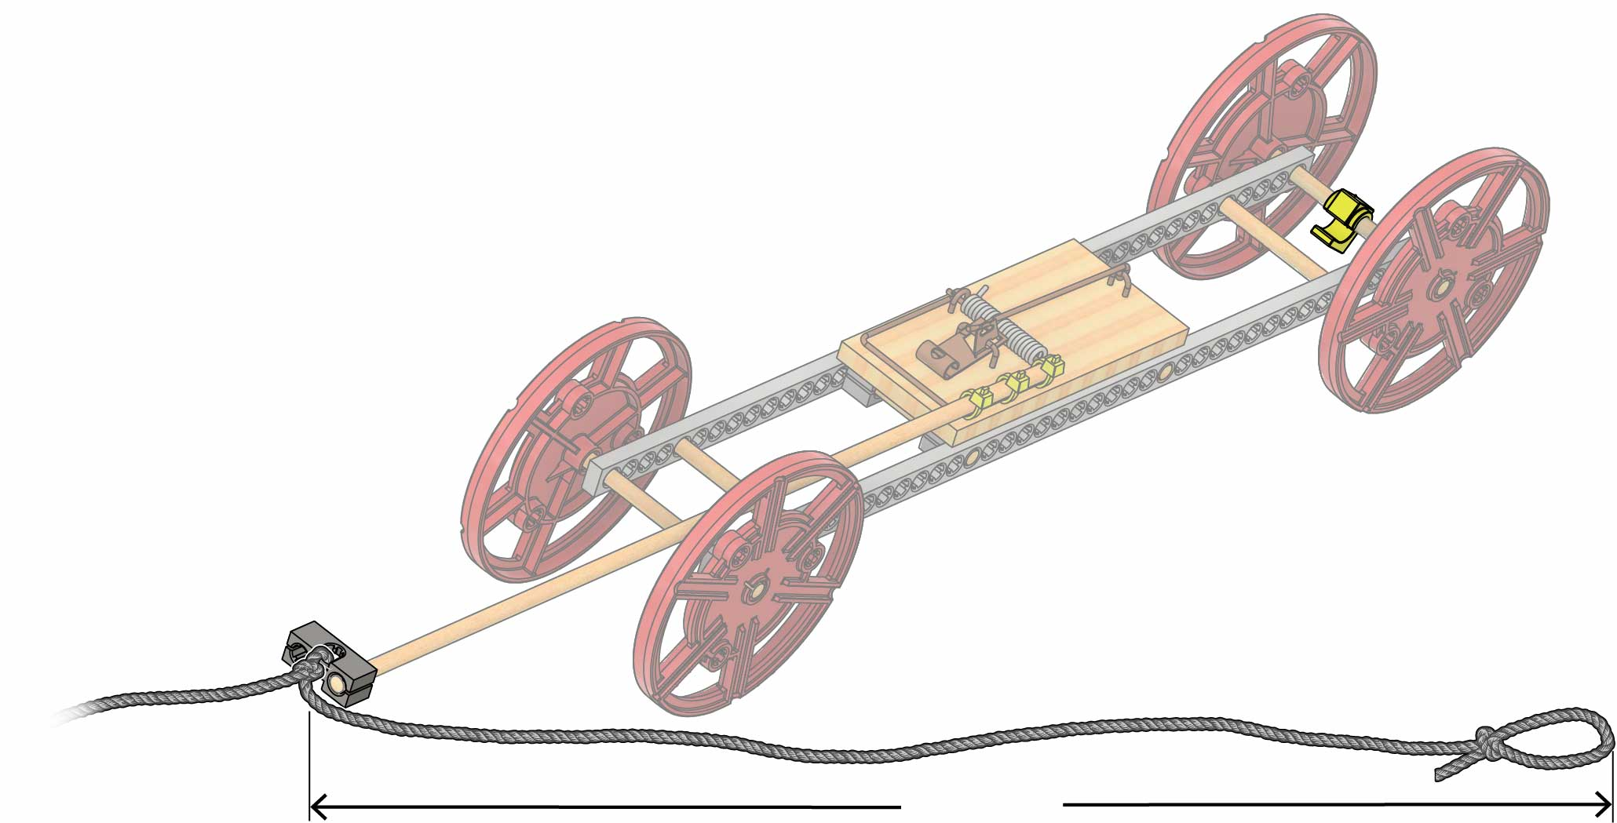
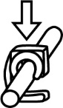
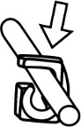
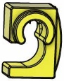
Download the Lever Lab at teachergeek.com/mousetrap
Your example build is done, but you’re just getting started! Try the Lever Lab or continue on to create your own unique design and begin a challenge!
Race It!
Hook the string loop on the clip.
Turn the wheels to wind up the car.
Tip: pull the lever as you
turn the wheels.
VROOOM!!!
Let it go!
14
12
13
Wheels spinning out? Add tire rubber bands!
Get A Grip!
10
Tie a loop in the string.
11
Tie the string to the block.
Block
Wiggle a block onto the end of the lever arm (dowel).
9
8
Snap a clip onto the back axle.
String
On
Off
≈47 cm
(≈19 in)
Clip
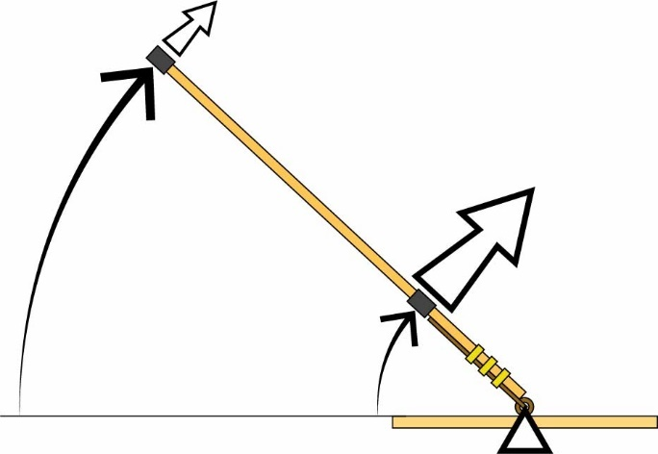
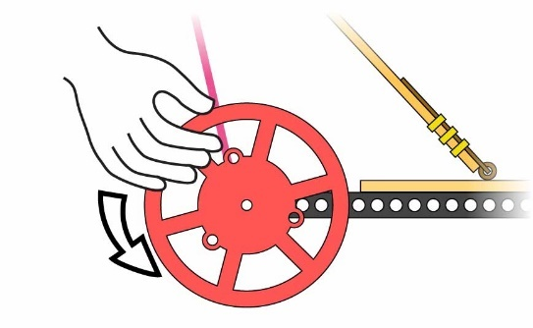
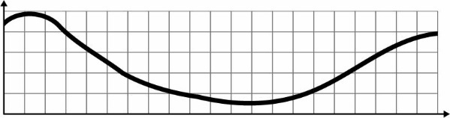
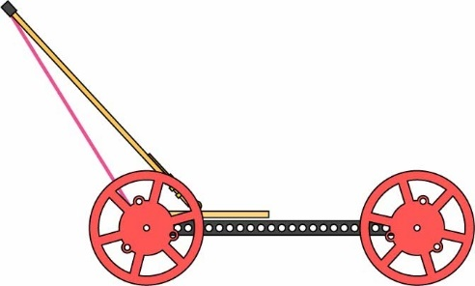
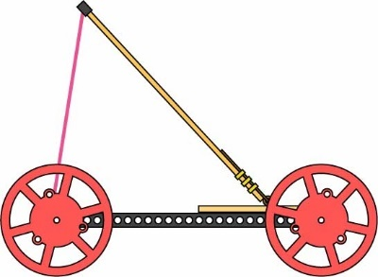
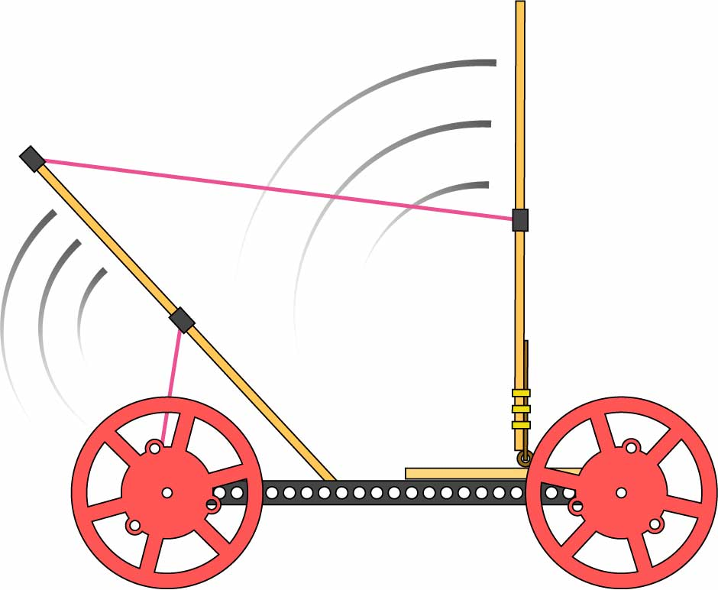
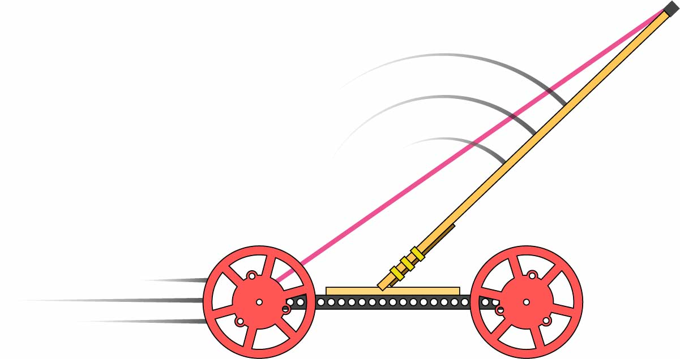
Can you re-engineer it for greater distance? Greater speed?
Change the Lever’s Length
Trade between force and distance by sliding the block/string along the dowel.

Small Force
Big Distance
Big Force
Small Distance
Test Your Power Delivery
Feel how hard it is to turn the wheel as you’re winding up. Easier to turn means more distance, harder means more force (and bigger speed gains).
Force
Wind-Up Distance
Force changes
as you wind it up!
Move the Mousetrap
The lever’s position can give you a big speed boost off the start line, or more consistent power throughout.
VS
Add a 2nd Lever
Experiment with additional levers to get even more control over your power delivery.
Race your vehicle!
Keep changing it and testing it.
Play Time
Keep Playing!
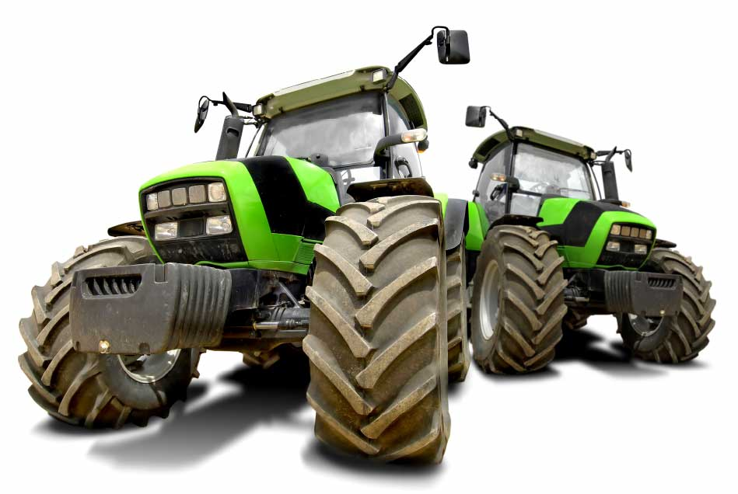
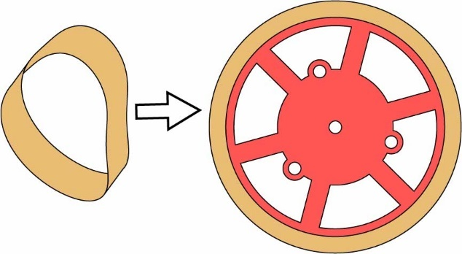
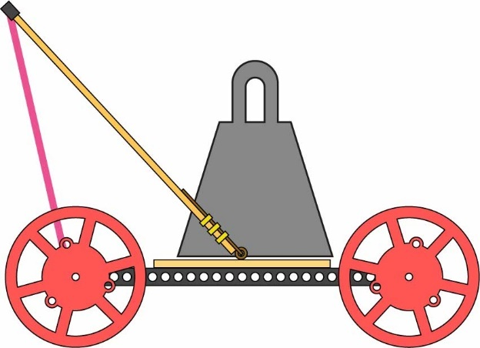
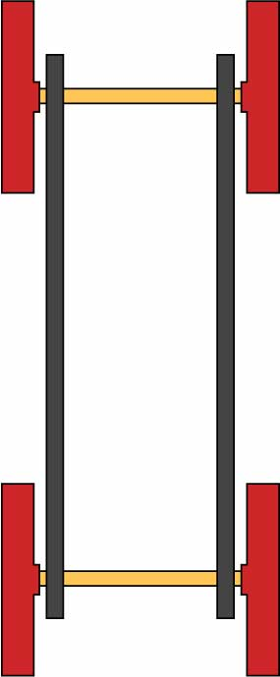
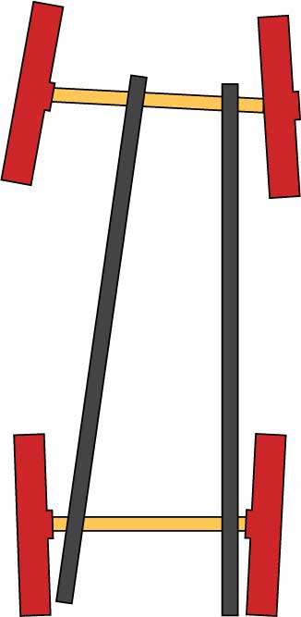
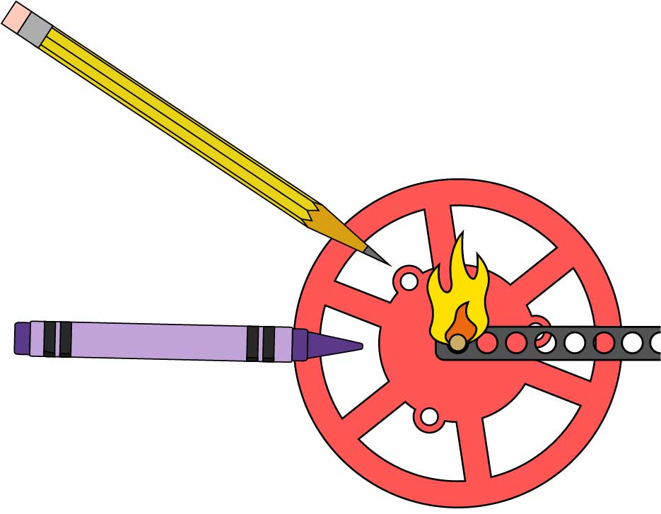
Traction & Rolling Resistance
Are you so fast you’re spinning out? Tires will give you more traction, so you can gain speed quicker! But tires also increase rolling resistance, which slows your car down over longer distances.
Inertia
Going for massive distance? More inertia (mass) makes it harder for your racer to slow down, but it also makes it harder for your racer to gain speed.
Tracking
Is your car making a turn for the worse? Make sure the frame and wheels are straight and symmetrical. Also, longer frames go straighter than shorter ones.
Axle Friction
Wherever parts rub, there’s friction! Don’t let friction in your axles slow you down. Try lubricating with wax (crayon) or graphite (pencil lead).
VS
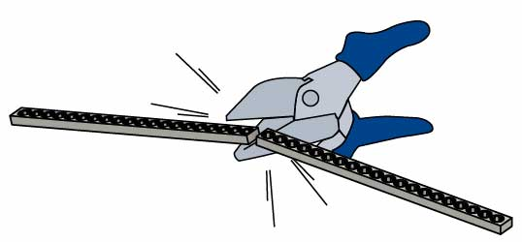
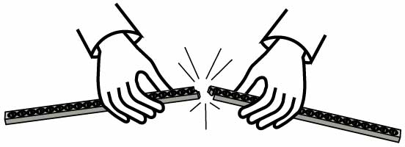
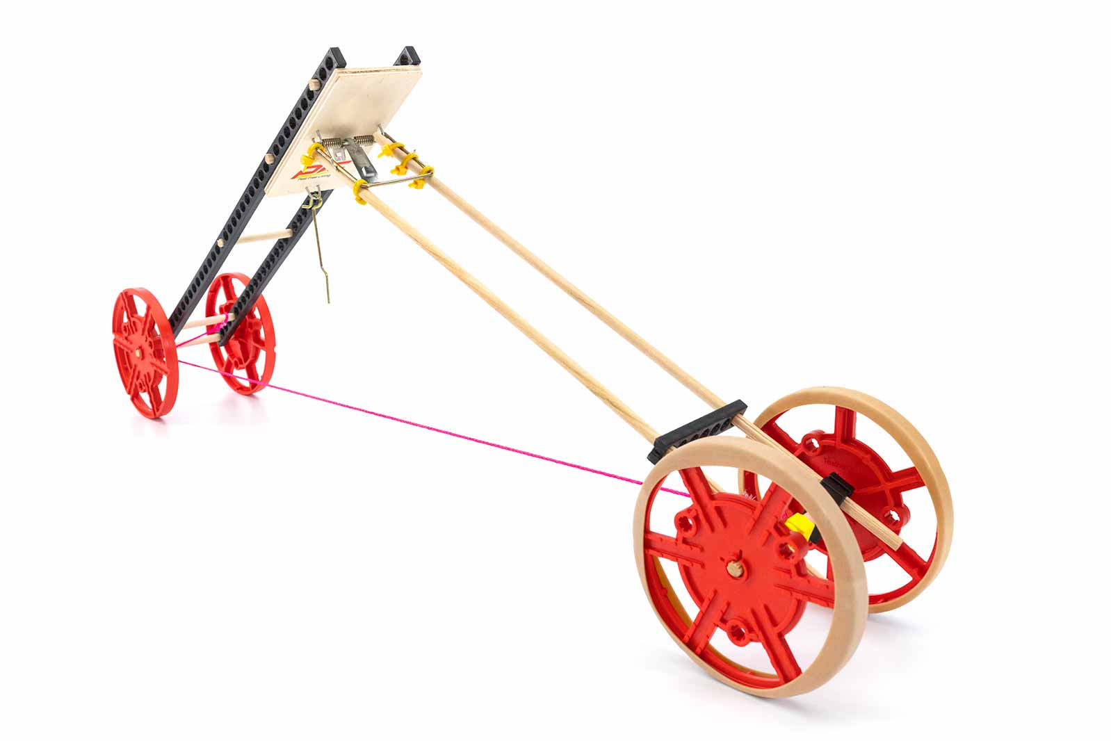
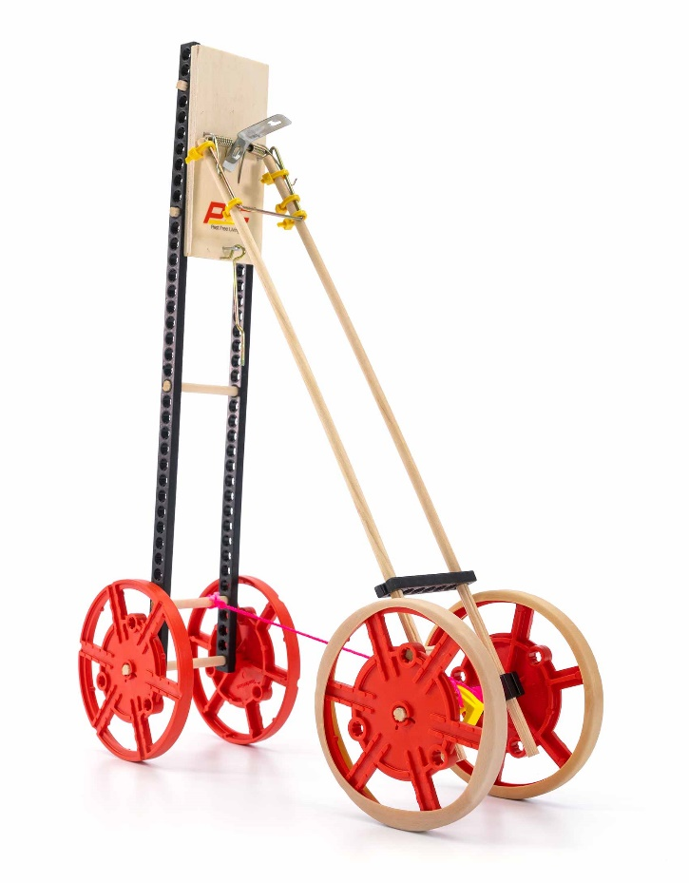
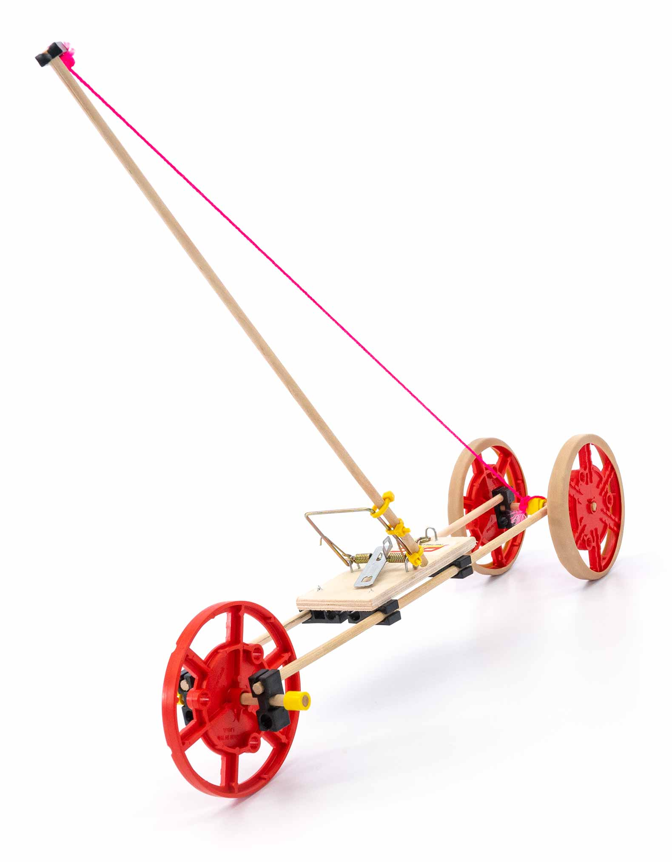
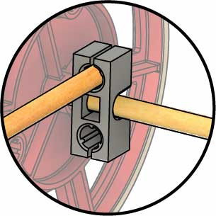
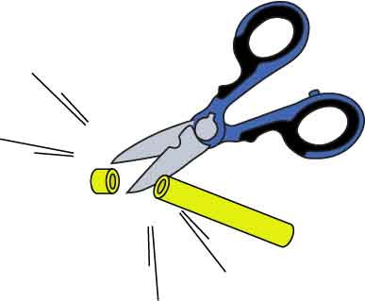
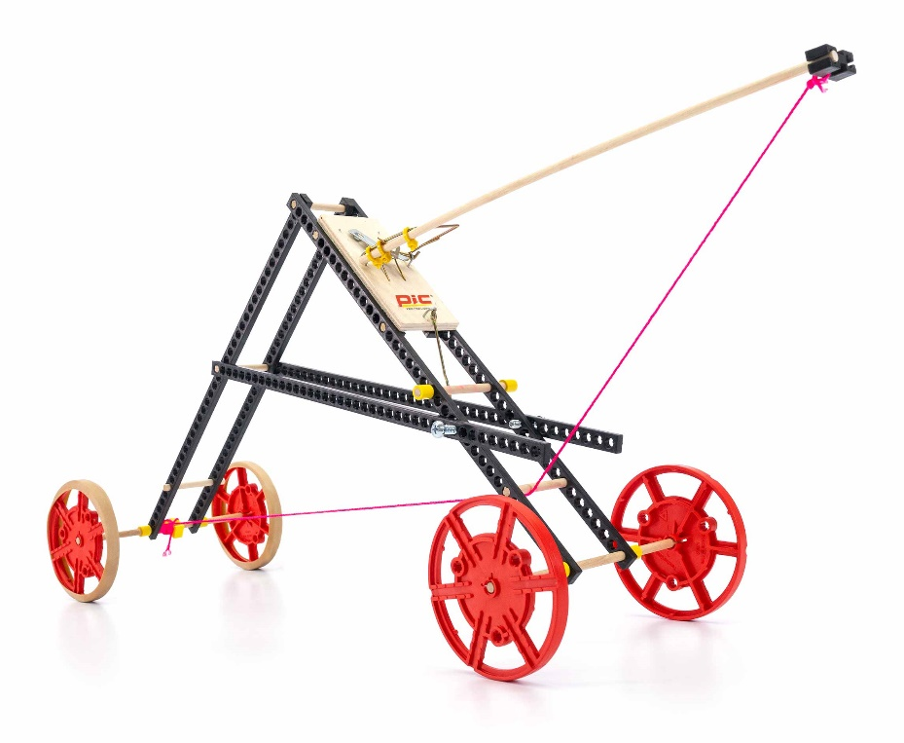
Cut or snap strips to make them shorter.
Crazy & Different
Dowel Frame
Connect your dowels with blocks. Ream holes where axles will spin.
Slide Stop keeps dowels from sliding through reamed holes.
All-Terrain

Design

Process

Design

Redesign

Test

Evaluate
The engineering design process never ends. There is no perfect design!
These builds are just examples to get you started. Keep re-engineering and testing your vehicle – you can make designs that are much better than these!
Re-Engineer Your Vehicle
Long Shot Challenge


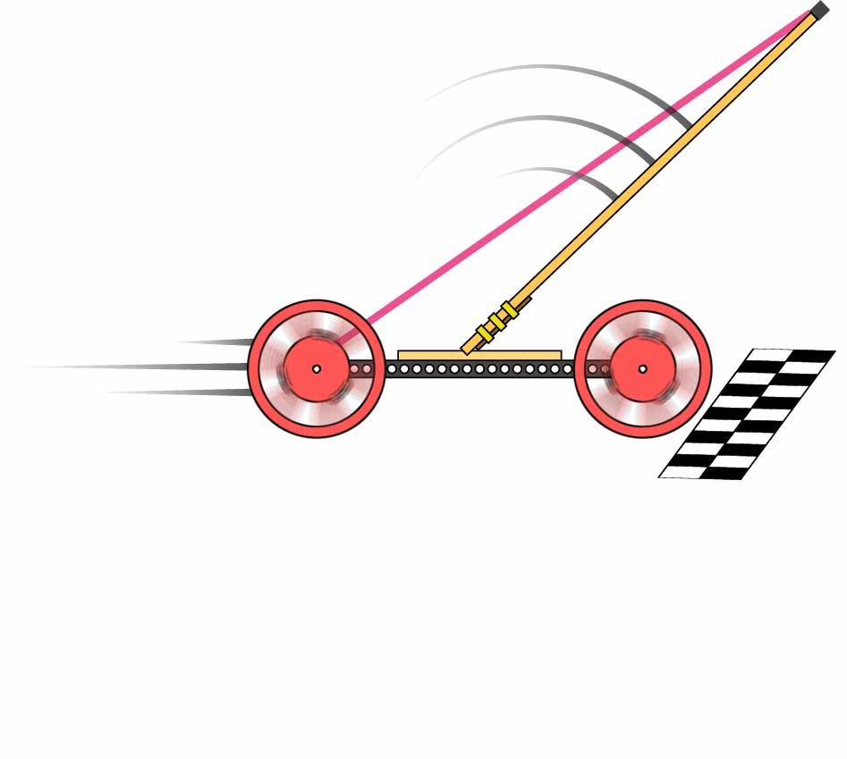

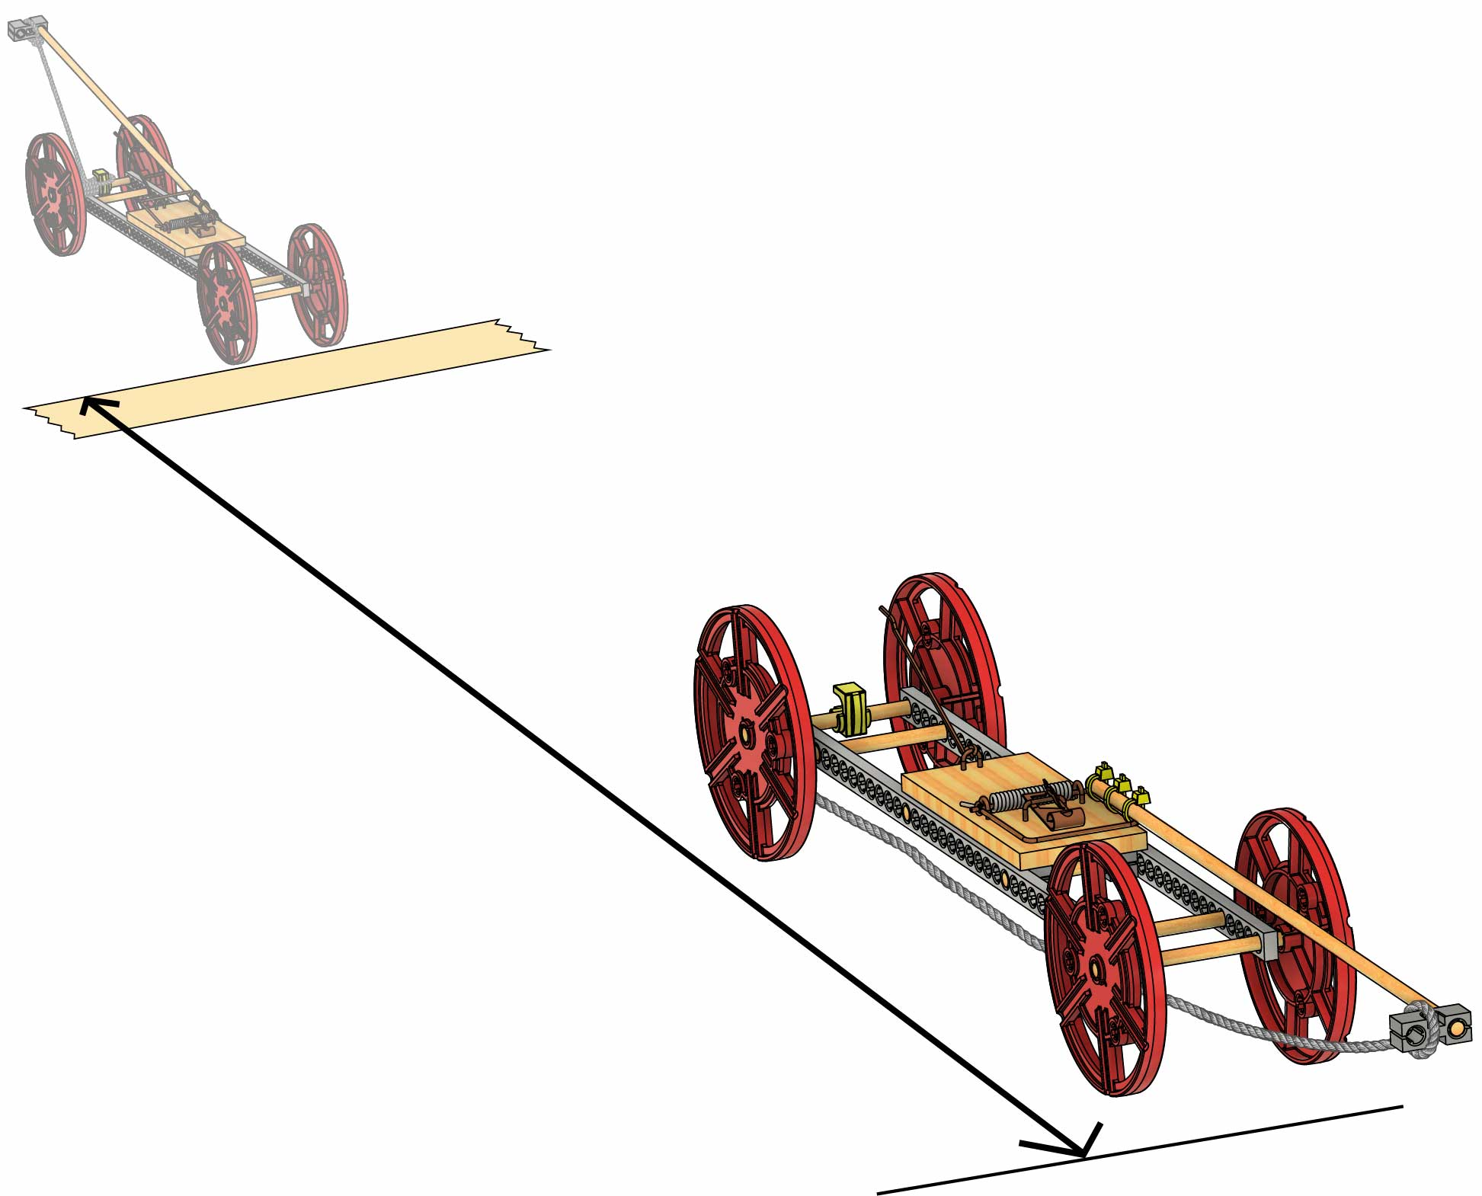
Target Challenge
Design your racer to stop as close to the bullseye as possible. The closest vehicle wins!
You can also use a finish line as a target.
Redesign your vehicle go the farthest distance possible!
Your vehicle must travel down the track the greatest distance from the start line.
Criteria:
(what your design must do)
Sprint Challenge
Compete for the fastest time on a 3 m (10 ft) track. The fastest vehicle wins!
Constraints:
(rules and limits for your design)
Your vehicle can only be powered by the mousetrap that came with this activity.
You may only use the TeacherGeek components listed on Page 1.

There is no limit on recycling
bin materials.
Do not modify the mousetrap, except by adding screws to mount it.
Measure in a straight line
from the start line to the front
of where the vehicle stops.
START
Optional Challenges
These challenges use the same constraints as the Long Shot Challenge (above).

