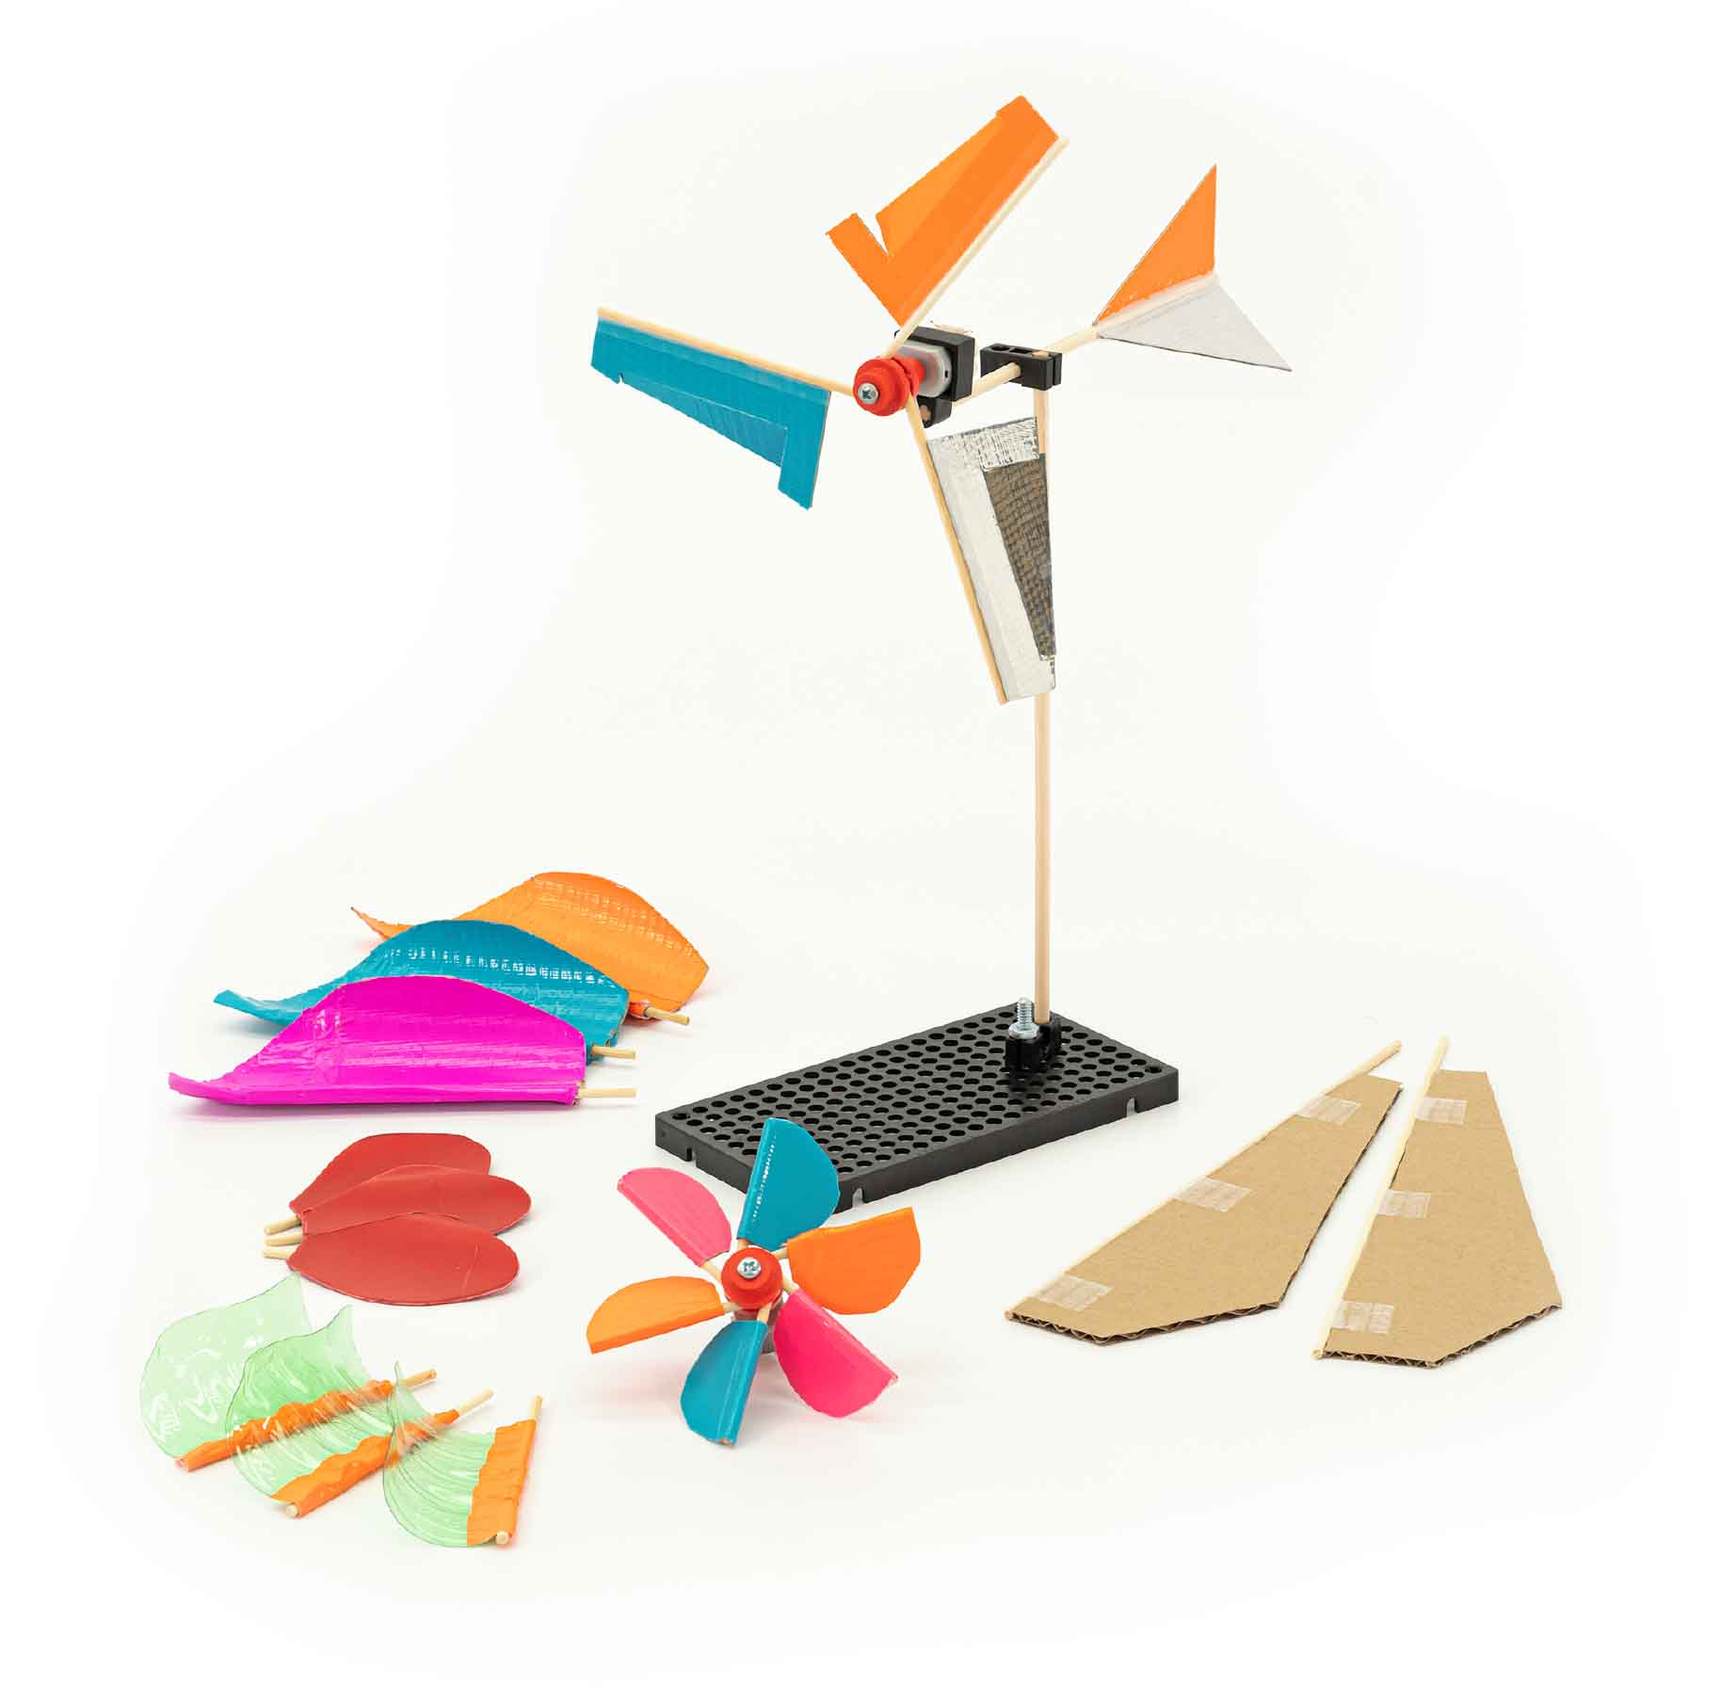

**In this lab, you’ll isolate one variable of your blade’s design, experiment with it, and use what you learned to make your turbine even better!**

# Lab Supplies

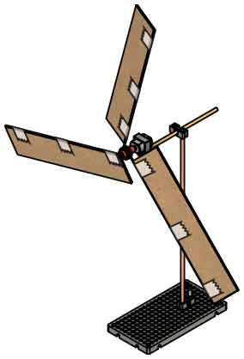

**4x Alligator Clip Leads**

optional – for connecting the multimeter

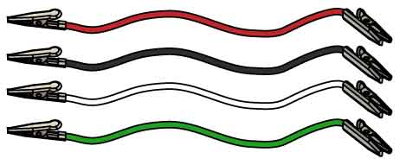

**Scissors**

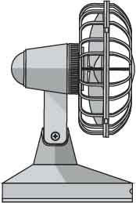

**Fan**

**Blade Materials**

Cardboard, recycling bin materials, tape, etc.

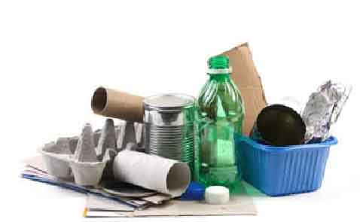

**Digital Multimeter**   
or Voltmeter

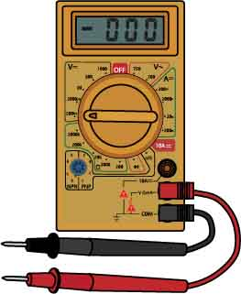

**“Built” Mini Wind Turbine**

**2.7 Ω Resistor**

optional – smooths voltage readings



**Need to build your turbine?**

Download the [**Go Guide**](https://teachergeek.org/mini_wind_turbine_go_guide4H.docx)at [**shop4-h.org**](https://shop4-h.org/)

# Ask A Question

# 1

**Choose a variable to investigate:**

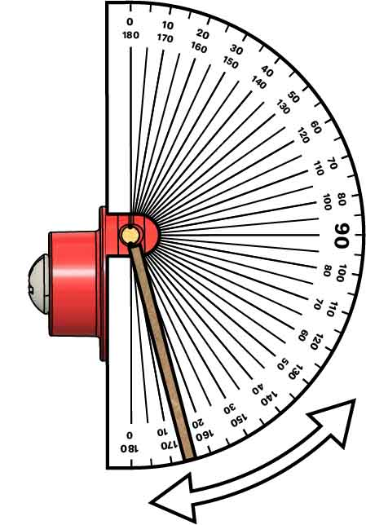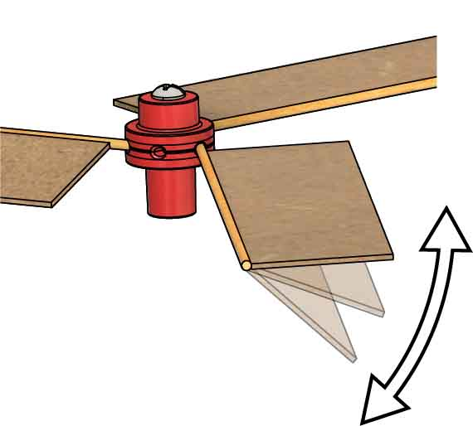

Blade Angle

Blade angle is the most important variable, and it’s also the easiest to change! **Try angles between 0° and 90°. Use a protractor to measure your angles.**

This blade is angled to 15°.

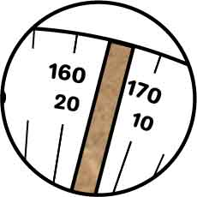

Blade Length

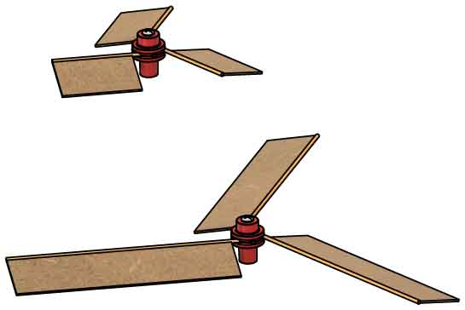

Each blade acts like a lever turning your generator. **What works better for speed – long or short blades/levers?** Test different lengths to find out!

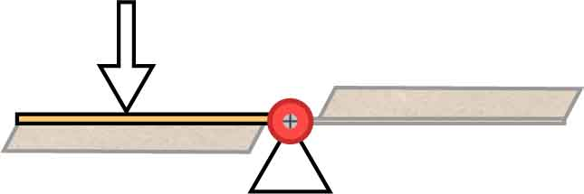

Blade Width

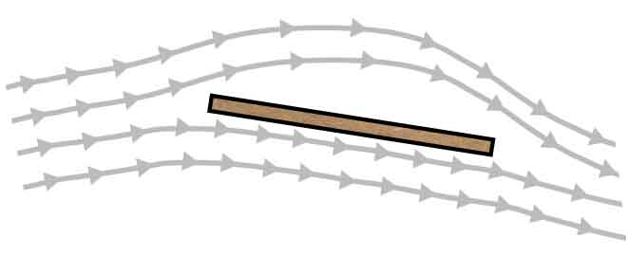

Wind

Blade

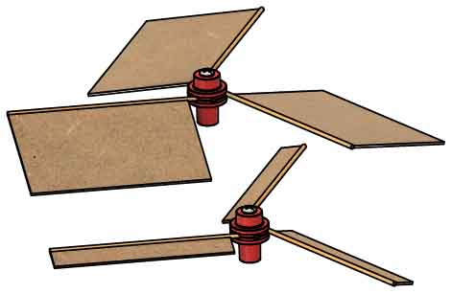

Wider blades catch more wind, but also have more friction.   
**What width works the best?** Design an experiment to find out!

Blades redirect   
the wind, which causes them to spin.

Other Variables

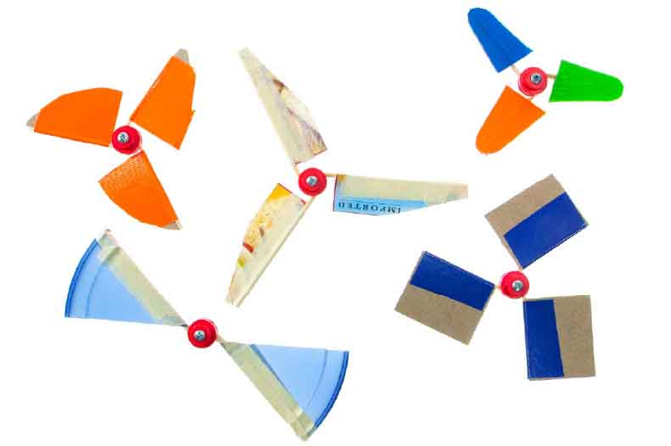



If doing this lab for school, make sure your teacher approves the variable you are testing.

Blade shape, blade materials, number of blades, … the possibilities are endless! **What variable will you investigate?**

Sketch:

_______________________________________________________________________________________________________________________________________________________________________________________________________________________________________________________________________________________________________________________________________________________________________________________________________________________________

Plan:

Write a plan for your experiment, including a sketch of the setup. Make sure you provide enough information for others to repeat your experiment.

# 3

# 2

|  |  |  |
| --- | --- | --- |
| **Independent Variable(s)** | **Dependent Variable(s)** | **Control Variable(s)** |
|  |  |  |

What variables do you need to keep track of?

# Plan Your Experiment

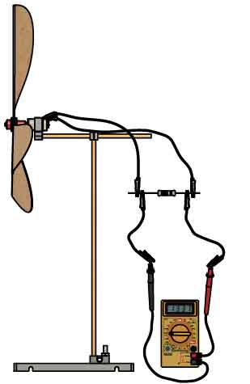

# 4

|  |  |  |  |  |  |  |  |  |  |  |  |  |  |  |  |  |  |  |  |  |  |  |  |  |  |  |  |  |  |  |
| --- | --- | --- | --- | --- | --- | --- | --- | --- | --- | --- | --- | --- | --- | --- | --- | --- | --- | --- | --- | --- | --- | --- | --- | --- | --- | --- | --- | --- | --- | --- |
|  |  |  |  |  |  |  |  |  |  |  |  |  |  |  |  |  |  |  |  |  |  |  |  |  |  |  |  |  |  |  |
|  |  |  |  |  |  |  |  |  |  |  |  |  |  |  |  |  |  |  |  |  |  |  |  |  |  |  |  |  |  |  |
|  |  |  |  |  |  |  |  |  |  |  |  |  |  |  |  |  |  |  |  |  |  |  |  |  |  |  |  |  |  |  |
|  |  |  |  |  |  |  |  |  |  |  |  |  |  |  |  |  |  |  |  |  |  |  |  |  |  |  |  |  |  |  |
|  |  |  |  |  |  |  |  |  |  |  |  |  |  |  |  |  |  |  |  |  |  |  |  |  |  |  |  |  |  |  |
|  |  |  |  |  |  |  |  |  |  |  |  |  |  |  |  |  |  |  |  |  |  |  |  |  |  |  |  |  |  |  |
|  |  |  |  |  |  |  |  |  |  |  |  |  |  |  |  |  |  |  |  |  |  |  |  |  |  |  |  |  |  |  |
|  |  |  |  |  |  |  |  |  |  |  |  |  |  |  |  |  |  |  |  |  |  |  |  |  |  |  |  |  |  |  |
|  |  |  |  |  |  |  |  |  |  |  |  |  |  |  |  |  |  |  |  |  |  |  |  |  |  |  |  |  |  |  |
|  |  |  |  |  |  |  |  |  |  |  |  |  |  |  |  |  |  |  |  |  |  |  |  |  |  |  |  |  |  |  |
|  |  |  |  |  |  |  |  |  |  |  |  |  |  |  |  |  |  |  |  |  |  |  |  |  |  |  |  |  |  |  |
|  |  |  |  |  |  |  |  |  |  |  |  |  |  |  |  |  |  |  |  |  |  |  |  |  |  |  |  |  |  |  |
|  |  |  |  |  |  |  |  |  |  |  |  |  |  |  |  |  |  |  |  |  |  |  |  |  |  |  |  |  |  |  |
|  |  |  |  |  |  |  |  |  |  |  |  |  |  |  |  |  |  |  |  |  |  |  |  |  |  |  |  |  |  |  |
|  |  |  |  |  |  |  |  |  |  |  |  |  |  |  |  |  |  |  |  |  |  |  |  |  |  |  |  |  |  |  |
|  |  |  |  |  |  |  |  |  |  |  |  |  |  |  |  |  |  |  |  |  |  |  |  |  |  |  |  |  |  |  |
|  |  |  |  |  |  |  |  |  |  |  |  |  |  |  |  |  |  |  |  |  |  |  |  |  |  |  |  |  |  |  |
|  |  |  |  |  |  |  |  |  |  |  |  |  |  |  |  |  |  |  |  |  |  |  |  |  |  |  |  |  |  |  |
|  |  |  |  |  |  |  |  |  |  |  |  |  |  |  |  |  |  |  |  |  |  |  |  |  |  |  |  |  |  |  |
|  |  |  |  |  |  |  |  |  |  |  |  |  |  |  |  |  |  |  |  |  |  |  |  |  |  |  |  |  |  |  |
|  |  |  |  |  |  |  |  |  |  |  |  |  |  |  |  |  |  |  |  |  |  |  |  |  |  |  |  |  |  |  |
|  |  |  |  |  |  |  |  |  |  |  |  |  |  |  |  |  |  |  |  |  |  |  |  |  |  |  |  |  |  |  |
|  |  |  |  |  |  |  |  |  |  |  |  |  |  |  |  |  |  |  |  |  |  |  |  |  |  |  |  |  |  |  |
|  |  |  |  |  |  |  |  |  |  |  |  |  |  |  |  |  |  |  |  |  |  |  |  |  |  |  |  |  |  |  |
|  |  |  |  |  |  |  |  |  |  |  |  |  |  |  |  |  |  |  |  |  |  |  |  |  |  |  |  |  |  |  |
|  |  |  |  |  |  |  |  |  |  |  |  |  |  |  |  |  |  |  |  |  |  |  |  |  |  |  |  |  |  |  |
|  |  |  |  |  |  |  |  |  |  |  |  |  |  |  |  |  |  |  |  |  |  |  |  |  |  |  |  |  |  |  |
|  |  |  |  |  |  |  |  |  |  |  |  |  |  |  |  |  |  |  |  |  |  |  |  |  |  |  |  |  |  |  |
|  |  |  |  |  |  |  |  |  |  |  |  |  |  |  |  |  |  |  |  |  |  |  |  |  |  |  |  |  |  |  |

# Collect Data

**Need help setting up   
for testing?**

See Page 4 of the [**Go Guide**](https://teachergeek.org/mini_wind_turbine_go_guide4H.docx), availableat[**shop4-h.org**](https://shop4-h.org/)

Do your experiment! Record your data on these pages in lists or tables. Then graph it to look for patterns.

## Collect Data (continued)

|  |  |  |  |  |  |  |  |  |  |  |  |  |  |  |  |  |  |  |  |  |  |  |  |  |  |  |  |  |  |  |
| --- | --- | --- | --- | --- | --- | --- | --- | --- | --- | --- | --- | --- | --- | --- | --- | --- | --- | --- | --- | --- | --- | --- | --- | --- | --- | --- | --- | --- | --- | --- |
|  |  |  |  |  |  |  |  |  |  |  |  |  |  |  |  |  |  |  |  |  |  |  |  |  |  |  |  |  |  |  |
|  |  |  |  |  |  |  |  |  |  |  |  |  |  |  |  |  |  |  |  |  |  |  |  |  |  |  |  |  |  |  |
|  |  |  |  |  |  |  |  |  |  |  |  |  |  |  |  |  |  |  |  |  |  |  |  |  |  |  |  |  |  |  |
|  |  |  |  |  |  |  |  |  |  |  |  |  |  |  |  |  |  |  |  |  |  |  |  |  |  |  |  |  |  |  |
|  |  |  |  |  |  |  |  |  |  |  |  |  |  |  |  |  |  |  |  |  |  |  |  |  |  |  |  |  |  |  |
|  |  |  |  |  |  |  |  |  |  |  |  |  |  |  |  |  |  |  |  |  |  |  |  |  |  |  |  |  |  |  |
|  |  |  |  |  |  |  |  |  |  |  |  |  |  |  |  |  |  |  |  |  |  |  |  |  |  |  |  |  |  |  |
|  |  |  |  |  |  |  |  |  |  |  |  |  |  |  |  |  |  |  |  |  |  |  |  |  |  |  |  |  |  |  |
|  |  |  |  |  |  |  |  |  |  |  |  |  |  |  |  |  |  |  |  |  |  |  |  |  |  |  |  |  |  |  |
|  |  |  |  |  |  |  |  |  |  |  |  |  |  |  |  |  |  |  |  |  |  |  |  |  |  |  |  |  |  |  |
|  |  |  |  |  |  |  |  |  |  |  |  |  |  |  |  |  |  |  |  |  |  |  |  |  |  |  |  |  |  |  |
|  |  |  |  |  |  |  |  |  |  |  |  |  |  |  |  |  |  |  |  |  |  |  |  |  |  |  |  |  |  |  |
|  |  |  |  |  |  |  |  |  |  |  |  |  |  |  |  |  |  |  |  |  |  |  |  |  |  |  |  |  |  |  |
|  |  |  |  |  |  |  |  |  |  |  |  |  |  |  |  |  |  |  |  |  |  |  |  |  |  |  |  |  |  |  |
|  |  |  |  |  |  |  |  |  |  |  |  |  |  |  |  |  |  |  |  |  |  |  |  |  |  |  |  |  |  |  |
|  |  |  |  |  |  |  |  |  |  |  |  |  |  |  |  |  |  |  |  |  |  |  |  |  |  |  |  |  |  |  |
|  |  |  |  |  |  |  |  |  |  |  |  |  |  |  |  |  |  |  |  |  |  |  |  |  |  |  |  |  |  |  |
|  |  |  |  |  |  |  |  |  |  |  |  |  |  |  |  |  |  |  |  |  |  |  |  |  |  |  |  |  |  |  |
|  |  |  |  |  |  |  |  |  |  |  |  |  |  |  |  |  |  |  |  |  |  |  |  |  |  |  |  |  |  |  |
|  |  |  |  |  |  |  |  |  |  |  |  |  |  |  |  |  |  |  |  |  |  |  |  |  |  |  |  |  |  |  |
|  |  |  |  |  |  |  |  |  |  |  |  |  |  |  |  |  |  |  |  |  |  |  |  |  |  |  |  |  |  |  |
|  |  |  |  |  |  |  |  |  |  |  |  |  |  |  |  |  |  |  |  |  |  |  |  |  |  |  |  |  |  |  |
|  |  |  |  |  |  |  |  |  |  |  |  |  |  |  |  |  |  |  |  |  |  |  |  |  |  |  |  |  |  |  |
|  |  |  |  |  |  |  |  |  |  |  |  |  |  |  |  |  |  |  |  |  |  |  |  |  |  |  |  |  |  |  |
|  |  |  |  |  |  |  |  |  |  |  |  |  |  |  |  |  |  |  |  |  |  |  |  |  |  |  |  |  |  |  |
|  |  |  |  |  |  |  |  |  |  |  |  |  |  |  |  |  |  |  |  |  |  |  |  |  |  |  |  |  |  |  |
|  |  |  |  |  |  |  |  |  |  |  |  |  |  |  |  |  |  |  |  |  |  |  |  |  |  |  |  |  |  |  |
|  |  |  |  |  |  |  |  |  |  |  |  |  |  |  |  |  |  |  |  |  |  |  |  |  |  |  |  |  |  |  |
|  |  |  |  |  |  |  |  |  |  |  |  |  |  |  |  |  |  |  |  |  |  |  |  |  |  |  |  |  |  |  |
|  |  |  |  |  |  |  |  |  |  |  |  |  |  |  |  |  |  |  |  |  |  |  |  |  |  |  |  |  |  |  |
|  |  |  |  |  |  |  |  |  |  |  |  |  |  |  |  |  |  |  |  |  |  |  |  |  |  |  |  |  |  |  |
|  |  |  |  |  |  |  |  |  |  |  |  |  |  |  |  |  |  |  |  |  |  |  |  |  |  |  |  |  |  |  |
|  |  |  |  |  |  |  |  |  |  |  |  |  |  |  |  |  |  |  |  |  |  |  |  |  |  |  |  |  |  |  |

# Interpret Data

What did you learn, and how will you use it to make a better turbine?

__________________________________________________________________________________________________________________________________________________________________________________________________________________________________________________________________________________________________________________________________________________________________________________________________________________________________________________________________________________________________________________

What do you think is going on? Why did you observe what you did?

____________________________________________________________________________________________________________________________________________________________________________________________________________________________________________________________________________________________________________________________________________

Examine your graphs and tables. How are the independent and dependent variables related (e.g. proportional, linear, exponential, inverse, …)? How do you know?

__________________________________________________________________________________________________________________________________________________________________________________________________________________________________________________________________________________________________________________________________________________________________________________________________________________________________________________________________________________________________________________

# Construct an Explanation

# 5

# 7

# 6