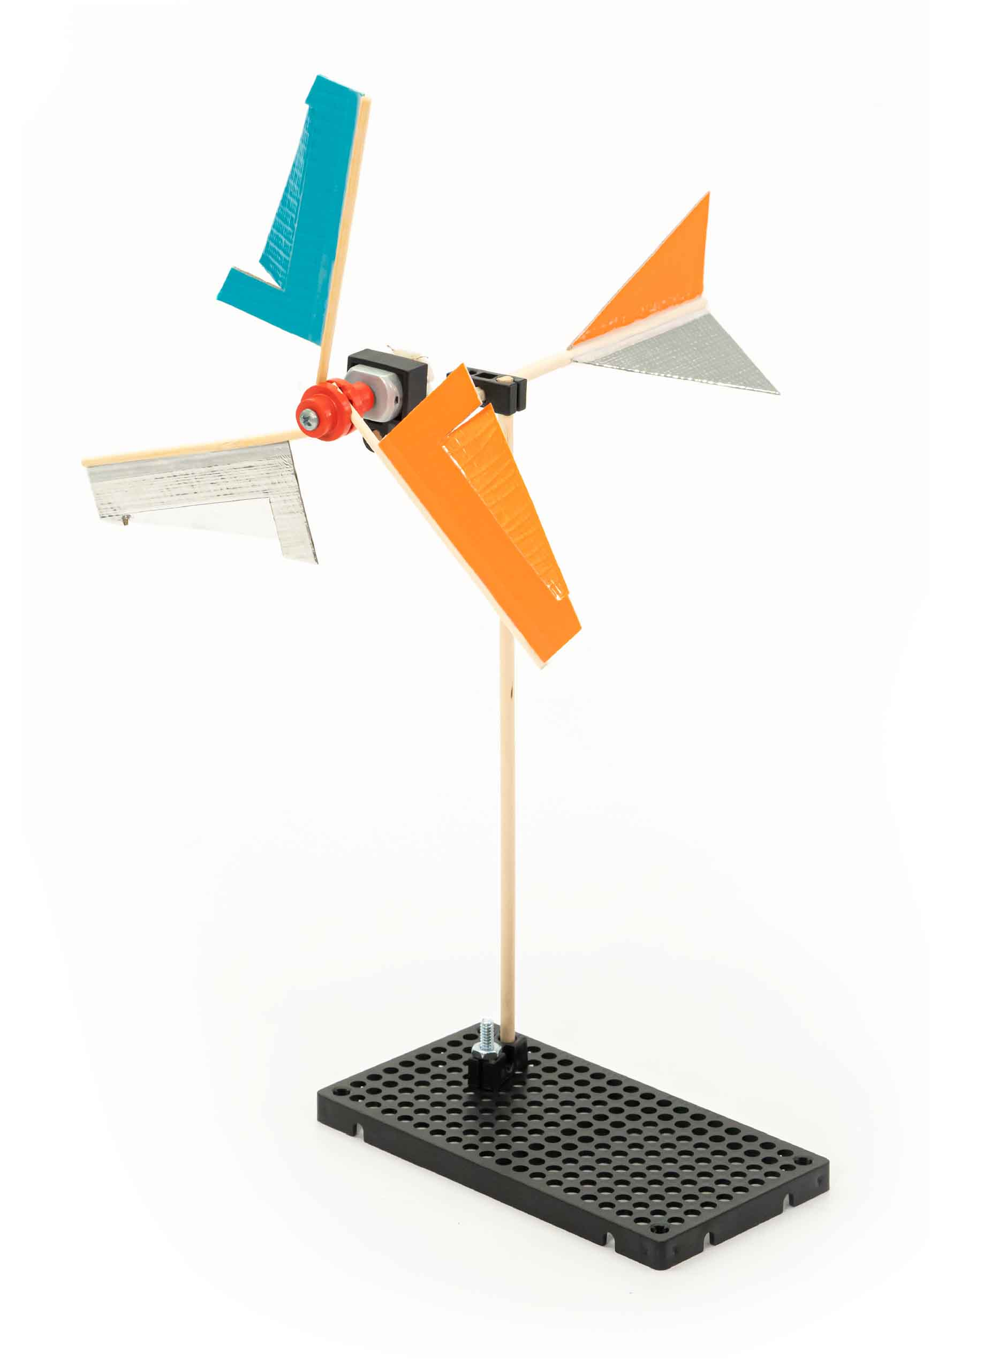

You Are Here

Go Guide

Start here! Build your Mini Wind Turbine, evolve your design, and begin the Voltage Challenge!

Optional Labs

Optional Challenges

-[Blade Design Lab](https://teachergeek.org/mini_wind_turbine_lab_blade_design.pdf) (Ages 8+)

-Wind Speed Challenge*  
-Wind Direction Challenge*  
-Environmental Challenge*

*See Page 7

**Choose how you would like to complete this activity.  
Download documents & videos at** [**teachergeek.com/miniwind**](https://teachergeek.com/miniwind)

**Learn about wind energy by designing your very   
own Mini Wind Turbine!**

## WHOOOSH!

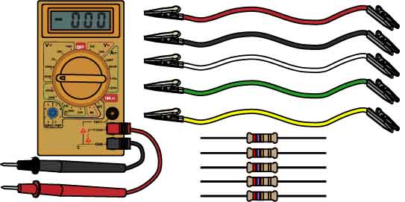

* **Phillips Screwdriver**
* **Fan**
* **Digital Multimeter**(to measure voltage generated)
* **4x Alligator Clip Leads**(*optional* – for connecting Multimeter)
* **2.7 Ω Resistor**(*optional* – to smooth voltage readings)
* **Tape**
* **Recycling Materials**(to use as turbine blades)

Do you have a …

Get everything you need to test your turbine in one convenient kit!

SKU 1823-68

**Turbine Test Kit**

Have a Maker Cart? Use Multi-Cutters to cut your own dowels.

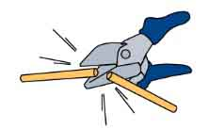

**Dowels**various sizes  
SKU 1821-20

**PICTURE**

**NAME**

**QTY**

**3**

**Hole Plate**  
SKU 1821-32

**Blocks**  
SKU 1821-34

**Nuts**# 10 Hex  
SKU 1821-25

**Screws**25 mm (1 in)  
SKU 1821-22

**Mini Hub Screw**  
SKU 1821-66

**Mini Hub Cover**  
SKU 1821-66

**Mini Hub Base**  
SKU 1821-66

**Motor**1.5V – 3V  
SKU 1821-75

**Motor Mount**Small 1.5V – 3V  
SKU 1821-69

**Project Sticks**various sizes  
SKU 1821-17 & 1821-18

**12**

**1**

**1**

**1**

**1**

**1**

**1**

**1**

**2**

**1**

**Chipboard**22 cm x 5 cm

(8.5 in x 2 in)  
SKU 1823-48

**3**

Dowel Sizes  
1x 30 cm (12 in)  
1x 15 cm (6 in)  
1x 5 cm (2 in)

Stick Sizes  
6x 25 cm (10 in)  
6x 10 cm (4 in)

Maker Cart Users: These are the   
**Red Hubs**, not   
the Green Hubs.

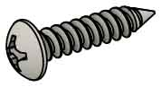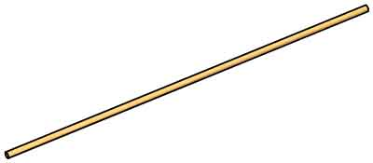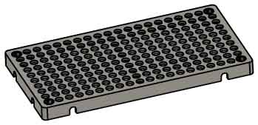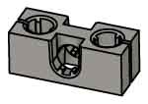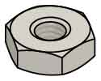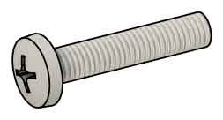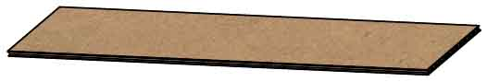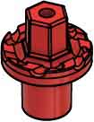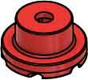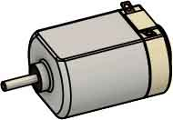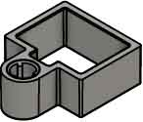

MATERIALS YOU SUPPLY

These are the parts you need to build one Mini Wind Turbine, plus some extras, so you can make your own unique designs.

TURBINE PARTS

# Supplies

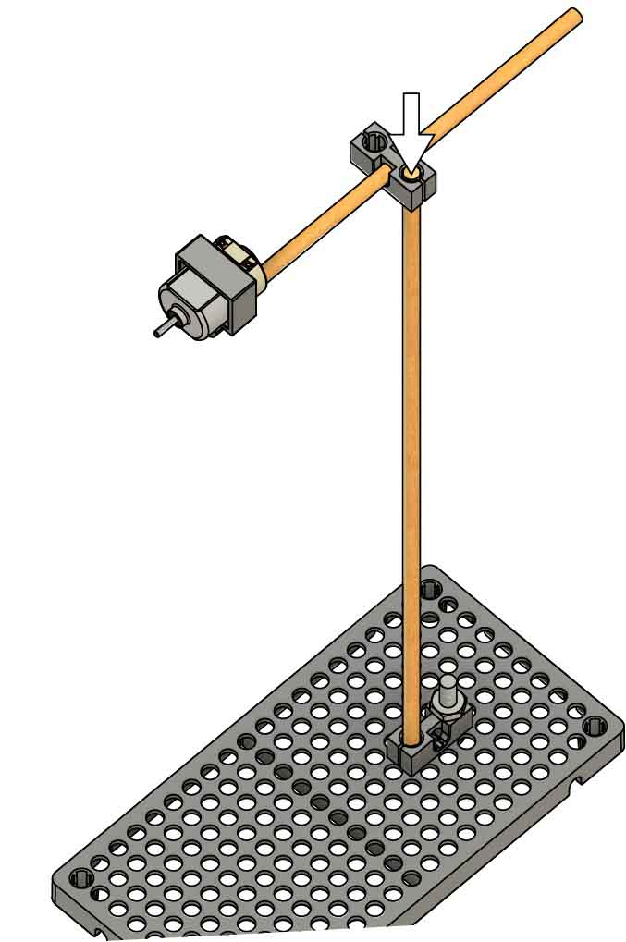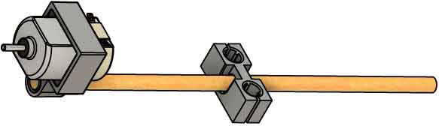

# 2

**Wiggle** or tap   
the **30 cm** (12 in)   
**dowel** into the **block** to create the **turbine** **tower**.

**Push** or tap the **block onto**the **tower**.

# 6

**Motor**

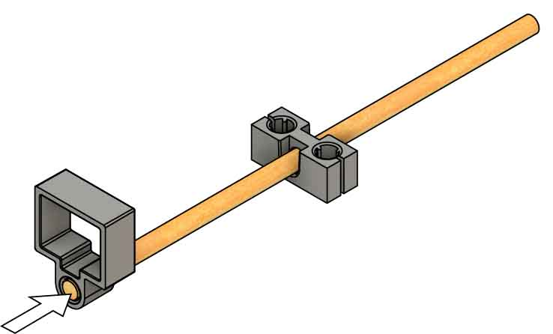

**Motor Mount**

# 4

**Push** or tap the **motor mount onto** the end of the **dowel.**

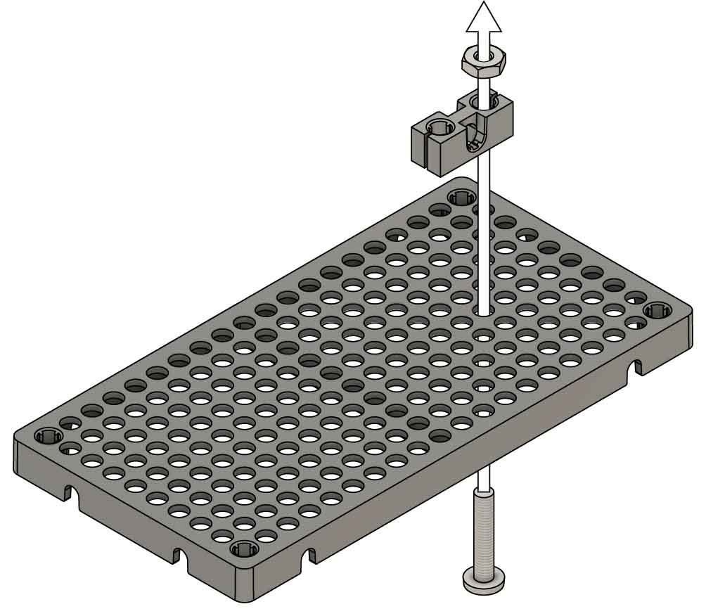

**Screw**

**Nut**

**Block**

**Hole Plate**

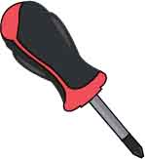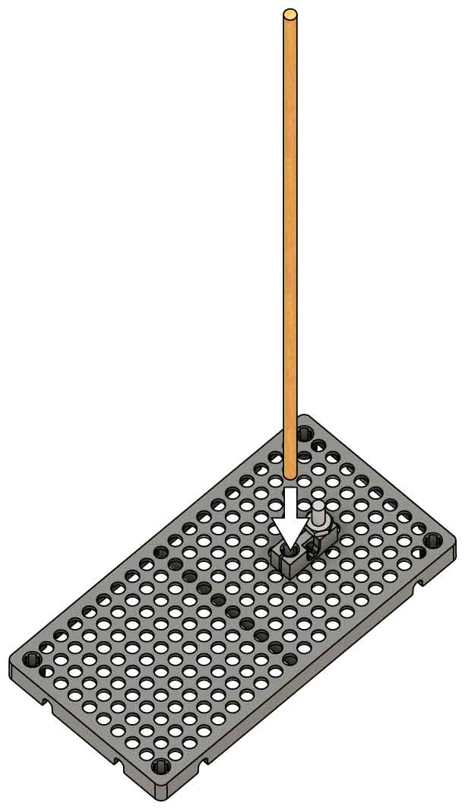

**30 cm** (12 in) **Dowel**

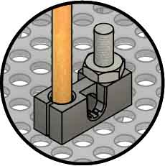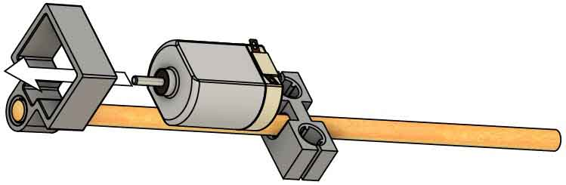

**Wiggle** or pushthe **motor into** the **mount** so the **terminals**   
face up.

# 5

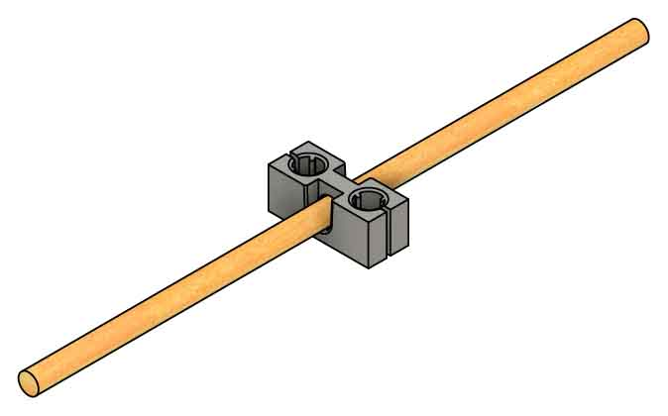

**15 cm** (6 in) **Dowel**

Get the dowel started like this.

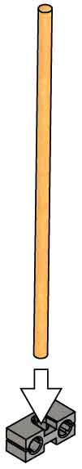

# 3

**Wiggle** or tap the **15 cm** (6 in) **dowel** into the **center hole** of a **block**, so it is near the middle.

# Build the Base

# 1

**Attach** a **block** to the top   
of the **hole** **plate** using   
a **25 mm** (1 in) **screw**   
and **nut**.

# Add the Rotor

**Push** the **hub** onto the **motor** axle.

# 8

**Attach** the **hub** **cover** tothe **base** with the **hub** **screw**.

# 7

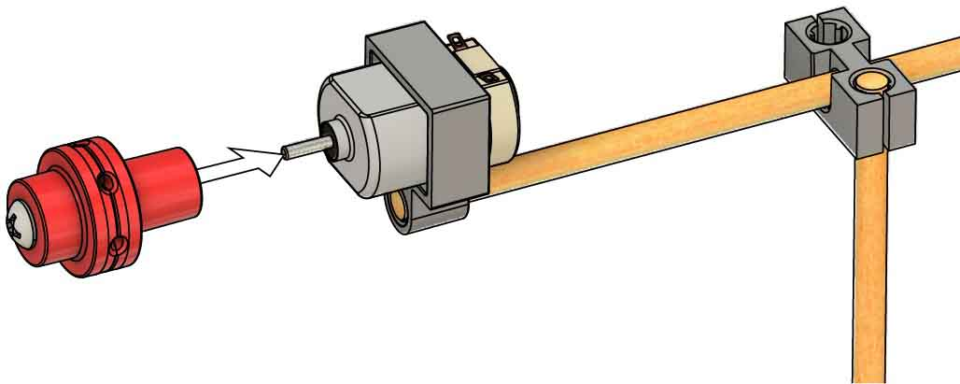

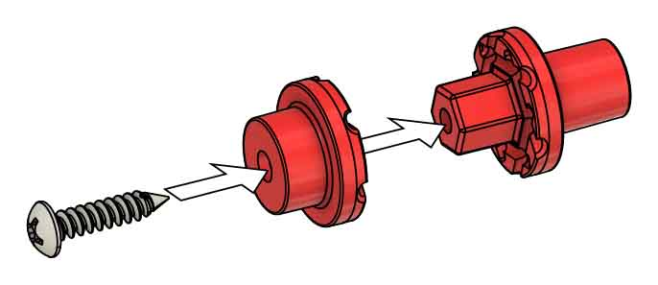

**Hub Screw**

**Cover**

**Base**

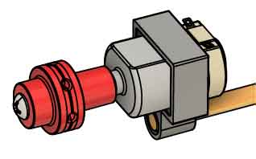

**Mounted Hub**

If you’re doing the [**Blade Design Lab**](https://teachergeek.org/mini_wind_turbine_lab_blade_design.pdf), **don’t alter your blades yet!** You’ll do that in the lab.

**Tape** a **project** **stick** **to** each **edge**, leaving some **extra** on one side.

# 10

# 9

Get **three** 22 cm x 5 cm   
(8.5 in x 2 in) **pieces**   
of **chipboard**.

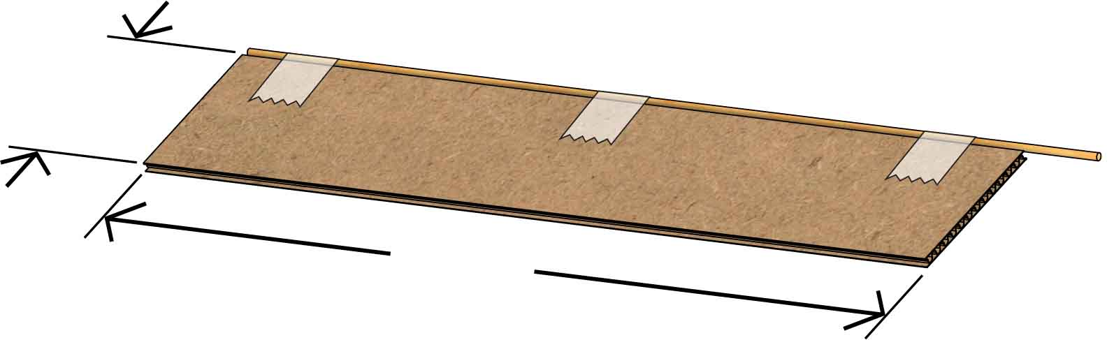

**22 cm**  
(8.5 in)

**5 cm**  
(2 in)

3x

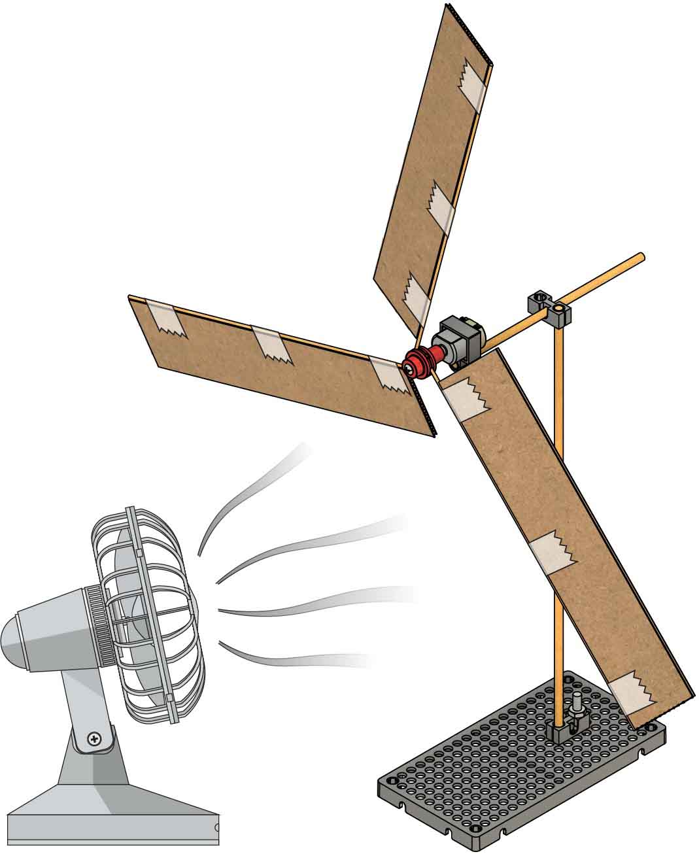

# 11

**Loosen** the mini hub **screw** just enough to allow the blades to be   
pushed in.

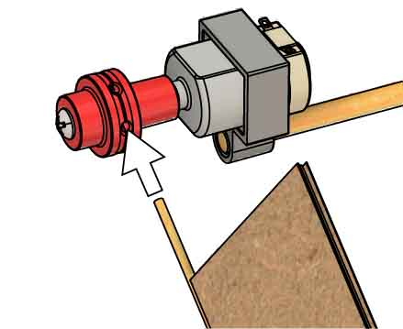



# 12

**Add** **the** **blades**, being sure to **angle** **them** (that’s what will make them spin).

# 13

**Tighten** the hub **screw** and **test it out!**

**Your turbine is done, but you aren’t.** Keep reading to learn how to test your turbine, then do a lab or challenge!

**There are two ways to connect your meter**. Option 1 is a little bit easier to set up, but Option 2 fluctuates less when testing.

You are going to hook up a Multi-Meter to your turbine to measure the voltage it generates – the faster your blades spin, the greater the voltage will be. More volts means more power!

Circuit Diagrams:

Can you figure out what the symbols mean?

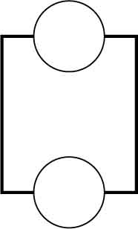

G

V

**Option 1**

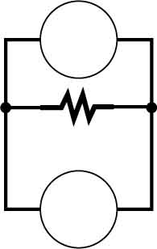

G

V

**2.7 Ω**

**Option 2**

OR

Option 1: Multimeter Only

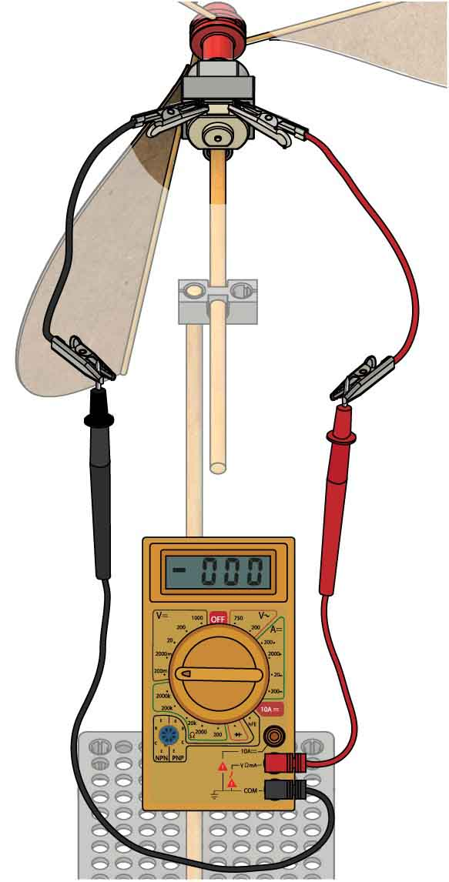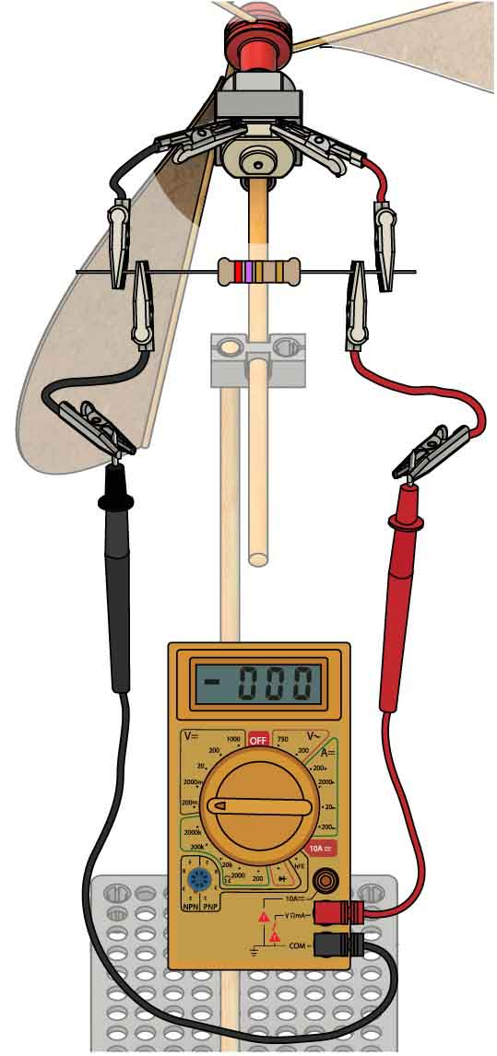

Option 2: Meter & 2.7 ΩResistor

Resistor  
(2.7 Ω)

**Recommended**

**Connect your meter.**

# 15

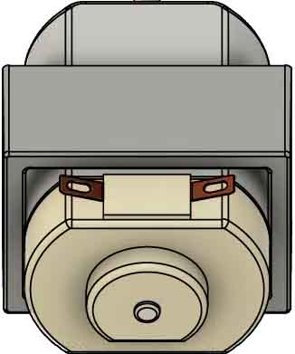

You will **connect** your **meter** to the **terminals** of the motor/generator.

# Testing

# 14

**Set up your meter.**

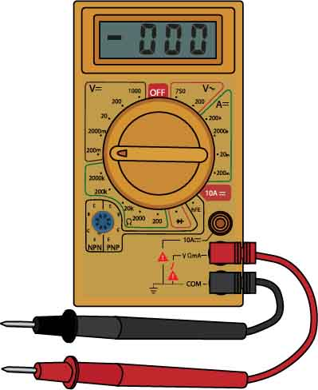

Set your dial to **200mV DC**.

Connect your **Leads** to the **V and COM Terminals**.

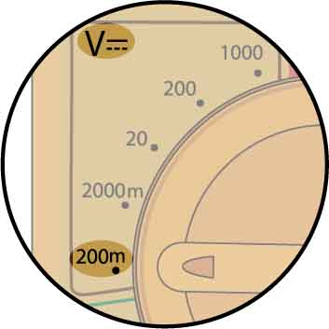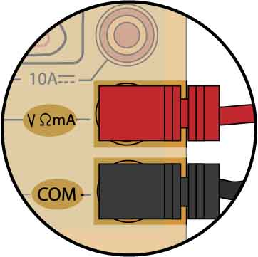

**How well does your turbine work? Hook up a Multi-Meter to find out!**

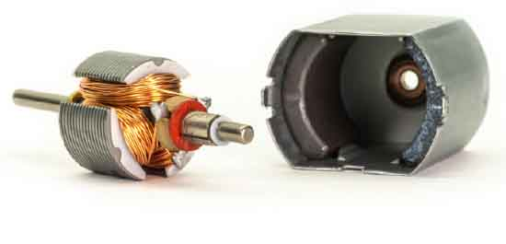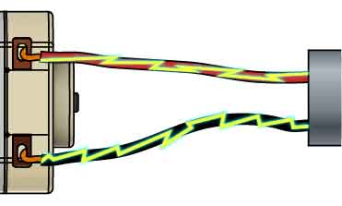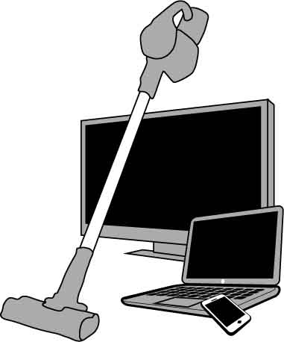

The **Light Bulb** uses the Electrical Energy, so it’s called the Load.

C

**Loads** are anything that uses electrical energy, like your TV, vacuum cleaner, and phone.

Only one of the turbine testing options, from Page 4, has a load. Which one? What’s the load?

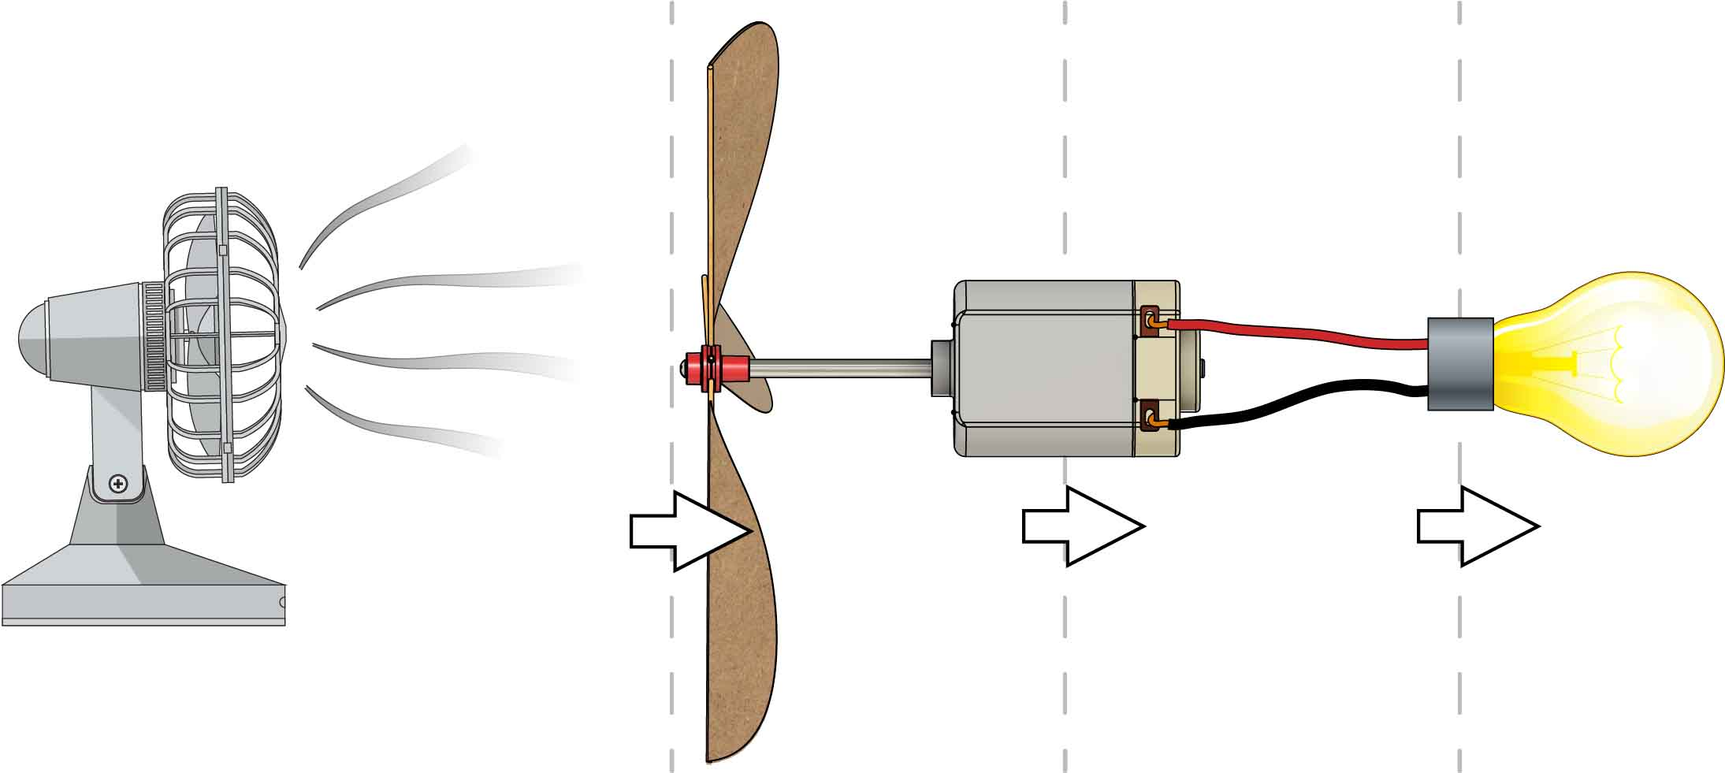

Wind Energy

Mechanical Energy

Electrical Energy

Load

A

B

C

The **Generator** converts Mechanical Energy into Electrical Energy.

B

When the **Generator** (motor) spins, the wire coils and magnets inside create electricity.

**Electrical Energy** is the energy of electricity (electrons traveling through the wires).

The **Turbine Blades** convert Wind Energy to Mechanical Energy.

A

**Wind Energy** is really Kinetic Energy – it’s the energy of the moving air molecules.

**Mechanical Energy** is the Kinetic and Potential Energy of the spinning turbine blades.

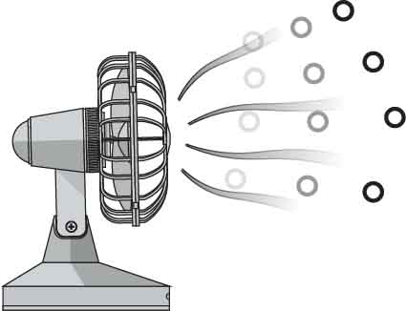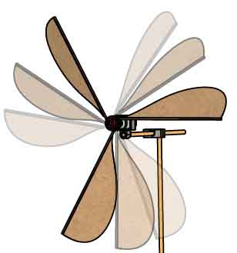

# Energy Transfers

Your turbine isn’t strong enough to power a light bulb, but it is strong enough to measure the electrical power.

Note:

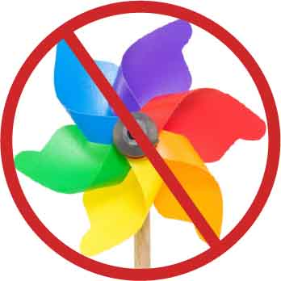

Blades must not be dangerous (e.g. metal, sharp edges, etc.).

You may only use the supplies listed on Page 1.

You can use as many recycling bin materials as you want!

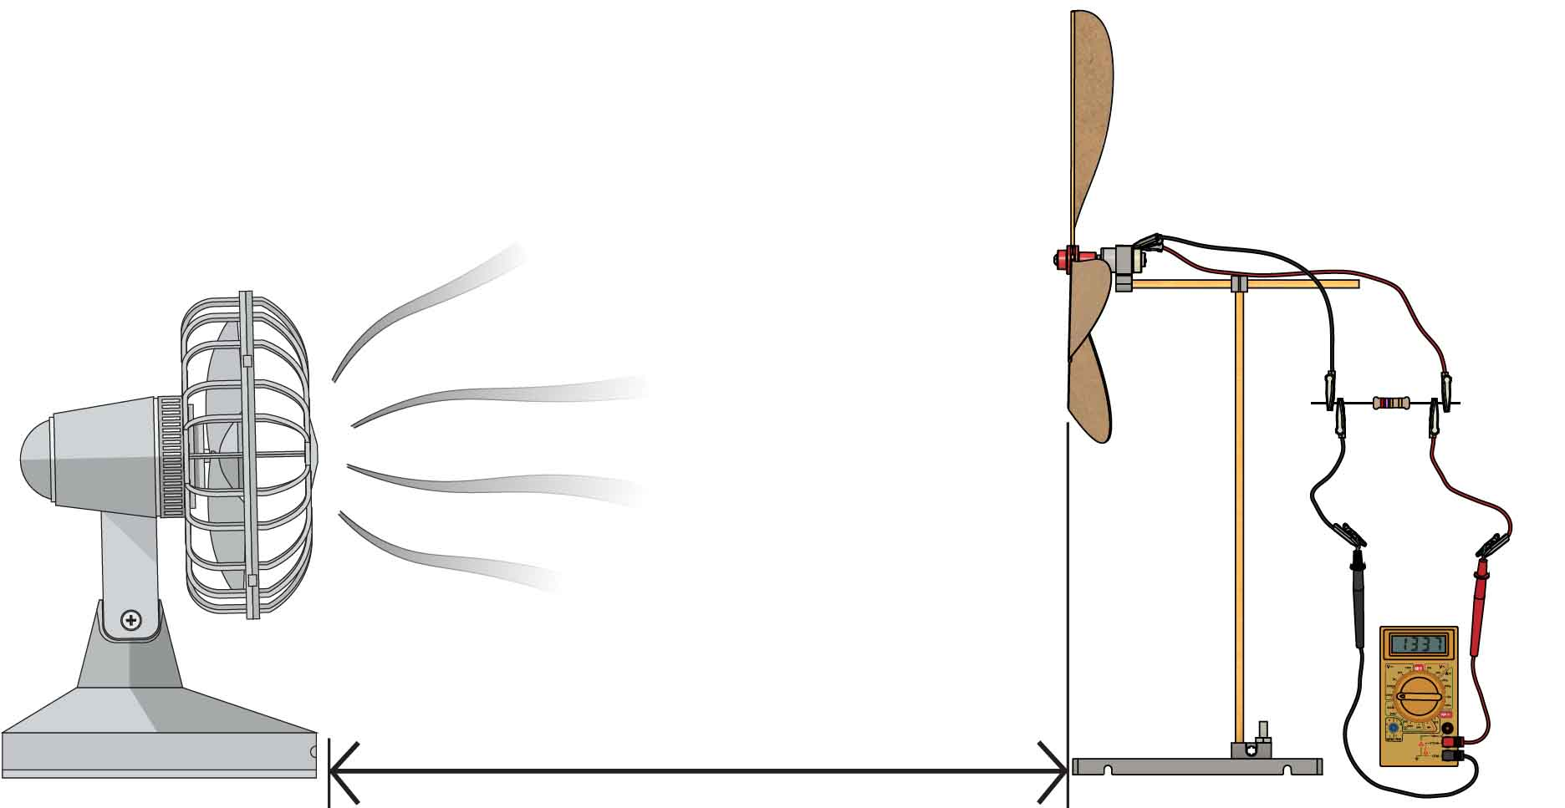

**60 cm**  
(24 in)

Your **wind** **turbine** must be at least **60 cm** (24 in) from the **fan**.

The **fan** must be the **only power source** for your turbine.

All designs must use the **same testing circuit**.

See Page 5 for testing setup.

Materials:

You may not use   
pre-fabricated blades   
(e.g. from a pinwheel).

You must design your own blades.

# Voltage Challenge

The design that generates the greatest voltage wins!

Setup:

Constraints:

(rules and limits for your design)

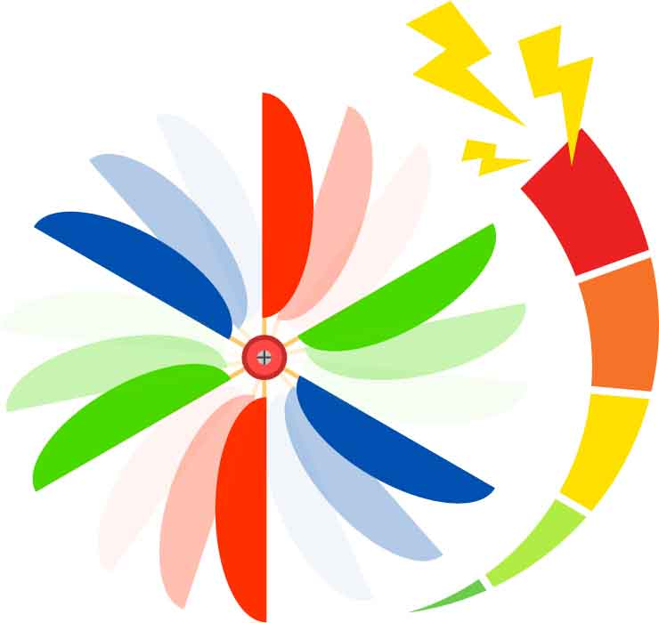

Wind turbines are criticised for looking ugly and killing birds. **Modify your turbine to look nice in nature and have safety features to protect birds from the blades.**

Environmental Challenge:

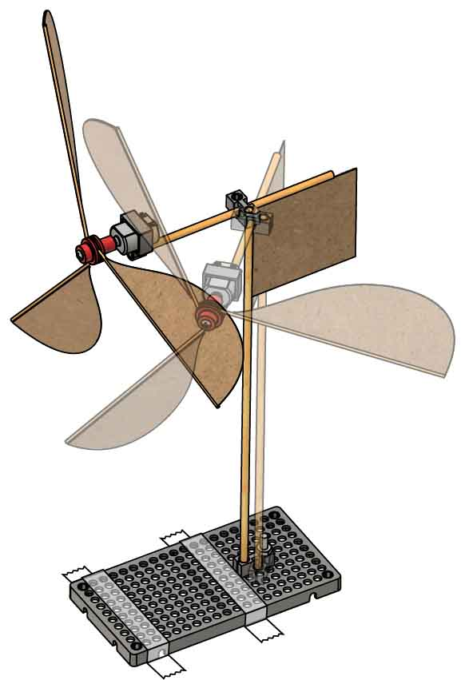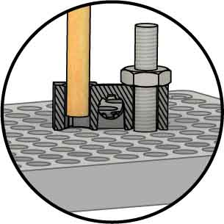

Dowel pulled up from hole plate.

Screw & nut slightly loose.

**Use tape** or a weight (e.g. a book) to hold your turbine in place.

**Design Tips:**

**Add a vane** (blade) to the back of your turbine to make it turn to face the wind.

**Make your block pivot** (turn) on the hole plate.

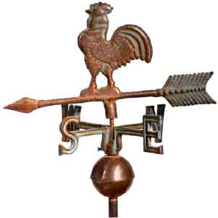

Weather vanes turn to face the wind – can you make your turbine do it, too?

Each competitor does **three trials**, back-to-back, with different fan speeds (**Low, Medium, High**). There is a **1 minute adjustment period** between trials to swap/adjust the blades for each speed.

**The turbine that generates the   
greatest voltage wins!**

An opponent places your turbine 60 cm (24 in) from the fan, turned whichever way they want. **Your turbine needs to use wind power to rotate and turn into the wind.**

**The turbine that generates the   
greatest voltage wins!**

Wind Direction Challenge:

**You finished the Voltage Challenge and want more? Try one of these!** Use the same setup and material constraints as the Voltage Challenge.

Wind Speed Challenge:

# Additional Challenges

Torque / moment inertia – RPM!!

[](https://teachergeek.org/mini_wind_turbine_lab_blade_design.docx)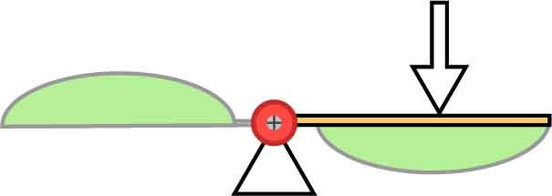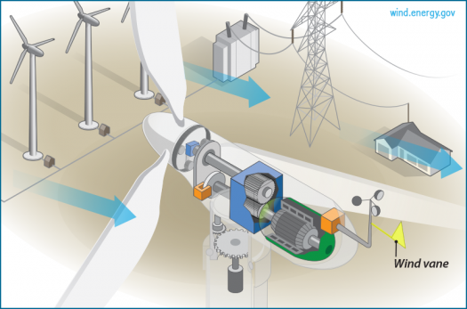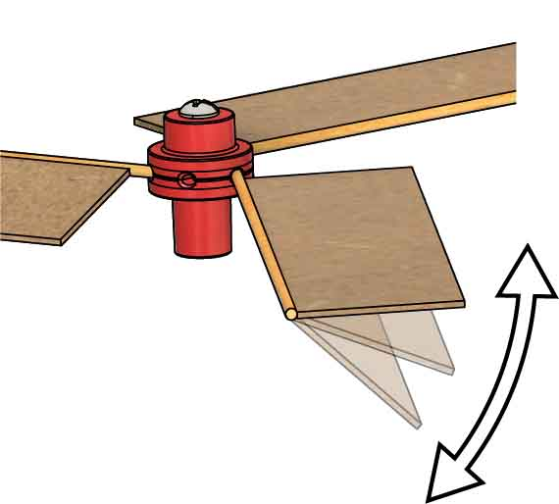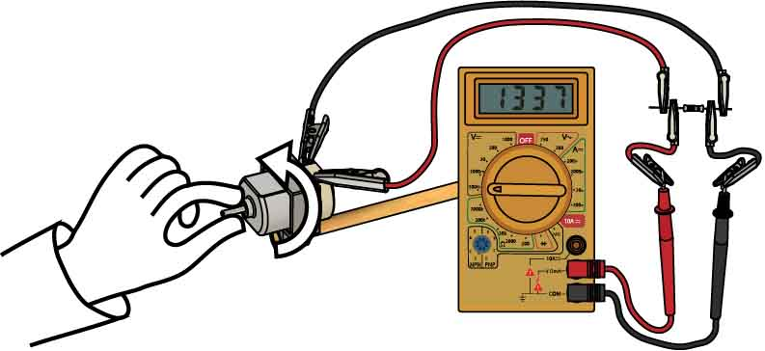

Full size wind turbines use **gears** to spin the generator quickly, even though the blades move slowly. Gears trade **torque** for speed, like levers.

Blade angle is the most important variable, and it’s also the easiest to change! **Try shallow and deep angles – what works best?**

**Want to learn more about turbine blade designs?**

Download the [**Blade Design Lab**](https://teachergeek.org/mini_wind_turbine_lab_blade_design.pdf) at[**teachergeek.com/miniwind**](https://shop4-h.org/)  **Ages 8+**

Each blade acts like a lever turning your generator. **What works better for speed – long or short blades/levers?**

Once you figure out how blade length   
and angle affect your turbine, **try changing the shape and number of blades.**

**Torque** is turning force.

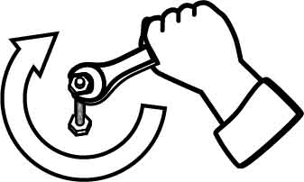

# Tuning Your Turbine

**Blade Length**

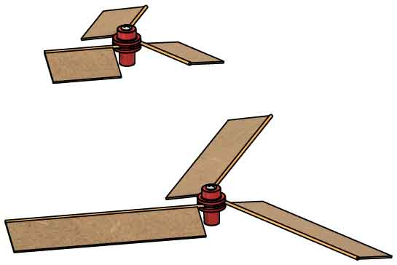

**Other Variables**

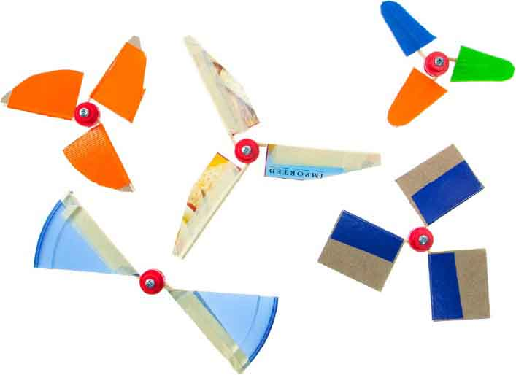

**Optional Lab**

Try **spinning the shaft at different speeds** in your fingers, and check the reading on the meter.

**Blade Angle**

**What makes it spin faster?**

**Test it out!**

Resistor Optional

**Want to generate more voltage? You need to spin the generator fast!**

**Make a fan** by using 1 or 2 AA **batteries** to   
power your motor.

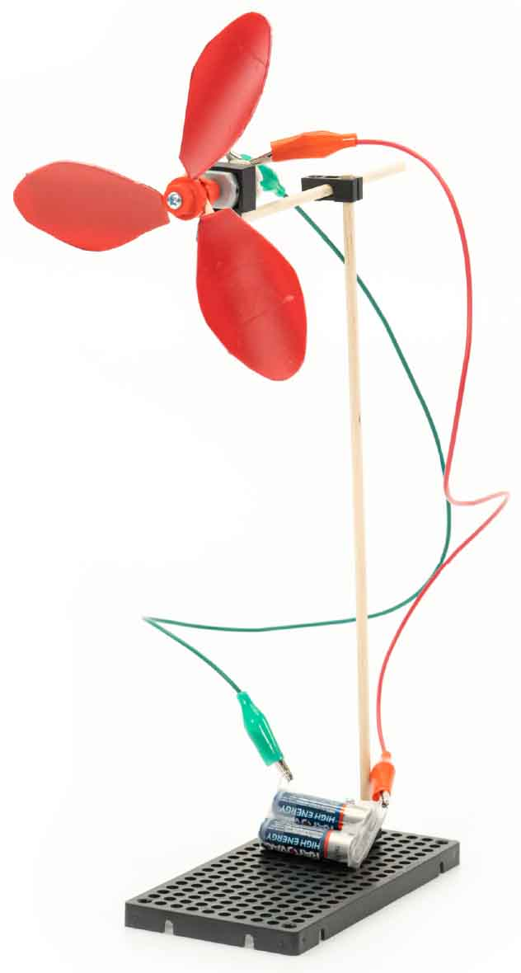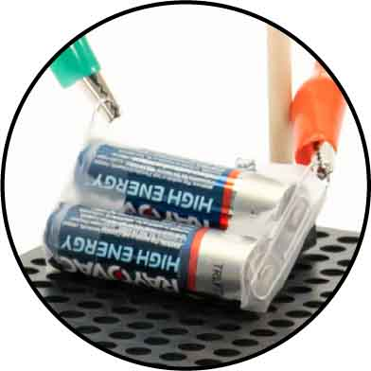

Paperclips

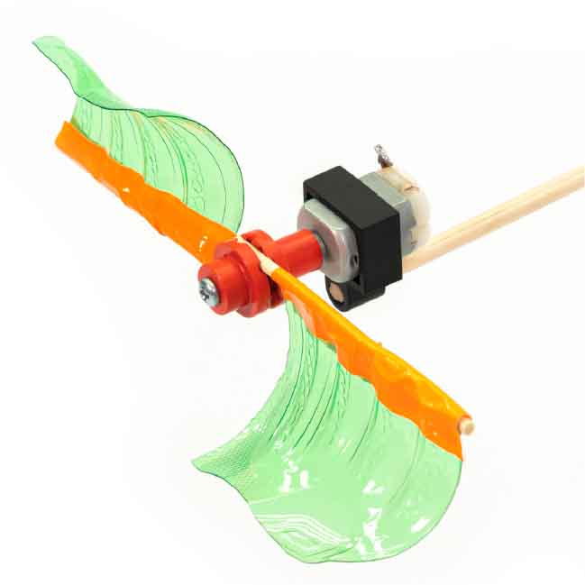

Make unique **3D shapes** by cutting up plastic bottles and other **recyclable materials**.

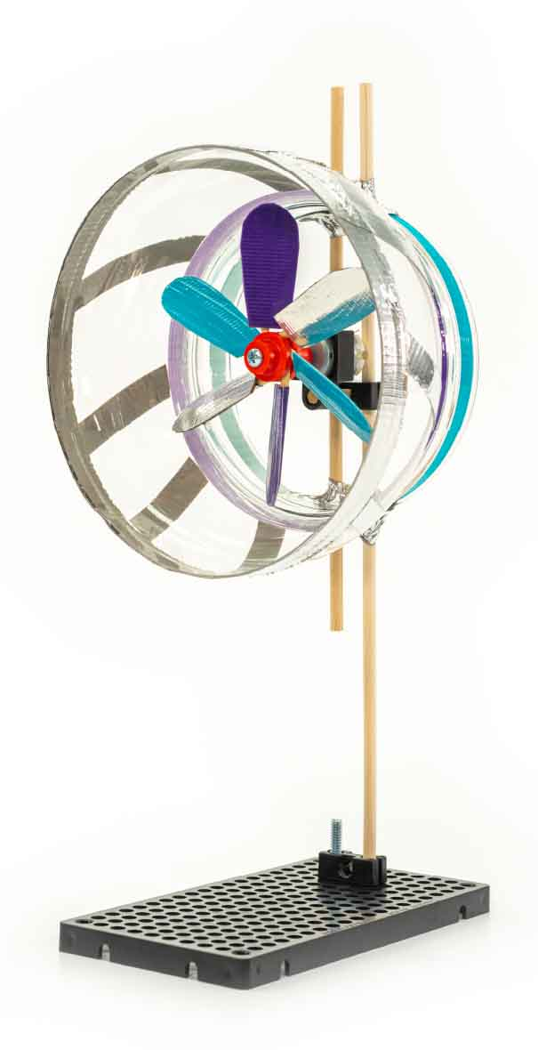

Use a **shroud** to **increase** the speed of the **wind** hitting your blades.

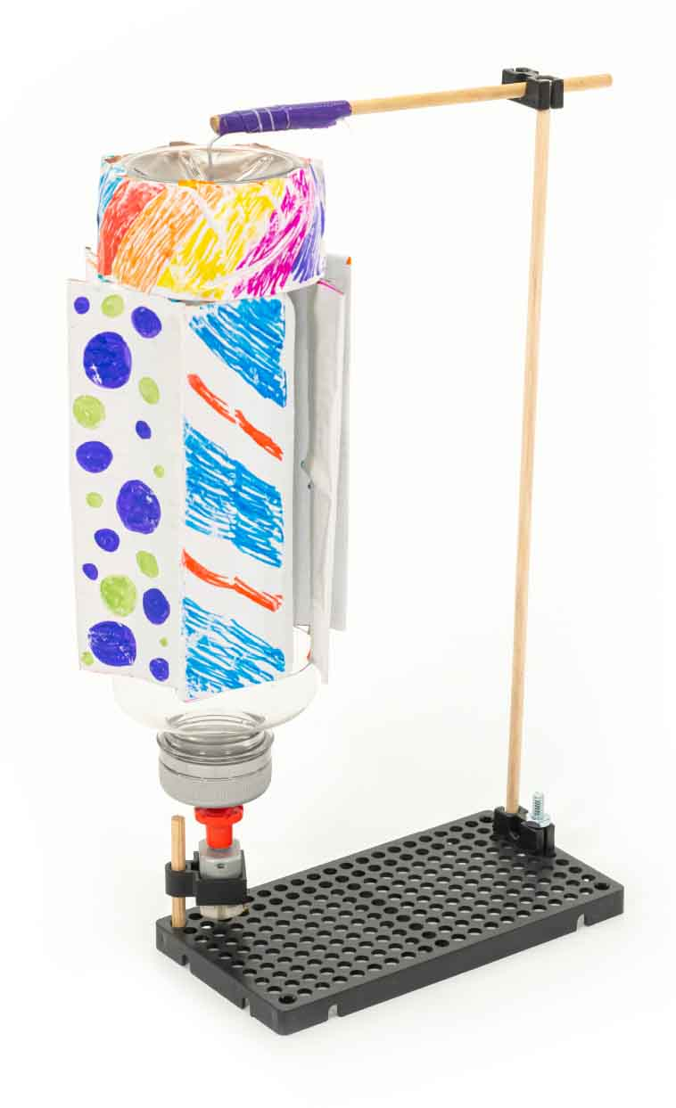

**Vertical Axis Turbines** work no matter what direction the wind comes from!

Paperclip

## Design

## Process

## Design

## Redesign

## Test

## Evaluate

**There is no perfect design.  
The design process never ends!**

# Inspiration