



**THINKING AHEAD** *How does changing the angle of your launcher impact how far your ball goes?*

Download Documents and get   
your supplies at **teachergeek.com**

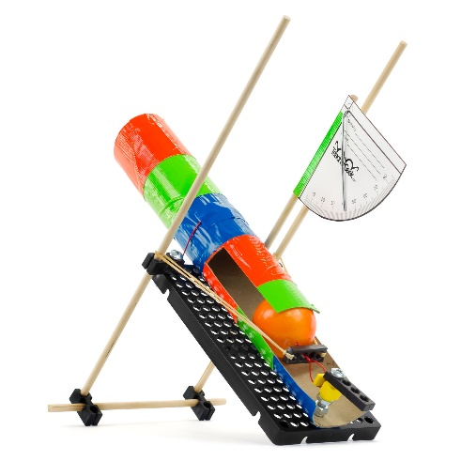**Recommended Age level:**

Activity Age Level: 8-18

Lab Age Level: Grades 3-12

Recommended Group Size: 2-4



Engineer a Launcher that can lob a ping pong ball as far as possible.  
Start by building the example projectile launcher in the “Build Guide”.   
Learn about accuracy and precision by completing the optional Lab Activities.   
Then, design and build your own Launcher to compete in Engineering Challenges.



What’s unique about this, and other TeacherGeek activities?

This is a **True STEM/Engineering** activity. It allows kids to:

* *Tinker and experiment*
* *Grow understanding through experimentation and labs*
* *Isolate variables and utilize the scientific method*
* *Apply math and science concepts*
* *Create their own unique designs to become innovators.*

Every project turns out different, and evolves with their understanding. When you create a project using TeacherGeek, the data works (it’s usable). This allows  
kids to apply the math and science, see the results,   
and experience “I-get-it” moments (understanding   
*why* they need the math/science and *what* it does).

Adapted from Bloom’s Taxonomy



**Make It Your Own:** The documents for this activity are available   
in **PDF** and **Microsoft Word** format. If you wish to edit a document,   
simply download the Microsoft Word format.



**Next Generation Science Standards:**

**Motion and Stability: Forces and Interactions**

**K-PS2-1:** Plan and conduct an investigation to compare the effects of different strengths or different directions of pushes and pulls on the motion of an object.

**3-PS2-1:** Plan and conduct an investigation to provide evidence of the effects of balanced and unbalanced forces on the motion of an object.

**3-PS2-2:** Make observations and/or measurements of an object's motion to provide evidence that a pattern can be used to predict future motion.

**MS-PS2-1:** Apply Newton's Third Law to design a solution to a problem involving the motion of two colliding objects.

**MS-PS2-2:** Plan an investigation to provide evidence that the change in an object's motion depends on the sum of the forces on the object and the mass of the object.

**MS-PS3-4:** Plan an investigation to determine the relationships among the energy transferred, the type of matter, the mass, and the change in the average kinetic energy of the particles as measured by the temperature of the sample.

**MS-PS3-5:** Construct, use, and present arguments to support the claim that when the motion energy of an object changes, energy is transferred to or from the object**.**

**MS-PS1-6:** Undertake a design project to construct, test, and modify a device that either releases or absorbs thermal energy by chemical processes.

**Engineering Design**

**MS-ETS1-1:** Define the criteria and constraints of a design problem with sufficient precision to ensure   
a successful solution, considering relevant scientific principles and potential impacts on people   
and the natural environment that may limit possible solutions.

**MS-ETS1-2:** Evaluate competing design solutions using a systematic process to determine how well they meet the criteria and constraints of the problem.

**MS-ETS1-3:** Analyze data from tests to determine similarities and differences among several design solutions to identify the best characteristics of each that can be combined into a new solution to better meet the criteria for success.

**MS-ETS1-4:** Develop a model to generate data for iterative testing and modification of a proposed object, tool, or process such that an optimal design can be achieved.

**Energy**

**MS-PS3-1:** Construct and interpret graphical displays of data to describe the relationships of kinetic energy to the mass of an object and to the speed of an object.

**MS-PS3-2:** Develop a model to describe that when the arrangement of objects interacting at a distance changes, different amounts of potential energy are stored in the system.

**MS-PS3-5:** Construct, use, and present arguments to support the claim that when the kinetic energy of an object changes, energy is transferred to or from the object.

**HS-PS3-1:** Create a computational model to calculate the change in the energy of one component in a system when the change in energy of the other component(s) and energy flows in and out of the system are known.

**HS-PS3-2:** Develop and use models to illustrate that energy at the macroscopic scale can be accounted for as either motions of particles or energy stored in fields.

**HS-PS3-3:** Design, build, and refine a device that works within given constraints to convert one form of energy into another form of energy.



**Kinematics** are the features or properties of *motion* in an object.

* **Motion:** movement in any direction.
* **Projectiles:** objects with both vertical and horizontal motion, impacted only by gravity.
* **Projectile Motion:**free-fall motion of any object in a horizontal path with constant velocity.
* **Gravity:** a force that attracts mass to the center of the earth.
* **Newton’s First Law of Motion:** An object at rest stays at rest. An object in motion stays in motion   
  (with the same speed and in the same direction) unless acted upon by an unbalanced force.
* **Inertia:**Newton’s First Law of Motion.
* **Parabolic Curve:** vertical free fall motion and constant horizontal motion
* **Trajectory:** flight path of a projectile.
* **Time:** A measurement of how long an event or occurrence happens.
* **Distance:** A numerical description of how far apart objects are.
* **Acceleration:** increase in rate of speed of an object.
* **Velocity:** the speed of something in a given direction.
* **Accuracy:** how close a result comes to the true value.
* **Precision:** how consistent, or repeatable, results are**.**



Below is the list of “*ingredients*” you’ll need for one Launcher.

|  |  |  |  |  |  |
| --- | --- | --- | --- | --- | --- |
|  |  |  |  | |  |
| [**10 - Blocks**](https://teachergeek.com/collections/secondary-schools-camps/products/ping-pong-ball-launcher-projectile-launcher?variant=344626559) | [**5 - Dowels** 30cm (12″)](https://teachergeek.com/collections/secondary-schools-camps/products/ping-pong-ball-launcher-projectile-launcher?variant=344626559) | [**2 - Connector Strips**](https://teachergeek.com/collections/secondary-schools-camps/products/ping-pong-ball-launcher-projectile-launcher?variant=344626559) | [**1 - Hole Plate**](https://teachergeek.com/collections/secondary-schools-camps/products/ping-pong-ball-launcher-projectile-launcher?variant=344626559) | | [**1 - Ping Pong Ball**](https://teachergeek.com/collections/secondary-schools-camps/products/ping-pong-ball-launcher-projectile-launcher?variant=344626559) |
|  |  |  |  | |  |
| [**2 - Nuts** #10](https://teachergeek.com/collections/secondary-schools-camps/products/ping-pong-ball-launcher-projectile-launcher?variant=344626559) | [**2 - Lock Nuts** #10](https://teachergeek.com/collections/secondary-schools-camps/products/ping-pong-ball-launcher-projectile-launcher?variant=344626559) | [**1 - 38mm Screw** 38mm (1½″) #10](https://teachergeek.com/collections/secondary-schools-camps/products/ping-pong-ball-launcher-projectile-launcher?variant=344626559) | **[1 - 25mm Screw](https://teachergeek.com/collections/secondary-schools-camps/products/ping-pong-ball-launcher-projectile-launcher?variant=344626559)**  [(1″) #10](https://teachergeek.com/collections/secondary-schools-camps/products/ping-pong-ball-launcher-projectile-launcher?variant=344626559) | | [**10 - Rubber Bands**](https://teachergeek.com/collections/secondary-schools-camps/products/ping-pong-ball-launcher-projectile-launcher?variant=344626559) |
|  |  |  |  |  | |
| [**2 - Stop Clips**](https://teachergeek.com/collections/secondary-schools-camps/products/ping-pong-ball-launcher-projectile-launcher?variant=344626559) | [**1 - Slide Stop** 76mm (3″)](https://teachergeek.com/collections/secondary-schools-camps/products/ping-pong-ball-launcher-projectile-launcher?variant=344626559) | [**1 - Metal Wire** 7.5cm (3″)](https://teachergeek.com/collections/secondary-schools-camps/products/ping-pong-ball-launcher-projectile-launcher?variant=344626559) | **[1 - Plastic](https://teachergeek.com/collections/secondary-schools-camps/products/ping-pong-ball-launcher-projectile-launcher?variant=344626559)**  **[Coated Wire](https://teachergeek.com/collections/secondary-schools-camps/products/ping-pong-ball-launcher-projectile-launcher?variant=344626559)**  [8cm (3¼″)](https://teachergeek.com/collections/secondary-schools-camps/products/ping-pong-ball-launcher-projectile-launcher?variant=344626559) | [*Cut from Wire Roll*](https://teachergeek.com/collections/secondary-schools-camps/products/ping-pong-ball-launcher-projectile-launcher?variant=344626559) | |

*[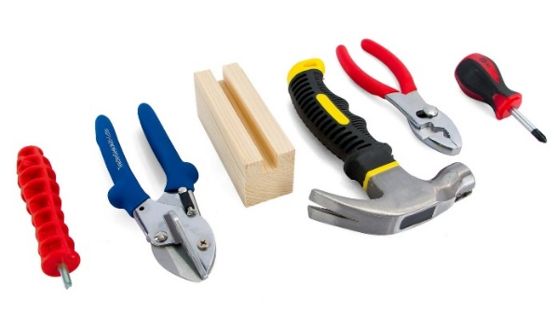](https://teachergeek.com/products/easy-engineering-tool-set?variant=344866731)*

This isn’t a kit. You’re going to really build   
(cut, ream, screw) your Launcher.   
Here are tools you’ll need to get started.   
They can be shared by up to 4 groups at a time.



**Tip:** Save all your materials (even what you cut off). Keep them in a bag. They can be used later.

* **TeacherGeek Reamer**
* **TeacherGeek** [**Multi-Cutter**](https://teachergeek.com/products/1823-81)
* **TeacherGeek Screwdriver**
* **Teachergeek Pliers -** optiona





Have you ever played with a **sling-shot** before? Gathering pebbles, pulling-back and shooting them to break bottles or hit a target – just more examples of **kinematic** principles at play. These “geometeries   
of motion” are essential to understanding **projectile motion**.

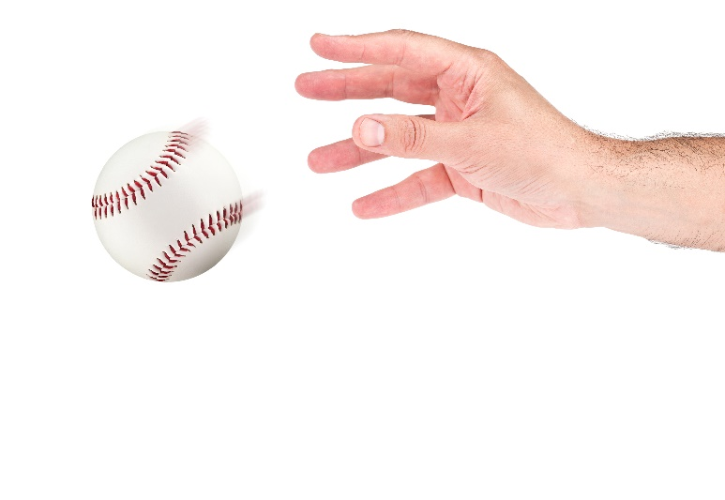

Pebbles, darts, ping pong balls or   
even marshmallows are all types  
of **projectiles** *(objects with both****vertical*** *and* ***horizontal*** *motion,   
under the influence of* ***gravity***).



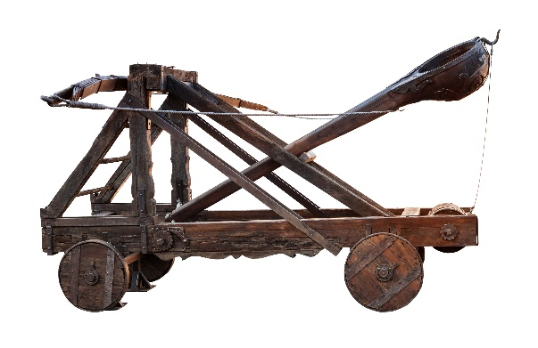

A **catapult** is any device that can throw an object –   
a **trebuchet** is a type of catapult, which uses **gravity** (counterweights) to throw items a great distance.   
It doesn’t use built-up **tension** like a sling-shot   
or your launcher would for its “throwing force”.



These ancient **seige** weapons were highly effective in warfare – achieving great distance without the aid of explosives is an invaluable military strategy. The ancient Greeks created some of the first **cross-bow** technology, which later evolved into the large-scale launchers we saw in Roman and Medievel ballistics.

**Projectile motion** is critical to nerf gun battles, helicopter rescue operations, professional sports   
and throwing paper airplanes to pass notes.  
  
*What other examples of projectile motion   
in the world around you can you think of?*



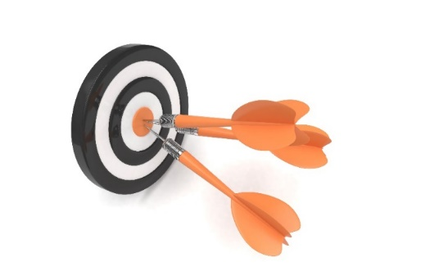





*Newton’s   
Cradle*

There are “a ton” of resources to help you complete this activity. Pick and choose the ones that will work for you. They are available as links below, or at **teachergeek.com/learn**.

**Projectile Launcher Documents**

* Classroom Overview - This is it (you’re reading it).
* Projectile Launcher Build Guide – Required
  + [Basic Build Guide](https://teachergeek.org/launcher_all_in_one.pdf)
  + [Advanced Build Guide](http://teachergeek.org/launcher_build.pdf)
* [Precision & Accuracy Lab](https://teachergeek.org/precision_accuracy_lab.pdf)
* [Graphing & Launching Tip Sheet](https://teachergeek.org/projectile_launcher_how_to_hit__the_target_using_graphs.pdf)
* [Projectile Launcher Engineering Challenges](http://teachergeek.org/Judo-Bot-r-r-rumble-challenge.pdf) - Optional

**Projectile Launcher Videos**

* [Launchpad: Newton’s Laws of Motion On-Board the International Space Station](https://www.youtube.com/watch?v=KvPF0cQUW7s)- Youtube Video

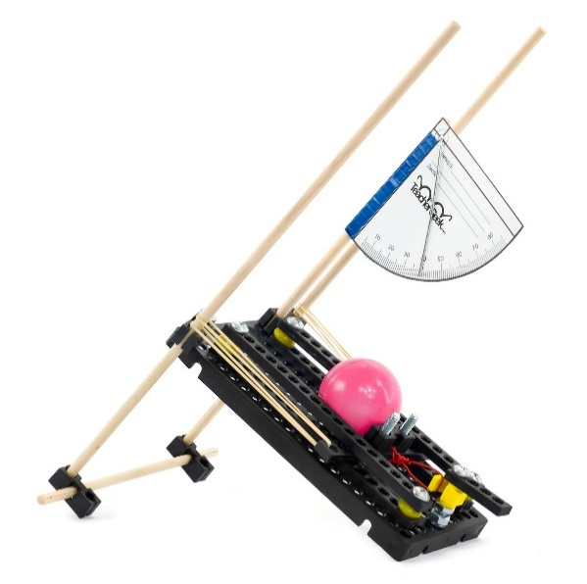



There are many optional Labs for your **Projectile Launcher**.

Links in the Build Guide indicate when during the building process

these Labs and Challenges can be completed, if you want to.

After you’ve finished, you can download the Engineering Challenges

and [Engineering Notebook](http://teachergeek.org/engineering_notebook.pdf) sheets to take your designs to the next level.

Documents are available as links below or at teachergeek.com/learn.



**Build Guide — Required**

During this step, you will create an example Projectile Launcher.   
The launcher can be kept together and used in the labs and challenges or   
taken apart at the end of the activity to be used during other class sessions.

[Download the Projectile Launcher Basic Build Guide](https://teachergeek.org/launcher_all_in_one.pdf)  
[Download the Projectile Launcher Advanced Build Guide](https://teachergeek.org/launcher_all_in_one.pdf)



**Lab Activity** **— Optional**

**Precision & Accuracy Lab**

This Lab allows students to explore precision and accuracy, and the value of scientific measurement in interpreting and estimating with data.

**Instructions:**

* + Discuss the following concepts with your students.   
    Ask them to provide describe, define, and/or give examples for each:
    - Projectile
    - Measurement
    - Precision
    - Accuracy
    - Mean
    - Range
  + Distribute Lab sheets. Explain the lab procedure and let them get to work.

[Download the Precision & Accuracy Lab](https://teachergeek.org/precision_accuracy_lab.pdf)



 **E****ngineering Challenges**

**Tip Sheet — Optional**

**Graphing & Launching Sheet**Students can use this sheet to learn how to hit a target distance using graphs and estimation. They will plot data points, determine the curve or line of best fit, and   
learn about outliers, all the while testing their launcher designs and re-designs.

[Download the Graphing & Launching Tip Sheet](https://teachergeek.org/projectile_launcher_how_to_hit__the_target_using_graphs.pdf)

The following challenges are optional. It’s an Engineering Challenge –

immersing students in the Engineering Design process. Learn more

about the Engineering Design Process on the next page.

[Download the Engineering Notebook Sheets](https://teachergeek.org/ELEM_launcher_engineering_notebook.pdf)

**Note:** Each challenge should utilize a Launcher Engineering Notebook Sheet   
so students can complete the design process with sketches, notes and graphs.

[Download the Bull’s-Eye Challenge!](https://teachergeek.org/launcher_bullseye_challenge.pdf)  
*Ready, Aim, Fire!* Students will re-design their launcher and trigger mechanisms to   
best aim and hit targets placed at various (and ever-more-challenging!) distances.  
Practice accuracy and precision, graph the trajectory of a projectile and explore   
how the engineering and design process can produce innovative, effective creations!

[Download the Moving Target Challenge!](https://teachergeek.org/moving_target_challenge.pdf)  
*Keep on your toes!* Students will re-design their launcher and trigger mechanisms for targets that move each trial. The engineering process and innovation are essential tools to solving the ever-changing design problem, as angles and materials shift for new goals and new distances. Excellent for classroom competition or home use.

[Download the STEM Siege Challenge!](https://teachergeek.org/stem_siege_challenge.pdf)

*Have fun storming the castle!* Students will re-design their launcher and trigger mechanisms to knock down a “castle wall” as fast as possible in a three-minute span. Siege techniques used by medieval armies, with catapults and trebuchets

*Starting Line*

*Bull’s-Eye Target*



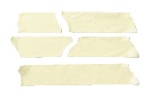

**Bull’s-Eye Challenge Preparation**

1. Place three (or more) targets on a flat surface, in front of the established starting line.

2. Use paper, tape, rugs or brimmed bins and buckets for the target material   
 (a bull’s-eye center can encourage more **precise** launches).

3. Each target should be placed at an increasing distance from the starting line.

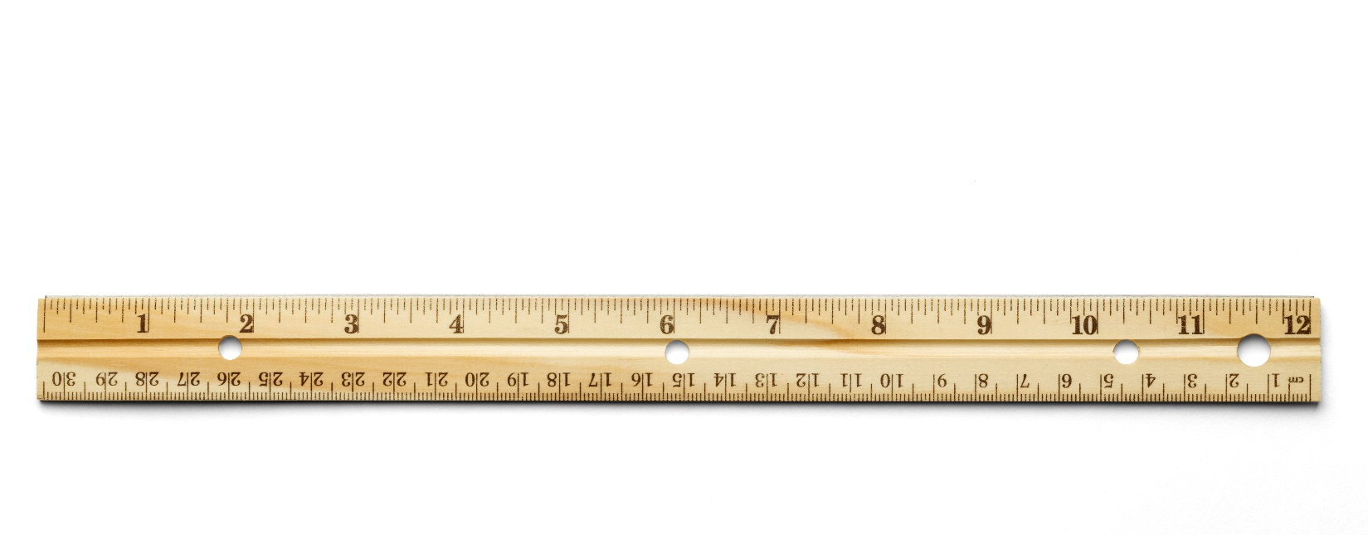

**Suggestions for Target Distance**  
**Target A:** 1.5 - 2.5 meters (5 - 8 ft)   
**Target B:** 3 - 3.5 meters (9 - 10.5 ft)  
**Target C:** 4 - 5 meters (12 - 15.5 ft)





*Plop!*

**Moving Target Challenge Preparation**  
1. Establish the starting line with tape, or the groove between tiles.

2. Place one target any distance away from the starting line.

3. After each group or launcher design takes 3 shots at the target,   
 place it in another location, with the same starting line. Repeat.

*Try Styrofoam,   
old cardboard,   
paper, plastic,  
TeacherGeek  
components*



**STEM Siege Challenge Preparation**  
1. Establish the starting line with tape, or the groove between tiles.

2. Use cardboard, Styrofoam, building blocks, pop bottles or other   
 recycling materials to construct the “castle wall”. Ensure it contains   
 several elements, easily falls and isn’t anchored to the floor or table.

3. Give students 3 minutes to launch as many ping-pong balls as they   
 can at the wall structure, aiming to hit weak points to make it collapse.



*Castle walls can   
be a cup or even   
a card tower!*





Do you have a challenge to solve? Is there something you want to invent, fix or improve? You do? Excellent…   
the **Engineering Design Process** is exactly what you need.

Inventing, fixing, improving… these are really ways to create a solution to a problem. A problem can be as complicated as creating a way to live on Mars, or as simple as stopping   
a door from squeaking. You have a problem to solve: design   
a Projectile Launcher to fling ping-pong balls over a distance.  
The Design Process will help you solve it. Here’s how it works:



**What is the problem (what needs to be solved/made better)?**

The Design Process helps you solve a problem. Therefore, you need to start the   
Design Process by identifying a problem. In this activity, your problem is to create   
a Launcher that can accurately hit a target from increasing and changing distances.

After constructing your first Launcher and going through the initial Design Process,   
your problem may change. Your next problem might be to make the Launcher shoot   
ping-pong balls farther and higher in its trajectory, with a new trigger mechanism design.

There is no perfect design, so there is no end to the Design Process. You can always identify a new problem (make your Launcher better) and go through the Design Process again.

**Research: How have others solved, or attempted to solve this problem?**

If you are going to solve the problem, you better know what you are doing.   
After identifying the problem, look at how others have solved, or tried to solve it.  
Look around your class, search the library and internet, or ask other people.

**What are the constraints (things your design cannot, or must, do or be)?**

It would be great if you could solve this problem any way you want, with anything you want. The truth is… you can’t! You have these things called “constraints” which limit what your design can do, can’t do, must be, or can’t be (How confusing is that?). Constraints could be resources like time or materials. They could also be rules – like what materials can be used for end effectors. You need to identify the constraints to your problem before you can solve it.

 **Brainstorm, sketch and describe possible solutions (different ideas might solve the problem).**

This is a fun part. You can brainstorm, or use another process, to come up with as many possible solutions to your problem as possible. Consider your problem, constraints and research while generating possible solutions. Do not judge, or pick, your best solution   
at this point. Just write as many down as you can. Note: whacky/unique ideas   
sometimes lead to wonderful new design solutions. Value creativity and originality!

**Choose the best solution. Circle it. Why do you think it is best?**

Ok - now it’s time to judge. Pick what you think will be the best solution to your problem. Make sure it fits the constraints. It’s ok to feel sorry for all the possible solutions that didn’t   
get picked. They were good ideas too.



**Draw the solution you choose. Include the details you will need to create it.**

Neatly sketch the design you choose (the one you are going to build).   
The sketch should include details and descriptions about how it will work, or be built.



**Build the solution you planned.**

Is this the step you have been waiting for? You finally get to build the solution to   
your problem (the new design). Have fun! Take the time to make it properly.

**Test it.**

Test your solution (new design). How does it work? Does the Launcher shoot too high?   
Is the trigger too loose or tight, depending on the amount of rubber bands used?   
Make small adjustments to optimize it (to try and make this design solution work best).

**Make observations. Record results.**

Pay close attention while testing your solution. Write down what happened   
Was your Launcher design more accurate or precise in the distances it reached.  
You will use this information to make your Launcher even better.



**Did you solve the problem?**

Look at the test results. Reflect on your observations.   
Did your solution solve the problem as you had planned?

**Yes? Great! Identify a new problem (a way to make your design even better).**

There is no perfect design (yep... your design can still be improved).   
Identify another problem that will make your Launcher even better.   
Grab another Engineering Notebook Sheet and try to solve it.

**No? That’s OK. What did you learn that can help solve it in a new/different way?**

You learn more from failures than you do from successes. The best solutions come   
from/after failures (ideas that didn’t work). Most inventions do not work the first   
time around the Design Process. Learn from what didn’t work. Grab another   
Engineering Notebook Sheet and try to solve the problem a different way.



Fill in a TeacherGeek Engineering Notebook Sheet (front and back)  
every time you go around the Design Process. Keep your Notebook Sheets.   
Assemble them into an Engineering Notebook at the end of the project.

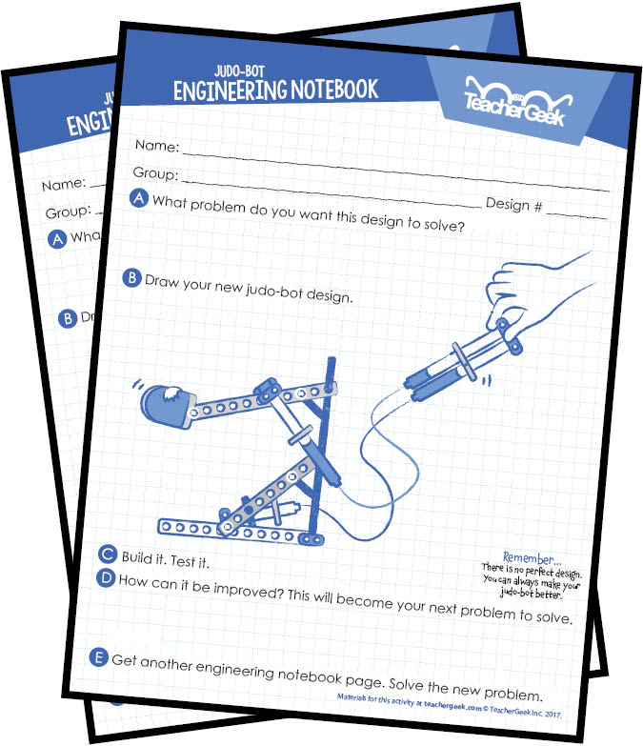[*Download the Engineering Notebook Sheets*](http://teachergeek.org/engineering_notebook.pdf)

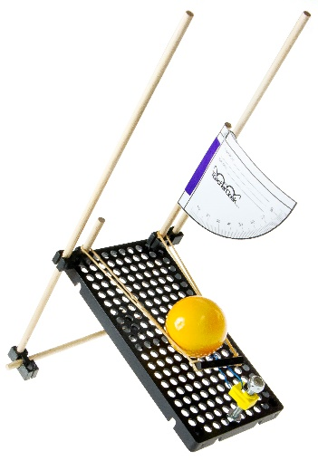***Question*** *Do you need to fill out a new Engineering Notebook Sheet for small changes or tweaks to an existing design?*

*Nope… just record what you did on the current Notebook Sheet.*