

**Target C**

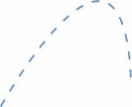

*Boing!*

**Target B**

***Ready, Aim, Fire!***   
Redesign your launcher   
to hit three targets –   
*shoot for the center to win!*



**Target A**



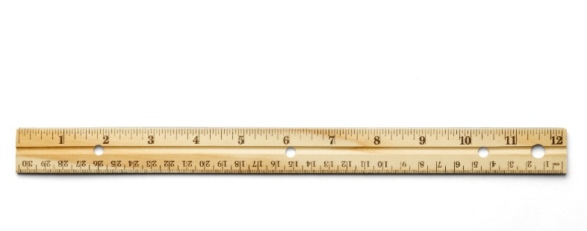

**Starting Line**Use tape or the   
crack between   
floor tiles.

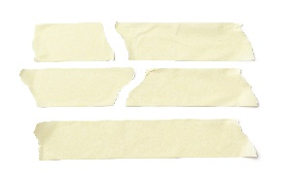****

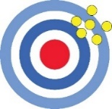

**Accuracy** is how close   
you get to the ***actual***   
(true) target or goal   
(e.g. center of target).

**Precision** is   
how ***consistent***   
(repeatable)   
your results are.

**Before You Start:** Make sure   
you have built a launcher for   
use on this challenge.  
Documents & Supplies at:   
**teachergeek.com**

1. Adjust the angle and trigger design.  
2. Aim. Take three shots and try to hit **Target A**!  
3. Record your results on an Engineering Notebook Sheet.  
4. Repeat for **Targets B & C**.



**Challenge Supplies:**Launcher (from Build Guide), protractor,   
bucket or target material, ruler, tape,   
stop-watch, ping pong balls

**Teacher’s Note:**Find more information on setting up   
targets and running this challenge,   
in the Launcher Classroom Overview.

**►**

**►**

**►**

(rules and limits for your design)

**Allowable Materials:**• TeacherGeek Components• Found & Recycling Bin • Teacher Approved• Non-Hazardous

**►**

**►**

**Ground Rules:**• Launch from behind the starting line  
• Judges check if targets are hit successfully

**Difficulty:** Easy-Medium



**Time Limit:** ___________

Fill in how much   
time you have



*The time from building   
and re-designing your   
launcher to the start   
of the competition.*