

Start by building the example launcher, then turn it into ***your own*** unique design.







Download documents at [**teachergeek.com**](https://teachergeek.com/)**/learn**

For use with TeacherGeek [Projectile Launcher Activity](https://teachergeek.com/products/ping-pong-ball-launcher-projectile-launcher),   
or [Maker Cart](https://teachergeek.com/products/maker-cart) available at [**teachergeek.com**](https://teachergeek.com/).

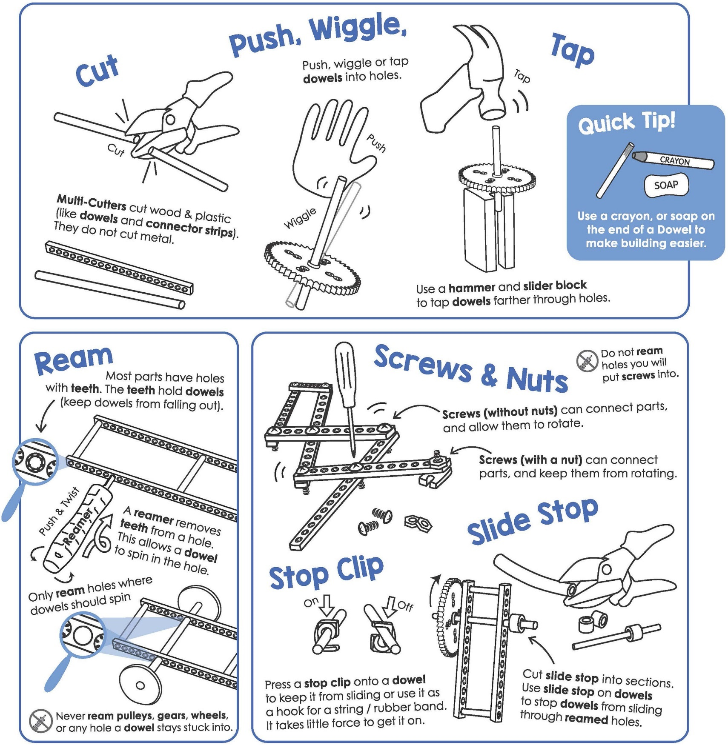



TeacherGeek components for the example projectile launcher,   
and extra pieces to turn it into your own unique design.

|  |  |  |  |  |  |
| --- | --- | --- | --- | --- | --- |
|  |  |  |  | |  |
| [**10 - Blocks**](https://teachergeek.com/collections/secondary-schools-camps/products/ping-pong-ball-launcher-projectile-launcher?variant=344626559) | [**5 - Dowels** 30cm (12″)](https://teachergeek.com/collections/secondary-schools-camps/products/ping-pong-ball-launcher-projectile-launcher?variant=344626559) | [**2 - Connector Strips**](https://teachergeek.com/collections/secondary-schools-camps/products/ping-pong-ball-launcher-projectile-launcher?variant=344626559) | [**1 - Hole Plate**](https://teachergeek.com/collections/secondary-schools-camps/products/ping-pong-ball-launcher-projectile-launcher?variant=344626559) | | [**1 - Ping Pong Ball**](https://teachergeek.com/collections/secondary-schools-camps/products/ping-pong-ball-launcher-projectile-launcher?variant=344626559) |
|  |  |  |  | |  |
| [**2 - Nuts** #10](https://teachergeek.com/collections/secondary-schools-camps/products/ping-pong-ball-launcher-projectile-launcher?variant=344626559) | [**2 - Lock Nuts** #10](https://teachergeek.com/collections/secondary-schools-camps/products/ping-pong-ball-launcher-projectile-launcher?variant=344626559) | [**1 - 38mm Screw** 38mm (1½″) #10](https://teachergeek.com/collections/secondary-schools-camps/products/ping-pong-ball-launcher-projectile-launcher?variant=344626559) | **[1 - 25mm Screw](https://teachergeek.com/collections/secondary-schools-camps/products/ping-pong-ball-launcher-projectile-launcher?variant=344626559)**  [(1″) #10](https://teachergeek.com/collections/secondary-schools-camps/products/ping-pong-ball-launcher-projectile-launcher?variant=344626559) | | [**10 - Rubber Bands**](https://teachergeek.com/collections/secondary-schools-camps/products/ping-pong-ball-launcher-projectile-launcher?variant=344626559) |
|  |  |  |  |  | |
| [**2 - Stop Clips**](https://teachergeek.com/collections/secondary-schools-camps/products/ping-pong-ball-launcher-projectile-launcher?variant=344626559) | [**1 - Slide Stop** 76mm (3″)](https://teachergeek.com/collections/secondary-schools-camps/products/ping-pong-ball-launcher-projectile-launcher?variant=344626559) | [**1 - Metal Wire** 7.5cm (3″)](https://teachergeek.com/collections/secondary-schools-camps/products/ping-pong-ball-launcher-projectile-launcher?variant=344626559) | **[1 - Plastic](https://teachergeek.com/collections/secondary-schools-camps/products/ping-pong-ball-launcher-projectile-launcher?variant=344626559)**  **[Coated Wire](https://teachergeek.com/collections/secondary-schools-camps/products/ping-pong-ball-launcher-projectile-launcher?variant=344626559)**  [8cm (3¼″)](https://teachergeek.com/collections/secondary-schools-camps/products/ping-pong-ball-launcher-projectile-launcher?variant=344626559) | [*Cut from Wire Roll*](https://teachergeek.com/collections/secondary-schools-camps/products/ping-pong-ball-launcher-projectile-launcher?variant=344626559) | |

**►**

Components available in the TeacherGeek [Ping Pong Launcher Activity](https://teachergeek.com/collections/secondary-schools-camps/products/ping-pong-ball-launcher-projectile-launcher?variant=2271543108),   
TeacherGeek [Maker Cart](https://teachergeek.com/products/maker-cart), or at [**teachergeek.com**](https://teachergeek.com/)



This isn’t a kit. You’re going to really build (cut, ream, screw) your launcher.   
Here are the tools you’ll need.

|  |  |  |
| --- | --- | --- |
|  |  |  |
| **Multi-Cutter** [SKU 1823-81](https://teachergeek.com/products/1823-81) | **Reamer** [SKU 1823-87](https://teachergeek.com/collections/tools-resources/products/teachergeek-reamer) | **Screwdriver** [SKU 1823-90](https://teachergeek.com/products/stubby-2-screwdriver) | **Pliers** [SKU 1823-86](https://teachergeek.com/products/slip-joint-pliers-6) |

Tools available at [**teachergeek.com**](https://teachergeek.com/products/easy-engineering-tool-set?variant=344866731)



You will need these non-TeacherGeek supplies:

|  |  |  |  |
| --- | --- | --- | --- |
|  |  |  |  |
| **Tape**  Masking, Painter’s, Duct; Any kind of tape will work. | **Safety Goggles**  Should be worn during the activity. Inventing can be projectile! | **Recycling Materials**  Add to your design | **Scissors**  For cutting out the protractor and recycling materials. |

[](http://teachergeek.org/protractor-angle_finder.pdf)

**TeacherGeek Protractor**

Print on cardstock or thicker paper for a sturdier protractor.

Printable Protractor Download:

<http://teachergeek.org/protractor-angle_finder.pdf>

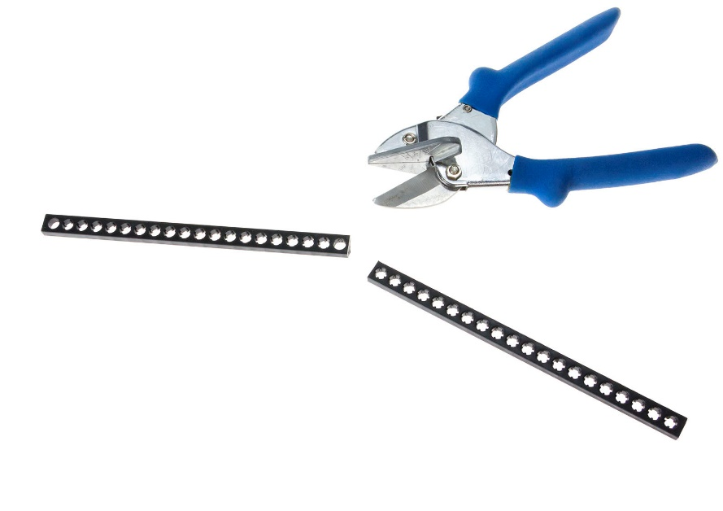



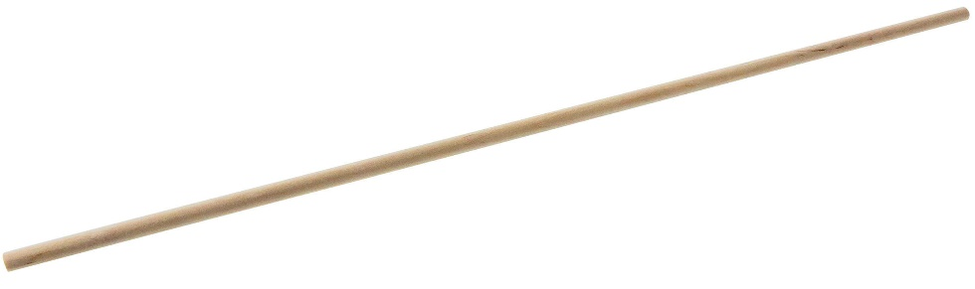

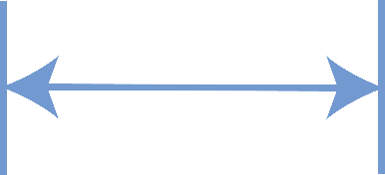

|  |  |  |  |
| --- | --- | --- | --- |
| 13cm | **Cut** a 13cm (5”) and  5cm (2”) **dowel**.  5cm |  | **Push** or tap each **dowel** from **Step 1** into a **block** as shown,  so the dowels stick out a little.      5cm      Block  13cm |
|  | **Push** or tap the **dowels** from **Step 2** into the **hole plate,** as shown.    Hole Plate  *Tap!* |  | **Rub** a crayon or bar of soap  on two **full** (30cm) **dowels**.  This helps the dowels slide*.*  30cm dowel  Slide the **dowels**  from **Step 4**  Launch  Pad  through the  **block holes**  hanging off  the hole plate. |
| TeacherGeek Protractor | Print, cut, and tape your **protractor** to the launcher,  as shown.      7.5cm Metal Wire | Use a dowel or  pencil to bend   the hook.  6.5cm | **Bend** a 1.5cm hook on the  7.5cm **metal** **wire**. **Poke** it  through the **protractor** at the . Hang it on the paper as shown.  Poke!  Make sure the metal wire points **straight down** when the protractor is tilted. |

Launch Pad

Don’t cover the   
cross-hair (circle)   
with tape.

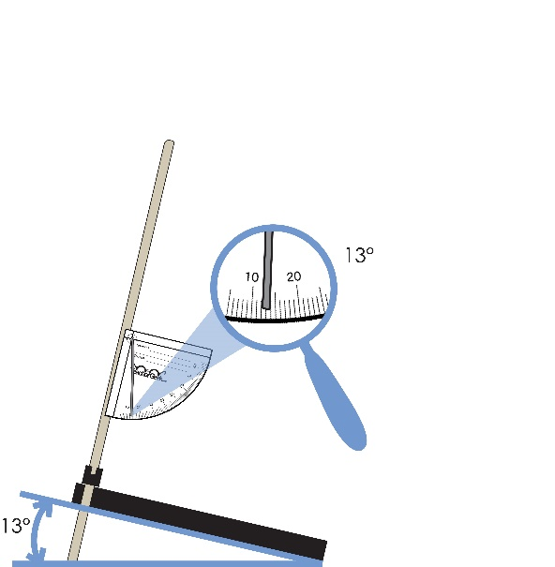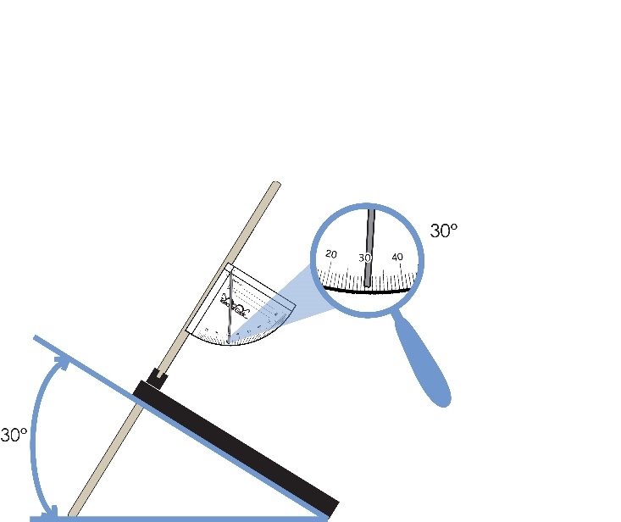

Change the angle of your launch pad   
by sliding these dowels up and down.

Check the angle using the protractor.





**►**

**Congratulations!**   
Your Launch Pad is finished!  
Now, it’s time to create   
the Launching Mechanism.

Printable Protractor Available at:

<http://teachergeek.org/protractor-angle_finder.pdf>



|  |  |  |  |
| --- | --- | --- | --- |
|  | **Cut** a piece of **connector strip**, four **holes** long.      4 holes |  | Loop a **rubber band** through each **hole** on either side.    Rubber Band  Loop!      Getting it right can be tricky. Take your time! |
|  | **Cut**, or find a 8cm (3”) piece  of plastic coated **wire.** Bend it  in half and put the endsthrough  the **connector strip,** as shown.  8cm Wire Piece |  | Twist **wire** ends together  to create a **loop**.  Wire |
|  | **Slide** the **rubber bands** over the  inner **dowels** of your **Launch Pad**  from **Step 5**, as shown.  Rubber Bands  **Congratulations!** Your Launch Mechanism is finished. Now, let’s create a  trigger to fire a ping-pong ball. | | |
|  | On the other side of the **hole plate**, put a **38mm screw**  through the **underside** (bottom) of the plate. **Fasten** with a **nut**.    Tighten!  *Nut*  *38mm screw*  *Top View*  *Underside of Plate* | | |
|  | **Push** a **stop clip** on the  **screw** to create your **trigger**.      *Trigger*    *Stop Clip* |  | **Cap** the **screw** with a **lock nut.** This will prevent the **stop clip**  from sliding off.  *Lock Nut* |



1. **Pull** back the **launching mechansism**   
   and **attach** it to the **trigger** (stop clip).
2. **Place** a ping-pong **ball**   
   into the **launch mechanism**.
3. ***Turn the trigger (stop clip) to fire!***





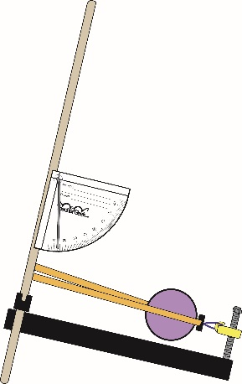

**Tip:** Make sure trigger is lined-up with the center   
of the ball.



*Pull!*



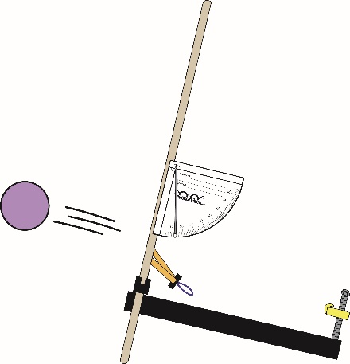





**Caution:** Wear safety glasses. *Never* launch at another person.

**You Did It!**   
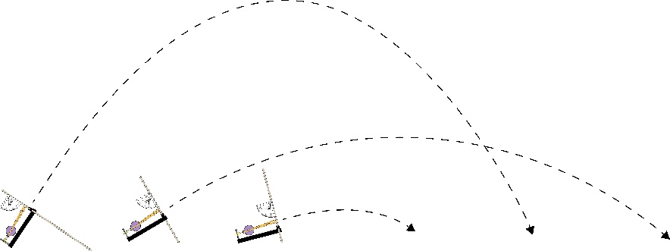Your example Launcher is finished,   
but its design works just okay.  
You can make it *so much* better.

**►**



Your launcher should launch balls with **precision** and **accuracy**.

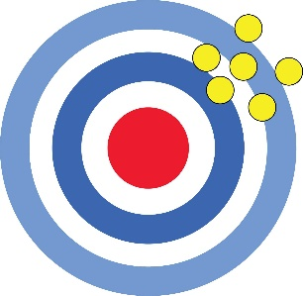

**Precision** is how *consistent* (repeatable) your results are.

**Accuracy** is how *close* you get to the actual (true) target or goal, such as the center of a target.



The example launcher is a little wimpy. Can you make your launch   
mechanism and trigger more **powerful**, as well as **accurate** and **precise**?

