Name: _______________________________________________________ Set: ________ Date: ________

In this lab, you’ll use math to analyze the accuracy of your launcher.

# Lab Supplies

**Measuring Tape**to measure launch distance

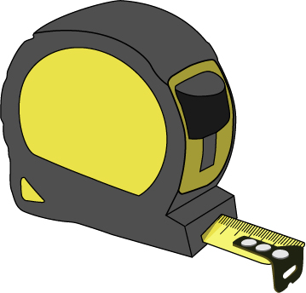

**Tape**to mark your shots/targets

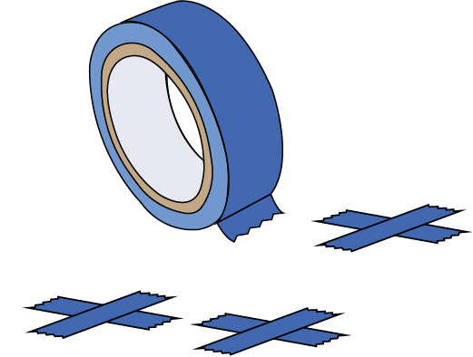

**Ping Pong Balls**

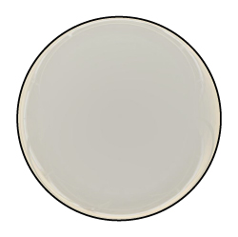

**“Built” Launcher**with protractors

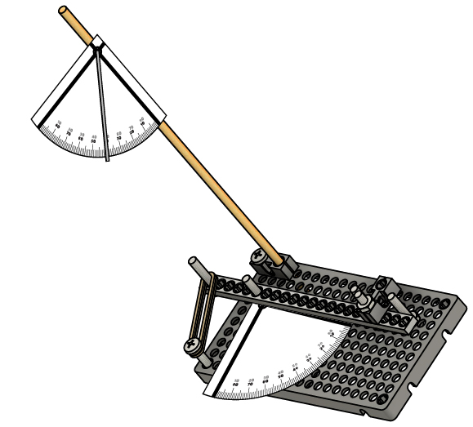

Build your launcher using the [**Go Guide**](https://teachergeek.org/launcher2.0_go_guide.docx) – download it from [**teachergeek.com/launcher2.0**](https://teachergeek.com/launcher2.0)

# Target Practice

**Team 2**

# 1

Team 1 and Team 2 are competing for the most bullseyes. They both aimed directly at the bullseye for every shot.

**Team 1**

Which team won the practice round?

_________________________________

# A

If both teams aimed directly at the bullseye in the competition, who would win?

______________________________________________________________________

# B

If each team could aim anywhere they wanted, who do you think would   
win the competition? Why?

______________________________________________________________________

______________________________________________________________________

______________________________________________________________________

# C

Teachers – the ISO Standards redefined accuracy and precision, so these definitions may be new to you.

**Only accurate launchers can hit the bullseye every time. Accurate launchers are both precise and true.**

# Precision, Trueness, & Accuracy

**Precision** is repeatability – getting the same result every time. It doesn’t have to be the result you want, but it’s always the same.

**Trueness** is when your results average where you want them – they can be spread out, but they are centered in the right place.

**Accuracy** is both precision and trueness – your launcher must hit the target consistently to be considered accurate.

# 2

Circle the option that best describes each launcher.

|  |  |
| --- | --- |
| Accurate | Precise |
| True | None |

|  |  |
| --- | --- |
| Accurate | Precise |
| True | None |

|  |  |
| --- | --- |
| Accurate | Precise |
| True | None |

|  |  |
| --- | --- |
| Accurate | Precise |
| True | None |

**Launcher 1**

**Launcher 2**

**Launcher 3**

**Launcher 4**

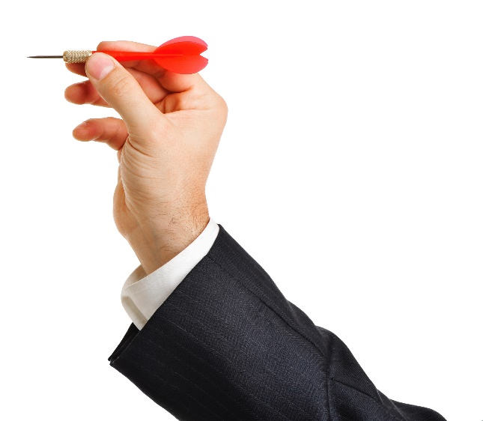

# 3

Which launcher do you think is the best? Why?

________________________________________________________

________________________________________________________

________________________________________________________

________________________________________________________

________________________________________________________

________________________________________________________

**Now that you know what precision and accuracy are, you’re going to measure the precision of your launcher!**

# Launch Stuff!

|  |  |  |  |  |  |
| --- | --- | --- | --- | --- | --- |
| Angle | Launch 1 | Launch 2 | Launch 3 | Mean | Range |
| **60°** |  |  |  |  |  |
| **45°** |  |  |  |  |  |
| **30°** |  |  |  |  |  |

Complete the table by finding the **range** for each angle.

# 7

Example Mean:

|  |  |  |  |
| --- | --- | --- | --- |
| Launch 1 | Launch 2 | Launch 3 | Mean |
| 2.4 m | 2.2 m | 2.0 m | 2.2 m |

$\frac{2.4 m + 2.2 m + 2.0 m}{3}=2.2 m$

Add your data, then divide by how many there are.

Example Range:

|  |  |  |
| --- | --- | --- |
| Launch 1 | Launch 2 | Launch 3 |
| 2.4 m | 2.2 m | 2.0 m |

Subtract the least value from the greatest value.

|  |
| --- |
| Range |
| 0.4 m |

$$2.4 m-2.0 m=0.4 m$$

Greatest

Least

Using your example launcher, adjust the launch angle to 60°. Then fire your launcher three times, recording the distance in the table below.

Work:

# 6

# 5

# 4

Find the **mean** (average) distance for each angle you tested. Show your work below, and record your answers in the table.

Repeat Step 4 for launch angles of 45° and 30°.

# Conclusion

Which launch angle went the furthest average (mean) distance?

___________________________________________________________________

Which launch angle had the greatest precision? How can you tell?

___________________________________________________________________

___________________________________________________________________

Sabrina says that the smaller the range, the more precision the launcher has. Do you agree or disagree? Why?

___________________________________________________________________

___________________________________________________________________

___________________________________________________________________

___________________________________________________________________

Mateo’s needs to hit the bullseye to win the competition it’s exactly   
4 m away. Based on his data, what launch angle should he use? Why?

_____________________________________

_____________________________________

_____________________________________

_____________________________________

Is it more important to design your launcher for precision or trueness? Why?

___________________________________________________________________

___________________________________________________________________

___________________________________________________________________

___________________________________________________________________

___________________________________________________________________

# 8

# 9

# 10

# 11

|  |  |  |
| --- | --- | --- |
| Angle | Mean | Range |
| **60°** | 4.02 m | 0.5 m |
| **45°** | 6.00 m | 0.4 m |
| **30°** | 3.98 m | 0.2 m |

Mateo’s Data:

# 12