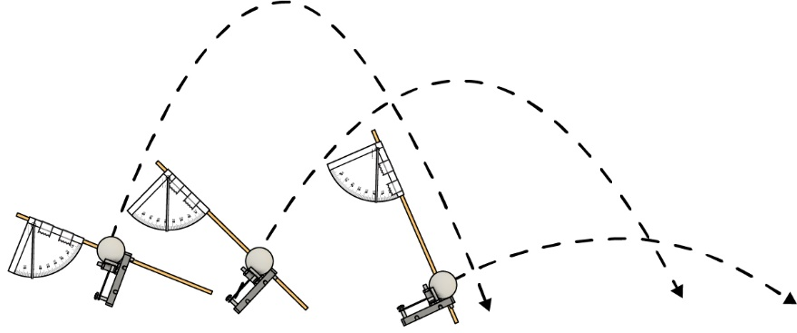

Nombre: __________________________________________ Fecha: ______________________

En este laboratorio, ¡aprenderás a usar gráficas para representar la distancia de tus tiros!

# Material del Laboratorio

**Cinta métrica**para medir la distancia de tiro

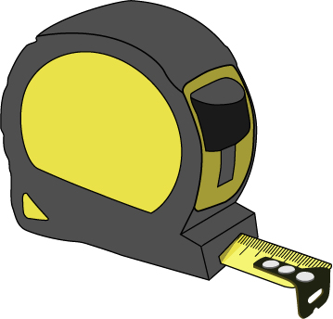

**Cinta adhesiva**para marcar tus tiros

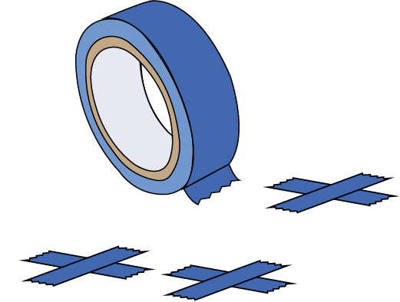

**Pelotas de Ping Pong**

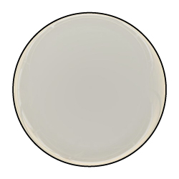

**Lanzador “construido”** con transportadores.

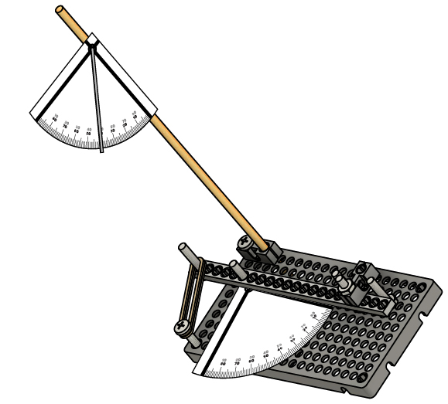

Construye tu lanzador usando la [**Guía**](https://teachergeek.org/launcher2.0_go_guide.docx) **Go**, descárgala en [**teachergeek.com/launcher2.0**](https://teachergeek.com/launcher2.0)

# Planea tu Experimento

**Elige una variable para cambiar y, ¡observa cómo afecta la distancia de tiro!**

¿Qué variable vas a cambiar? ¿Qué variables vas a mantener constantes? Registra las variables de tu lanzador en la tabla de abajo.

# 1

* # de ligas
* Ángulo del pateador
* Distancia de tiro
* Ángulo de tiro
* Variables específicas a tu lanzador único

Variables:

**¡Tus variables de control necesitan mediciones!** Ejemplo: no solo escribas en tu control   
*# de ligas*, más bien escribe *ligas = 5*.

|  |  |  |
| --- | --- | --- |
| Variable(s) Independientes | Variable(s) Dependientes | Variable(s) de Control |
|  |  |  |

.

|  |  |  |  |
| --- | --- | --- | --- |
|  | Distancia de tiro | | |
| Ángulo de pateador | Intento 1 | Intento 2 | Intento 3 |
| 0° | 0.00 m | 0.00 m | 0.00 m |
| 10° | 0.61 m | 0.76 m | 0.74 m |
| 15° | 0.76 m | 1.00 m | 1.12 m |
| 20° | 0.20 m | 1.51 m | 1.58 m |
| 25° | 2.67 m | 2.47 m | 2.39 m |
| 30° | 3.03 m | 3.19 m | 2.77 m |
| 35° | 3.50 m | 3.54 m | 0.97 m |

Ejemplo de tabla de datos:

¡Haz tu experimento! Cambia la variable independiente (del paso 1), y observa cómo afecta tu distancia de tiro. Escribe tus datos en esta página, en listas o tablas.

# 2

# Recopila los Datos

|  |  |  |  |  |  |  |  |  |  |  |  |  |  |  |  |  |  |  |  |  |  |  |  |  |  |  |  |  |  |  |
| --- | --- | --- | --- | --- | --- | --- | --- | --- | --- | --- | --- | --- | --- | --- | --- | --- | --- | --- | --- | --- | --- | --- | --- | --- | --- | --- | --- | --- | --- | --- |
|  |  |  |  |  |  |  |  |  |  |  |  |  |  |  |  |  |  |  |  |  |  |  |  |  |  |  |  |  |  |  |
|  |  |  |  |  |  |  |  |  |  |  |  |  |  |  |  |  |  |  |  |  |  |  |  |  |  |  |  |  |  |  |
|  |  |  |  |  |  |  |  |  |  |  |  |  |  |  |  |  |  |  |  |  |  |  |  |  |  |  |  |  |  |  |
|  |  |  |  |  |  |  |  |  |  |  |  |  |  |  |  |  |  |  |  |  |  |  |  |  |  |  |  |  |  |  |
|  |  |  |  |  |  |  |  |  |  |  |  |  |  |  |  |  |  |  |  |  |  |  |  |  |  |  |  |  |  |  |
|  |  |  |  |  |  |  |  |  |  |  |  |  |  |  |  |  |  |  |  |  |  |  |  |  |  |  |  |  |  |  |
|  |  |  |  |  |  |  |  |  |  |  |  |  |  |  |  |  |  |  |  |  |  |  |  |  |  |  |  |  |  |  |
|  |  |  |  |  |  |  |  |  |  |  |  |  |  |  |  |  |  |  |  |  |  |  |  |  |  |  |  |  |  |  |
|  |  |  |  |  |  |  |  |  |  |  |  |  |  |  |  |  |  |  |  |  |  |  |  |  |  |  |  |  |  |  |
|  |  |  |  |  |  |  |  |  |  |  |  |  |  |  |  |  |  |  |  |  |  |  |  |  |  |  |  |  |  |  |
|  |  |  |  |  |  |  |  |  |  |  |  |  |  |  |  |  |  |  |  |  |  |  |  |  |  |  |  |  |  |  |
|  |  |  |  |  |  |  |  |  |  |  |  |  |  |  |  |  |  |  |  |  |  |  |  |  |  |  |  |  |  |  |
|  |  |  |  |  |  |  |  |  |  |  |  |  |  |  |  |  |  |  |  |  |  |  |  |  |  |  |  |  |  |  |
|  |  |  |  |  |  |  |  |  |  |  |  |  |  |  |  |  |  |  |  |  |  |  |  |  |  |  |  |  |  |  |
|  |  |  |  |  |  |  |  |  |  |  |  |  |  |  |  |  |  |  |  |  |  |  |  |  |  |  |  |  |  |  |
|  |  |  |  |  |  |  |  |  |  |  |  |  |  |  |  |  |  |  |  |  |  |  |  |  |  |  |  |  |  |  |
|  |  |  |  |  |  |  |  |  |  |  |  |  |  |  |  |  |  |  |  |  |  |  |  |  |  |  |  |  |  |  |
|  |  |  |  |  |  |  |  |  |  |  |  |  |  |  |  |  |  |  |  |  |  |  |  |  |  |  |  |  |  |  |
|  |  |  |  |  |  |  |  |  |  |  |  |  |  |  |  |  |  |  |  |  |  |  |  |  |  |  |  |  |  |  |
|  |  |  |  |  |  |  |  |  |  |  |  |  |  |  |  |  |  |  |  |  |  |  |  |  |  |  |  |  |  |  |
|  |  |  |  |  |  |  |  |  |  |  |  |  |  |  |  |  |  |  |  |  |  |  |  |  |  |  |  |  |  |  |
|  |  |  |  |  |  |  |  |  |  |  |  |  |  |  |  |  |  |  |  |  |  |  |  |  |  |  |  |  |  |  |
|  |  |  |  |  |  |  |  |  |  |  |  |  |  |  |  |  |  |  |  |  |  |  |  |  |  |  |  |  |  |  |
|  |  |  |  |  |  |  |  |  |  |  |  |  |  |  |  |  |  |  |  |  |  |  |  |  |  |  |  |  |  |  |
|  |  |  |  |  |  |  |  |  |  |  |  |  |  |  |  |  |  |  |  |  |  |  |  |  |  |  |  |  |  |  |
|  |  |  |  |  |  |  |  |  |  |  |  |  |  |  |  |  |  |  |  |  |  |  |  |  |  |  |  |  |  |  |
|  |  |  |  |  |  |  |  |  |  |  |  |  |  |  |  |  |  |  |  |  |  |  |  |  |  |  |  |  |  |  |
|  |  |  |  |  |  |  |  |  |  |  |  |  |  |  |  |  |  |  |  |  |  |  |  |  |  |  |  |  |  |  |
|  |  |  |  |  |  |  |  |  |  |  |  |  |  |  |  |  |  |  |  |  |  |  |  |  |  |  |  |  |  |  |



0° 5° 10° 15° 20° 25° 30° 35°

4.0

3.5

3.0

2.5

2.0

1.5

1.0

0.5

0

Ángulo del pateador

Distancia (metros)

**Curva ajustada**

**Datos atípicos**

Distancia vs ángulo de pateador

Ejemplo de gráfica:

# ¡Grafícalo!

# 3

Grafica tus datos abajo, luego traza la curva ajustada. Nota: Los datos atípicos (como los errores) se deben ignorar cuando traces la curva ajustada.

|  |  |  |  |  |  |  |  |  |  |  |  |  |  |  |  |  |  |  |  |  |  |  |  |  |  |  |  |  |  |  |
| --- | --- | --- | --- | --- | --- | --- | --- | --- | --- | --- | --- | --- | --- | --- | --- | --- | --- | --- | --- | --- | --- | --- | --- | --- | --- | --- | --- | --- | --- | --- |
|  |  |  |  |  |  |  |  |  |  |  |  |  |  |  |  |  |  |  |  |  |  |  |  |  |  |  |  |  |  |  |
|  |  |  |  |  |  |  |  |  |  |  |  |  |  |  |  |  |  |  |  |  |  |  |  |  |  |  |  |  |  |  |
|  |  |  |  |  |  |  |  |  |  |  |  |  |  |  |  |  |  |  |  |  |  |  |  |  |  |  |  |  |  |  |
|  |  |  |  |  |  |  |  |  |  |  |  |  |  |  |  |  |  |  |  |  |  |  |  |  |  |  |  |  |  |  |
|  |  |  |  |  |  |  |  |  |  |  |  |  |  |  |  |  |  |  |  |  |  |  |  |  |  |  |  |  |  |  |
|  |  |  |  |  |  |  |  |  |  |  |  |  |  |  |  |  |  |  |  |  |  |  |  |  |  |  |  |  |  |  |
|  |  |  |  |  |  |  |  |  |  |  |  |  |  |  |  |  |  |  |  |  |  |  |  |  |  |  |  |  |  |  |
|  |  |  |  |  |  |  |  |  |  |  |  |  |  |  |  |  |  |  |  |  |  |  |  |  |  |  |  |  |  |  |
|  |  |  |  |  |  |  |  |  |  |  |  |  |  |  |  |  |  |  |  |  |  |  |  |  |  |  |  |  |  |  |
|  |  |  |  |  |  |  |  |  |  |  |  |  |  |  |  |  |  |  |  |  |  |  |  |  |  |  |  |  |  |  |
|  |  |  |  |  |  |  |  |  |  |  |  |  |  |  |  |  |  |  |  |  |  |  |  |  |  |  |  |  |  |  |
|  |  |  |  |  |  |  |  |  |  |  |  |  |  |  |  |  |  |  |  |  |  |  |  |  |  |  |  |  |  |  |
|  |  |  |  |  |  |  |  |  |  |  |  |  |  |  |  |  |  |  |  |  |  |  |  |  |  |  |  |  |  |  |
|  |  |  |  |  |  |  |  |  |  |  |  |  |  |  |  |  |  |  |  |  |  |  |  |  |  |  |  |  |  |  |
|  |  |  |  |  |  |  |  |  |  |  |  |  |  |  |  |  |  |  |  |  |  |  |  |  |  |  |  |  |  |  |
|  |  |  |  |  |  |  |  |  |  |  |  |  |  |  |  |  |  |  |  |  |  |  |  |  |  |  |  |  |  |  |
|  |  |  |  |  |  |  |  |  |  |  |  |  |  |  |  |  |  |  |  |  |  |  |  |  |  |  |  |  |  |  |
|  |  |  |  |  |  |  |  |  |  |  |  |  |  |  |  |  |  |  |  |  |  |  |  |  |  |  |  |  |  |  |
|  |  |  |  |  |  |  |  |  |  |  |  |  |  |  |  |  |  |  |  |  |  |  |  |  |  |  |  |  |  |  |
|  |  |  |  |  |  |  |  |  |  |  |  |  |  |  |  |  |  |  |  |  |  |  |  |  |  |  |  |  |  |  |
|  |  |  |  |  |  |  |  |  |  |  |  |  |  |  |  |  |  |  |  |  |  |  |  |  |  |  |  |  |  |  |
|  |  |  |  |  |  |  |  |  |  |  |  |  |  |  |  |  |  |  |  |  |  |  |  |  |  |  |  |  |  |  |
|  |  |  |  |  |  |  |  |  |  |  |  |  |  |  |  |  |  |  |  |  |  |  |  |  |  |  |  |  |  |  |
|  |  |  |  |  |  |  |  |  |  |  |  |  |  |  |  |  |  |  |  |  |  |  |  |  |  |  |  |  |  |  |
|  |  |  |  |  |  |  |  |  |  |  |  |  |  |  |  |  |  |  |  |  |  |  |  |  |  |  |  |  |  |  |
|  |  |  |  |  |  |  |  |  |  |  |  |  |  |  |  |  |  |  |  |  |  |  |  |  |  |  |  |  |  |  |
|  |  |  |  |  |  |  |  |  |  |  |  |  |  |  |  |  |  |  |  |  |  |  |  |  |  |  |  |  |  |  |
|  |  |  |  |  |  |  |  |  |  |  |  |  |  |  |  |  |  |  |  |  |  |  |  |  |  |  |  |  |  |  |
|  |  |  |  |  |  |  |  |  |  |  |  |  |  |  |  |  |  |  |  |  |  |  |  |  |  |  |  |  |  |  |

# Usa Tu Gráfica

# 4

¿Cuál crees que es la mayor distancia que tu lanzador puede alcanzar (sin cambiar las variables de control)? ¿Por qué?

________________________________________________________________________________

________________________________________________________________________________

________________________________________________________________________________

________________________________________________________________________________

# 5

¿Qué variables de control puedes cambiar para hacer que la pelota llegue más lejos?

________________________________________________________________________________

________________________________________________________________________________

________________________________________________________________________________

________________________________________________________________________________

# 6

Si pudieras repetir este experimento, ¿Harías algo diferente? Explica.

________________________________________________________________________________

________________________________________________________________________________

________________________________________________________________________________

________________________________________________________________________________

________________________________________________________________________________

# 7

¿Qué sucede si cambias tu diseño? ¿Todavía puedes usar tu gráfica? ¿Por qué?

________________________________________________________________________________

________________________________________________________________________________

________________________________________________________________________________

________________________________________________________________________________

¡Terminaste el laboratorio! Después, probablemente quieras hacer un desafío. Mientras sigues modificando y mejorando tu diseño, recuerda como usar gráficas para sacar el mayor provecho a *tu* lanzador.

¿Qué puede hacer el equipo 1 para graficar un mejor modelo para la distancia de su lanzador?

________________________________________________________________________________

________________________________________________________________________________

________________________________________________________________________________

________________________________________________________________________________

Dos equipos (derecha) están compitiendo para  
acertar en el blanco el mayor número de   
veces. Si el objetivo está exactamente a 3 m,  
¿cuál equipo crees que gane? Explica.

_______________________________________

_______________________________________

_______________________________________

________________________________________________________________________________

________________________________________________________________________________

________________________________________________________________________________

________________________________________________________________________________



0° 10° 20° 30° 40° 50°

5

4

3

2

1

0

Ángulo de tiro

Distancia (metros)

Equipo 2



0° 10° 20° 30° 40° 50°

5

4

3

2

1

0

Ángulo de tiro

Distancia (metros)

Equipo 1

La gráfica de Tony se muestra a la derecha. Si Tony   
quisiera darle a un objetivo a 4 m de distancia, ¿Qué   
ángulo de tiro debería usar? ¿Por qué?

_____________________________________________

_____________________________________________

_____________________________________________

_____________________________________________

________________________________________________________________________________

________________________________________________________________________________

________________________________________________________________________________



0° 10° 20° 30° 40° 50° 60° 70° 80° 90°

6

5

4

3

2

1

0

Ángulo de tiro

Distancia (metros)

Lanzador de Tony

# 10

# 9

# 8