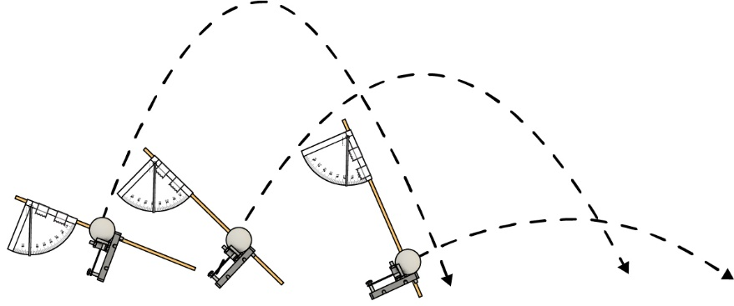

Name: ____________________________________________ Date:_____________________

In this lab, you’ll learn how to use graphs to dial in your launch distance!

# Lab Supplies

Build your launcher using the [**Go Guide**](https://teachergeek.org/launcher2.0_go_guide.docx) – download it from [**teachergeek.com/launcher2.0**](https://teachergeek.com/launcher2.0)

**“Built” Launcher**with protractors

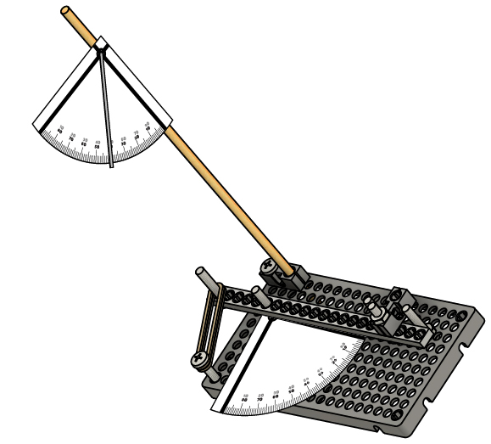

**Measuring Tape**to measure launch distance

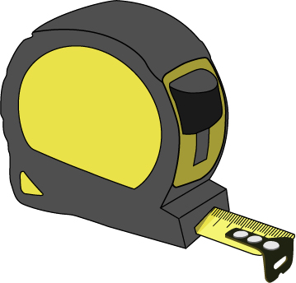

**Tape**to mark your shots

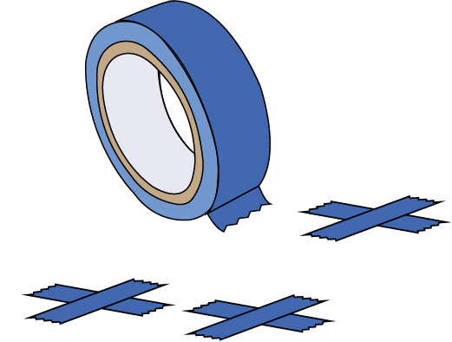

**Ping Pong Balls**

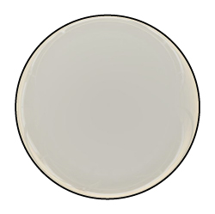

# Plan Your Experiment

**Choose one variable to change and see how it affects launch distance!**

Which variable will you change? Which variables will you keep constant? Record your launcher’s variables in the table below.

# 1

* # of Rubber Bands
* Wind-Up Amount
* Launch Distance
* Launch Angle
* Variables specific to *your* unique launcher

Variables:

**Your control variables need measurements!** E.g. don’t just write your controlling the   
*# of rubber bands*, but write *rubber bands = 5*.

|  |  |  |
| --- | --- | --- |
| Independent Variable(s) | Dependent Variable(s) | Control Variable(s) |
|  |  |  |

.

Example Data Table:

|  |  |  |  |
| --- | --- | --- | --- |
|  | Launch Distance | | |
| Wind-Up | Trial 1 | Trial 2 | Trial 3 |
| 0° | 0.00 m | 0.00 m | 0.00 m |
| 10° | 0.61 m | 0.76 m | 0.74 m |
| 15° | 0.76 m | 1.00 m | 1.12 m |
| 20° | 0.20 m | 1.51 m | 1.58 m |
| 25° | 2.67 m | 2.47 m | 2.39 m |
| 30° | 3.03 m | 3.19 m | 2.77 m |
| 35° | 3.50 m | 3.54 m | 0.97 m |

Do your experiment! Change the independent variable (from Step 1), and test how it affects your launch   
distance. Record your data on this page in lists or tables.

# 2

# Collect Data

|  |  |  |  |  |  |  |  |  |  |  |  |  |  |  |  |  |  |  |  |  |  |  |  |  |  |  |  |  |  |  |
| --- | --- | --- | --- | --- | --- | --- | --- | --- | --- | --- | --- | --- | --- | --- | --- | --- | --- | --- | --- | --- | --- | --- | --- | --- | --- | --- | --- | --- | --- | --- |
|  |  |  |  |  |  |  |  |  |  |  |  |  |  |  |  |  |  |  |  |  |  |  |  |  |  |  |  |  |  |  |
|  |  |  |  |  |  |  |  |  |  |  |  |  |  |  |  |  |  |  |  |  |  |  |  |  |  |  |  |  |  |  |
|  |  |  |  |  |  |  |  |  |  |  |  |  |  |  |  |  |  |  |  |  |  |  |  |  |  |  |  |  |  |  |
|  |  |  |  |  |  |  |  |  |  |  |  |  |  |  |  |  |  |  |  |  |  |  |  |  |  |  |  |  |  |  |
|  |  |  |  |  |  |  |  |  |  |  |  |  |  |  |  |  |  |  |  |  |  |  |  |  |  |  |  |  |  |  |
|  |  |  |  |  |  |  |  |  |  |  |  |  |  |  |  |  |  |  |  |  |  |  |  |  |  |  |  |  |  |  |
|  |  |  |  |  |  |  |  |  |  |  |  |  |  |  |  |  |  |  |  |  |  |  |  |  |  |  |  |  |  |  |
|  |  |  |  |  |  |  |  |  |  |  |  |  |  |  |  |  |  |  |  |  |  |  |  |  |  |  |  |  |  |  |
|  |  |  |  |  |  |  |  |  |  |  |  |  |  |  |  |  |  |  |  |  |  |  |  |  |  |  |  |  |  |  |
|  |  |  |  |  |  |  |  |  |  |  |  |  |  |  |  |  |  |  |  |  |  |  |  |  |  |  |  |  |  |  |
|  |  |  |  |  |  |  |  |  |  |  |  |  |  |  |  |  |  |  |  |  |  |  |  |  |  |  |  |  |  |  |
|  |  |  |  |  |  |  |  |  |  |  |  |  |  |  |  |  |  |  |  |  |  |  |  |  |  |  |  |  |  |  |
|  |  |  |  |  |  |  |  |  |  |  |  |  |  |  |  |  |  |  |  |  |  |  |  |  |  |  |  |  |  |  |
|  |  |  |  |  |  |  |  |  |  |  |  |  |  |  |  |  |  |  |  |  |  |  |  |  |  |  |  |  |  |  |
|  |  |  |  |  |  |  |  |  |  |  |  |  |  |  |  |  |  |  |  |  |  |  |  |  |  |  |  |  |  |  |
|  |  |  |  |  |  |  |  |  |  |  |  |  |  |  |  |  |  |  |  |  |  |  |  |  |  |  |  |  |  |  |
|  |  |  |  |  |  |  |  |  |  |  |  |  |  |  |  |  |  |  |  |  |  |  |  |  |  |  |  |  |  |  |
|  |  |  |  |  |  |  |  |  |  |  |  |  |  |  |  |  |  |  |  |  |  |  |  |  |  |  |  |  |  |  |
|  |  |  |  |  |  |  |  |  |  |  |  |  |  |  |  |  |  |  |  |  |  |  |  |  |  |  |  |  |  |  |
|  |  |  |  |  |  |  |  |  |  |  |  |  |  |  |  |  |  |  |  |  |  |  |  |  |  |  |  |  |  |  |
|  |  |  |  |  |  |  |  |  |  |  |  |  |  |  |  |  |  |  |  |  |  |  |  |  |  |  |  |  |  |  |
|  |  |  |  |  |  |  |  |  |  |  |  |  |  |  |  |  |  |  |  |  |  |  |  |  |  |  |  |  |  |  |
|  |  |  |  |  |  |  |  |  |  |  |  |  |  |  |  |  |  |  |  |  |  |  |  |  |  |  |  |  |  |  |
|  |  |  |  |  |  |  |  |  |  |  |  |  |  |  |  |  |  |  |  |  |  |  |  |  |  |  |  |  |  |  |
|  |  |  |  |  |  |  |  |  |  |  |  |  |  |  |  |  |  |  |  |  |  |  |  |  |  |  |  |  |  |  |
|  |  |  |  |  |  |  |  |  |  |  |  |  |  |  |  |  |  |  |  |  |  |  |  |  |  |  |  |  |  |  |
|  |  |  |  |  |  |  |  |  |  |  |  |  |  |  |  |  |  |  |  |  |  |  |  |  |  |  |  |  |  |  |
|  |  |  |  |  |  |  |  |  |  |  |  |  |  |  |  |  |  |  |  |  |  |  |  |  |  |  |  |  |  |  |
|  |  |  |  |  |  |  |  |  |  |  |  |  |  |  |  |  |  |  |  |  |  |  |  |  |  |  |  |  |  |  |



0° 5° 10° 15° 20° 25° 30° 35°

4.0

3.5

3.0

2.5

2.0

1.5

1.0

0.5

0

Wind-Up Angle

Distance (meters)

**Best Fit Curve**

**Outliers**

Distance vs Wind-Up Angle

Example Graph:

# Graph It!

# 3

Graph your data below, then sketch a best-fit curve.  
Note: Outliers (like misfires) should be ignored when drawing your best-fit curve.

|  |  |  |  |  |  |  |  |  |  |  |  |  |  |  |  |  |  |  |  |  |  |  |  |  |  |  |  |  |  |  |
| --- | --- | --- | --- | --- | --- | --- | --- | --- | --- | --- | --- | --- | --- | --- | --- | --- | --- | --- | --- | --- | --- | --- | --- | --- | --- | --- | --- | --- | --- | --- |
|  |  |  |  |  |  |  |  |  |  |  |  |  |  |  |  |  |  |  |  |  |  |  |  |  |  |  |  |  |  |  |
|  |  |  |  |  |  |  |  |  |  |  |  |  |  |  |  |  |  |  |  |  |  |  |  |  |  |  |  |  |  |  |
|  |  |  |  |  |  |  |  |  |  |  |  |  |  |  |  |  |  |  |  |  |  |  |  |  |  |  |  |  |  |  |
|  |  |  |  |  |  |  |  |  |  |  |  |  |  |  |  |  |  |  |  |  |  |  |  |  |  |  |  |  |  |  |
|  |  |  |  |  |  |  |  |  |  |  |  |  |  |  |  |  |  |  |  |  |  |  |  |  |  |  |  |  |  |  |
|  |  |  |  |  |  |  |  |  |  |  |  |  |  |  |  |  |  |  |  |  |  |  |  |  |  |  |  |  |  |  |
|  |  |  |  |  |  |  |  |  |  |  |  |  |  |  |  |  |  |  |  |  |  |  |  |  |  |  |  |  |  |  |
|  |  |  |  |  |  |  |  |  |  |  |  |  |  |  |  |  |  |  |  |  |  |  |  |  |  |  |  |  |  |  |
|  |  |  |  |  |  |  |  |  |  |  |  |  |  |  |  |  |  |  |  |  |  |  |  |  |  |  |  |  |  |  |
|  |  |  |  |  |  |  |  |  |  |  |  |  |  |  |  |  |  |  |  |  |  |  |  |  |  |  |  |  |  |  |
|  |  |  |  |  |  |  |  |  |  |  |  |  |  |  |  |  |  |  |  |  |  |  |  |  |  |  |  |  |  |  |
|  |  |  |  |  |  |  |  |  |  |  |  |  |  |  |  |  |  |  |  |  |  |  |  |  |  |  |  |  |  |  |
|  |  |  |  |  |  |  |  |  |  |  |  |  |  |  |  |  |  |  |  |  |  |  |  |  |  |  |  |  |  |  |
|  |  |  |  |  |  |  |  |  |  |  |  |  |  |  |  |  |  |  |  |  |  |  |  |  |  |  |  |  |  |  |
|  |  |  |  |  |  |  |  |  |  |  |  |  |  |  |  |  |  |  |  |  |  |  |  |  |  |  |  |  |  |  |
|  |  |  |  |  |  |  |  |  |  |  |  |  |  |  |  |  |  |  |  |  |  |  |  |  |  |  |  |  |  |  |
|  |  |  |  |  |  |  |  |  |  |  |  |  |  |  |  |  |  |  |  |  |  |  |  |  |  |  |  |  |  |  |
|  |  |  |  |  |  |  |  |  |  |  |  |  |  |  |  |  |  |  |  |  |  |  |  |  |  |  |  |  |  |  |
|  |  |  |  |  |  |  |  |  |  |  |  |  |  |  |  |  |  |  |  |  |  |  |  |  |  |  |  |  |  |  |
|  |  |  |  |  |  |  |  |  |  |  |  |  |  |  |  |  |  |  |  |  |  |  |  |  |  |  |  |  |  |  |
|  |  |  |  |  |  |  |  |  |  |  |  |  |  |  |  |  |  |  |  |  |  |  |  |  |  |  |  |  |  |  |
|  |  |  |  |  |  |  |  |  |  |  |  |  |  |  |  |  |  |  |  |  |  |  |  |  |  |  |  |  |  |  |
|  |  |  |  |  |  |  |  |  |  |  |  |  |  |  |  |  |  |  |  |  |  |  |  |  |  |  |  |  |  |  |
|  |  |  |  |  |  |  |  |  |  |  |  |  |  |  |  |  |  |  |  |  |  |  |  |  |  |  |  |  |  |  |
|  |  |  |  |  |  |  |  |  |  |  |  |  |  |  |  |  |  |  |  |  |  |  |  |  |  |  |  |  |  |  |
|  |  |  |  |  |  |  |  |  |  |  |  |  |  |  |  |  |  |  |  |  |  |  |  |  |  |  |  |  |  |  |
|  |  |  |  |  |  |  |  |  |  |  |  |  |  |  |  |  |  |  |  |  |  |  |  |  |  |  |  |  |  |  |
|  |  |  |  |  |  |  |  |  |  |  |  |  |  |  |  |  |  |  |  |  |  |  |  |  |  |  |  |  |  |  |
|  |  |  |  |  |  |  |  |  |  |  |  |  |  |  |  |  |  |  |  |  |  |  |  |  |  |  |  |  |  |  |

# Use Your Graph

# 4

What is the farthest distance you think your launcher can shoot (without changing the control variables)? How can you tell?

________________________________________________________________________________

________________________________________________________________________________

________________________________________________________________________________

________________________________________________________________________________

# 5

What control variables could you change to launch your ball even farther?

________________________________________________________________________________

________________________________________________________________________________

________________________________________________________________________________

________________________________________________________________________________

# 6

If you could do this experiment over, would you do anything differently? Explain.

________________________________________________________________________________

________________________________________________________________________________

________________________________________________________________________________

________________________________________________________________________________

________________________________________________________________________________

# 7

What happens if you change your design? Can you still use your graph? Why or why not?

________________________________________________________________________________

________________________________________________________________________________

________________________________________________________________________________

________________________________________________________________________________

The two teams below are competing to hit   
the most bullseyes. If the target is exactly   
3 m away, which team do you think will win?   
Explain.

_______________________________________

_______________________________________

_______________________________________

________________________________________________________________________________

________________________________________________________________________________

________________________________________________________________________________

________________________________________________________________________________



0° 10° 20° 30° 40° 50°

5

4

3

2

1

0

Launch Angle

Distance (meters)

Team 2



0° 10° 20° 30° 40° 50°

5

4

3

2

1

0

Launch Angle

Distance (meters)

Team 1

Tony’s graph is to the right. If Tony wants to hit a   
target that is 4 m away, what launch angle   
should Tony use? Why?

_____________________________________________

_____________________________________________

_____________________________________________

_____________________________________________

________________________________________________________________________________

________________________________________________________________________________

________________________________________________________________________________



0° 10° 20° 30° 40° 50° 60° 70° 80° 90°

6

5

4

3

2

1

0

Launch Angle

Distance (meters)

Tony’s Launcher

You’re done with the lab! Next, you’ll probably do a challenge. As you keep tinkering and improving your design, remember how to use graphs to get the most out of *your* launcher.

# 10

What can Team 1 do to make their graph a better model for their launcher’s distance?

________________________________________________________________________________

________________________________________________________________________________

________________________________________________________________________________

________________________________________________________________________________

# 9

# 8