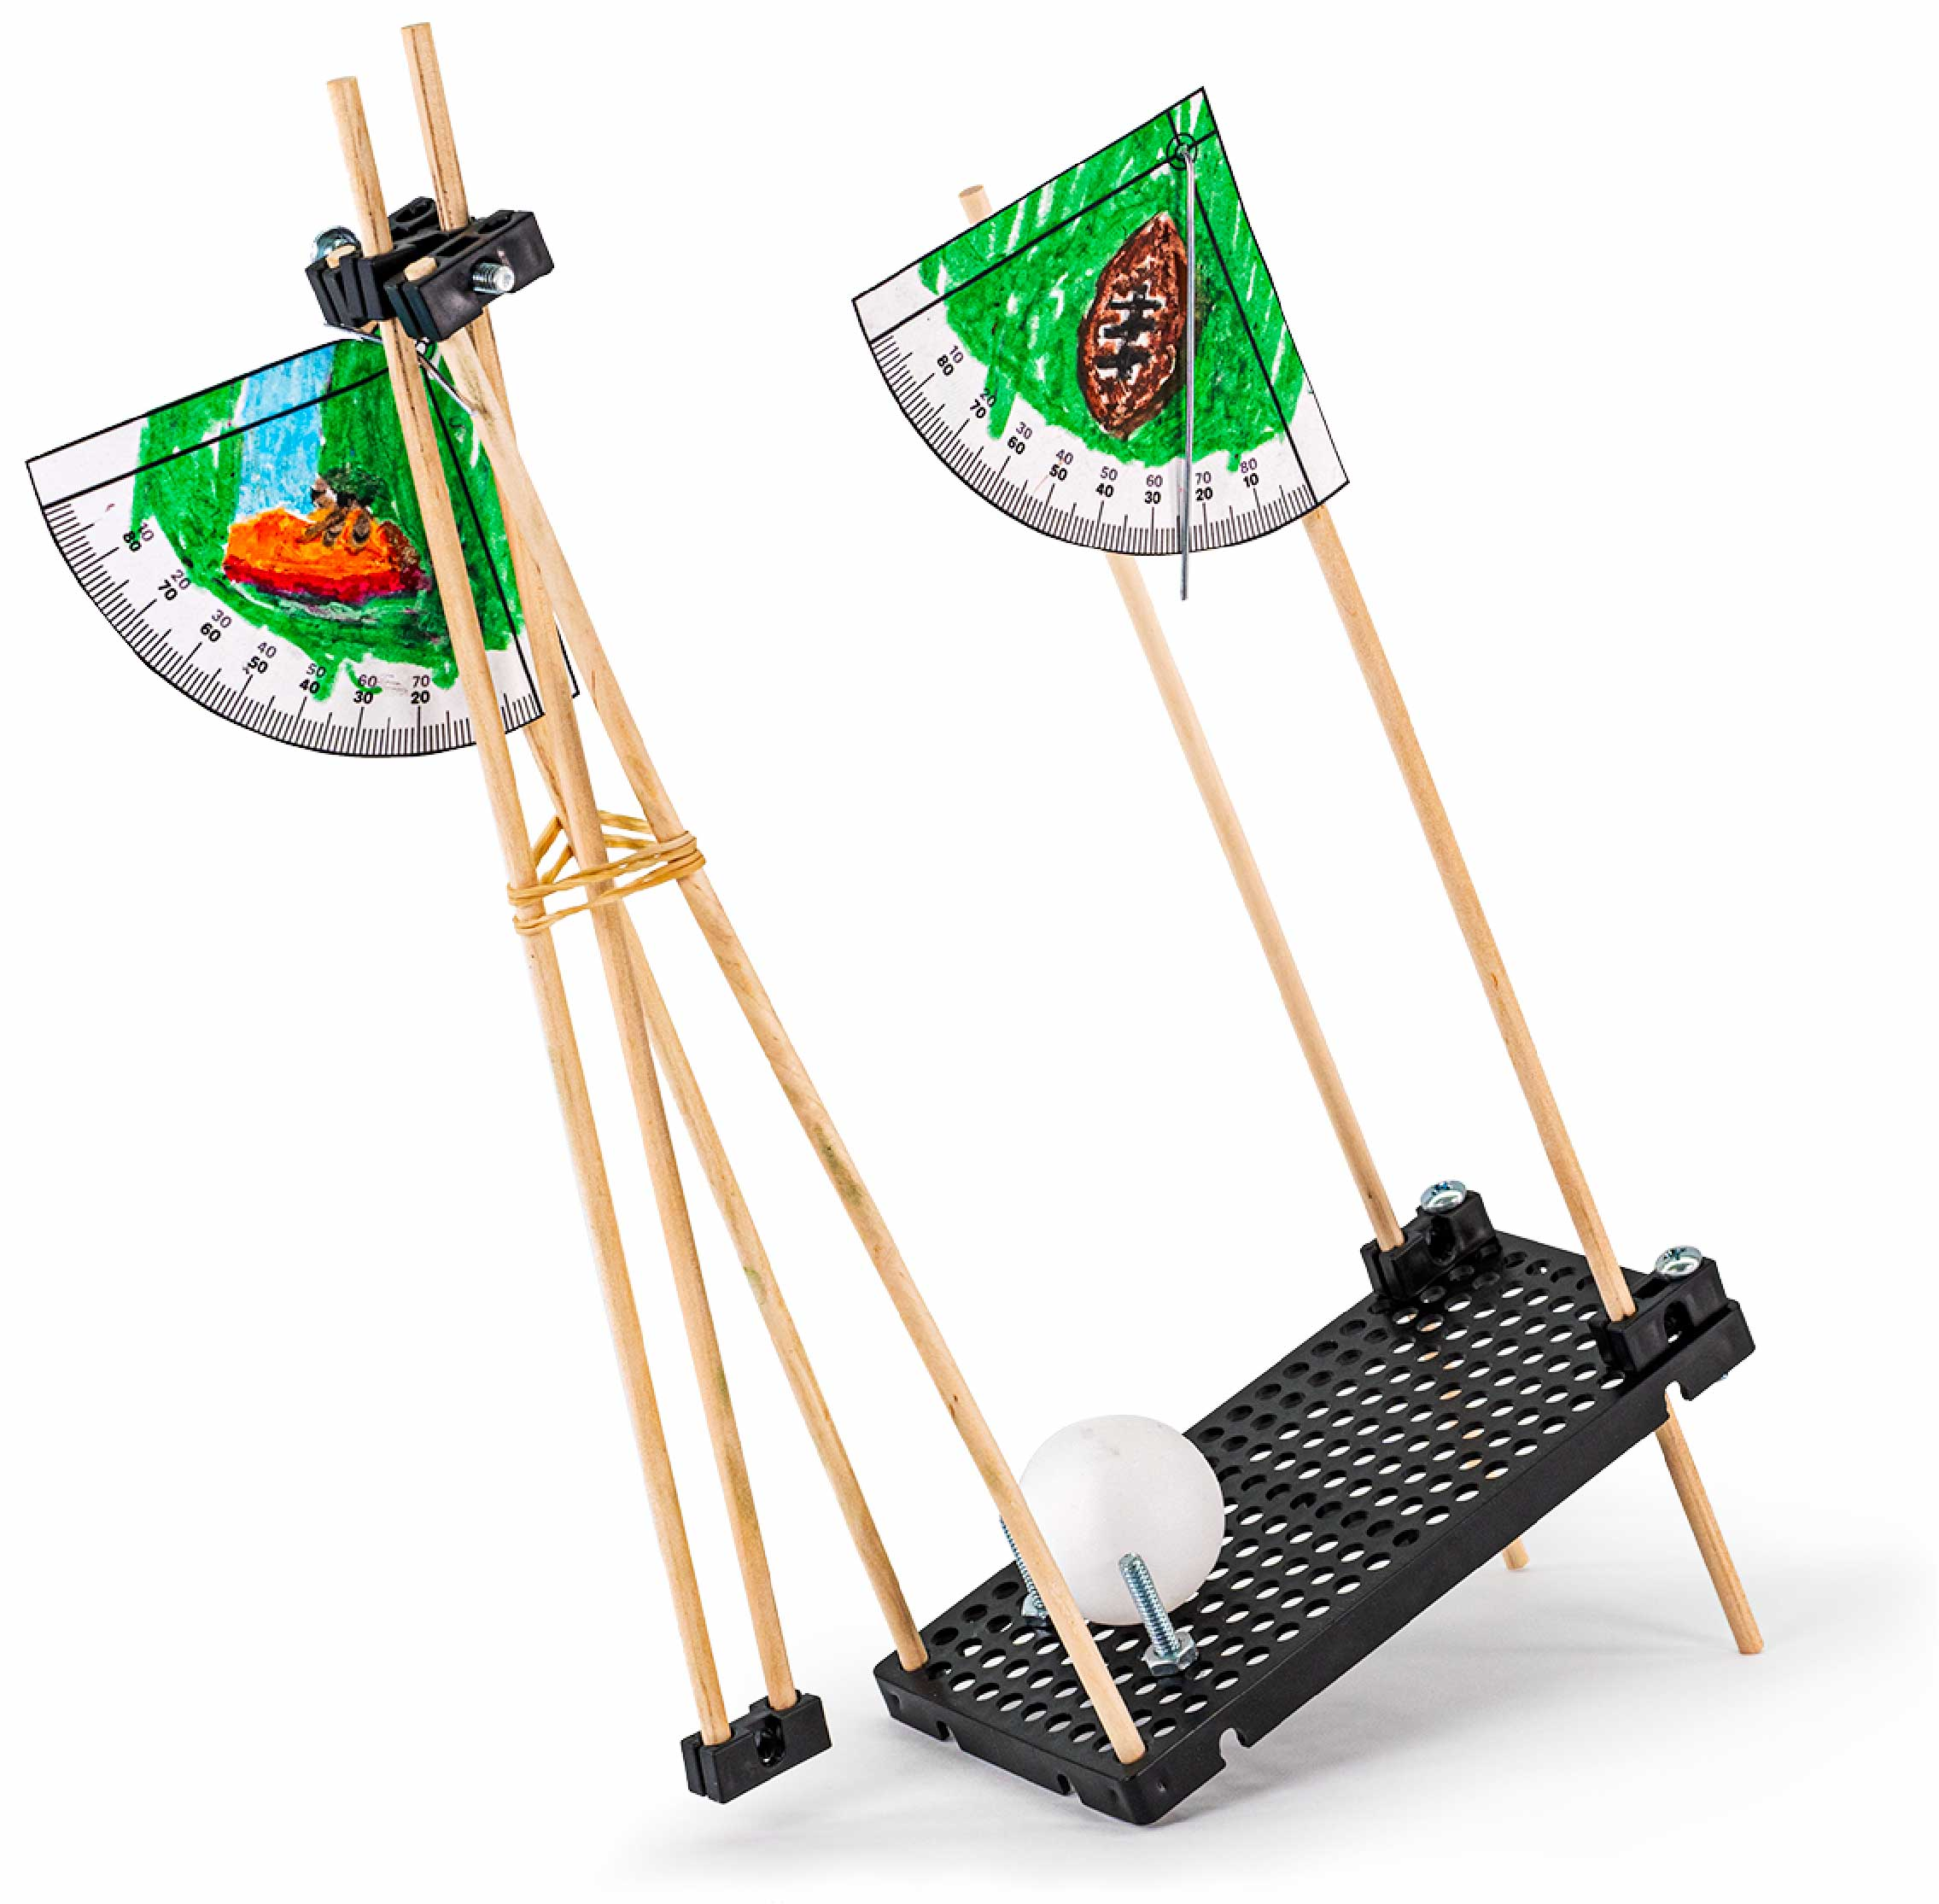

TRUE

STEM

STEAM

**Learn about projectile motion by designing and building your very own Launcher!**

You Are Here

Start here! Build your launcher, evolve your design, and begin the Bullseye Challenge!

Optional Labs

Optional Challenges

[-Precision & Accuracy Lab  
 (Ages 13+)](https://teachergeek.org/launcher2.0_lab_precision_accuracy.docx)  
[-Hit the Target Lab  
 (Ages 13+)](https://teachergeek.org/launcher2.0_lab_hit_the_target.docx)

-Moving Target Challenge*  
-Distance Challenge*  
-Siege Challenge*

*See Page 8

Go Guide

**Choose how you would like to complete this activity.  
Download documents & videos at** [**teachergeek.com/launcher2.0**](http://teachergeek.com/claw)

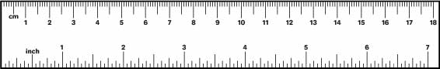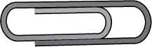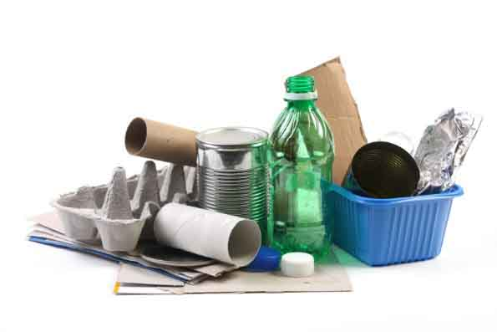

Have a Maker Cart? Use Multi-Cutters to cut your own dowels.

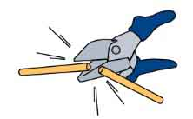

**Dowels**various sizes  
SKU 1821-20

**PICTURE**

**NAME**

**QTY**

**8**

**Hole Plates**  
SKU 1821-32

**Blocks**  
SKU 1821-34

**Strips**30 cm (12 in)  
SKU 1821-31

**Screws**2.5 cm (1 in)  
SKU 1821-22

**Screws**5 cm (2 in)  
SKU 1821-27

**Nuts**#10 Hex  
SKU 1821-25

**Rubber Bands**SKU 1823-41

**1**

**8**

**7**

**2**

**1**

**Ping Pong Balls**SKU 1821-44

**8**

**8**

**1**

**Protractors**

**3**

**Rulers**

**1**

**Paperclip**

**1**

Dowel Sizes  
6x 30 cm (12 in)  
2x 10 cm (4 in)

Protractors & rulers are   
on the last page, or you   
can print them from [**teachergeek.com/launcher2.0**](https://teachergeek.com/launcher2.0)

You will need to supply these if using a Maker Cart.

You can also use 10 cm   
(4 in) of steel building wire if you have a Maker Cart.

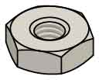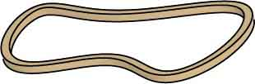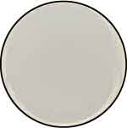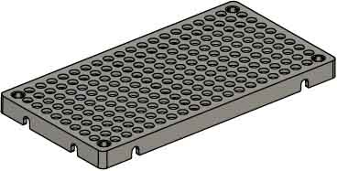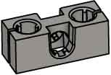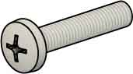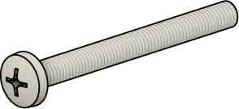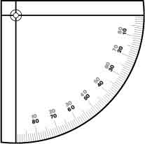

* **Phillips Screwdriver**
* **Scissors**
* **Tape**
* **Pliers** (optional)
* **Crayon** (optional)
* **Recycling Bin Materials**to incorporate into your designs

These are the parts you need to build one launcher, plus some extras, so you can make your own unique designs.

## MATERIALS YOU SUPPLY

## TEACHERGEEK PARTS

# Supplies

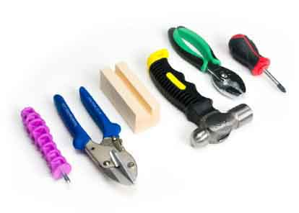

Modify materials to make even more creative designs with the **Maker Tool Set**

SKU 1823-84

**Optional Tools**

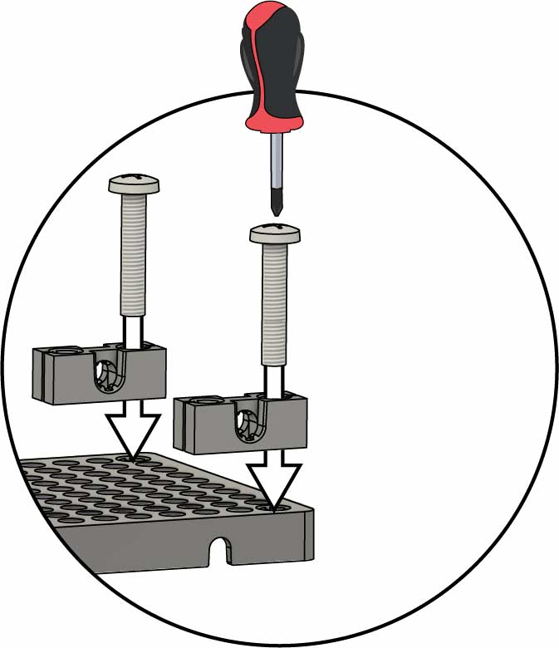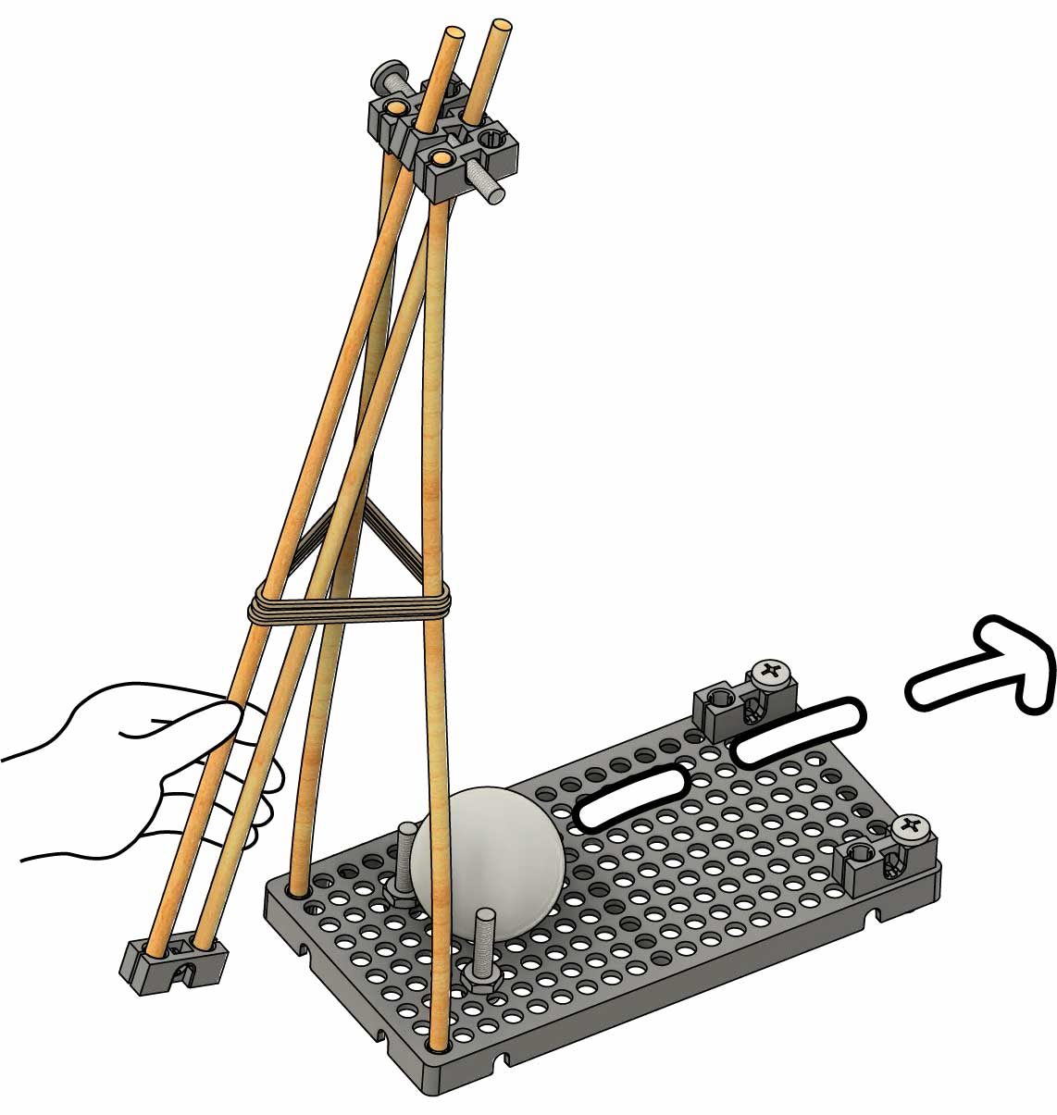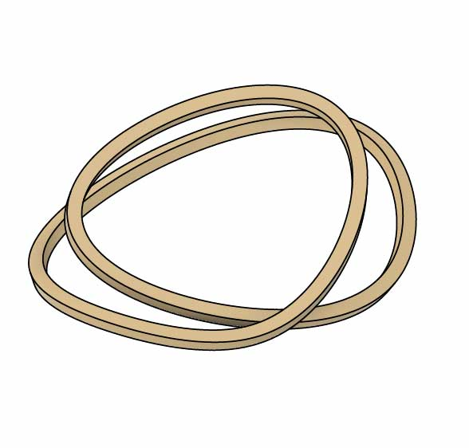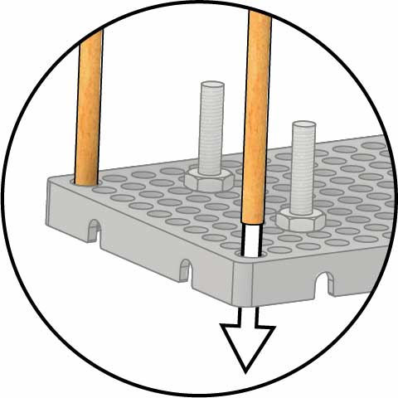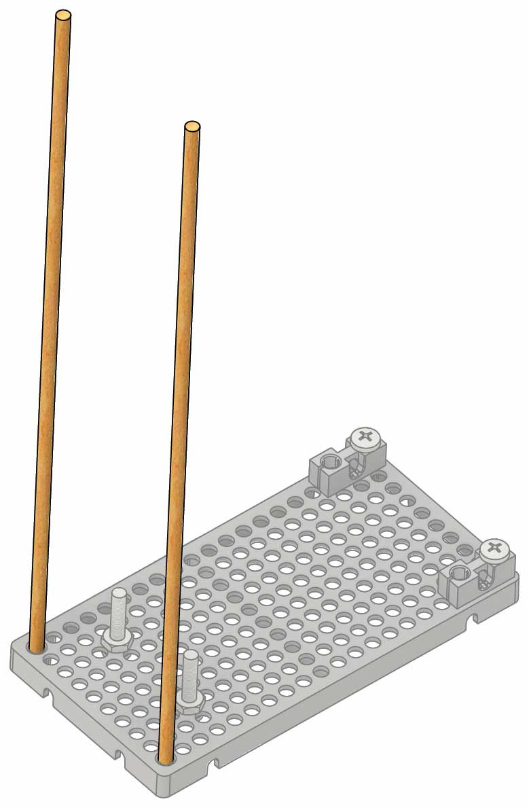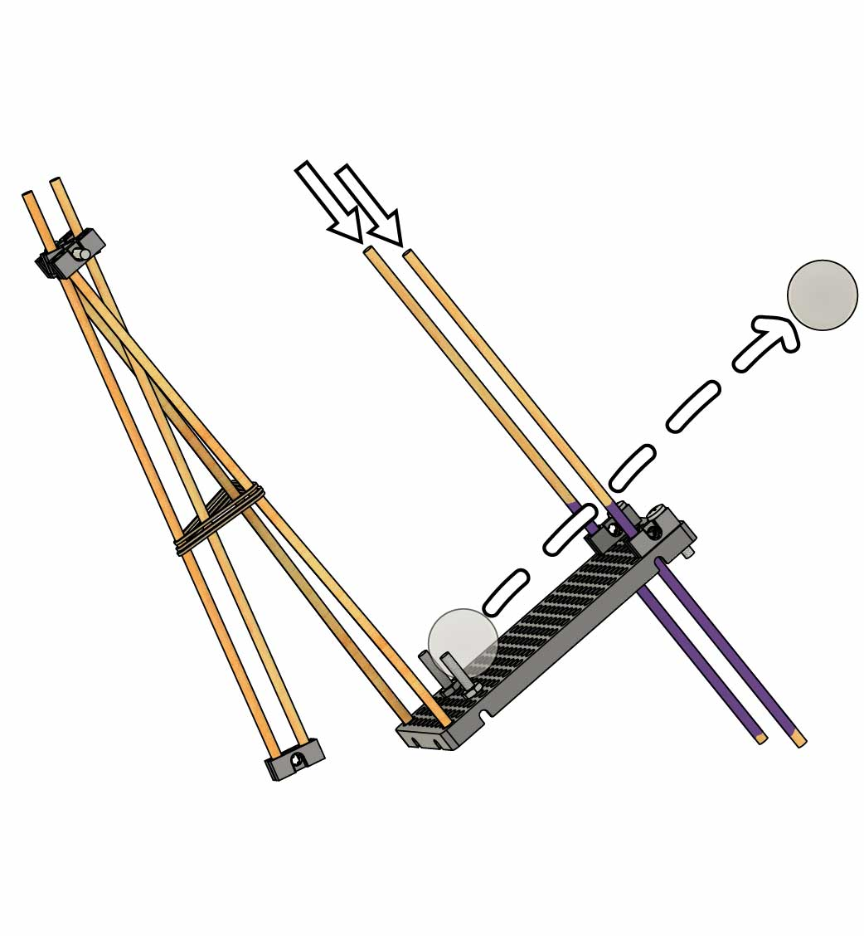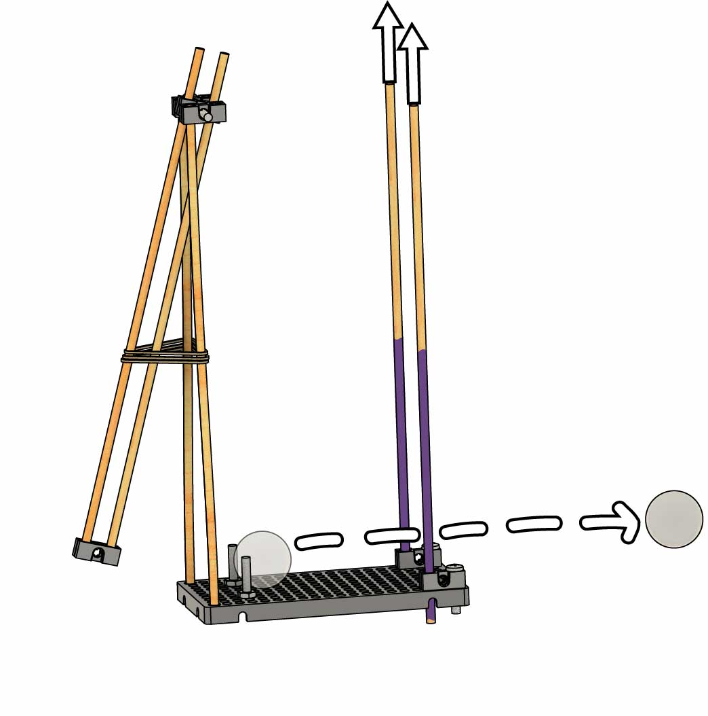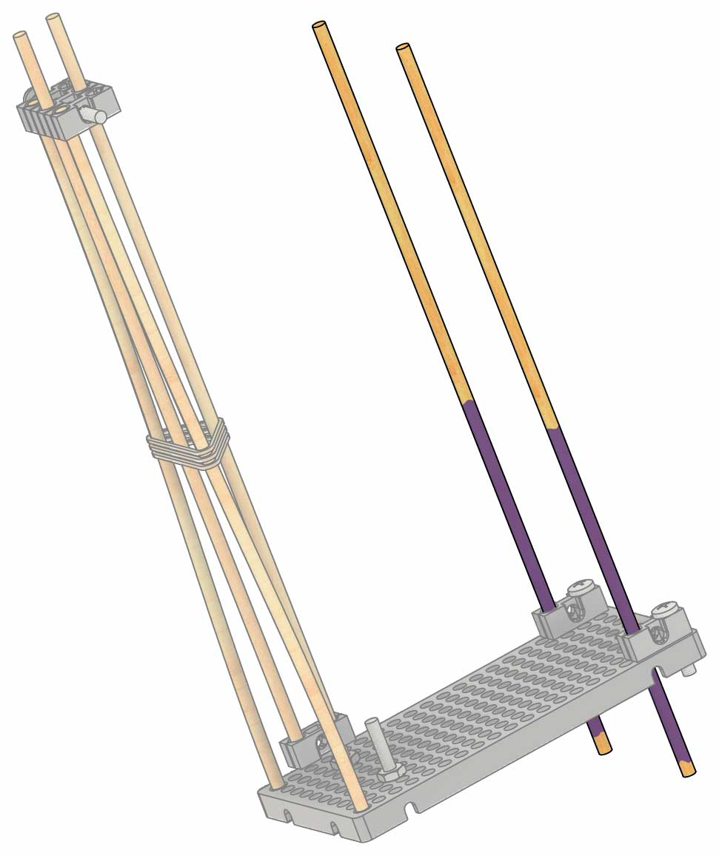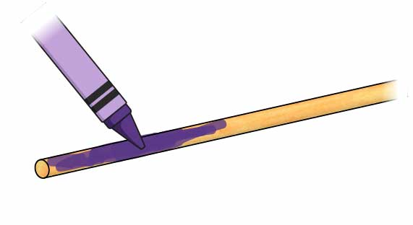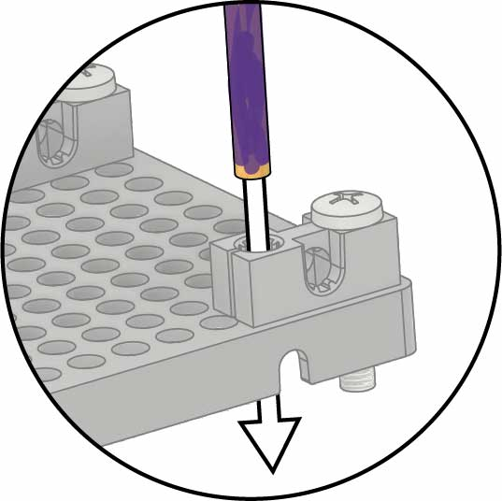](https://teachergeek.com/launcher2.0)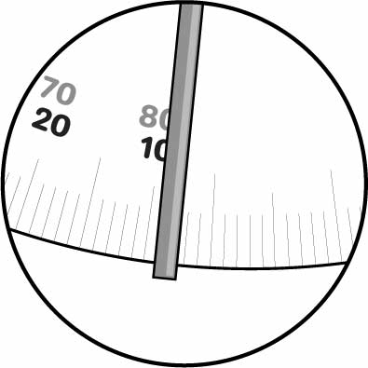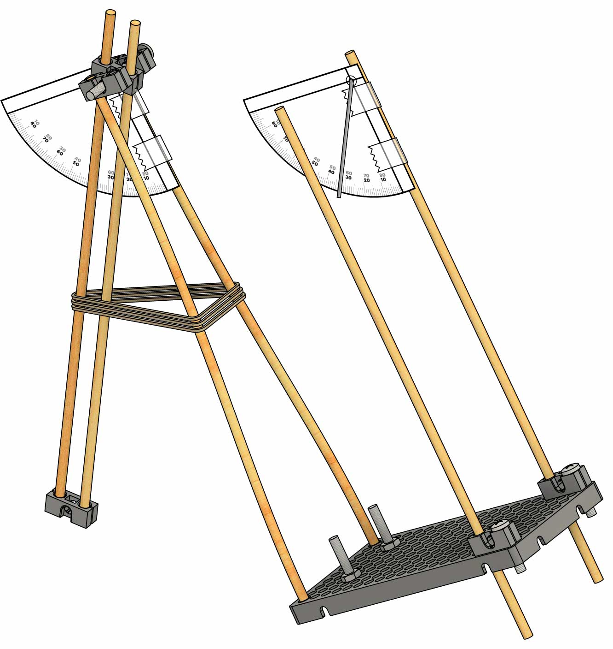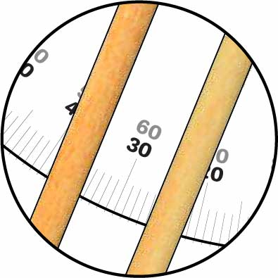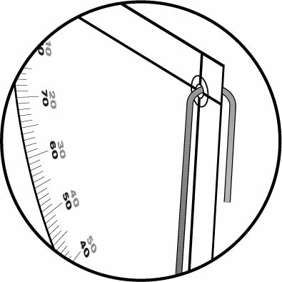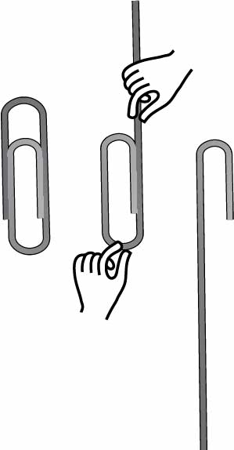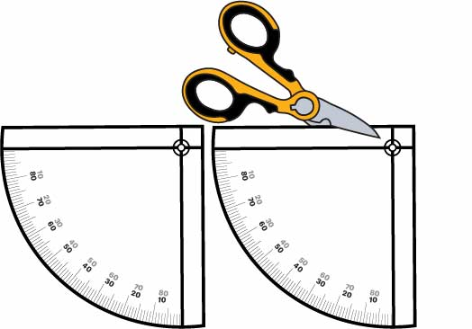

Use this to measure, or cut out a longer ruler on Page 10.

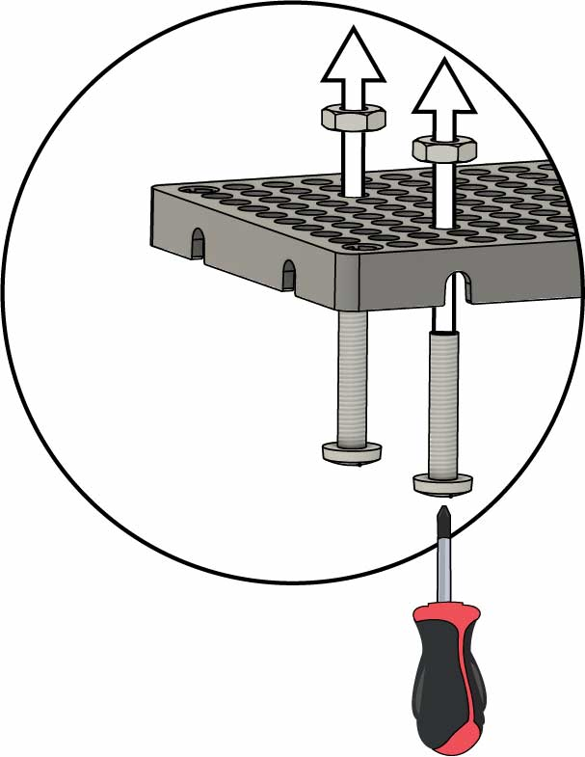

**Nuts**

**Hole Plates**

**Screws**2.5 mm (1 in)

**Your kicker is done!** Time to connect it to the base.

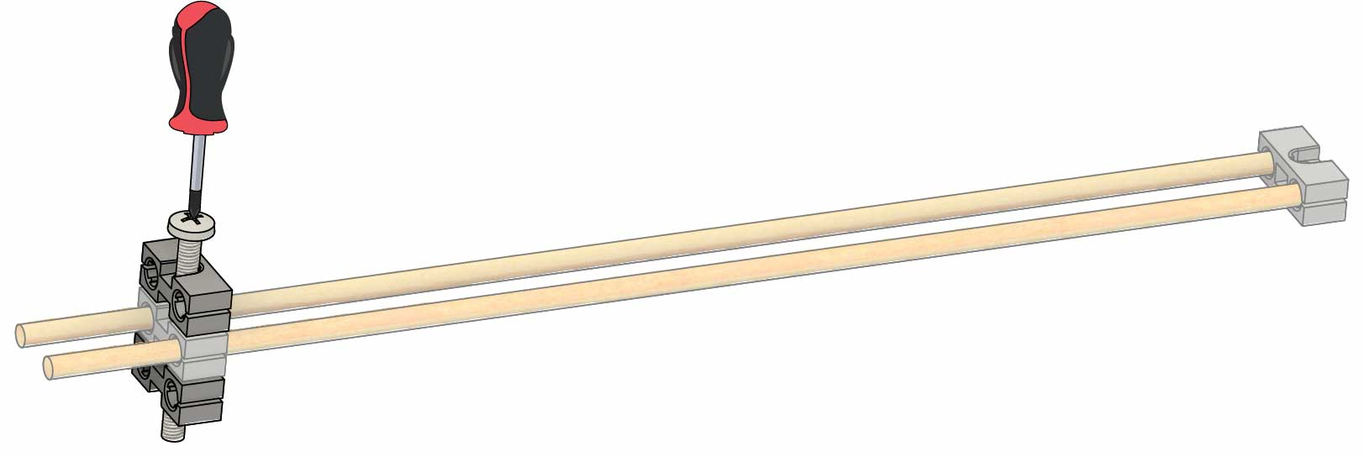

**Screw** – 5 cm (2 in)

**Block**

**Block**

# 3

**Tap** or **wiggle** **two 30 cm** (12 in) **dowels** through **two** **blocks**,   
as shown.

# Build the Kicker

# 4

**Connect two** more **blocks** usinga **5 cm** (2 in) **screw**.

**2.5 cm** (1 in) **sticking out**

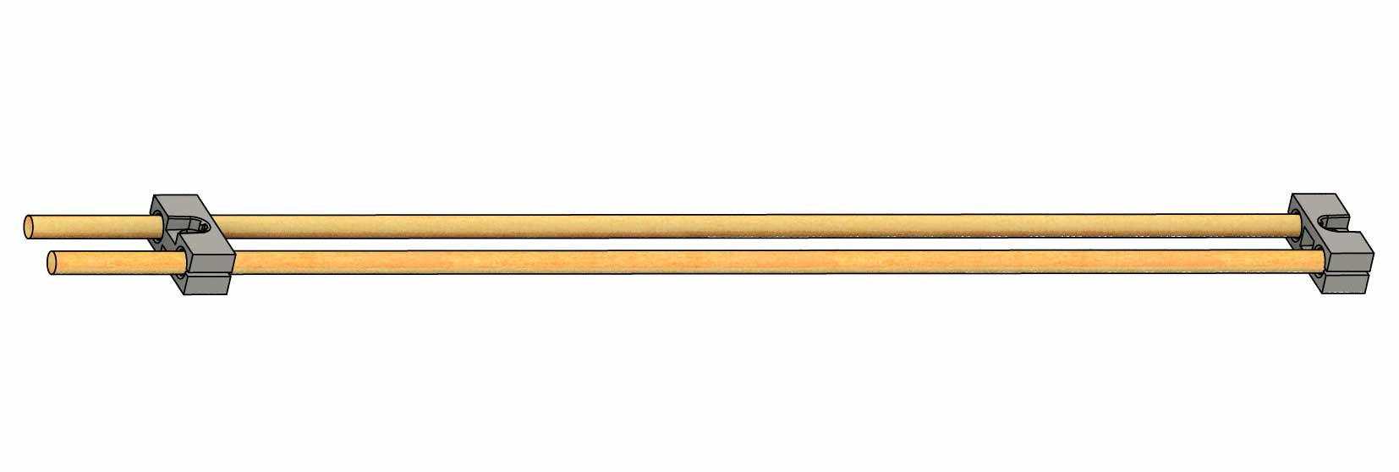

**Block**

**Block**

**Dowels –** 30 cm(12 in)

Attach **two** **blocks** to the corners of a **hole** **plate** with **two** **2.5** **cm** (1 in) **screws**.

# 2

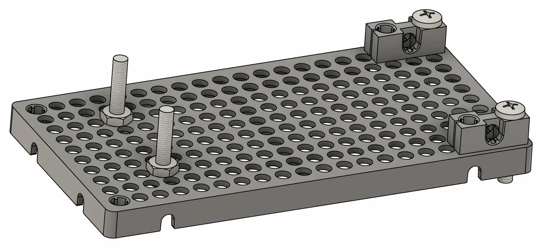

**Finished Base**

# Build the Base

Push **two** **25** **mm** (1 in) **screws** through the bottom of the **hole** **plate**, then **spin** **nuts** onto them.

# 1

**You’re ready to launch!** Next you’ll adjust the launch angle.

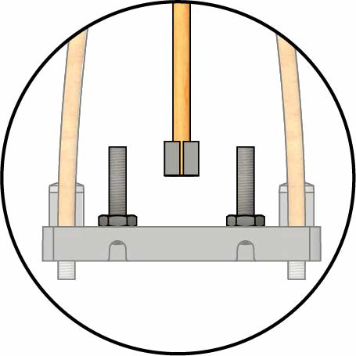

Make sure your kicker is vertical.

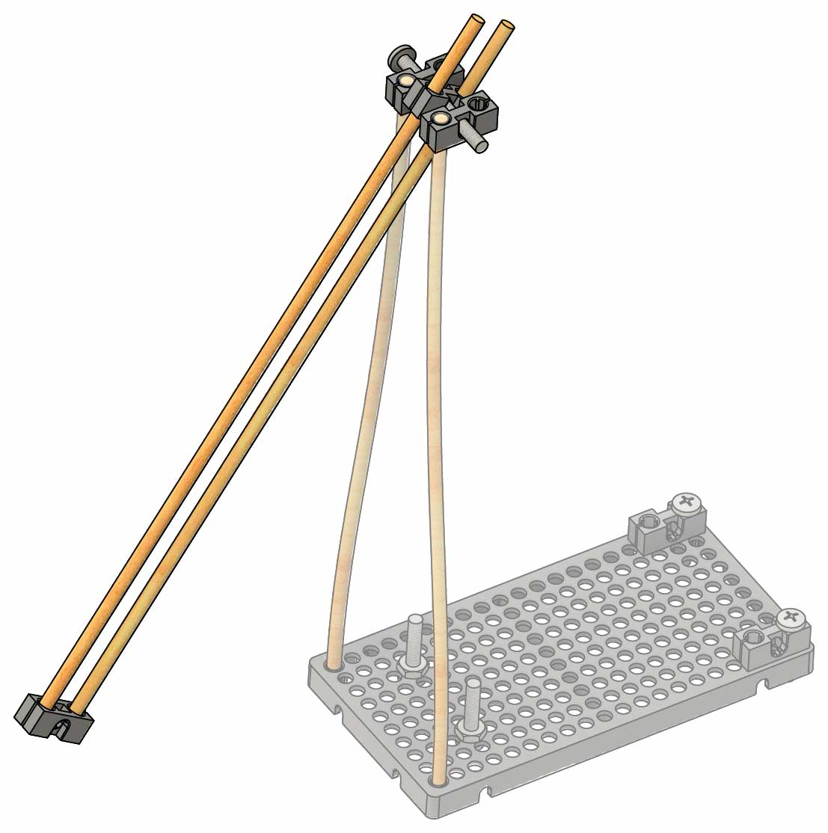

**Kicker**

# 6

**Tap** or **push** the **kicker,** fromStep 4,ontothe **dowels.**

**Add rubber bands**,then **test it out!**

# 7

**Rubber Bands**

Tip

**Double up** your **rubber bands** to make them tighter.

**Dowels**30 cm (12 in)

**Tap** or **wiggle** **two** **30** **cm** (12 in) **dowels** into the **hole** **plate**.

# 5

# Connect the Kicker

# Change the Launch Angle

**Dowels Up**

**Dowels Down**

**Test it out! Slide** the **dowels** upanddownto **change** the **launch angle.**

# 9

OR

Flat Angle

Steep Angle

Make the dowels **slide** **easier** by **coloring** them with **crayons** or a **pencil**.

Tip

**Tap** or **wiggle two 30 cm** (12 in) **dowels** intothefrontofyourbase**.**

# 8

Get optional labs and more at [**teachergeek.com/launcher2.0**](https://teachergeek.com/launcher2.0)

**Your example launcher is done, but you aren’t…** Make it better, try a lab, or start a challenge!

The bent paperclip points downward at your launch angle.

Inclinometer

Protractor

Use the protractor to measure how far you pull the kicker back.

Make the **front** **protractor** into an **inclinometer** by **poking** a **bent** **paperclip** (or wire) through it.

**Cut out two protractors** fromPage10 and **tape** them on.

# Add Protractors

# 10

# 11

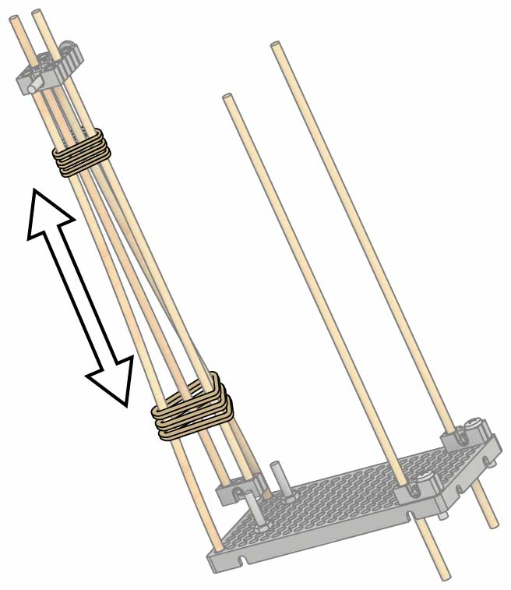

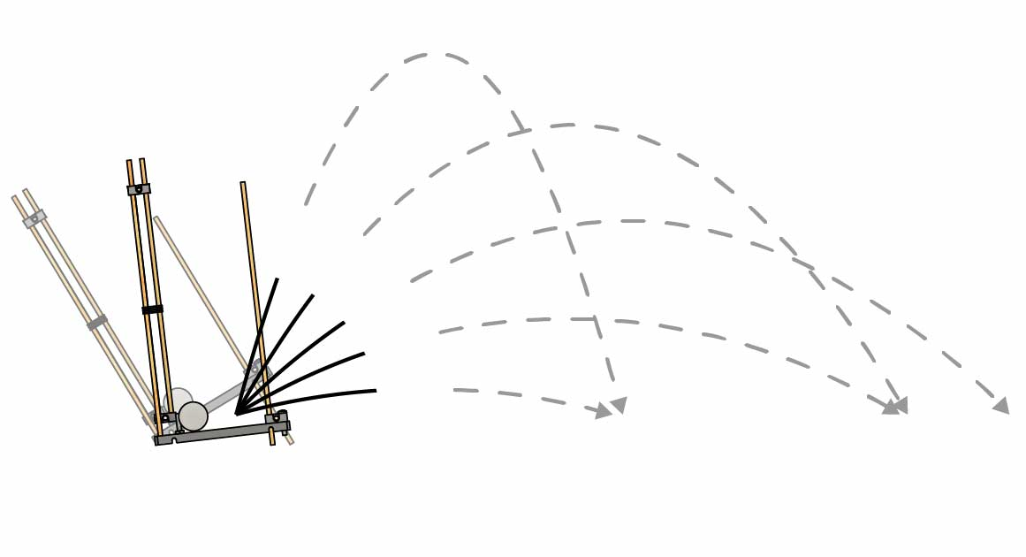

15°

30°

45°

60°

75°

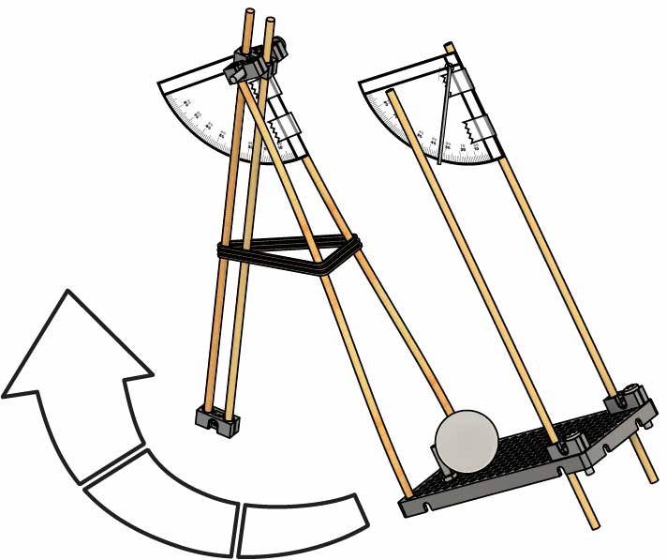

Power

Rubber Bands

Adjust the power by changing the number of rubber bands or how they’re attached (doubled up, tripled up, etc.).

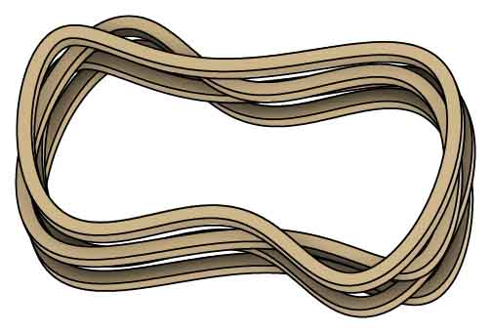

## Design

## Process

## Design

## Redesign

## Test

## Evaluate

The Engineering Design Process never ends!   
There is no perfect design.

Leverage

Move the rubber bands up and down the kicker to change their leverage.

Wind Up

The farther you wind up your launcher, the farther the ball goes! Use the protractor to keep track of your wind-up angle.

Launch Angle

Change the distance and trajectory by adjusting the launch angle, which you can measure with the inclinometer.

**There are tons of ways to adjust your launcher! Here are just a few variables you can tinker with.**

# Tinker with your Launcher

# Redesign Your Launcher

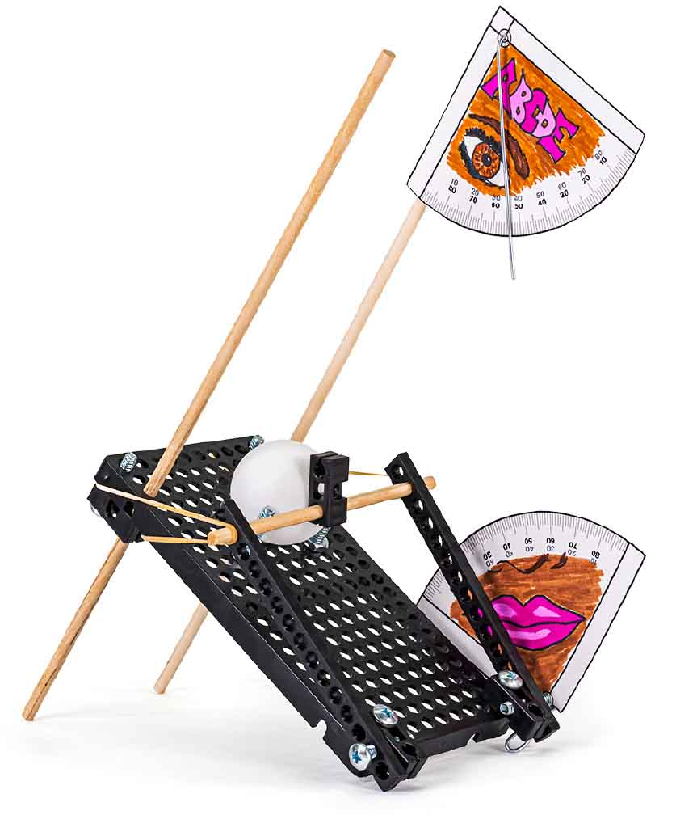

## The Mousetrap

**The Punter is just a design to get you started – there are much better designs! What will** your **launcher look like?**

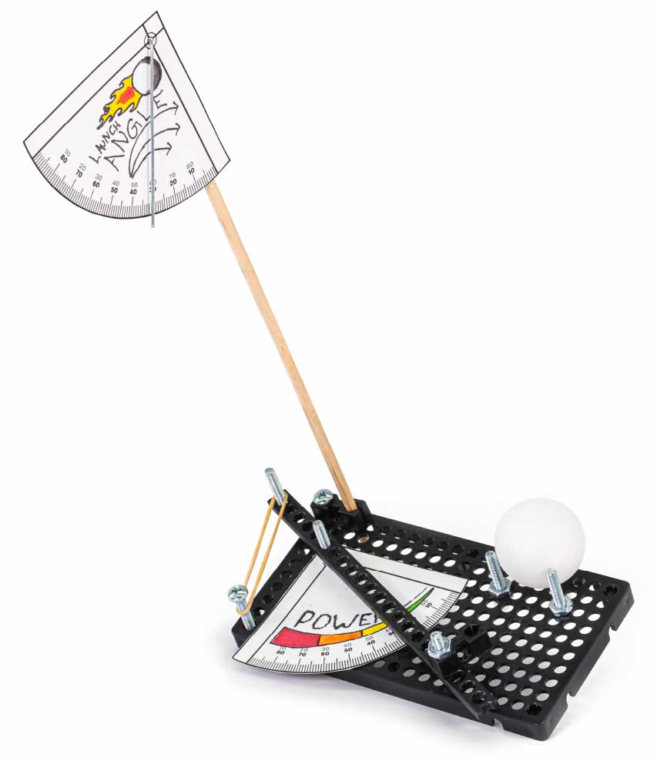

## The Side- Kicker

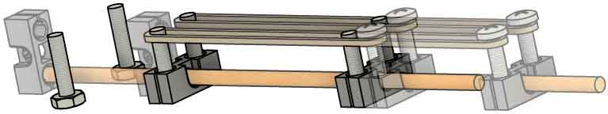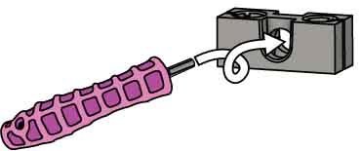

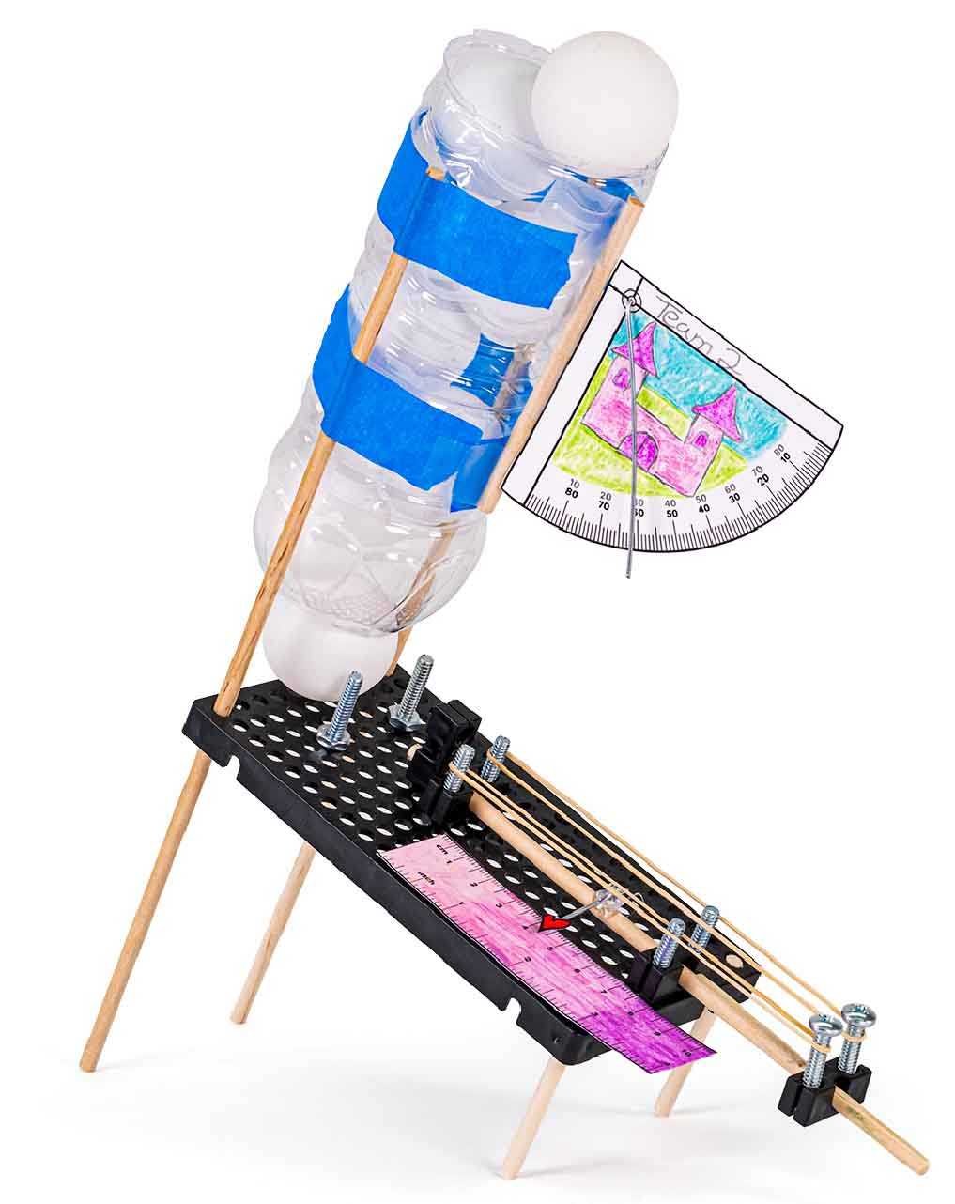

## The Plunger (tools required)

Use a Reamer to remove teeth so the plunger can slide.

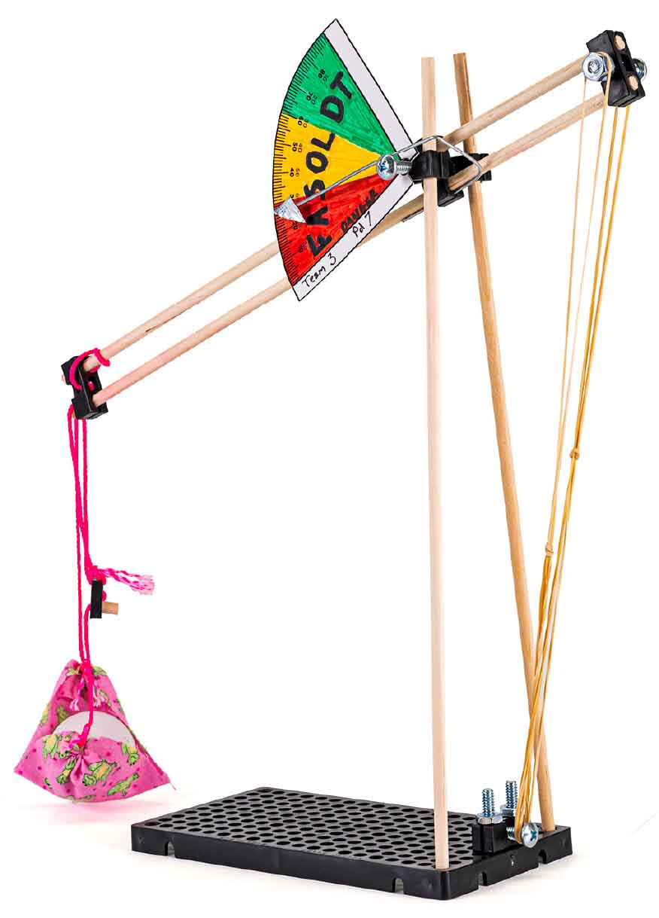

## The Trebuchet

Trebuchets are very tricky to make! It takes a lot of trial and error to make these sucessfully.

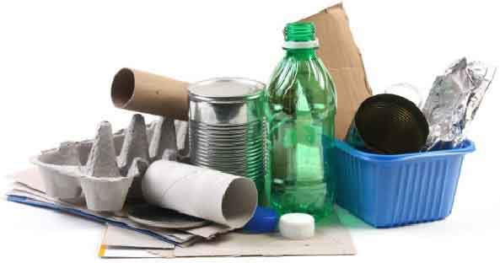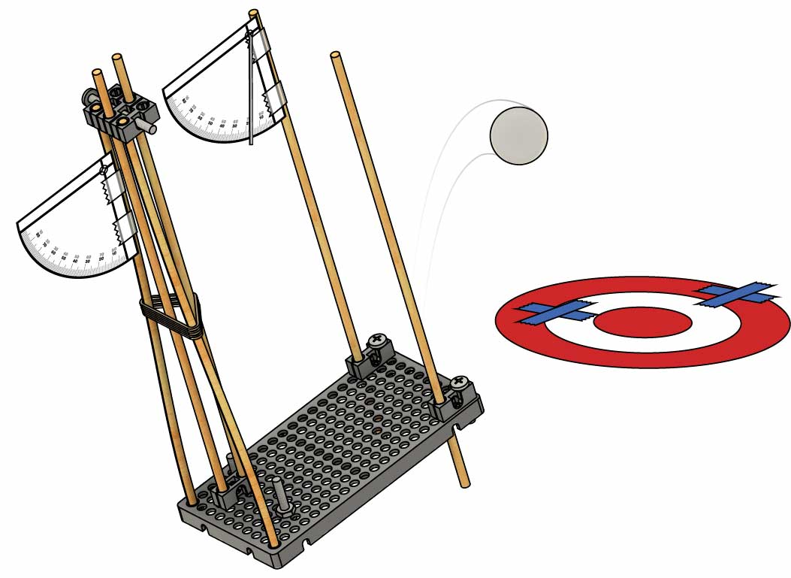

Moving Target Challenge

Complete 3 rounds, moving the target each time. Measure each shot’s distance from the bullseye, and add them at the end. The launcher with the least total distance wins!

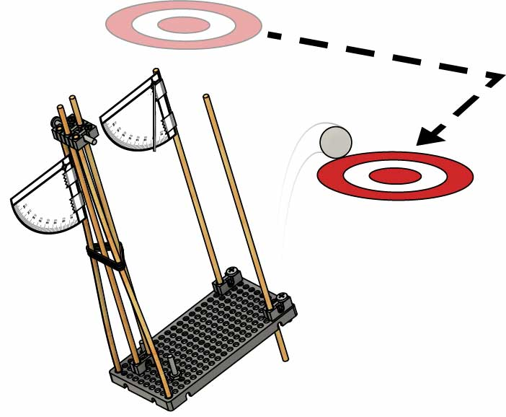

Siege Challenge

One team stacks disposable cups to make a wall, and another shoots it down. The launcher that knocks every cup down in the shortest time wins!

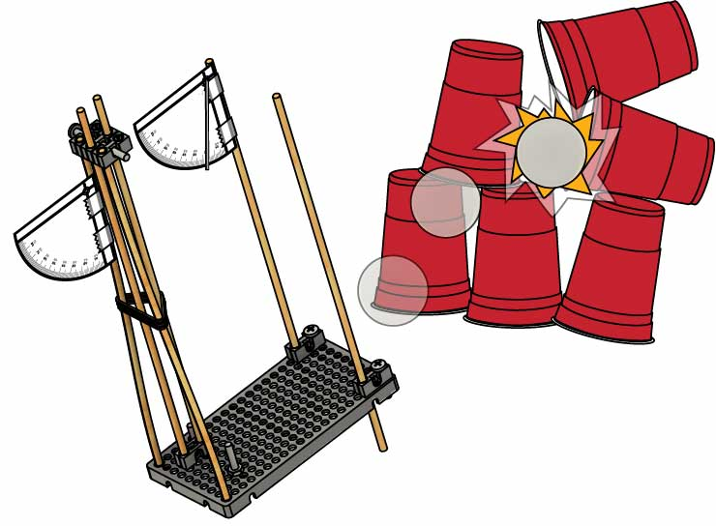

The launcher that sends the ball the greatest distance wins!

Distance Challenge

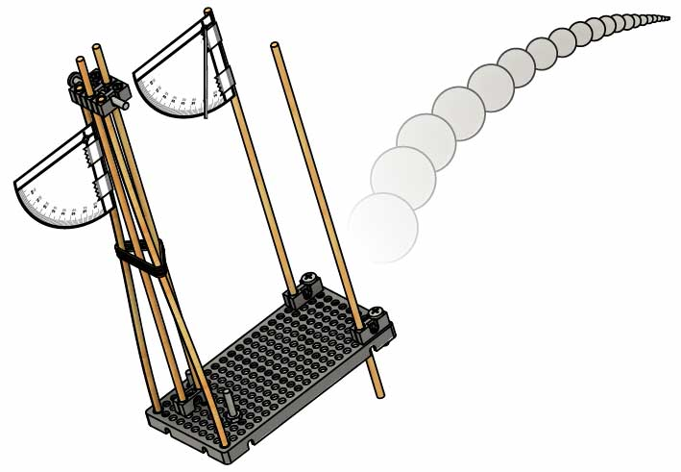

# Additional Challenges

**Use the constraints above for these challenges.**

Criteria:  
(what your design must do)

* You may use no more than 8 rubber bands   
  to power your launcher.
* You may only use the supplies listed on Page 1.
* There is no limit on recycling bin materials.

Constraints:  
(rules and limits for your design)

* The launcher that hits closest to the center wins!
* Each team gets three launches – only the best launch counts.
* Each launcher must launch from the same position towards the same target.

The most accurate launcher wins!

# Bullseye Challenge

**Page 9**

**Cut out the rulers and protractors to add more precision to your design!**

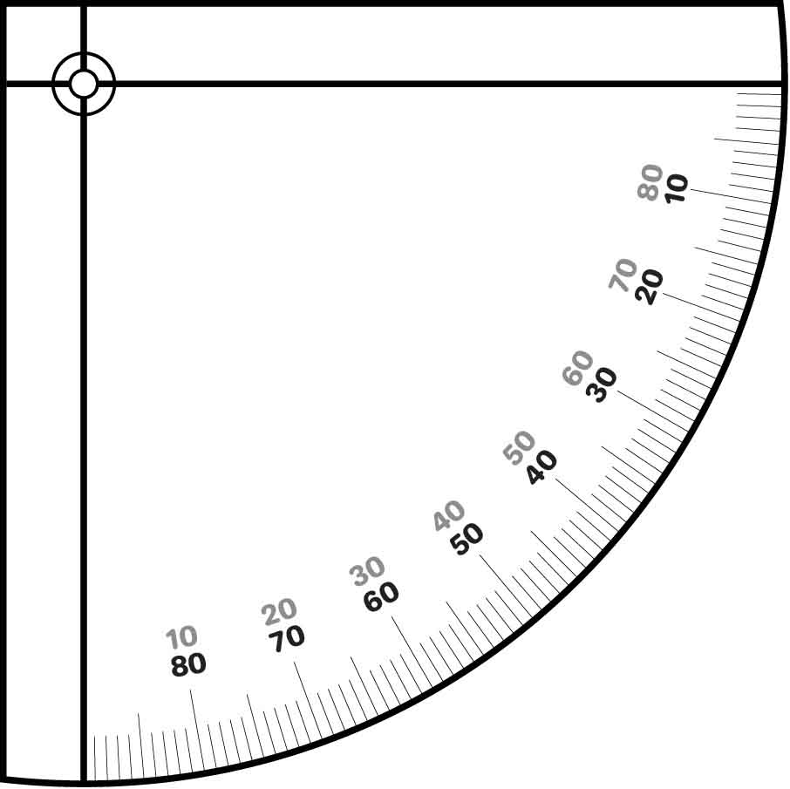

Add a paperclip or wire to the protractor to make an inclinometer (which measures launch angle). See Page 5.





15°

30°

45°

60°

75°





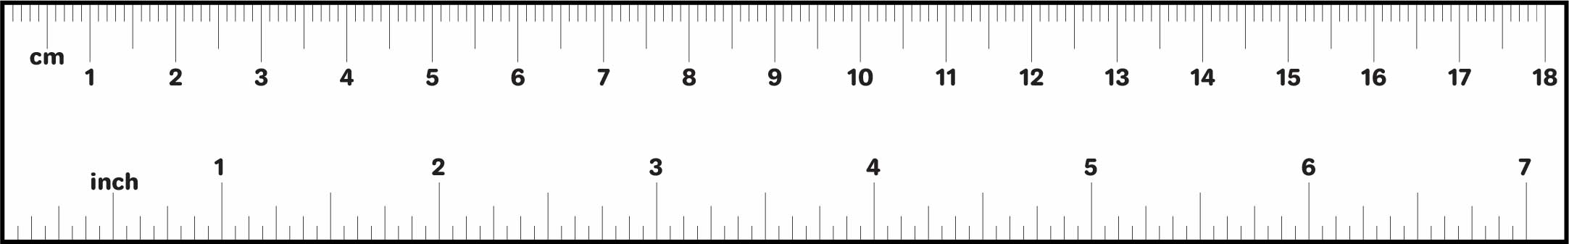

**Page 10**