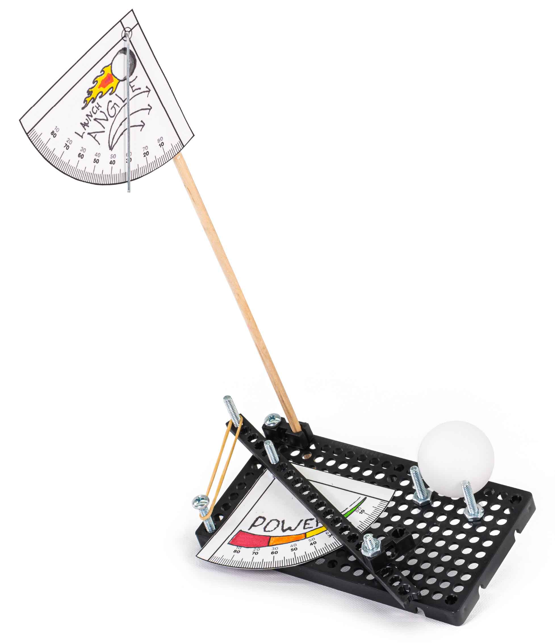

You Are Here

Start here! Build your launcher, evolve your design, and begin the Bullseye Challenge!

Optional Labs

Optional Challenges

[-Precision & Accuracy Lab  
 (Ages 13+)](https://teachergeek.org/launcher2.0_lab_precision_accuracy.docx)  
[-Hit the Target Lab  
 (Ages 13+)](https://teachergeek.org/launcher2.0_lab_hit_the_target.docx)

-Moving Target Challenge*  
-Distance Challenge*  
-Siege Challenge*

*See Page 5

Go Guide

**Choose how you would like to complete this activity.  
Download documents & videos at** [**teachergeek.com/launcher2.0**](http://teachergeek.com/claw)

**Learn about projectile motion by designing and building your very own Launcher!**

TRUE

STEM

STEAM



Check out our [**activity videos**](https://vimeo.com/showcase/7399396) by scanning the QR Code or going to [**teachergeek.com/launcher2.0**](https://www.teachergeek.com/launcher2.0)

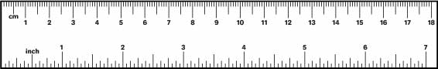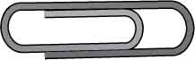

Have a Maker Cart? Use Multi-Cutters to cut your own dowels.

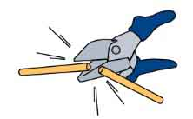

**Dowels**various sizes  
SKU 1821-20

**PICTURE**

**NAME**

**QTY**

**8**

**Hole Plates**  
SKU 1821-32

**Blocks**  
SKU 1821-34

**Strips**30 cm (12 in)  
SKU 1821-31

**Screws**2.5 cm (1 in)  
SKU 1821-22

**Screws**5 cm (2 in)  
SKU 1821-27

**Nuts**#10 Hex  
SKU 1821-25

**Rubber Bands**SKU 1823-41

**1**

**8**

**7**

**2**

**1**

**Ping Pong Balls**SKU 1821-44

**8**

**8**

**1**

**Protractors**

**3**

**Rulers**

**1**

**Paperclip**

**1**

Dowel Sizes  
6x 30 cm (12 in)  
2x 10 cm (4 in)

Protractors & rulers are   
on the last page, or you   
can print them from [**teachergeek.com/launcher2.0**](https://teachergeek.com/launcher2.0)

You will need to supply these if using a Maker Cart.

You can also use 10 cm   
(4 in) of steel building wire if you have a Maker Cart.

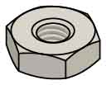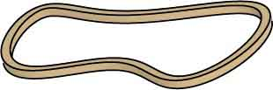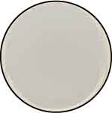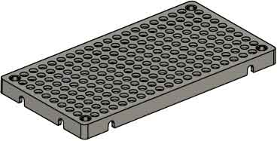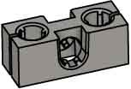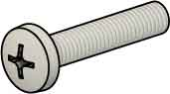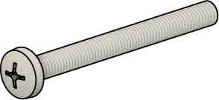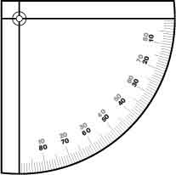

* **Phillips Screwdriver**
* **Scissors**
* **Tape**
* **Pliers** (optional)
* **Recycling Bin Materials**to incorporate into your designs

These are the parts you need to build one launcher, plus some extras, so you can make your own unique designs.

## MATERIALS YOU SUPPLY

## TEACHERGEEK PARTS

# Supplies

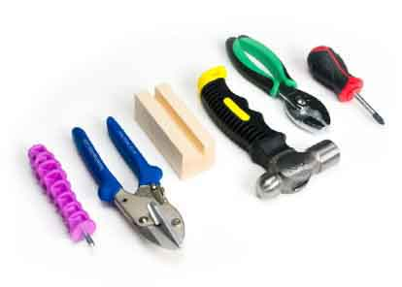

Modify materials to make even more creative designs with the **Maker Tool Set**

SKU 1823-84

**Optional Tools**

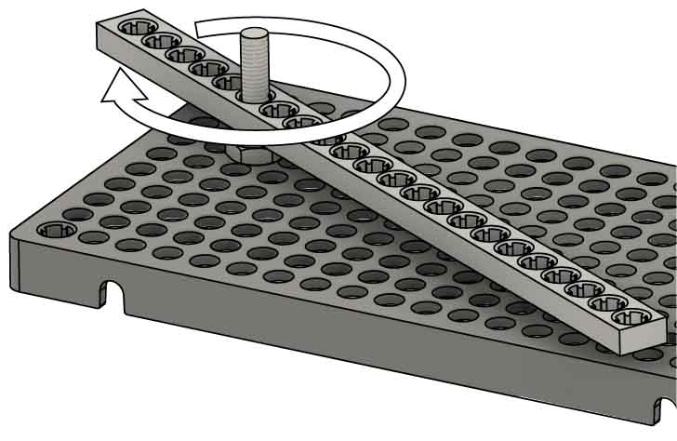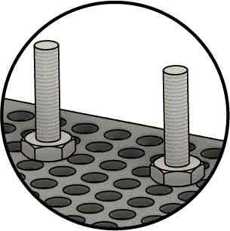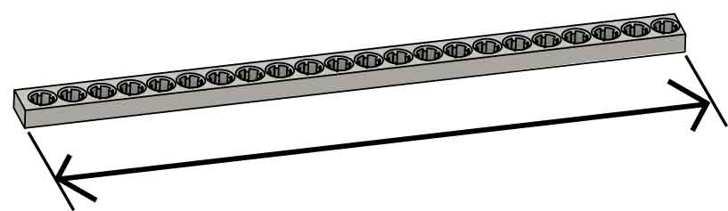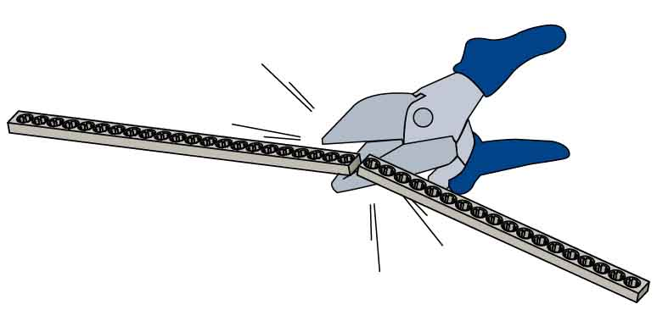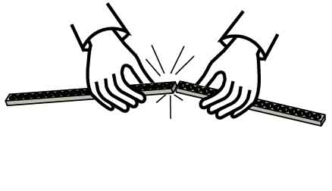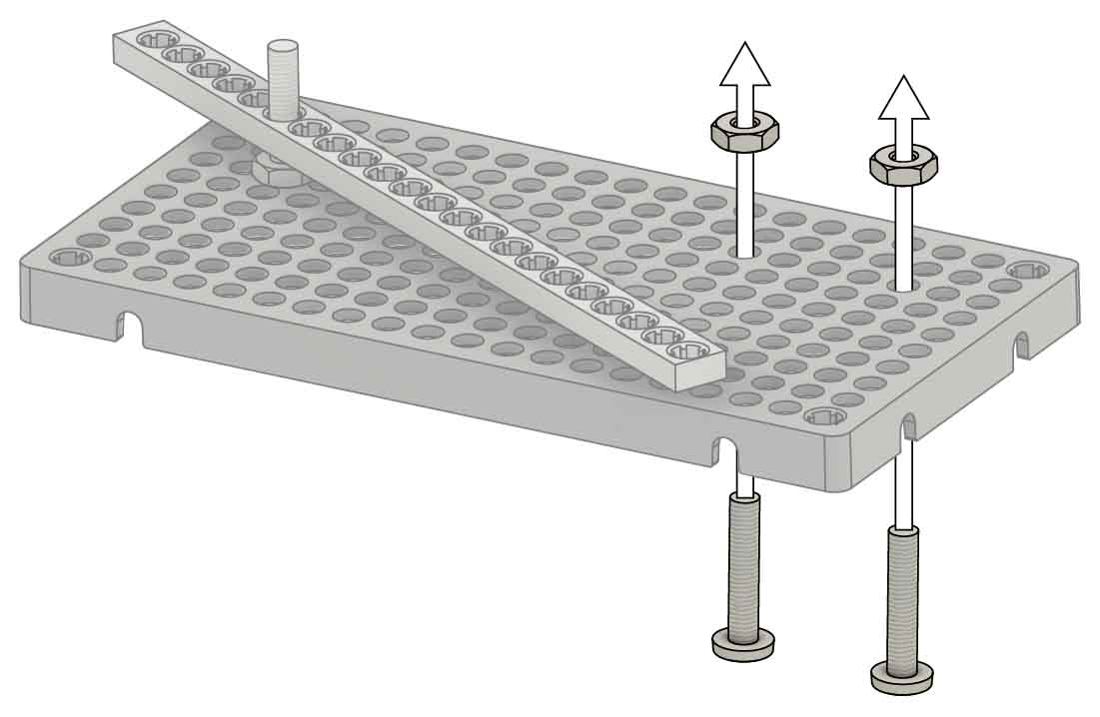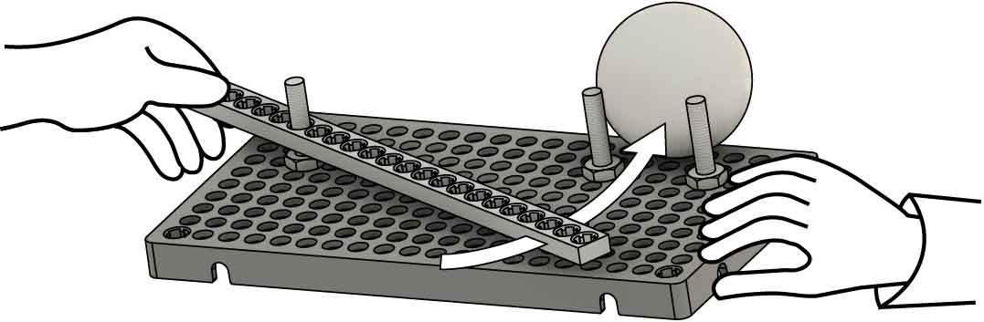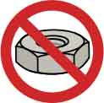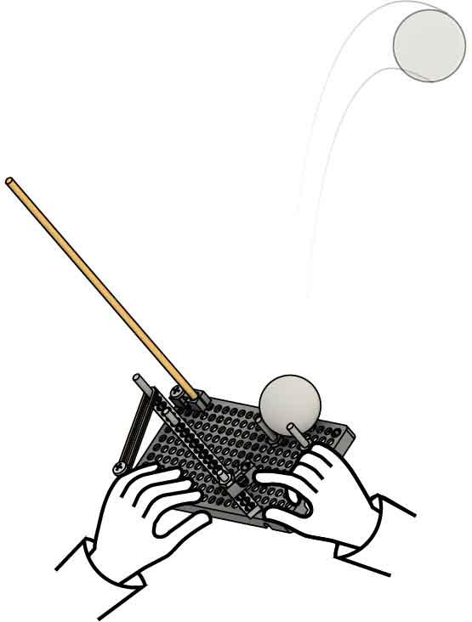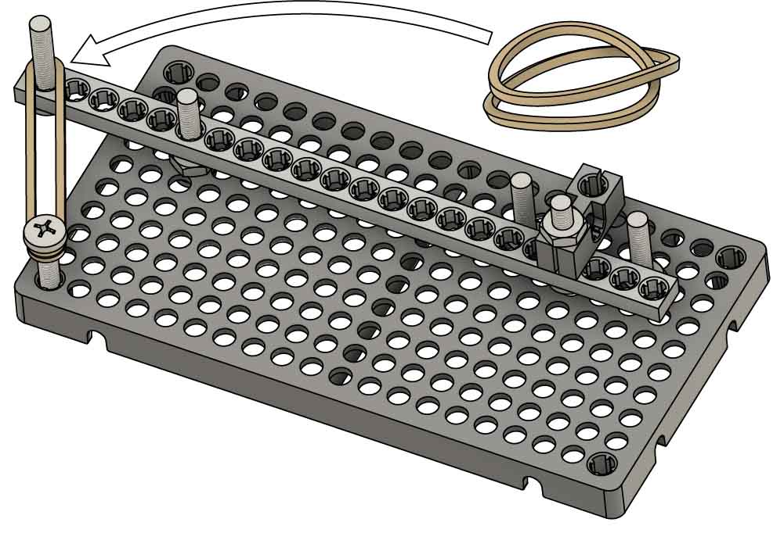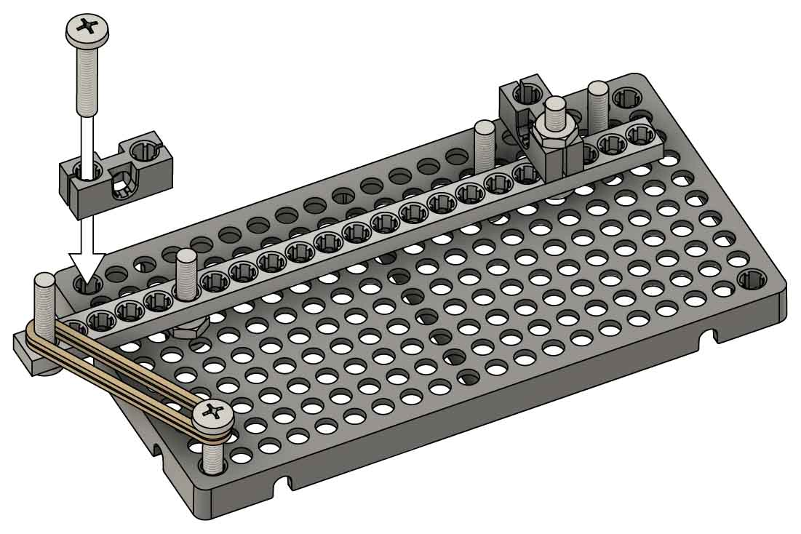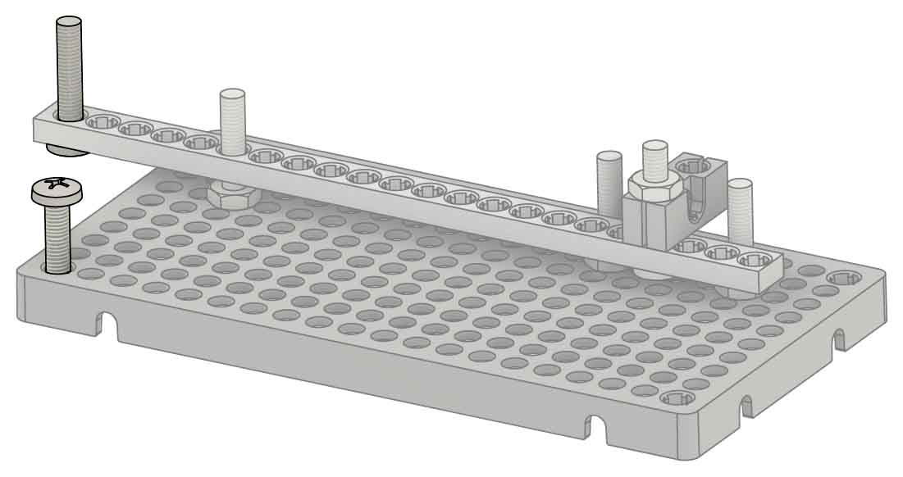[](https://teachergeek.com/launcher2.0)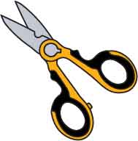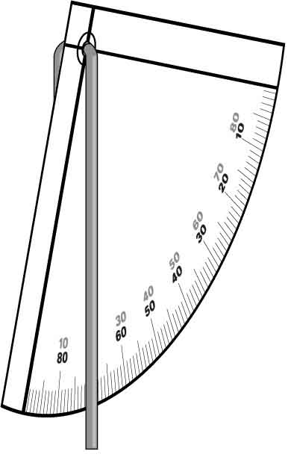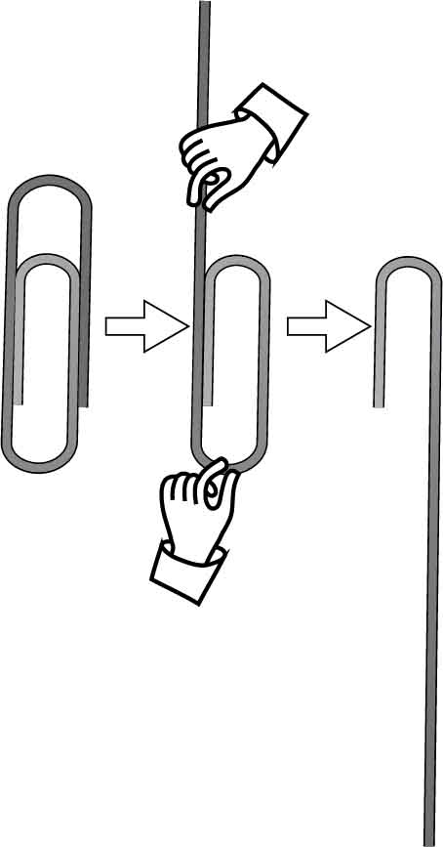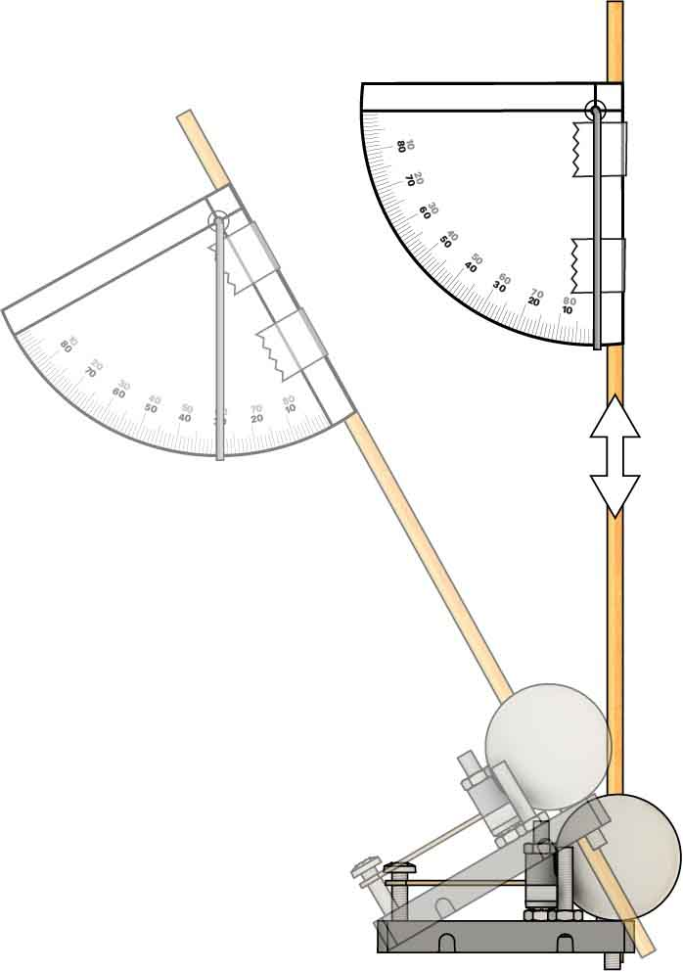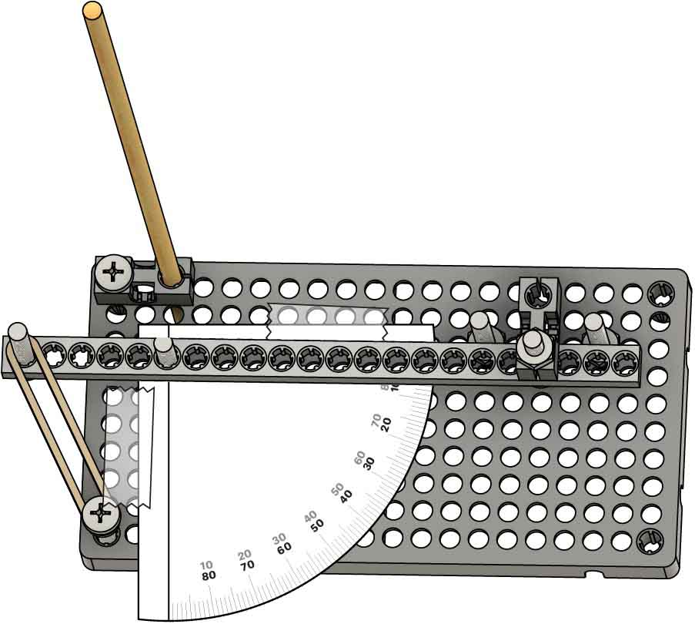

Is your screw spinning? Make sure that nut from #1   
is tight!

Finished

**Add** **two** more **screws** **and** **two** more **nuts** to make your ball-holder.

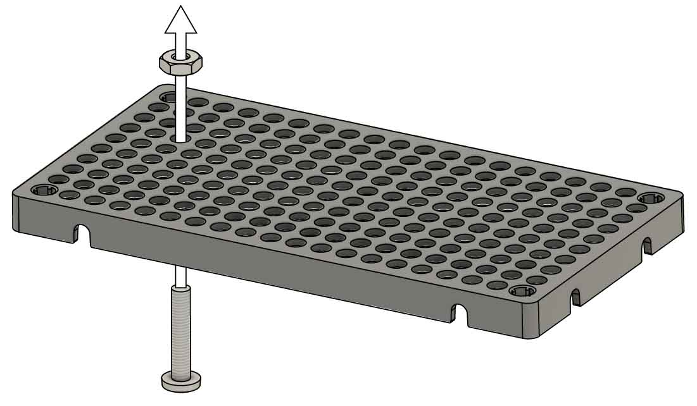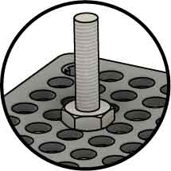

Finished

Nut

Screw

Hole Plate

Make sure your nut is tight!

Finished Strip

**Spin the strip from Step 2 onto the screw**. Don’t make it too tight – the strip should be able to spin.

# 2

**Cut** or snap a **17 cm** (6½ in) **strip**.

Your kicker won’t hit the ball every time, but we’ll fix that!

**17 cm**   
(6½ in)

**Your kicker is done! Test it out.** Next, we’ll add power.

Push a **screw** **through** your **hole** **plate** and **tighten** a **nut** on top.

# 3

# 1

# 4

# Build the Kicker

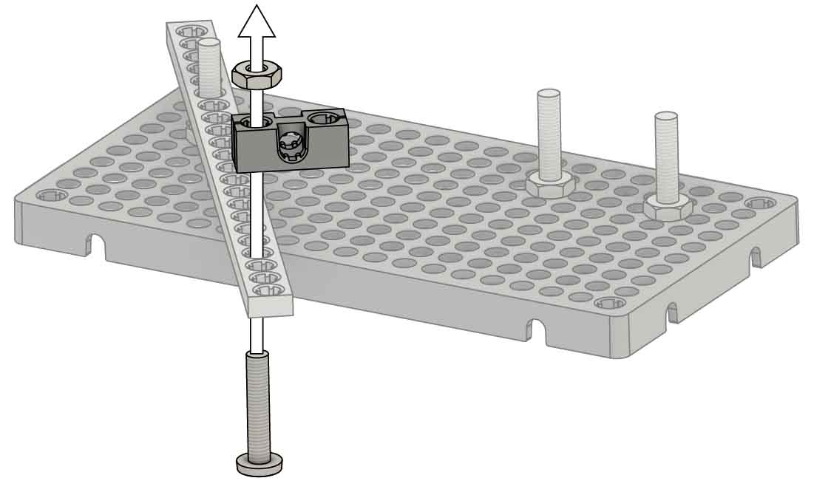

Block

Centered

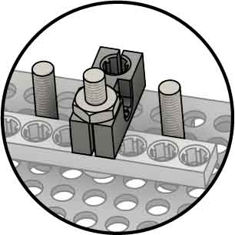

Don’t add nuts.

Slide dowel to change launch angle.

You’re ready to   
launch – test it out!   
Test it out. Next, we’re going to make it easier to aim.

**Screw** a **block** into the corner of the **hole** **plate**.

# 8

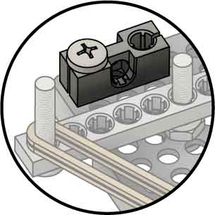

Finished

# 9

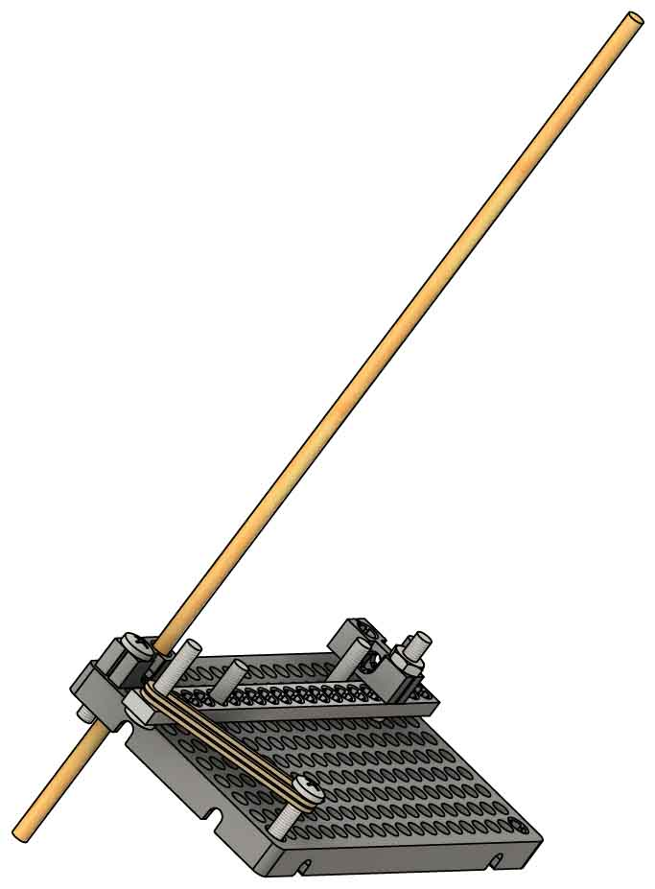

**Push** a 30 cm (12 in) **dowel** **through** the **block** **and** **hole plate** to make a stand.

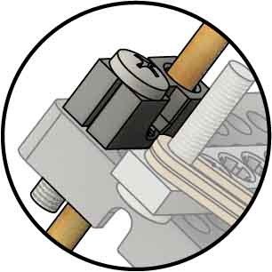

# 7

**Add** **a** **rubber** **band**!   
Double it over if it’s too loose.

# 6

**Add** **two** more **screws**.   
They will hold rubber bands.

# 5

**Screw** a **block** and **nut to** the **strip** so the block is **centered** in the ball holder.  
**half** **strip**, **block**, and **nut**.

# Power Up!

Crayon will make the dowel slide more easily.

Get the labs at [**teachergeek.com/launcher2.0**](https://teachergeek.com/launcher2.0)

Make an **inclinometer** by **poking** a **bent paperclip** (or wire) **through** a **protractor.**

The inclinometer measures the angle, or incline, of your launcher.

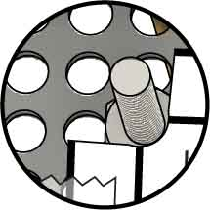

Cut notch for screw



**Protractors let you measure the Wind-Up and Launch Angle so you can hit targets more consistently.**

Optional Labs:

[**Precision & Accuracy Lab** (Ages 13+)](https://teachergeek.org/launcher2.0_lab_precision_accuracy.docx)

[**Hit the Target Lab** (Ages 13+)](https://teachergeek.org/launcher2.0_lab_hit_the_target.docx)

Protractors are on the last page.

Slide the dowel to change your angle.

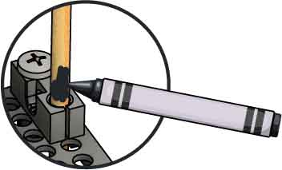

# 12

**Tape** the **inclinometer**, from Step 11, to the **dowel**.

# 11

**Tape** a **protractor** **under** the **kicker**. This lets you measure your wind-up.

# 10

**Your launcher is done, but you aren’t…** Make it better, try a lab, or start a challenge!

# Add Protractors

# Tune Your Launcher

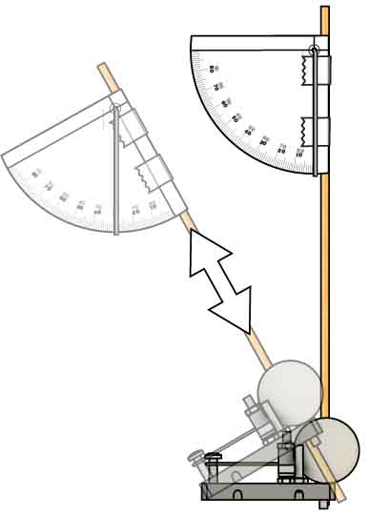

Rubber Bands

Adjust the power by changing the number of rubber bands, where they’re attached, or how they’re attached (doubled up, tripled up, etc.).

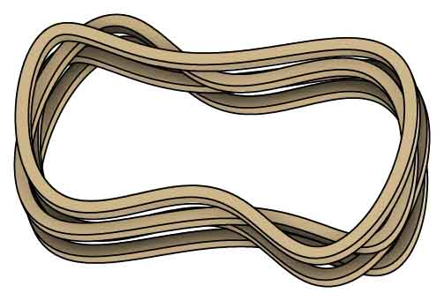

Launch Angle

Change the distance and trajectory by adjusting the launch angle, which you can measure with the inclinometer.

**There are tons of ways to adjust your launcher! Here are a few variables you can tinker with.**

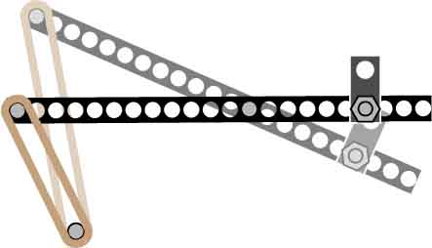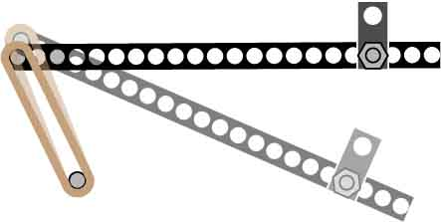

## VS

Fulcrum

Change the fulcrum, or pivot point, for your kicker. Like all levers, moving the fulcrum will trade between speed and torque.

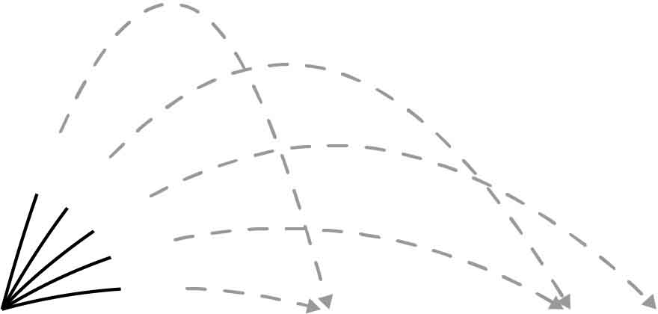

15°

30°

45°

60°

75°

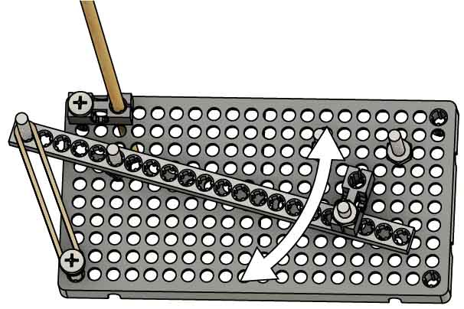

POWER

Wind Up

The farther you wind up your launcher, the farther the ball goes! Use the protractor to keep track of your wind-up angle.

# Redesign Your Launcher

Use a Reamer to remove teeth so the plunger can slide.

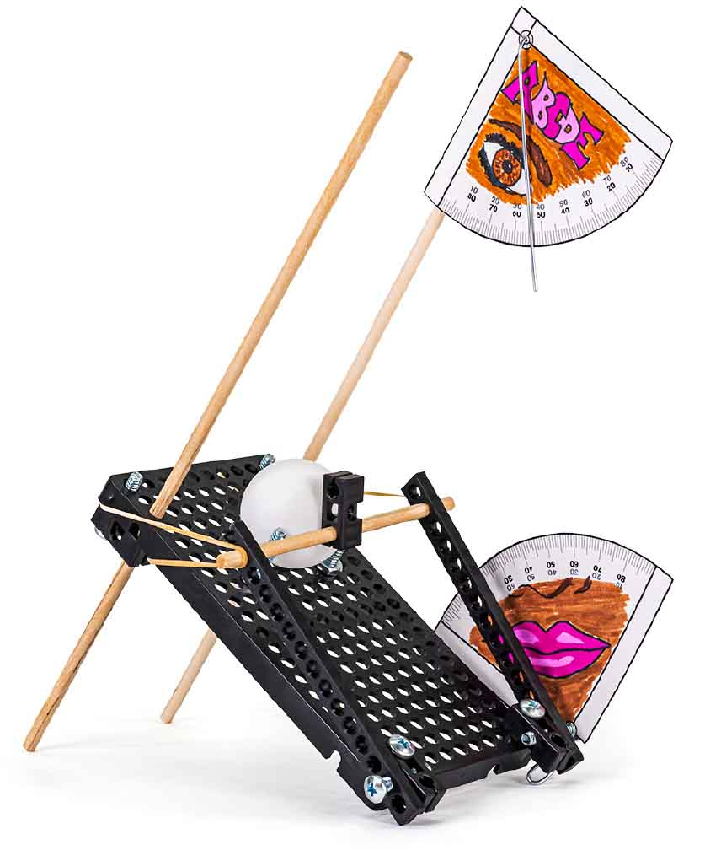

**The kicker is just a design to get you started – there are much better designs! What will** your **launcher look like?**

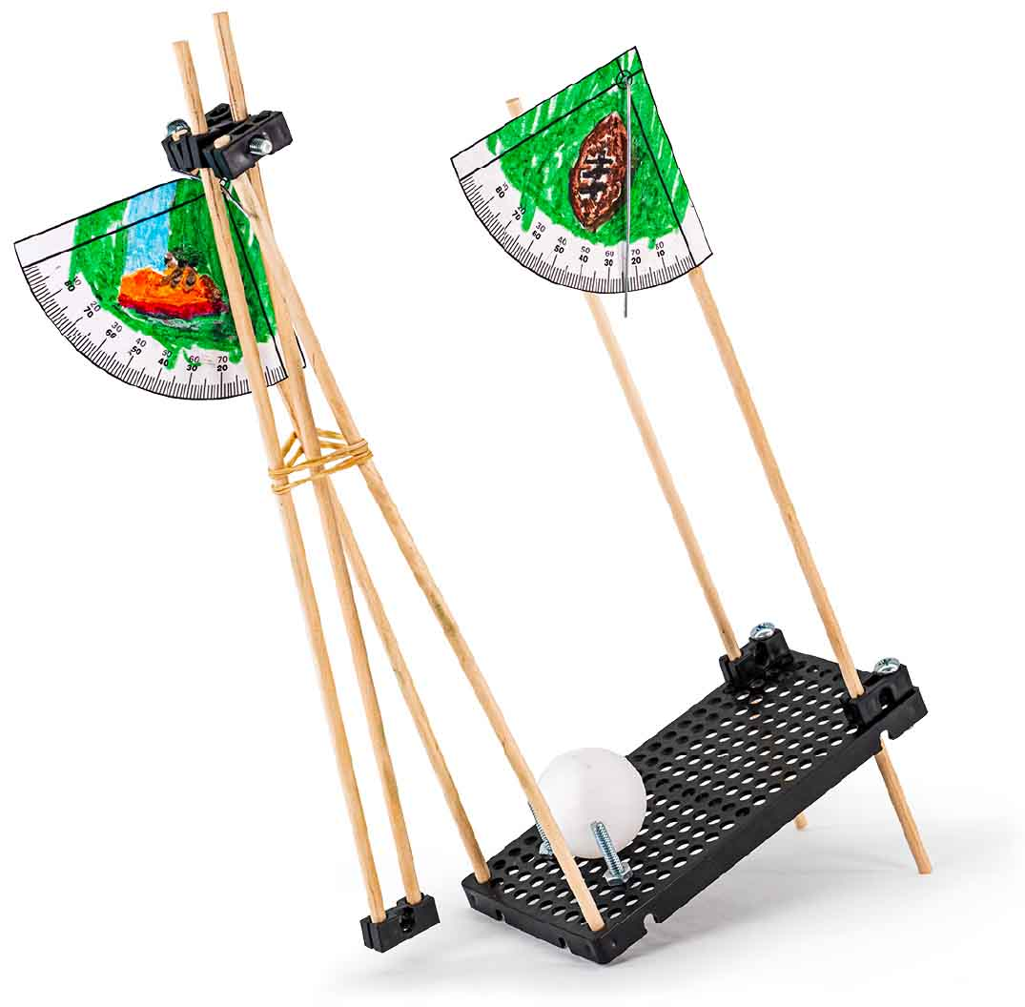

## The Mousetrap

## The Punter

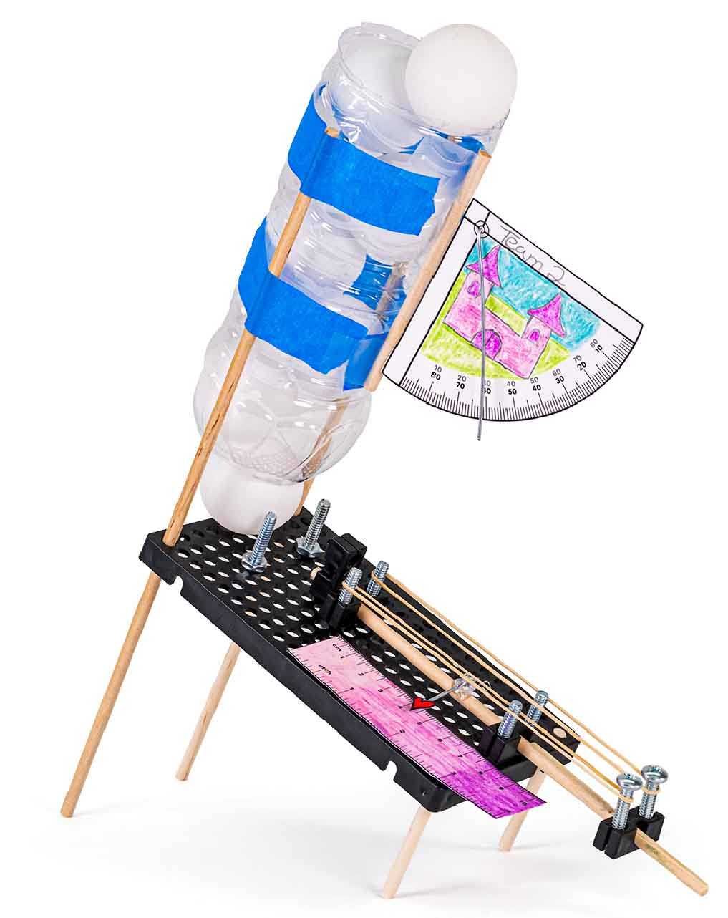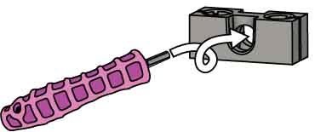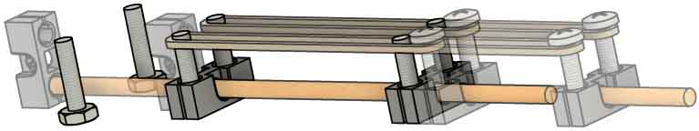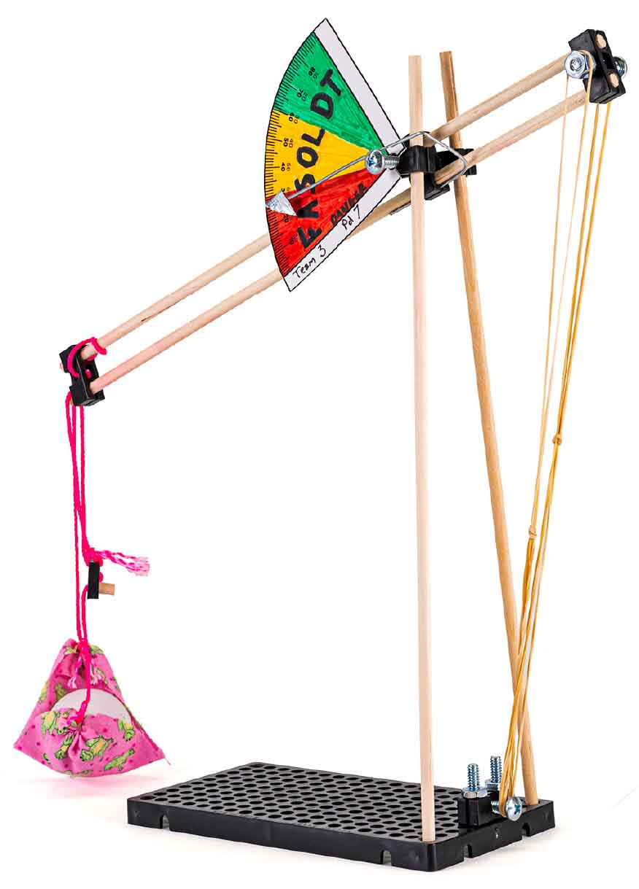

## The Plunger (tools required)

Trebuchets are very tricky to make, but it can be done!

## The Trebuchet

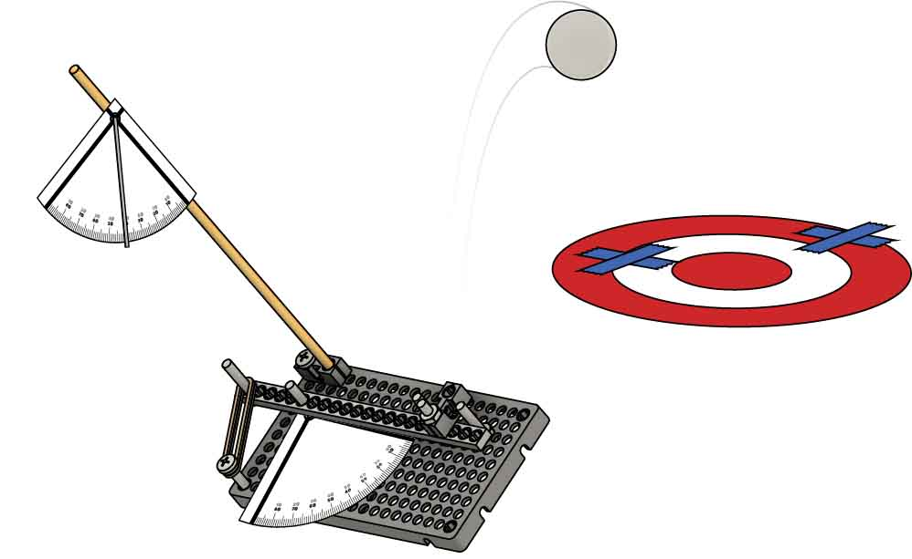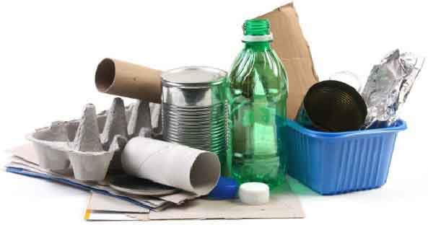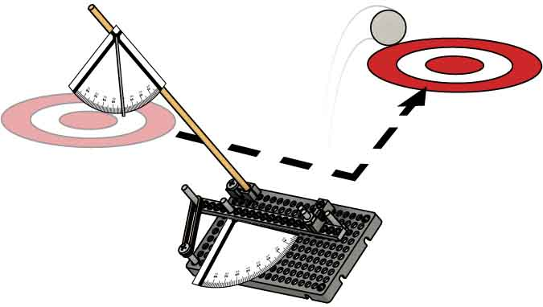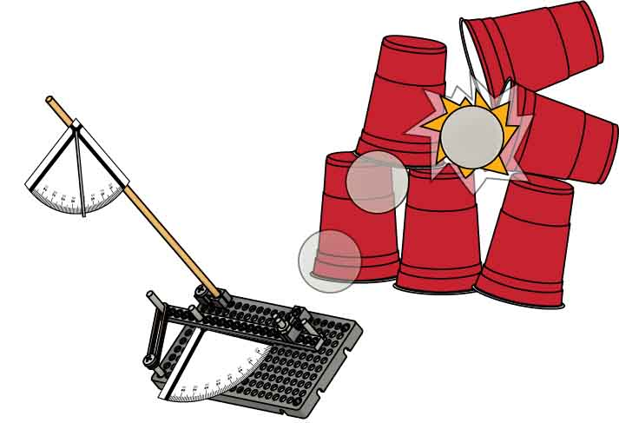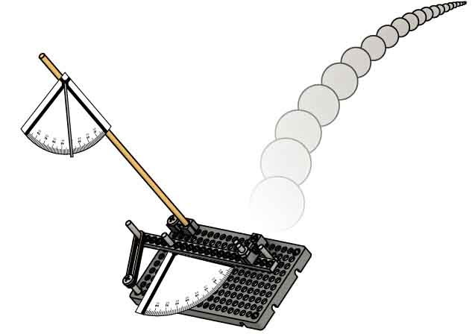

**Use the constraints above for these challenges.**

Complete 3 rounds, moving the target each time. Measure each shot’s distance from the bullseye, and add them at the end. The launcher with the least total distance wins!

Distance Challenge

Criteria:  
(what your design must do)

* The launcher that hits closest to the center wins!
* Each team gets three launches – only the best launch counts.
* Each launcher must launch from the same position towards the same target.
* You may use no more than 8 rubber bands   
  to power your launcher.
* You may only use the supplies listed on Page 1.
* There is no limit on recycling bin materials.

Constraints:  
(rules and limits for your design)

One team stacks disposable cups to make a wall, and another shoots it down. The launcher that knocks every cup down in the shortest time wins!

Siege Challenge

Moving Target Challenge

The launcher that sends the ball the greatest distance wins!

# Additional Challenges

The most accurate launcher wins!

# Bullseye Challenge

**Cut out the rulers and protractors to add more precision to your design!**

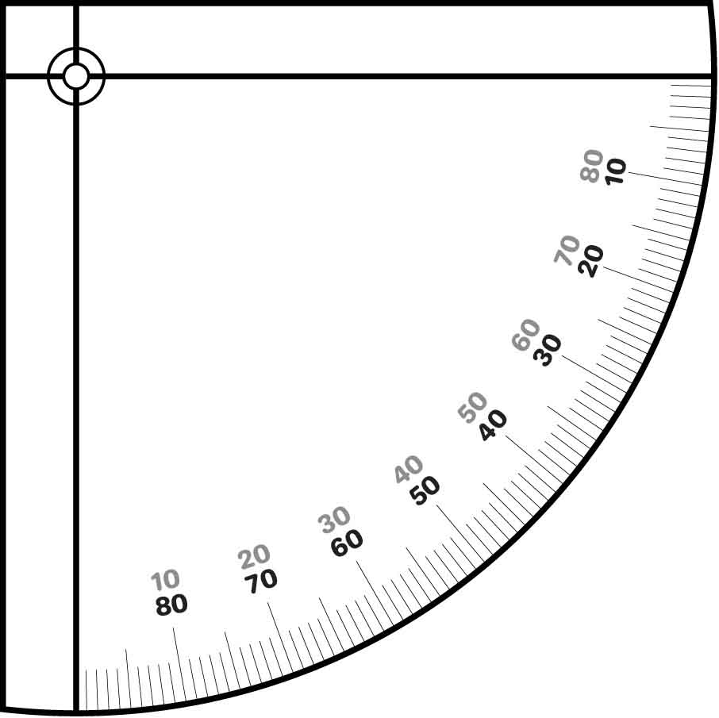



15°

30°

45°

60°

75°

Add a paperclip or wire to the protractor to make an inclinometer (which measures launch angle). See Page 4.



Use the protractor or ruler to measure wind-up distance.

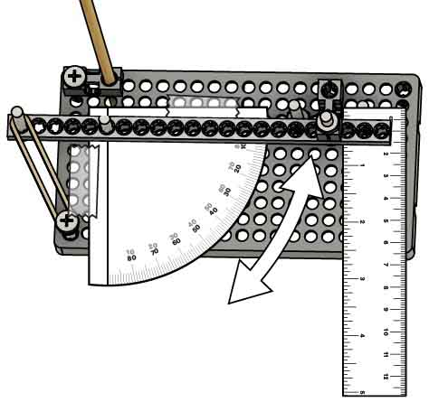

POWER



