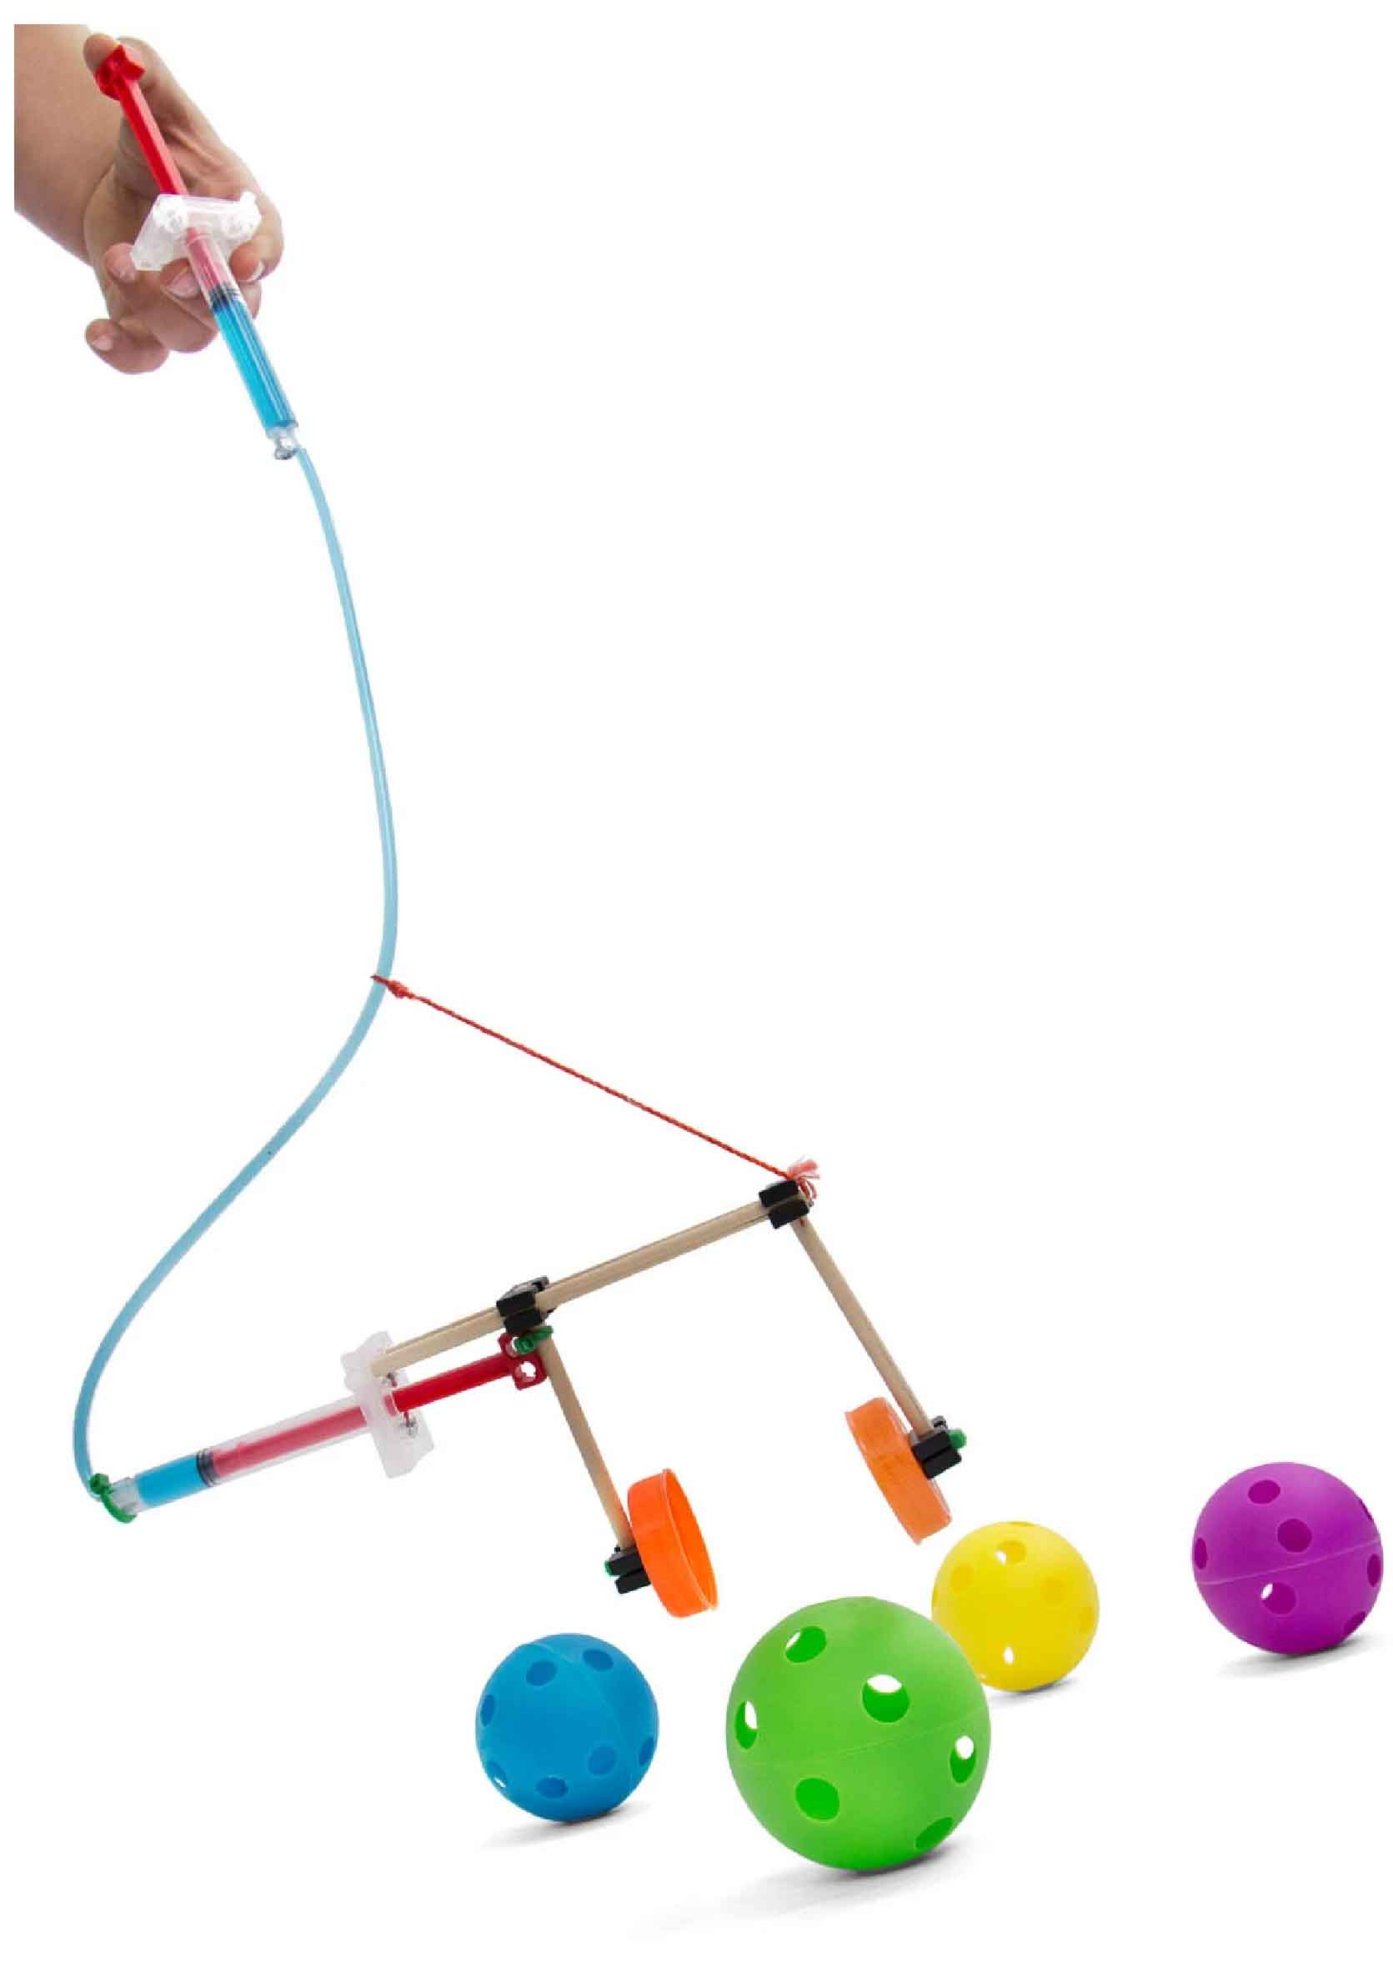

**Build an example claw, then experiment and evolve your own unique design!**

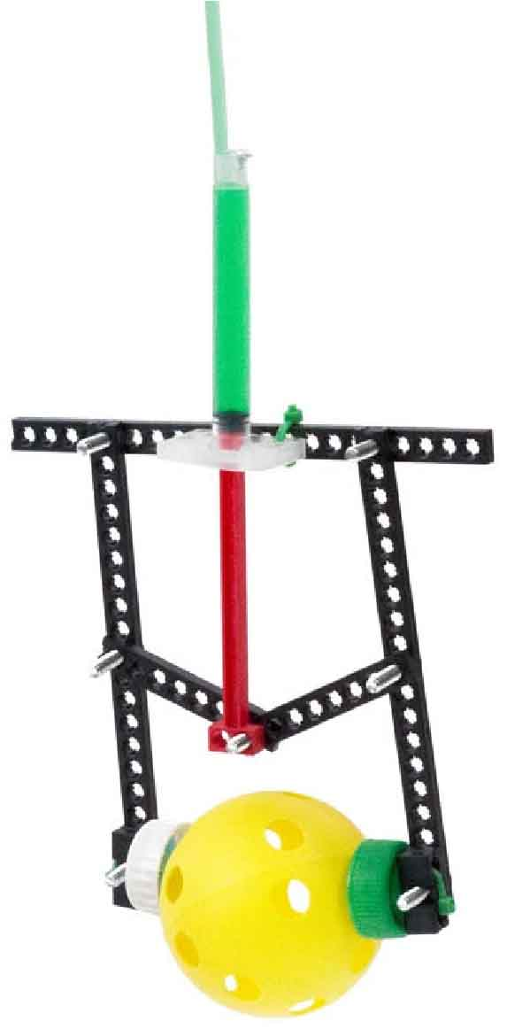

You Are Here

Start here! Build your Claw, evolve your design, and begin the Ocean Cleanup Challenge!

Optional Lab

Optional Challenges

[-Fluid Power Lab   
 (Ages 12+)](http://teachergeek.org/fluid_power_Hydraulic_Claw_Revision4H.pdf)

-Claw Ball Challenge*  
-HORSE Challenge*

*See Page 10

Go Guide

**Choose how you would like to complete this activity.  
Download documents & videos at** [**shop4-h.org**](https://shop4-h.org/)

Supplies

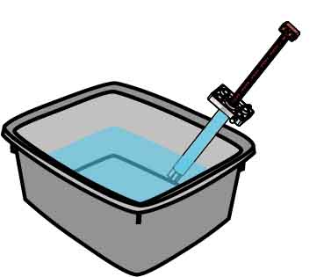

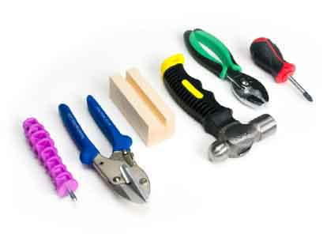

Modify materials to make even more creative designs with the **Maker Tool Set**

SKU 1823-84

**Optional Tools**

**String**

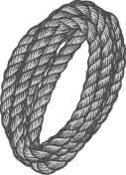

**Screwdriver**

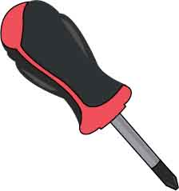

**A Container**To hold water for filling cylinders

**Tape**

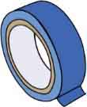

**Cylinder Screws**SKU 1821-21

**2**



**Strips**

30 cm (12 in)

SKU 1821-31

**4**



**Dowels**

various sizes

SKU 1821-20

**12**

**Slide Stop**7 cm (3 in)SKU 1821-49

**1**



**Screws**25 mm (1 in)  
SKU 1821-22

**8**



**Nuts**#10 hex  
SKU 1821-25

**4**



**Blocks**SKU 1821-34

**4**

**Cylinders**4.5 mlSKU 1821-52

**2**

**Tubing**38 cm (15 in)SKU 1821-51

**1**

**Zip Ties**1823-50

**4**

**PICTURE**

**NAME**

**QTY**

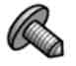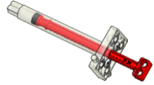

Dowel Sizes

2x 15 cm (6”)  
4x 7.5 cm (3”)  
6x 5 cm (2”)



Claw Parts

These are the parts you need to build one claw, plus some extra parts for your own unique designs.

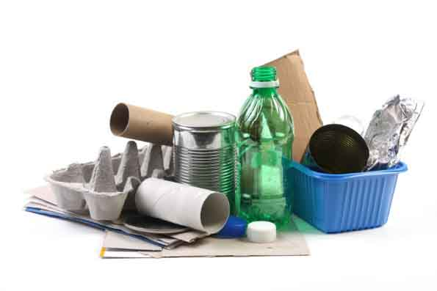

**Recycling Materials**What can you use for   
your claw grippers?

Materials You Supply

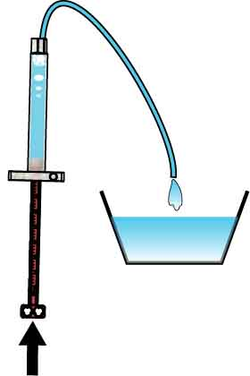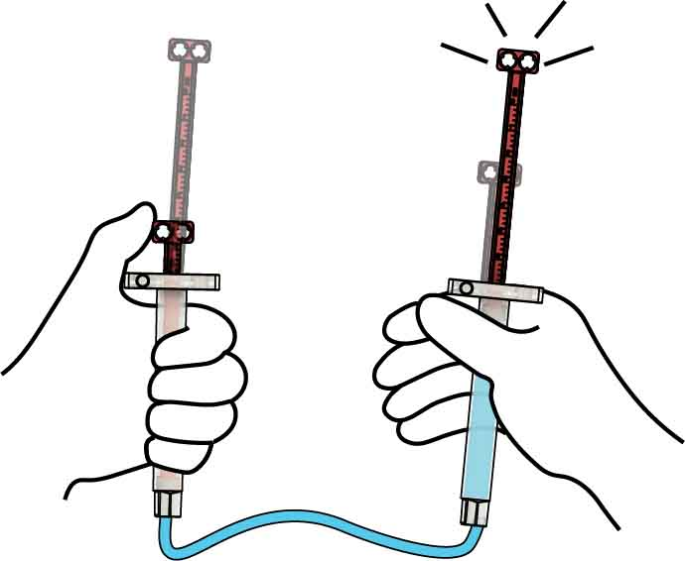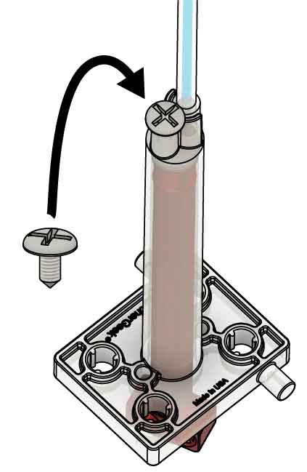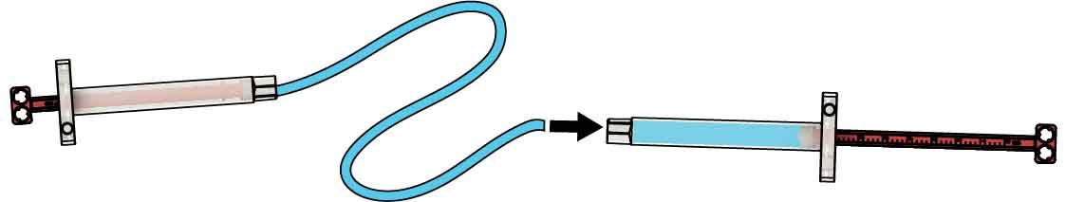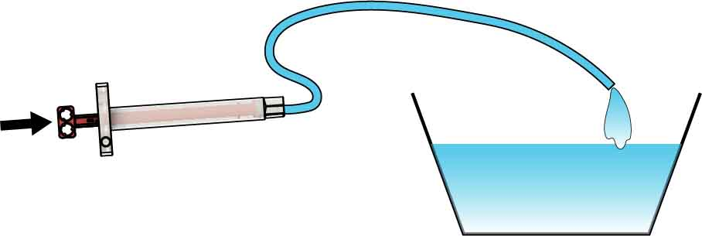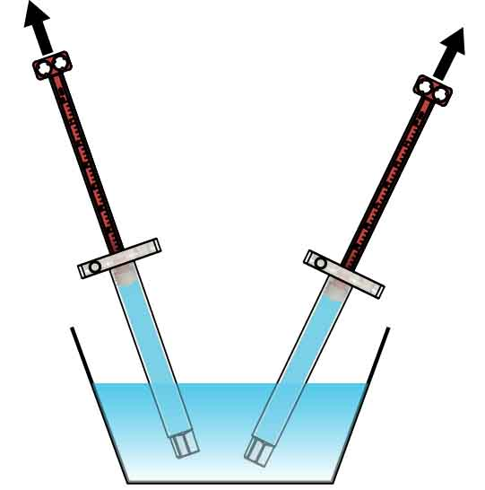[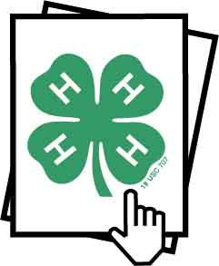](http://teachergeek.org/fluid_power_Hydraulic_Claw_Revision4H.pdf)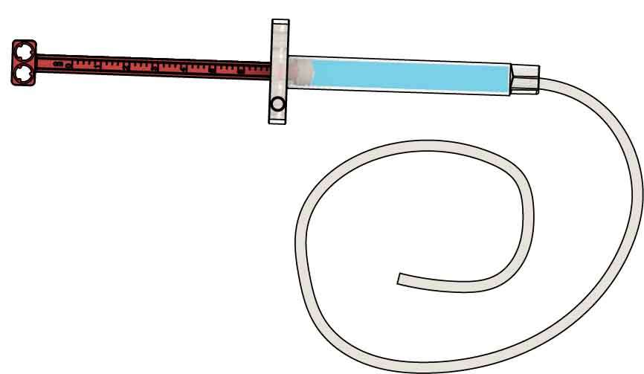

# 5

# 4

# 3

# 2

# 1

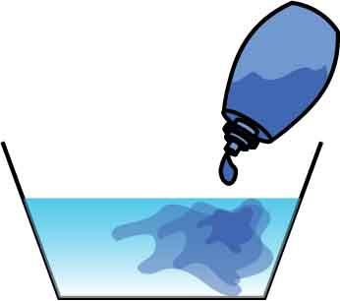

Food coloring makes water easier to see.

Optional Tip

**Want to learn more about hydraulics?**

Download the   
[**Fluid Power Lab**](http://teachergeek.org/fluid_power_Hydraulic_Claw_Revision4H.pdf) at[**shop4-h.org**](https://shop4-h.org/) **Ages 12+**

Your **hydraulics** are **done**! Test them out.

**Insert** a cylinder **screw** into each cylinder to secure the tubing.

Remove all bubbles from cylinders & tubing for best performance.

Tip the cylinder so bubbles rise   
to the base of the tube.

Push the air out and refill.

**Attach** the **tubing** to the other cylinder.

**Fill** the **tubing** completely with water by **pushing** **the** **piston** all the way **in**.

Push & Pull

**Attach** **38 cm** (15 in) of **tubing** to just **one** filled **cylinder**.

**Fill** both **cylinders** with **water**.

Place tips under water.

Pull pistons to completely fill with water.

Fill The Hydraulics

Tubing longer than 38 cm (15 in) is harder to fill.

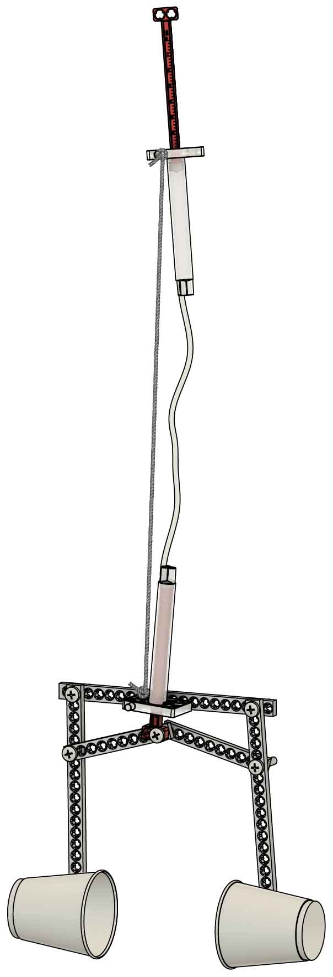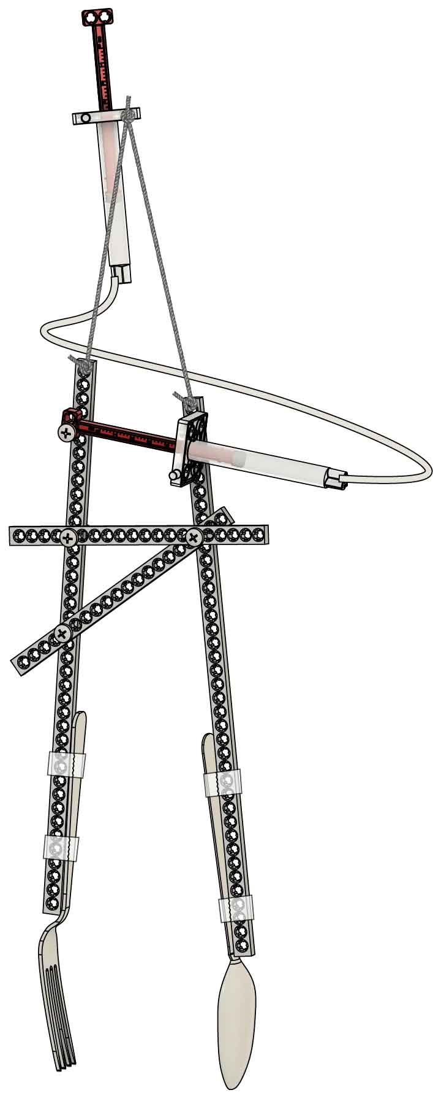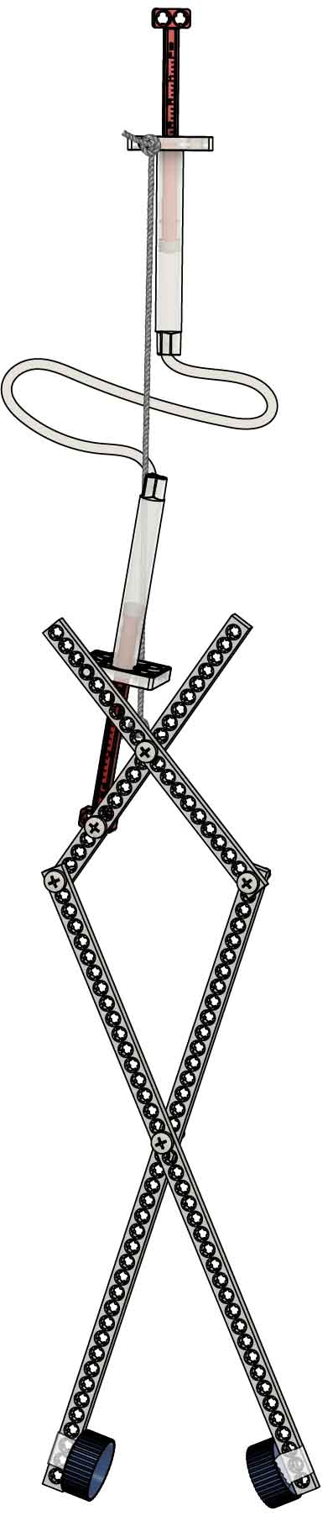

**After you make your claw, try a Challenge!** (Page 9-10)

Accordion  
(Page 4)

**These examples get you started, then you can experiment and evolve your own unique design!**

Which Claw Will You Make?

Pincer  
(Page 8)

Chopsticks  
(Page 6)

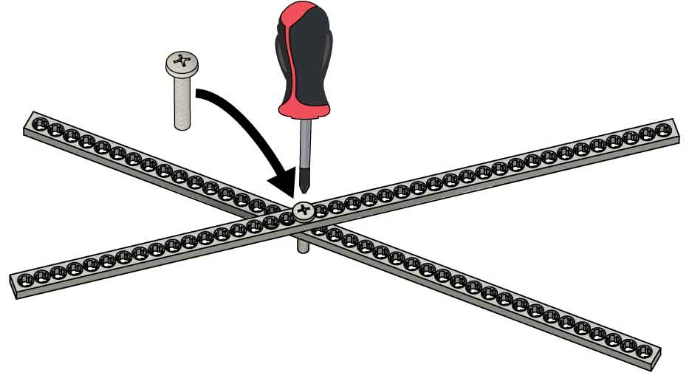

Accordion Example

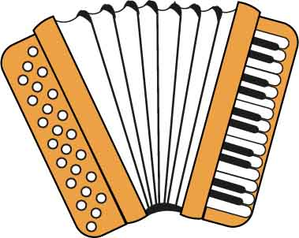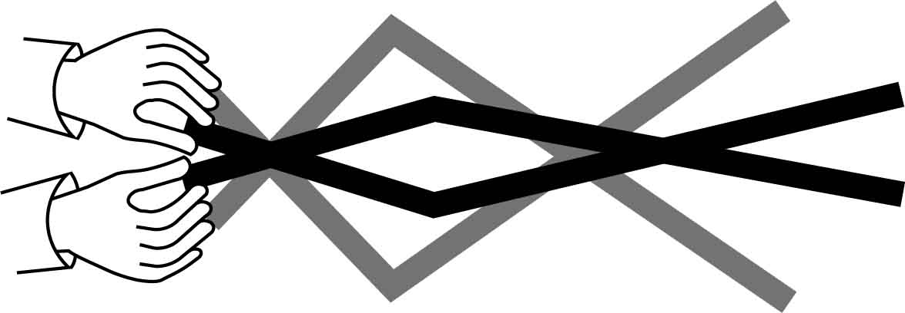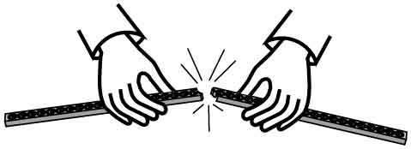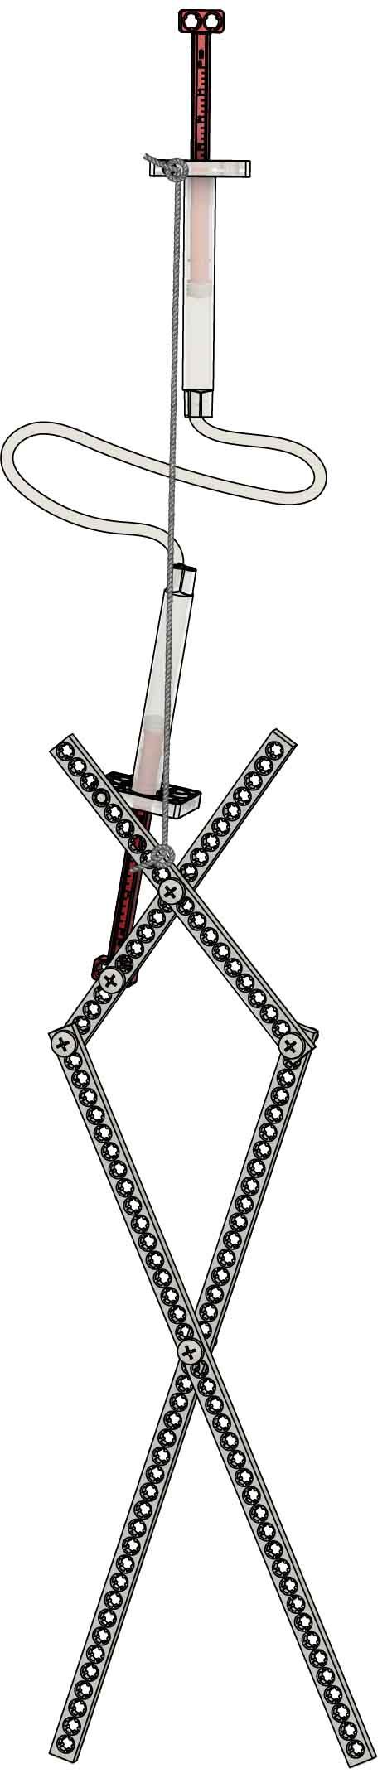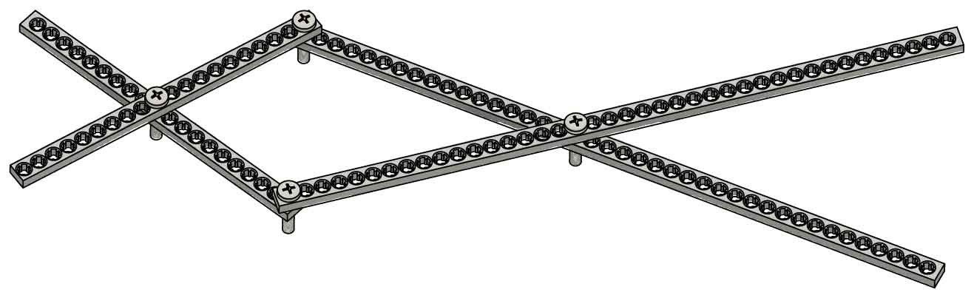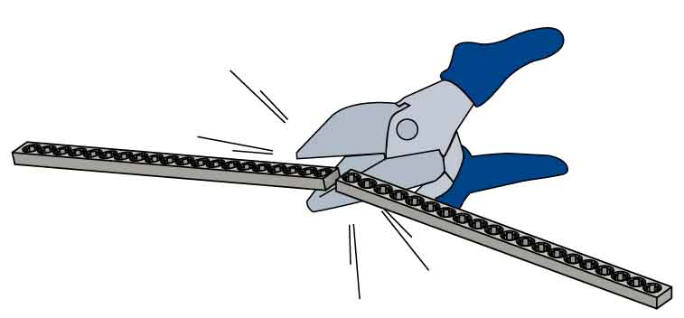

**Cross** **two** **strips** and **add** a **screw** near the middle.

# 2

# 4

# 3

# 1

Full Strip

**Make** two **half** **strips**, if you don’t already have them, by **cutting** **or** **snapping** a full strip.

Half Strips

2x

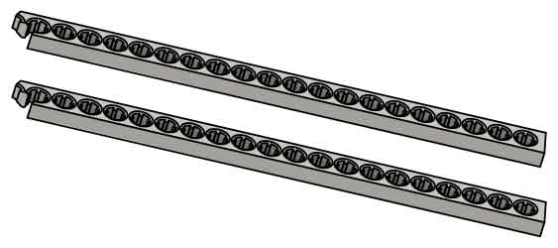

This mechanism moves like an accordion.

**Test your mechanism!**   
Next, you are going to add hydraulics.

Add the half-strips and screws to   
**make** an **accordion-style mechanism**.

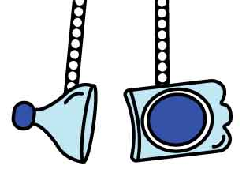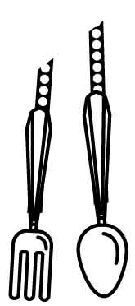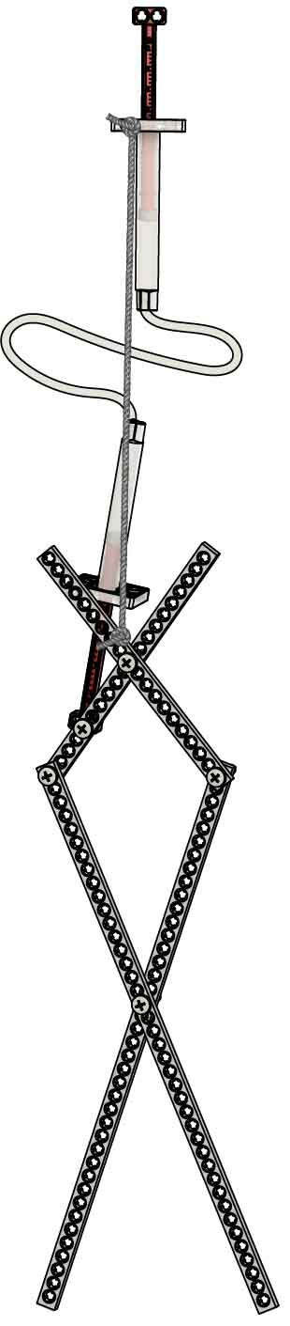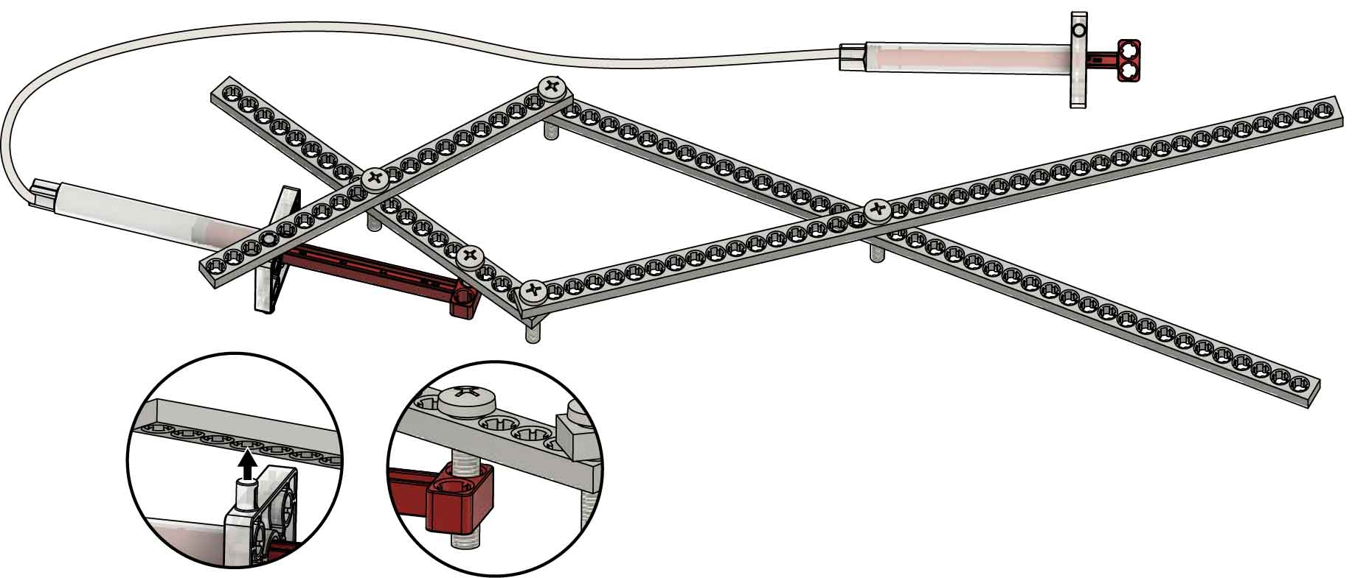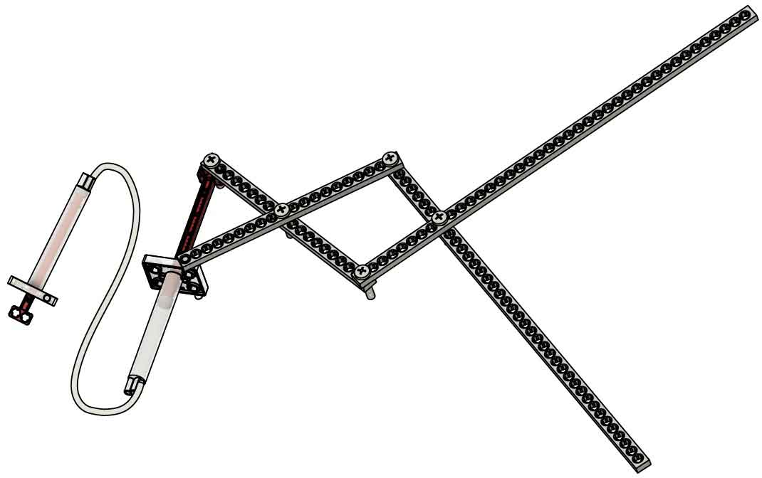

# 7

# 6

# 5

**Add end effectors** to grip or scoop objects.

**Pop** **in** the cylinder **pin**.

**String**(optional)

**Test your claw!** If it’s tipping over, use string to hold it up.

Your example is done, but you aren’t… **Tinker with it and keep evolving the design!**

Test a lot of them – they all have different strengths and weaknesses.

Then **screw** in the **piston**.

**Add** your **cylinder** assembly to the mechanism.

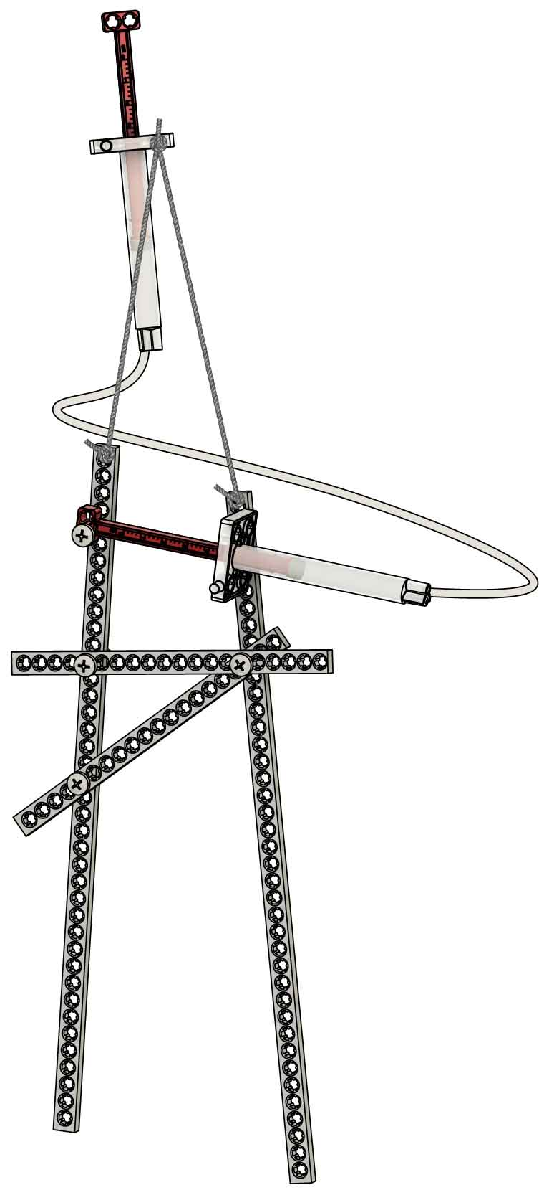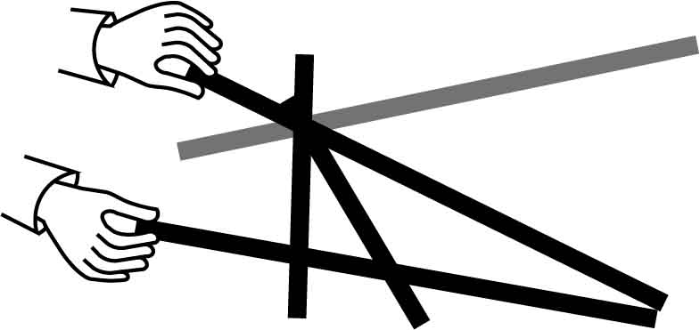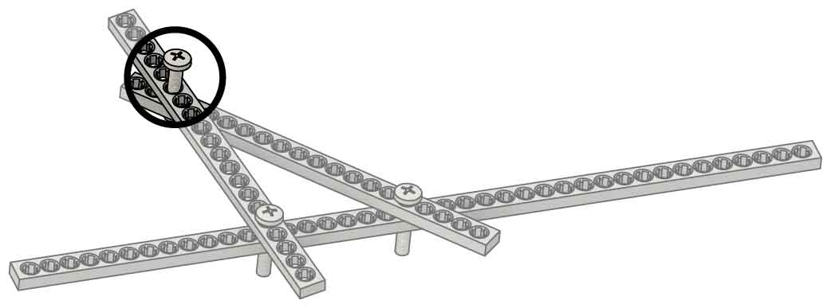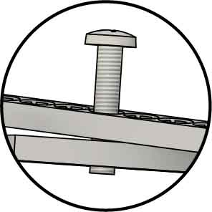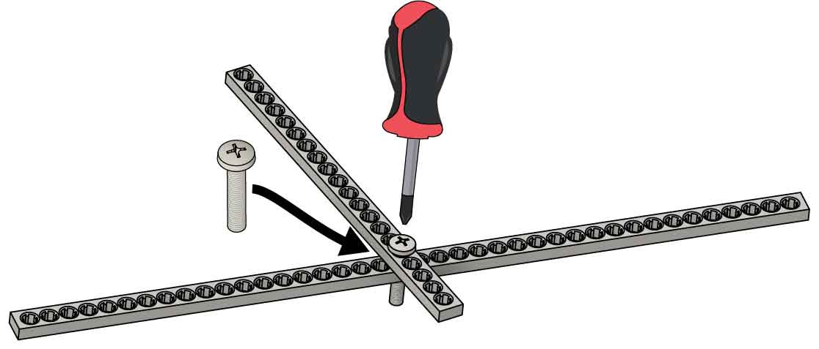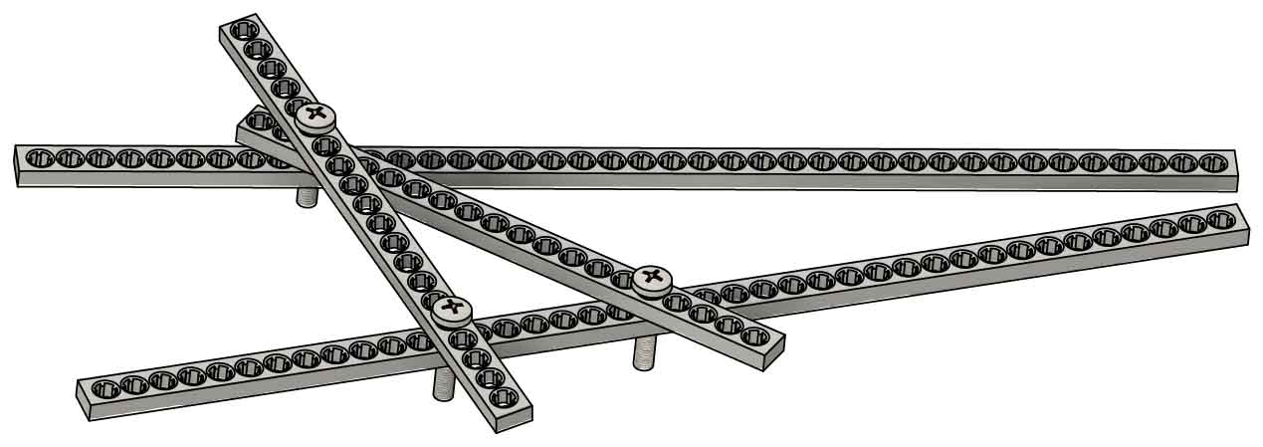

# 5

# 6

# 4

# 3

# 2

# 1

Put a **full strip** **under** the **screw** from Step 4 and **screw it in.**

Half Strips

Full Strip

**Make** **two** **half** **strips**, if you don’t already have them, **by** **cutting** **or** **snapping** a full strip.

**Screw** the ends of the **half** **strips** **together**, so the screw barely sticks out the bottom.

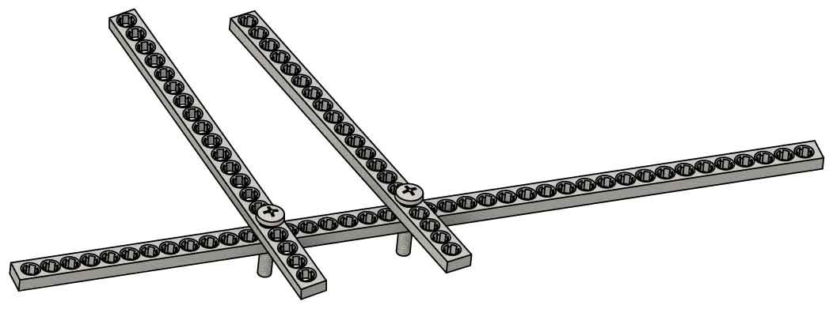

**Screw on another half strip.** It doesn’t have to match the picture exactly.

**Screw** a **half strip** **to** a   
**full strip** near the middle.

**Test your claw!** Next, you are going to add hydraulics.

2x

Chopsticks Example

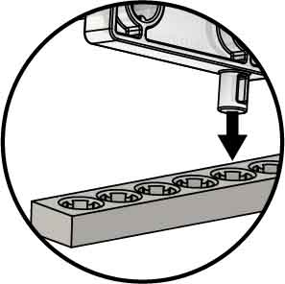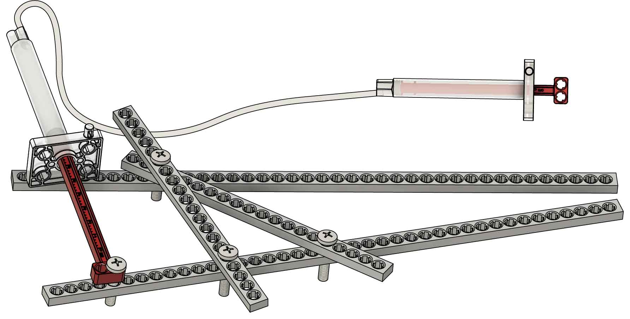

# 7

**Add** your **cylinder** assembly to the mechanism.

**Pop** **in** the   
cylinder **pin**.

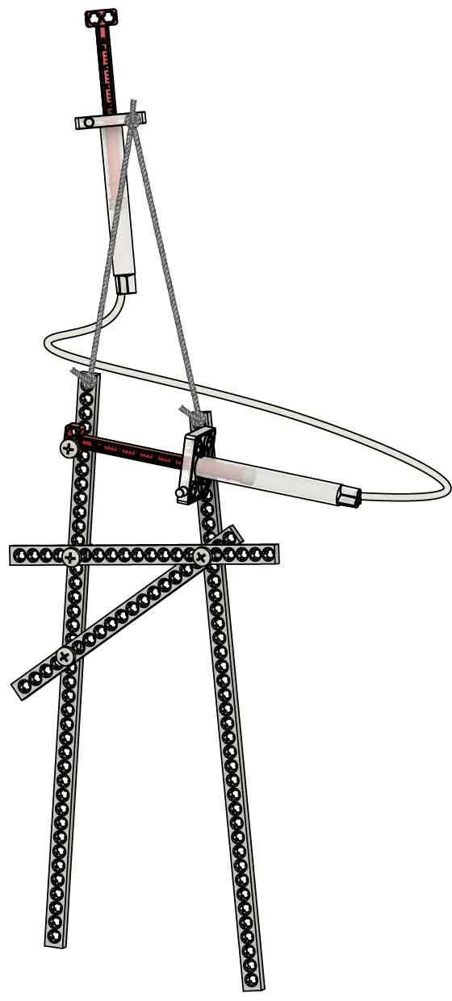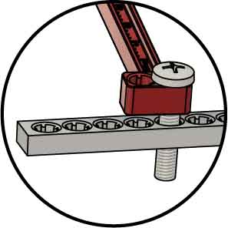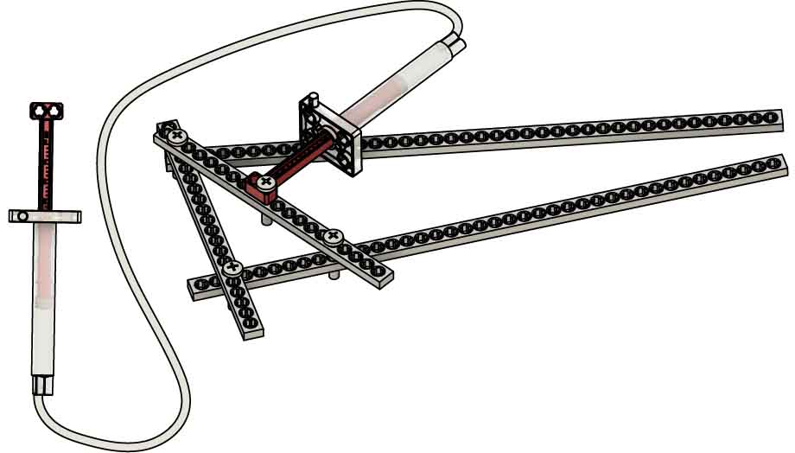

# 8

**Test your claw!** If it’s tipping over, use string to hold it up.

# 9

Your example is done, but you aren’t… **Tinker with it and keep evolving the design!**

**Add end effectors** to grip or scoop objects.

Test a lot of them – they all have different strengths and weaknesses.

**String**(optional)

Then **screw** **in**  
the piston.

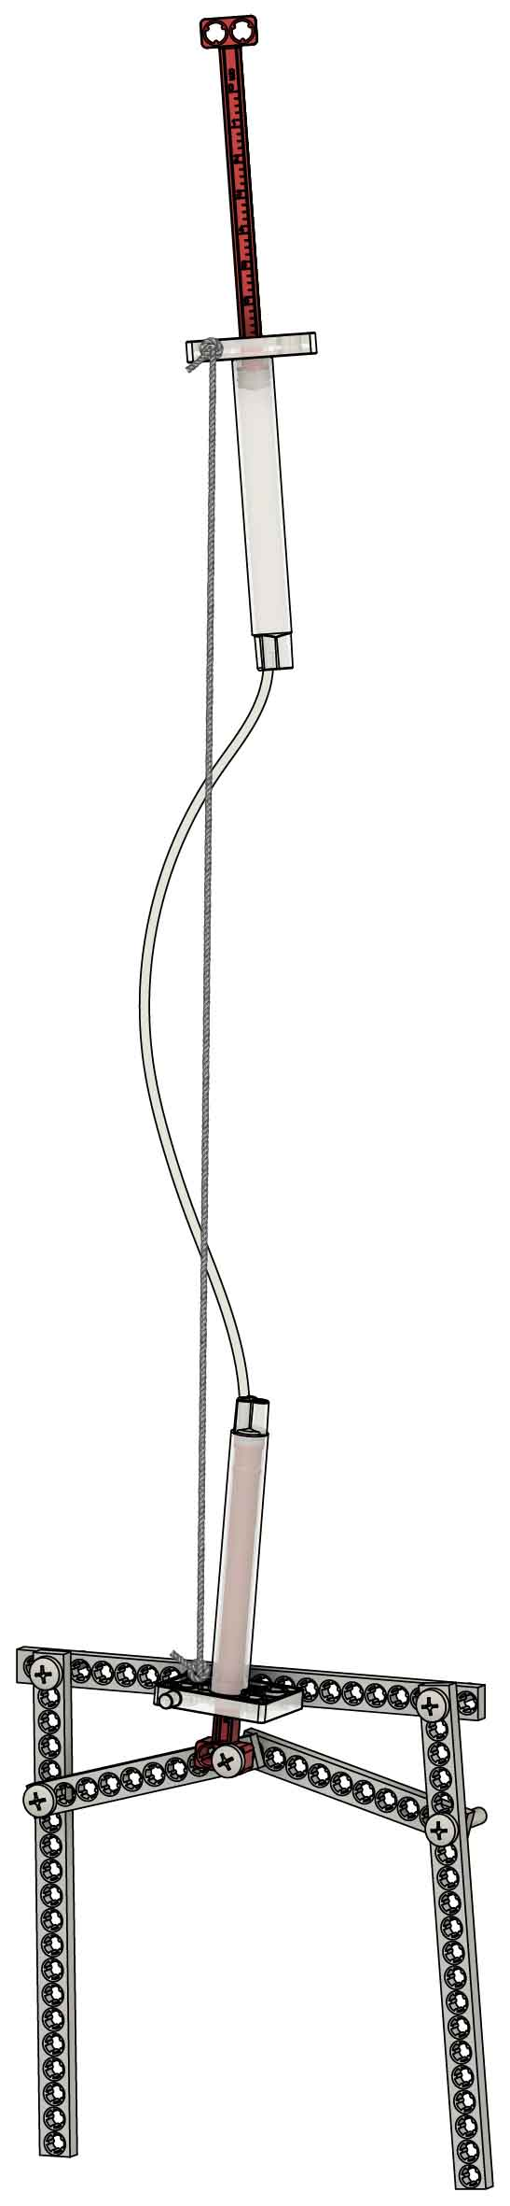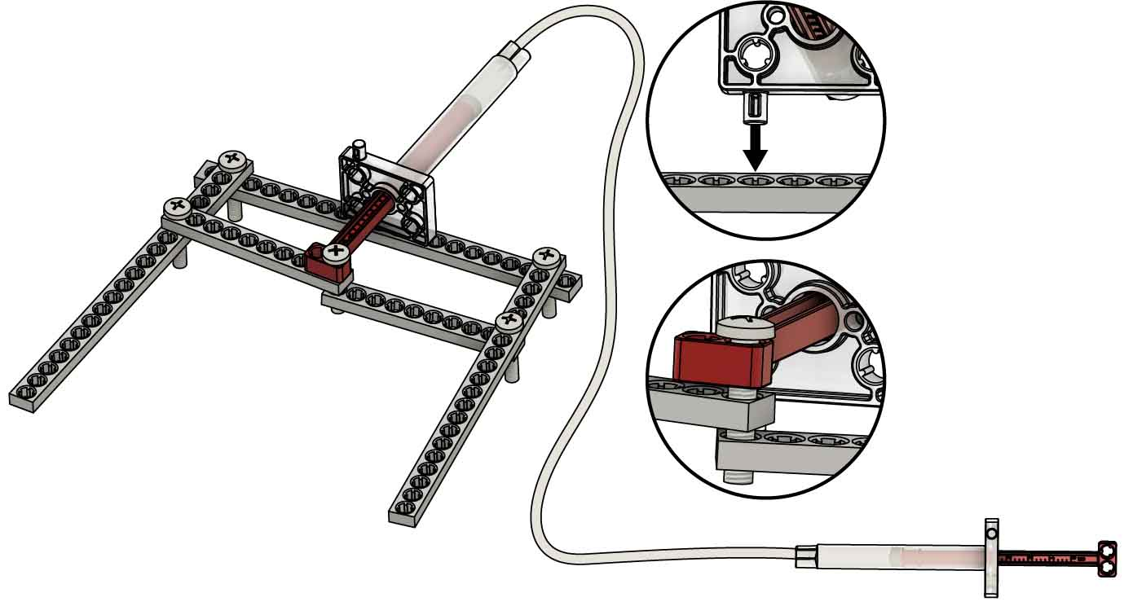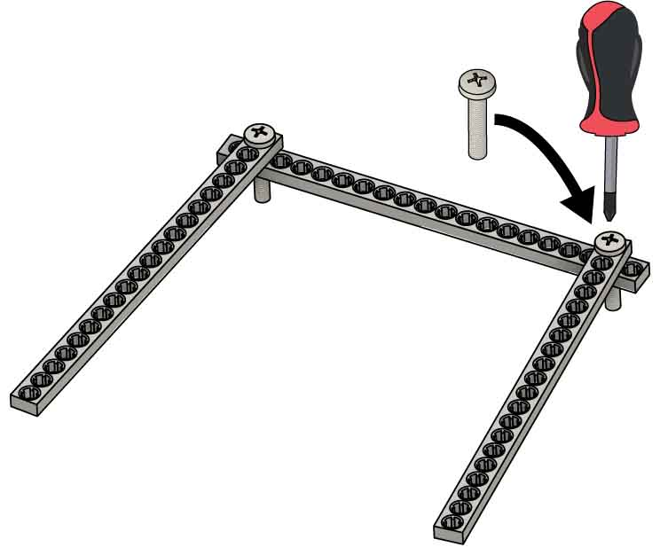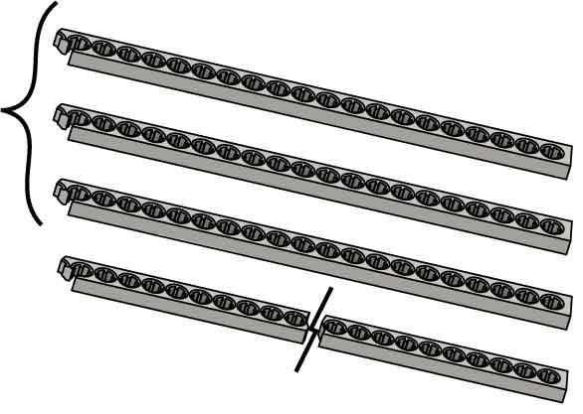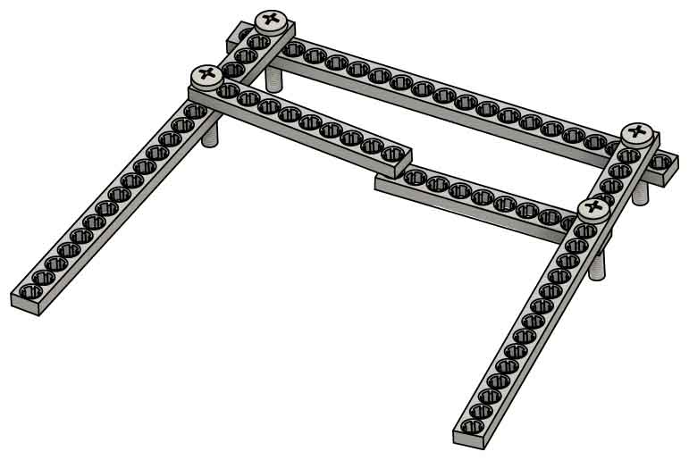

**Make three half strips** and **two quarter** **strips** if you don’t already have them. (This will require 2 full strips.)

3x

2x

Half Strips

Quarter Strips

# 5

# 6

# 4

# 3

# 2

# 1

**Add end effectors** to grip or scoop objects.

Your example is done, but you aren’t… **Tinker with it; keep evolving the design!**

**Pop** **in** the cylinder **pin**.

**Screw** in the **piston** to both quarter strips.

Use two more screws to **attach** the **two quarter strips**.

Full Strip

**Test your claw!**If it’s tipping over,   
hold it up with **string** (optional).

**Screw** the three   
**half strips together**.

**Add** your **cylinder assembly**.

Pincer Example

Ocean Cleanup Challenge

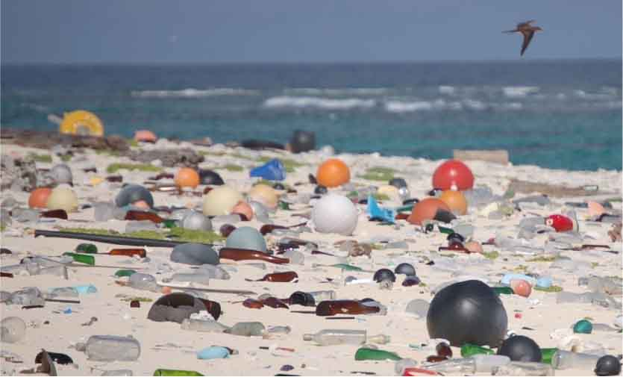

Design your claw to clean up the ocean!

Plastic trash is harming ocean wildlife and washing up on beaches around the world. **Use your claw to complete all three stations of the challenge (you can change your design between stations).**

Learn more about seaborne trash at [**fws.gov/refuges/features/OceansOfTrash.html**](https://fws.gov/refuges/features/OceansOfTrash.html)

One claw can’t do it all (at least not well), so change your claw design for each part!  
The engineering design process is never done – there is no perfect design.

* You must use a claw **powered by hydraulic cylinders**.
* You may **only use claw supplies** listed on Page 1
* You have **_____ minutes to complete each station** of the challenge
* You have **_____ minutes to change designs** between each station

(rules and limits for your design)

Constraints:

Station 1: Garbage Patch

Huge amounts of trash are floating in the ocean. **Load trash into the container as fast as possible.**

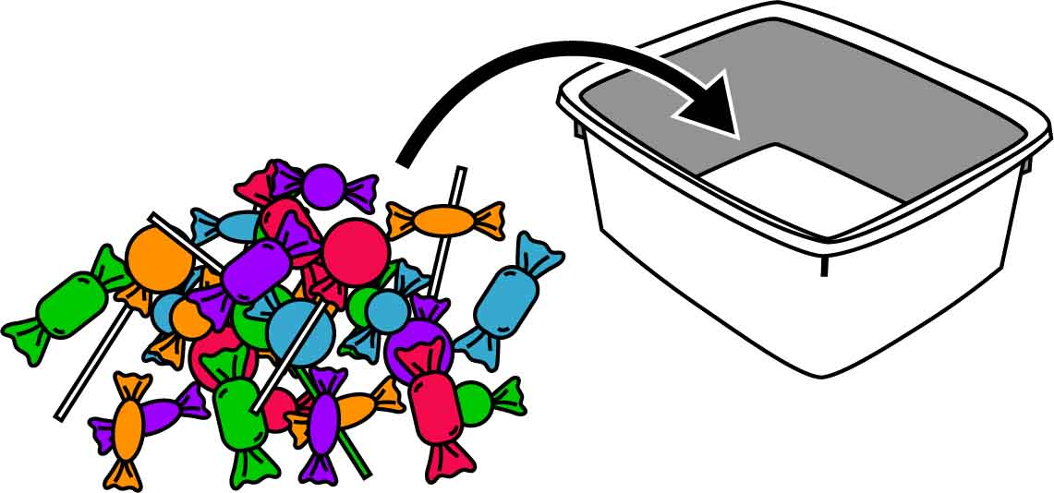

Criteria:

**+5 points** for every piece of “trash”

**+1 point** for every extra second left on the clock

You can use anything almost for “trash.”   
Candy, office supplies, toys, recyclables, etc.

Station 2: Load the Barge

Containers of trash must be shipped to land for processing. **Stack containers on the barge as fast as possible.**

Criteria:

**+5 points** for each “container” on the “barge”

**+1 point** for every extra second left on the clock

Anything that can be stacked can be a “container.” Snack bars, candy, blocks, etc.

Use paper or an index card for the “barge.”

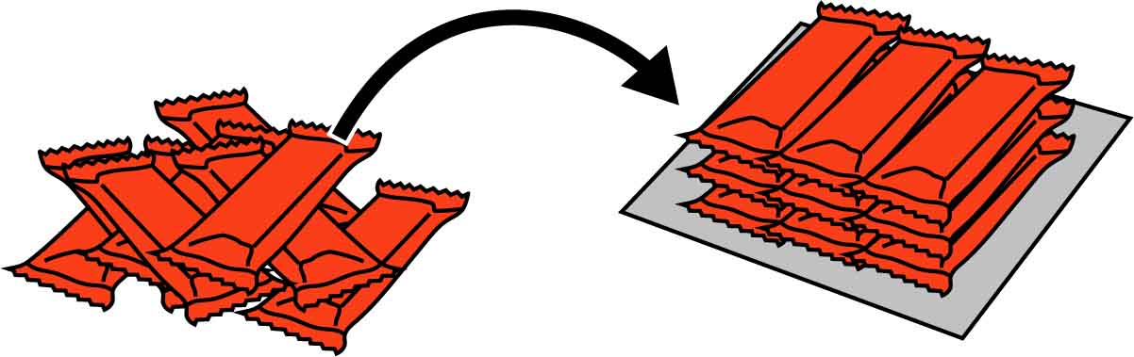

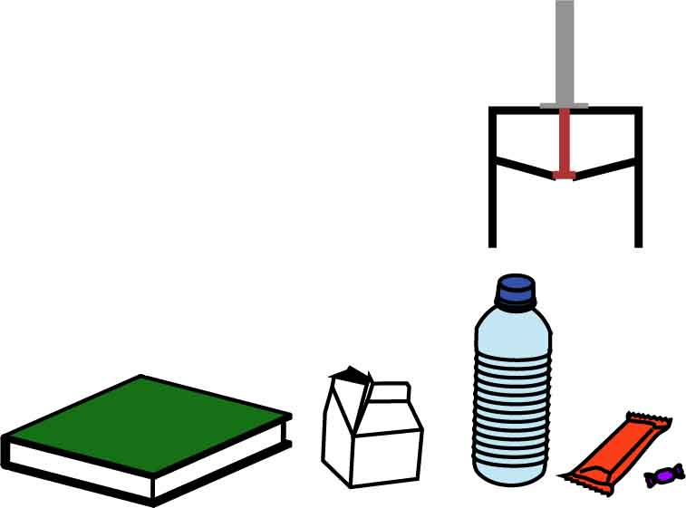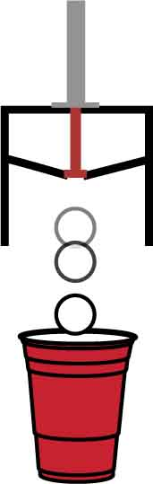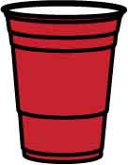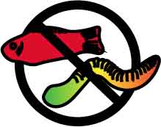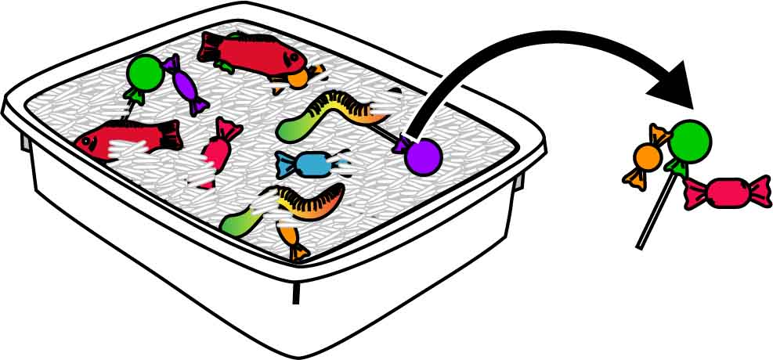

**GOAL 2**

Claw Ball Challenge

Put a cup (goal) on each side of the room. Each team can pick up the ball but must pass or drop the ball after walking three steps. The first team to get 5 goals wins!

Station 3: Beach Cleanup

Pieces of trash are washing up onto beaches. Design a claw to separate the trash from the sand without disturbing any of the wildlife.

Criteria:

Rice or sugar can be used as sand. Candy, fishing lures, etc. can be used for trash/wildlife.

**+5 points** for every piece of “trash”

**–10 points** for every piece of wildlife

**+1 point** for every extra second left on the clock

**GOAL 1**

HORSE Challenge

Take turns picking up different objects. If one player can pick it up, and the other players can’t, that player gets a letter towards the word “HORSE.” The first player to spell   
“HORSE” wins!

Additional Challenges

Leave Wildlife

Remove Trash

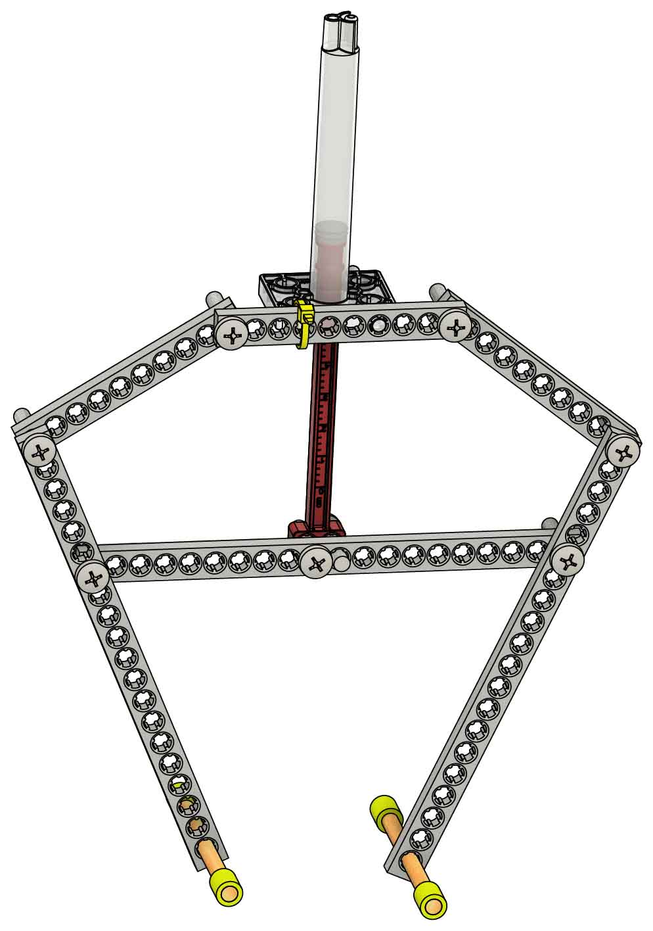

**Try making completely different designs!**

Inspiration

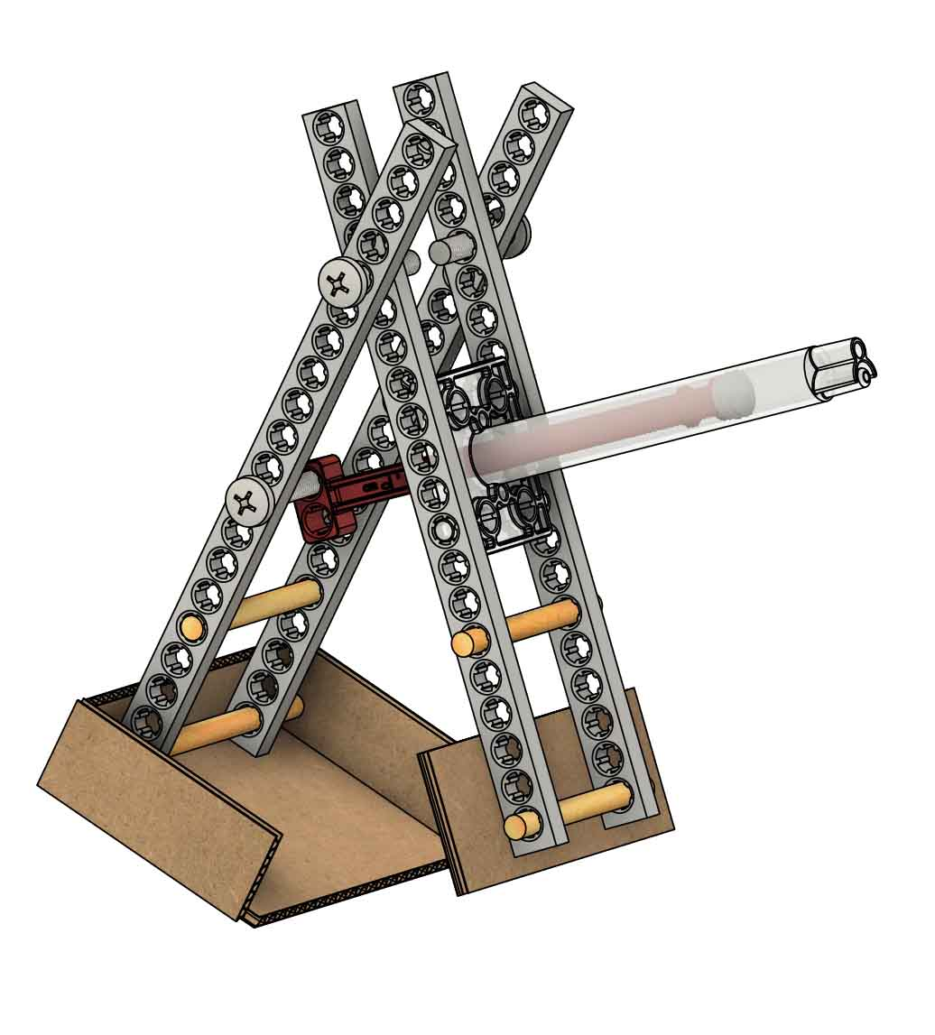

Zip Tie

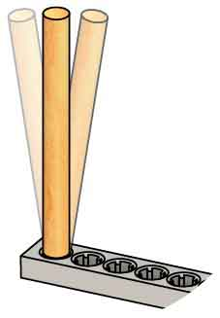

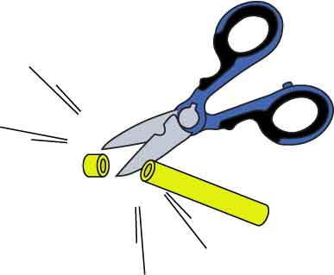

Tap or wiggle dowels into holes with teeth to secure them.

Cut slide stop with scissors.

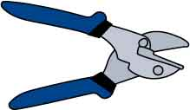

Cutters Optional

**Tools unlock even more design possibilities!**

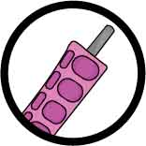

Ream these two holes.

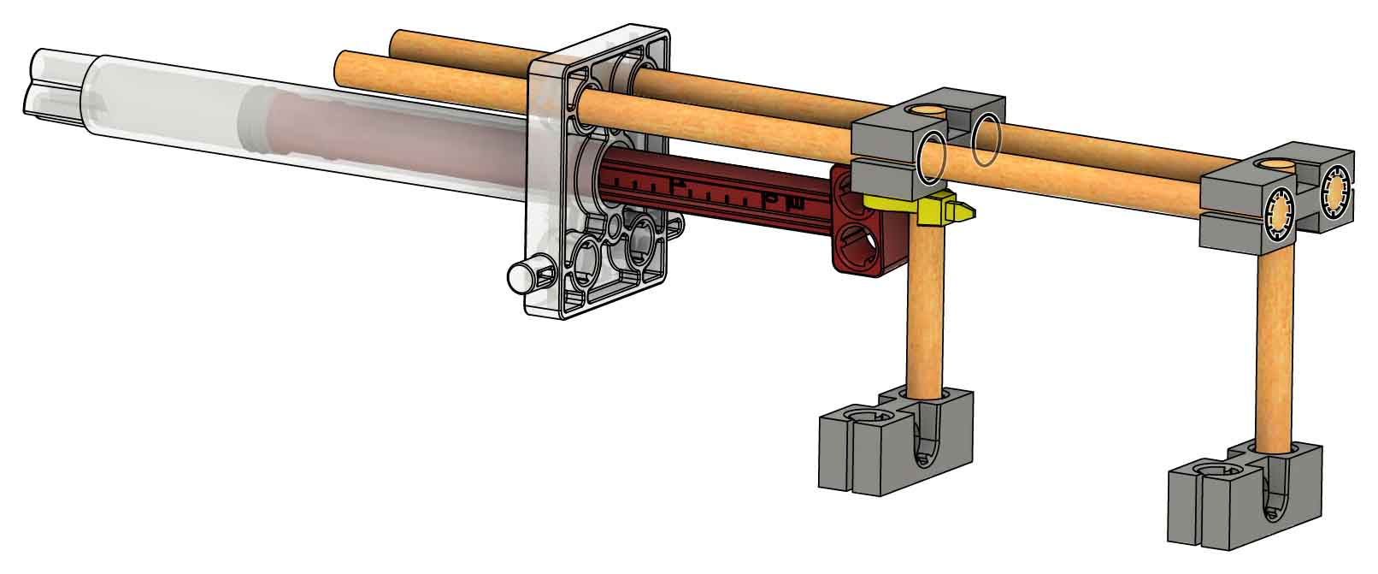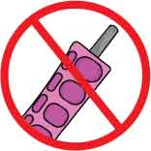

Don’t ream these holes.

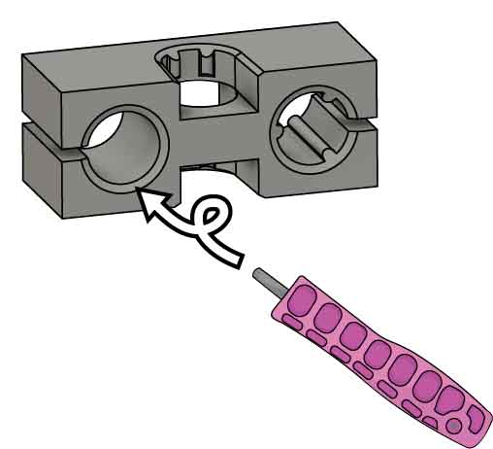

Zip Tie

Ream the teeth out of holes to let dowels slide freely.

Push & Twist