**A container of nuclear waste has been damaged! Create as many solutions as possible to transfer nuclear waste from one container to another.**

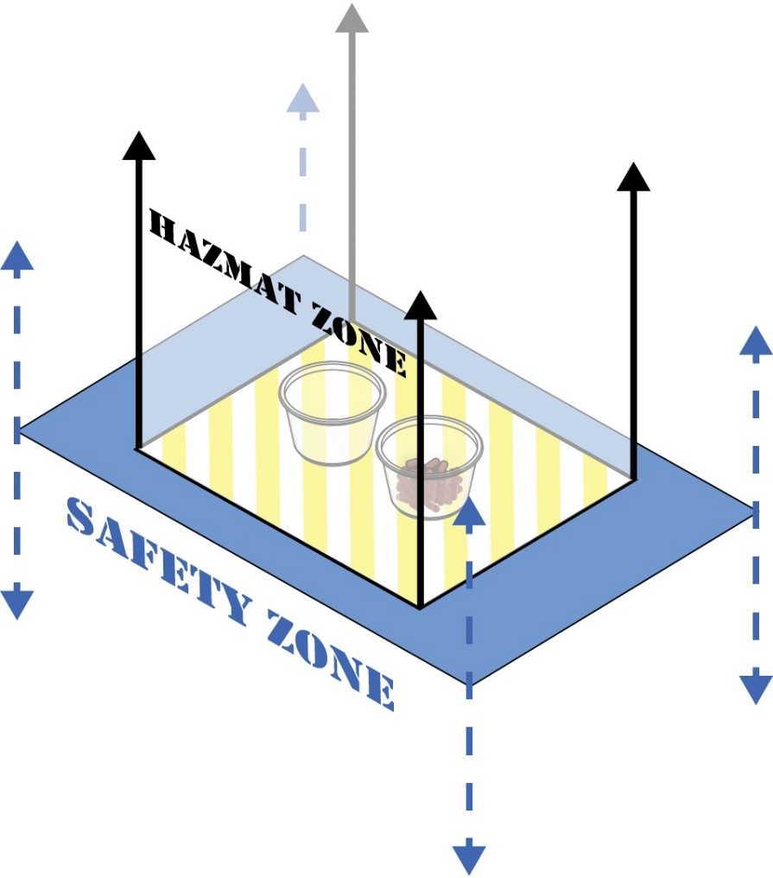

* If you need to start over, you may reach into the Safety Zone to reset the nuclear waste and cups.
* Cups must remain in the Hazmat Zone (the paper and the area above it).
* No part of your body may enter the Safety Zone (the poster board and the area above and below it).
* You must start over if:
  + The toxic waste spills.
  + A cup or cups leave the Hazmat Zone.
  + A body part enters the area directly over the Safety Zone.

Arena Supplies:

* 1 - Printed Hazmat Arena Sheet
* 1 - Sheet of Poster Board
* 2 - Paper or Plastic Cups
* ¼ Cup - “Hazardous Material” (M&M’s, dried beans, etc.)

Recommended Parts:

**TeacherGeek Components:**

* 4 - 1ft Dowels
* 4 - Connector Strips
* 4 - Perpendicular Blocks
* Whatever else is on hand!

**Other Supplies:**

* 3 - Rubber Bands
* 3ft of String
* Masking Tape
* 3 Sheets of Paper



(Rules and limits for your design.)

* Each new solution will give your team a point.
* When a solution has been successfully used, it is considered “patented” and no other group can get a point for a solution like it.
* The team with the most points wins the challenge.



(How is your solution judged?)