**Build a Half Atwood’s Machine to use with your TeacherGeek Car.**

• Sail Car • Electric Race Car •   
• Rubber Band Racer •

**Then complete the Half Atwood’s Lab!**

Download the lab at [**teachergeek.com/atwoods**](http://teachergeek.com/atwoods)

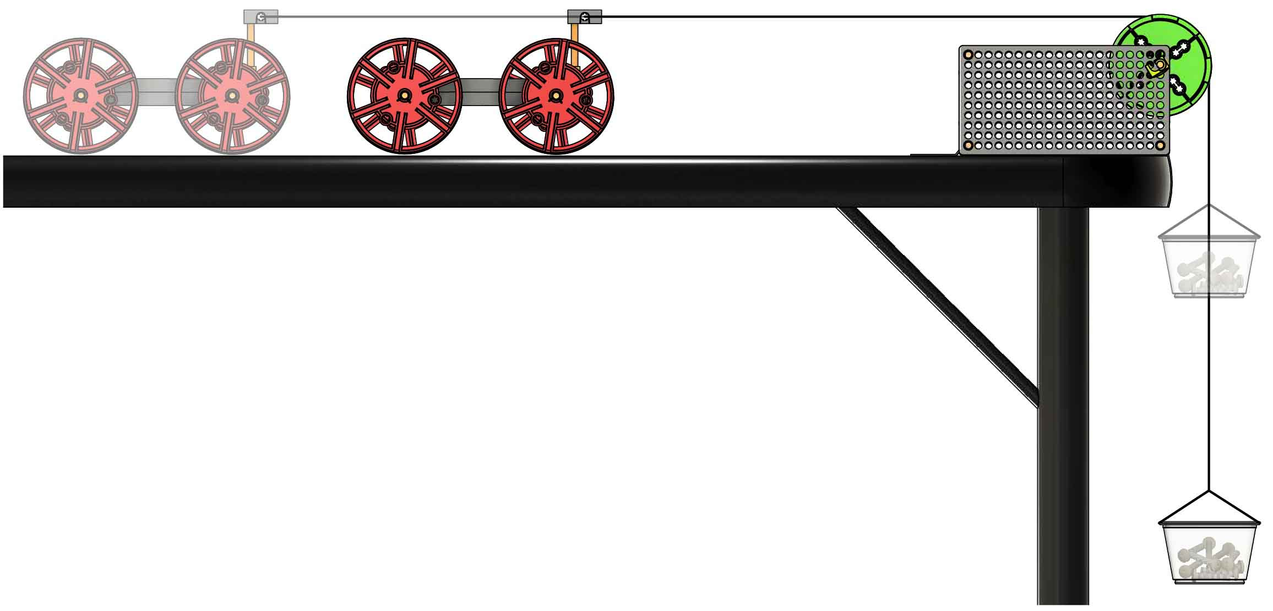

The Half Atwood’s Machine applies a constant force to a car, allowing you to measure how force and mass affect motion.



Other Supplies

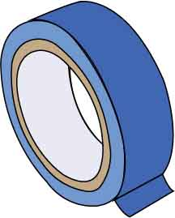

**Tape**

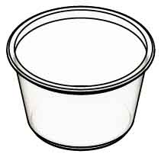

**Plastic Cup**

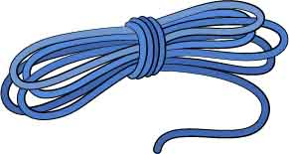

**String**

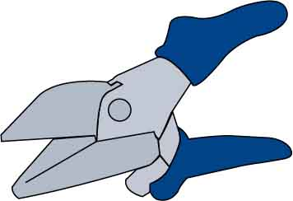

**Multi-Cutter**SKU 1823-81

TeacherGeek Tools

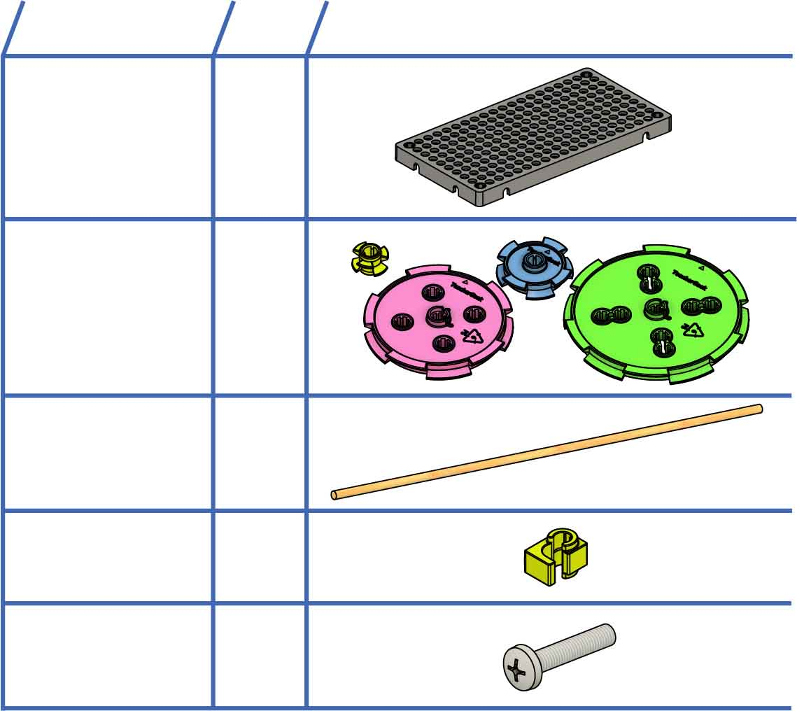

**Hole Plates**SKU 1821-32

**2**

**Dowels**30cm (12in.)  
SKU 1821-20

**2**

**1  
set**

**Pulley Set**SKU 1821-29

**Stop Clips**SKU 1821-60

**2**

**Screws**25mm (1in.)  
SKU 1821-22

**10**

**NAME**

**QTY**

**PICTURE**

TeacherGeek Parts

Order the parts to build this at [**teachergeek.com**](http://teachergeek.com)

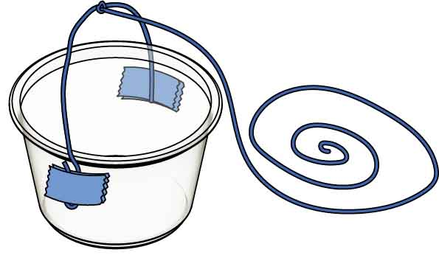

string

Download [**Atwood’s Lab**](http://teachergeek.org/half_atwoods_lab.docx) at [**teachergeek.com/atwoods**](http://teachergeek.com/atwoods)

You are now **ready to begin the lab!** The lab will cover **attaching the car** and **calibrating the machine.**

**Tie** a **100 cm** (39 in) **string** to the string from Step 9.

**100 cm**(39 in)

**Tape** a **20 cm** (8 in)   
piece of **string** **to**   
the **cup**, as shown.

**Snap** a stop **clip** **on** **each** **side** **of** the pulley’s **axle**.

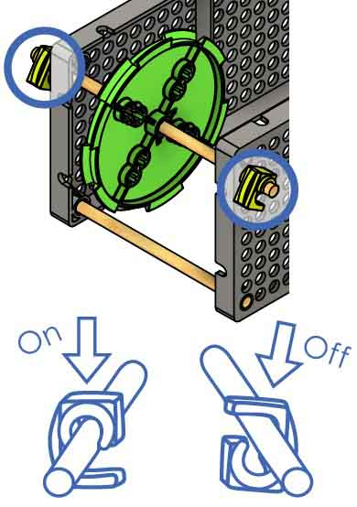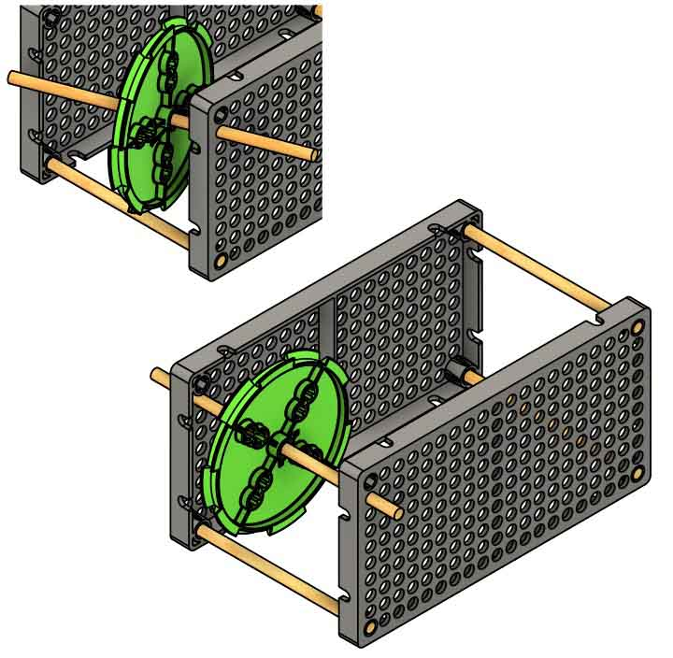

**Slide** the **pulley** **into** the **hole** **under** the **empty**

**corner** of   
the base.

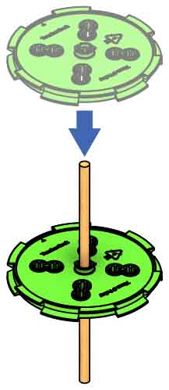

**Wiggle** the **largest** **pulley** **into** the **center** **of** the   
**dowel**.

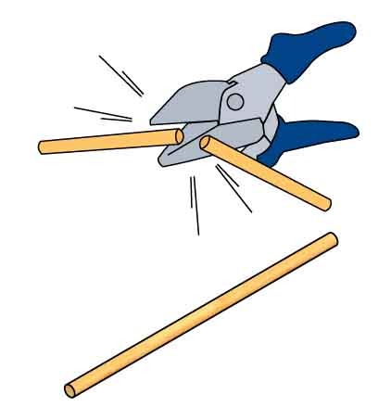

**Cut** a **13 cm** (5 in) **dowel**.

**13 cm**(5 in)

**10 cm**(4 in)

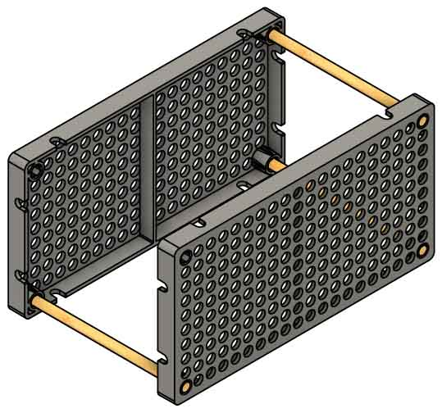

Your base is **done**.

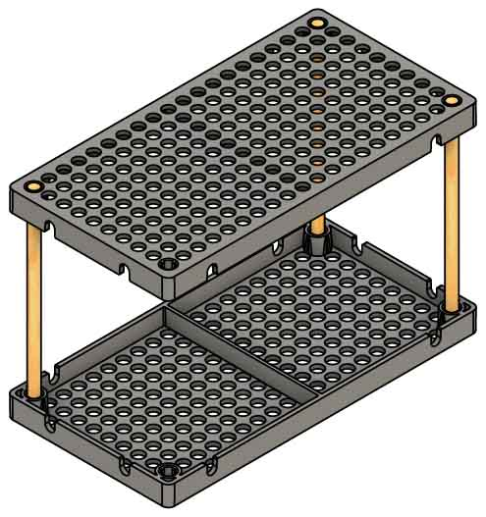

**Push** a hole **plate** **onto** the **other** **side**.

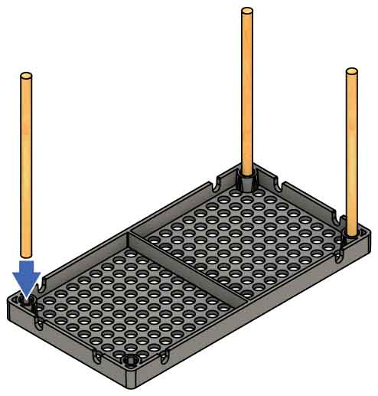

**Wiggle** the cut **dowels** **into** a hole **plate’s corner holes**.

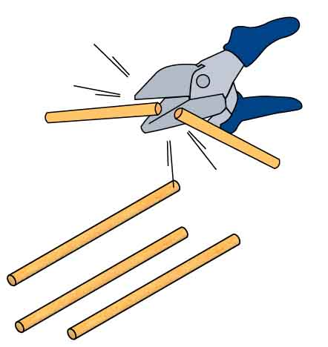

**Cut three** **10 cm** (4 in) **dowels**.