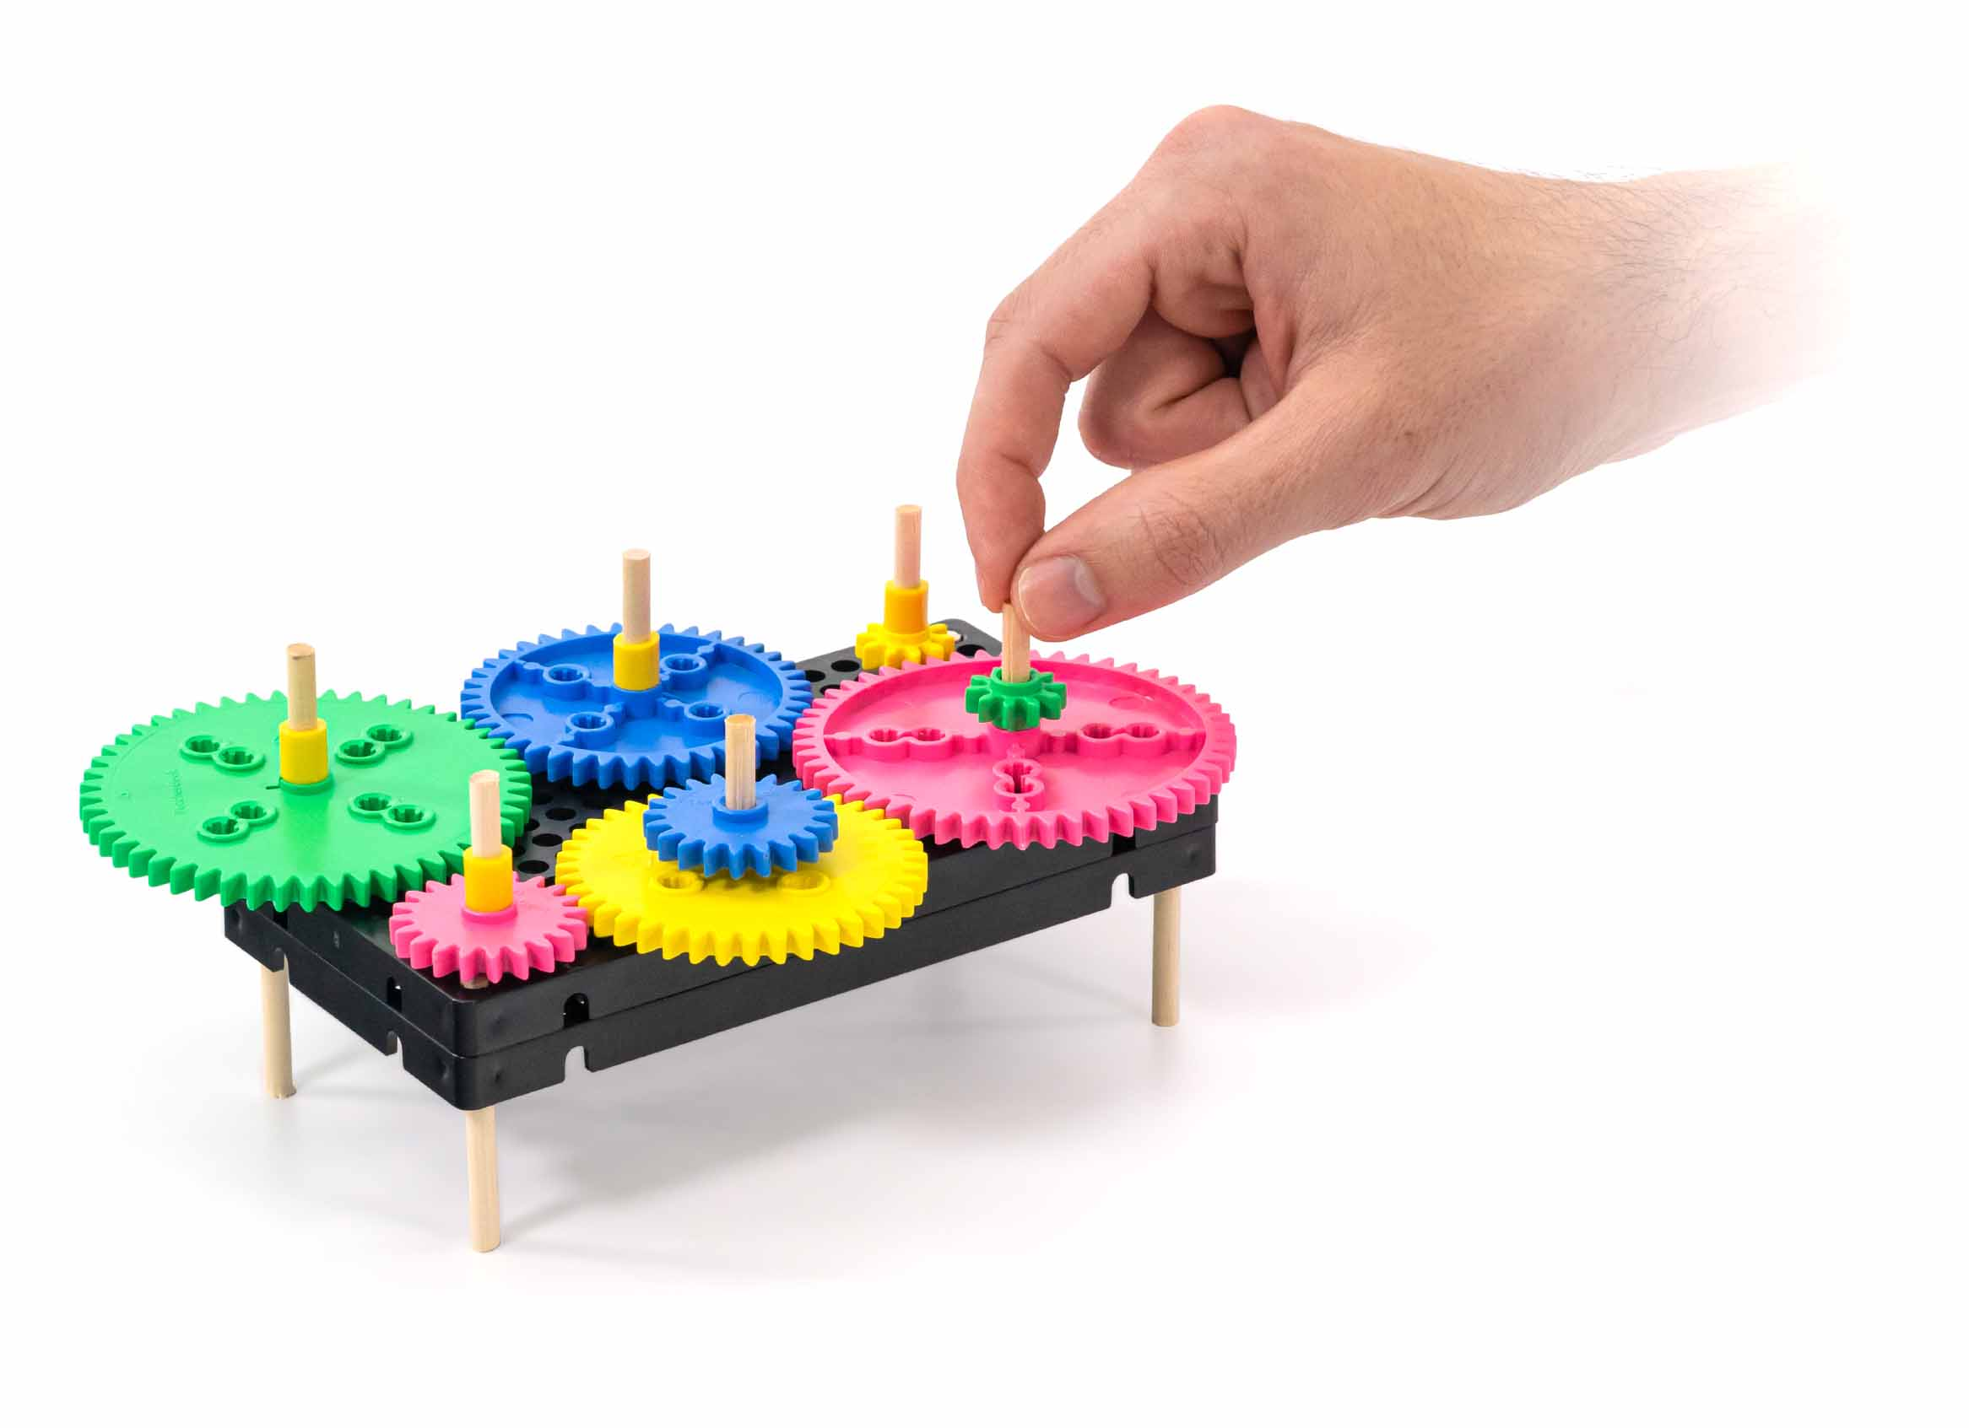

**How do gears work?**

**Do they change speed, direction, force?**

**Build your base and   
gears to find out!**

You Are Here

Set-Up Guide

Optional Labs

Optional Challenges

Start here to build your tinker set. Tinker forever with the reusable base and gears.

[-Fraction](https://teachergeek.org/gears_fraction_lab.docx)  
[-Ratio & Proportion](https://teachergeek.org/gears_ratio_&_proportion_lab.docx)  
[-Mechanical Advantage   
 Reference Sheet](https://teachergeek.org/gears_mechanical_advantage.docx)

[-Obstacle Course](https://teachergeek.org/gears_obstacle_course_challenge.docx)  
[-Kinetic Sculpture](https://teachergeek.org/gears_kinetic_sculpture_challenge.docx)  
[-Amusement Park](https://teachergeek.org/gears_amusement_park_challenge.docx)

Optional Teacher Overview

**Choose how you would like to complete this activity.  
Download these documents at** [**teachergeek.com/gears**](https://teachergeek.com/gears)

**If doing this activity with young children,** have an adult set it up first. Once set up, this activity can be re-used without taking it apart! Kids can still modify and tinker with it year after year.

# Supplies

These are the parts you need to build one Tinker Set. Extra parts are included for engineering challenges and creating your own designs.

You’ll need to supply…

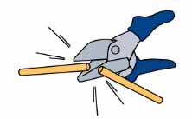

Have a Maker Cart, bulk components, or uncut dowels? Use Multi-Cutters to cut them before moving on.

**Dowels**5 cm (2 in)  
SKU 1821-20

**PICTURE**

**NAME**

**QTY**

**2**

**Hole Plates**  
SKU 1821-32

**Gear Sets**  
SKU 1821-28

**Blocks**  
SKU 1821-34

**Slide Stop**8 cm (3 in)  
SKU 1821-20

**2 sets**8 Gears

**2**

**1**

**10**

Gear colors vary – they’re not color coded

1 set

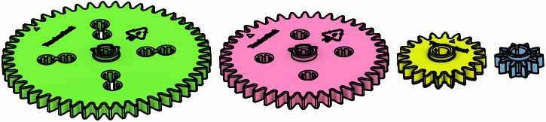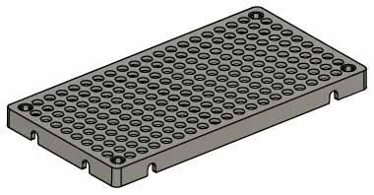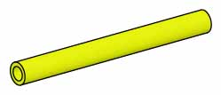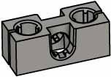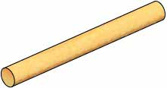

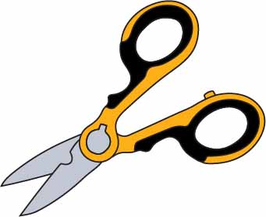

**Scissors**

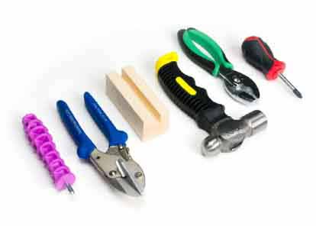

Modify materials to make even more creative designs with the **Maker Tool Set**

SKU 1823-84

**Optional Tools**

# Build the Base

# 1

**Tap** or push **5 cm** (2 in) **dowels** **into** **two** stacked, upside-down **hole** **plates**.

**Congratulations**! Your base is done.

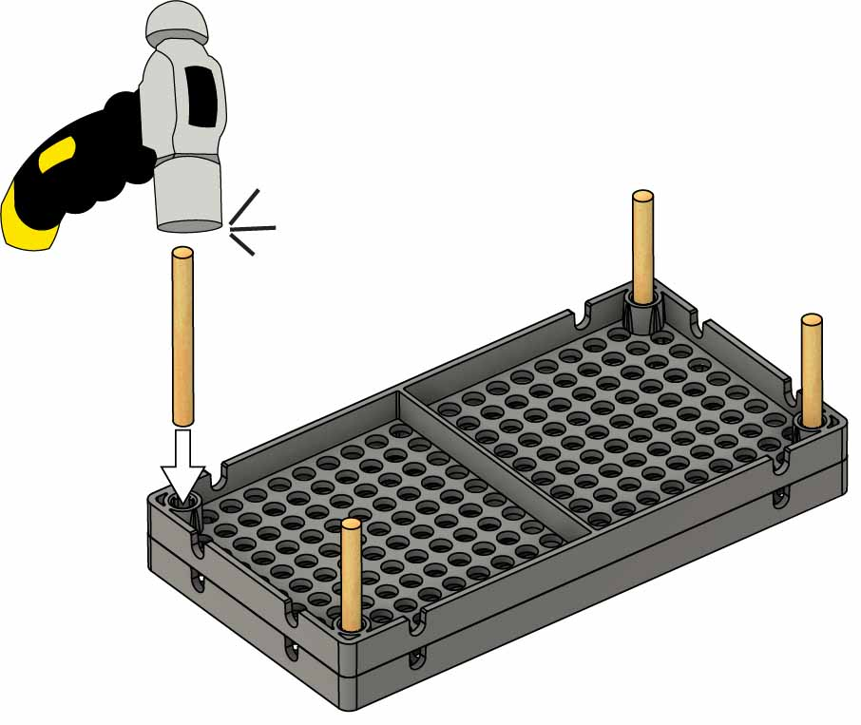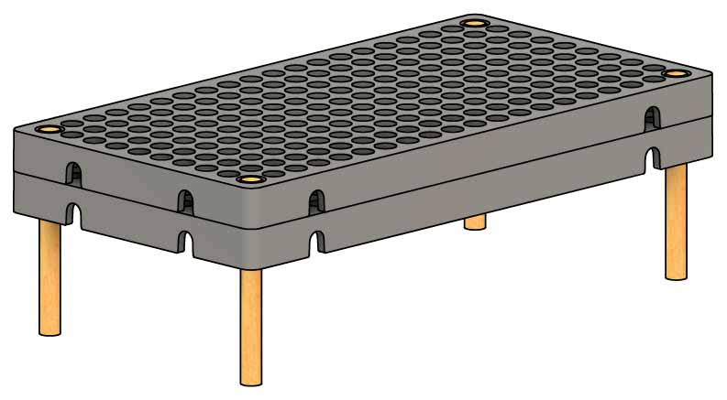

**5 cm** (2 in) **Dowels**

**Hole Plates**

Dowels should not stick out the top of the base.

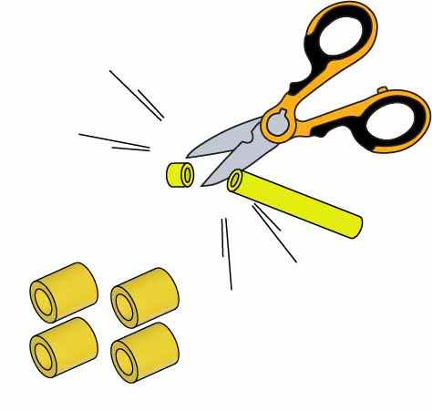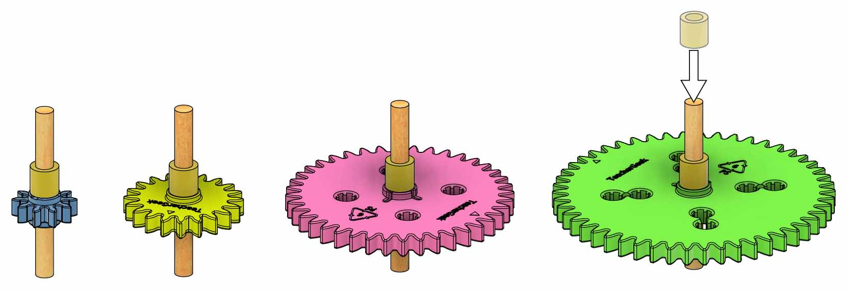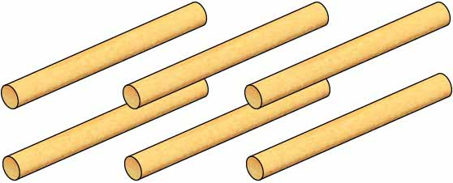

# 3

# 2

# 4

# 6

Compound gears don’t need   
slide stop.

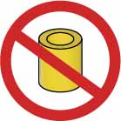

**Make the compound gears** below with your remaining shafts and gears.

**Make one gear of each size.** Tap or wiggle the shaft through the gear’s center hole.

You will have 2 shafts & 4 gears   
left over.

# Make the Gears

**Get six 5 cm** (2 in) **dowels** to use as gear shafts.

50 Tooth  
Gear

**1 cm**   
(3/8 in)

**Cut four 1 cm** (3/8 in) pieces of **slide stop**to use as spacers.

Centered on shaft

Tapping Block

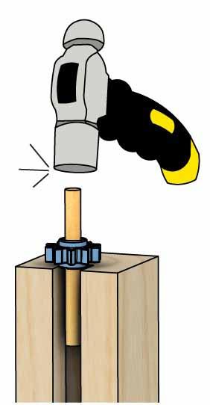

40 Tooth  
Gear

20 Tooth  
Gear

10 Tooth  
Gear

**Add slide stop** to the shafts.

# 5

**5 cm**(2 in)

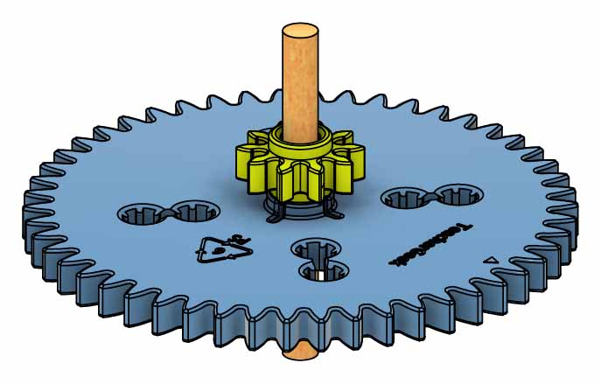

10 Tooth &  
50 Tooth

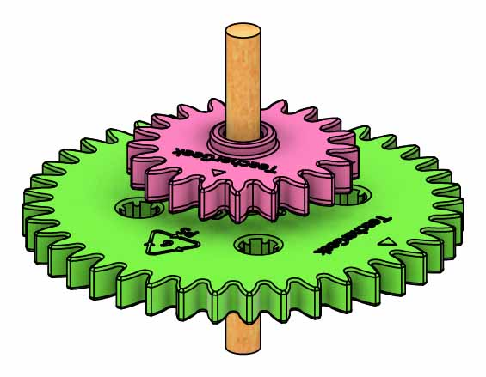

20 Tooth &  
40 Tooth

# Mesh the Gears

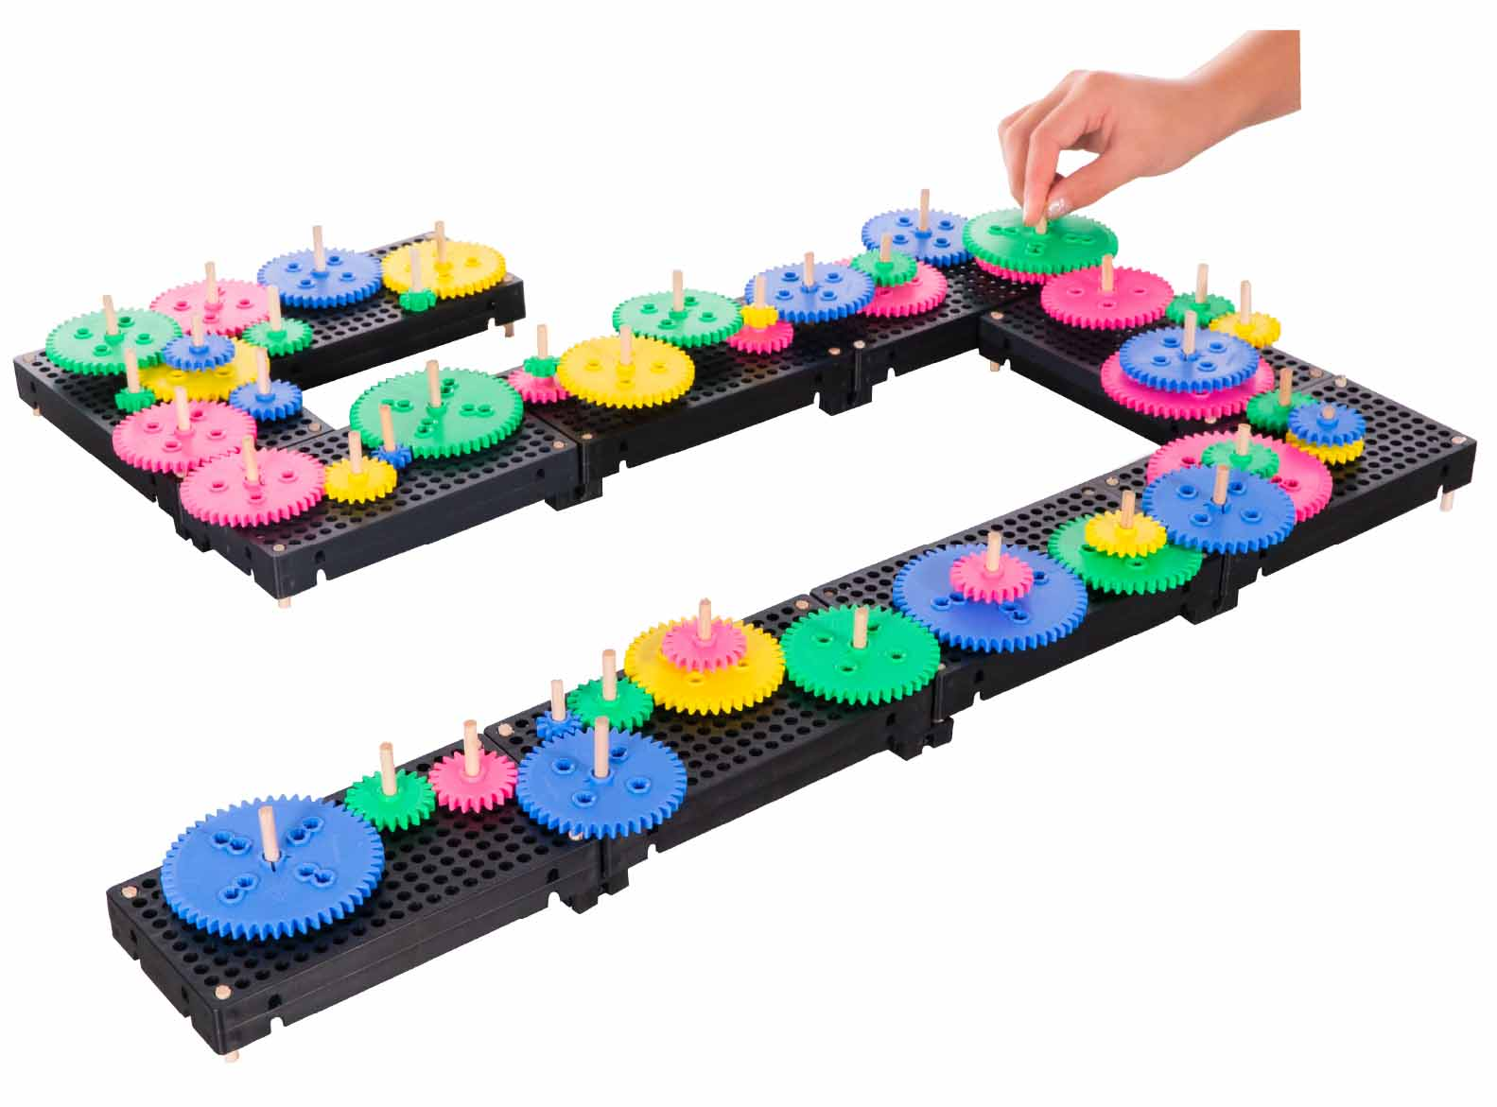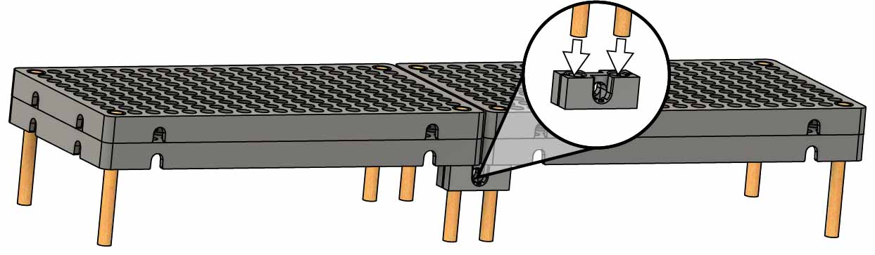[](http://teachergeek.com/gears)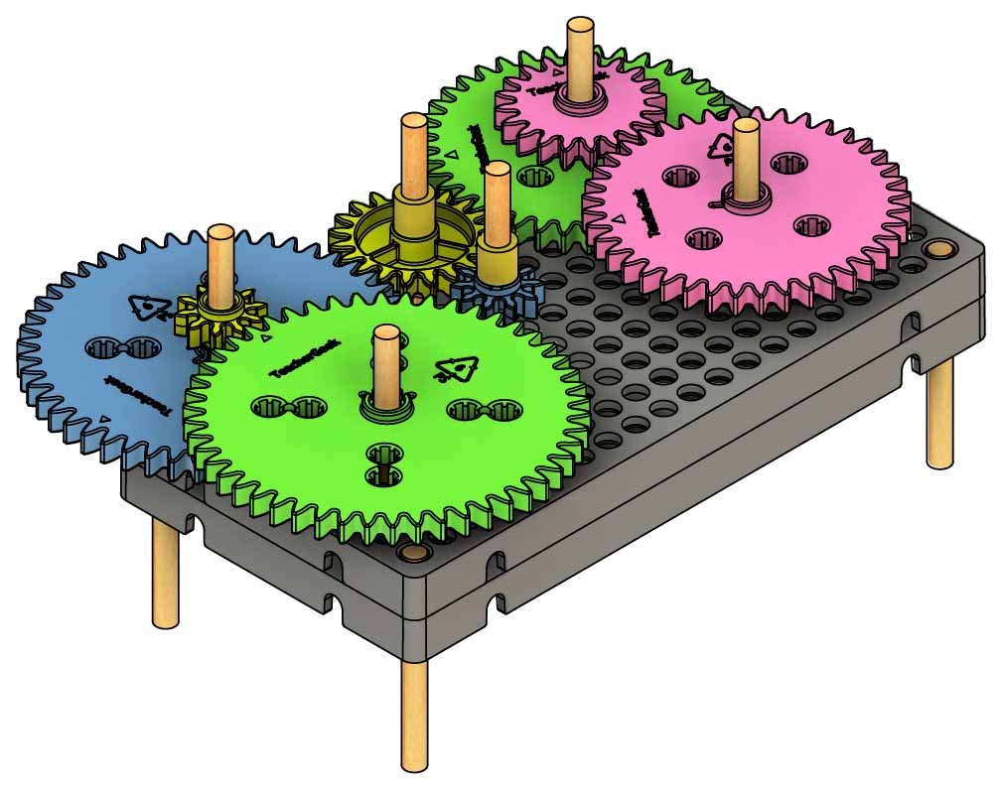

[**-Obstacle Course**](https://teachergeek.org/gears_obstacle_course_challenge.docx)

[**-Kinetic Sculpture**](https://teachergeek.org/gears_kinetic_sculpture_challenge.docx)

[**-Amusement Park**](https://teachergeek.org/gears_amusement_park_challenge.docx)

[**-Fraction**](https://teachergeek.org/gears_fraction_lab.docx) **Lab**

[**-Ratio & Proportion**](https://teachergeek.org/gears_ratio_&_proportion_lab.docx) **Lab**

[**-Mechanical Advantage   
 Reference Sheet**](https://teachergeek.org/gears_mechanical_advantage.docx)

# 7

**Congratulations**! Your tinker set is done… but you aren’t! It’s time to do an optional lab or challenge!

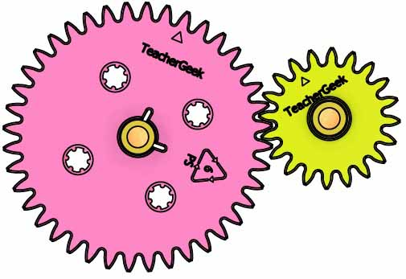

Gears that are too close, or too far apart, won’t mesh correctly.

OPTIONAL

# Bigger Bases

**Have a class set?   
Make a giant gear train!**

Use **blocks** to combine bases.

**Challenges:**

**Labs:**

Get the documents at [**teachergeek.com/gears**](https://teachergeek.com/gears)

Mesh on different layers by flipping the gears.

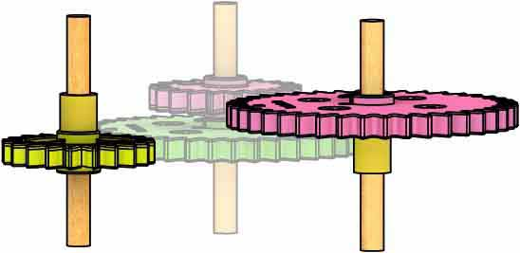

**Mesh** your **gears on** the **base. Tinker and experiment!**