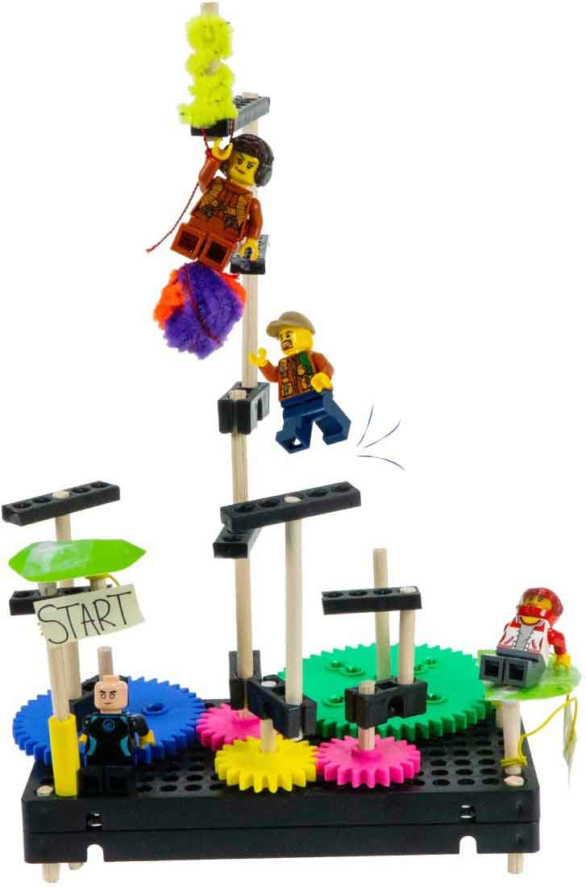

**Name:____________________________ Date:_________________**

**Create a moving, spinning obstacle course for your toys!**

**Criteria**: Get the most points by creating many unique obstacles! Your toys will need to jump, climb, swing, slide, dodge, and balance!

Calculate your points on the back of this page.



The maximum number of parts that can be used on your obstacle course.



[**Classroom Overview**](https://teachergeek.org/gears_overview.docx) and   
additional documents available   
at [**teachergeek.com/gears**](http://teachergeek.com/gears)

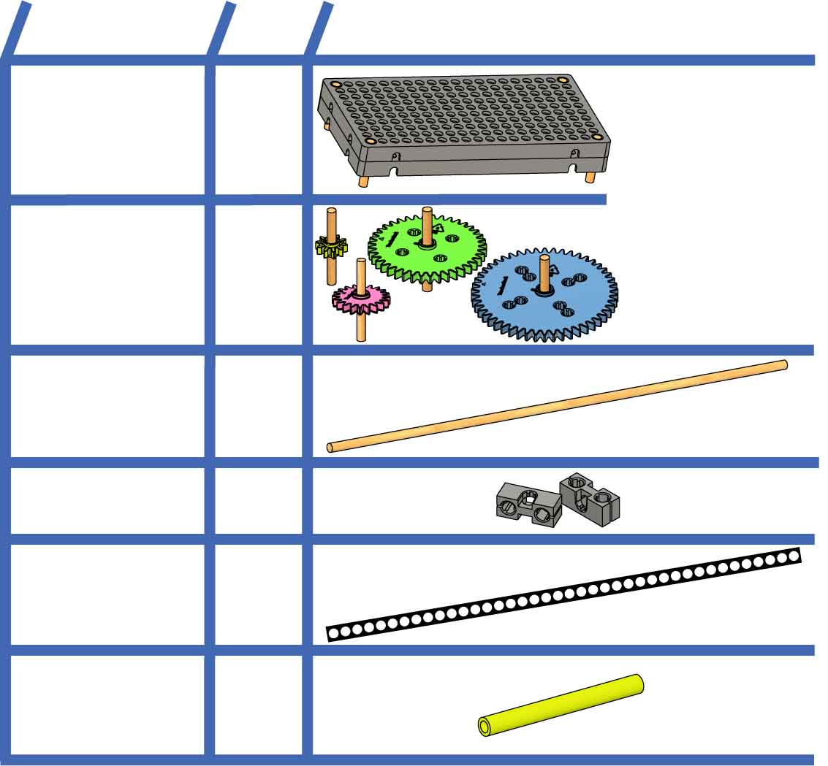

**NAME**

**QTY**

**PICTURE**

**Base**

**2**

**Dowels**30cm(12in.)  
SKU 1821-32

**Strips**30cm(12in.)  
SKU 1821-31

**Slide Stop**8cm(3in.)  
SKU 1821-49

**1**

**10**

**1**

**7**

**Blocks**SKU 1821-34

**Gear Sets with shafts**10, 20, 40,   
50 tooth

**2  
sets**

Build the Base and Gears with Shafts in the [**Set Up Guide**](https://teachergeek.org/gears_set_up_guide.docx).

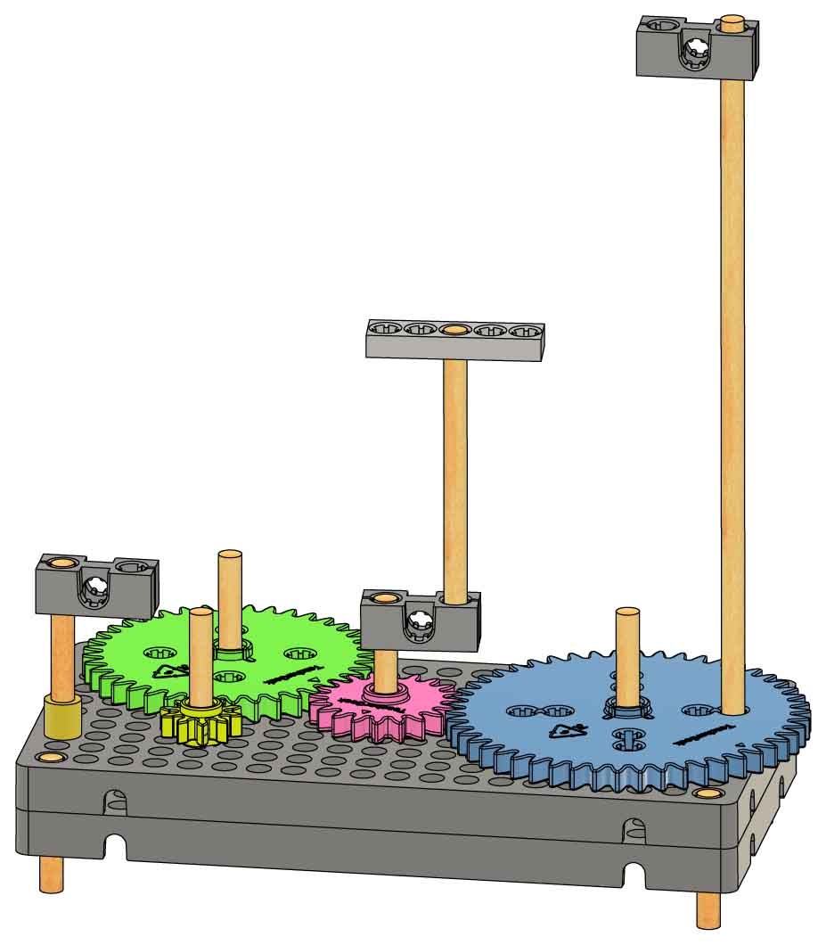

Non-moving platforms are attached with   
**slide** **stop**.

**Strip** (cut)

Moving platforms are attached to **gears**.

**Dowel** (cut)

**Block**



**Recycling Bin Materials** (optional) can be used to make even more obstacles!

**



Make one path, with a start and a finish, to **double   
your points!**

**Start**

**Finish**

**Bonus!**

**Each unique obstacle earns 1 point.**

You need an obstacle in every category before putting 2 obstacles in the same category. You need 2 obstacles in every category before making 3 obstacles in the same category (and so on).





The Design Process never ends! There is no perfect design – keep improving!

**_________ Points**

Add your tallies. Then double if you completed the bonus!

**Total**

**Climbing**



**Jumping**



**Categories:**

**Swinging**

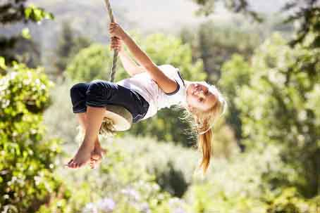

**Point Tally:______**

**Balancing**

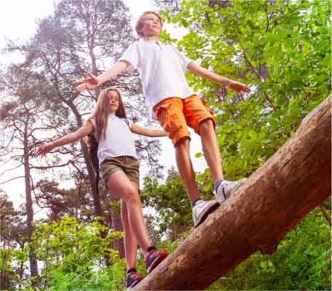

**Point Tally:______**

**Dodging**

**Point Tally:______**

**Sliding**



**Point Tally:______**

**Point Tally:______**

**Point Tally:______**