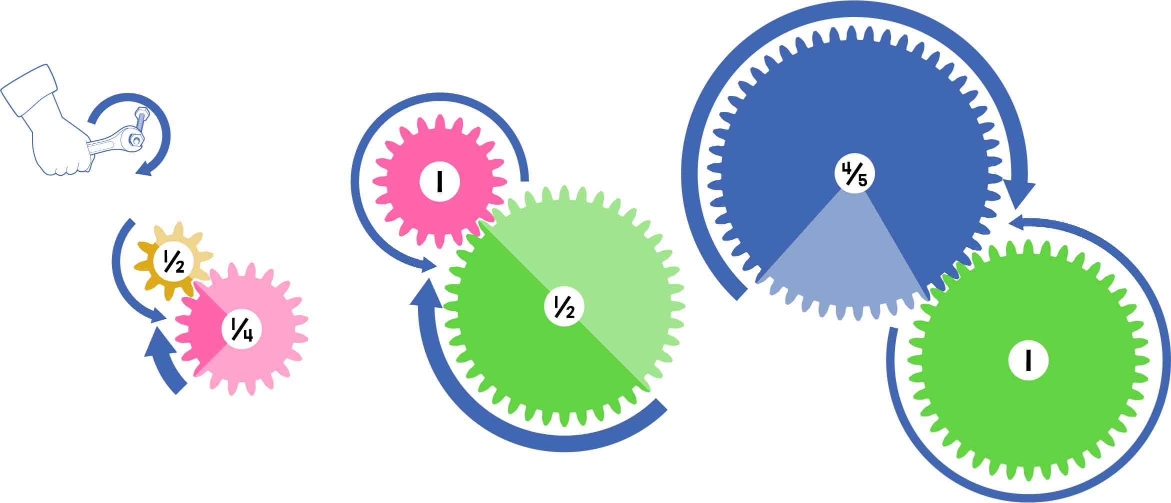

**Mechanical advantage lets you amplify torque or distance, but you have to trade one to get the other!**

Twisting Force

½ distance   
2x TORQUE



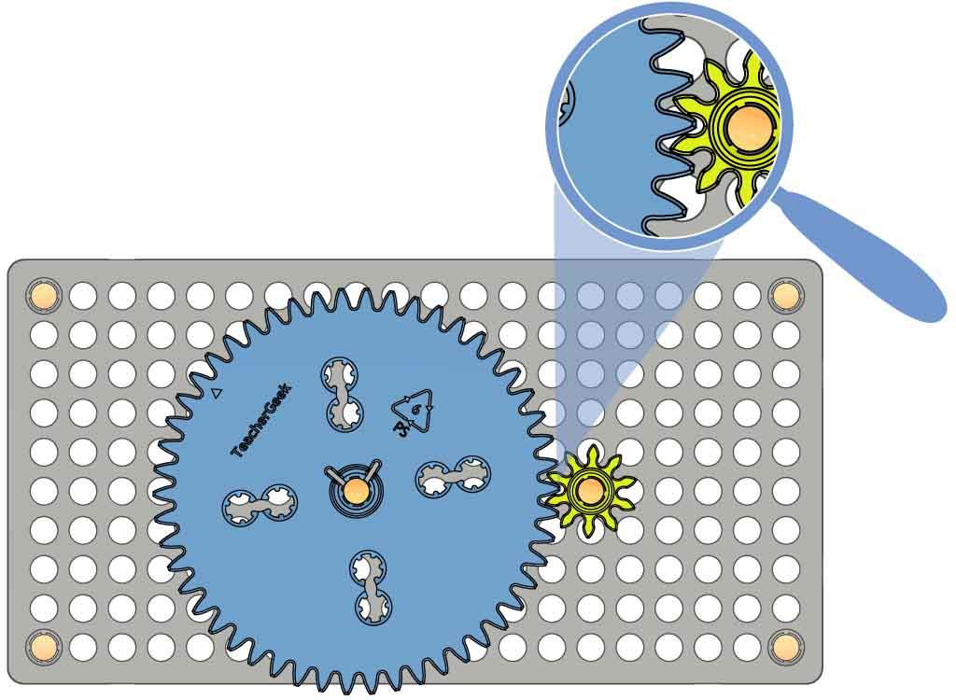

Mesh two different sized gears.

Meshing

Try spinning your gears, switching the input and output gears. Which way amplifies speed?

Input Gear

Output Gears

**OR**

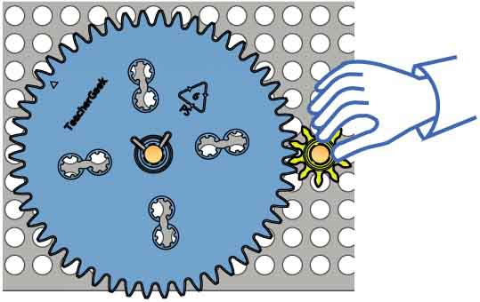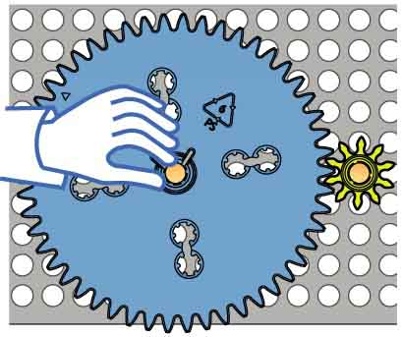

Input Gear

Have a twisting contest with a partner! Which gear amplifies force?

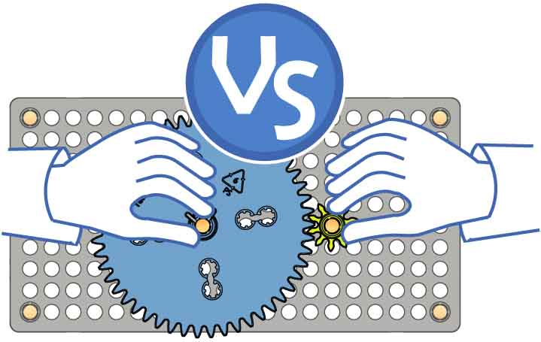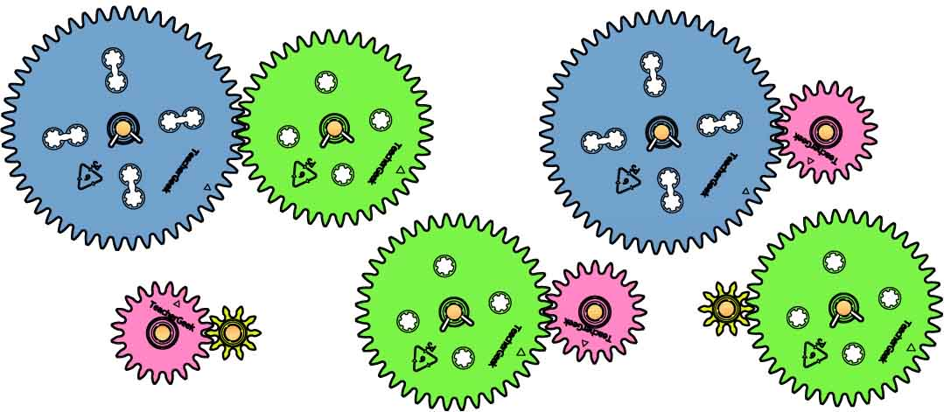

Try different sets of gears!



**Amplifying Speed**

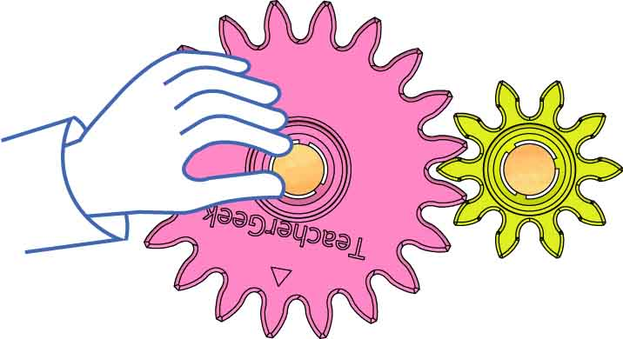

2x DISTANCE  
½ torque

BIG INPUT GEAR  
small output gear

Mechanical Advantage =

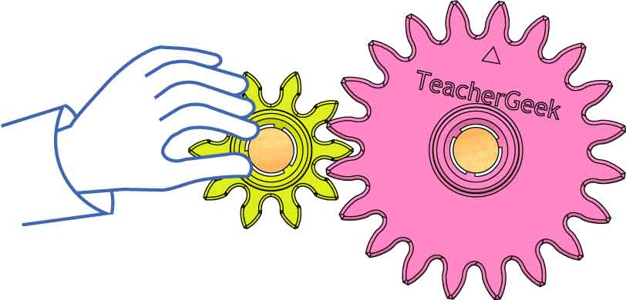

½ distance   
2x TORQUE

**Amplifying Force**

small input gear   
BIG OUTPUT gear

Mechanical Advantage = $2$

OPTIONAL

Make a gear train! Can you get more speed? Force?

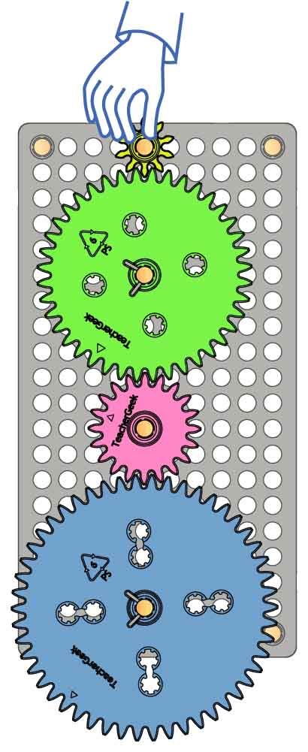

What if you use compound gears in your gear train?

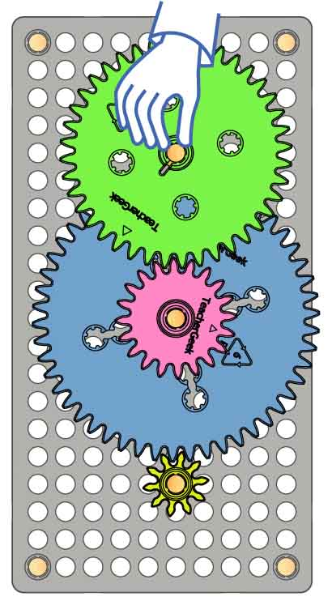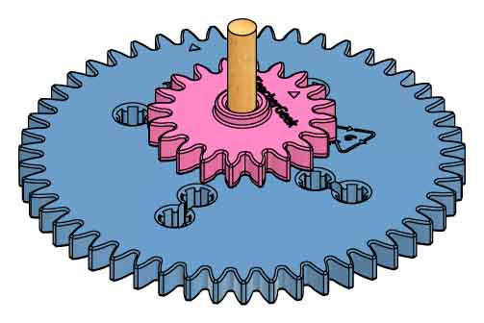

Compound gears are two gears on the same axle.

GEAR TRAINS

When mechanical advantage is less than 1, force goes down (and speed goes up).

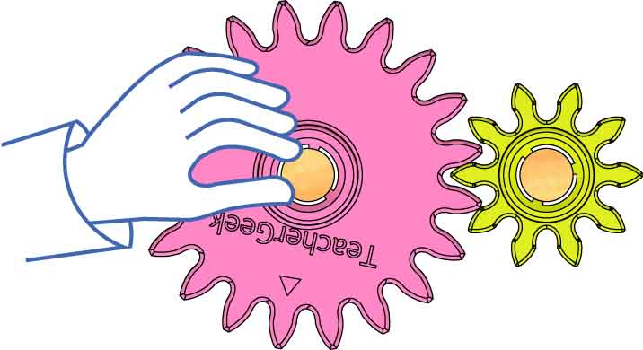

20 Input Teeth

10 Output Teeth

**Mechanical Advantage**

When mechanical advantage is bigger than 1, force goes up (and speed goes down).



$$\frac{20}{10}=\frac{2}{1}=2$$

10 Input Teeth

20 Output Teeth

**Mechanical Advantage**

**Find mechanical advantage using the gears’ teeth.**