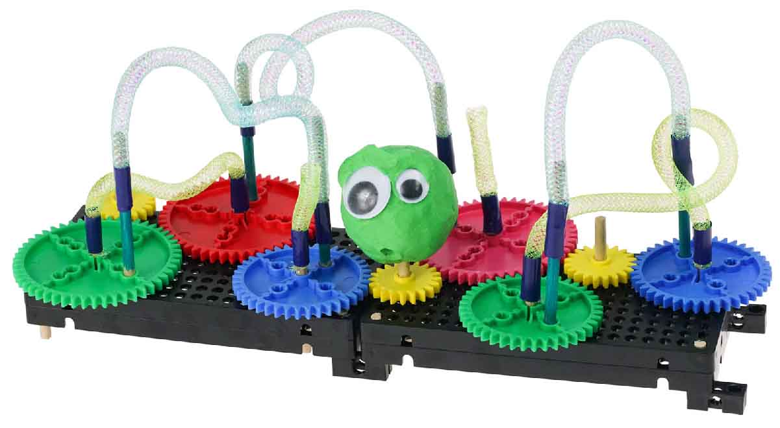

**Design and build a kinetic sculpture  
with your gears and pulleys tinker set!**

**Kinetic Energy** is energy in motion. With your gears, you can harness this energy to power animated sculptures, making art that *moves*.

[**Classroom Overview**](https://teachergeek.org/gears_overview.docx) and additional documents available at [**teachergeek.com/gears**](http://teachergeek.com/gears)



Sculpture Materials:

:

**Clay  
Pipe Cleaners**

**Paper  
Tape  
String  
Recycled Materials**

TeacherGeek Parts:

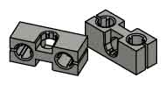

**Blocks (10x)**SKU 1821-34

**“Built” Gears Tinker Set**

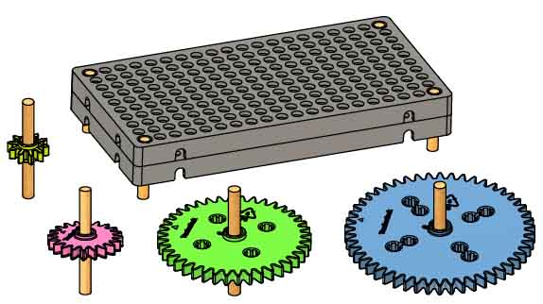

Build your Tinker Set using the [**Set-Up Guide**](https://teachergeek.org/gears_set_up_guide.docx)**.**  Get it at [**teachergeek.com/gears**](https://teachergeek.com/gears)

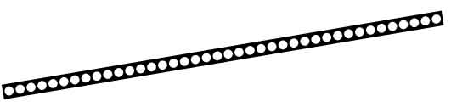

**Strips (2x)**30cm(12in.)  
SKU 1821-31

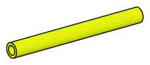

**Slide Stop (1x)**8cm(3in.)  
SKU 1821-49

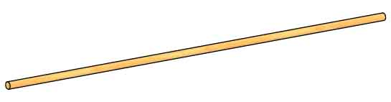

**Dowels (5x)**30cm(12in.)  
SKU 1821-32



**Art looks beautiful or makes you feel emotion. Use gears to make your art interactive!**

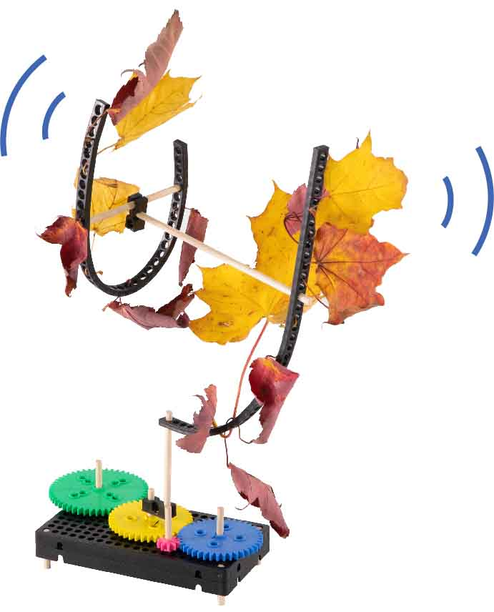

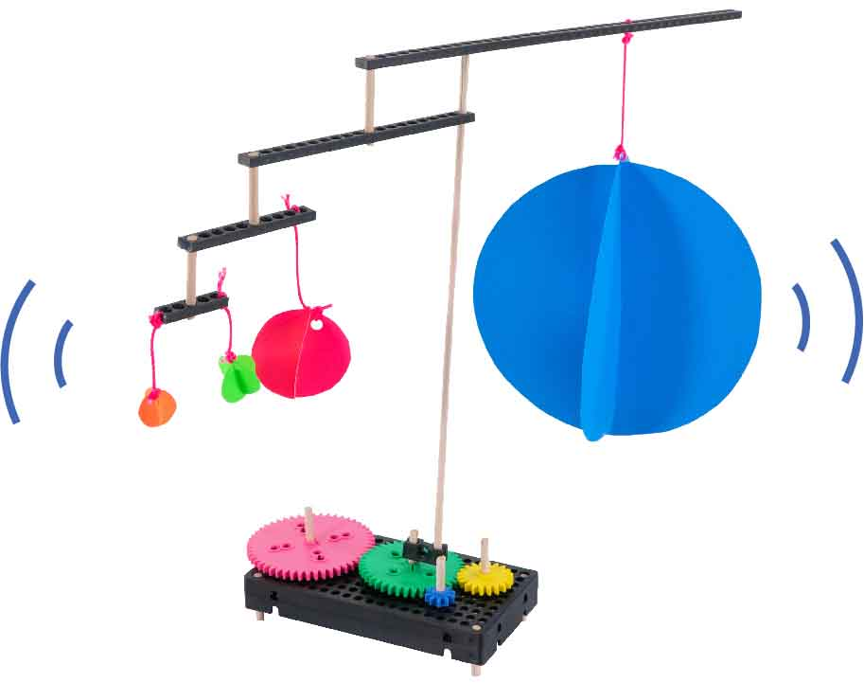

The leaves in this sculpture rustle when the gears are turned – it feels like a relaxing fall day.

The shapes in this sculpture are pleasing to look at and fun! Turn the gears to make them spin and swing.

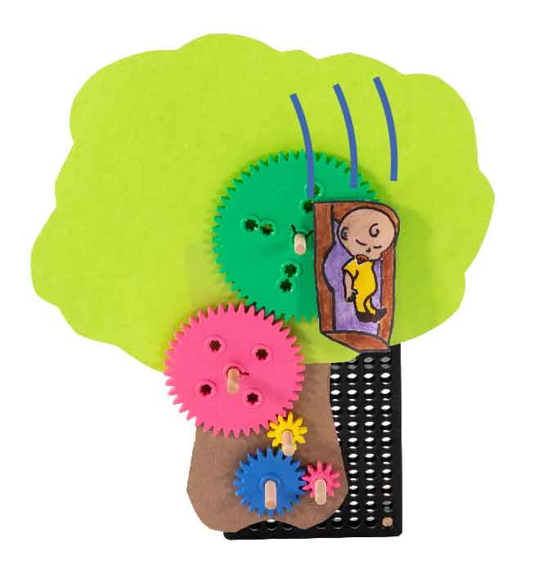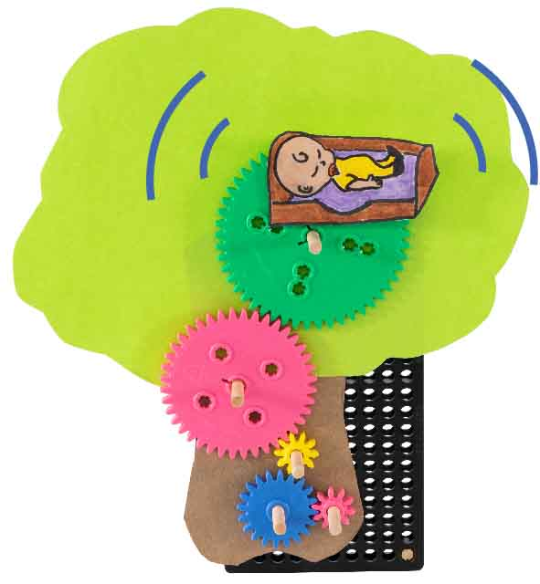

**Recreate a scene from your favorite story or write your own tale!**

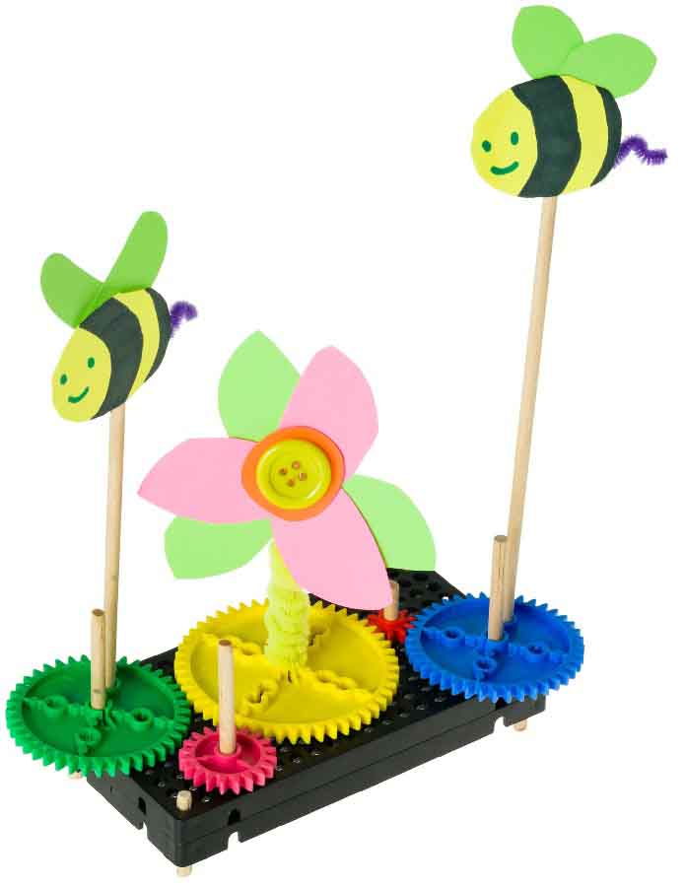

…And down will come Baby,  
cradle and all.

Rock-a-bye Baby  
on the tree top.

“Buzz, buzz,”  
Buzzed the bee.  
Finding flowers;  
Making honey.



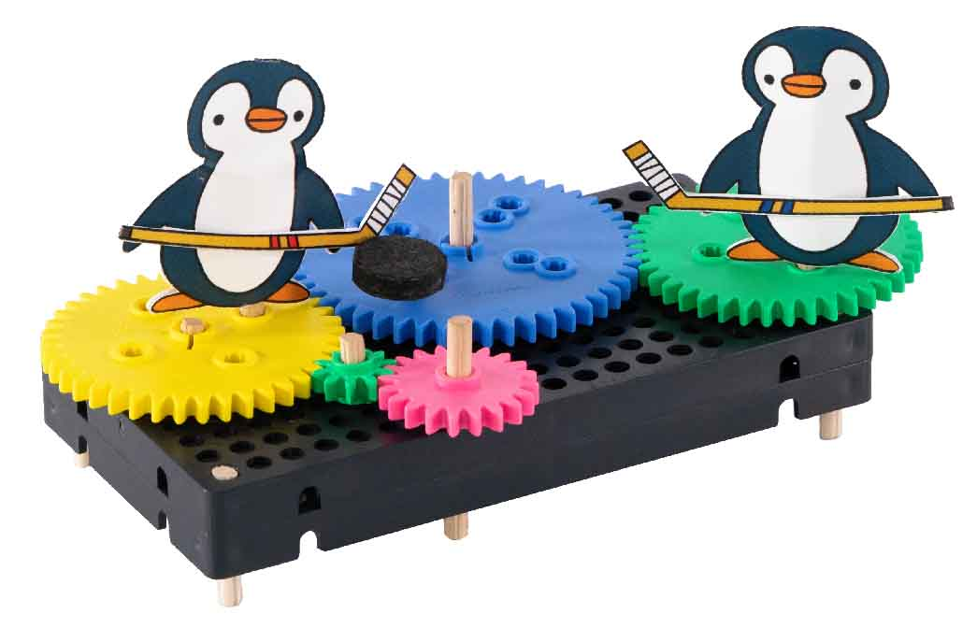

Peter Penguin passes the puck to Pauly. He shoots; he scores!



**It’s all about the motion! Experiment with:**



**Movement**

**Speed**

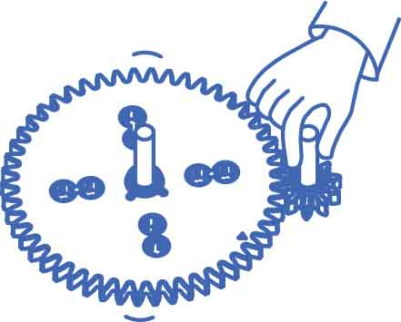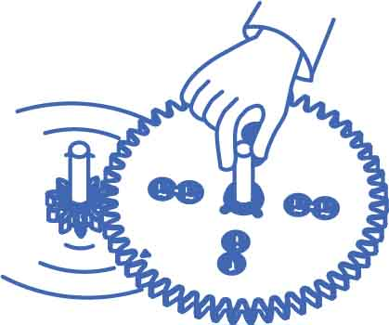

CIRCLING

Penguin on the outside.

SLOW

Small input gear, big output gear.

SPINNING

Penguin in the middle.

JITTERING

Penguin anywhere! Move the gear back and forth.

FAST

Big input gear, small output gear.

