*****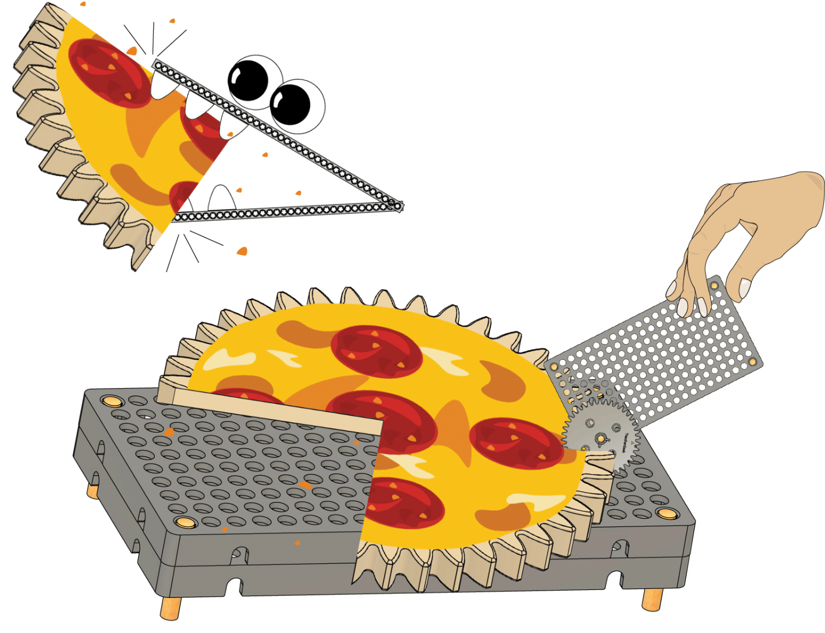­­­­*



**[Classroom Overview](https://teachergeek.org/gears_overview.docx)** and   
 additional documents available   
 at [**teachergeek.com/gears**](http://teachergeek.com/gears)

**Learn about fractions using gears and pizza!**

**Name: _______________________________________ Date: _________________**

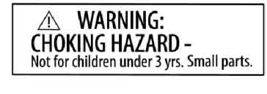

**Adult supervision required. Not a toy.   
Educational product.**

**Warning: To avoid danger of suffocation,   
keep enclosed bags away from babies   
and children. Do not use in cribs, beds,   
carriages, or playpens.**

**It’s imaginary pizza.   
Don’t eat the gears!**

What parts will you need for your lab?



Build the Base and Gears with   
 Shafts in the [**Set-Up Guide**](https://teachergeek.org/gears_set_up_guide.docx)!   
  
 Documents available at   
 [teachergeek.com/gears](https://teachergeek.com/gears)

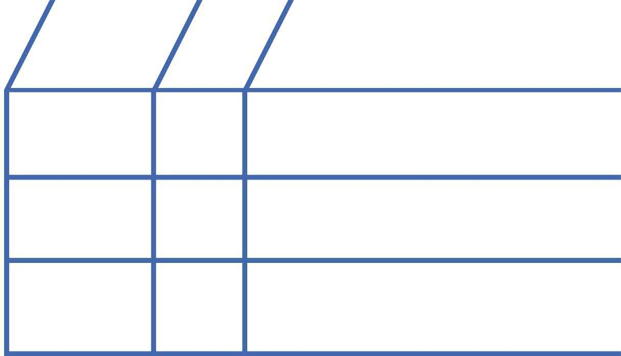

**3**

**1**

**1**

**Dry Erase Marker**

**Base**

**Gears with Shafts**  
(10-, 20-, and 40-tooth)

**NAME**

**QTY**

**PICTURE**

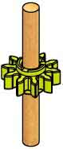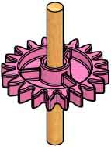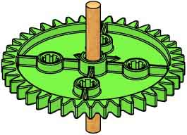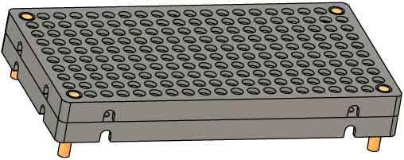

Markers are not included. You must supply one.

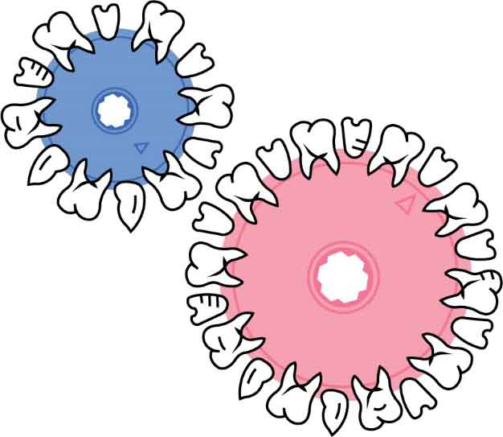

A **gear** is a wheel with **teeth**.   
The teeth **mesh** (connect) with other gears, to make them *turn* together.

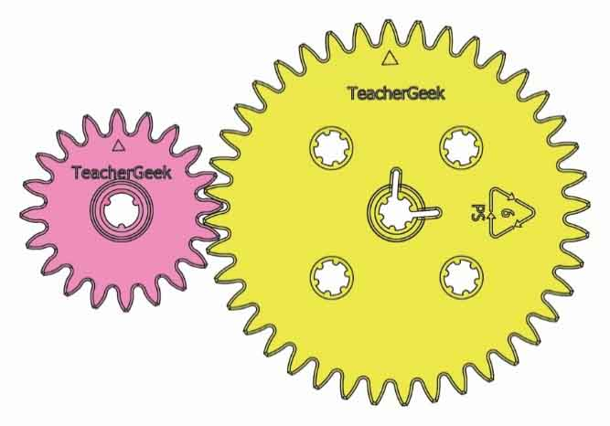

**Input Gear**:   
The gear you turn!

**Output Gear:**   
The gear that   
gets turned!

**Meshed Teeth**



Not real teeth, silly.





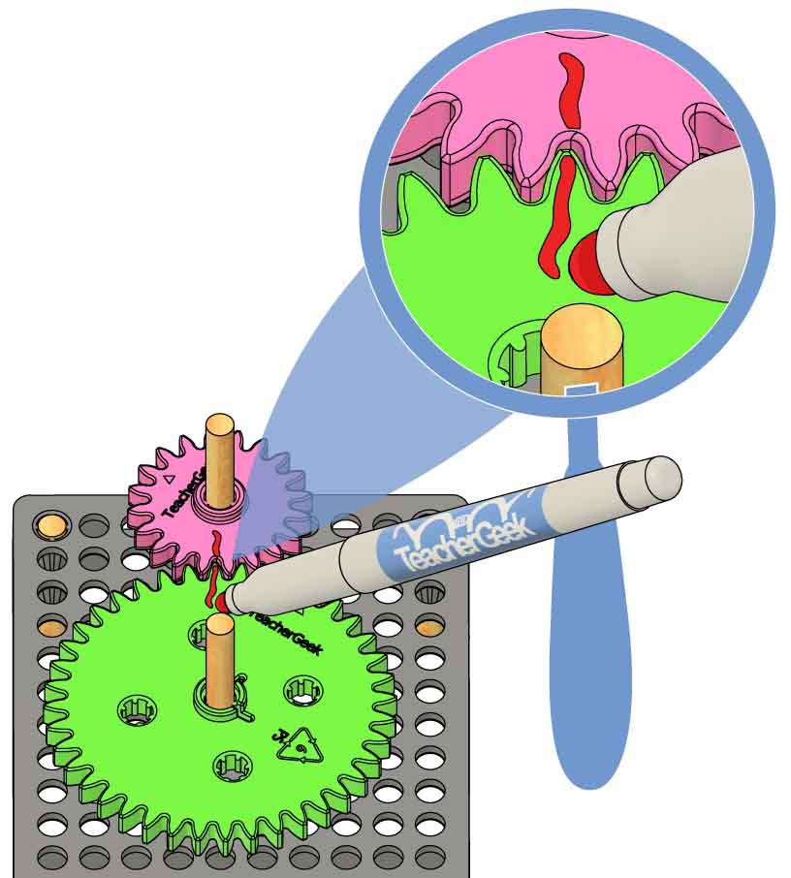

**Mark** **both** **gears** where they mesh.

**Marks**

**Mesh** a **20-tooth gear** and **40-tooth gear** on your **base**.

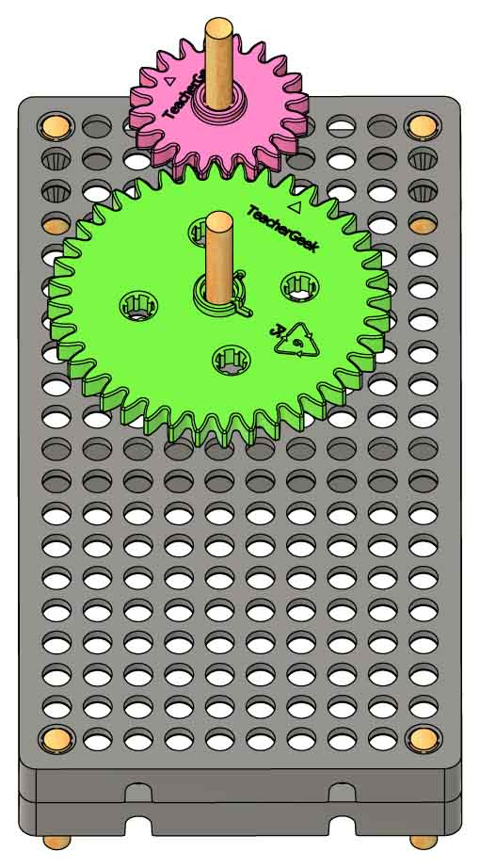

**Base**

**20-Tooth Gear**

**40-Tooth Gear**

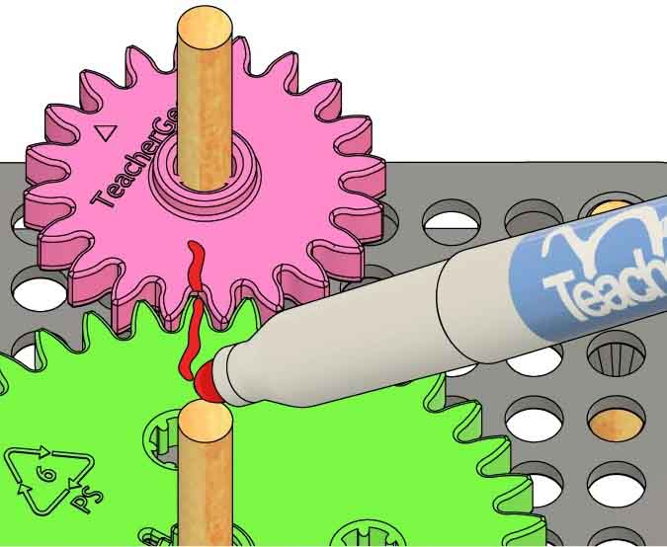

**Repeat** **Steps** **3** **and** **4** until you get back to your first mark.



**Add** **a** **new** **mark** on the **big** **gear** next to the old mark on the little gear.

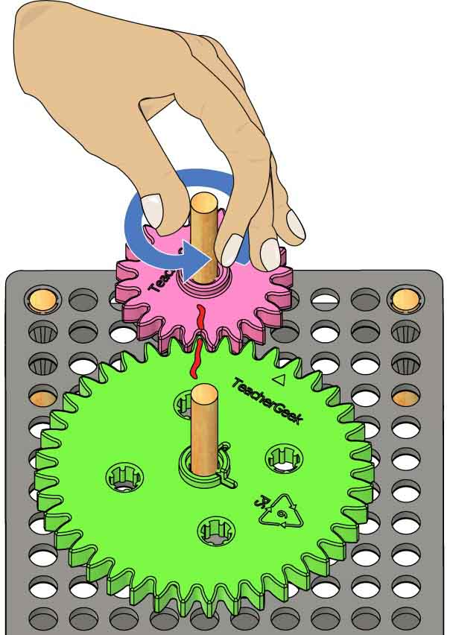

**Turn** the **small** **gear** around **one** **time** (called a **revolution**).



**Your gear is divided! Be careful not to erase the marks – you will keep using them.**

**Old Mark**

**New Mark**



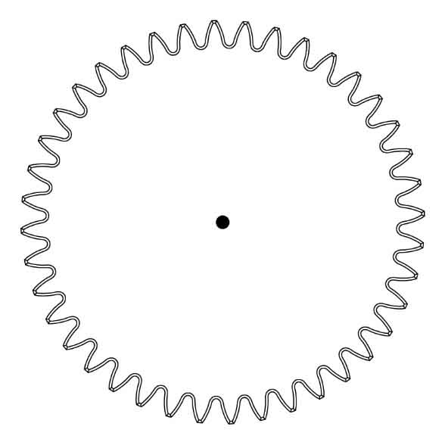

**Center**



Finish your diagram by **drawing** a **line** **to** **connect** the **marks** **to** the **center**.



**Add** the **marks** from your big gear **to** **the** **diagram**.

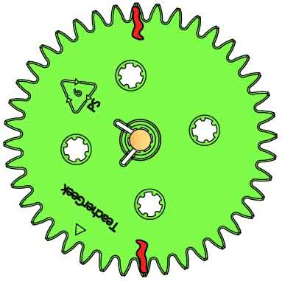

**Marks**

**Diagram**



**Your diagram is done! It should look like the pizzas below.**

**Fill** **in** **the** **fractions** for these pizzas!

You divided your gear into two parts, called **fractions.** The diagram shows the fraction .

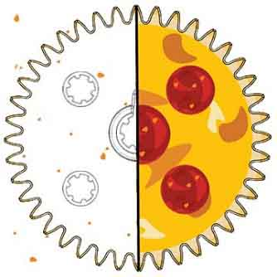

1 piece is **shown**

2 pieces make a **whole** pizza

Fractions follow this pattern:

**# of Pieces You Have**

**# of Pieces to Make a Whole**

**What’s a fraction?**

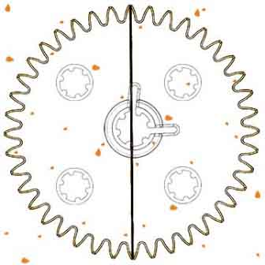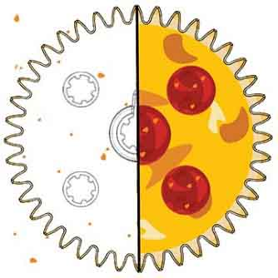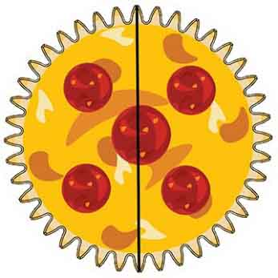



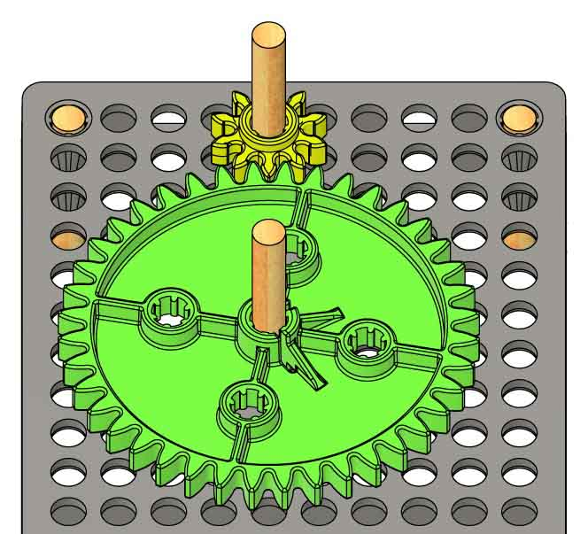

**40-Tooth Gear**(old marks on bottom)

**10-Tooth Gear**

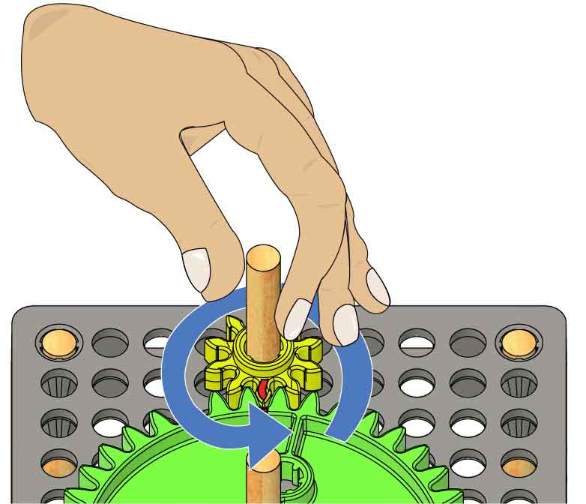

**Repeat** **Steps** **11** **and** **12** until you get back to your first mark.



**Your diagram is done! Time for more pizza!**

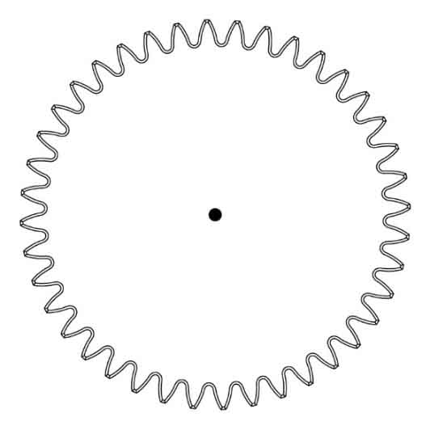

**Make another diagram**, like you did in Steps 6 and 7.

**Turn** the **small** **gear** around **one** **revolution**.

**Add** a **new** **mark** on the **big** gear next to the old mark on the little gear.

**Mark** **both** **gears** where they mesh.

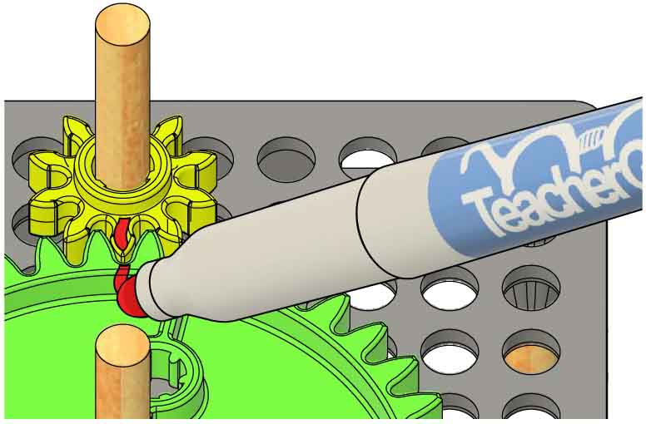

**Mesh** your **40-tooth** **gear** **with** a **10-tooth** **gear** so your **old** **marks** **face** **down**. Do NOT erase your marks.





(with a side of big words)

**Fill** **in** the **numerators** and **denominators** for each fraction diagram.



is the   
**denominator**

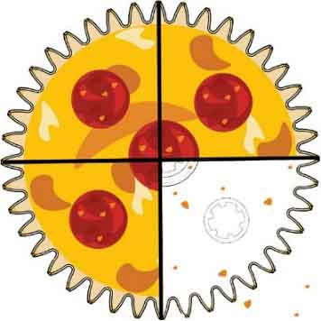

is the   
**denominator**

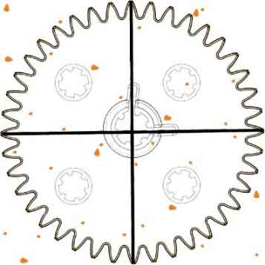

is the   
**numerator**

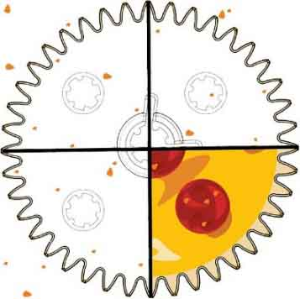

is the   
**numerator**

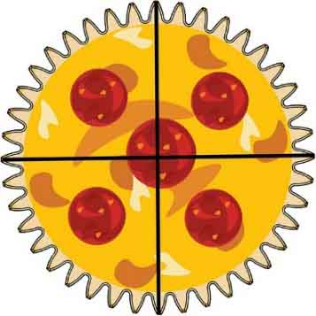

is the   
**denominator**

$$\frac{1}{2}$$

**numerator**: goes **up** – the number of pieces you have

**denominator**: goes **down** – the number of pieces to make a whole

**Numera-WHAT?**

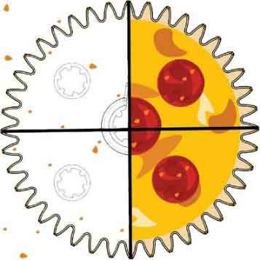

is the   
**numerator**

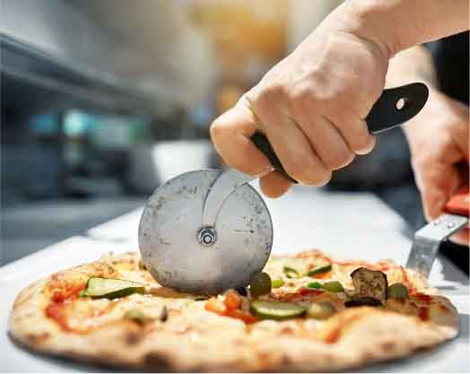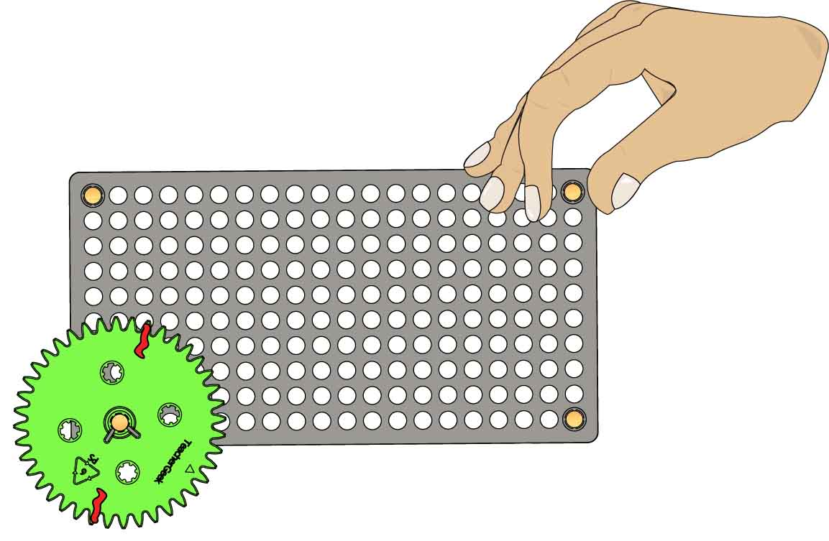

**Practice Pizza**

**Two marks are on top.**

**4-Mark Side**

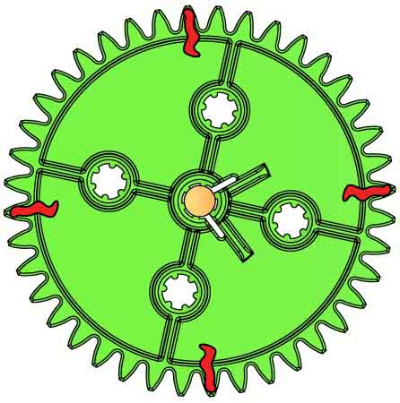

**2-Mark Side**

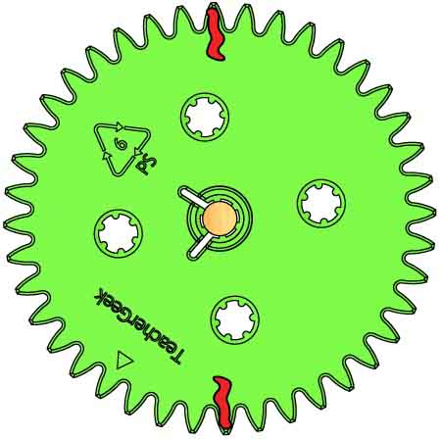

**Practice cutting pizza!**

**Place** your **40-tooth** **gear** **in** the **corner** **of** the **base** so two   
marks are on   
top.



**Your pizza cutter is done! Now it’s time to cut number lines with it.**

**Make** **sure** your 40-tooth **gear** **still** **has** two **marks** on one side and four on the other. Remake the marks if they aren’t there.

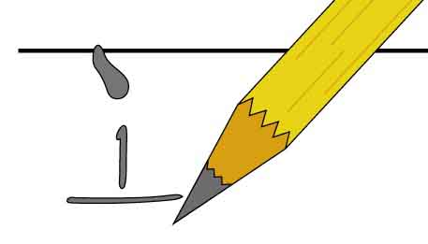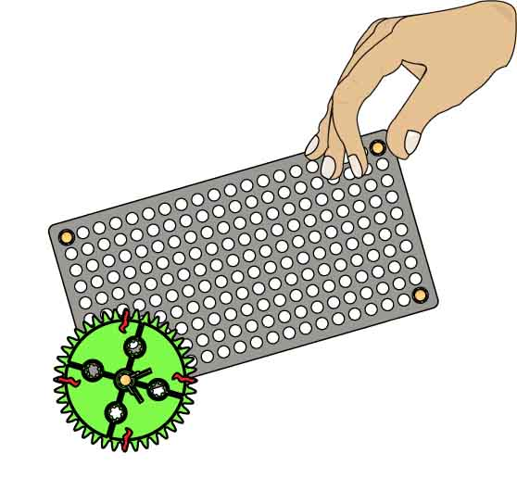

**Roll** the **gear** and **mark the number line**,asyou did before.



**Under each** pencil **mark,** writea **new fraction.**



**Flip** your **gear** sothe **4 marks** are **on top.**

**Divide** the **number line   
again with** the **other side**ofthegear**.**

**Pencil Mark**

**Number Line**



$1$ whole

$$0$$

$$1$$

$$0$$

**Number Line**

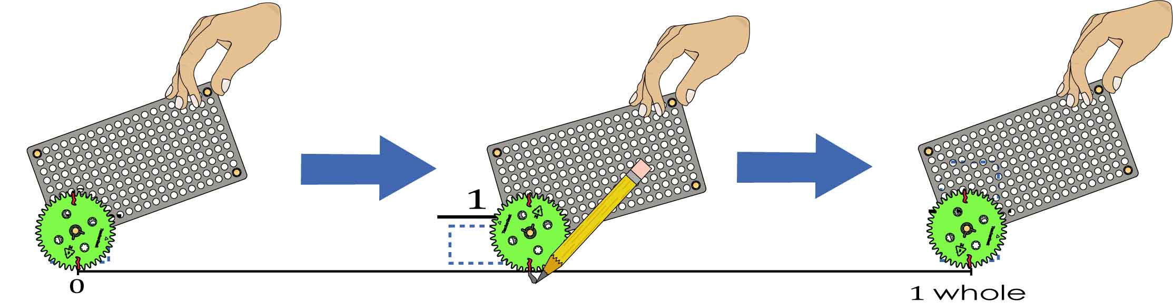

**Fill in** the **fractions**.

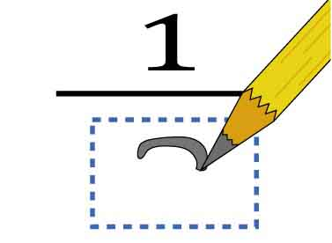

When you get to the end, your gear should be **back** **to** **the** **first** **mark**.

**Roll** the **gear**. **Mark** your **number** **line** whenever a mark touches it.



**Line** **up** a gear **mark** with **zero**.



**Use** your **pizza cutter to divide** the **number line!**





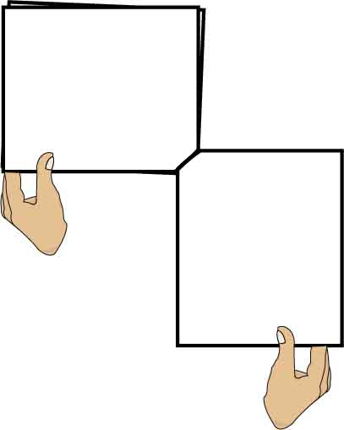

**Page 7**

**This Page**



**Use your number line**, from page 7, to answer the questions below.

Write down one pair of equal fractions.

$$=$$



How do you know those fractions are equal?

______________________________________________________________________________________________________________________________________



Find two more pairs of equal fractions and write them below.



$$=$$

$$=$$

There is a pattern for equal fractions. What is the pattern?

______________________________________________________________________________________________________________________________________________________________________________________________________



Make up some equivalent fractions and write them below. You do not need to use your number line for this question.

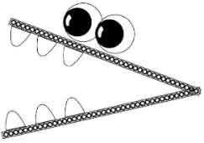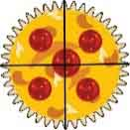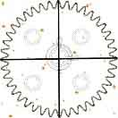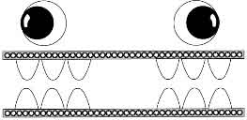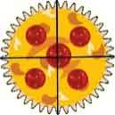





Fill in the blank fractions below. Then show which is greater by writing >, <, or = in the middle blank.

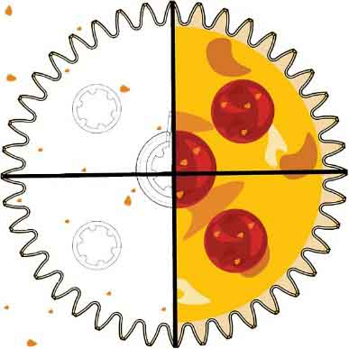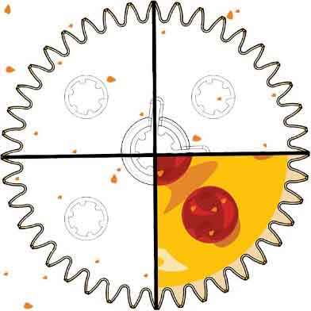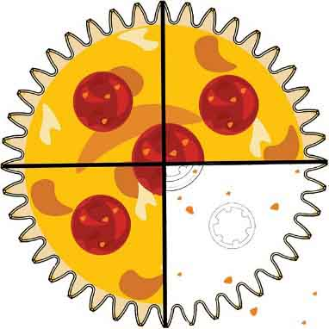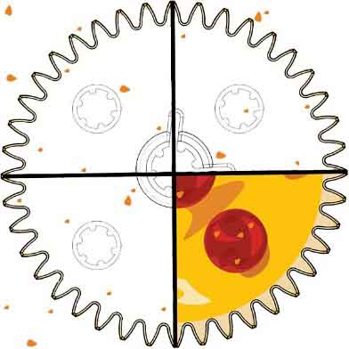

______________________________________________________________________________________________________________________________________________________________________________________________________



The fractions above have the same denominator. How can you use the numerators to find out which fraction is greater?





**I don’t follow the rules!**



Fill in the blank fractions below. Then show which is greater by writing >, <, or = in the middle blank.

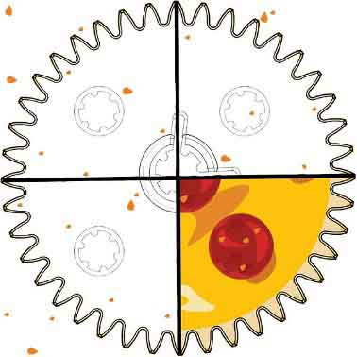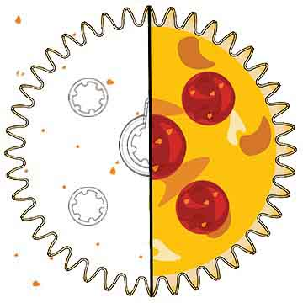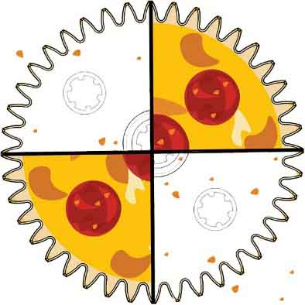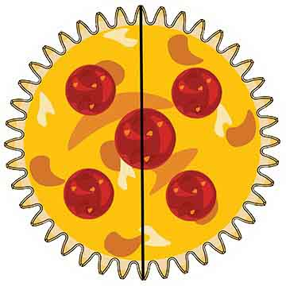

The fractions above have the same numerator. How can you use the denominators to find out which fraction is greater?



______________________________________________________________________________________________________________________________________________________________________________________________________

Use the rules to fill in the blanks with > < =.





**50 Tooth Gear**

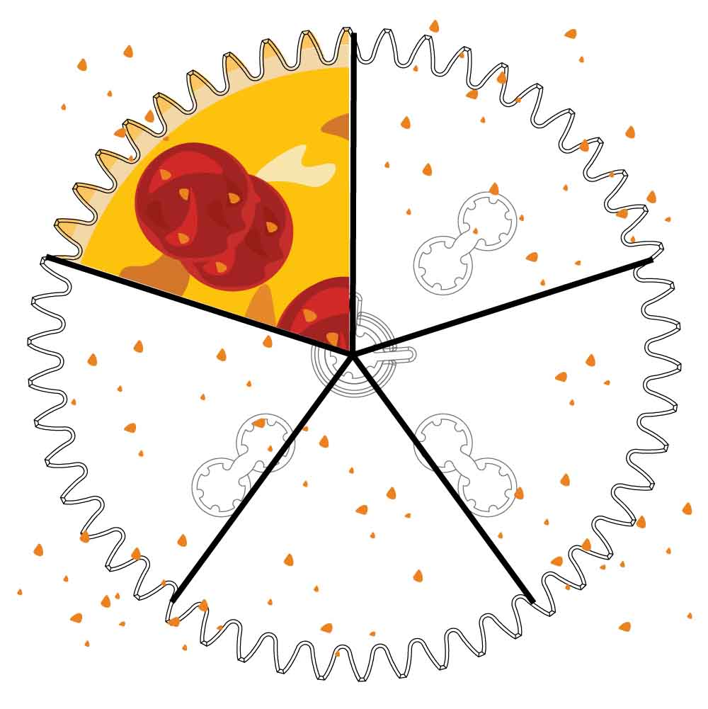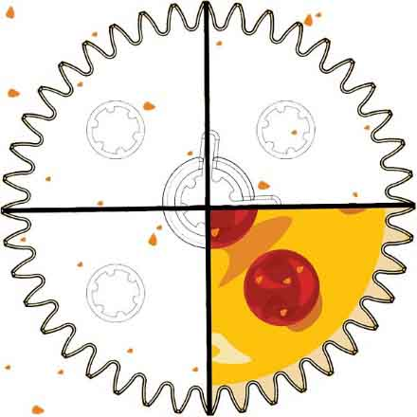

**40 Tooth Gear**

Use the fraction diagrams to answer the questions below. The diagrams are actual size.

________________________________________________________________________________________________________________________________________________________________________________________________________________________

Joey believes that the fraction on the left is greater than the fraction on the right. Why might Joey think this?



Why don’t the rules apply to these gears? Explain.

________________________________________________________________________________________________________________________________________________________________________________________________________________________________________________________________________________________________

