

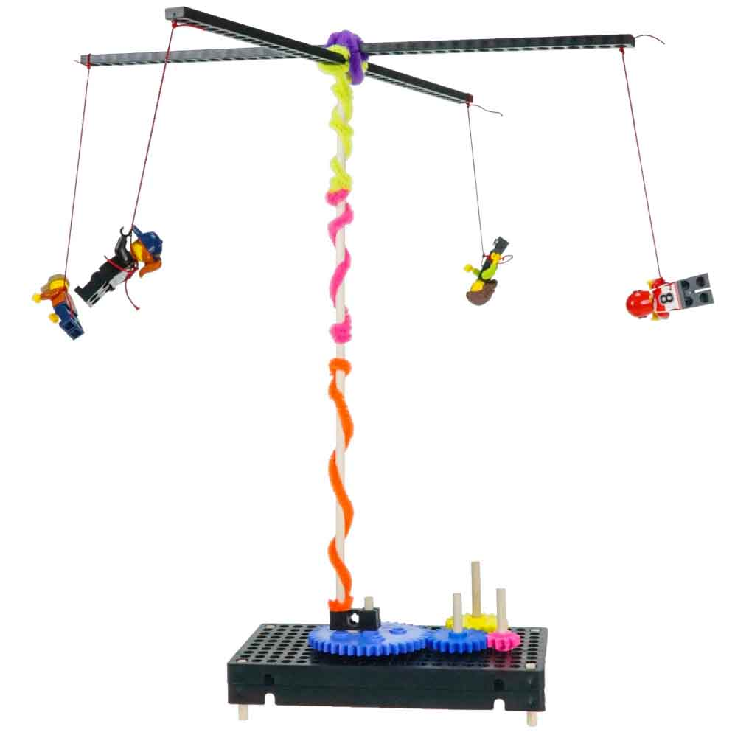

**Make as many unique rides as possible!**

Get **one point for each unique combination** of ride type and energy source (see page 2).

Make a ride, get a point, then transform it into a new one.   
**Get the most points to win.**



**Materials You Supply:**

**TeacherGeek Parts:**

The maximum number of parts that can be used on any single design.

* **Rubber Bands**
* **Recycled Materials**(optional)

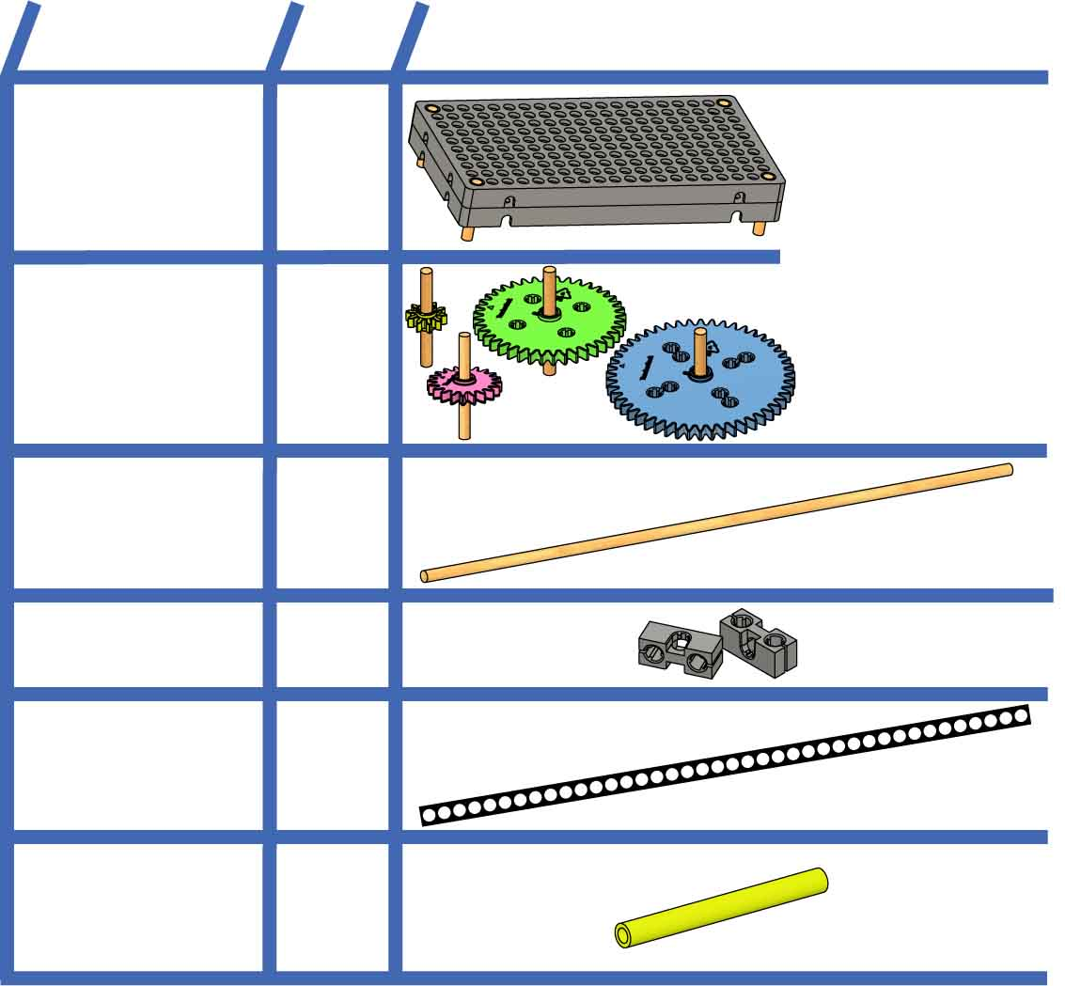

**NAME**

**QTY**

**PICTURE**

**Base**

**2**

**Dowels**30cm(12in.)  
SKU 1821-32

**Strips**30cm(12in.)  
SKU 1821-31

**Slide Stop**8cm(3in.)  
SKU 1821-49

**1**

**10**

**1**

**7**

**Blocks**SKU 1821-34

**Gear Sets with shafts**10, 20, 40,   
50 tooth

**2  
sets**

Build the Base and Gears with Shafts in   
the [**Set-Up Guide**](https://teachergeek.org/gears_set_up_guide.docx)!   
  
Documents available at [teachergeek.com/gears](https://teachergeek.com/gears)

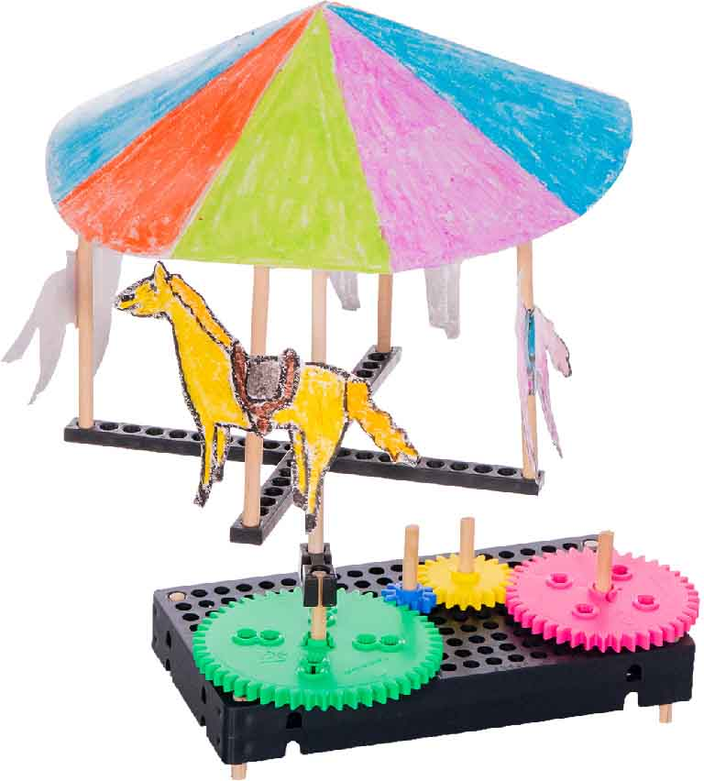



[**Classroom Overview**](https://teachergeek.org/gears_overview.docx) and   
additional documents available   
at [**teachergeek.com/gears**](http://teachergeek.com/gears)

**Page 1**





**Bouncing**

Riders move up and down.

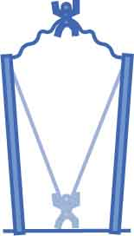

**Page 2**

Human Energy   
**does not include** energy transferred to **Potential Energy**.

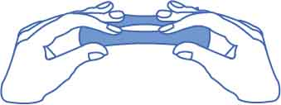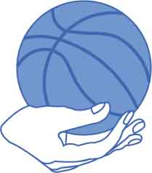

It spins. It’s tall. But **you can only choose one ride type per design.**

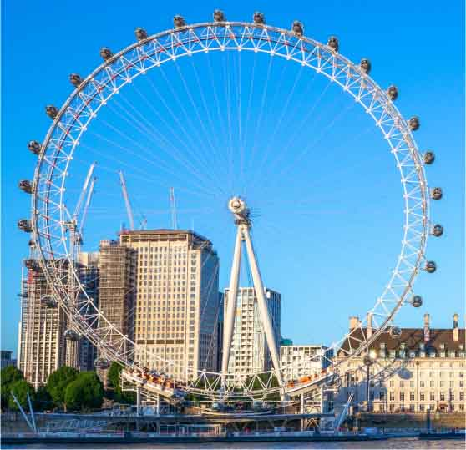

**Isn’t it 2 types?**

**Can you make them all?**

**Linear Motion**

Riders move in a straight line.

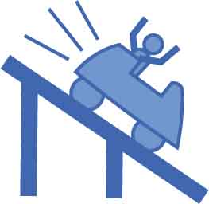

**Launching**

Riders are thrown through the air!

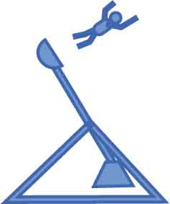

**Swinging**

Riders sway back and forth.

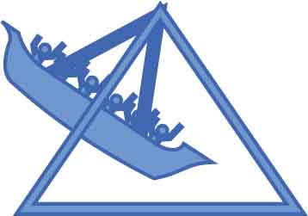

**Heights**

Riders move from ground-level to a higher elevation.

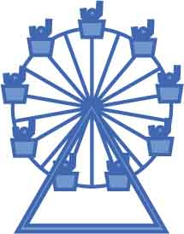

**Spinning**

Riders move in a circular motion.

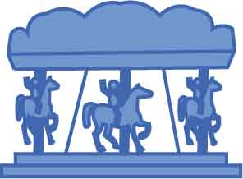

You can only use **Human Energy** to **turn** **an** **input** **gear**. You can’t use human energy in any other way.

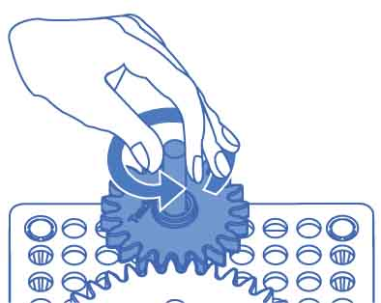

Gravitational

Lifting objects so they can fall, slide, or roll stores energy as **Gravitational Potential Energy**.

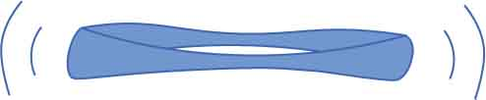

Elastic

Stretching rubber bands stores energy as **Elastic Potential Energy**.

**Human Energy:** Human Energy is energy that *you* are adding to your contraption.

**Potential Energy:** Potential Energy is stored energy that can make objects move. You can use two types:

**How can you make your ride move?**



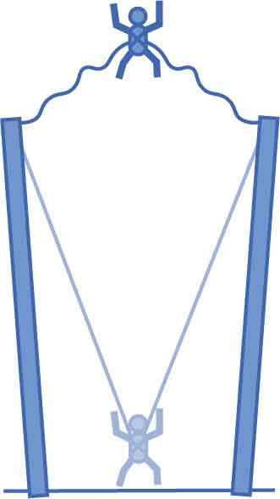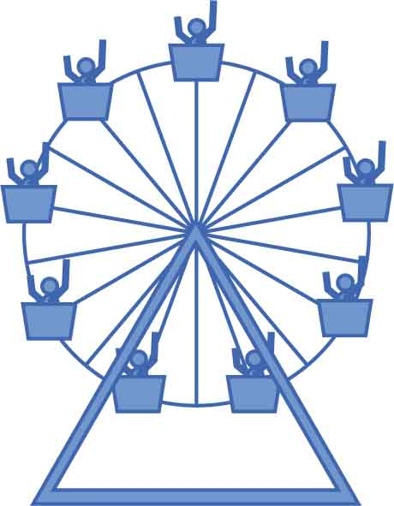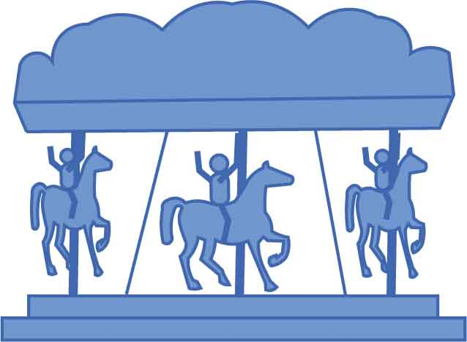

**Gravity**

**Human**

**Elastic**

Adult Approval

Adult Approval

Adult Approval

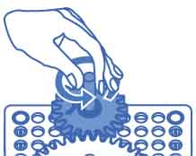

**Get your ride approved to get a point, then transform it into a new ride!**

SCORE

**Name: ________________________ Date: _____________**

**Gravity**

**Human**

**Elastic**

Adult Approval

Adult Approval

Adult Approval

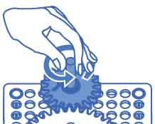

**Gravity**

**Human**

**Elastic**

Adult Approval

Adult Approval

Adult Approval



**Bouncing**

**Heights**

**Spinning**

**Gravity**

**Human**

**Elastic**

Adult Approval

Adult Approval

Adult Approval



**Swinging**

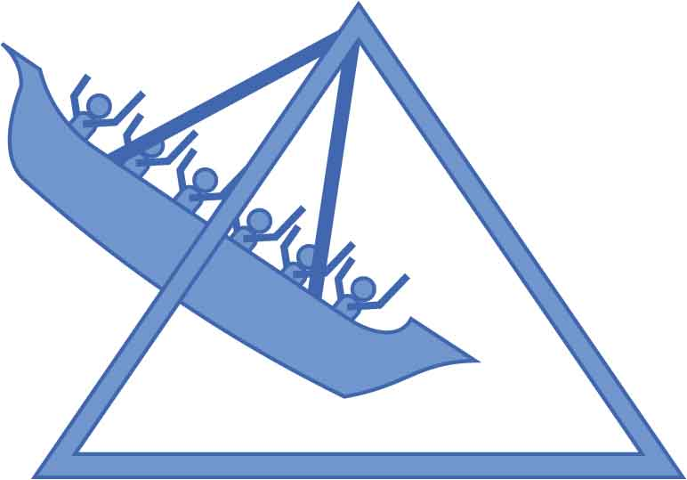

**Launching**

**Gravity**

**Human**

**Elastic**

Adult Approval

Adult Approval

Adult Approval



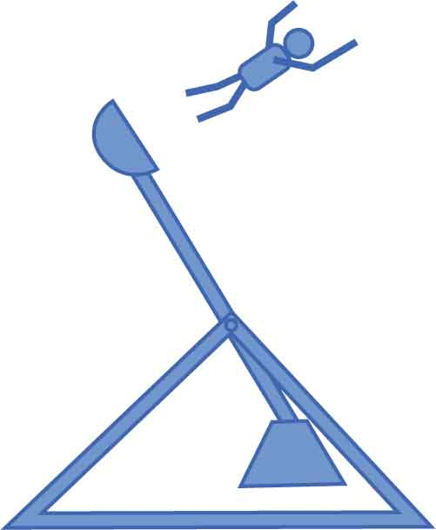

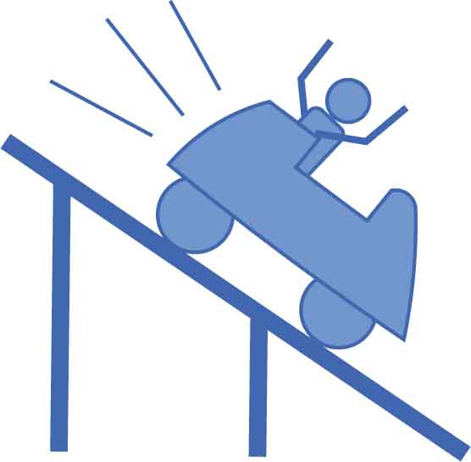

**Linear Motion** (straight line)

**Gravity**

**Human**

**Elastic**

Adult Approval

Adult Approval

Adult Approval

