Name:__________________________________ Date:__________________
Lab Supplies
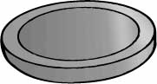
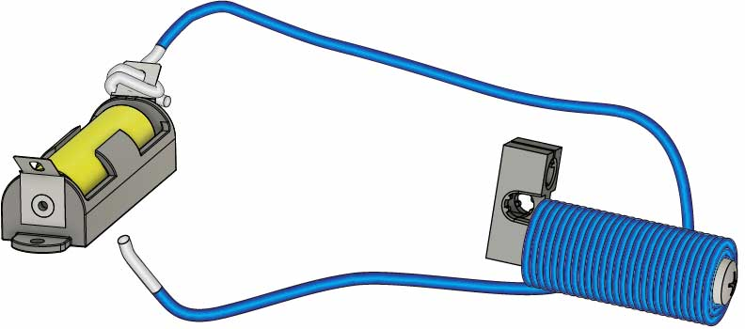
Ideas: (what else can you test?)
- Staple
- Chair Leg
- Quarter

Objects To Test
Built Electromagnet
- Electromagnet Wire
- Doorknob
- Paper Clip

Build your electromagnet using the Go Guide, available at teachergeek.com/electromagnet
Test Stuff!
Magnetic objects will attract or stick to your electromagnet. Pick some objects from the list above or find your own. Then test them to see if they’re magnetic.
Record the results below.

Object | Predict: Will it  be magnetic? | Test: Is it magnetic? | Material: What’s it made of?

Conclusion

What was similar about the materials that were magnetic?

1
__________________________________________________________________________
__________________________________________________________________________
__________________________________________________________________________
__________________________________________________________________________

2
What was similar about the materials that weren’t magnetic?
__________________________________________________________________________
__________________________________________________________________________
__________________________________________________________________________
__________________________________________________________________________

3
How can you predict if an object will be magnetic?
__________________________________________________________________________
_________________________________________________________________________
__________________________________________________________________________
__________________________________________________________________________

