**Optional** -   
recommended for Clip Hanger Challenge on Page 5

* **AA Battery**
* **Paperclips**
* **Tape**
* **Cup**

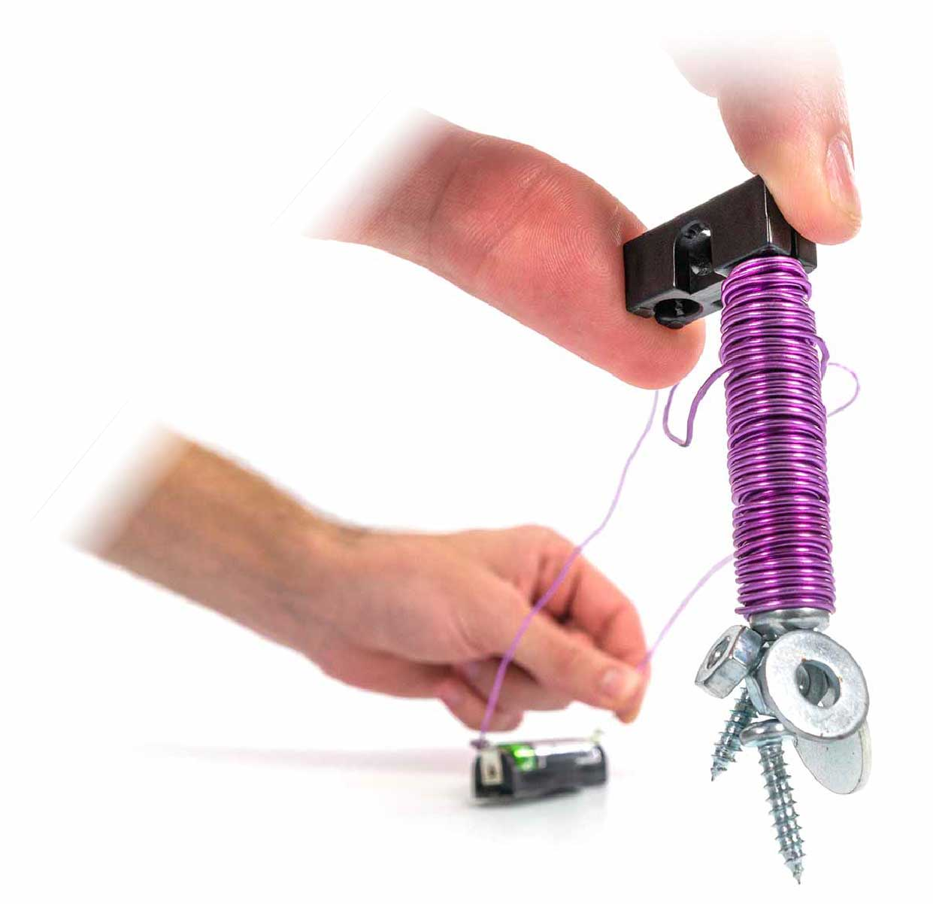

**Learn about electricity and magnetism by designing   
and building your very own Electromagnet!**

You Are Here

Start here! Build your Crane,   
evolve your design, and begin   
the In-The-Bucket Challenge!

Optional Challenges

-Clip-Hanger Challenge*  
-Stack-It Challenge*  
-Washer-Hanger Challenge*

Go Guide

*See Page 5

Optional Lab

-[Magnetic Materials Lab  
 (Ages 8+)](https://teachergeek.org/electromagnet_lab_magnetic_materials.docx)

**Choose how you would like to complete this activity.   
Download documents & videos at** [**teachergeek.com/electromagnet**](https://teachergeek.com/electromagnet)

Maker Cart Users: We recommend using Aluminum Wire for this activity (not included with Maker Carts until summer 2021).

**Picture**

**Name**

**Qty**

**1**

**1**

**1**

**Block**SKU 1821-34

**Wire Roll**5 m (16.4 ft)  
SKU 1823-47

**Screw**50 mm (2 in)  
SKU 1821-27

**Battery Holder**Single AA  
SKU 1821-62

**1**

**Washers**#10  
SKU 1821-24

**10**

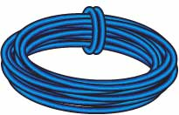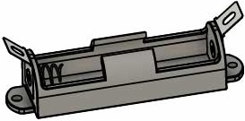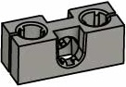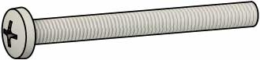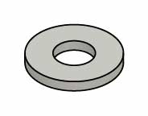

Magnet Parts

# Supplies

Materials You Supply

TRUE

STEM

STEAM

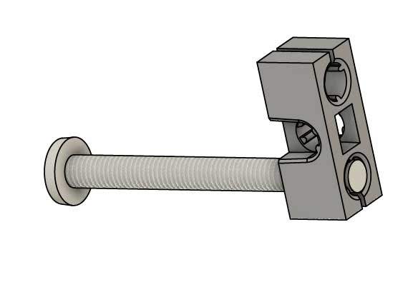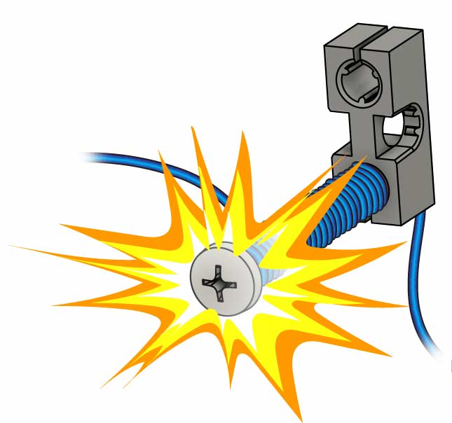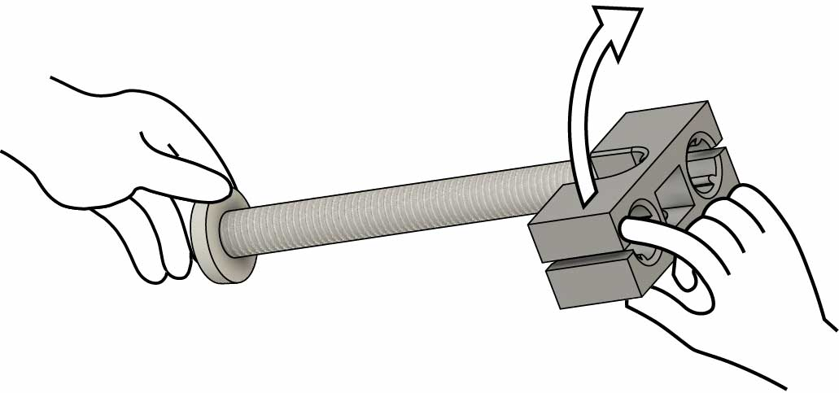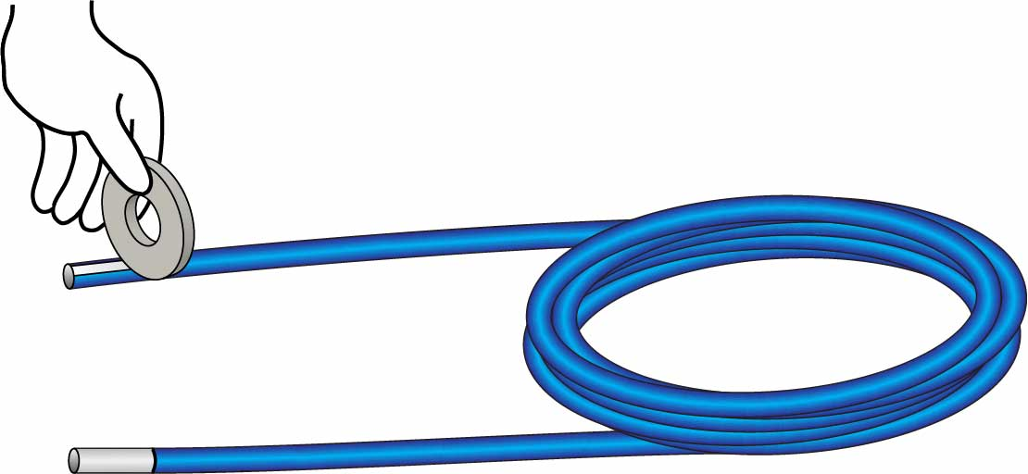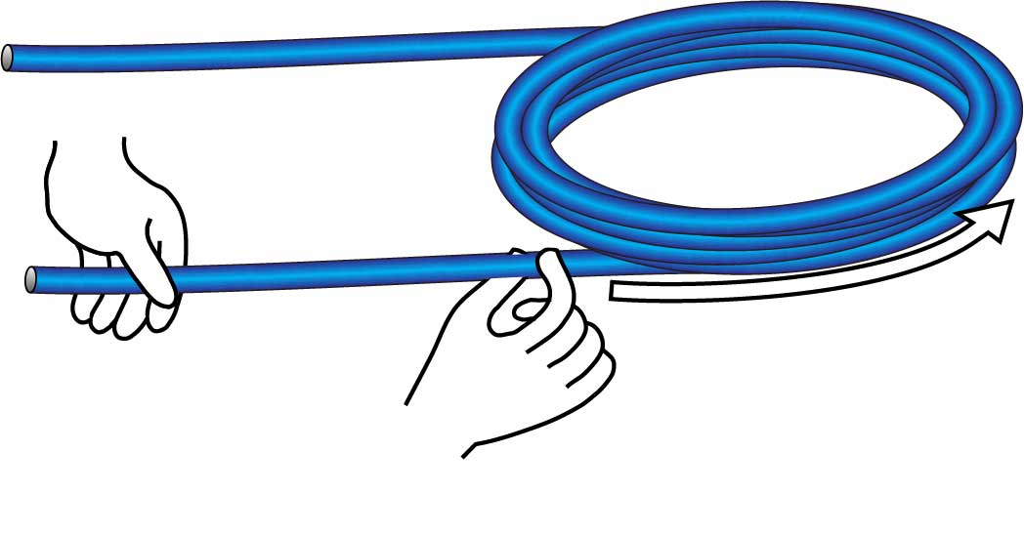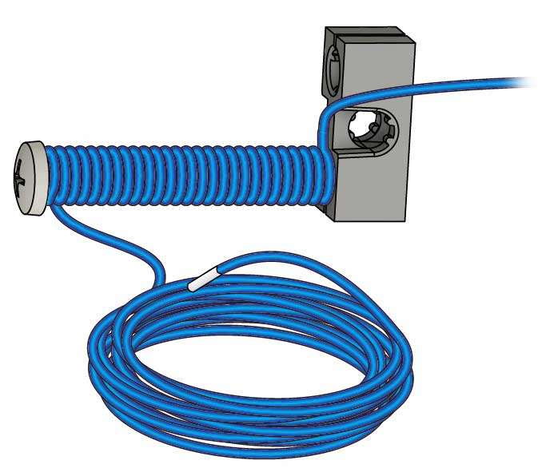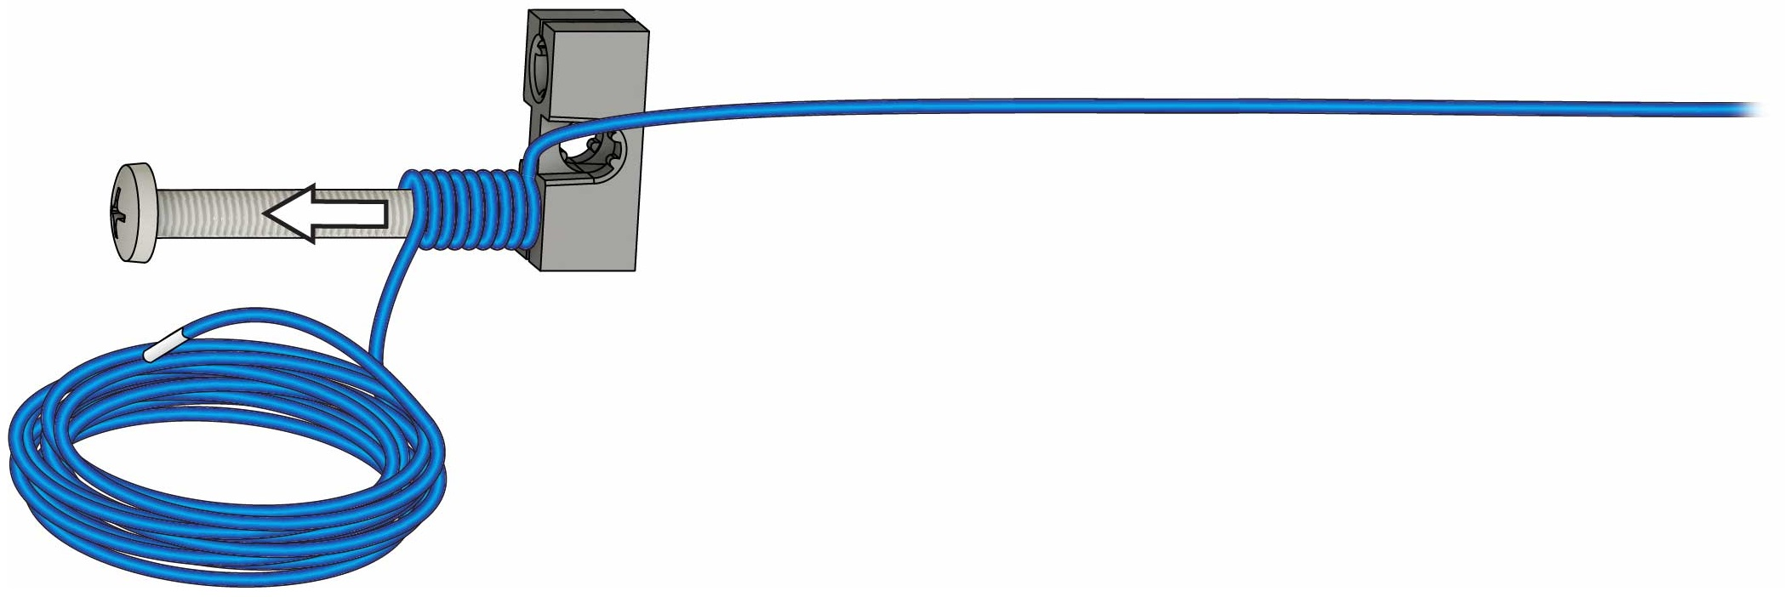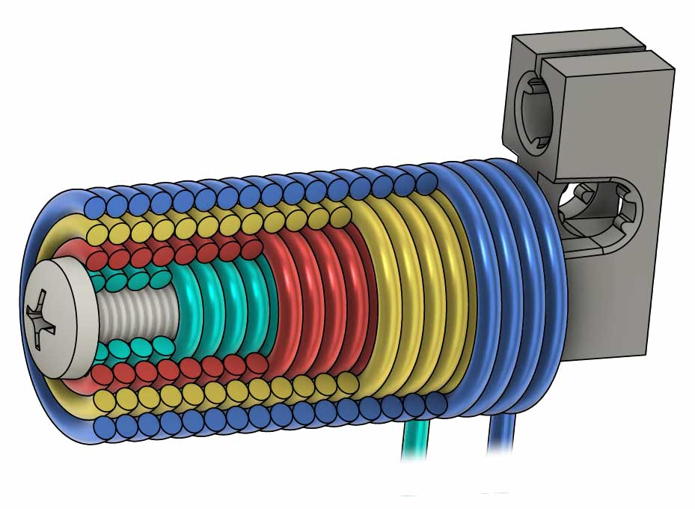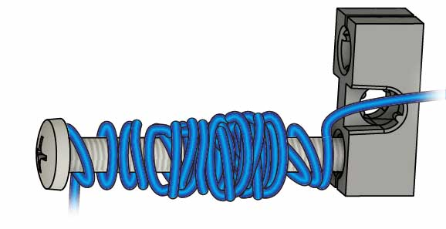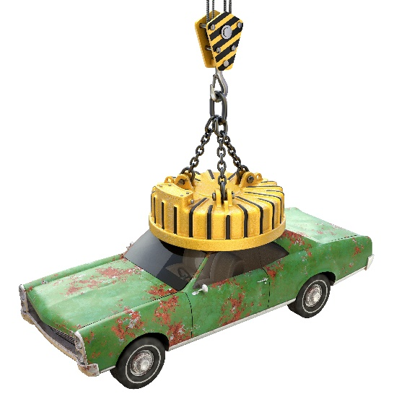

**Scrape** **2 cm** (1 in) of **enamel** off **both** **ends** of the wire.

# 2

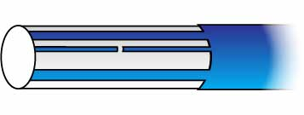

Missed Enamel

**Not Scraped**

**Scraped**

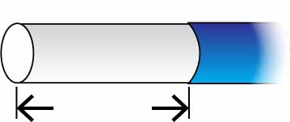

**2 cm**  
(1 in)

# 1

**Carefully** **uncoil** **both** **ends** of the wire. Don’t tangle it!

**Screw**

**Block**

**Finished**

**Your wire and core are ready!** Next, you’ll make them into   
an electromagnet!

# 3

**Turn** the **block** onto the **screw**.

Make the Core

Uncoil

Get your wire and core ready – they’ll become your magnet.

# Prepare the Parts

Prepare Your Wire

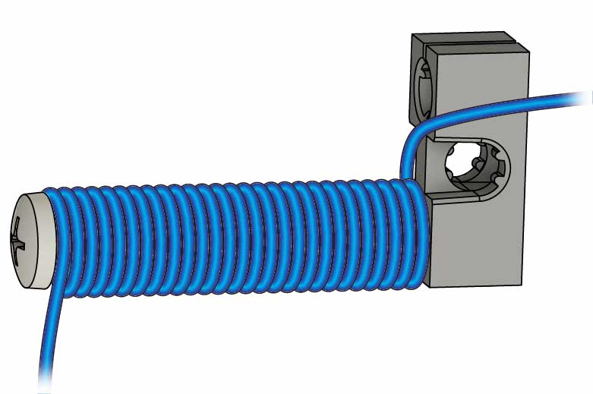

Electromagnets are made by wrapping wire around a magnetic core.

**Wire**

**Core**

4 Layers of Wire

**Finished**

**65 cm** (25 in) of **extra wire**

# 4

**Wrap** one layer of **wire** down the **screw**, leaving **50 cm** (20 in) of **extra wire** at the base.

Do you think more wraps will make your magnet stronger or weaker?

Don’t make your magnet like this…   
**Neat magnets are stronger!**

Your magnet will get four layers of wire wrapping. After you add each layer, you’ll test your magnet.

Neatness Counts!

**Your magnet is ready! Let’s see how much   
it can pick up.**

# Wrap the First Layer

# Test Your Magnet!

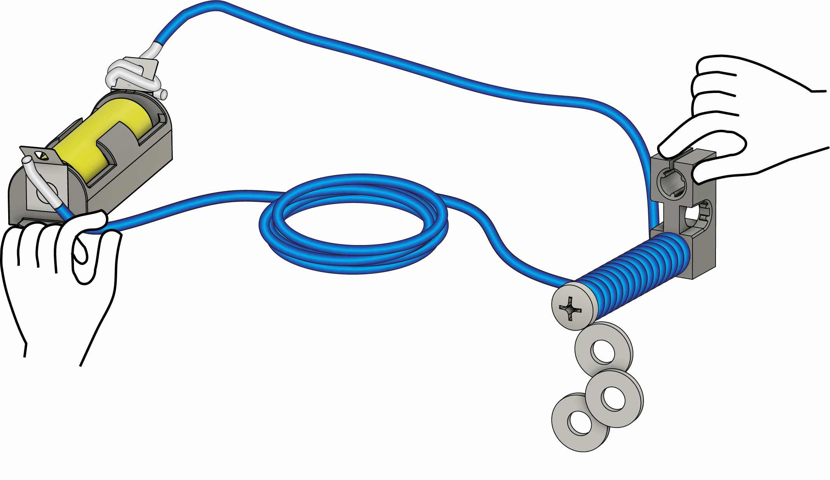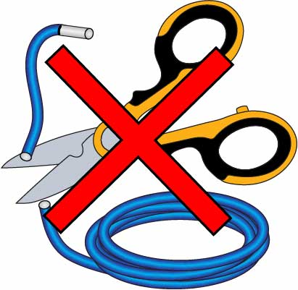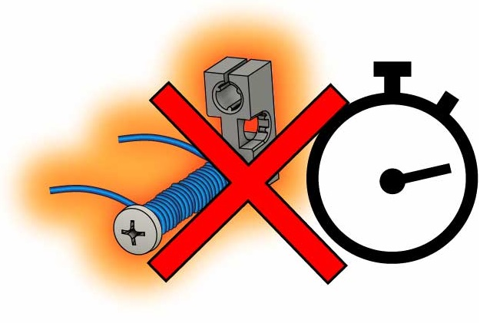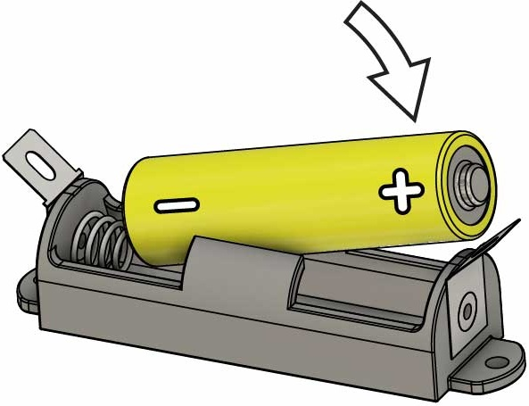

Grab!

65 cm (25 in) side of wire

Twist

Touch

How many washers can you pick up?

The wire, battery, and battery holder can get *very* hot.

Do not permanently attach the magnet to the battery, run the magnet continuously, or cut the wire much shorter.

You may see sparks, but you won’t get shocked!

**Don’t leave your magnet on!**

**Don’t cut the wire!**

# 5

# 6

**Hook up your magnet and pick stuff up!**

**!**

Don’t Overheat!

Flat side of battery against the spring.

Put the **battery** **into** the **holder**.

# Wrap More Layers

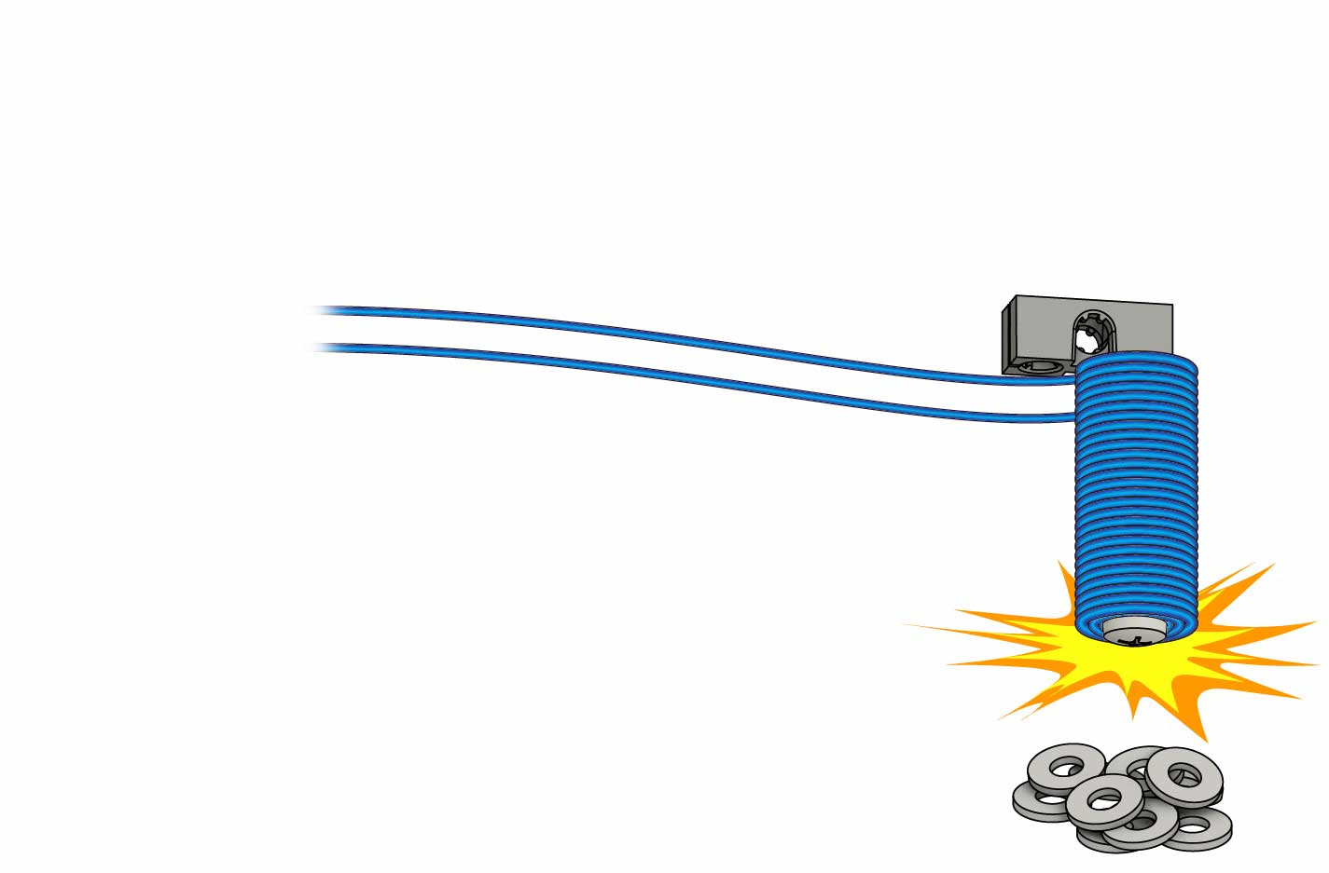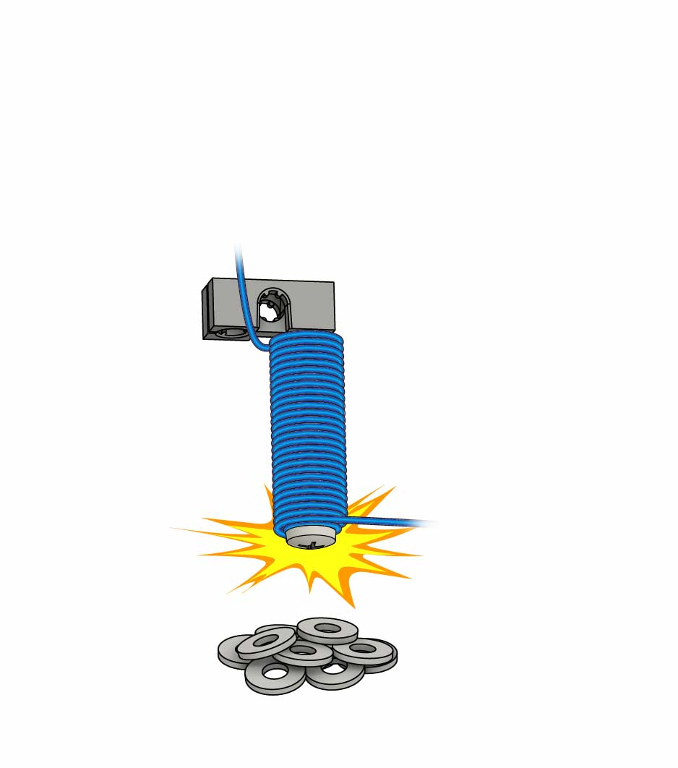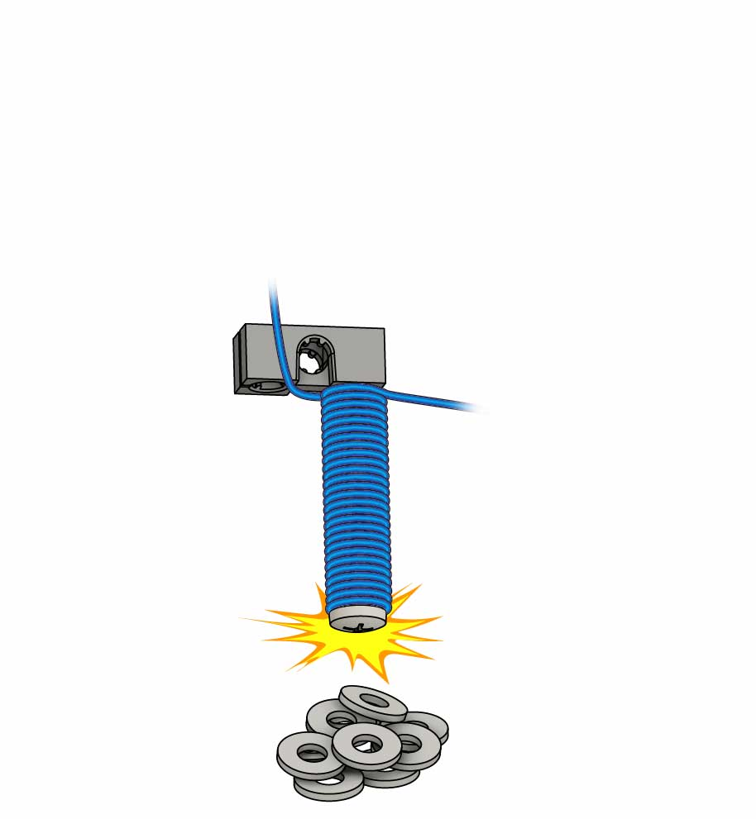



**Want to learn more about magnets?**

Download the [**Magnetic Materials**](https://teachergeek.org/electromagnet_lab_magnetic_materials.docx)   
at [**teachergeek.com/electromagnet**](https://teachergeek.com/electromagnet)

**Ages 8+**

How many washers   
can you grab now?

**Both wires about 65 cm (25 in)**

**Your magnet is done.   
Time for a lab or a challenge!**

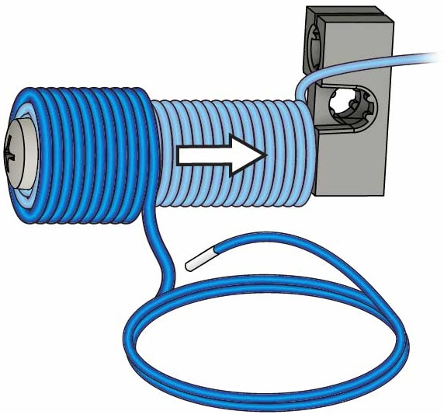

Layer 4

# 9

**Wrap** until both **wires** are the **same** **length**, then **test it!**

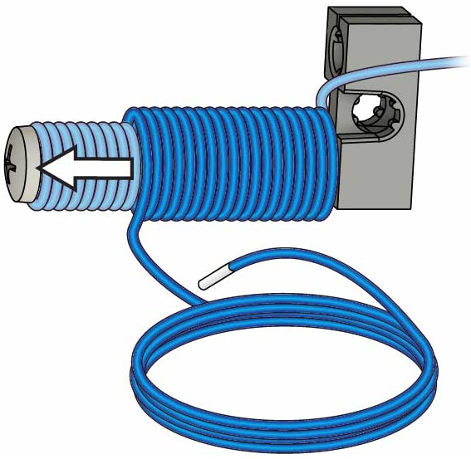

Layer 3

# 8

Wrap a **third layer**, then **test your magnet!**

How many washers   
can you grab now?

How many washers   
can you grab now?

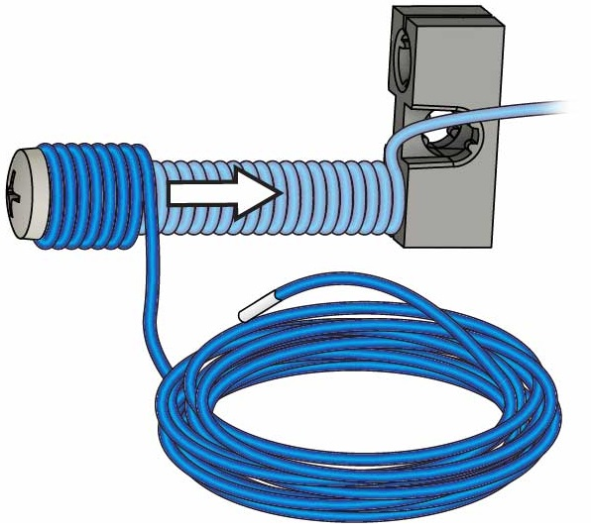

Layer 2

# 7

Wrap a **second layer**, then **test your magnet!**

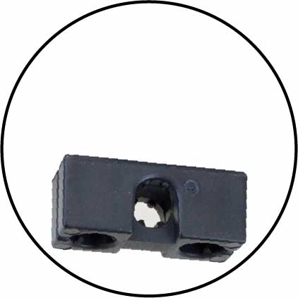

Through this hole

# Clip-Hanger Challenge

(what your design must do)

You have 1 minute to earn as many points as you can.

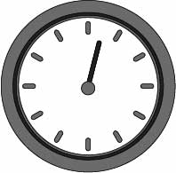

**Washers** and **paperclips** mustbehungon **different hooks**, or they count as negative points.

Criteria

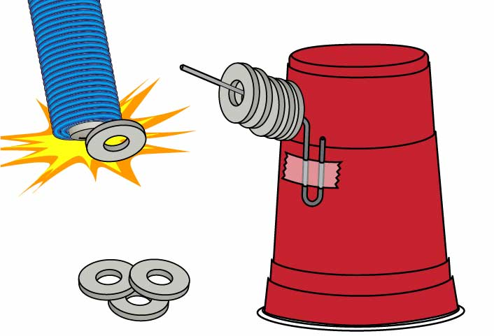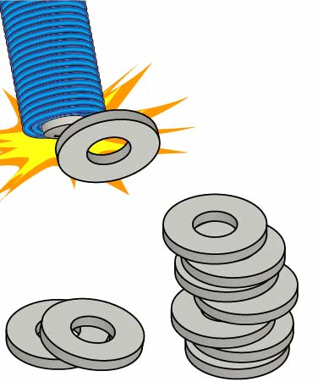

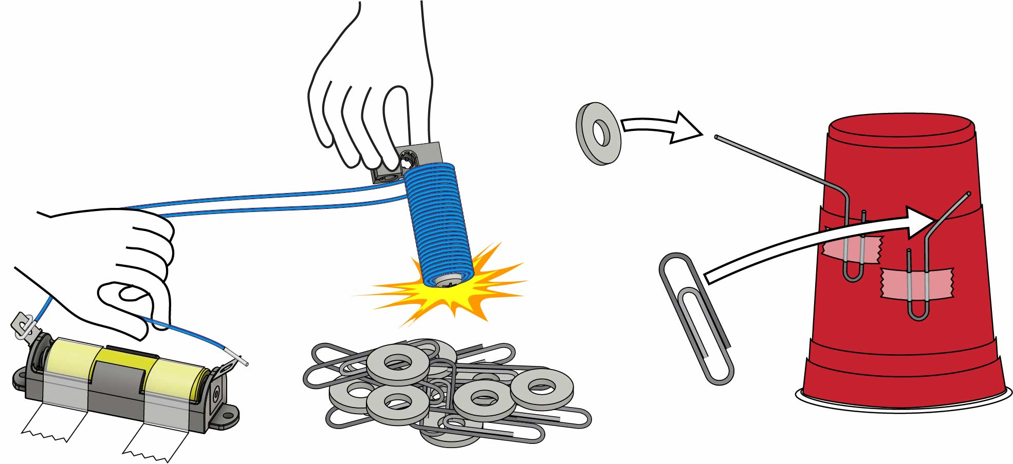

2 Points   
**Each**

Make hooks by bending paperclips and taping to a cup.

You can only use your **electromagnet** to **move** paperclips & washers.

1 Point   
**Each**

Tape battery to table to make it easier to turn magnet on and off.

10 washers & 10 paperclips

The team with the most points wins!

Complete the same way as the challenge above, but with just washers. This challenge requires only one paperclip to use as a hook.

Using only your electromagnet, stack as many washers as you can! You have one minute. The team with the tallest stack wins.

If two teams tie for height, the faster team wins!

Washer-Hanger Challenge

Stack-It Challenge

# Additional Challenges

Hang as many paperclips and washers as you can!