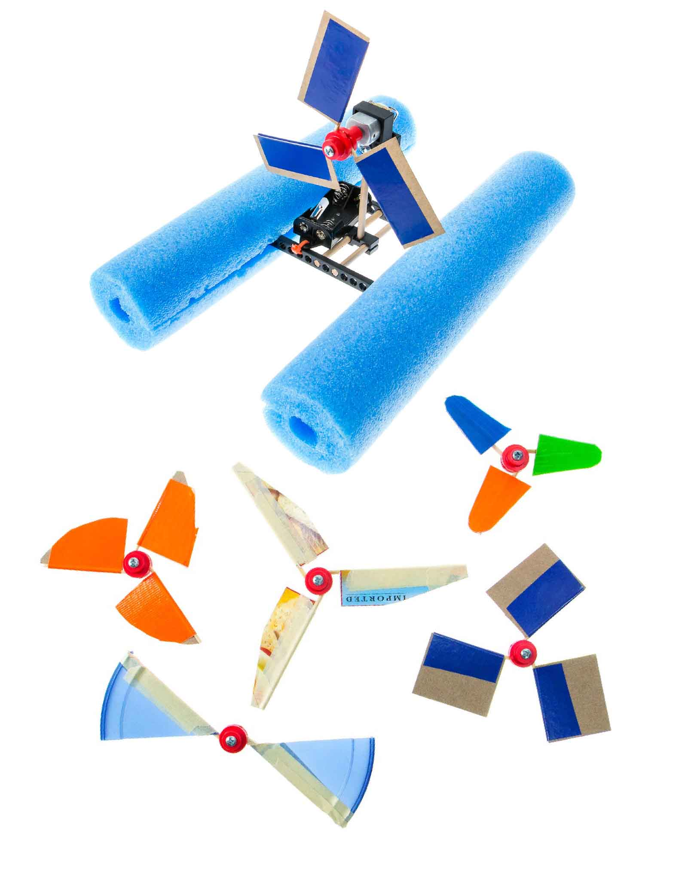

**En este laboratorio, aislarás una variable del diseño de tus aspas, experimentarás con ella y, ¡usarás lo que haz aprendido para mejorar tu bote!**

# **Materiales del Laboratorio**

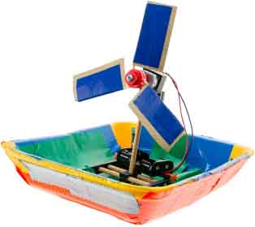

**Materiales para las Hélices**

Cartón, materiales reciclados, cinta adhesiva, etc.

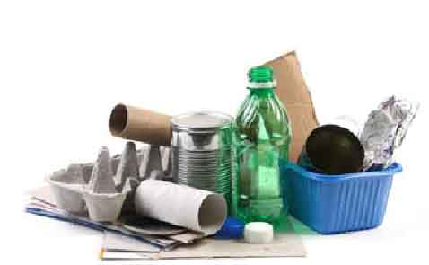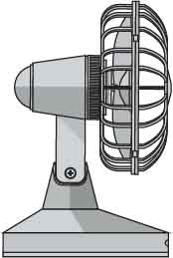

**Ventilador**



**Tijeras**

**Bote “Construido”**

**¿Necesitas construir tu bote?**

Descarga la [**Guía Go**](https://teachergeek.org/boat_go_guide.docx)en [**teachergeek.com/boat**](https://teachergeek.com/boat)

# **Haz Una Pregunta**

1

**Elige una variable para investigar:**

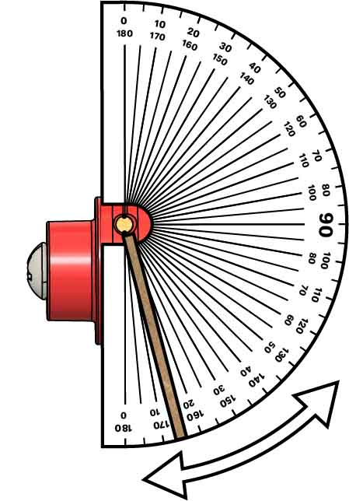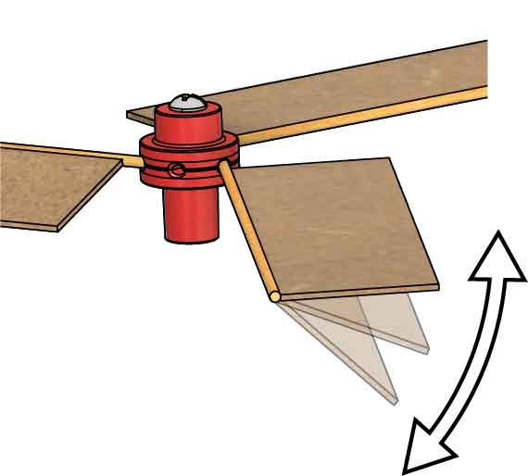

**Ángulo de las Aspas**

El ángulo de la aspas es la variable más importante, también es la más sencilla de modificar. **Intenta ángulos entre 0° y 90°. Usa un transportador para medir tus ángulos.**

Esta aspa tiene un ángulo de 15°.

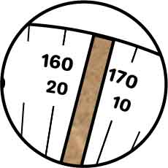

**Longitud de las Aspas**

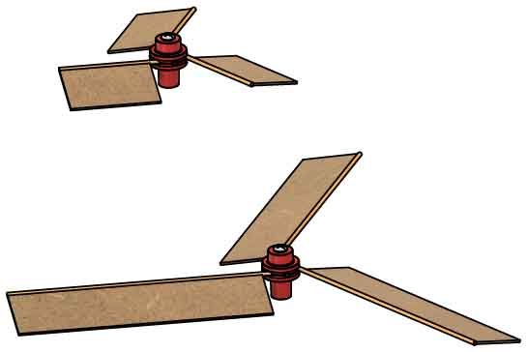

Las aspas largas se mueven más rápido que las cortas, si tu motor es suficientemente potente como para poder empujar. **¡Prueba diferentes longitudes para ver cual funciona mejor!**

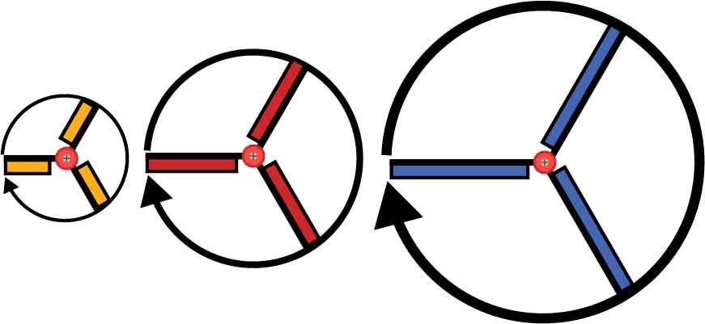

Si el motor gira a 50 revoluciones por minuto, las aspas más largas necesitan recorrer una mayor distncia, entonces se mueven más rápido .

**Ancho de las Aspas**

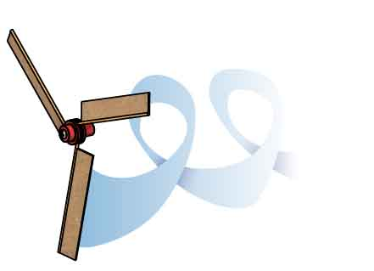

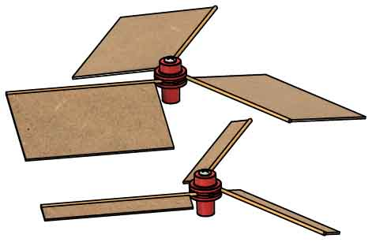

Las aspas más anchas empujan más viento, pero también producen más fricción. **¿Qué ancho funciona mejor?**

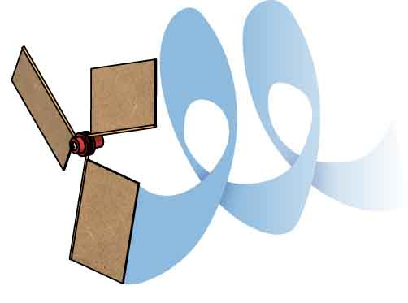

**Otras Variables**

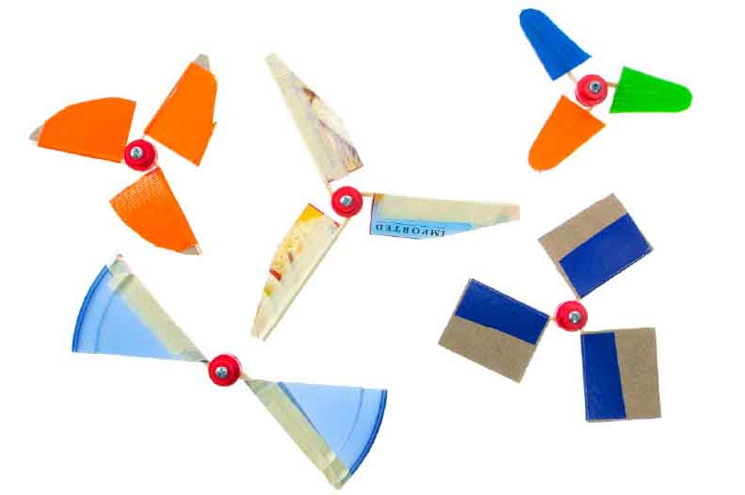



Si haces este laboratorio en la escuela, asegúrate de que tu profesor(a) apruebe la variable que estás probando.

Forma de las aspas, material de las aspas, cantidad de aspas, … ¡las posibilidades son infinitas! **¿Qué variable vas a investigar?**

**Bosquejo:**

# **Planea tu Experimento**

_______________________________________________________________________________________________________________________________________________________________________________________________________________________________________________________________________________________________________________________________________________________________________________________________________________________________

**Plan:**

Escribe un plan para tu experimento, incluyendo un bosquejo del prototipo. Asegúrate de proveer suficiente información para que otros puedan repetir tu experimento.

# 3

# 2

|  |  |  |
| --- | --- | --- |
| **Variable(s) Independientes** | **Variable(s) Independientes** | **Variable(s) de Control** |
|  |  |  |

¿Qué variables necesitas registrar?

# 4

|  |  |  |  |  |  |  |  |  |  |  |  |  |  |  |  |  |  |  |  |  |  |  |  |  |  |  |  |  |  |  |
| --- | --- | --- | --- | --- | --- | --- | --- | --- | --- | --- | --- | --- | --- | --- | --- | --- | --- | --- | --- | --- | --- | --- | --- | --- | --- | --- | --- | --- | --- | --- |
|  |  |  |  |  |  |  |  |  |  |  |  |  |  |  |  |  |  |  |  |  |  |  |  |  |  |  |  |  |  |  |
|  |  |  |  |  |  |  |  |  |  |  |  |  |  |  |  |  |  |  |  |  |  |  |  |  |  |  |  |  |  |  |
|  |  |  |  |  |  |  |  |  |  |  |  |  |  |  |  |  |  |  |  |  |  |  |  |  |  |  |  |  |  |  |
|  |  |  |  |  |  |  |  |  |  |  |  |  |  |  |  |  |  |  |  |  |  |  |  |  |  |  |  |  |  |  |
|  |  |  |  |  |  |  |  |  |  |  |  |  |  |  |  |  |  |  |  |  |  |  |  |  |  |  |  |  |  |  |
|  |  |  |  |  |  |  |  |  |  |  |  |  |  |  |  |  |  |  |  |  |  |  |  |  |  |  |  |  |  |  |
|  |  |  |  |  |  |  |  |  |  |  |  |  |  |  |  |  |  |  |  |  |  |  |  |  |  |  |  |  |  |  |
|  |  |  |  |  |  |  |  |  |  |  |  |  |  |  |  |  |  |  |  |  |  |  |  |  |  |  |  |  |  |  |
|  |  |  |  |  |  |  |  |  |  |  |  |  |  |  |  |  |  |  |  |  |  |  |  |  |  |  |  |  |  |  |
|  |  |  |  |  |  |  |  |  |  |  |  |  |  |  |  |  |  |  |  |  |  |  |  |  |  |  |  |  |  |  |
|  |  |  |  |  |  |  |  |  |  |  |  |  |  |  |  |  |  |  |  |  |  |  |  |  |  |  |  |  |  |  |
|  |  |  |  |  |  |  |  |  |  |  |  |  |  |  |  |  |  |  |  |  |  |  |  |  |  |  |  |  |  |  |
|  |  |  |  |  |  |  |  |  |  |  |  |  |  |  |  |  |  |  |  |  |  |  |  |  |  |  |  |  |  |  |
|  |  |  |  |  |  |  |  |  |  |  |  |  |  |  |  |  |  |  |  |  |  |  |  |  |  |  |  |  |  |  |
|  |  |  |  |  |  |  |  |  |  |  |  |  |  |  |  |  |  |  |  |  |  |  |  |  |  |  |  |  |  |  |
|  |  |  |  |  |  |  |  |  |  |  |  |  |  |  |  |  |  |  |  |  |  |  |  |  |  |  |  |  |  |  |
|  |  |  |  |  |  |  |  |  |  |  |  |  |  |  |  |  |  |  |  |  |  |  |  |  |  |  |  |  |  |  |
|  |  |  |  |  |  |  |  |  |  |  |  |  |  |  |  |  |  |  |  |  |  |  |  |  |  |  |  |  |  |  |
|  |  |  |  |  |  |  |  |  |  |  |  |  |  |  |  |  |  |  |  |  |  |  |  |  |  |  |  |  |  |  |
|  |  |  |  |  |  |  |  |  |  |  |  |  |  |  |  |  |  |  |  |  |  |  |  |  |  |  |  |  |  |  |
|  |  |  |  |  |  |  |  |  |  |  |  |  |  |  |  |  |  |  |  |  |  |  |  |  |  |  |  |  |  |  |
|  |  |  |  |  |  |  |  |  |  |  |  |  |  |  |  |  |  |  |  |  |  |  |  |  |  |  |  |  |  |  |
|  |  |  |  |  |  |  |  |  |  |  |  |  |  |  |  |  |  |  |  |  |  |  |  |  |  |  |  |  |  |  |
|  |  |  |  |  |  |  |  |  |  |  |  |  |  |  |  |  |  |  |  |  |  |  |  |  |  |  |  |  |  |  |
|  |  |  |  |  |  |  |  |  |  |  |  |  |  |  |  |  |  |  |  |  |  |  |  |  |  |  |  |  |  |  |
|  |  |  |  |  |  |  |  |  |  |  |  |  |  |  |  |  |  |  |  |  |  |  |  |  |  |  |  |  |  |  |
|  |  |  |  |  |  |  |  |  |  |  |  |  |  |  |  |  |  |  |  |  |  |  |  |  |  |  |  |  |  |  |
|  |  |  |  |  |  |  |  |  |  |  |  |  |  |  |  |  |  |  |  |  |  |  |  |  |  |  |  |  |  |  |
|  |  |  |  |  |  |  |  |  |  |  |  |  |  |  |  |  |  |  |  |  |  |  |  |  |  |  |  |  |  |  |

¡Haz tu experimento! Registra tus datos en estas páginas en listas o tablas. Luego grafícalos para ver los comportamientos.

# **Recopila Información**

## **Recopila Información** (continuación)

|  |  |  |  |  |  |  |  |  |  |  |  |  |  |  |  |  |  |  |  |  |  |  |  |  |  |  |  |  |  |  |
| --- | --- | --- | --- | --- | --- | --- | --- | --- | --- | --- | --- | --- | --- | --- | --- | --- | --- | --- | --- | --- | --- | --- | --- | --- | --- | --- | --- | --- | --- | --- |
|  |  |  |  |  |  |  |  |  |  |  |  |  |  |  |  |  |  |  |  |  |  |  |  |  |  |  |  |  |  |  |
|  |  |  |  |  |  |  |  |  |  |  |  |  |  |  |  |  |  |  |  |  |  |  |  |  |  |  |  |  |  |  |
|  |  |  |  |  |  |  |  |  |  |  |  |  |  |  |  |  |  |  |  |  |  |  |  |  |  |  |  |  |  |  |
|  |  |  |  |  |  |  |  |  |  |  |  |  |  |  |  |  |  |  |  |  |  |  |  |  |  |  |  |  |  |  |
|  |  |  |  |  |  |  |  |  |  |  |  |  |  |  |  |  |  |  |  |  |  |  |  |  |  |  |  |  |  |  |
|  |  |  |  |  |  |  |  |  |  |  |  |  |  |  |  |  |  |  |  |  |  |  |  |  |  |  |  |  |  |  |
|  |  |  |  |  |  |  |  |  |  |  |  |  |  |  |  |  |  |  |  |  |  |  |  |  |  |  |  |  |  |  |
|  |  |  |  |  |  |  |  |  |  |  |  |  |  |  |  |  |  |  |  |  |  |  |  |  |  |  |  |  |  |  |
|  |  |  |  |  |  |  |  |  |  |  |  |  |  |  |  |  |  |  |  |  |  |  |  |  |  |  |  |  |  |  |
|  |  |  |  |  |  |  |  |  |  |  |  |  |  |  |  |  |  |  |  |  |  |  |  |  |  |  |  |  |  |  |
|  |  |  |  |  |  |  |  |  |  |  |  |  |  |  |  |  |  |  |  |  |  |  |  |  |  |  |  |  |  |  |
|  |  |  |  |  |  |  |  |  |  |  |  |  |  |  |  |  |  |  |  |  |  |  |  |  |  |  |  |  |  |  |
|  |  |  |  |  |  |  |  |  |  |  |  |  |  |  |  |  |  |  |  |  |  |  |  |  |  |  |  |  |  |  |
|  |  |  |  |  |  |  |  |  |  |  |  |  |  |  |  |  |  |  |  |  |  |  |  |  |  |  |  |  |  |  |
|  |  |  |  |  |  |  |  |  |  |  |  |  |  |  |  |  |  |  |  |  |  |  |  |  |  |  |  |  |  |  |
|  |  |  |  |  |  |  |  |  |  |  |  |  |  |  |  |  |  |  |  |  |  |  |  |  |  |  |  |  |  |  |
|  |  |  |  |  |  |  |  |  |  |  |  |  |  |  |  |  |  |  |  |  |  |  |  |  |  |  |  |  |  |  |
|  |  |  |  |  |  |  |  |  |  |  |  |  |  |  |  |  |  |  |  |  |  |  |  |  |  |  |  |  |  |  |
|  |  |  |  |  |  |  |  |  |  |  |  |  |  |  |  |  |  |  |  |  |  |  |  |  |  |  |  |  |  |  |
|  |  |  |  |  |  |  |  |  |  |  |  |  |  |  |  |  |  |  |  |  |  |  |  |  |  |  |  |  |  |  |
|  |  |  |  |  |  |  |  |  |  |  |  |  |  |  |  |  |  |  |  |  |  |  |  |  |  |  |  |  |  |  |
|  |  |  |  |  |  |  |  |  |  |  |  |  |  |  |  |  |  |  |  |  |  |  |  |  |  |  |  |  |  |  |
|  |  |  |  |  |  |  |  |  |  |  |  |  |  |  |  |  |  |  |  |  |  |  |  |  |  |  |  |  |  |  |
|  |  |  |  |  |  |  |  |  |  |  |  |  |  |  |  |  |  |  |  |  |  |  |  |  |  |  |  |  |  |  |
|  |  |  |  |  |  |  |  |  |  |  |  |  |  |  |  |  |  |  |  |  |  |  |  |  |  |  |  |  |  |  |
|  |  |  |  |  |  |  |  |  |  |  |  |  |  |  |  |  |  |  |  |  |  |  |  |  |  |  |  |  |  |  |
|  |  |  |  |  |  |  |  |  |  |  |  |  |  |  |  |  |  |  |  |  |  |  |  |  |  |  |  |  |  |  |
|  |  |  |  |  |  |  |  |  |  |  |  |  |  |  |  |  |  |  |  |  |  |  |  |  |  |  |  |  |  |  |
|  |  |  |  |  |  |  |  |  |  |  |  |  |  |  |  |  |  |  |  |  |  |  |  |  |  |  |  |  |  |  |
|  |  |  |  |  |  |  |  |  |  |  |  |  |  |  |  |  |  |  |  |  |  |  |  |  |  |  |  |  |  |  |
|  |  |  |  |  |  |  |  |  |  |  |  |  |  |  |  |  |  |  |  |  |  |  |  |  |  |  |  |  |  |  |
|  |  |  |  |  |  |  |  |  |  |  |  |  |  |  |  |  |  |  |  |  |  |  |  |  |  |  |  |  |  |  |
|  |  |  |  |  |  |  |  |  |  |  |  |  |  |  |  |  |  |  |  |  |  |  |  |  |  |  |  |  |  |  |

**Interpreta la Información**

¿Qué aprendiste, y cómo lo vas a usar para mejorar tus hélices?

__________________________________________________________________________________________________________________________________________________________________________________________________________________________________________________________________________________________________________________________________________________________________________________________________________________________________________________________________________________________________________________

¿Qué crees que es lo que está sucediendo con el experimento? ¿Por qué observaste lo que hiciste?

____________________________________________________________________________________________________________________________________________________________________________________________________________________________________________________________________________________________________________________________________________

Examina tus gráficas y tablas. ¿De qué manera se relacionan las variables independientes con las dependientes? (ej. proporcional, lineal, exponencial, inversa, …) ¿Cómo lo sabes?

__________________________________________________________________________________________________________________________________________________________________________________________________________________________________________________________________________________________________________________________________________________________________________________________________________________________________________________________________________________________________________________

**Construye una Explicación**

# 5

# 7

# 6