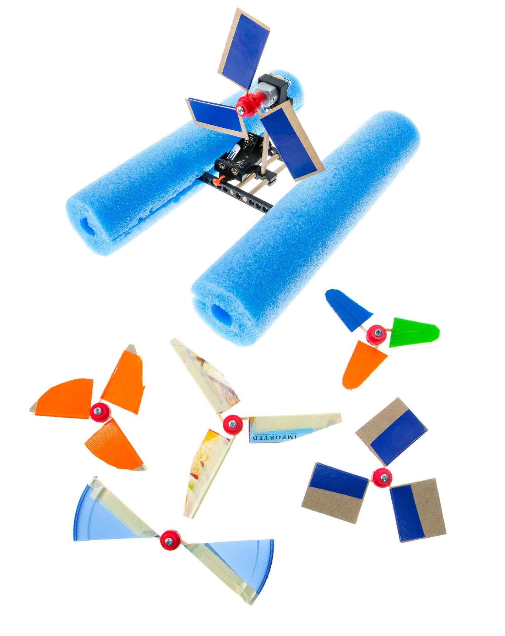

**In this lab, you’ll isolate one variable of your blade’s design, experiment with it, and use what you learned to make your boat   
even better!**

# Lab Supplies

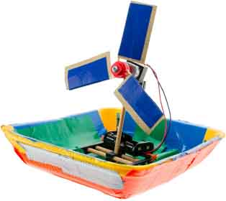

**Blade Materials**

Cardboard, recycling bin materials, tape, etc.

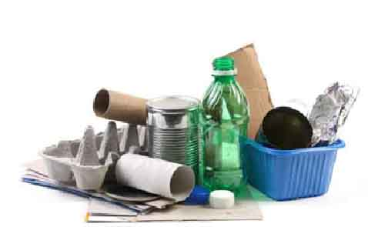

**Scissors**

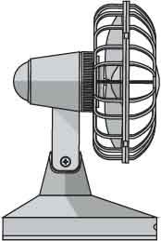

**Fan**

**“Built” Boat**

**Need to build your boat?**

Download the [**Go Guide**](https://teachergeek.org/boat_go_guide4H.docx)at [**shop4-h.org**](https://shop4-h.org/)

# Ask A Question

# 1

**Choose a variable to investigate:**

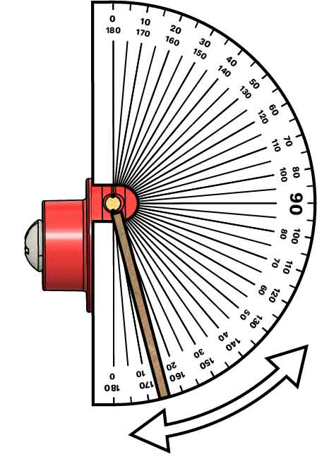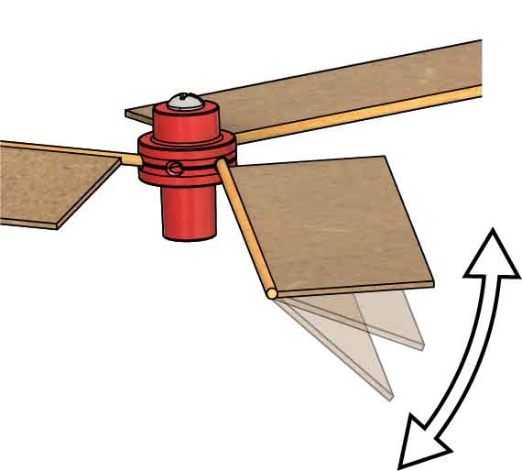

Blade Angle

Blade angle is the most important variable, and it’s also the easiest to change! **Try angles between 0° and 90°. Use a protractor to measure your angles.**

This blade is angled to 15°.

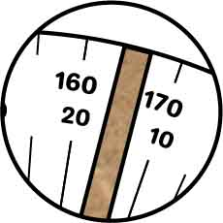

Blade Length

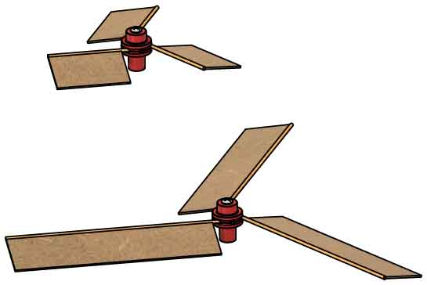

Longer blades move faster than shorter blades, if your motor is strong enough to push them. **Test different lengths to see which works the best!**

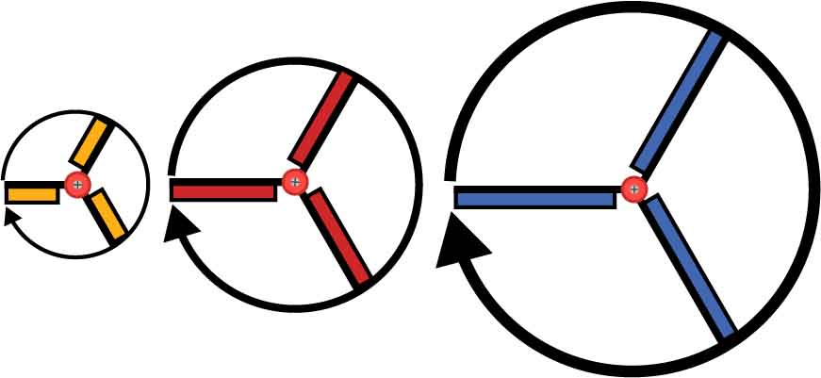

If the motor spins each propeller 50 rotations per minute, the big blades go a greater distance, so they must move faster.

Blade Width

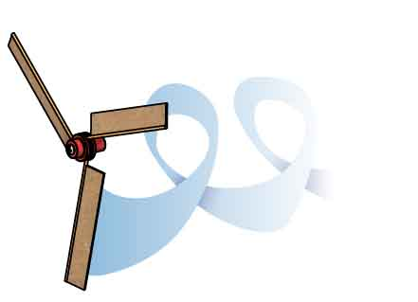

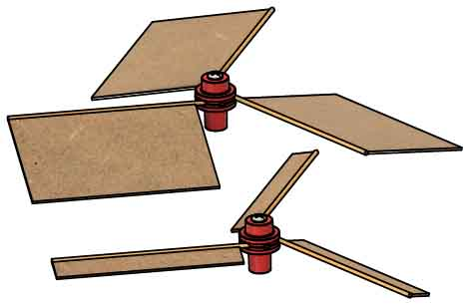

Wider blades push more air by taking bigger “bites,” but they also have more friction with the air. **What width works the best?**

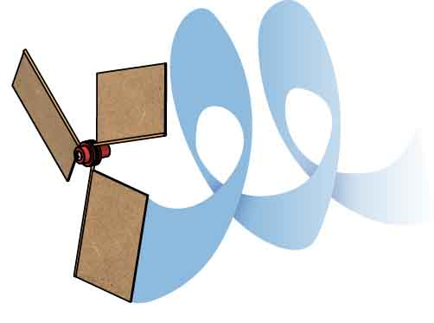

Other Variables

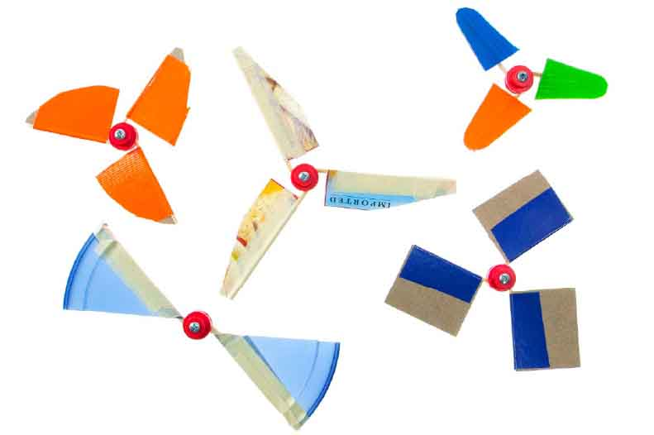



If doing this lab for school, make sure your teacher approves the variable you are testing.

Blade shape, blade materials, number of blades, … the possibilities are endless! **What variable will you investigate?**

Sketch:

_______________________________________________________________________________________________________________________________________________________________________________________________________________________________________________________________________________________________________________________________________________________________________________________________________________________________

Plan:

Write a plan for your experiment, including a sketch of the setup. Make sure you provide enough information for others to repeat your experiment.

# 3

# 2

|  |  |  |
| --- | --- | --- |
| **Independent Variable(s)** | **Dependent Variable(s)** | **Control Variable(s)** |
|  |  |  |

What variables do you need to keep track of?

# Plan Your Experiment

# 4

|  |  |  |  |  |  |  |  |  |  |  |  |  |  |  |  |  |  |  |  |  |  |  |  |  |  |  |  |  |  |  |
| --- | --- | --- | --- | --- | --- | --- | --- | --- | --- | --- | --- | --- | --- | --- | --- | --- | --- | --- | --- | --- | --- | --- | --- | --- | --- | --- | --- | --- | --- | --- |
|  |  |  |  |  |  |  |  |  |  |  |  |  |  |  |  |  |  |  |  |  |  |  |  |  |  |  |  |  |  |  |
|  |  |  |  |  |  |  |  |  |  |  |  |  |  |  |  |  |  |  |  |  |  |  |  |  |  |  |  |  |  |  |
|  |  |  |  |  |  |  |  |  |  |  |  |  |  |  |  |  |  |  |  |  |  |  |  |  |  |  |  |  |  |  |
|  |  |  |  |  |  |  |  |  |  |  |  |  |  |  |  |  |  |  |  |  |  |  |  |  |  |  |  |  |  |  |
|  |  |  |  |  |  |  |  |  |  |  |  |  |  |  |  |  |  |  |  |  |  |  |  |  |  |  |  |  |  |  |
|  |  |  |  |  |  |  |  |  |  |  |  |  |  |  |  |  |  |  |  |  |  |  |  |  |  |  |  |  |  |  |
|  |  |  |  |  |  |  |  |  |  |  |  |  |  |  |  |  |  |  |  |  |  |  |  |  |  |  |  |  |  |  |
|  |  |  |  |  |  |  |  |  |  |  |  |  |  |  |  |  |  |  |  |  |  |  |  |  |  |  |  |  |  |  |
|  |  |  |  |  |  |  |  |  |  |  |  |  |  |  |  |  |  |  |  |  |  |  |  |  |  |  |  |  |  |  |
|  |  |  |  |  |  |  |  |  |  |  |  |  |  |  |  |  |  |  |  |  |  |  |  |  |  |  |  |  |  |  |
|  |  |  |  |  |  |  |  |  |  |  |  |  |  |  |  |  |  |  |  |  |  |  |  |  |  |  |  |  |  |  |
|  |  |  |  |  |  |  |  |  |  |  |  |  |  |  |  |  |  |  |  |  |  |  |  |  |  |  |  |  |  |  |
|  |  |  |  |  |  |  |  |  |  |  |  |  |  |  |  |  |  |  |  |  |  |  |  |  |  |  |  |  |  |  |
|  |  |  |  |  |  |  |  |  |  |  |  |  |  |  |  |  |  |  |  |  |  |  |  |  |  |  |  |  |  |  |
|  |  |  |  |  |  |  |  |  |  |  |  |  |  |  |  |  |  |  |  |  |  |  |  |  |  |  |  |  |  |  |
|  |  |  |  |  |  |  |  |  |  |  |  |  |  |  |  |  |  |  |  |  |  |  |  |  |  |  |  |  |  |  |
|  |  |  |  |  |  |  |  |  |  |  |  |  |  |  |  |  |  |  |  |  |  |  |  |  |  |  |  |  |  |  |
|  |  |  |  |  |  |  |  |  |  |  |  |  |  |  |  |  |  |  |  |  |  |  |  |  |  |  |  |  |  |  |
|  |  |  |  |  |  |  |  |  |  |  |  |  |  |  |  |  |  |  |  |  |  |  |  |  |  |  |  |  |  |  |
|  |  |  |  |  |  |  |  |  |  |  |  |  |  |  |  |  |  |  |  |  |  |  |  |  |  |  |  |  |  |  |
|  |  |  |  |  |  |  |  |  |  |  |  |  |  |  |  |  |  |  |  |  |  |  |  |  |  |  |  |  |  |  |
|  |  |  |  |  |  |  |  |  |  |  |  |  |  |  |  |  |  |  |  |  |  |  |  |  |  |  |  |  |  |  |
|  |  |  |  |  |  |  |  |  |  |  |  |  |  |  |  |  |  |  |  |  |  |  |  |  |  |  |  |  |  |  |
|  |  |  |  |  |  |  |  |  |  |  |  |  |  |  |  |  |  |  |  |  |  |  |  |  |  |  |  |  |  |  |
|  |  |  |  |  |  |  |  |  |  |  |  |  |  |  |  |  |  |  |  |  |  |  |  |  |  |  |  |  |  |  |
|  |  |  |  |  |  |  |  |  |  |  |  |  |  |  |  |  |  |  |  |  |  |  |  |  |  |  |  |  |  |  |
|  |  |  |  |  |  |  |  |  |  |  |  |  |  |  |  |  |  |  |  |  |  |  |  |  |  |  |  |  |  |  |
|  |  |  |  |  |  |  |  |  |  |  |  |  |  |  |  |  |  |  |  |  |  |  |  |  |  |  |  |  |  |  |
|  |  |  |  |  |  |  |  |  |  |  |  |  |  |  |  |  |  |  |  |  |  |  |  |  |  |  |  |  |  |  |

# Collect Data

Do your experiment! Record your data on these pages in lists or tables. Then graph it to look for patterns.

## Collect Data (continued)

|  |  |  |  |  |  |  |  |  |  |  |  |  |  |  |  |  |  |  |  |  |  |  |  |  |  |  |  |  |  |  |
| --- | --- | --- | --- | --- | --- | --- | --- | --- | --- | --- | --- | --- | --- | --- | --- | --- | --- | --- | --- | --- | --- | --- | --- | --- | --- | --- | --- | --- | --- | --- |
|  |  |  |  |  |  |  |  |  |  |  |  |  |  |  |  |  |  |  |  |  |  |  |  |  |  |  |  |  |  |  |
|  |  |  |  |  |  |  |  |  |  |  |  |  |  |  |  |  |  |  |  |  |  |  |  |  |  |  |  |  |  |  |
|  |  |  |  |  |  |  |  |  |  |  |  |  |  |  |  |  |  |  |  |  |  |  |  |  |  |  |  |  |  |  |
|  |  |  |  |  |  |  |  |  |  |  |  |  |  |  |  |  |  |  |  |  |  |  |  |  |  |  |  |  |  |  |
|  |  |  |  |  |  |  |  |  |  |  |  |  |  |  |  |  |  |  |  |  |  |  |  |  |  |  |  |  |  |  |
|  |  |  |  |  |  |  |  |  |  |  |  |  |  |  |  |  |  |  |  |  |  |  |  |  |  |  |  |  |  |  |
|  |  |  |  |  |  |  |  |  |  |  |  |  |  |  |  |  |  |  |  |  |  |  |  |  |  |  |  |  |  |  |
|  |  |  |  |  |  |  |  |  |  |  |  |  |  |  |  |  |  |  |  |  |  |  |  |  |  |  |  |  |  |  |
|  |  |  |  |  |  |  |  |  |  |  |  |  |  |  |  |  |  |  |  |  |  |  |  |  |  |  |  |  |  |  |
|  |  |  |  |  |  |  |  |  |  |  |  |  |  |  |  |  |  |  |  |  |  |  |  |  |  |  |  |  |  |  |
|  |  |  |  |  |  |  |  |  |  |  |  |  |  |  |  |  |  |  |  |  |  |  |  |  |  |  |  |  |  |  |
|  |  |  |  |  |  |  |  |  |  |  |  |  |  |  |  |  |  |  |  |  |  |  |  |  |  |  |  |  |  |  |
|  |  |  |  |  |  |  |  |  |  |  |  |  |  |  |  |  |  |  |  |  |  |  |  |  |  |  |  |  |  |  |
|  |  |  |  |  |  |  |  |  |  |  |  |  |  |  |  |  |  |  |  |  |  |  |  |  |  |  |  |  |  |  |
|  |  |  |  |  |  |  |  |  |  |  |  |  |  |  |  |  |  |  |  |  |  |  |  |  |  |  |  |  |  |  |
|  |  |  |  |  |  |  |  |  |  |  |  |  |  |  |  |  |  |  |  |  |  |  |  |  |  |  |  |  |  |  |
|  |  |  |  |  |  |  |  |  |  |  |  |  |  |  |  |  |  |  |  |  |  |  |  |  |  |  |  |  |  |  |
|  |  |  |  |  |  |  |  |  |  |  |  |  |  |  |  |  |  |  |  |  |  |  |  |  |  |  |  |  |  |  |
|  |  |  |  |  |  |  |  |  |  |  |  |  |  |  |  |  |  |  |  |  |  |  |  |  |  |  |  |  |  |  |
|  |  |  |  |  |  |  |  |  |  |  |  |  |  |  |  |  |  |  |  |  |  |  |  |  |  |  |  |  |  |  |
|  |  |  |  |  |  |  |  |  |  |  |  |  |  |  |  |  |  |  |  |  |  |  |  |  |  |  |  |  |  |  |
|  |  |  |  |  |  |  |  |  |  |  |  |  |  |  |  |  |  |  |  |  |  |  |  |  |  |  |  |  |  |  |
|  |  |  |  |  |  |  |  |  |  |  |  |  |  |  |  |  |  |  |  |  |  |  |  |  |  |  |  |  |  |  |
|  |  |  |  |  |  |  |  |  |  |  |  |  |  |  |  |  |  |  |  |  |  |  |  |  |  |  |  |  |  |  |
|  |  |  |  |  |  |  |  |  |  |  |  |  |  |  |  |  |  |  |  |  |  |  |  |  |  |  |  |  |  |  |
|  |  |  |  |  |  |  |  |  |  |  |  |  |  |  |  |  |  |  |  |  |  |  |  |  |  |  |  |  |  |  |
|  |  |  |  |  |  |  |  |  |  |  |  |  |  |  |  |  |  |  |  |  |  |  |  |  |  |  |  |  |  |  |
|  |  |  |  |  |  |  |  |  |  |  |  |  |  |  |  |  |  |  |  |  |  |  |  |  |  |  |  |  |  |  |
|  |  |  |  |  |  |  |  |  |  |  |  |  |  |  |  |  |  |  |  |  |  |  |  |  |  |  |  |  |  |  |
|  |  |  |  |  |  |  |  |  |  |  |  |  |  |  |  |  |  |  |  |  |  |  |  |  |  |  |  |  |  |  |
|  |  |  |  |  |  |  |  |  |  |  |  |  |  |  |  |  |  |  |  |  |  |  |  |  |  |  |  |  |  |  |
|  |  |  |  |  |  |  |  |  |  |  |  |  |  |  |  |  |  |  |  |  |  |  |  |  |  |  |  |  |  |  |
|  |  |  |  |  |  |  |  |  |  |  |  |  |  |  |  |  |  |  |  |  |  |  |  |  |  |  |  |  |  |  |

# Interpret Data

What did you learn, and how will you use it to make a better propeller?

__________________________________________________________________________________________________________________________________________________________________________________________________________________________________________________________________________________________________________________________________________________________________________________________________________________________________________________________________________________________________________________

What do you think is going on? Why did you observe what you did?

____________________________________________________________________________________________________________________________________________________________________________________________________________________________________________________________________________________________________________________________________________

Examine your graphs and tables. How are the independent and dependent variables related (e.g. proportional, linear, exponential, inverse, …)? How do you know?

__________________________________________________________________________________________________________________________________________________________________________________________________________________________________________________________________________________________________________________________________________________________________________________________________________________________________________________________________________________________________________________

# Construct an Explanation

# 5

# 7

# 6