

Start by building the example launcher, then turn it into ***your own*** unique design.





Download documents at [**teachergeek.com**](https://teachergeek.com/)**/learn**

For use with TeacherGeek [Projectile Launcher Activity](https://teachergeek.com/products/ping-pong-ball-launcher-projectile-launcher),   
or [Maker Cart](https://teachergeek.com/products/maker-cart) available at [**teachergeek.com**](https://teachergeek.com/).

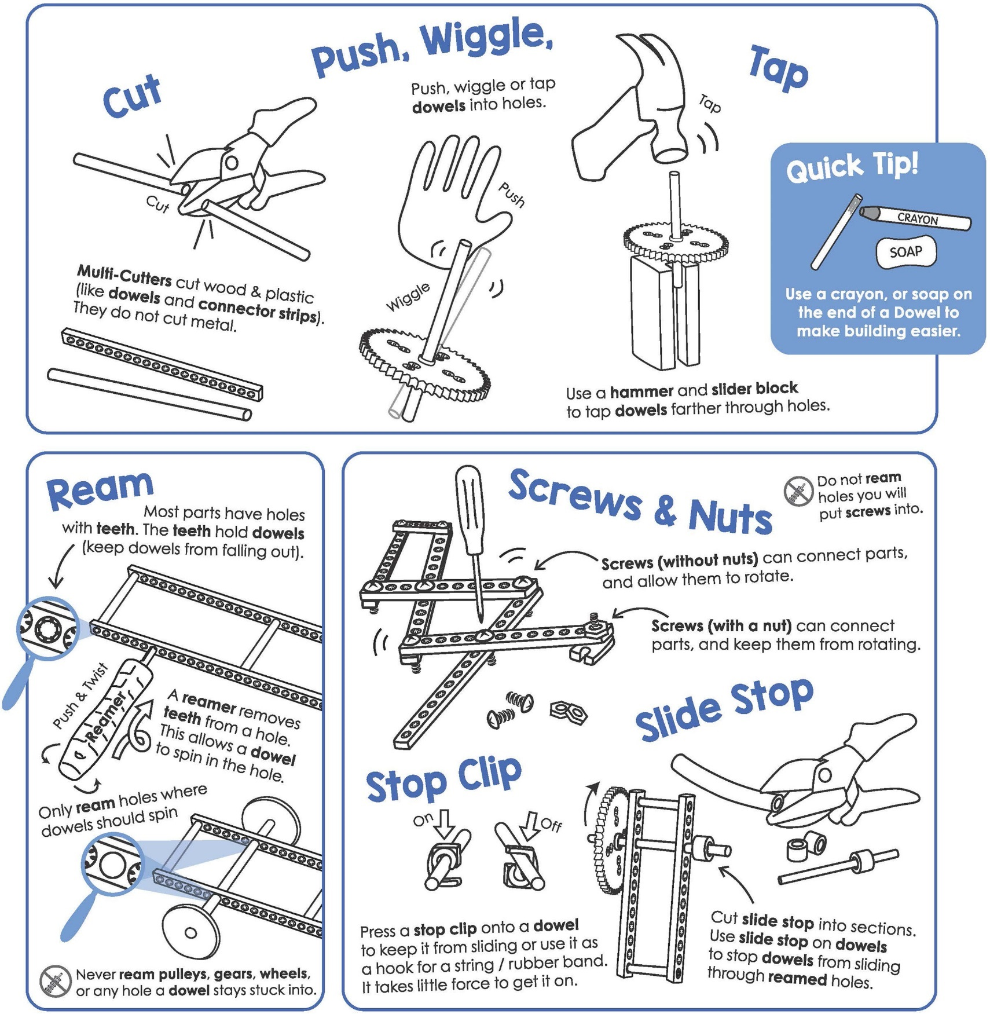



Here are TeacherGeek components to make the example projectile launcher,   
and then turn it into your own unique design.

|  |  |  |  |  |  |
| --- | --- | --- | --- | --- | --- |
|  |  |  |  | |  |
| [**8 - Blocks**](https://teachergeek.com/collections/secondary-schools-camps/products/ping-pong-ball-launcher-projectile-launcher?variant=344626559) | [**6 - Dowels** 30cm (12″)](https://teachergeek.com/collections/secondary-schools-camps/products/ping-pong-ball-launcher-projectile-launcher?variant=344626559) | [**4 - Connector Strips**](https://teachergeek.com/collections/secondary-schools-camps/products/ping-pong-ball-launcher-projectile-launcher?variant=344626559) | [**2 - Hole Plate**](https://teachergeek.com/collections/secondary-schools-camps/products/ping-pong-ball-launcher-projectile-launcher?variant=344626559) | | [**1 - Ping Pong Ball**](https://teachergeek.com/collections/secondary-schools-camps/products/ping-pong-ball-launcher-projectile-launcher?variant=344626559) |
|  |  |  |  | |  |
| [**12 - Nuts** #10](https://teachergeek.com/collections/secondary-schools-camps/products/ping-pong-ball-launcher-projectile-launcher?variant=344626559) | [**2 - Lock Nuts** #10](https://teachergeek.com/collections/secondary-schools-camps/products/ping-pong-ball-launcher-projectile-launcher?variant=344626559) | [**2 - 38mm Screw** 38mm (1½″) #10](https://teachergeek.com/collections/secondary-schools-camps/products/ping-pong-ball-launcher-projectile-launcher?variant=344626559) | **[10 - 25mm Screw](https://teachergeek.com/collections/secondary-schools-camps/products/ping-pong-ball-launcher-projectile-launcher?variant=344626559)**  [(1″) #10](https://teachergeek.com/collections/secondary-schools-camps/products/ping-pong-ball-launcher-projectile-launcher?variant=344626559) | | [**8 - Rubber Bands**](https://teachergeek.com/collections/secondary-schools-camps/products/ping-pong-ball-launcher-projectile-launcher?variant=344626559) |
|  |  |  |  | **2 - Angle Brackets** | |
| [**4 - Stop Clips**](https://teachergeek.com/collections/secondary-schools-camps/products/ping-pong-ball-launcher-projectile-launcher?variant=344626559) | [**1 - Slide Stop** 76mm (3″)](https://teachergeek.com/collections/secondary-schools-camps/products/ping-pong-ball-launcher-projectile-launcher?variant=344626559) | [**1 - Steel Wire** 7.5cm (3″)](https://teachergeek.com/collections/secondary-schools-camps/products/ping-pong-ball-launcher-projectile-launcher?variant=344626559) | **[1 - Plastic](https://teachergeek.com/collections/secondary-schools-camps/products/ping-pong-ball-launcher-projectile-launcher?variant=344626559)**  **[Coated Wire](https://teachergeek.com/collections/secondary-schools-camps/products/ping-pong-ball-launcher-projectile-launcher?variant=344626559)**  [8cm (3¼″)](https://teachergeek.com/collections/secondary-schools-camps/products/ping-pong-ball-launcher-projectile-launcher?variant=344626559) |  | |

[](https://teachergeek.com/collections/secondary-schools-camps/products/ping-pong-ball-launcher-projectile-launcher?variant=344626559)

Components available in the TeacherGeek [Ping Pong Launcher Activity](https://teachergeek.com/collections/secondary-schools-camps/products/ping-pong-ball-launcher-projectile-launcher?variant=2271543108),   
TeacherGeek [Maker Cart](https://teachergeek.com/products/maker-cart), or at [**teachergeek.com**](https://teachergeek.com/)

[*You*](https://teachergeek.com/collections/secondary-schools-camps/products/ping-pong-ball-launcher-projectile-launcher?variant=344626559) *might need to cut this from a wire roll.*

**►**



This isn’t a kit. You’re going to really build (cut, ream, screw) your launcher.   
Here are the tools you’ll need.

|  |  |  |
| --- | --- | --- |
|  |  |  |
| **Multi-Cutter** [SKU 1823-81](https://teachergeek.com/products/1823-81) | **Reamer** [SKU 1823-87](https://teachergeek.com/collections/tools-resources/products/teachergeek-reamer) | **Screwdriver** [SKU 1823-90](https://teachergeek.com/products/stubby-2-screwdriver) | **Pliers** [SKU 1823-86](https://teachergeek.com/products/slip-joint-pliers-6) |

Tools available at [**teachergeek.com**](https://teachergeek.com/products/easy-engineering-tool-set?variant=344866731)



You will need these non-TeacherGeek supplies:

|  |  |  |  |
| --- | --- | --- | --- |
|  |  |  |  |
| **Tape**  Masking, Painter’s, Duct; Any kind of tape will work. | **Safety Goggles**  Should be worn during the activity. | **Recycling Materials**  Add to your design | **Scissors**  For cutting out the protractor and recycling materials. |

[](http://teachergeek.org/protractor-angle_finder.pdf)

**TeacherGeek Protractor**

Print on cardstock or thicker paper for a sturdier protractor.

Printable Protractor Download:

<http://teachergeek.org/protractor-angle_finder.pdf>

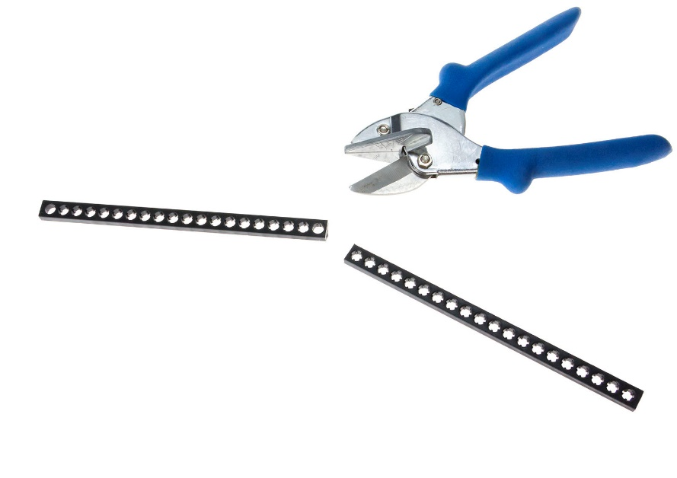



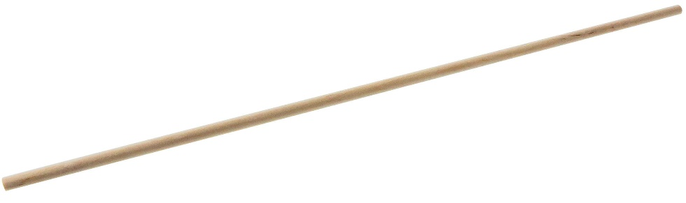

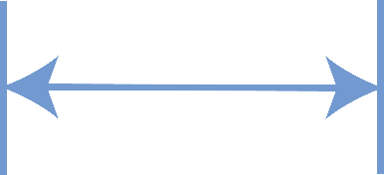

|  |  |  |  |
| --- | --- | --- | --- |
| 13cm | **Cut** a 13cm (5”) **dowel**, and  5cm  a 5cm (2”) **dowel**. |  | **Push,** or tap, each **dowel** from **Step 1** into a **block** as shown.  The dowels should stick out a little.      5cm      Block  13cm |
|  | **Push** or tap the **dowels** from **Step 2** into the **hole plate,** as shown.    Hole Plate  *Tap!* |  | **Rub** a crayon, wax, or bar of soap, on two **full** (30cm) **dowels**.  This helps the dowels slide*.*  30cm dowel  Slide the **dowels**  from **Step 4**  Launch  Pad  through the  **blocks** from  **Step 3**. These will be  the **legs.**  Legs |
| TeacherGeek Protractor | Print, cut, and tape a **protractor** to the launcher, as shown. | Use a dowel or  pencil to bend   the hook. | **Bend** a 1.5cm hook at the end of a 7.5cm **Steel** **wire** (Not the plastic coated wire). **Poke** it through the **protractor** at the . Hang it on the paper as shown.  Poke!  6.5cm  7.5cm Metal Wire  Make sure the metal wire points **straight down** when the protractor is tilted. |

Launch Pad

Don’t cover the   
cross-hair (circle)   
with tape.



Change the angle of the launch pad   
by sliding the leg dowels up and down.

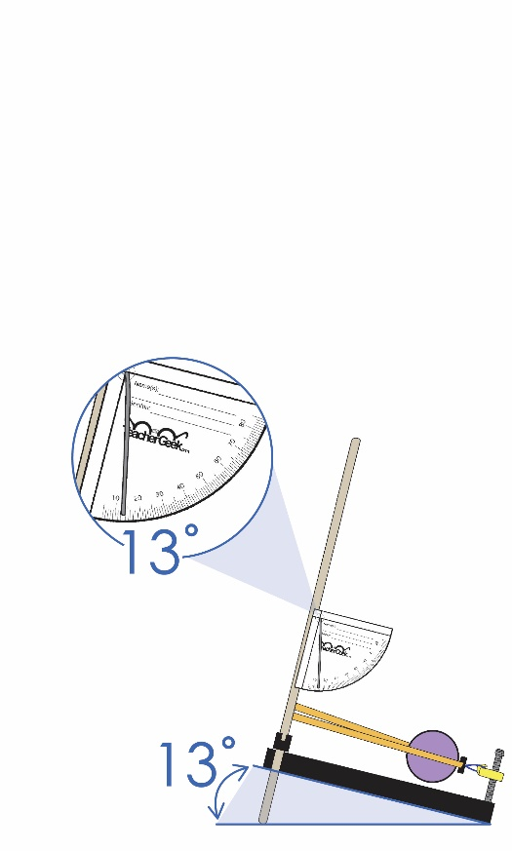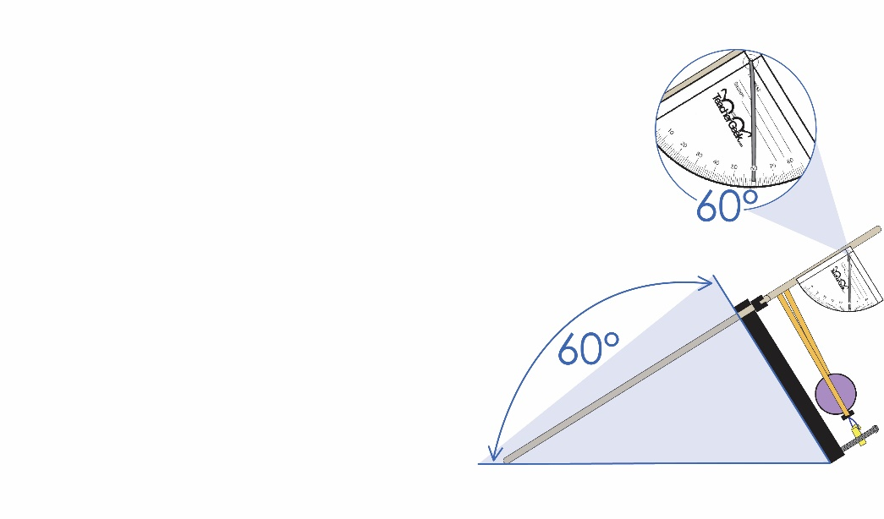

Read the angle   
on the **protractor**.



Legs

**►**

**Congratulations!**   
Your Launch Pad is finished!  
Now, it’s time to create   
the Launching Mechanism.



Printable Protractor Available at:

<http://teachergeek.org/protractor-angle_finder.pdf>



|  |  |  |  |
| --- | --- | --- | --- |
|  | **Cut** a piece of **connector strip**, four **holes** long.      4 holes |  | **Connect** two **rubber bands** to the cut **connector strip**, as shown.    Rubber Band  Loop!      Getting it right can be tricky. Take your time! |
|  | **Cut**, or find, a 8cm (3”) piece  of plastic coated **wire.** Fold it in half and place each end through a **connector strip** hole.  8cm Wire Piece |  | Twist **wire** ends together to create a strong **loop**. This will be the launch mechanism.  Wire |
| **►** | **Slide** the launch mechanism  **rubber bands** over the  Launch Pad **dowels** shown.  Rubber Bands  **Give it a try…** Pull it back, place a ping-pong  ball in the launch mechanism,  let go and watch it fly.  Can you get it to hit the same  spot twice? Probably not…  Try building a trigger to help out. | | |
|  | Place a **38mm** (1 ½”) **screw** through the bottom of the **hole plate**, as shown. **Fasten** it with a **nut**.    Tighten!  *Nut*  *38mm screw*  *Top View*  *Underside of Plate* | | |
|  | **Place** a **stop clip** on the **screw** to create a **trigger**.      *Trigger*    *Stop Clip*    Test Your Launcher Out! |  | **Place** a **lock nut** on the **screw** to prevent the stop clip from sliding off.  *Lock Nut* |

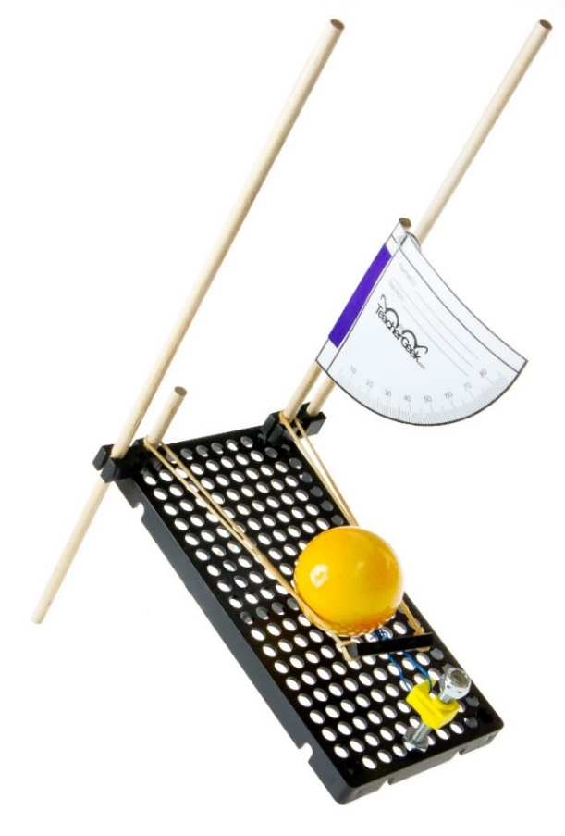

**A**

**Pull** back the **launching mechansism**   
and **attach** it to the **trigger** (stop clip).

**Place** a ping-pong **ball**   
into the **launch mechanism**.

***Turn the trigger (stop clip) to fire!***



**B**

**C**

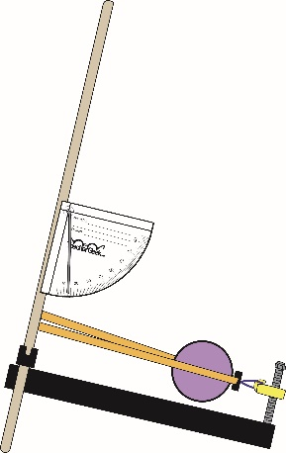

**Tip:** Make sure trigger is lined-up with the center   
of the ball.



*Pull!*

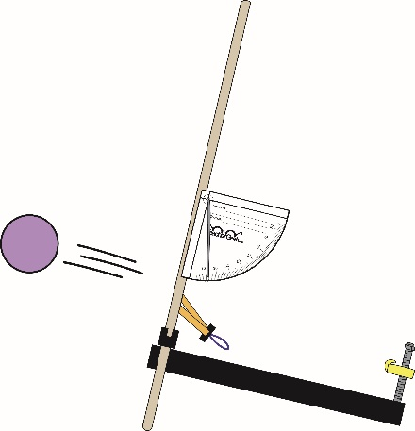



**Caution:** Wear safety glasses.   
*Never* launch at another person.

**C**

**B**

[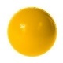](https://teachergeek.com/collections/secondary-schools-camps/products/ping-pong-ball-launcher-projectile-launcher?variant=344626559)

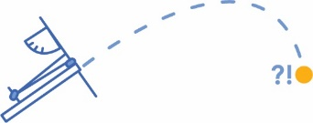

**=**

**Projectile**

**=**

**Trajectory**

The **angle** of launch affects the projectile’s **trajectory** (how high + far it launches).

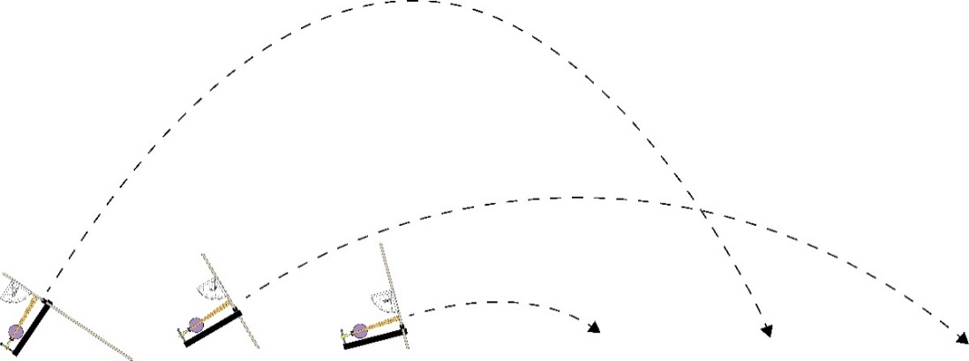

**Small˚**

**Medium˚**

**Large˚**



**Try It Out:** Slide the legs   
to change the **angle** *of the launcher? How does angle affect the projectile’s trajectory?*



**Small**

**Medium**

**Large**

< 30˚

30˚-60˚

> 60˚



**Target** (Bull’s-Eye Center)

**=**





**The example launcher is just…ok**You can redesign it much better!

**Redesign Your Launcher to Be…**



**Accurate** or how close you get to the ***actual*** (true) target or goal (bull’s-eye).

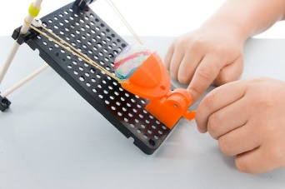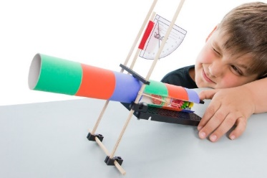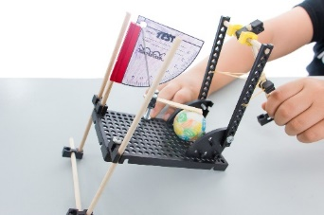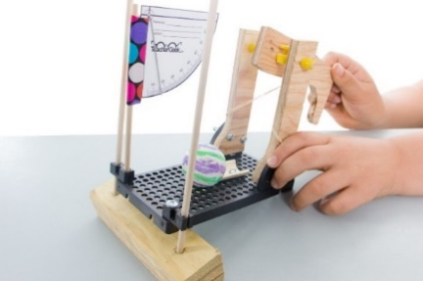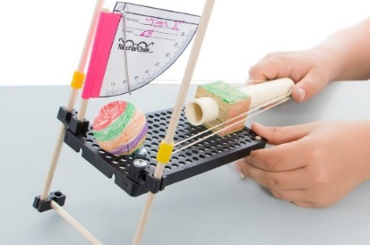

**Pew!**

**Pew!**



**Precise** orhow ***constant*** (repeatable) the results are (landing in the same spot).

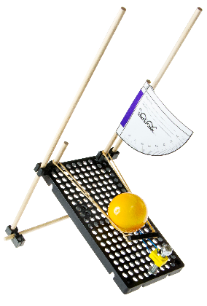

**Able to Launch Really, Incredibly Far**  
Power adds distance to your shots. Change how much power

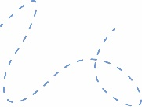



*I’m a little wimpy -  
my launch mechanism needs more* ***accuracy****!*

Use recycling bin materials, Teachergeek components & 3D printing for your design!



**There are many ways to send a ball flying. Here are a few ideas…**



**Sling It**

Pull back and let it go! This is the most popular launch mechanism. The example launcher uses it. You can design your own “better” version.





**Hit It**

Hit it like a golf ball or baseball. Get the launch mechanism moving   
before it contacts the ball.

**Toss It**

Toss it like a catapult, ballista or trebuchet. Note: It can be difficult to change only one independent variable (see below) with this launch mechanism.





**Variables:** The things that change in an experiment   
(when you launch a projectile and measure where it goes).   
Design and test your launcher so that only the independent and dependent variables change.

**Dependent Variable:** The variable being tested and measured.   
*Only have one dependent variable in your experiment, such as the* ***distance*** *projectile travels.*

**Independent Variable:** The thing you change in the   
experiment, to test how it effects the dependent variable.   
Only have one independent variable in your experiment**,** such as **launch angle**.

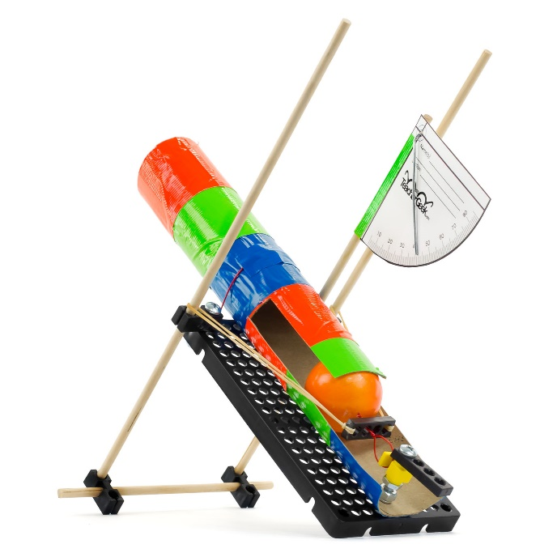



What are you waiting for? It’s time to start into a lab   
or engineering challenge. It’s going to be a blast!



Visit teachergeek.com/learn to download launcher lab and challenge documents.