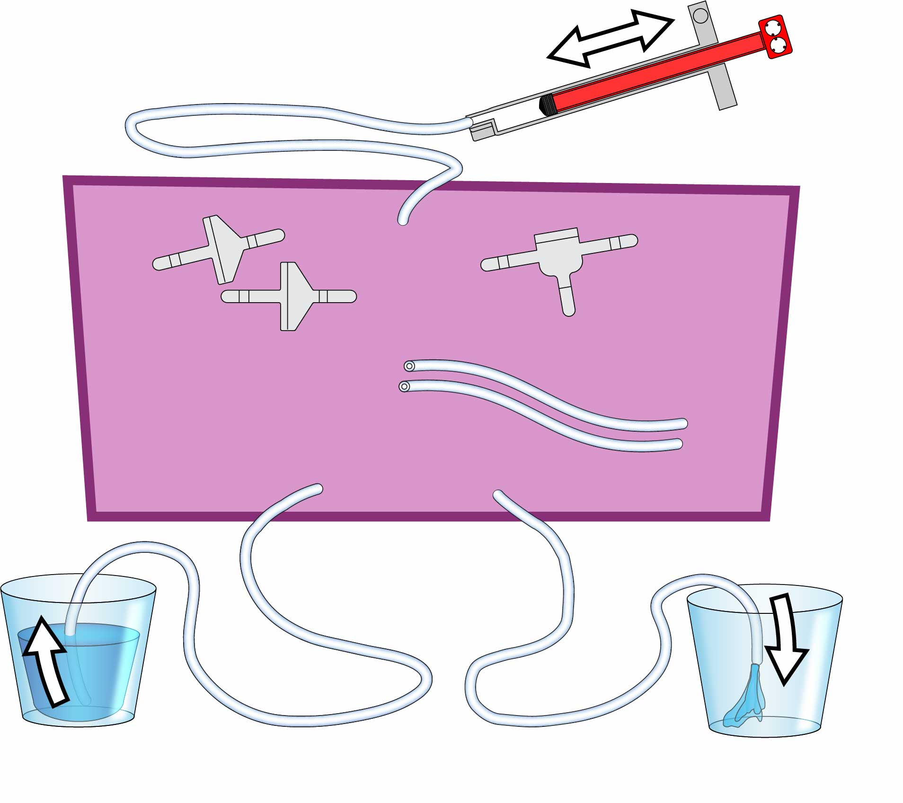

Mystery Parts

**Tubing  
30 cm** (12 in)

**2x**

**2x**

**1x**

**Tubing  
30 cm** (12 in)

**Check Valves**

Only let water (or air) through in one direction.

**T-Connector**

Joins 3 sections of tubing.

**Tubing  
15 cm** (6 in)

**Cylinder**

**Cup of Water**

**Empty Cup**



**Check out the** [**Scenario Video**](https://vimeo.com/411195838)**!**   
Play it by scanning the   
QR Code or going to[**teachergeek.com/windpump**](https://teachergeek.com/products/wind-pump-wind-turbine-mill-activity_v1-2)

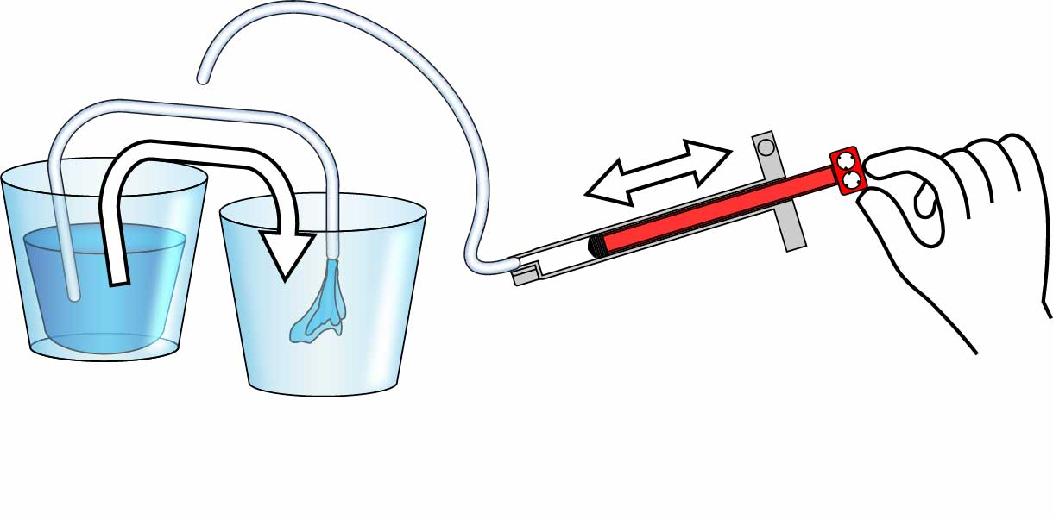

Mystery Parts

Your pump must move water from one cup to the other when you push & pull the cylinder.

**You’re going to engineer your very own hand pump!**

# Make Your Pump

**Tinker with the Mystery Parts!**   
You will need to **use all of them** to make your pump!

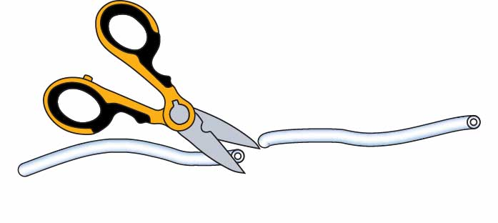

**Cut your tubing** to make   
 -**3x 30 cm** (12 in) sections &   
 -**2x 15 cm** (6 in) sections.

Can you figure out how to use these parts to build your pump?