

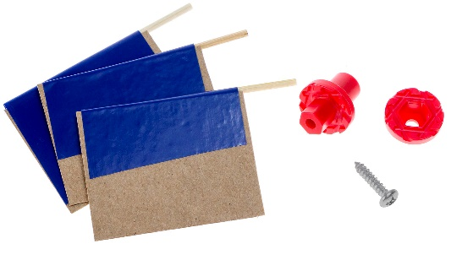

* **Red** **Mini Motor Mount Hub Base & Cover**
* Tape (any kind will do)
* Hub Screw
* Toothpicks (or skewers)
* Recycling Bin Materials



**Safety First**  
If you’re not already, wear eye protection during these steps & when operating your propeller.



|  |  |  |  |
| --- | --- | --- | --- |
| **Skewers Option**  Cut to size and cut off the pointed ends of **skewers**. | Cut the both ends off the **toothpicks**. |  | Measure and cut three  3cm x 6cm strips of **recycling materials.**  3cm  6cm    *These will be your blades.* |
|  | Lay a piece of **tape** (sticky side up) and lay a **toothpick** in the middle.  *sticky side up* |  | Place the **blade** on one half of the **tape**.  6cm  3cm |
| Make sure the tape is creased tight around. | Fold over the **tape** (around  the **toothpick** and **blade**). |  | Measure **15mm** from the end of **blade**… and cut.    **Congratulations!**  You made your first prop blade. Now, make *two more.*  You should have  *three* when finished. |





|  |  |  |  |  |  |
| --- | --- | --- | --- | --- | --- |
|  | Screw the **cover** to the **base** using a **screw**.  **Quick Tip** *Hold the base with pliers when turning in the screw.*      #6 screw    cover  base | | |  | Loosen the **screw** ½ turn.    Front View |
|  | Push the **blade** ends  into the **hub**. When set, retighten the **screw**. |  | Once you have your **hub** assembled, push it onto your **motor** as shown on the left. | | |





**Try Changing Blade Angle**

1. Loosen the hub screw a half turn.
2. Change the blade angle using   
   the protractor as shown.
3. Tighten the screw again.

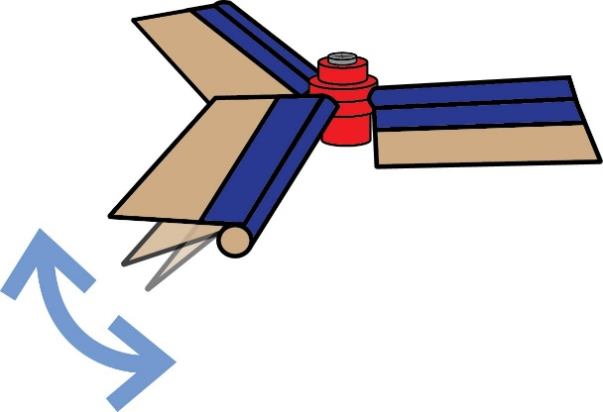

**Try Changing Blade Shape & Size**

Blade designs come in all shapes   
and sizes. Try adding to your blades   
by taping on extra pieces or cutting   
them down into new shapes.

Or try using only two blades.

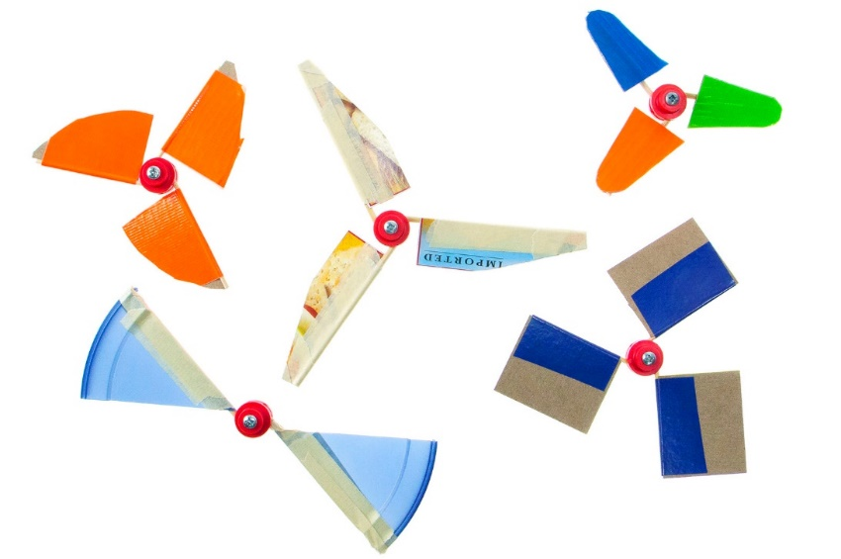



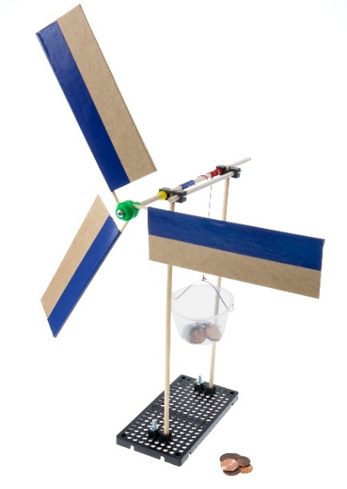



* **Green Mini Dowel Mount Hub Base & Cover**
* Tape (any kind will do)
* Hub Screw
* Toothpicks (or skewers)
* Recycling Bin Materials



|  |  |
| --- | --- |
|  | Cut **points** off **skewers**. |
|  | Tape your **recycling materials** (cardboard, card stock,  cereal boxes, etc.) to the **skewers** as shown below. |



1. Cut a section of **recycling material**. This will be one of your **blades**.



b. Place **tape** half over the edge   
 of the **blade**.



c. Place a **skewer** at the edge of   
 the **blade**, overhanging to one side.



d. Fold the **tape** over the **skewer**.  
 **Press** to secure tape.



|  |  |  |
| --- | --- | --- |
|  | **Push** or **tap** the **mini hub base** onto the **dowel** as shown.  mini hub screw  cover  base | **Attach** the **mini hub cover** to the **base** using a **mini hub screw**.  **Hub Assembly**  *This is what it should look*  *like when you are done.* |

|  |  |
| --- | --- |
|  | **Loosen** the **mini hub** **screw** about **1½** **turns** to allow the **skewers** to **slide** in.  First, **loosen** the mini hub screw  by **1½ turns**.  Then, carefully **slide** the skewers into the **mini hub’s holes**. **Angle** your blades and **re-tighten**.  skewer |