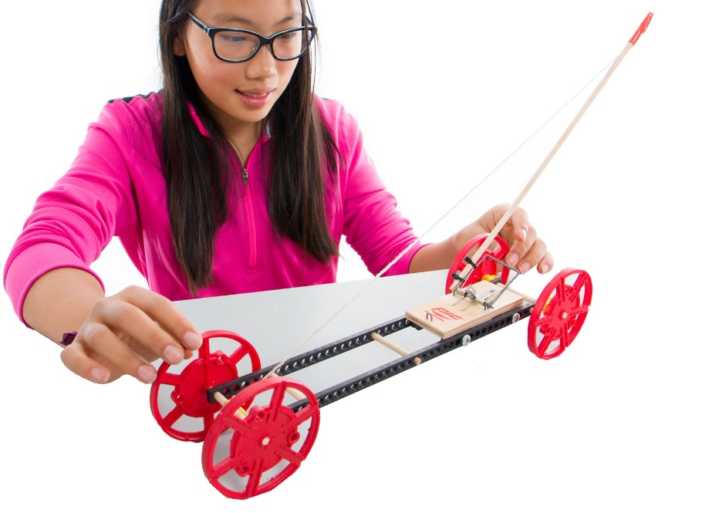

**The Challenge:** Redesign your vehicle  
 to go ***as far*** as possible.

**Challenge Supplies:**Mousetrap vehicle, ruler, tape,   
a flat 10 m (30ft) long area of floor

**Difficulty:** Easy-Medium



**Before you start…** Make sure you have built   
a **Mousetrap Vehicle** for use on this challenge.

Documents & supplies at teachergeek.com/learn

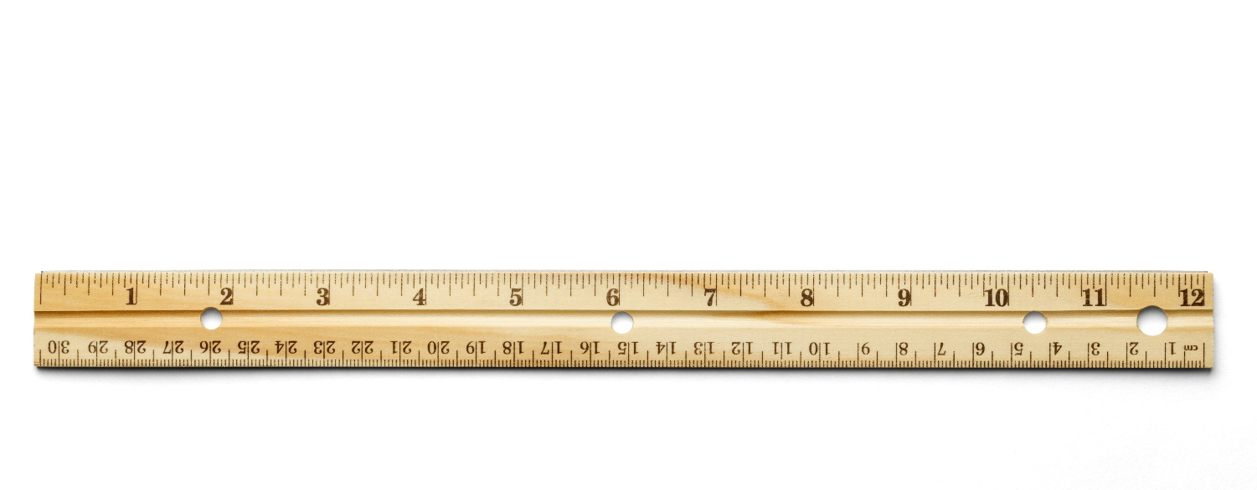



Add materials to   
the floor to add   
friction & difficulty.







**Ways to Play:**Scoring: Set the trap and let it go!  
When it stops, take a piece of tape   
(with your vehicle/team name on it).   
Keep **redesigning** and **retesting** - if your   
vehicle travels farther than a previous run,   
move the tape to mark this *new distanc*e.

**Customize & Brand Your Vehicle With The   
STEAM Sheets** at teachergeek.com/learn



**Constraints:** (rules and limits for your design)

**Allowable Materials**  
• TeacherGeek components  
• Recycled food packaging  
• Other available materials   
 (wood, plastic, etc.)

**Geometry**  
•At the start of the competition,   
 vehicles must fit within a   
 50cm x 50 cm x 50cm area.

**Function**• Your vehicle’s wheels must   
 begin behind starting line.  
• Measure the distance the   
 vehicle travels to its front wheels.



**Time Limit:**You will have ____________to complete the challenge.

*The time from building and   
re-designing your vehicle   
to the start of the competition.*

Fill in how much   
time you have



|  |  |  |  |  |  |  |
| --- | --- | --- | --- | --- | --- | --- |
|  | **Distance Reached by Mousetrap Vehicle in One Long Shot** | | | | | |
| **Vehicle or Design Name** | **Run #1** | **Run #2** | **Run #3** | **Run #4** | **Run #5** | **Run #6** |
|  |  |  |  |  |  |  |
|  |  |  |  |  |  |  |
|  |  |  |  |  |  |  |
|  |  |  |  |  |  |  |
|  |  |  |  |  |  |  |
|  |  |  |  |  |  |  |
|  |  |  |  |  |  |  |
|  |  |  |  |  |  |  |
|  |  |  |  |  |  |  |

**6.5 miles**

Name: _________________________________________________________ Set: __________

|  |  |  |  |  |  |  |  |  |  |  |  |
| --- | --- | --- | --- | --- | --- | --- | --- | --- | --- | --- | --- |
|  |  |  |  |  |  |  |  |  |  |  |  |
|  |  |  |  |  |  |  |  |  |  |  |  |
|  |  |  |  |  | **Revolutions/Distance Ratio** |  |  |  |  |  |  |
|  |  |  |  |  |  |  |  |  |  |  |  |
|  |  |  |  |  |  |  |  |  |  |  |  |
| 10m  9m  8m  7m  6m  5m  4m  3m  2m |  |  |  |  |  |  |  |  |  |  |  |
|  |  |  |  |  |  |  |  |  |  |  |  |
|  |  |  |  |  |  |  |  |  |  |  |  |
|  |  |  |  |  |  |  |  |  |  |  |  |
|  |  |  |  |  |  |  |  |  |  |  |  |
|  |  |  |  |  |  |  | Revolutions to Looped Clip/Mousetrap  (Independent Variable) |  |  |  |  |



Distance Traveled

(Dependent Variable)