You created an amazing design. You think it’s great, but would someone else? What would happen if you put it onto a store shelf   
(like a toy or tool), or really created it (like a bridge or building)?   
Would people want to bring it home to their house or have it built in their community? No???? Let’s fix that with some marketing.

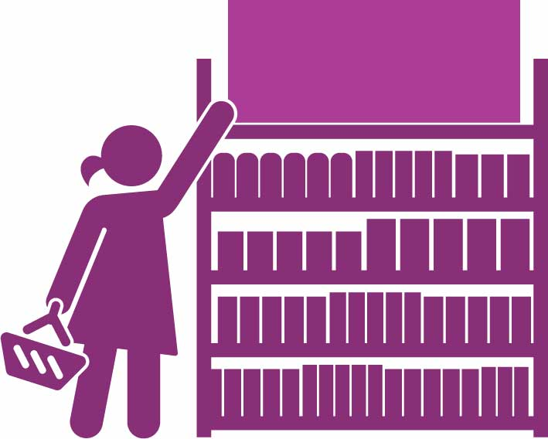

YOUR  
PRODUCT

# Your Challenge

Store Shelf

Turn your design into a retail product   
(a product that could be sold in stores or built in your community). Create marketing materials to persuade people to buy it.

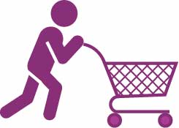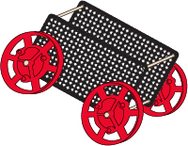

Marketing is the action of promoting and selling products or services.

# 4 Ps of Marketing

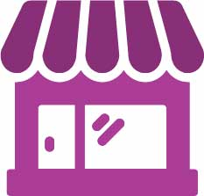

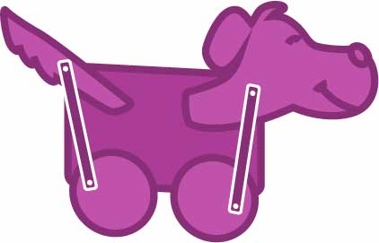Marketing is often broken down into 4 ‘Ps’: Product, Placement, Price, Promotion

BUY MY STUFF



SALE

* What price will you sell

your product for?

* How will your price compare with your competitors?

**Price**

* What does the customer want   
  or need from the product?
  + Function: What does your product do? What features does it have that make it stand out, or work better than other similar products?
  + Form: Is your product attractive? Does it make people feel an emotion?
* What will your product be called?
* Will it have a brand?

How and where will you market your product?

**Promotion**

**Placement**

* Who is your target customer? What are the best ways to reach them with your marketing?
* Convince your customers to get your product by creating promotional materials. Here are some ideas…
  + A Commercial for TV or Internet
  + A Billboard (not full size) or In-Store Advertisement (poster)
  + Retail Packaging (a decorated box or bag designed to protect and

market your product)

**Product**

Where will your product be sold?