STEM Cart Application + Helpful Info
Everything you’ll need to apply for your free Cart!
sales@teachergeek.com
These are the questions you will see when you apply online plus some helpful
info you’ll need to craft your responses.
PDF available at TeacherGeek.com/IowaSTEM
Fill out and submit your application at iowastem.org/Scale-Up-Application
Applicant Information

- Applicant First Name: Applicant Last Name:
- City: Applicant STEM Region:
- Applicant Organization/School Building:
- Applicant Title in Organization/School:
- Applicant Organization/School Address:
- Applicant Organization/School Address 2:
- County: Zip Code:
- Applicant Phone Number (with area code):
- Applicant Summer Phone Number (with area code):
- Applicant School/Organization Email:
- Confirm Applicant School/Organization Email:
- Is your shipping address for STEM Scale-Up Program
materials and equipment different from above?
- Administrator's First Name:
- Administrator's Last Name:
- Administrator's Email:
- Administrator's Phone Number:
- Institution's Fiscal Agent/Business Manager First Name:
- Institution's Fiscal Agent/Business Manager Last Name:
- Institution's Fiscal Agent/Business Manager Email:
- Institution's Fiscal Agent/Business Manager Phone Number:
- Educators Implementing and Attending Required Professional Development:
- Educator 1 Information
  - First Name:
  - Last Name:
  - Title:
  - Phone Number (Ex. 111-111-1111):
  - Email:
  - Summer Email:
  - Grade Level(s):
Implementation Questions
- Who are your intended participants?
- Grade Levels: Will this program be implemented in school or out of school or both?
Cart activities span grades Pre-K to 12+ (ages 4 to 18+)
Kids grades 3 (age 8) and below will need some adult assistance

Help with Answering this Question
- How many classrooms, sections, or youth groups will implement the program during the year?
These educators may apply to Share a Cart  (max of 3 educators per Cart) | These educators should apply for  Their Own Carts  (sharing not recommended)
- Elementary Classroom Teachers  - Secondary Science Teachers | - STEM Teachers  - Elementary Specials/Enrichment Teachers  - Secondary Elective Teachers  (e.g. Technology, Engineering, etc.)

Help with Answering this Question

- Estimated total number of youth who will participate:
The STEM Cart has enough components to make 100 of any activity (300 kids in groups of 3), and enough tools for one class of 36 kids to be making at one time.
Help with Answering this Question
- What percentage of youth are on free/reduced lunch? (round to nearest whole number) Please refer to https://educateiowa.gov/data-reporting/education-statistics-pk-12#Student_Enrollment for guidance of free/reduced lunch by Iowa Schools. Any questions about this report, please email them to info@iowastem.org.
- What will be the estimated number of females participating in the program?
- What will be the estimated number of youth of diversity (e.g. youth of color, disability) participating in the program?
- If applying for more than one STEM Scale-Up Program for this location, please rank preference for this program (e.g. 1st of 3, 2nd of 2).
9. How will the STEM Scale-Up program fit into and improve your current STEM
units, lessons, curricula? Please provide a specific example. (500 word limit)
Help with Answering this Question

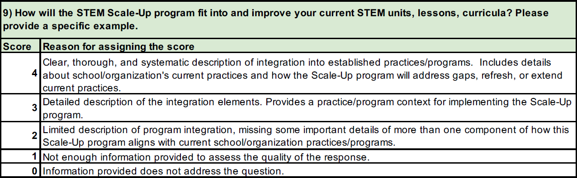
How this question will be scored…
(from IowaSTEM.org/Scale-Up-Application)

Clear, thorough, and systematic description of integration into established practices/programs. Includes details about school/organization’s current practices and how the Scale-Up program will address gaps, refresh, or extend current practices.
Ideas for writing your response...
Ways to integrate  STEM Cart | How STEM Cart integration addresses gaps, refresh,  or extend current practices
Incorporate Activities into Science Units  Recommended for elementary classroom teachers and secondary science teachers | - Included curriculum makes Science/STEM truly interdisciplinary, incorporating Science, Technology, Engineering, Math, Reading, and sometimes other core subjects (e.g. Social Studies) in essential documents; optional modules extend any activity into Art and Marketing disciplines  - Easily meet NGSS standards for Engineering while connecting engineering activities to many other NGSS Disciplinary Core Ideas and mathematics through optional labs and inquiry that’s infused in STEM Cart curriculum  - Makes science more engaging (hands-on learning, competitions + challenges, immersive scenario videos)  - Kids apply the science they are learning, bringing them to higher cognitive domains (Bloom’s Taxonomy, Depth of Learning); this leads to deeper understanding of information and reduces the time kids need to review their learning
Retool or Create STEM/Engineering Curriculum  Recommended for dedicated STEM teachers and elective teachers | - Included curriculum makes Science/STEM truly interdisciplinary, incorporating Science, Technology, Engineering, Math, Reading, and sometimes other core subjects (e.g. Social Studies) in essential documents; optional modules extend any activity into Art and Marketing disciplines  - Easily meet NGSS standards for Engineering while connecting engineering activities to many other NGSS Disciplinary Core Ideas and mathematics through optional labs and inquiry that’s infused in STEM Cart curriculum  - Perfect amount of structure – guided activities get students started, guide their exploration, and push them create their own unique designs  - Real engineering – kids actually design, test, redesign, and repeat; there’s no perfect design so kids are never done making  - Real data – data so good kids can measure the effects of design changes, even using the data to complete optional science labs  - Tons of ready-to-go resources from editable guides, labs, and challenge documents to scenario videos that launch and immerse kids in an engineering problem
Upgrade/Create
a Makerspace or STEM Room
Be sure to describe and relate to your current practices
More info on how STEM Cart activities can improve your current programs: TeacherGeek.org/STEM-Check.pdf
10. Describe the implementation plan and the students for whom, when and where
the Scale-Up program will be used so that reviewers can understand for whom and
where the program will be implemented. (500 word limit)
Help with Answering this Question

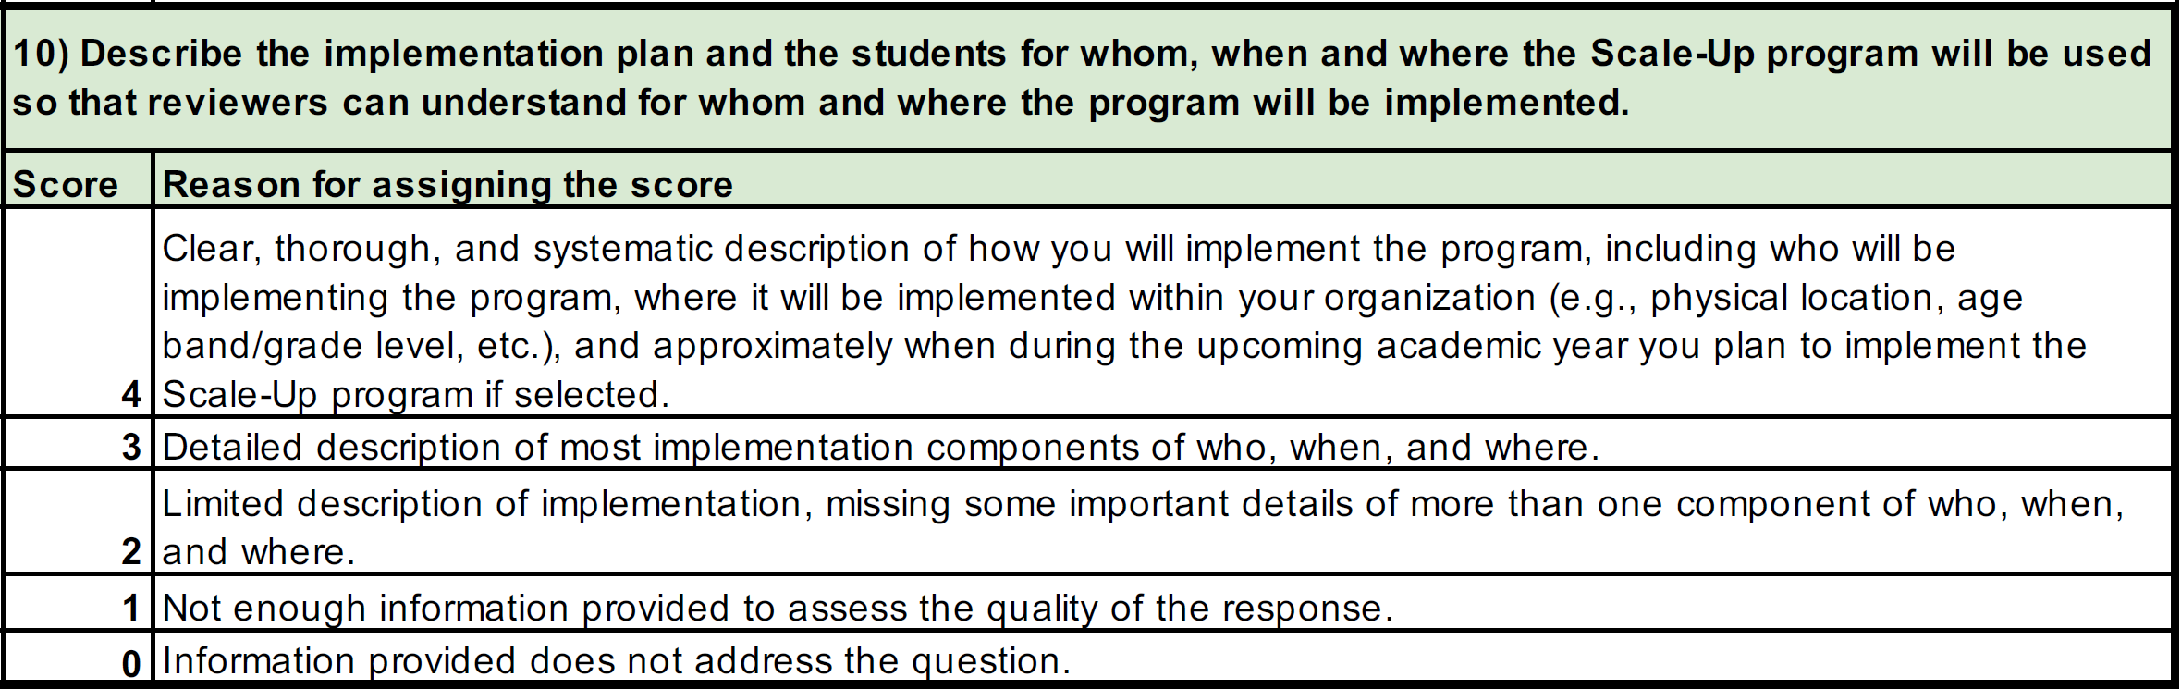
How this question will be scored…
(from IowaSTEM.org/Scale-Up-Application)

Clear, thorough, and systematic description of how you will implement the program, including who will be implementing the program, where it will be implemented within your organization (e.g., physical location, age band/grade level, etc.), and approximately when during the upcoming academic year you plan to implement the Scale-Up program if selected.
Info for writing your response...
Who may implement the STEM Cart | Where it will be implemented within your organization | Approximately when you plan to implement the STEM Cart
Elementary Schools:  - Classroom Teachers  max of 3 teachers taking turns with 1 cart  - STEM Teachers  teachers need own carts  sharing not recommended  - Specials/Enrichment Teachers  teachers need own carts  sharing not recommended  - Other appropriate faculty  Secondary Schools:  - Science Teachers  max of 3 teachers sharing 1 cart  - Elective Teachers  (e.g. Tech, Engineering, STEM, etc.)  max of 1 teacher per cart  - Other appropriate faculty  Other Organizations:  - Any appropriate adult | Physical Location:  - Cart Dimensions:  52” wide x 72” tall x 17” deep  dimensions are approximate  - The Cart can be rolled from location-to-location and should be stored where kids do not have unsupervised access to the Cart  Ages & Grades:  - Activities for grades  Pre-K to 12+ (ages 4 to 18+)  Kids grades 3 (age 8) and below will need some  adult assistance | 11/01/2023 is the safest date to begin implementation. Plan your implementation using the dates below:  - PD Sessions to be completed over summer break before the 2023-24 school year  - Curriculum is always publicly available at TeacherGeek.com/learn  (no purchase or login necessary)  - Cart Deliveries expected to be complete by 08/31 (no carts will be delivered after 10/31)

11. The goal of the STEM Scale-Up Program of the Iowa Governor’s STEM
Advisory Council is to “seed” or start programs (not sustain). What is your plan to
cover the costs of sustaining this program in future years (supplies and materials,
fees, additional training, etc.)? (300 word limit)
Help with Answering this Question
How this question will be scored…
(from IowaSTEM.org/Scale-Up-Application)

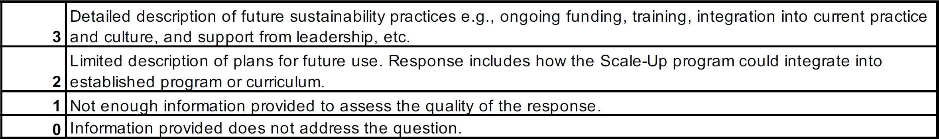
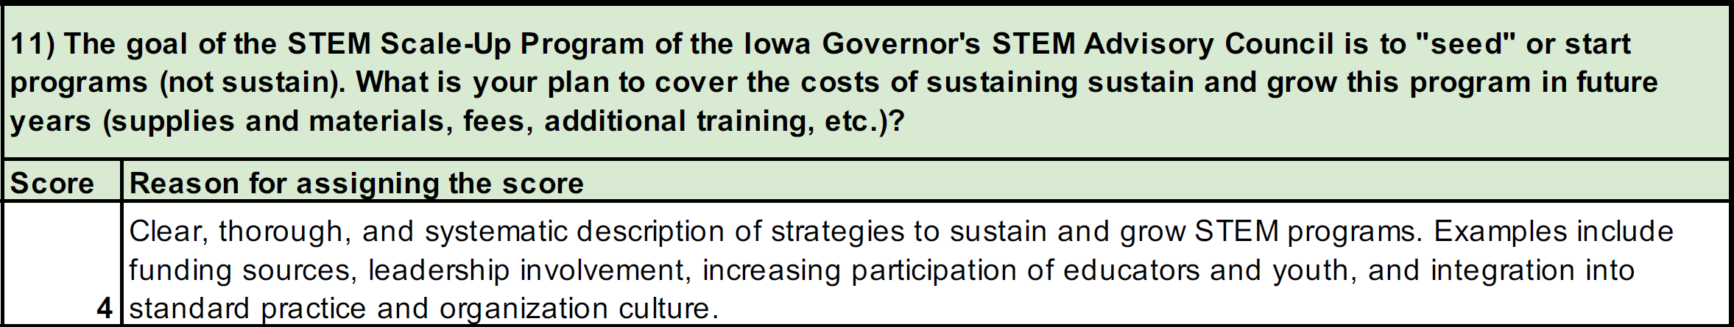
Clear, thorough, and systematic description of strategies to sustain and grow STEM programs. Examples include funding sources, leadership involvement, increasing participation of educators and youth, and integration into standard practice and organization culture.

Info/Ideas:

Ideas for writing your response...

Funding | Sustainability Cost: under $200/year for most schools  Possible Community Partners: see TeacherGeek.com/IowaFunding  Perks for Community Partners: (why might they fund your program?)  - Low-cost way for partners to positively impact their community  - Partners can showcase their social impact to strengthen their brands
Leadership Involvement | Community Partners will ideally go beyond funding – they should participate in STEM Cart engineering challenges with students, preferably following a routine (e.g. once per quarter)  - All community partners can connect students’ STEM problem solving to the problem solving that adults do in real-life  - Community partners with backgrounds in STEM can give STEM-specific feedback to students during engineering challenges  - Business-minded partners can assist students in the STEAM Market-It Challenge, where kids transform their STEM Cart creations into retail products
Increasing Participation of Youth & Educators | Educators:  - Free Professional Development videos will be available starting Summer 2023 to train new teachers (note: in-person PD is required to get the STEM cart award – video PD can be used to sustain only)  Youth:  - The STEM Cart increases participation of youth by:  - Engaging kids with hands-on learning, competitions + challenges, immersive scenario videos, picture-heavy documents  - Scaffolds that support struggling learners who might otherwise become disengaged due to frustration  - Giving students equal access to quality building components, leveling the competition for kids who are economically disadvantaged
Integration into Standard Practice | - Ideally, community partners assist with engineering challenges a few times each year, and the relationship would persist, where their involvement becomes an integrated into standard practices for engineering activities

12. The STEM Council established the priority to reach children of high need and/or under-served (specifically rural/urban, ethnic/racial minority, gender distribution, free or reduced lunch, special needs and low STEM academic performance). Please identify the high-need groups you will serve using this program. (500 word limit)
Help with Answering this Question

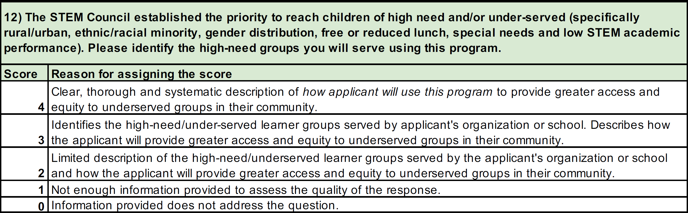
How this question will be scored…
(from IowaSTEM.org/Scale-Up-Application)

Clear, thorough, and systematic description of how applicant will use this program to provide greater access and equity to underserved groups in their community.

Ideas for writing your response...

Identify and remedy barriers for underrepresented youth in STEM
Barrier | Remedy
Financial hardship | STEM Carts level the playing field for materials. All students have access to the same components, so the child whose guardian has a machine shop in their garage will no longer outperform the child repurposing items from the recycling bin.
Frustration, gaps in prior knowledge, or insufficient support | Guided activities appropriately balance challenge and support by getting students started, ensuring some initial success, and guiding students through testing and re-engineering their creations. Documents are rich with pictures and graphics to assist struggling readers. They are also editable and modular, so curriculum can be customized to meet the needs of specific populations.
Insufficient engagement due to lack of interest  or relevance | Curriculum is designed to engage all students. Documents are picture-heavy, connecting to real-world applications and, where possible, other subjects and cultures. Activities are hands-on with heavily graphical documents and videos to engage different learning styles/preferences. Optional scenarios and scenario videos immerse kids and the challenges, making them more relevant and fun.

Ways that you (not your district/organization) can use this program beyond the classroom to impact underrepresented youth, if none are in your classroom
- Collaborate with other classrooms or schools who may have more students with disadvantages (e.g. share
the Cart, create an afterschool program, peer mentorship program, etc.)
- Create an afterschool or lunch workshop for students outside your classroom who are struggling/unengaged
in science

