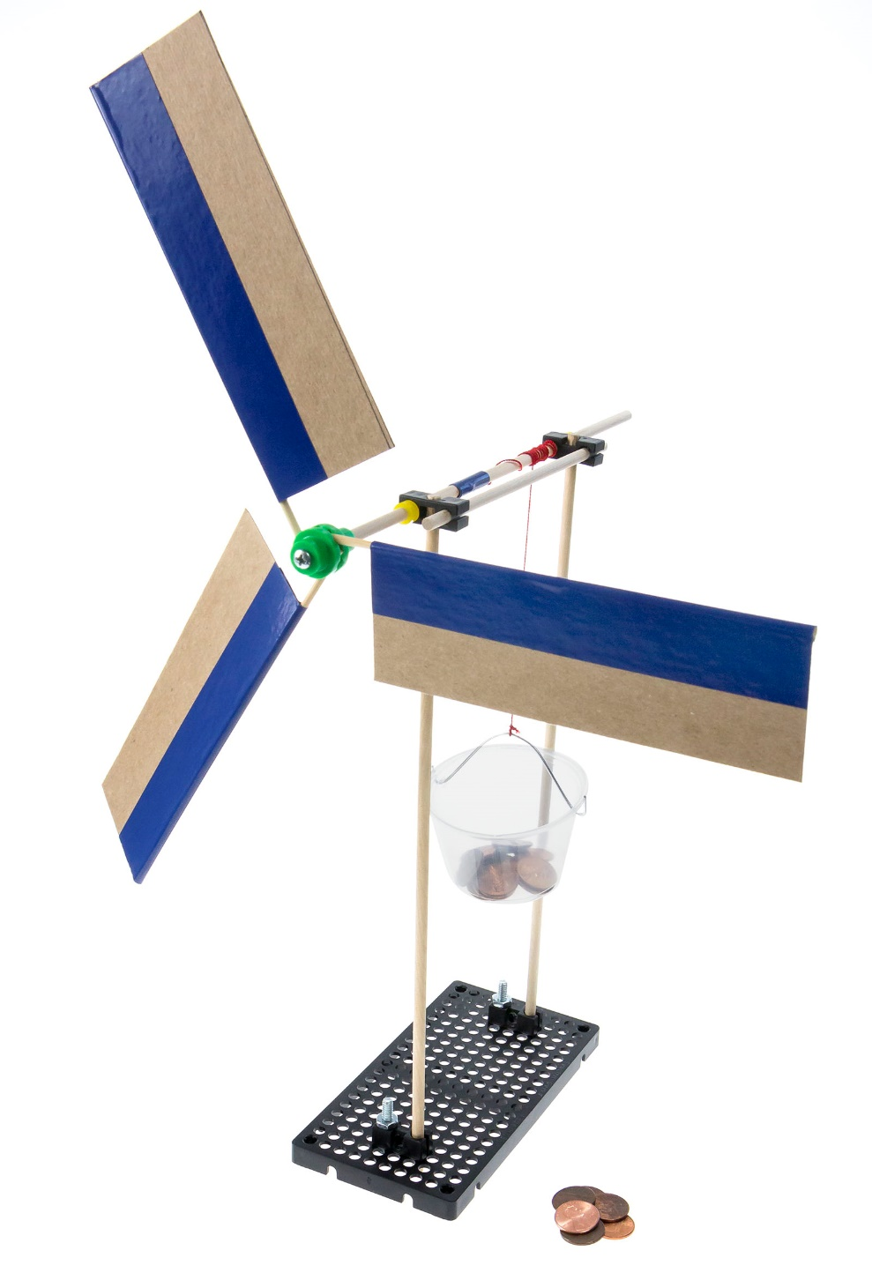

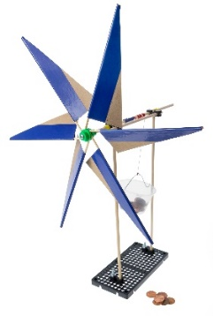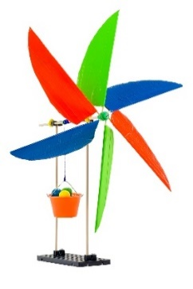

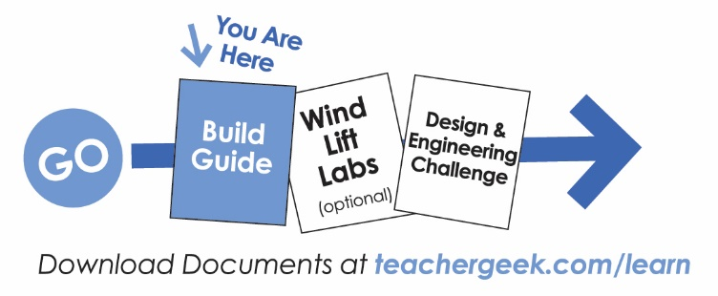

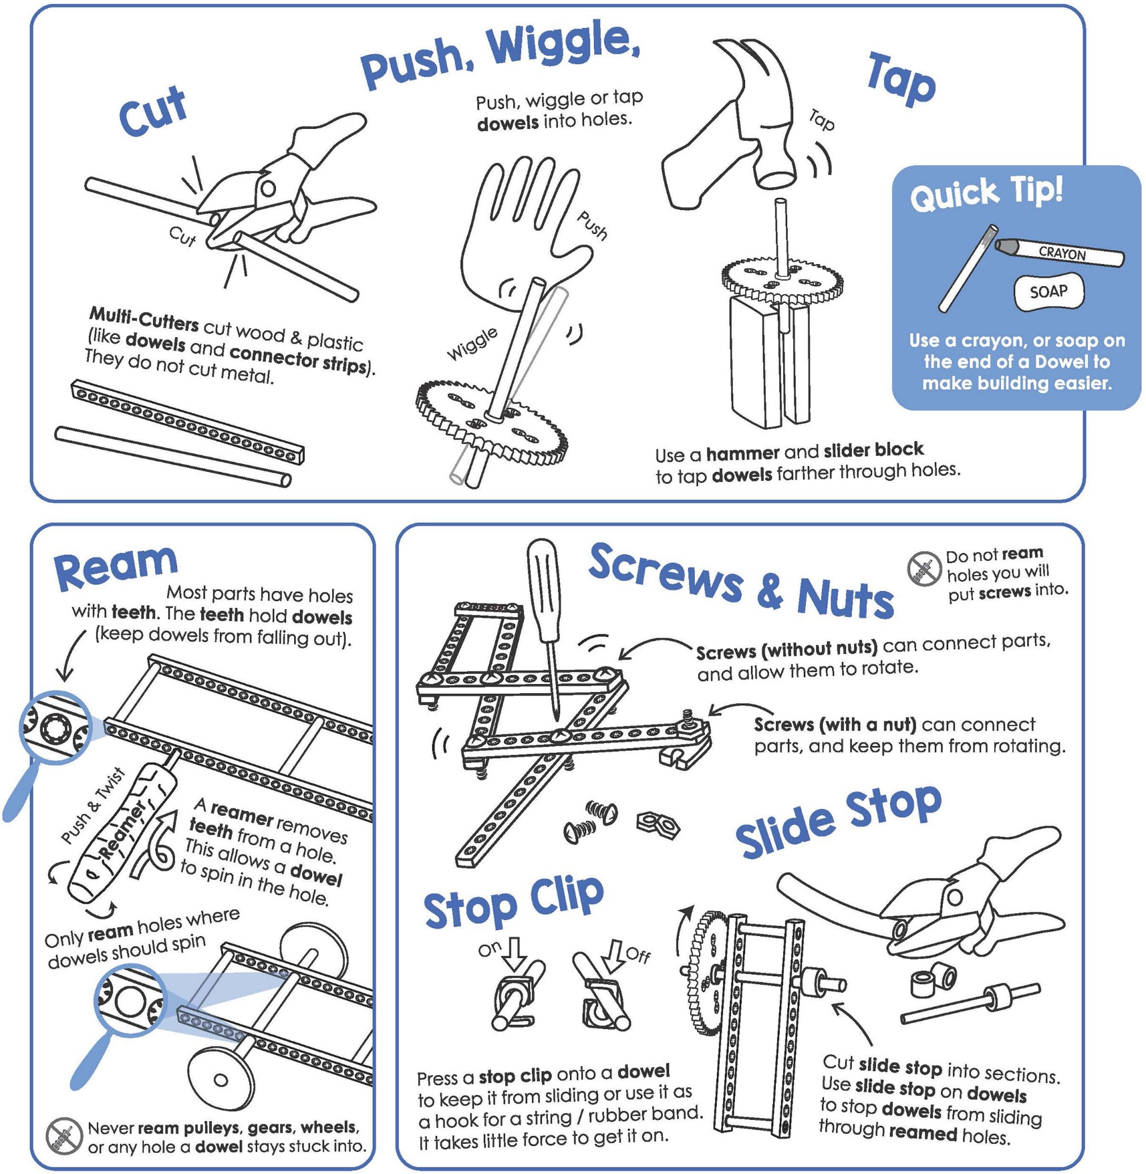

*Start by building the example Wind Lift,   
then turn it into your own unique design.*

For use with TeacherGeek [Wind Lift Activity Pack](https://teachergeek.com/products/teachergeek-wind-lift?variant=344617145), or [Maker Cart](https://teachergeek.com/products/maker-cart). Find documents and activity materials at [**teachergeek.com**](https://teachergeek.com/).



[](https://teachergeek.com/products/teachergeek-wind-lift?variant=344617145)Below is the list of “ingredients” you’ll need to build one Wind Lift.   
It includes some extra components to allow you to create your own unique design.

|  |  |  |  |  |  |
| --- | --- | --- | --- | --- | --- |
|  |  |  |  |  |  |
| **4 -** [**Blocks**](https://teachergeek.com/products/teachergeek-wind-lift?variant=344617145) | **4 -** [**Dowels**](https://teachergeek.com/products/teachergeek-wind-lift?variant=344617145)  300mm (12″) | **1 -** [**Hole Plate**](https://teachergeek.com/products/teachergeek-wind-lift?variant=344617145) | **1 -** [**Slide Stop**](https://teachergeek.com/products/teachergeek-wind-lift?variant=344617145)  100mm (3″) | **2 - 25mm** [**Screw**](https://teachergeek.com/products/teachergeek-wind-lift?variant=344617145)**s** #10 25mm (1″) | **2 -** [**Nut**](https://teachergeek.com/products/teachergeek-wind-lift?variant=344617145)**s** #10 |
|  |  |  |  |  |  |
| **1 -** [**Mini Hub Screw**](https://teachergeek.com/products/teachergeek-wind-lift?variant=344617145) | **1 -** [**Mini Hub Cover**](https://teachergeek.com/products/teachergeek-wind-lift?variant=344617145) | **1 -** [**Mini Hub Base**](https://teachergeek.com/products/teachergeek-wind-lift?variant=344617145) | [**10 – Large Project**](https://teachergeek.com/products/teachergeek-wind-lift?variant=344617145) **Sticks** | **1 -** [**Wire Roll  or section**](https://teachergeek.com/products/teachergeek-wind-lift?variant=344617145) | **1 -** [**Portion Cup**](https://teachergeek.com/products/teachergeek-wind-lift?variant=344617145) |



|  |  |  |  |
| --- | --- | --- | --- |
|  |  |  |  |
| [**Multi-Cutter**](https://teachergeek.com/products/1823-81)[SKU 1823-81](https://teachergeek.com/products/1823-81) | [**Reamer**](https://teachergeek.com/collections/tools-resources/products/teachergeek-reamer)[SKU 1823-87](https://teachergeek.com/collections/tools-resources/products/teachergeek-reamer) | [**Screwdriver**](https://teachergeek.com/products/stubby-2-screwdriver)[SKU 1823-90](https://teachergeek.com/products/stubby-2-screwdriver) | [**Pliers**](https://teachergeek.com/products/slip-joint-pliers-6)[SKU 1823-86](https://teachergeek.com/products/slip-joint-pliers-6) |



|  |  |  |  |
| --- | --- | --- | --- |
|  |  | Image result for pennies |  |
| **Tape** | **String**  450mm (1.5ft) | **Pennies**  100 or moreto lift | **Recycling Materials** (for blades) |





|  |  |  |  |  |  |
| --- | --- | --- | --- | --- | --- |
| top view  nut  block  25mm screw  bottom view | **Attach** two **blocks** to the **hole plate** using a **25mm screw** and **nut.** | | | | |
|  | Take **two** **dowels**. **Tap** each one into the **middle hole** of a **block.**  block  dowels | |  | | Push **dowels** through the **blocks** on the **hole plate** as shown.  **Quick Tip**  *Keep block holes lined up straight.* |
|  | Cut a **15cm** (4”) dowel.    15cm  **Ream** the two holes marked with the  symbol.    25cm  **Quick Tip**  Be sure to ream holes very well. | |  | | **Insert** the **dowel** into the **block** holes in the **uprights** as shown.    15cm dowel  upright  upright  Cut a **25cm** (10″) **dowel**.  *\*images not to scale* |
|  | **Cut** a **6mm** (¼″) **slide stop** section.  6mm slide stop  **Push** or **tap** the **mini hub base** onto the **dowel** as shown.  base  **Slide** the **dowel** into the **reamed** holes of the **blocks** as shown. | |  | | **Push** the **slide stop** 5cm (2″)  onto the **dowel**.  5cm  **Attach** the **mini hub cover** to the **base** using a **mini hub screw.**  mini hub screw  cover  **Hub Assembly**  *This is what it should look*  *like when you are done.*  **Tape** the **45cm** (1.5ft) **string** onto the **dowel** in the **reamed holes**.  tape  string |
|  | Make a **handle** for the **portion cup** out of **wire**.  **Poke** two **holes** with scissors or a screwdriver  to **tie** the **wire** through.  wire | | | | |
|  | **Tie** the **handle** to the **string**. | **Quick Tip** Add more slide stop  to keep the dowel  from falling out. | |  | |

**Congratulations!**

*You did it. You made the lift mechanism of your design.*

*Experiment and play.   
Spin the dowel to see how the cup rises and lowers.*

*Next, let’s add blades to use the power of the wind.*



Now it’s time to make your blades. Make the example blades shown below. Then, in the Engineering Challenges, make them into your own unique design.

|  |  |
| --- | --- |
|  | Cut **points** off the **large bamboo project sticks**. |
|  | Tape your **recycling materials** (cardboard, card stock,  cereal boxes, etc.) to the **skewers** as shown below. |



c. Place a **stick** at the edge of   
 the **blade**, overhanging to one side.



1. Cut a section of **recycling material**. This will be one of your **blades**.



b. Place **tape** half over the edge   
 of the **blade**.



d. Fold the **tape** over the **stick**.  
 **Press** to secure tape.

|  |  |
| --- | --- |
|  | **Loosen** the **mini hub** **screw** about **1 turn** to allow the **project sticks** to **slide** in.  First, **loosen** the mini hub screw  by **1 full turns**.  Then, carefully **slide** the sticks into the **mini hub’s holes**. **Angle** your blades and **re-tighten**.  skewer |

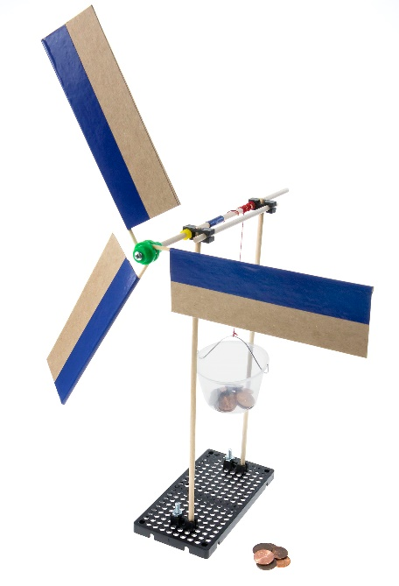



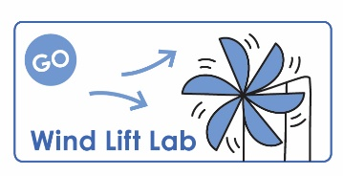

Documents at **teachergeek.com/learn**

If you are going   
to do the optional   
*Wind Lift Lab*,   
now’s the time!