Name: ________________________________________ Set: _______ Date: _______

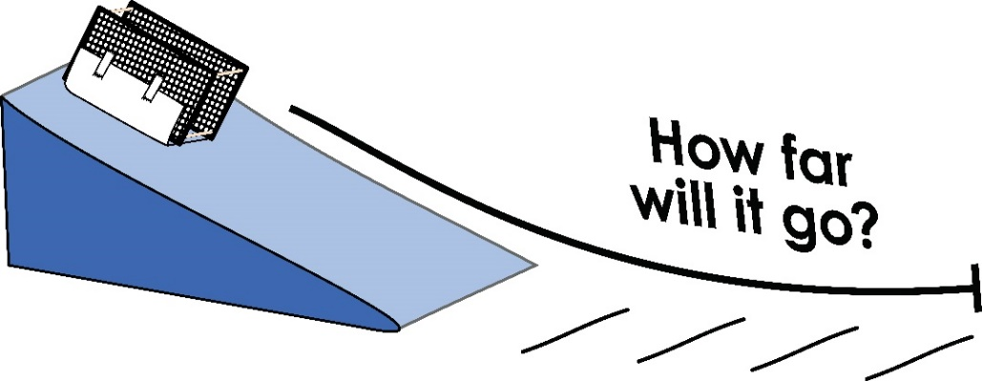

**The Challenge:**

Create a sled that will slide down the ramp and travel the farthest distance on the floor. Attach materials to the bottom of it to lower friction and make it go farther.

Instructions for building the ramp are available at teachergeek.com/learn

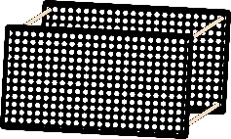**The Frame:**

You will need a **frame** for this challenge. The **Rubber Band Racer**, **Ramp Roller** or **Toy Workshop Build Guides** show how to make one.

**Materials Used to Make the Sled:**

* 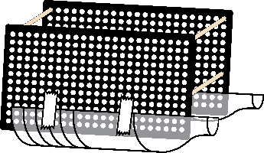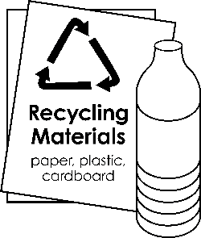Recycling Bin materials
* Teacher/School materials
* Masking tape
* Paper & Craft Supplies
* Crayons & Markers

**Criteria** (the rules)**:**

* Must use a frame made of two TeacherGeek hole plates and four dowels
* The sled must slide (no wheels may be used)
* The sled may only be powered by gravity (do not push it)
* Materials may not be left on the ramp (water, oil, etc.)
* The sled may be no more than 25x25x25cm (10x10x10in) in area
* You must give the sled a name: ________________________________________

**Hypothesis:** What materials do you think will allow your sled to slide the farthest? Why do you think they will work well?

_____________________________________________________________________________

_____________________________________________________________________________

_____________________________________________________________________________

**Test it:** Attach different materials to the bottom of the sled. Place it at the top of the ramp and let it slide. Observe how far and fast it travels.

|  |  |  |
| --- | --- | --- |
| **Material Attached to Bottom of Sled** | **Distance Traveled** | **Conclusion** |
|  |  |  |
|  |  |  |
|  |  |  |
|  |  |  |
|  |  |  |
|  |  |  |

**Conclusion:** Did the materials work like you thought? What happened?

_____________________________________________________________________________

_____________________________________________________________________________

_____________________________________________________________________________

**Class: _________________________________________________ Set: ________________**



How far did your racer go?

|  |  |  |  |  |  |  |  |  |  |
| --- | --- | --- | --- | --- | --- | --- | --- | --- | --- |
| **Team** | **Test**  **#1** | **Test**  **#2** | **Test**  **#3** | **Test**  **#4** | **Test**  **#5** | **Test**  **#6** | **Test**  **#7** | **Test**  **#8** | **Test**  **#9** |
|  |  |  |  |  |  |  |  |  |  |
|  |  |  |  |  |  |  |  |  |  |
|  |  |  |  |  |  |  |  |  |  |
|  |  |  |  |  |  |  |  |  |  |
|  |  |  |  |  |  |  |  |  |  |
|  |  |  |  |  |  |  |  |  |  |
|  |  |  |  |  |  |  |  |  |  |
|  |  |  |  |  |  |  |  |  |  |
|  |  |  |  |  |  |  |  |  |  |
|  |  |  |  |  |  |  |  |  |  |
|  |  |  |  |  |  |  |  |  |  |
|  |  |  |  |  |  |  |  |  |  |
|  |  |  |  |  |  |  |  |  |  |