  
Nombre: **________________________________**

Área de la pista: 10 m (30 pies) de largo por 2 m (6 pies) de ancho. Se recomienda piso sin alfombra.

Marcas de cinta adhesiva cada metro (3 pies).

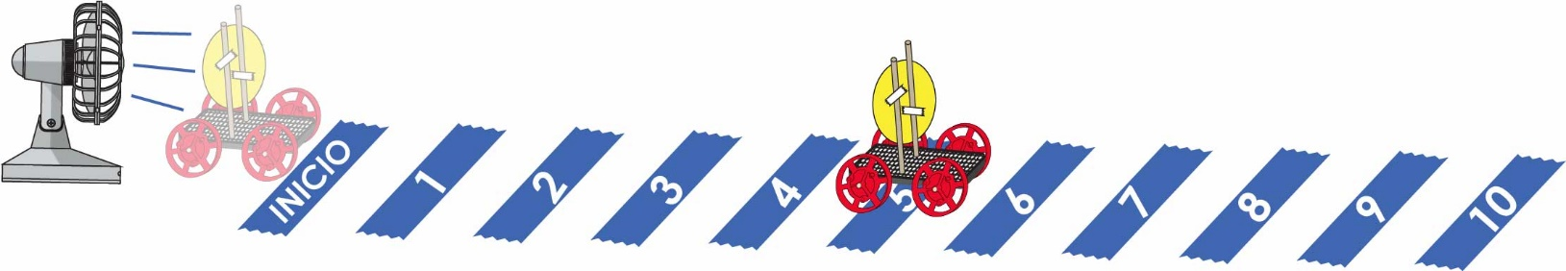

Revisa el [**Video**](https://vimeo.com/406308538) **del Laboratorio** escaneando el código QR o ingresando en [**teachergeek.com/sailcar**](https://www.teachergeek.com/sailcar)

**Predice:** Circula qué tan lejos *crees* que llegará.



**Pequeño**

|  |  |  |  |  |  |  |  |  |  |  |
| --- | --- | --- | --- | --- | --- | --- | --- | --- | --- | --- |
|  | **1** | **2** | **3** | **4** | **5** | **6** | **7** | **8** | **9** | **10** |

**Prueba:** Circula, ¿Qué tan lejos llegó?

|  |  |  |  |  |  |  |  |  |  |  |
| --- | --- | --- | --- | --- | --- | --- | --- | --- | --- | --- |
|  | **1** | **2** | **3** | **4** | **5** | **6** | **7** | **8** | **9** | **10** |

**Predice:** Circula qué tan lejos *crees* que llegará.



**Mediano**

|  |  |  |  |  |  |  |  |  |  |  |
| --- | --- | --- | --- | --- | --- | --- | --- | --- | --- | --- |
|  | **1** | **2** | **3** | **4** | **5** | **6** | **7** | **8** | **9** | **10** |

**Prueba:** Circula, ¿Qué tan lejos llegó?

|  |  |  |  |  |  |  |  |  |  |  |
| --- | --- | --- | --- | --- | --- | --- | --- | --- | --- | --- |
|  | **1** | **2** | **3** | **4** | **5** | **6** | **7** | **8** | **9** | **10** |

**Predice:** Circula qué tan lejos *crees* que llegará.



**Grande**

|  |  |  |  |  |  |  |  |  |  |  |
| --- | --- | --- | --- | --- | --- | --- | --- | --- | --- | --- |
|  | **1** | **2** | **3** | **4** | **5** | **6** | **7** | **8** | **9** | **10** |

**Prueba:** Circula, ¿Qué tan lejos llegó?

|  |  |  |  |  |  |  |  |  |  |  |
| --- | --- | --- | --- | --- | --- | --- | --- | --- | --- | --- |
|  | **1** | **2** | **3** | **4** | **5** | **6** | **7** | **8** | **9** | **10** |

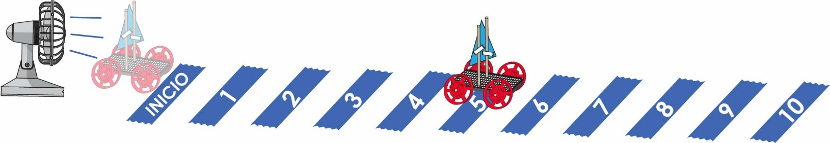  
Nombre: **____________________________________________**

**Predice:** Circula qué tan lejos *crees* que llegará.



**Pequeño**

A

|  |  |  |  |  |  |  |  |  |  |  |
| --- | --- | --- | --- | --- | --- | --- | --- | --- | --- | --- |
|  | **1** | **2** | **3** | **4** | **5** | **6** | **7** | **8** | **9** | **10** |

**Prueba:** Circula, ¿Qué tan lejos llegó?

|  |  |  |  |  |  |  |  |  |  |  |
| --- | --- | --- | --- | --- | --- | --- | --- | --- | --- | --- |
|  | **1** | **2** | **3** | **4** | **5** | **6** | **7** | **8** | **9** | **10** |

**Predice:** Circula qué tan lejos *crees* que llegará.



**Mediano**

B

|  |  |  |  |  |  |  |  |  |  |  |
| --- | --- | --- | --- | --- | --- | --- | --- | --- | --- | --- |
|  | **1** | **2** | **3** | **4** | **5** | **6** | **7** | **8** | **9** | **10** |

**Prueba:** Circula, ¿Qué tan lejos llegó?

|  |  |  |  |  |  |  |  |  |  |  |
| --- | --- | --- | --- | --- | --- | --- | --- | --- | --- | --- |
|  | **1** | **2** | **3** | **4** | **5** | **6** | **7** | **8** | **9** | **10** |

**Predice:** Circula qué tan lejos *crees* que llegará.

|  |  |  |  |  |  |  |  |  |  |  |
| --- | --- | --- | --- | --- | --- | --- | --- | --- | --- | --- |
| **Grande**  C | **1** | **2** | **3** | **4** | **5** | **6** | **7** | **8** | **9** | **10** |

**Prueba:** Circula, ¿Qué tan lejos llegó?

|  |  |  |  |  |  |  |  |  |  |  |
| --- | --- | --- | --- | --- | --- | --- | --- | --- | --- | --- |
|  | **1** | **2** | **3** | **4** | **5** | **6** | **7** | **8** | **9** | **10** |

Nombre: **____________________________________________**

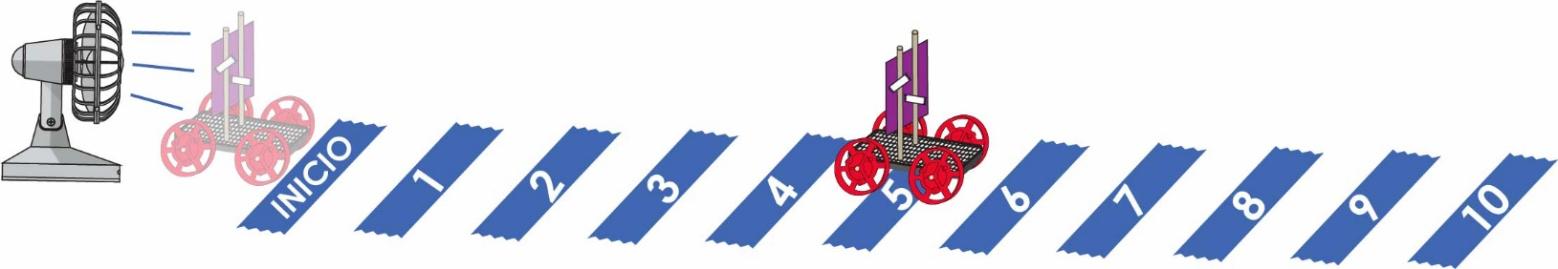

**Predice:** Circula qué tan lejos *crees* que llegará.



**Pequeño**

A

|  |  |  |  |  |  |  |  |  |  |  |
| --- | --- | --- | --- | --- | --- | --- | --- | --- | --- | --- |
|  | **1** | **2** | **3** | **4** | **5** | **6** | **7** | **8** | **9** | **10** |

**Prueba:** Circula, ¿Qué tan lejos llegó?

|  |  |  |  |  |  |  |  |  |  |  |
| --- | --- | --- | --- | --- | --- | --- | --- | --- | --- | --- |
|  | **1** | **2** | **3** | **4** | **5** | **6** | **7** | **8** | **9** | **10** |

**Predice:** Circula qué tan lejos *crees* que llegará.



**Mediano**

B

|  |  |  |  |  |  |  |  |  |  |  |
| --- | --- | --- | --- | --- | --- | --- | --- | --- | --- | --- |
|  | **1** | **2** | **3** | **4** | **5** | **6** | **7** | **8** | **9** | **10** |

**Prueba:** Circula, ¿Qué tan lejos llegó?

|  |  |  |  |  |  |  |  |  |  |  |
| --- | --- | --- | --- | --- | --- | --- | --- | --- | --- | --- |
|  | **1** | **2** | **3** | **4** | **5** | **6** | **7** | **8** | **9** | **10** |

**Predice:** Circula qué tan lejos *crees* que llegará.



**Grande**

C

|  |  |  |  |  |  |  |  |  |  |  |
| --- | --- | --- | --- | --- | --- | --- | --- | --- | --- | --- |
|  | **1** | **2** | **3** | **4** | **5** | **6** | **7** | **8** | **9** | **10** |

**Prueba:** Circula, ¿Qué tan lejos llegó?

|  |  |  |  |  |  |  |  |  |  |  |
| --- | --- | --- | --- | --- | --- | --- | --- | --- | --- | --- |
|  | **1** | **2** | **3** | **4** | **5** | **6** | **7** | **8** | **9** | **10** |



Vela Circular Pequeña



Corta las siguientes formas de velas usando cartón, cartulina o papel grueso. Las formas pueden reusarse entre grupos de carros.



Vela Circular Mediana



Vela Circular Grande



Nota interesante: Las velas grandes tienen el doble de área que las velas medianas. Las velas medianas tienen el doble de área que las velas pequeñas. Si sigues las matemáticas… una vela grande es CUATRO veces mayor que una pequeña.

Vela Triangular Grande

C

A

Vela Cuadrada Pequeña



Vela Triangular Pequeña

A



Vela Triangular Mediana

B





B

Vela Cuadrada Mediana



C

Vela Cuadrada Grande

